Build for Billions
  - Initial Screening Proposal
CasePilot AI — A source-linked legal case preparation assistant
Team Name: MIB
Team Leader: Sharad Siddanagoudar
Team Members: Akshata Patil, Aayush Kumar Rai
College/University: KLE Technological University
Selected Track: Agentic AI

1. Problem Statement
Small and mid-sized law firms spend significant time manually reviewing documents, reconstructing case histories, finding missing information, and organizing follow-up work. Facts are scattered across agreements, payment records, notices, emails, and other evidence. This makes case preparation slow and makes it difficult to verify where a claim came from.
Independent lawyers and small legal teams may have limited staff to perform this work. In a property dispute, inconsistent possession dates or payment claims can be overlooked when documents are reviewed separately. The challenge is to turn a case file into a structured, verifiable brief while keeping legal judgment with the lawyer.

2. Proposed Solution
CasePilot AI is a proposed AI case-preparation assistant that converts uploaded documents into an evidence-linked case brief. A controlled agent workflow extracts information, compares accounts across documents, identifies potential gaps, and proposes follow-up tasks for lawyer review.
Users create a case and upload text-based PDF, DOCX, or TXT files. The system preserves page or passage references during extraction, identifies parties and factual claims, and generates a summary and timeline. Lawyers can inspect the evidence behind findings and edit, approve, or reject suggested tasks.
Source-linked brief. Key parties, facts, and events link to supporting passages; PDF page references are shown where available.
Conflicts and gaps. The system presents competing accounts and flags information not found in the uploaded material for human verification.
Review and history. Suggested tasks remain pending until reviewed. An activity history records AI suggestions and user decisions.
The 24-hour prototype will demonstrate a fictional property possession and payment dispute using approximately six short documents. Scanned files will be flagged as needing OCR. CasePilot supports preparation; it does not make autonomous legal decisions or execute consequential legal actions without human approval.

3. Target Users and Impact
Primary users are independent lawyers, small and mid-sized law firms, paralegals, and legal-aid teams. The intended benefit is less repetitive document organization and faster access to evidence, helping limited legal staff prepare cases more consistently. Clients in underserved communities could benefit indirectly when legal-aid teams can use their time more effectively. These benefits are proposed and will require user validation.

4. Technology Stack
Frontend: React, TypeScript, and Tailwind CSS for uploads, the case workspace, source viewing, and task review.
Backend: Node.js with TypeScript for document parsing, job processing, AI orchestration, and API endpoints.
Data and access: Supabase Postgres, private Supabase Storage, and Supabase Auth for case records, files, and user access. Case ownership checks and row-level security will restrict access.
AI integration: A hosted language model through the NVIDIA API Catalog, subject to available developer access and quota. The final model will be selected after testing extraction quality, latency, and structured output. API keys remain on the backend.
Processing: PDF text extraction and DOCX/TXT parsing preserve source identifiers. JSON schema validation and citation checks validate output structure and source references; legal interpretation remains subject to review.
Planned flow: Upload → extract text → extract evidence → analyze the case → validate references → lawyer review. Processing status is stored in Postgres and shown in the interface. The prototype will analyze a bounded set of short documents.

5. Innovation and Scalability
The proposed differentiation is an evidence-first review workflow: summaries, timeline events, conflicts, and tasks share traceable source records. Conflicting accounts remain visible rather than being silently resolved. Document statements are distinguished from AI inferences, and missing material is described as absent from the uploaded file set, not proven nonexistent.
The agentic workflow connects document understanding to proposed follow-up work, with an explicit human approval boundary. This allows lawyers to verify a finding, inspect its source, and decide what to do next in one workspace. The prototype will use fictional data and will not include external messaging or legal research.
Beyond the hackathon, processing could move to dedicated workers with queued jobs, document chunking, and retrieval for larger files. Future extensions could include OCR, regional-language support, and workflows for tenancy, consumer, and contract disputes. Broader deployment would require stronger tenant isolation, retention controls, security evaluation, and testing with legal professionals.

6. Prototype and References
Current status: proposal and concept wireframe; a working prototype is planned for the hackathon. The wireframe illustrates document intake and evidence review. All displayed case facts and excerpts are fictional.
Wireframe reference: Appendix A in this document and the accompanying CasePilot_Wireframe.png file.
Planned AI platform: https://build.nvidia.com/
NVIDIA API integration guide: https://docs.api.nvidia.com/nim/docs/api-quickstart
Supabase documentation: https://supabase.com/docs

7. Team Contribution
Sharad Siddanagoudar — Team Leader: System architecture, backend development, Supabase integration, document processing, and AI orchestration.
Akshata Patil: Frontend development for case creation, uploads, and source viewing; wireframe refinement and submission documentation.
Aayush Kumar Rai: Frontend development for the brief, timeline, issue review, and task decisions; documentation and demo preparation.
The team will jointly test and demonstrate the complete workflow.

Appendix A Concept Wireframe
Two proposed screens show the path from document upload to evidence inspection and lawyer review. This is a design reference, not a functioning application.
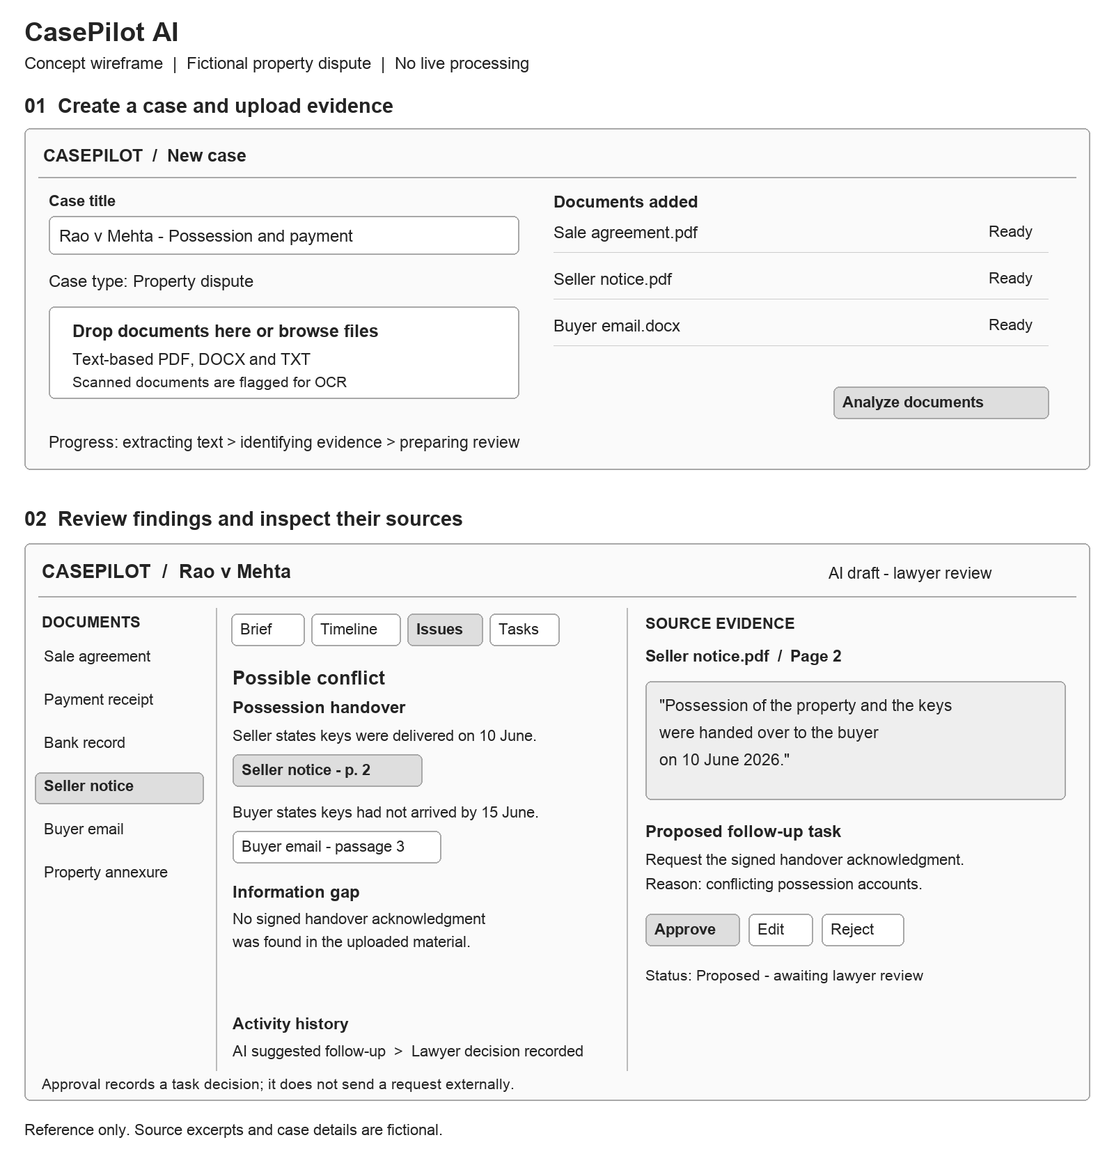
Demonstration sequence: upload the fictional documents, inspect a possession-date conflict, open both source references, and record a decision on the proposed follow-up task.

