Job Market Analysis Report

1. Introduction
This report analyzes job market trends using structured data. It focuses on salary patterns, hiring demand, and skill requirements. The study helps understand how industries recruit and what factors influence employment opportunities.
Key Points:
- Analyze job market trends
- Identify hiring patterns
- Understand salary variations
- Evaluate skill demand

2. Problem Statement
Job data is often unstructured and inconsistent. Extracting meaningful insights is difficult. This project aims to clean and analyze data to provide clear insights for decision-making.
Key Points:
- Data is unstructured
- Missing values present
- Insights not easily visible
- Need structured analysis

3. Objectives
The project aims to analyze job data and derive useful insights. It focuses on salary trends, job demand, and skill requirements across industries and locations.
Key Points:
- Identify high-demand jobs
- Analyze salary distribution
- Study skill requirements
- Provide actionable insights

4. Data Source
The dataset was extracted from a MySQL database. It contains job-related information such as salary, company, location, and required skills.
Key Points:
- 742 rows of data
- 42 features available
- Includes job and company details
- Contains skill indicators
*Type of Analysis Used
This project is based on Descriptive Data Analysis, where historical job market data is analyzed to identify patterns, trends, and relationships. No predictive or machine learning models were used. Instead, statistical aggregation techniques and data visualization tools were applied to derive meaningful insights.
5. Data Extraction
Data was retrieved using SQL query and Python libraries. The dataset was loaded into a DataFrame for further processing.
Key Points:
- Used SQL query
- Connected via Python
- Loaded into Pandas
- Prepared for analysis

6. Data Cleaning
Data cleaning improved data quality. Missing values were handled and unnecessary columns were removed.
Key Points:
- Removed null column
- Replaced invalid values
- Imputed missing data
- Ensured consistency

7. Data Transformation
Data was standardized for better analysis. Columns were formatted and location was split into meaningful parts.
Key Points:
- Standardized column names
- Cleaned company names
- Split location data
- Formatted text values

8. Feature Engineering
New features were created to improve analysis. Salary and revenue fields were converted into usable formats.
Key Points:
- Converted salary values
- Created avg_salary column
- Transformed revenue data
- Improved data usability

9. Tools & Technologies
Multiple tools were used for analysis and visualization. Each tool played a specific role in the workflow.
Key Points:
- Python for processing
- Pandas for data handling
- Power BI for dashboard
- MySQL for database

10. State-wise Job Distribution
Job postings vary across states. Some regions show higher job concentration due to industry presence.
Key Points:
- Jobs concentrated in few states
- Indicates economic strength
- Helps location analysis
- Useful for job seekers

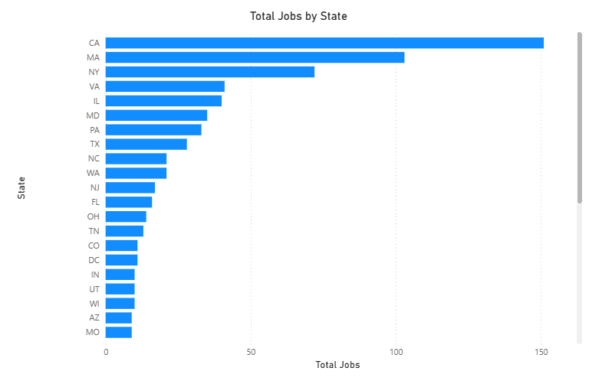
11. Average Salary by State
Salary varies across states. Regions with strong industries offer better compensation.
Key Points:
- Salary differs by location
- Higher in developed regions
- Industry impacts pay
- Location influences earnings
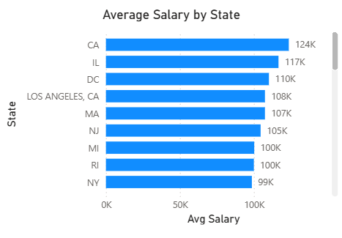
12. Salary Range Analysis
Salary range shows variation within states. It highlights minimum and maximum earning potential.
Key Points:
- Shows salary variation
- Indicates pay range
- Helps comparison
- Useful for analysis
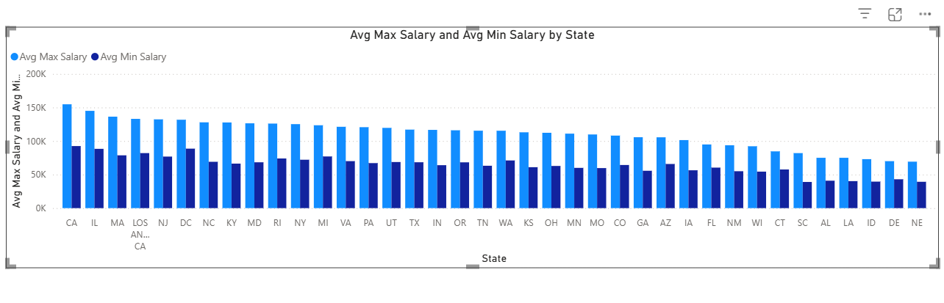
13. Top Industries
Certain industries dominate job postings. These industries actively hire data professionals.
Key Points:
- Few industries lead hiring
- Technology dominates
- Data roles increasing
- Shows industry demand
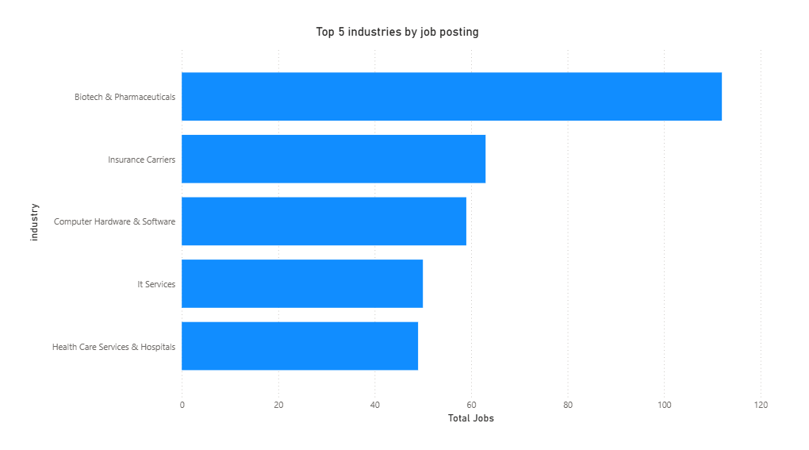

14. Company Hiring Trends
Some companies offer more job opportunities. These companies drive hiring activity.
Key Points:
- Top companies hire more
- Indicates company growth
- More opportunities available
- Helps target employers

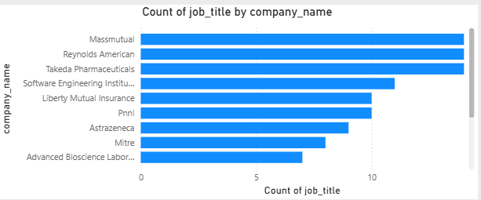

15. Job Titles with Most Jobs
Certain job roles appear frequently. These roles reflect current market demand.
Key Points:
- Data roles most common
- High demand skills
- Indicates career trends
- Popular job categories
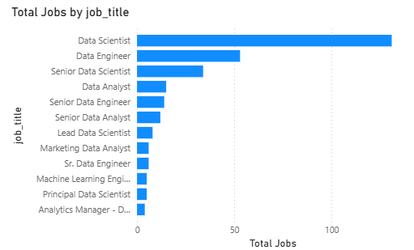

16. Salary by Job Title
Salary varies across job roles. Technical roles tend to offer higher pay.
Key Points:
- Salary differs by role
- Technical roles pay more
- Skills affect salary
- Experience matters

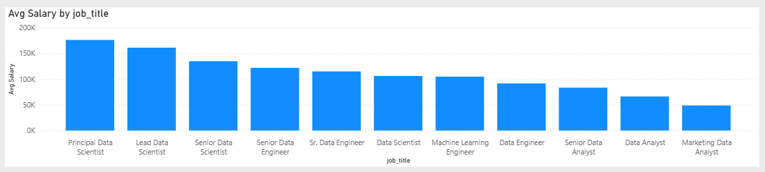

17. Skills Demand Analysis
Skill analysis shows required competencies. Technical and analytical skills are highly demanded.
Key Points:
- Python widely used
- SQL highly demanded
- Cloud skills rising
- Skills improve employability
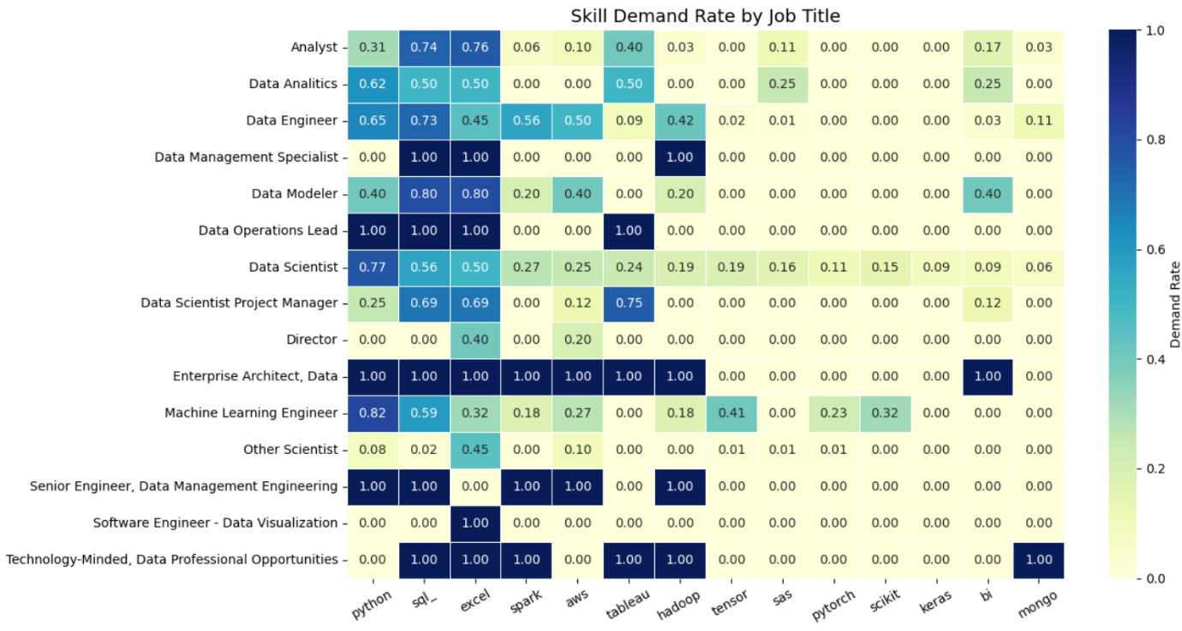

18. Education vs Salary
Education impacts salary levels. Higher qualifications often lead to better pay.
Key Points:
- Higher education pays more
- Skills also important
- Experience matters
- Education adds value
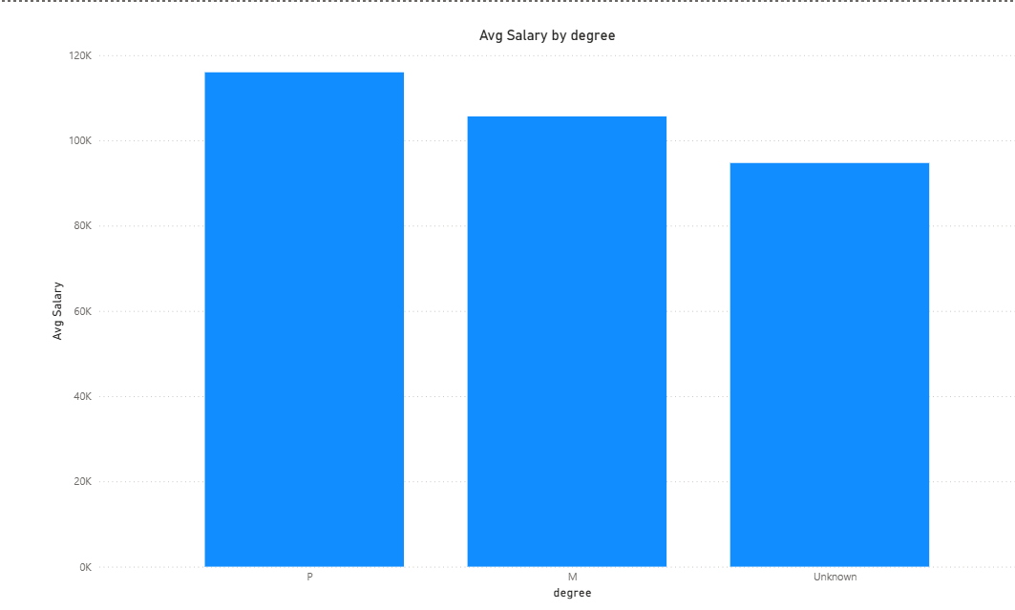

19. Correlation Analysis
Correlation shows relationships between variables. It helps understand influencing factors.
Key Points:
- Shows variable relationships
- Helps deeper analysis
- Identifies patterns
- Supports insights

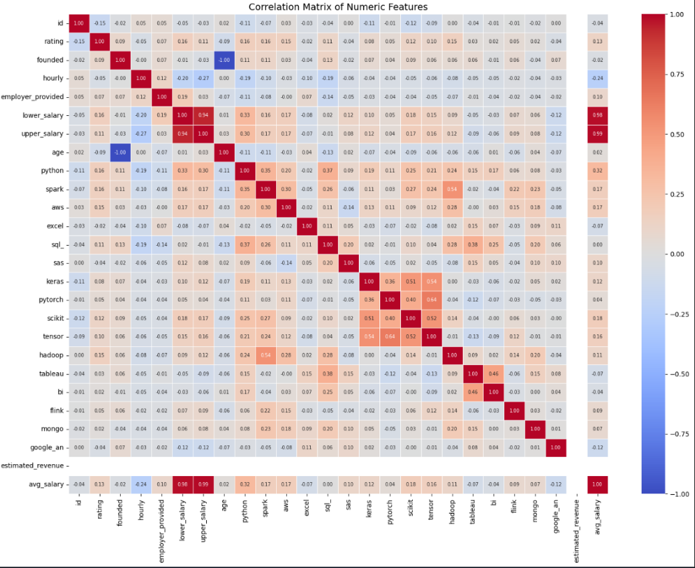
20. Salary Distribution
Salary distribution shows spread of values. It highlights common salary ranges.
Key Points:
- Shows salary spread
- Identifies common range
- Detects outliers
- Useful for analysis

21. Overall Skill Demand
Overall skill demand highlights most required tools. It shows industry expectations.
Key Points:
- Python most demanded
- SQL essential skill
- Tools widely used
- Skills drive hiring
22. Business Insights
The analysis provides key insights for decision-making. It helps both job seekers and companies.
Key Points:
- High demand for data roles
- Skills influence salary
- Location impacts jobs
- Industry drives demand

23. Challenges Faced
Several challenges were encountered during the project. These were handled using proper techniques.
Key Points:
- Missing data issues
- Data inconsistency
- Complex salary fields
- Cleaning required effort

24. Conclusion
The project successfully analyzed job market trends. It provides meaningful insights for better decision-making.
Key Points:
- Achieved project goals
- Generated useful insights
- Improved data understanding
- Supports decision-making

25. Future Scope
The project can be extended further. Advanced techniques can improve analysis.
Key Points:
- Use real-time data
- Apply machine learning
- Predict job trends
- Enhance dashboard

