Session 1

Q1. Write a short paragraph in your own words defining what a 'program' is and give one real-life example from any app you use daily (like Instagram, Zomato, or Paytm).

Ans:
A program is a set of instructions that tells a computer what to do. It helps the computer perform specific tasks automatically.

Real-Life Example: Paytm
When you send money using Paytm, the program checks your account balance, transfers the money to the receiver, and shows a success message after the payment is completed.

Q2. List three popular programming languages you have heard of, and for each, mention whether it is usually compiled, interpreted, or can be both. (Hint: Think of languages like Java, Python, and JavaScript.)

Ans:
Java - both (Compiled and Interpreted)
Python - Interpreted
JavaScript - Interpreted
Q3. Draw a flowchart (on paper or using any online tool) for the process of booking a movie ticket on BookMyShow, starting from opening the app to receiving the booking confirmation.
Ans:
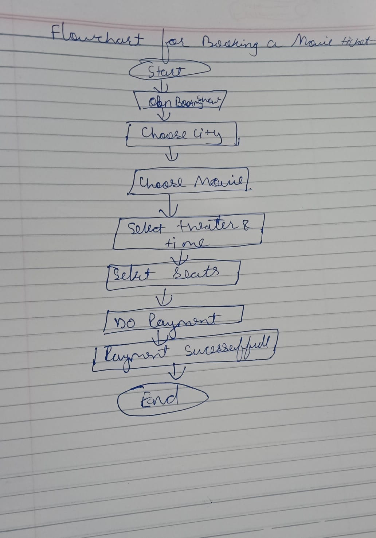

Q4. Write down the steps (as an algorithm, using simple numbered instructions) for ordering food on Swiggy — from opening the app to completing payment.
Ans:
Step 1: Open the Swiggy app.
Step 2: Log in to your account.
Step 3: Select your delivery location.
Step 4: Search for a restaurant.
Step 5: Choose the food items.
Step 6: Add the items to the cart.
Step 7: Review your order.
Step 8: Click Proceed to Payment.
Step 9: Choose a payment method (UPI, Card, Wallet, or Cash on Delivery).
Step 10: Complete the payment.
Step 11: Receive the order confirmation.
Step 12: Track the order until it is delivered.
Step 13: End.

