Session 2

Q1. Install GCC on your computer and verify the installation by running gcc --version in your terminal or command prompt.
Ans:
Code block is installed.

Q2. Open VS Code or DevC++ and create a new file named hello.c. Write a C program that prints 'Hello, Instagram World!' to the console.
Ans:
Code done in code block.

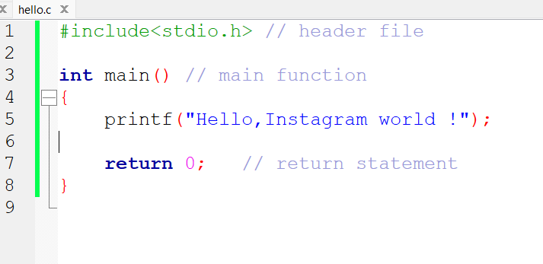
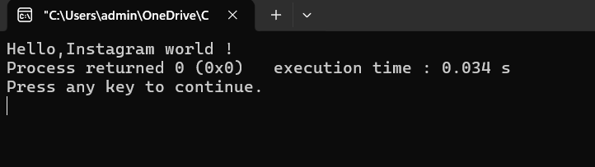

Q3. Identify and label the header, main function, and return statement in your hello.c program using comments.
Ans:


Q4. Compile your hello.c file using the GCC command line (gcc hello.c -o hello) and run the output file to display the Windows, the output file will be hello.exe; on Linux/Mac, it will be hello.
Ans:
Compile with mingw compiler.

