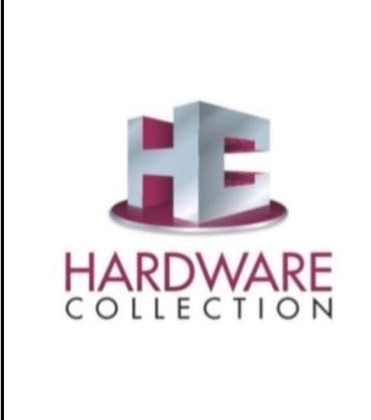 | HARDWARE COLLECTION  1/18, Kashidih (Near Durga Puja Maidan), Sakchi, Jamshedpur  State: Jharkhand | PIN: 831001  Ph: 2441866 | Fax: 2440466 | Mob: +91 98351 90738  Email: hardwarecollectionjsr@gmail.com  Authorized Dealer: Dorset • Hafele • Labacha

WE ARE HIRING
Shop & Digital Operations Assistant
We are looking for a smart, honest, and responsible individual to join our team. This role combines in-store customer support with digital and accounting tasks — ideal for someone eager to grow with a reputed hardware brand.
Key Responsibilities
- Handle customer interaction in store
- Reply to Google reviews & WhatsApp messages
- Manage basic Instagram / digital inquiries
- Do billing & accounting entry in Tally
- Assist in daily store operations
Requirements & Skills
- Basic computer knowledge (MS Office, typing, email)
- Comfortable using WhatsApp Business and social media platforms
- Basic knowledge of Tally accounting software (preferred, not mandatory)
- Good communication skills — polite and professional with customers
- Honest, punctual, responsible, and willing to learn on the job
- Local candidate from Jamshedpur preferred

Location | Sakchi, Jamshedpur, Jharkhand – 831001
Experience | 0–2 Years (Freshers welcome to apply)
Job Type | Full-Time | In-Store + Digital Role
How to Apply | Interested candidates can send their details on WhatsApp.  Mukesh Khandelwal : +91 98351 90738

Mukesh Khandelwal | Hardware Collection, 1/18 Kashidih, Sakchi, Jamshedpur – 831001
hardwarecollectionjsr@gmail.com | +91 98351 90738

