Gate-Crashers: Project Guide
Motion Planning & Control (TE7864) | Ankita Mehta, SIT Pune

1. What this project is
A software-only simulation of a quadrotor that flies through gates which slide sideways like a sine wave. The drone only sees noisy gate positions. A Kalman filter estimates the gate's position and velocity, a minimum-jerk (quintic) planner builds a path to where the gate WILL be, and a feedforward + PD controller flies that path on a linearised quadrotor model.
Success rule: at the instant the drone reaches the gate's plane, its 3-D distance to the gate's true centre must be below 0.3 m.

2. What is in the folder
File | What it does | Syllabus topic
dynamics.py | Linearised quadrotor + RK4 integrator | Dynamics
controller.py | Feedforward + PD tracker (Kp 8, Kd 4, tilt clip 25°) | Control
gate.py | Sliding gate (truth) and noisy sensor | Sensing
kalman.py | 6-state constant-velocity Kalman filter | State estimation
planner.py | Quintic minimum-jerk trajectory | Trajectory planning
pipeline.py | Joins everything; 3 planner modes; Monte Carlo | Integration
run_1 ... run_5 | Component tests, single gate, 3 gates, baselines, animation | Experiments
run_all.py | Runs all five in order (about 5 minutes)
results/, docs/ | Figures, animation, this guide, the slides

3. How to run it
- Needs Python 3 with numpy and matplotlib: pip install -r requirements.txt
- Open the MPC_FINAL folder in VS Code, open a terminal there, and run:
python run_all.py
- Or run one step, for example: python run_2_single_gate.py
- Figures pop up one after another; close each window to continue. The animation is saved as results/gate_crashers.mp4 (needs ffmpeg) or .gif (automatic fallback).
- To run without pop-ups on Windows PowerShell: $env:MPC_NO_SHOW=1; python run_all.py

4. How the system works

4.1 Model and controller
Hover-linearised quadrotor: ẍ = g·θ, ÿ = −g·φ, z̈ = a_z. State = [x y z vx vy vz]. Integrated with RK4 and a zero-order hold on the input.
Control law: a = a_ref + Kp(p_ref − p) + Kd(v_ref − v), then θ = a_x/g and φ = −a_y/g, clipped to ±25° so the small-angle model stays valid. The feedforward term a_ref removes the lag that plain PD has on moving references.

4.2 Kalman filter
Prediction x⁻ = F x, P⁻ = F P Fᵀ + Q. Update K = P⁻Hᵀ(H P⁻ Hᵀ + R)⁻¹, x = x⁻ + K(z − Hx⁻). Only position is measured (H = [I 0]); velocity is inferred.
Process noise uses the white-noise-acceleration form Q = q·[[dt³/3, dt²/2],[dt²/2, dt]] (per axis), with q = 0.1. A plain diagonal Q was our first attempt and gave a velocity error about 3.5 times worse.

4.3 Minimum-jerk quintic
Minimise ∫(x‴)² dt. Euler-Lagrange gives x⁽⁶⁾ = 0, so x(t) is a 5th-order polynomial with six coefficients, fixed by six boundary conditions (position, velocity, acceleration at t = 0 and t = T). c0 = p0, c1 = v0, c2 = a0/2; c3, c4, c5 come from the 3×3 system:
[ T^3 T^4 T^5 ] [c3] [ p1 - (p0 + v0 T + a0 T^2/2) ]
[ 3T^2 4T^3 5T^4 ] [c4] = [ v1 - (v0 + a0 T) ]
[ 6T 12T^2 20T^3] [c5] [ a1 - a0 ]

4.4 Strategy: cruise, then intercept
For each gate: cruise at 1 m/s for T_OBS = 3.3 s while the filter watches the gate; then plan one quintic of T_ARR = 0.7 s to the gate's forecast position and velocity at the crossing, and fly it. The forecast horizon is short on purpose: a constant-velocity model is only trustworthy well under a quarter of the gate's period (0.7 s is 12% of 6 s). T_OBS and T_ARR satisfy remaining x-distance = cruise speed × T_ARR (4 − 3.3 = 0.7 m), which stops the quintic from dipping backwards.
Phase sync: gate i is shifted by −ω·i·LEG_T so that each gate is at the same point of its cycle when the drone arrives. This is the designed condition; Section 6 shows what happens when it is removed.

5. Results (all produced by the final code)
Experiment | Result | Script
Component checks | all 3 PASS; KF position error 0.018 m (raw 0.051), velocity 0.15 m/s | run_1
Single gate, 100 seeds, synced | 100% success, median miss 0.13 m, worst 0.21 m | run_2
3-gate chain, 50 seeds, synced | 100% per gate, 100% full chain | run_3
Baselines, synced phase (per gate) | predictive 100%, filtered 0%, naive 0% | run_4
Baselines, random phase (per gate) | predictive 83%, filtered 25%, naive 24% | run_4

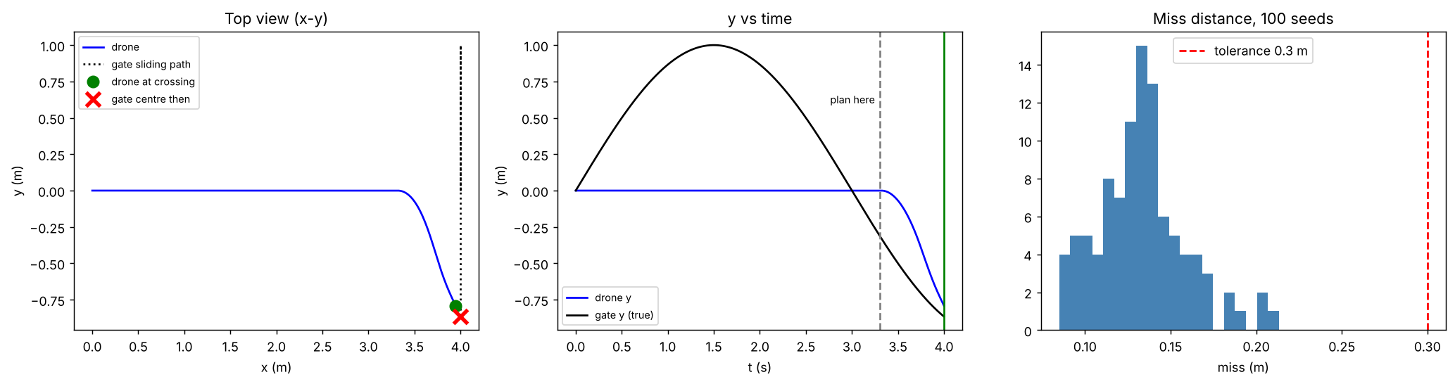
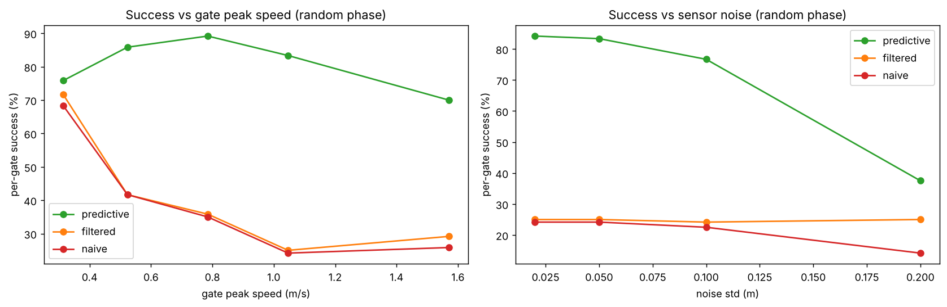
Reading the baselines: all three planners use the same pipeline; only the information about the gate changes. The velocity forecast is what makes the difference. Filtering alone (zero velocity) does not help, because the gate can move up to about 0.7 m during the intercept.

6. Honest limits (say these in the viva before they are asked)
- Phase dependence: 100% needs the phase-synced gates. With random phases the same method gets 83% per gate. It is weakest when the gate reverses direction near the crossing, which a constant-velocity forecast cannot see.
- Noise: 84% at 2 cm, 83% at 5 cm, 77% at 10 cm, 38% at 20 cm (random phase).
- Speed: random-phase success is 76 to 89% for gate peak speeds of 0.3 to 1.05 m/s and 70% at 1.57 m/s. The drop at the slowest gate is likely the 1 m sideways move in 0.7 s; I did not isolate this.
- Idealised: linearised model, no wind, no actuator lag, known gate x-position, 2-D motion of the gate only.
- Next step: forecast with a sinusoidal or constant-acceleration model to predict through reversals.

7. Bugs we hit (the debugging story)
Problem | Symptom | Fix
Wrong Q matrix | velocity error stuck near 0.9 m/s | white-noise-acceleration Q (0.25 m/s then)
Long prediction horizon | forecast through a gate reversal failed | cruise first, short 0.7 s intercept
Tilt saturation | tracking degraded above about 2 m/s | keep speeds near 1 m/s
Lateral offset carried over | success collapsed after gate 1 | re-centre cruise on the next gate
Leg time vs gate period | 3-gate success near 0% | phase sync per gate
Quintic ended with x-velocity 0 | drone flew backwards toward the gate | force end x-velocity = cruise speed
Gate seemed to slow down | looked like a bug | not a bug: sinusoidal speed varies

8. Viva questions and answers
Q1. Why a quintic and not a cubic?
Minimising jerk gives x⁽⁶⁾ = 0, a 5th-order polynomial. It lets us fix position, velocity AND acceleration at both ends (6 conditions, 6 coefficients); a cubic only fixes position and velocity.
Q2. Why a Kalman filter and not just the sensor value?
The sensor is noisy (5 cm) and has no velocity. The filter reduces position error to 0.018 m and gives velocity (0.15 m/s error), which the forecast needs.
Q3. Why did the first Q fail?
A plain diagonal Q ignores that acceleration noise affects position and velocity together. The white-noise-acceleration Q has the dt³/3, dt²/2, dt structure and gave a 3.5 times smaller velocity error.
Q4. Why not plan from the start in one go?
The gate is a sine. A constant-velocity forecast is valid only well under a quarter of its period; predicting far ahead goes through a reversal. Long plans also need high speeds that saturate the tilt limit.
Q5. What does the controller's feedforward do?
It adds the reference acceleration, so the PD terms only correct small errors. Without it a PD controller lags a moving reference.
Q6. Why clip tilt to 25 degrees?
The model is linearised for small angles; larger tilts make it inaccurate.
Q7. Why is the filtered-only baseline so bad?
It sends the drone to where the gate IS, with zero velocity. The gate can move up to about 0.7 m during the 0.7 s intercept, so it is missed.
Q8. Is 100% a fair claim?
Only for the phase-synced setup, which was designed. With random phase it is 83%. Both numbers are reported.
Q9. What is phase sync and why is it needed?
Each leg takes 4 s but the gate period is 6 s, so later gates would arrive at different points of their cycle. Shifting gate i by −ω·i·LEG_T makes every gate look the same on arrival.
Q10. How do you check success?
3-D distance between the drone and the gate's TRUE centre (not the estimate) at the planned crossing time, threshold 0.3 m.
Q11. What would you improve?
A sinusoid or constant-acceleration forecast, wind and actuator lag in the simulation, and an unknown gate x-position.
Q12. What does Monte Carlo mean here?
Repeating the run over many random sensor-noise seeds (and gate phases) to get a success rate instead of trusting one lucky run.

9. One-line memory aid
S-E-P-C: Sense (noisy), Estimate (Kalman), Plan (quintic), Control (FF+PD). Then: cruise, forecast 0.7 s, intercept.

