**UCS503- Software Engineering Lab**

**BETTERMEHTA**

**UCS 503 Software Engineering Project Report**

**END-Semester Evaluation**

**Submitted by:**

**(102203817)Aayush Singh**

**(102203800)Yuvika Sardana**

**(102203832)Pancham Agarwal**

**(102213020)Kuhu Mishra**

**BE Third Year, CSE**

**Group No: 3CO30**

**Submitted to: Dr. Anamika Sharma**



**Computer Engineering Department**

**TIET, Patiala**

**November 2023**

**UCS503- Software Engineering Lab**

**TABLE OF CONTENTS**

**S.No.** **Assignment** **Page No.**

1. **Project Selection Phase**

1.1 Software Bid

1.2 Project Overview

1.3 Feasibility Report

1.4 Gantt Chart

1. **Analysis Phase**

2.1 Use Cases

2.1.1 Use-Case Diagrams

2.1.2 Use Case Templates

2.2 Activity Diagram and Swimlane Diagrams

2.3 Data Flow Diagrams (DFDs)

2.3.1 DFD Level 0

2.3.2 DFD Level 1

2.3.2 DFD Level 2

2.4 Software Requirement Specification in IEEE Format

2.5 User Stories and Story Cards

1. **Design Phase ( At least two significant cases of each diagram)**

3.1 Class Diagram

3.2 Sequence Diagram

3.3 Collaboration Diagram

3.4 State Chart Diagrams

1. **Implementation**

4.1 Component Diagrams

4.2 Deployment Diagrams

4.3 Screenshots

1. **Testing**

5.1 Test Plan

5.2 Test Cases

5.3 Test Reports

1. **Project Selection Phase**
   1. **Software Bid**

**Software Bid/ Project Teams**

**UCS 503- Software Engineering Lab**

Group ID: 3CO30 Dated: 17 /8/2024

**Team Name: BetterMehta**

**Team ID(will be assigned by Instructor):**

|  |  |  |  |  |
| --- | --- | --- | --- | --- |
| Name | Roll No | Project Experience | Programming Language used | Signature |
| Yuvika Sardana | 102203800 | Adventure Retreat- A full-stack project enabling users to add, view, and rate camping sites | Node.Js  Mongo DB  Express.Js |  |
| Aayush Singh | 102203817 | Angular ERP- A single page ERP website which tracks the data of employees of a firm | Angular JS  TypeScript  MySQL  Express.Js |  |
| Pancham Agarwal | 102203832 | Thapar NightPass,  Thapar Hostel Management ,  Group Wallets,  Summer Internship at Genpact India. | Python, Java, Javascript, Node, PostgreSQL, Docker, Nginx |  |
| Kuhu Mishra | 102213020 | Frontend project on React, Netflix Clone | Javascript, React |  |

**Programming Language / Environment Experience**

1. Python (Django REST, Flask)
2. Javascript (Express, React)
3. Java (General Use, Springboot)
4. C++
5. Go

**Choices of Projects:**

|  |  |
| --- | --- |
| **First Choice** | BetterMehta: Streamline print shops by developing a web app that lets students send documents directly to vendors' printers, pay for prints, and collect them. It includes a React frontend, Python/Go backend, PostgreSQL + Cloudinary for storage, and C++ for managing multiple printers, reducing wait times and automating processes. |
| **Second Choice** | CyberGaurd: An ed-tech game which focuses on topic revolving around Cyber-Security. Provides a story based interactive platform for kids and young adults to learn concepts of Cyber Security |
| **Third Choice** | Nightpass: The web app enhances security and access for over 7,000 Thapar students during curfew hours. It features roles for Students, Admins, and Hostel Wardens, with an admin panel for adjusting monitoring parameters and oversight. Wardens receive real-time alerts and track student activities based on multiple factors |

**Additional Remarks/ Inputs**

We are really excited to work on our idea **BetterMehta** as it aims to significantly reduce wait times from **20mins in rush hours to <3mins**. It also ensures a smooth flow of events and guarantees the vendor receives all payments on time.

Our team comes with prior experience of implementing live projects on a large scale and we aim to host and make it operational during our time in this course.

Some previous live projects:

* permissions.thapar.edu
* merch.ccstiet.com
* codeboard.ccstiet.com
  1. **Project Idea:**

Current Issues:

* Stationery shops on campus offer printing services but become overcrowded during peak times, especially before classes.
* Only two computers are available to send documents to the printers, causing significant delays.
* The current process involves students emailing their documents to the vendor, who then downloads and prints them—this is inefficient and time-consuming.

Proposed Solution:

* Develop a cross-platform website for students to upload their documents, accessible via both phones and laptops.
* On the Vendor side:
  + Develop a desktop application that connects all printers to a single computer.
  + The application will call our API to fetch documents along with the information of the student to label the document for their collection and then it is printed automatically on approval by the vendor.
* The website will allow the students to:
  + Upload document for printing
  + Pay for the print service online
  + Collect the printed document from the shop at their convenience by scanning their student ID card
* Implementation Plan:
  + Website: Build the website to be cross-platform, accessible via phones and laptops.
  + Vendor Side: Develop the desktop application using the Printer Spooler API with C++.
  + Backend: Implement using Python. Frontend: Build using React. Database: Use MongoDB for data storage.
  1. **Feasibility Report:**

1. **Problem Statement:**

* Current process: Students email documents to vendors, who then download and print them from only two computers, creating bottlenecks.
* Proposed solution: A desktop application for students to send documents directly to the shopʼs printers, pay for prints, and later collect them. The vendor interface will connect multiple printers to one computer, automating the printing process.

1. Objectives:
   * Reduce waiting time for students
   * Streamline the printing process.
   * Automate vendor-side operations.
2. Technical Feasibility:
   * Frontend (React): User-friendly interface for students and vendors.
   * Backend (Python): Robust backend to manage document uploads, payments, and communication between student and vendor systems.
   * Database (MongoDB): Efficient storage of documents, payment records, and transaction logs.
   * Vendor-Side (C++ with Printer Spooler API) Efficient management of print jobs across multiple printers, enabling automatic printing.
3. Operational Feasibility:
   * The application will require deployment on student laptops and vendor computers.
   * Vendors will need training on the new system, but the automated approach will reduce manual effort.
   * Students can submit print jobs from their rooms, making the process more efficient.
4. Economic Feasibility:
   * Cost for development: Free for students and minimal for vendors (software installation, minimal training).
   * Potential savings: Reduced waiting times, better service, and potentially more business for vendors.
5. Schedule Feasibility:
   * The project can be developed in stages over a few months, with each module being tested and integrated progressively
6. Risks and Mitigation:
   * Technical risks: Integration of C++ with the Printer Spooler API may be challenging, but with thorough testing, these risks can be managed.
   * Operational risks: Vendors might resist change, so a simple and intuitive interface is essential.
   * Security risks: Ensuring the secure transfer and storage of documents will be critical.
   1. **Gantt Chart**

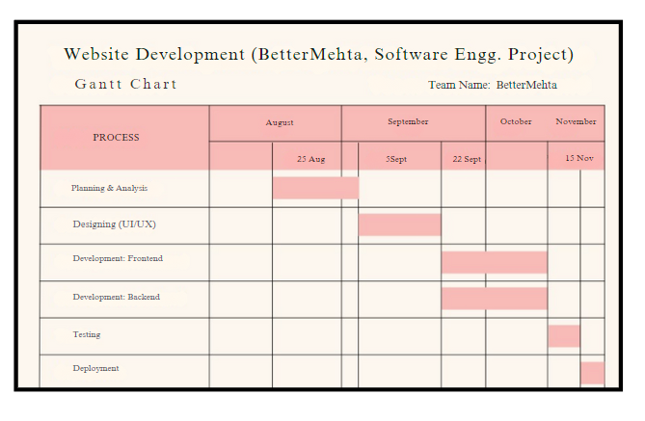

1. **Analysis Phase**

2.1 Use Cases

2.11 Use Case Diagrams

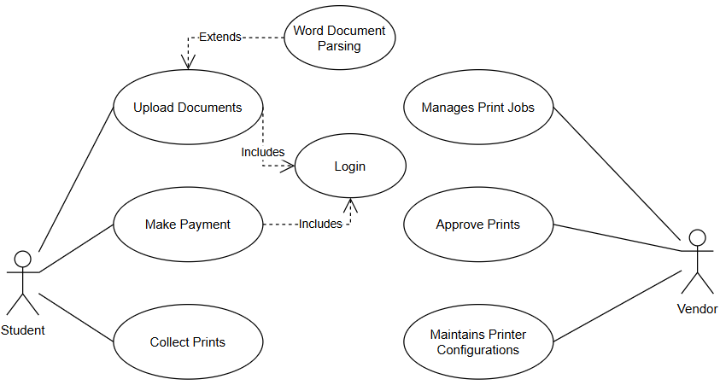

2.2 Activity Diagram Diagrams:

2.2.1 Activity Diagram

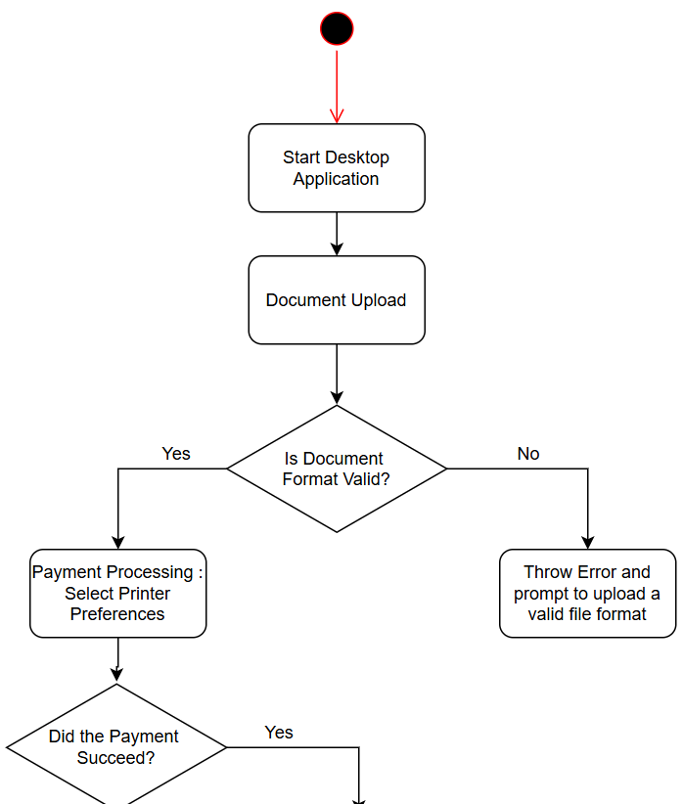 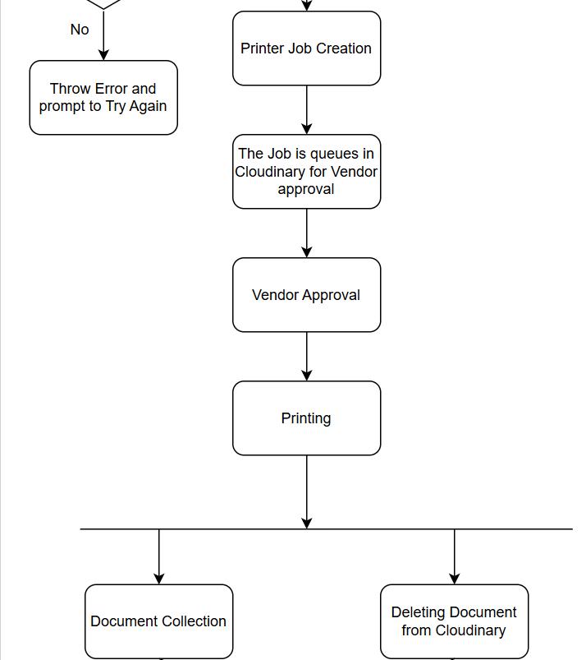



Data Flow Diagrams (DFDs)

**Software Requirements Specification Document**

Remote Printing for College Campuses

**Table of Contents**

|  |  |  |
| --- | --- | --- |
| **Chapter No.** | **Topic** | **Page No.** |
| 1 | Introduction | 3 |
| 1.1 | Purpose of this Document | 3 |
| 1.2 | Scope of the Development Project | 3 |
| 1.3 | Definitions, Abbreviations, and Acronyms | 4 |
| 1.4 | References | 5 |
| 1.5 | Overview | 6 |
| 2 | Overall Description | 7 |
| 2.1 | Product Perspective | 7 |
| 2.2 | Product Functions | 8 |
| 2.3 | User Characteristics | 10 |
| 2.4 | General Constraints, Assumptions, and Dependencies | 10 |
| 2.5 | Apportioning of the Requirements | 14 |
| 3 | Specific Requirements | 15 |
| 3.1 | External Interface Requirements | 15 |
| 3.2 | Detailed Description of Functional Requirements | 15 |
| 3.2.1 | Functional Requirements for Student Welcome Screen | 16 |
| 3.2.2 | Functional Requirements for Staff Welcome Screen | 16 |
| 3.2.3 | Functional Requirements for Student cum Staff Welcome Screen | 17 |
| 3.3 | Performance Requirements | 17 |
| 3.4 | Logical Database Requirements | 18 |
| 3.5 | Quality Attributes | 19 |
| 3.6 | Other Requirements | 19 |
| 4 | Change History | 19 |
| 5 | Document Approvers | 20 |

**1. Introduction**

**1.1 Purpose of the document**

The purpose of this SRS document is to provide a detailed overview of our software product, its parameters and goals. This document describes the project's target audience and its user interface, hardware and software requirements. It defines how our client, team and audience see the product and its functionality.

**1.2 Scope of the Development Project**

The scope of this project is to develop a streamlined printing system for campus stationery shops. It includes a cross-platform website where students can upload documents, make online payments, and collect their prints using their student ID. On the vendor side, a desktop application will automate document retrieval and printing, reducing waiting times and manual intervention during peak hours. The backend will be built using Python, with a React-based frontend for user interaction, and MongoDB for data storage. A Printer Spooler API in C++ will be used to integrate and manage printer connections for vendors.

The software must be able to perform the following operations:

1. **Document Upload and Management**: The software will enable students to upload their documents for printing via a user-friendly, cross-platform website. This site will be accessible from both mobile devices and laptops, making it convenient for students to submit print jobs on the go or from their dorm rooms. Uploaded documents will be stored temporarily until printed, streamlining the process and reducing the need for manual email-based submissions.
2. **Online Payment Processing**: Students can complete payments for print services directly through the platform. By integrating secure payment gateways, the system will allow various payment options such as credit/debit cards or digital wallets. This eliminates the need for cash transactions, reducing delays during peak hours and providing a seamless, cashless experience for both students and vendors.
3. **ID-based Document Retrieval**: To ensure efficient document collection, students will retrieve their printed documents by scanning their student ID cards at the vendor’s shop. This ID-based system helps reduce the risk of incorrect document collection or mix-ups. The vendor will have a clear record of which document belongs to which student, streamlining the collection process.
4. **Automated Print Job Handling**: The vendor’s desktop application, developed with a Printer Spooler API in C++, will automate print job retrieval from the central database. Upon student document submission, the application fetches the files, labels them with the student's information, and queues them for printing. The vendor only needs to approve the job before it is sent to the printer, significantly reducing manual intervention.
5. **Printer Status Monitoring and Management**: The desktop application will not only handle document processing but also monitor printer statuses in real-time. It will manage the print queue, alert the vendor in case of paper jams, low ink levels, or other technical issues, and help optimize printer usage during busy periods. This ensures smoother operation and faster service.

The scope of this system is not just limited to the university campus only as the same mechanism can be reused in other campuses as well.

**1.3 Definitions, abbreviations and acronyms**

**Definitions**

Table 1 gives an explanation of the most commonly used terms in this SRS document.

**Table 1: Definitions for most commonly used term**

|  |  |
| --- | --- |
| Document Upload | The process by which students submit their documents via a cross-platform website. The documents are stored temporarily until they are printed. |
| Payment Gateway | A secure system that processes online payments, allowing students to pay for printing services using credit cards, debit cards, or digital wallets. |
| Printer Spooler | A software program responsible for managing print jobs by queuing, prioritizing, and sending them to the printer. It helps optimize printing tasks. |
| Vendor Interface | A desktop application used by vendors to view, approve, and manage print jobs. It also monitors printer status and provides real-time alerts. |
| Cross-Platform Website | A website accessible from various devices (e.g., mobile, desktop) allowing students to upload documents, make payments, and track print job status. |
| Document Collection | The process by which students collect their printed documents by scanning their student ID at the vendor’s station to ensure accurate retrieval. |
| Print Queue | A sequence of pending print jobs managed by the Printer Spooler, awaiting vendor approval or processing. |
| Secure Payment System | A feature that ensures safe online financial transactions through encryption and verification protocols. |
| Real-Time Monitoring | The process of continuously checking printer status to alert vendors of issues such as low ink or paper jams, ensuring timely resolution. |

**Abbreviations**

Table 2 gives the full form of most commonly used mnemonics in this SRS document.

**Table 2: Full form for most commonly used mnemonics**

|  |  |  |
| --- | --- | --- |
| UI | User Interface | The design and layout that allows users to interact with the system, such as the website or desktop app. |
| API | Application Programming Interface | A set of protocols and tools for building software applications, allowing interaction between components. |
| SSO | Single Sign-On | A method of authentication that allows users to log in using a single set of credentials for multiple systems. |
| SSL | Secure Sockets Layer | A protocol for encrypting information over the internet, ensuring secure communication. |
| DB | Database | A structured collection of data stored electronically in a computer system, such as MongoDB used here. |
| RAM | Random Access Memory | A type of computer memory that stores data temporarily, crucial for system performance |

**1.4 References**

**1.5 Overview**

The remaining sections of this document provide a general description, including characteristics of the users of this project, the product's hardware, and the functional and data requirements of the product. General description of the project is discussed in section 2 of this document. Section 2 gives the functional requirements, data requirements and constraints and assumptions made while designing the multi-utility system. It also gives the user viewpoint of product use. Section 3 gives the specific requirements of the product. Section 3.0 also discusses the external interface requirements and gives detailed description of functional requirements.

**2. Overall Description**

**2.1 Product Perspective**

The proposed print management application aims to address the pressing challenges faced by students and stationery vendors on campus. By developing a cross-platform website for students and a dedicated desktop application for vendors, the solution seeks to create a seamless, efficient, and user-friendly printing experience. This product perspective outlines the intended features, target users, and the overall benefits of the application.

#### **Target Users**

The primary users of this application will be students attending the campus, who require quick and efficient access to printing services, particularly during peak hours before classes. The secondary users will be the stationery shop vendors responsible for managing print jobs, ensuring quality service, and maintaining printer operations. Both user groups will benefit from the streamlined processes, reducing the current inefficiencies associated with manual submissions and long waiting times.

#### **Features and Functionality**

1. **Cross-Platform Website for Students:** The application will feature a responsive website that allows students to upload documents directly from their smartphones or laptops. The intuitive interface will guide users through the upload process, supporting various document formats such as PDFs, Word documents, and images. This accessibility will empower students to manage their printing needs conveniently, whether they are on campus or offsite.
2. **Secure Online Payment System**: An integrated payment gateway will provide a secure environment for students to process payments. By offering multiple payment options—including credit/debit cards and digital wallets—the application will cater to diverse preferences, allowing students to complete transactions quickly and efficiently. This feature will eliminate the need for cash handling, reducing the time spent at the vendor's shop.
3. **Student ID-Based Collection System**: The application will employ an ID-based document retrieval system, enabling students to collect their printed documents by scanning their student ID cards. This approach not only enhances security but also streamlines the collection process, ensuring that students receive the correct documents without confusion. Vendors will maintain a digital record of document collections, improving accountability.
4. **Automated Document Processing for Vendors**: The vendor’s desktop application will leverage the Printer Spooler API to automate document retrieval and printing. This feature will significantly reduce manual intervention, allowing vendors to focus on managing print jobs and ensuring quality service. The application will provide a user-friendly interface for vendors to view pending jobs, approve prints, and monitor the status of multiple printers in real-time.
5. **Printer Status Monitoring and Management**: To maintain optimal printer functionality, the desktop application will include features for monitoring printer status. Vendors will receive real-time alerts for issues such as low ink, paper jams, or maintenance needs. This proactive approach will help prevent service interruptions, ensuring that students experience minimal delays when collecting their prints.

#### **Benefits and Value Proposition**

The implementation of this print management application will deliver significant value to both students and vendors. By reducing waiting times and streamlining the document submission process, the application will enhance the overall user experience for students, allowing them to focus on their studies without the stress of printing logistics. For vendors, the automation of print jobs and efficient management of resources will lead to improved service quality, increased customer satisfaction, and ultimately, higher revenue through enhanced operational efficiency.

Moreover, the application will contribute to a more organized and efficient campus environment, alleviating overcrowding in stationery shops during peak hours. By facilitating a smoother interaction between students and vendors, this solution has the potential to redefine the campus printing experience, establishing a model that can be replicated in other educational institutions facing similar challenges.

In conclusion, the proposed print management application represents a comprehensive solution to the pressing challenges of campus printing services. Its user-centric design, robust functionality, and focus on automation position it as a valuable tool for improving the efficiency and effectiveness of printing services for students and vendors alike.

**2.2 Product Functions**

1. **User-Friendly Document Upload**

The application will provide an intuitive interface for students to easily upload their documents for printing. Users can drag and drop files or use traditional file upload methods, supporting multiple formats like PDF, DOCX, and image files. The system will offer clear guidelines and previews to ensure students can verify their uploads, minimizing errors and enhancing the overall user experience.

1. **Secure Payment Processing**

The application will integrate a robust payment gateway to facilitate secure online transactions. Students will be able to choose from various payment methods, including credit/debit cards and digital wallets. The system will ensure data security through encryption, providing peace of mind for users. A payment receipt will be generated upon successful transaction, which students can reference when collecting their prints.

1. **Student ID-Based Document Collection:**

To streamline document retrieval, the application will implement a student ID scanning feature. Upon arrival at the vendor’s shop, students will simply scan their ID cards to access their printed documents. This method enhances security by ensuring that only the rightful owner collects the prints. The system will log each collection event, providing vendors with a clear record of transactions and improving accountability.

1. **Automated Print Job Management for Vendors**

The vendor-side desktop application will automate the management of incoming print jobs. It will fetch uploaded documents from the central database and present them to the vendor for approval. Once approved, the documents will be queued for printing. The system will display relevant details, such as student information and print preferences, to facilitate informed decision-making and ensure efficient workflow management.

1. **Real-Time Printer Monitoring and Alerts**

The desktop application will feature real-time monitoring capabilities for all connected printers. Vendors will receive instant alerts regarding printer status, including issues like low ink levels or paper jams. This proactive monitoring will allow vendors to address problems swiftly, reducing downtime and ensuring that print jobs are completed on schedule. A dashboard will provide an overview of printer health and performance metrics for effective management.

**2.3 User Characteristics**

The user characteristics for this print management application can be categorized into two primary groups: students and vendors, each with distinct needs and technological familiarity.

**Students**: This group comprises tech-savvy individuals, primarily aged between 18 and 25, who are accustomed to using digital platforms for various services. They often juggle multiple responsibilities, including coursework, extracurricular activities, and social engagements, leading to a preference for efficient and time-saving solutions. Students typically possess a basic understanding of technology, enabling them to navigate websites and mobile applications with ease. They value convenience, seeking a seamless user experience that allows them to upload documents, make payments, and collect prints without unnecessary delays or complications. Security is also a concern for students, as they want to ensure their personal and payment information is protected.

**Vendors**: Vendors are likely to be slightly older, with varying levels of technological proficiency. They may include staff members or owners of the stationery shops on campus, who may not be as familiar with advanced digital tools. Thus, the desktop application must feature an intuitive interface that simplifies document management and print job processing. Vendors prioritize operational efficiency and customer satisfaction, seeking tools that streamline their workflow and minimize manual tasks. Overall, the application should cater to both user groups, ensuring a smooth interaction that meets their unique needs and enhances the printing experience on campus.

**2.4 General Constraints, Assumptions and Dependencies**

**General Constraints**

1. **Network Connectivity:** The application will require a stable internet connection for both students and vendors to upload documents and process payments. Fluctuations in network availability may affect the user experience.
2. **Printer Compatibility:** The system must ensure compatibility with various printer models used by vendors. This includes managing different print formats and ensuring the Printer Spooler API can effectively communicate with all printers in use.
3. **Data Security and Privacy:** The application must comply with data protection regulations to safeguard students' personal and payment information. Implementing robust security measures is essential, which may impact system design and development timelines.
4. **User Load Capacity:** The system is expected to handle a significant number of concurrent users (up to 1000). Ensuring that the application can scale to meet this demand without performance degradation is a critical constraint.
5. **Vendor Training:** Vendors may require training to effectively use the desktop application. The time and resources needed for training can affect the deployment schedule and overall adoption of the system.

**Assumptions**

1. **User Familiarity with Technology:** It is assumed that students are comfortable using mobile and web applications for uploading documents and processing payments, allowing for a straightforward user interface.
2. **Stable Printer Operations:** It is assumed that the printers used by vendors are well-maintained and regularly serviced, minimizing downtime during peak usage times.
3. **Payment Gateway Reliability**: The system assumes that the integrated payment gateway will function reliably, ensuring smooth transaction processes without significant outages.
4. **Vendor Participation:** It is assumed that stationery shop vendors on campus will be willing to adopt the new system and collaborate in its implementation.
5. **Access to Necessary Resources:** It is assumed that the project team will have access to the required technological resources and support for development, deployment, and maintenance of the application.

**Dependencies**

1. **Third-Party Payment Gateway:** The application relies on a third-party payment gateway for secure online transactions, making it dependent on the reliability and security of that service.
2. **Printer Spooler API**: The functionality of the desktop application depends on the Printer Spooler API to manage print jobs and ensure effective communication with printers.
3. **Web Hosting Services:** The application will depend on a reliable web hosting service to ensure uptime and performance for the cross-platform website.
4. **Network Infrastructure:** The effectiveness of the application depends on the quality of the network infrastructure on campus, affecting both students’ and vendors’ access to the system.
5. **User Training Resources**:Successful implementation depends on the availability of training materials and sessions for vendors to familiarize them with the new system, ensuring they can use it effectively.

**2.5 Apportioning of the Requirements**

Apportioning the requirements for the print management system involves categorizing them based on priority and implementation phases to ensure a structured development approach.

1. **Essential Requirements**: These are critical functionalities that must be implemented in the initial version. They include user registration and authentication, document upload, payment processing, and basic print job management. These features ensure that the core functionality is available for students and vendors from the outset.
2. **Enhancements**: Once the essential features are functioning, additional capabilities can be developed. This includes advanced print preferences, enhanced user interfaces, and improved tracking of print jobs. Integrating real-time printer status monitoring and alerts will also be a priority in subsequent iterations.
3. **Optional Features**: These are non-critical features that can be implemented later, depending on time and resource availability. Examples include user ratings for print quality, integration with additional payment gateways, and mobile app development for on-the-go access.
4. **Performance and Security**: These aspects should be continuously evaluated throughout the development process. Regular testing for performance under load and security assessments must be conducted to ensure the system remains robust and reliable as new features are integrated.

**3. Specific Requirements:**

**3.1 External Interface Requirements**

The success of the print management system depends heavily on its ability to seamlessly interact with external components, including hardware, software, and third-party services. Below are the key external interface requirements for the project:

#### **1. User Interfaces (UI)**

* **Student Interface:** The student interface will be a cross-platform website, accessible from both desktop and mobile devices. It will allow users to log in, upload documents for printing, choose print specifications (such as color or black-and-white, number of copies, paper size), and make payments. The UI must be responsive, user-friendly, and optimized for different screen sizes to ensure accessibility. It should also include a progress tracker for document submission and payment confirmation.  
  Authentication will be required, likely via a student ID and password, providing access to previous orders and payment history. A search and filter function may be included to allow students to easily find and retrieve documents they previously uploaded.
* **Vendor Interface:** The vendor interface will be a desktop application designed to manage and process print jobs. This interface should display pending jobs in a queue, along with relevant details such as the document name, student information, and print preferences. The vendor will have the ability to approve or reject print jobs and initiate the printing process. Additionally, the interface will allow the vendor to monitor the status of connected printers, including alerts for issues like low ink or paper jams. This UI needs to be intuitive and easy to navigate, given that vendors may have varying levels of technical expertise.

#### **2. Hardware Interfaces**

* **Printers:** The desktop application will interact with printers via a Printer Spooler API. The system must support various printer models commonly used in campus shops. It will need to manage the print queue and ensure that documents are printed according to the specified preferences (e.g., color, duplex, page size). The system will monitor printer statuses, ensuring efficient handling of issues like low ink, paper jams, or hardware malfunctions.
* **ID Card Readers:** The system will require a card reader at the vendor’s station to scan student ID cards during the document collection process. This hardware interface must be compatible with existing student ID card systems and should accurately read and process the card data to identify the correct document for retrieval.

#### **3. Software Interfaces**

* **Payment Gateway:** The application will integrate with a third-party payment gateway for secure online transactions. It must support multiple payment options, including credit cards and digital wallets. The system should provide real-time transaction feedback, confirming payments and generating receipts. Security protocols like SSL encryption and tokenization will be required to protect sensitive user information during transactions.
* **Authentication System:** The student login process will require integration with the campus’s existing authentication system, such as an SSO (Single Sign-On) mechanism, to verify student identities securely. This integration must comply with campus IT policies and data protection regulations.

#### **4. Database Interfaces**

* **MongoDB:** The backend will interact with MongoDB for data storage, managing student information, uploaded documents, payment records, and printer statuses. The database must be optimized for handling large volumes of data, especially considering peak hours when up to 1000 students may be accessing the system simultaneously. It must support real-time read and write operations to ensure that uploads, approvals, and print jobs are handled without delay.

#### **5. Network Interfaces**

* **Internet Connectivity:** The system requires reliable internet access for both students and vendors. The website and desktop application must communicate with the backend server to fetch documents, update job statuses, and process payments. Downtime or network disruptions can significantly impact user experience and overall system efficiency. Network interface design must account for fluctuations in connectivity, with retries and error-handling mechanisms to ensure smooth operation.

**3.2 Detailed Description of Functional Requirements**

The functional requirements for this print management system are focused on delivering a seamless, efficient, and user-friendly experience for both students and vendors. The system will automate document uploads, payments, print job handling, and collection processes. Below are the key functional requirements that detail the system's core functionality.

#### **1. User Registration and Authentication**

Students must be able to create accounts and log in securely using their campus credentials, such as a student ID and password. The system should also support integration with Single Sign-On (SSO) services, allowing students to use their existing university accounts to access the platform. Vendors should have access to a separate administrative login to manage print jobs and monitor printer statuses.

* **Registration/Sign-in Functionality**: Students will create accounts by entering basic information, such as student ID, name, and email. The authentication system must verify the user’s identity before granting access. For vendors, their login will provide access to the desktop application to manage print jobs.

#### **2. Document Upload System**

The primary functionality of the student interface is to allow users to upload documents for printing. The system must support various file types, including PDF, DOCX, and image formats, with a maximum file size limit to prevent server overload. Once uploaded, the system should confirm the file details, allow students to preview the document, and select printing options such as paper size, color, and number of copies.

* **File Format and Size**: The system should support common document formats and have a size limit to ensure quick uploads and prevent delays. Documents will be stored temporarily until printing is completed, after which they will be deleted for security and storage efficiency.

#### **3. Print Preferences and Job Management**

Students should be able to specify printing preferences (e.g., single-sided, double-sided, black-and-white, or color) before submitting their documents. The system must store this information and send it to the vendor’s desktop application. Additionally, students should be able to track the status of their print jobs (e.g., “In Progress,” “Printed,” “Ready for Collection”).

* **Custom Print Settings**: The system should offer print options such as color, page size (A4, A3), and duplex printing, allowing students to customize their print jobs according to their needs. This data will be passed along to the vendor for proper handling.

#### **4. Online Payment Integration**

The system must include an online payment feature, allowing students to pay for printing services using credit/debit cards or digital wallets. A secure payment gateway will be integrated to ensure financial data is protected through encryption. Payment confirmation must be immediate, and students should receive an electronic receipt for each transaction.

* **Payment Processing**: Secure payment processing will be available through a third-party gateway. After submitting a print job, students must pay before the job is queued. A receipt will be generated for future reference.

#### **5. Automated Print Job Fetching and Processing for Vendors**

The vendor-side desktop application will automatically fetch documents from the central server, displaying pending jobs in a queue. Each job will include details such as the student’s name, print preferences, and document information. The vendor can approve or reject jobs, after which the document will be sent to the printer.

* **Vendor Print Queue Management**: Vendors can approve or reject jobs based on their availability. The system must ensure smooth communication with printers, utilizing the Printer Spooler API for seamless document handling.

#### 

#### **6. Student ID-Based Document Collection**

Once a print job is completed, the student will collect their document by scanning their student ID at the vendor’s shop. The desktop application will match the student’s ID with the printed document, ensuring the right document is handed over to the correct person.

* **Secure Document Collection**: The system will use ID-based validation to ensure students collect the correct prints, preventing mix-ups during busy hours.

#### **7. Real-Time Printer Status Monitoring**

The vendor application must continuously monitor the status of all connected printers. If any issues arise, such as low ink levels, paper jams, or maintenance needs, the system should alert the vendor immediately, allowing them to address the problem quickly.

* **Printer Alerts and Notifications**: Vendors will receive notifications for printer errors or malfunctions, helping them manage the printing process efficiently and reduce downtime.

**3.3 Performance Requirements**

1. **Concurrent User Handling:** The system must support up to 1000 concurrent users, especially during peak hours, with document uploads and interactions processed within 1-2 seconds to ensure a smooth user experience for both students and vendors.
2. **Real-Time Transaction Processing:** Payment transactions and backend operations, such as document retrieval and job status updates, must be executed in real-time with minimal latency. This ensures that students can quickly complete transactions and vendors can efficiently manage print jobs.
3. **Efficient Print Job Management:** The system must handle simultaneous print jobs, efficiently queueing and prioritizing tasks to avoid bottlenecks. Printer statuses should be monitored in real-time, allowing vendors to address issues like paper jams or low ink immediately.
4. **Scalability and Stability:** The application must be scalable to handle increased user demand without performance degradation. Both the website and desktop application should remain stable during heavy usage, ensuring that students and vendors experience uninterrupted service during peak periods.

**3.4 Logical Database Requirements**

**Figure 3 shows the E-R diagram for the entire system.**

**3.5 Quality Attributes:**

The key quality attributes for the print management system include:

1. **Usability**: The system should be intuitive and user-friendly for both students and vendors, with minimal training required.
2. **Scalability**: It must handle up to 1000 concurrent users without performance degradation, especially during peak times.
3. **Reliability**: The system should be stable and maintain high availability, ensuring uninterrupted service for document uploads, payments, and print job management.
4. **Security**: Strong encryption and data protection measures should safeguard user data, including payment and personal information.
5. **Performance**: Fast document uploads, payment processing, and print job handling, with minimal latency and real-time updates, are critical.

**3.6 Other Requirements**

None at this time

**4. Change History**

**5. Document Approvers**

SRS for Remote Printing for College Campuses approved by:

_**__________________ (name)**

**Designation Date:**