SQL Assignment -1
Retail DB Solutions

Q1. Basic Filtering – High-Value Products
Find all event records where the base_price is greater than 1,000.
Display:
- event_id
- store_id
- product_code
- base_price
- promo_type
Concepts:
SELECT, WHERE, comparison operators.

Sol 1:
select
event_id,
store_id,
product_code,
base_price,
promo_type
from fact_events where base_price > 1000;
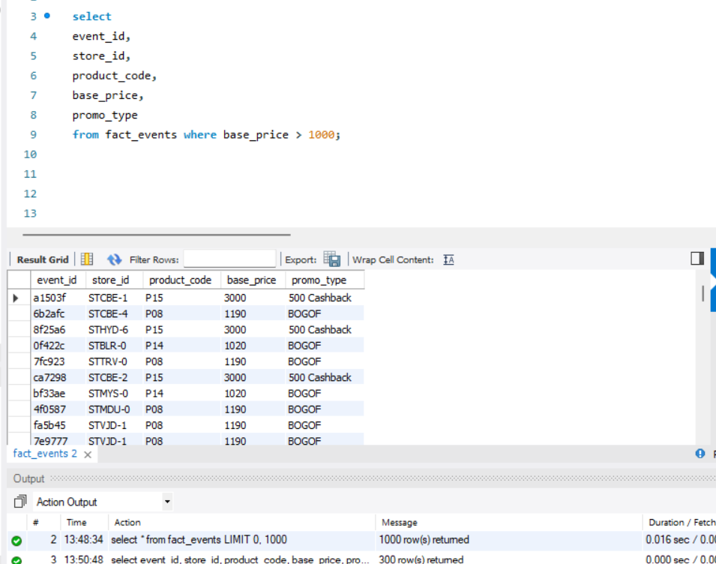

Q2. Sorting Promotional Events
Display all events where quantity sold after the promotion was greater than 100.

Display:
- event_id
- product_code
- promo_type
- quantity_sold(before_promo)
- quantity_sold(after_promo)

Sort by quantity_sold(after_promo) in descending order.

Concepts:
WHERE, ORDER BY, DESC.

Sol 2:
select
event_id,
product_code,
promo_type,
`quantity_sold(before_promo)`,
`quantity_sold(after_promo)`
from fact_events where `quantity_sold(after_promo)` > 100
order by `quantity_sold(after_promo)` desc;

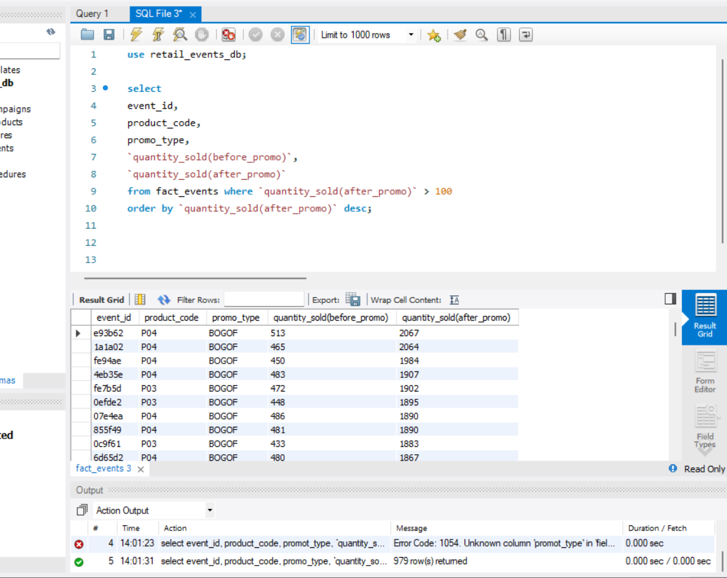

Q3. DISTINCT Promotion Types
Find all unique promotion types used in the dataset.

Display only the unique promo_type values.

Concepts: DISTINCT.
Sol 3:
select distinct promo_type from fact_events;

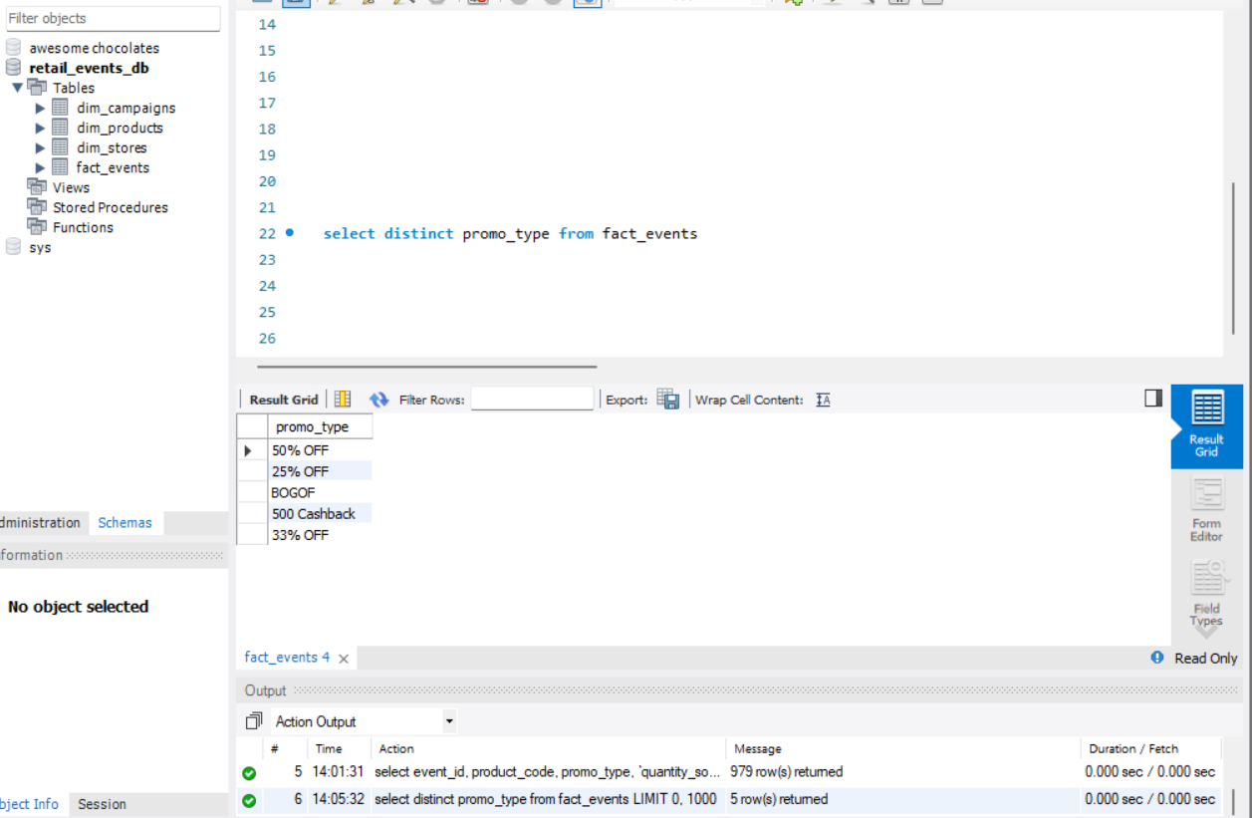

Q4. Basic Aggregation
Calculate the following for the complete fact_events table:

- Total number of events
- Total quantity sold before promotion
- Total quantity sold after promotion
- Average base price
- Maximum base price
- Minimum base price

Return all metrics in one row.

Concepts:
COUNT, SUM, AVG, MAX, MIN.

Sol 4:
select
COUNT(*) as Total_number_of_events,
SUM(`quantity_sold(before_promo)`) as Total_quantity_sold_before_promotion,
SUM(`quantity_sold(after_promo)`) as Total_quantity_sold_after_promotion,
AVG(base_price),
MAX(base_price),
MIN(base_price)
from fact_events;

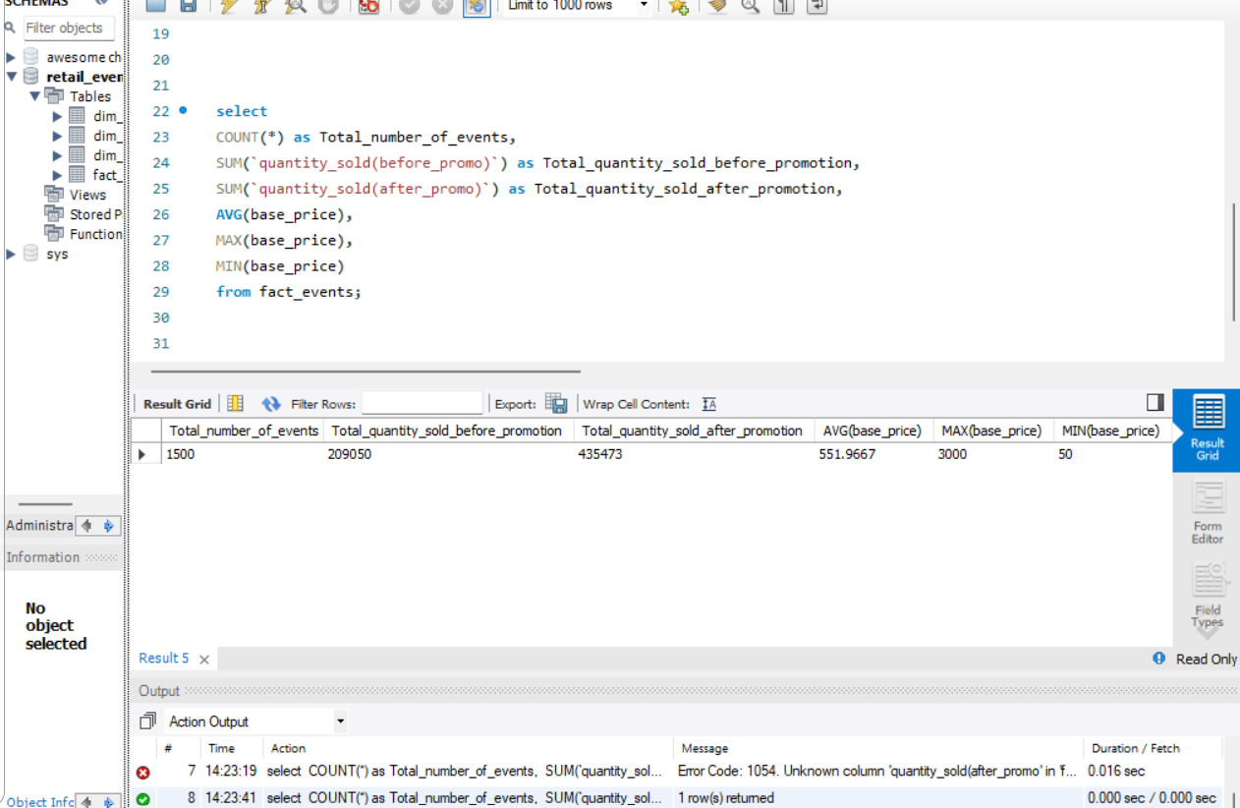

Q5. Sales Volume by Promotion Type
For each promo_type, calculate:

- Number of events
- Total quantity sold before promotion
- Total quantity sold after promotion

Sort by total quantity sold after promotion in descending order.

Concepts:
GROUP BY, COUNT, SUM, ORDER BY.

Sol 5:

select
promo_type,
COUNT(*) as Number_Of_Events,
SUM(`quantity_sold(before_promo)`) as Total_quantity_sold_before_promotion,
SUM(`quantity_sold(after_promo)`) as Total_quantity_sold_after_promotion
from fact_events
group by promo_type
order by Total_quantity_sold_after_promotion desc;

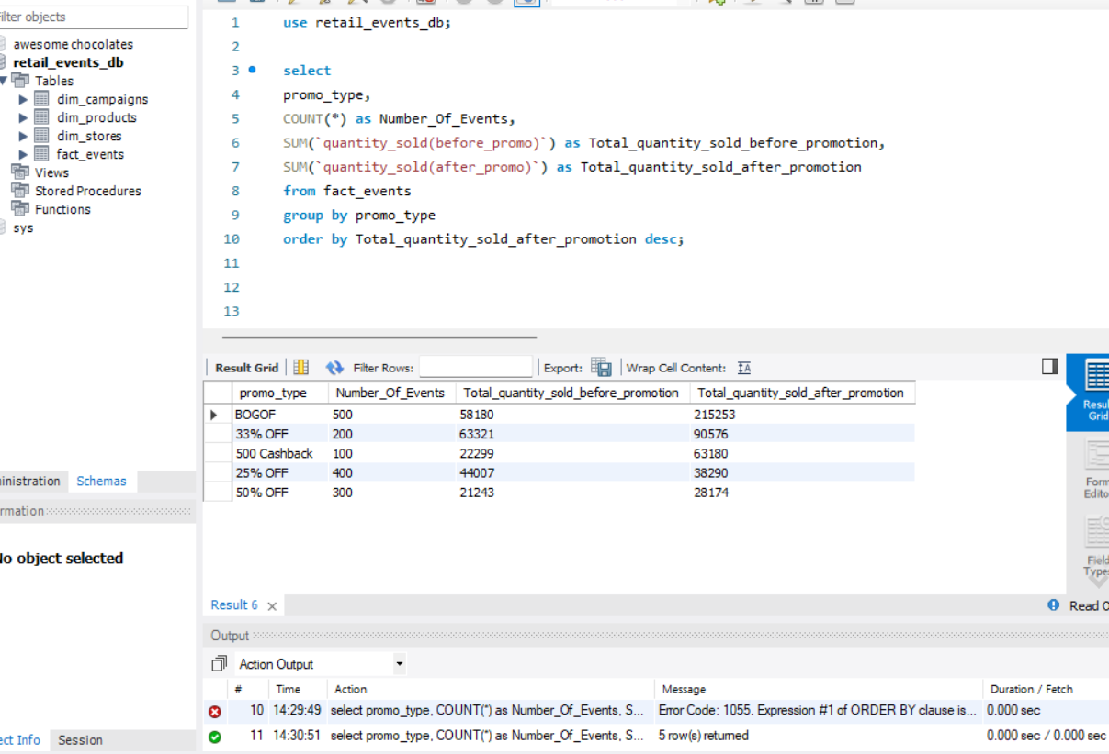

Q6. Promotion Uplift
For every promotion type, calculate:

- Total quantity before promotion
- Total quantity after promotion
- Quantity increase/decrease

Use:

Quantity Change = After Promo Quantity - Before Promo Quantity

Display:
- promo_type
- total_before
- total_after
- quantity_change

Sort by quantity_change descending.

Concepts:
GROUP BY, SUM, arithmetic calculations, aliases.

Sol 6:
select
promo_type,
SUM(`quantity_sold(before_promo)`) as Total_before,
SUM(`quantity_sold(after_promo)`) as Total_after,
(SUM(`quantity_sold(after_promo)`) - SUM(`quantity_sold(before_promo)`)) as Quantity_change
from fact_events
group by promo_type
order by Quantity_change desc;

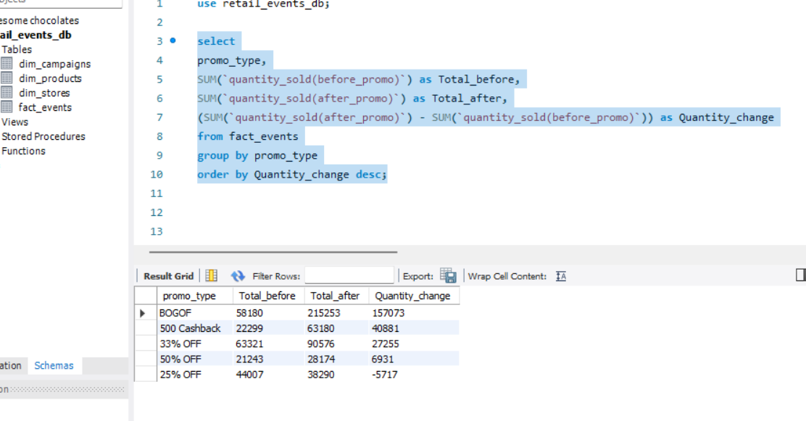

Q7. Product Performance
Using fact_events and dim_products, calculate total quantity sold after promotion for every product.

Display:
- product_code
- product_name
- category
- total quantity after promotion

Sort by total quantity after promotion descending.

Concepts:
INNER JOIN, GROUP BY, SUM, ORDER BY.

Sol 7:

select
pro.product_code,
pro.product_name,
pro.category,
SUM(eve.`quantity_sold(after_promo)`) as Total_after
from fact_events eve
inner join dim_products pro on pro.product_code = eve.product_code
group by pro.product_code, pro.product_name, pro.category
order by Total_after desc;

