


(6CS012) - Al and Machine Learning Materials
Image Classification of German Traffic Signs Using CNNs and Transfer Learning
https://github.com/aayushswkl/Ai-herald-last-sem

Image Classification of German Traffic Signs Using CNNs and Transfer Learning

Student Id : 2417735
Student Name : Aayush Chaulagain
Group : L6CG10
Tutor : Mr. Anish Khatiwoda
Module Leader : Mr. Simon Giri
Submission Date : 10/05/2026

Table of Contents
1
Traffic Sign Classification with CNNs and Transfer Learning 1
Abstract 1
1. Introduction 1
2. Dataset 1
3. Data Split and Preprocessing 1
4. Methodology 1
4.1 Baseline CNN 1
4.2 Deeper CNN with Regularization 1
4.3 Transfer Learning 1
5. Experiments and Results 1
5.1 Baseline CNN 1
5.2 Deeper CNN 1
5.3 Adam vs SGD 1
5.4 Ablation Study 1
5.5 Transfer Learning 1
5.6 Final Comparison 1
6. Discussion 1
7. Conclusion 1
References 1

Traffic Sign Classification with CNNs and Transfer Learning

Abstract
This report explains the saved results from the Part II notebook. The task was image classification on the German Traffic Sign Recognition Benchmark, or GTSRB. The notebook tested a baseline CNN, a deeper CNN with regularization, an optimizer comparison, an ablation study, and a transfer learning model. The saved notebook shows 39,209 clean training images, 12,630 official test images, and 43 traffic sign classes. The baseline CNN reached about 95.65% test accuracy. The deeper CNN improved this to about 98.65%. When dropout was removed, test accuracy fell to about 97.69%, which suggests that dropout helped generalization. The optimizer test showed that Adam gave slightly better final accuracy than SGD. The transfer learning model based on VGG16 gave the best saved result in the notebook, with about 99.20% test accuracy and 0.041 test loss. These results show that the dataset can be learned well with a simple CNN, but deeper models and transfer learning give better performance. The main trade-off is training cost, because the stronger models take more time.

1. Introduction
Traffic sign classification is an important computer vision task. It is useful in driver assistance systems and in self-driving research. The goal is to assign the correct class label to each traffic sign image. This is not always easy because some signs look similar, and the images can change in size, angle, and lighting.
This report is based on the saved output inside the notebook. It does not claim results that are not shown in the file. The report compares the main models required by the assignment and explains what the saved results show.

2. Dataset
The notebook uses the German Traffic Sign Recognition Benchmark, usually called GTSRB (Stallkamp et al., 2011). This dataset is a standard benchmark for traffic sign classification.
The saved notebook reports:
43 classes
39,209 clean training images
12,630 official test images
51,839 images in total
0 corrupted images
The class distribution is not balanced. The smallest class has 210 images. The largest class has 2,250 images. The average class size is 911.84 images. The image sizes also vary. The saved notebook shows a width range of 25 to 243 pixels and a height range of 25 to 225 pixels. Because of this, resizing was necessary before training.
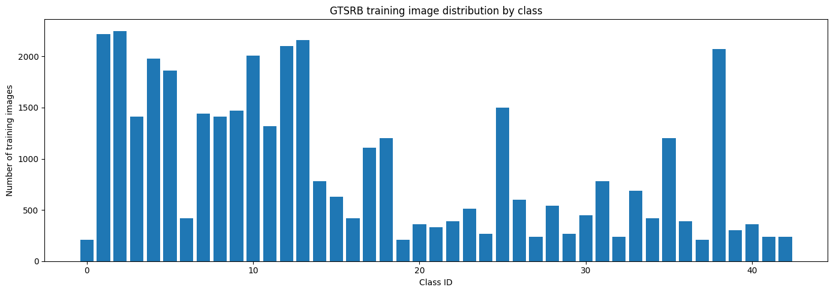
Figure 1. Training image distribution by class.
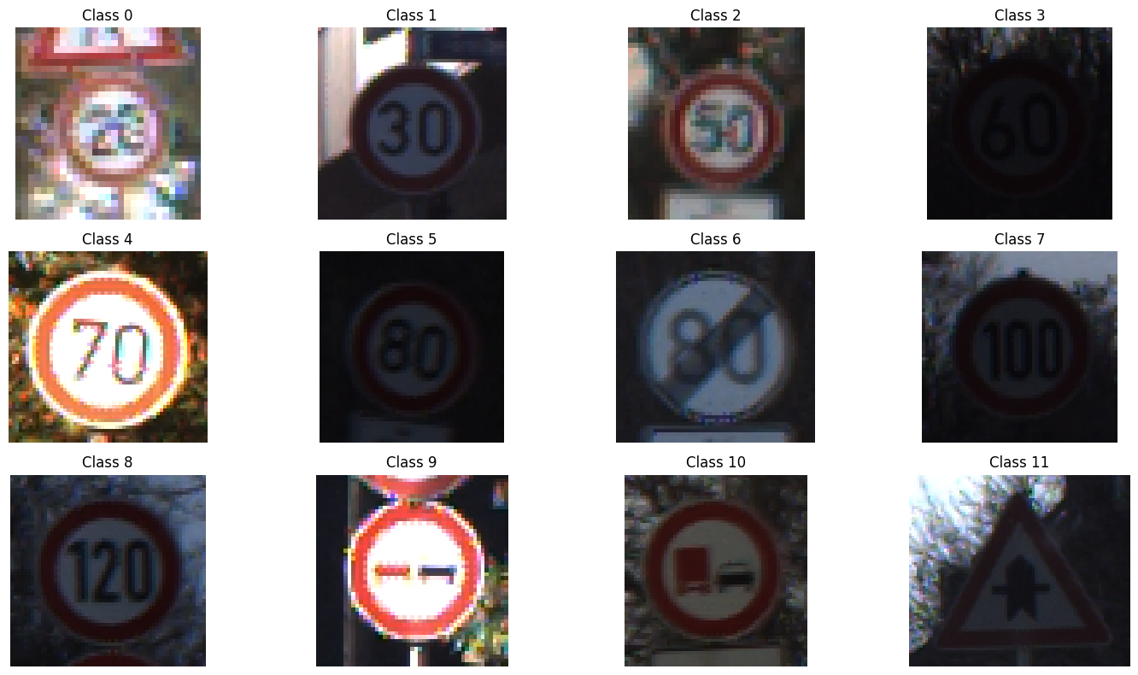
Figure 2. Sample traffic sign images from the dataset.
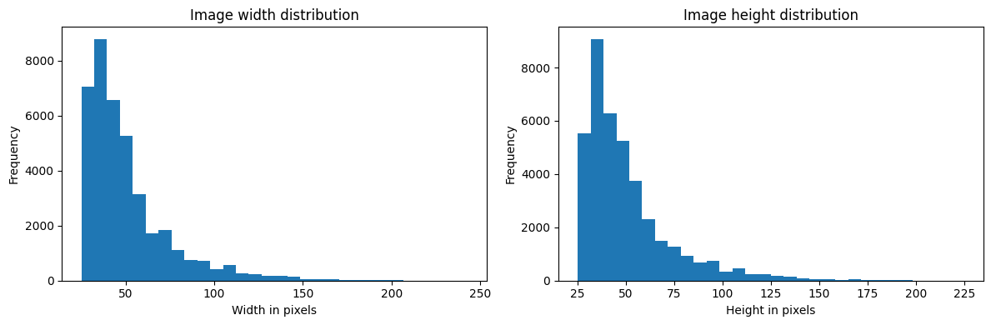
Figure 3. Width and height distributions in the raw dataset.

3. Data Split and Preprocessing
The notebook split the clean training data into 80% training and 20% validation by using stratified sampling. The saved counts are:
Training samples: 31,367
Validation samples: 7,842
Official test samples: 12,630
For the scratch CNN models, the images were converted to RGB and resized to 48 x 48 pixels. The pipeline used tf.data, batching, and prefetching. Pixel values were normalized inside the model with a rescaling layer.
For transfer learning, the images were resized to 224 x 224 pixels because VGG16 expects that size (Simonyan & Zisserman, 2015).
The notebook also used online augmentation:
small random rotation
random zoom
random translation
It did not use horizontal flips. That was a good choice because flipping a traffic sign can change its meaning.
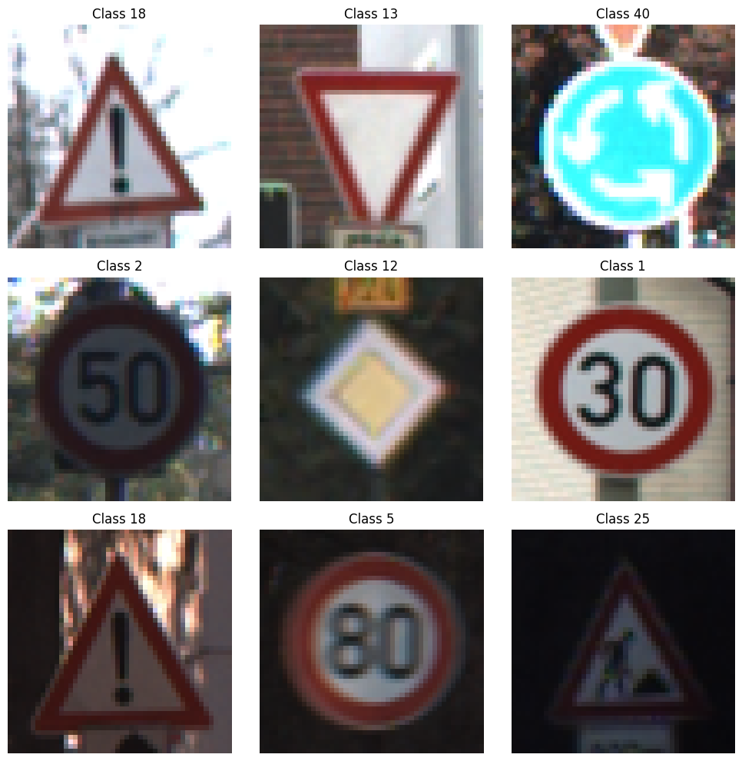
Figure 4. Example batch after resizing and loading.
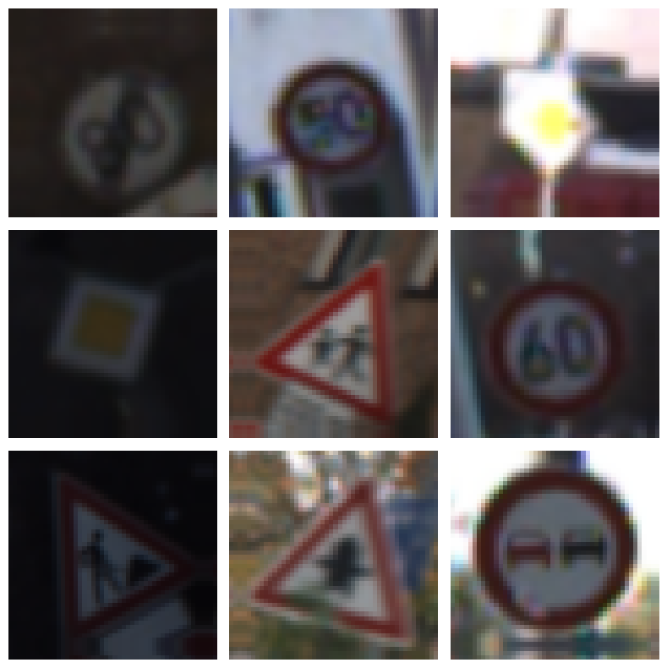
Figure 5. Sample augmented images.

4. Methodology

4.1 Baseline CNN
The baseline model follows the task structure from the requirement. It has:
3 convolution layers
3 pooling layers
3 fully connected layers
1 softmax output layer
In the saved notebook, the baseline model uses:
filters: 32, 64, 128
kernel size: 3 x 3
activation: ReLU
output classes: 43
The model summary in the notebook shows 1,317,099 trainable parameters.

4.2 Deeper CNN with Regularization
The deeper model is larger than the baseline. It has six convolution layers, batch normalization, dropout, and a deeper dense block. Batch normalization helps training stay stable (Ioffe & Szegedy, 2015). Dropout is used to reduce overfitting (Srivastava et al., 2014).
The saved summary shows:
total parameters: 1,512,971
trainable parameters: 1,511,563
non-trainable parameters: 1,408

4.3 Transfer Learning
The transfer learning model uses VGG16 with ImageNet weights (Simonyan & Zisserman, 2015). The notebook first freezes the convolution base and trains only the new classifier. After that, it unfreezes the last four layers and fine-tunes them with a lower learning rate.
The saved model summary shows:
total parameters: 14,857,067
trainable parameters in the frozen stage: 142,379
non-trainable parameters in the frozen stage: 14,714,688

5. Experiments and Results

5.1 Baseline CNN
The saved baseline evaluation reports:
test loss: 0.2447
test accuracy: 0.9565
weighted precision: about 0.96
weighted recall: about 0.96
weighted F1: about 0.96
This is a strong result for a simple model. It shows that even the smaller CNN learned useful visual features from the dataset.
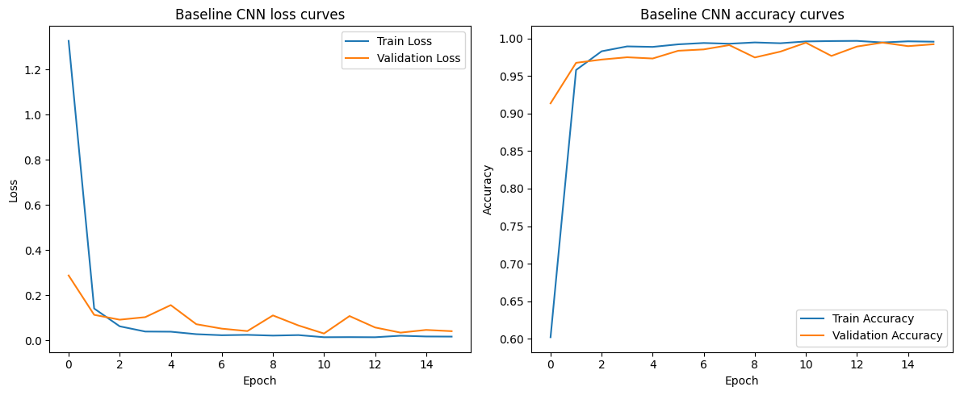
Figure 6. Baseline training and validation curves.
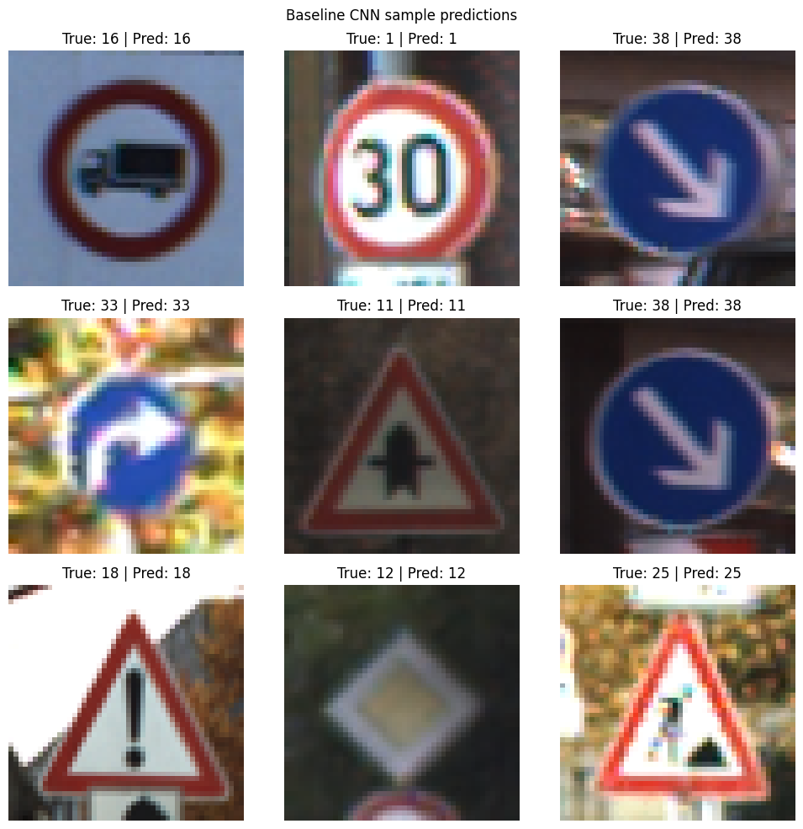
Figure 7. Baseline sample predictions.

5.2 Deeper CNN
The saved deeper-model evaluation reports:
test loss: 0.0651
test accuracy: 0.9865
macro F1: 0.97
weighted F1: 0.99
This is clearly better than the baseline. The deeper model learned stronger features and made fewer mistakes on the official test set.
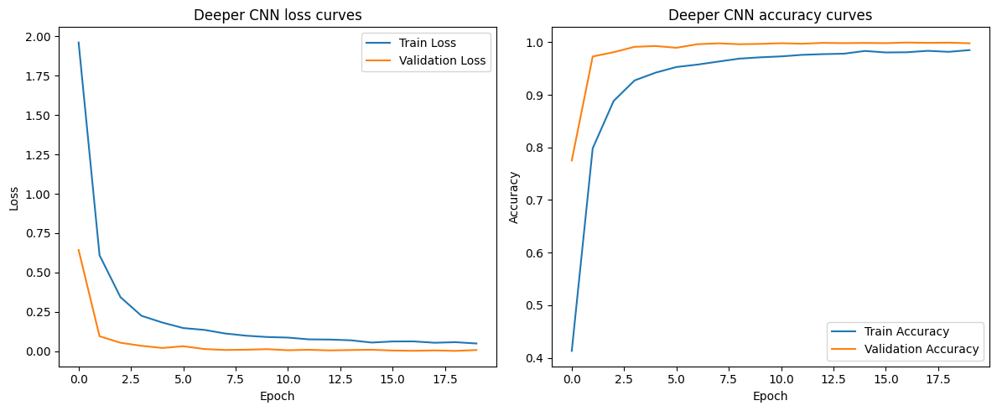
Figure 8. Deeper-model training and validation curves.
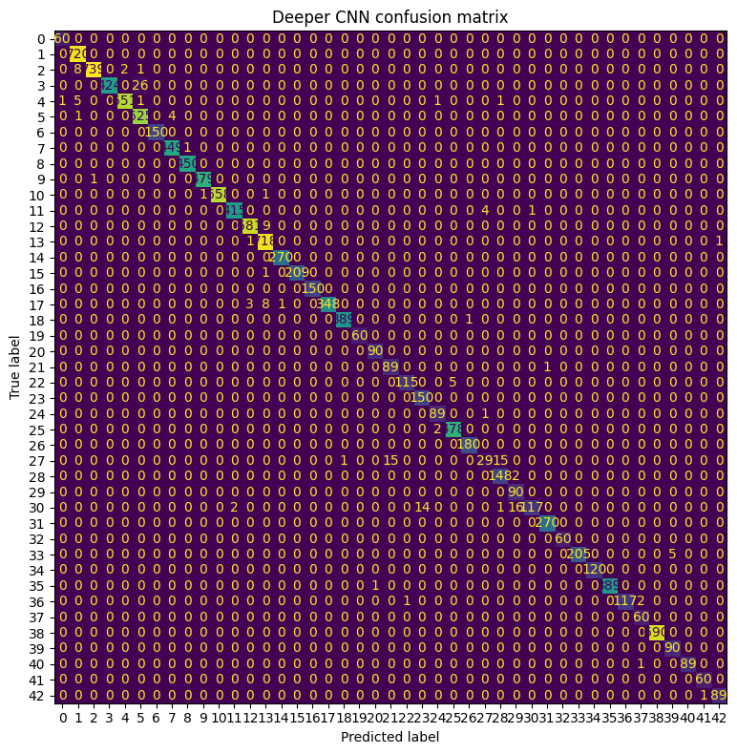
Figure 9. Deeper CNN confusion matrix.
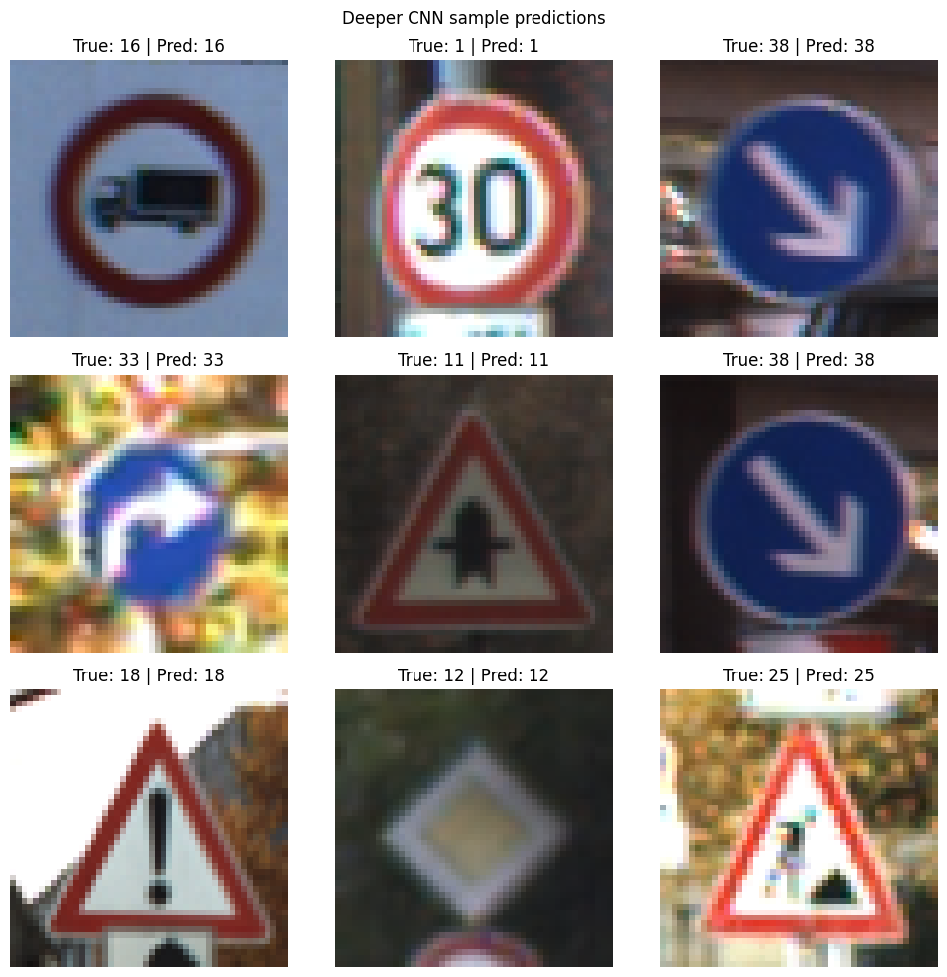
Figure 10. Deeper CNN sample predictions.
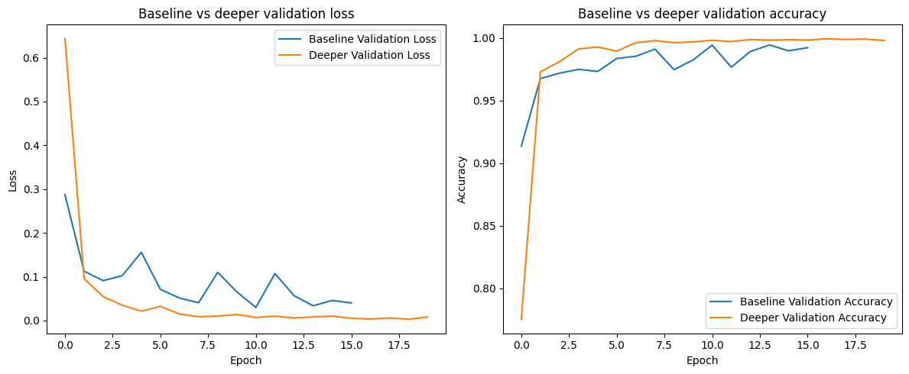
Figure 11. Baseline and deeper-model validation curves.

5.3 Adam vs SGD
The notebook trained the same deeper architecture with both Adam and SGD.
Saved results:
Model | Test Accuracy | Test Loss | Training Time (sec)
Deeper CNN with Adam | 0.9865 | 0.0651 | 752.01
Deeper CNN with SGD | 0.9835 | 0.0643 | 733.06

The difference is small, but Adam gave the better final accuracy in the saved run. SGD was a little faster.
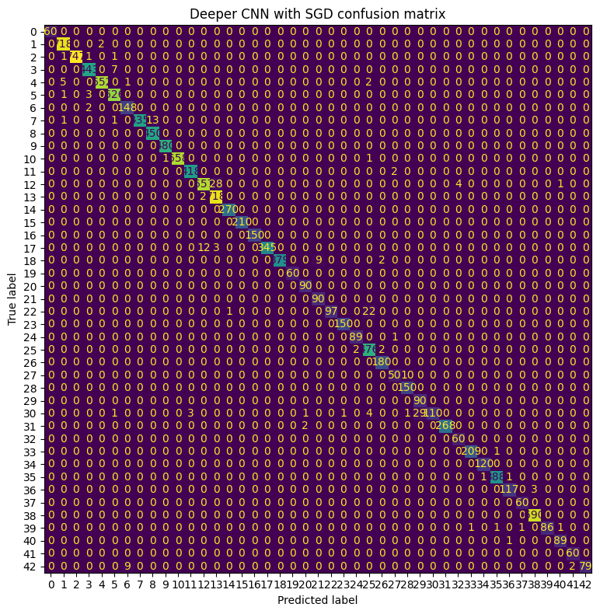
Figure 12. SGD confusion matrix.
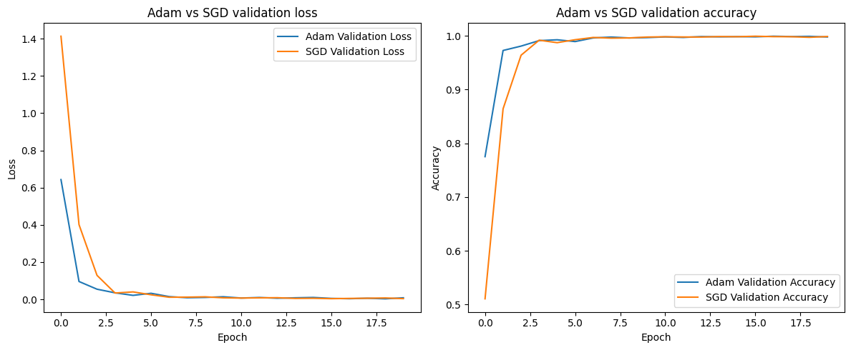
Figure 13. Adam and SGD validation curves.

5.4 Ablation Study
The ablation study removed dropout from the deeper CNN.
Saved results:
Model | Test Accuracy | Test Loss
Deeper CNN with dropout | 0.9865 | 0.0651
Deeper CNN without dropout | 0.9769 | 0.1140

The no-dropout model performed worse on the official test set. This suggests that dropout helped the model generalize better.
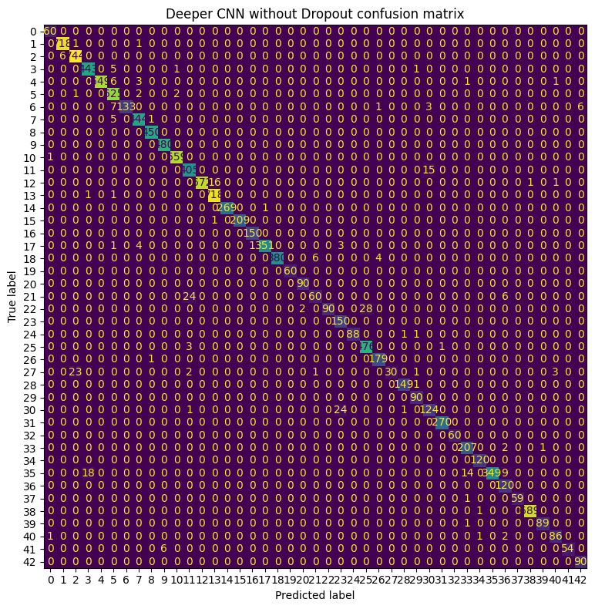
Figure 14. Confusion matrix without dropout.

5.5 Transfer Learning
The transfer learning model gave the best saved result in the notebook. The saved comparison table reports:
test accuracy: 0.9920
test loss: 0.0410
weighted precision: 0.99
weighted recall: 0.99
weighted F1: 0.99
The saved notebook also reports:
frozen-stage time: 1615.61 seconds
fine-tuning time: 2711.18 seconds
total transfer-learning time: 4326.78 seconds
This model performed best, but it also took much more time than the scratch models.
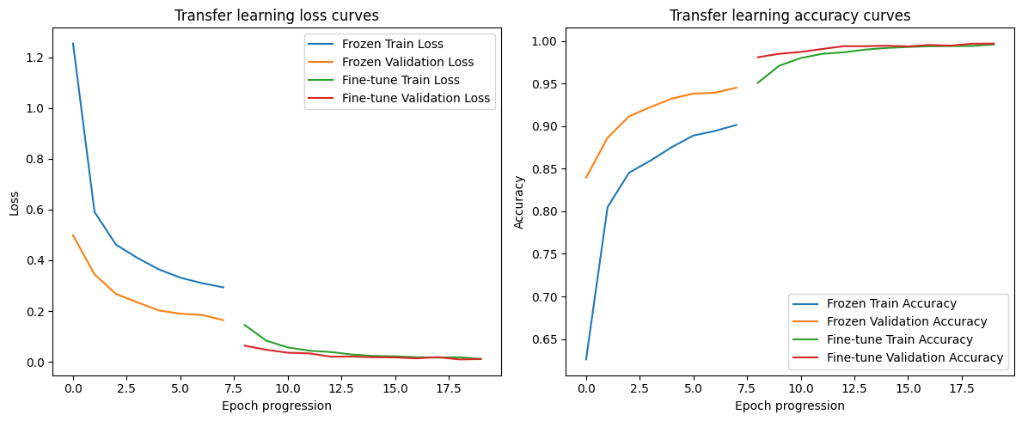
Figure 15. Transfer-learning curves.

5.6 Final Comparison
The saved notebook gives this overall pattern:
Baseline CNN worked well.
Deeper CNN worked better.
Removing dropout reduced performance.
Adam was slightly better than SGD in this run.
VGG16 transfer learning gave the best result.
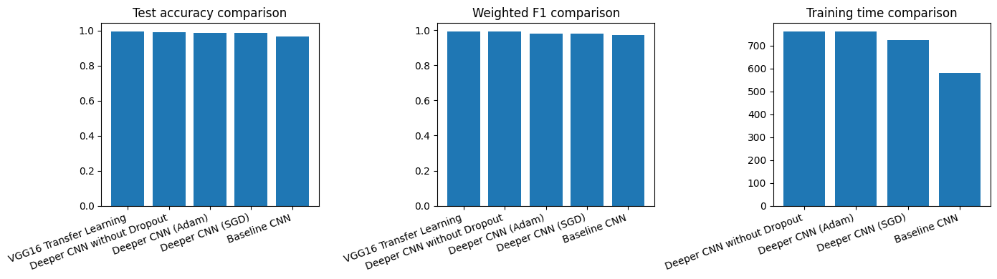
Figure 16. Final comparison chart.

6. Discussion
The saved results show that adding depth and regularization improved performance on this dataset. The baseline model already gave a good score, but the deeper model reduced loss and improved accuracy. The ablation study makes the role of dropout clear. The model without dropout trained well, but its test result was worse. That points to overfitting.
Transfer learning gave the strongest result. This is not surprising because VGG16 starts with features learned from a large image dataset. Still, the gain over the deeper scratch CNN was not huge when compared with the large increase in training time.
One more point is worth noting. The notebook outputs are saved from more than one run, so a few summary values are not perfectly consistent across all cells. In this report, I used the direct saved evaluation outputs where they were available, and I used the final saved comparison table for the transfer-learning result.

7. Conclusion
The Part II notebook shows that GTSRB can be classified very well with CNN-based models. The baseline CNN reached about 95.65% test accuracy. The deeper CNN improved this to about 98.65%. The ablation study showed that dropout helped performance. The transfer learning model based on VGG16 gave the best saved result at about 99.20% accuracy, but it also had the highest training cost.
In short, better models did give better results, but the gain came with higher computation time. For this dataset, the deeper CNN gives a strong balance between accuracy and cost, while transfer learning gives the best final score.

References
Ioffe, S., & Szegedy, C. (2015). Batch normalization: Accelerating deep network training by reducing internal covariate shift. *Proceedings of the 32nd International Conference on Machine Learning, 37*, 448-456. https://proceedings.mlr.press/v37/ioffe15.html
Simonyan, K., & Zisserman, A. (2015). Very deep convolutional networks for large-scale image recognition. *International Conference on Learning Representations*. https://arxiv.org/abs/1409.1556
Srivastava, N., Hinton, G., Krizhevsky, A., Sutskever, I., & Salakhutdinov, R. (2014). Dropout: A simple way to prevent neural networks from overfitting. *Journal of Machine Learning Research, 15*(56), 1929-1958.
Stallkamp, J., Schlipsing, M., Salmen, J., & Igel, C. (2011). The German traffic sign recognition benchmark: A multi-class classification competition. *2011 International Joint Conference on Neural Networks*, 1453-1460. https://doi.org/10.1109/IJCNN.2011.6033395

