


(6CS012) - Al and Machine Learning Materials
Sentiment and Hate-Speech Style Tweet Classigication Using RNN, LSTM, and Word2Vec
https://github.com/aayushswkl/Ai-herald-last-sem

Image Classification of German Traffic Signs Using CNNs and Transfer Learning

Student Id : 2417735
Student Name : Aayush Chaulagain
Group : L6CG10
Tutor : Mr. Anish Anish Khatiwoda
Module Leader : Mr. Simon Giri
Submission Date : 10/05/2026

Table of Contents
1
Tweet Classification with RNN, LSTM, and Pretrained Word Vectors 1
Abstract 1
1. Introduction 1
2. Dataset 1
3. Preprocessing and Tokenization 1
4. Methodology 1
4.1 SimpleRNN 1
4.2 LSTM 1
4.3 LSTM with Pretrained Embeddings 1
4.4 Evaluation 1
5. Results 1
5.1 SimpleRNN 1
5.2 LSTM 1
5.3 LSTM with Pretrained Embeddings 1
5.4 Overall Comparison 1
6. Error Analysis 1
7. GUI for Real-Time Prediction 1
8. Discussion 1
9. Conclusion 1
References 1

Tweet Classification with RNN, LSTM, and Pretrained Word Vectors

Abstract
This report explains the saved results from the Part III notebook. The notebook works on a binary tweet classification task with a strongly imbalanced dataset. It compares three models: a SimpleRNN with trainable embeddings, a bidirectional LSTM with trainable embeddings, and an LSTM that uses pretrained GloVe vectors loaded through gensim. The saved notebook shows 31,962 labeled training rows and 17,197 unlabeled test rows. The results show a clear difference between overall accuracy and class-wise performance. The SimpleRNN and the pretrained-embedding LSTM both reached about 92.99% accuracy, but both failed to detect the minority class. Their recall for class 1 was 0.00. The bidirectional LSTM performed much better. It reached about 95.38% accuracy, with 0.70 recall and 0.68 F1 score for class 1. This means the LSTM gave the best balance between overall accuracy and minority-class detection. The report below stays close to the saved notebook outputs and does not claim extra experiments that are not shown there.

1. Introduction
Tweet classification is useful in many real tasks. It can help with moderation, sentiment analysis, and harmful content detection. Tweets are short, noisy, and often informal. Because of that, sequence models are useful. They can read text in order and learn patterns across words.
The notebook compares three approaches:
SimpleRNN with trainable embeddings
LSTM with trainable embeddings
LSTM with pretrained GloVe embeddings
The assignment brief mentions Word2Vec-style pretrained embeddings. In the saved notebook, the actual external vectors come from glove-wiki-gigaword-50, which is a GloVe resource loaded through gensim. This report follows the notebook as it was saved.

2. Dataset
The notebook loads two CSV files from Google Drive:
train_racisit.csv
test_racisit.csv
The saved notebook reports:
labeled training rows: 31,962
unlabeled test rows: 17,197
The labeled data is strongly imbalanced:
class 0: 29,720
class 1: 2,242
This means about 93% of the labeled data belongs to class 0. Because of that, accuracy alone is not enough to judge model quality.

3. Preprocessing and Tokenization
The saved notebook applies these cleaning steps:
lowercase conversion
URL removal
@user mention removal
stopword removal
lemmatization
The notebook then splits the labeled data into 80% training and 20% testing with stratification. The saved counts are:
training samples: 25,563
testing samples: 6,391
Tokenization uses a vocabulary cap of 30,000 words. Padding length is based on the 95th percentile of training sequence lengths, with a minimum of 60. The saved notebook reports:
vocabulary size: 30,000
sequence length: 60
One issue is visible in the saved outputs. Some noisy tokens remain in the cleaned text, such as #love, &amp;, -, and ... style marks. So the cleaning pipeline is useful, but it is not fully clean.
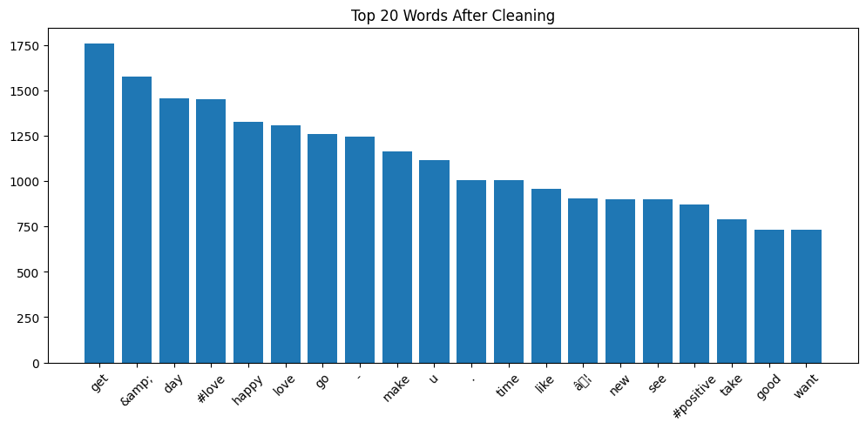
Figure 1. Most frequent words after cleaning.

4. Methodology

4.1 SimpleRNN
The first model uses:
embedding dimension: 128
one SimpleRNN(64) layer
one sigmoid output layer
The saved summary shows 3,852,417 trainable parameters.

4.2 LSTM
The second model uses:
embedding dimension: 128
one bidirectional LSTM(128, dropout=0.3) layer
one dense layer with 64 units and ReLU
one dropout layer with rate 0.3
one sigmoid output layer
The saved summary shows 4,119,681 trainable parameters. The notebook also uses class weights {0: 1.0, 1: 3.0} for this model. That choice makes sense because the dataset is imbalanced.

4.3 LSTM with Pretrained Embeddings
The third model loads glove-wiki-gigaword-50 through gensim and builds an embedding matrix of shape (30000, 50). It then uses:
pretrained embedding layer
one LSTM(64) layer
one sigmoid output layer
The saved summary shows 1,529,505 trainable parameters. The code comment says the embedding is frozen, but the actual argument is trainable=True, so in the saved notebook the embedding layer is trainable.

4.4 Evaluation
The notebook uses:
accuracy
precision
recall
F1 score
confusion matrix
training and validation curves
a small error-analysis section
It also includes a simple Gradio interface for real-time prediction.

5. Results

5.1 SimpleRNN
Saved evaluation results:
Metric | Value
Accuracy | 0.9299
Precision for class 1 | 0.00
Recall for class 1 | 0.00
F1 for class 1 | 0.00
Weighted F1 | 0.90

This model reached high accuracy only because the dataset is imbalanced. It mostly predicted the majority class.
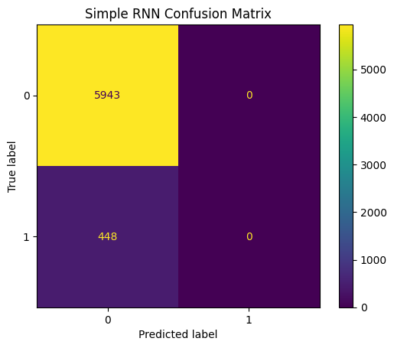
Figure 2. SimpleRNN confusion matrix.

5.2 LSTM
Saved evaluation results:
Metric | Value
Accuracy | 0.9538
Precision for class 1 | 0.66
Recall for class 1 | 0.70
F1 for class 1 | 0.68
Weighted F1 | 0.95

This is the best result in the saved notebook. The LSTM was much better at finding the minority class. It also improved overall accuracy.
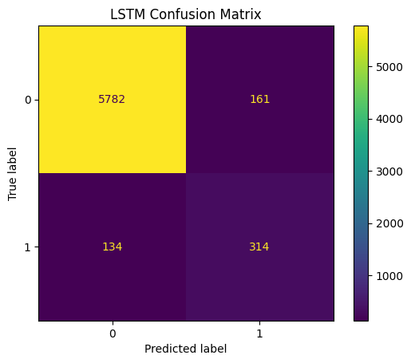
Figure 3. LSTM confusion matrix.

5.3 LSTM with Pretrained Embeddings
Saved evaluation results:
Metric | Value
Accuracy | 0.9299
Precision for class 1 | 0.00
Recall for class 1 | 0.00
F1 for class 1 | 0.00
Weighted F1 | 0.90

This model did not improve over the SimpleRNN in the saved run. It also failed to identify the minority class.
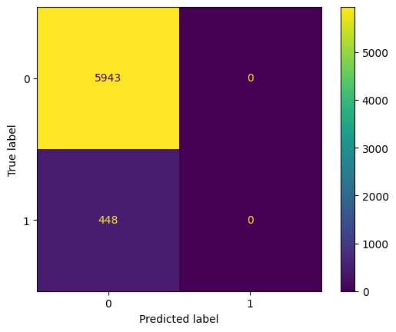
Figure 4. LSTM with pretrained embeddings confusion matrix.

5.4 Overall Comparison
The saved notebook supports this comparison:
Model | Accuracy | Recall for class 1 | F1 for class 1 | Main point
SimpleRNN | 0.9299 | 0.00 | 0.00 | Mostly predicted class 0
LSTM | 0.9538 | 0.70 | 0.68 | Best balance of metrics
LSTM + pretrained vectors | 0.9299 | 0.00 | 0.00 | No gain in the saved run

This table shows why accuracy alone is not enough. Two models reached about 93% accuracy, but both failed on class 1.
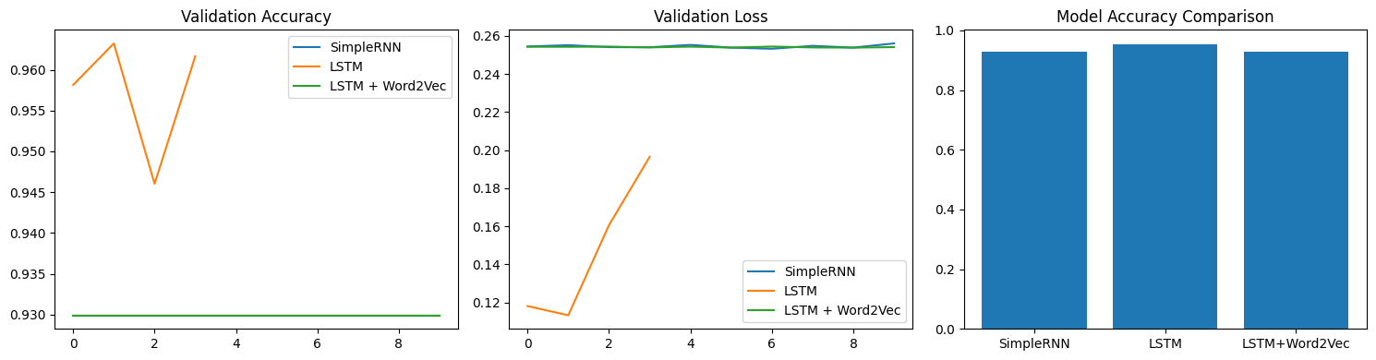
Figure 5. Validation curves and final model comparison.
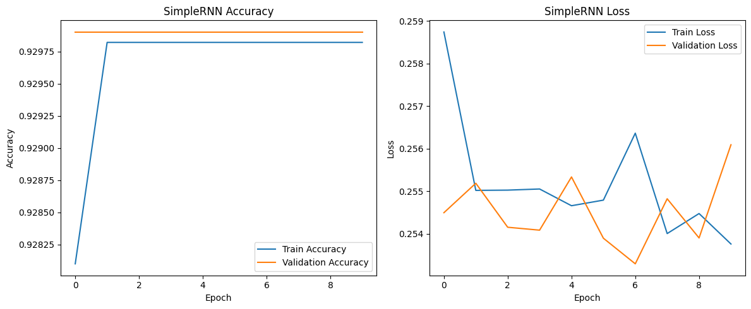
Figure 6. SimpleRNN training curves.
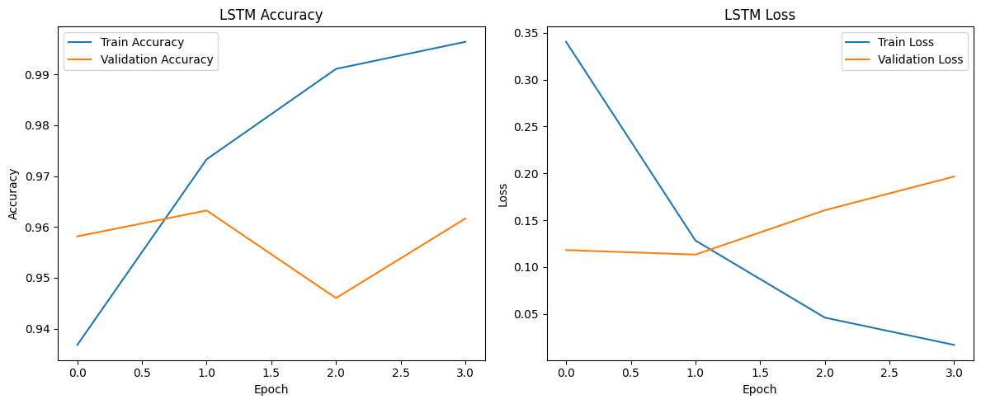
Figure 7. LSTM training curves.
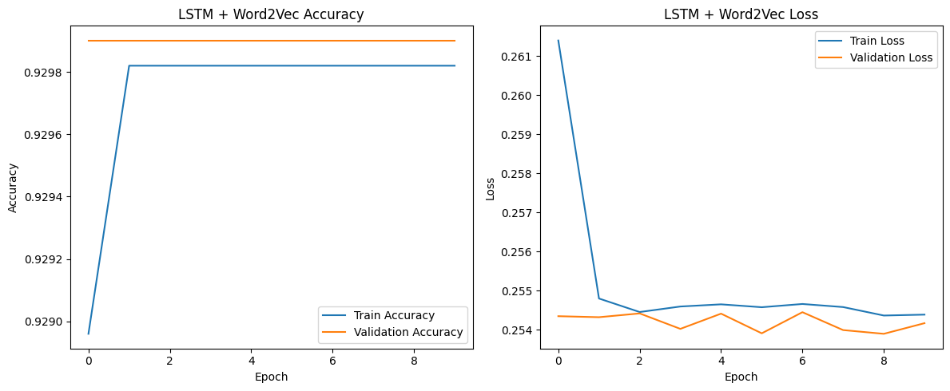
Figure 8. LSTM with pretrained vectors training curves.

6. Error Analysis
The saved notebook shows three wrong examples. In each case, the true label is class 1, but the model predicted class 0. The saved prediction scores are all about 0.06994.
The saved examples include:
like , #waronwomen, &amp; #guncontrol need #ru...
come #powerhungrytraitors. #hereticfoundation!
1. lmfao. no. non-white people #bigots #prejud...
These errors suggest several possible problems:
strong class imbalance
text cleaning that still leaves noisy tokens
short and difficult tweets
a threshold that may not be best for every model
external embeddings that may not match the tweet domain well

7. GUI for Real-Time Prediction
The notebook includes a Gradio interface called Tweet Classification. It takes a tweet as input, cleans it, tokenizes it, pads it, and then predicts either Racist/Sexist or Not Racist/Sexist. The saved notebook shows that Gradio launched successfully in Colab and created a temporary public link.

8. Discussion
The most important lesson from this notebook is that class-wise metrics matter. The SimpleRNN and the pretrained-embedding LSTM both look acceptable if we only read the accuracy value. But the confusion matrices and the class 1 scores show that both models perform poorly on the minority class.
The bidirectional LSTM is the strongest model in the saved notebook. It used class weights, a richer recurrent layer, and dropout. These choices likely helped it learn the harder class better.
The pretrained embedding model did not help in this saved run. One reason may be that the notebook uses GloVe vectors trained on general text, while the tweets in this dataset are noisy and domain-specific. Another reason is that the preprocessing still leaves some unwanted tokens in the text.

9. Conclusion
The saved Part III notebook shows that the LSTM with trainable embeddings is the best model among the three tested models. It reached about 95.38% accuracy and gave much better minority-class recall and F1 score than the other two models. The SimpleRNN and the pretrained-embedding LSTM both reached about 92.99% accuracy, but both mostly learned the majority class.
So the main conclusion is clear. For this dataset, the best model is not the one with the highest-looking accuracy alone. The best model is the one that keeps good overall accuracy and also detects the minority class. In the saved notebook, that model is the bidirectional LSTM.

References
Goodfellow, I., Bengio, Y., & Courville, A. (2016). *Deep learning*. MIT Press.
Hochreiter, S., & Schmidhuber, J. (1997). Long short-term memory. *Neural Computation, 9*(8), 1735-1780. https://doi.org/10.1162/neco.1997.9.8.1735
Mikolov, T., Sutskever, I., Chen, K., Corrado, G. S., & Dean, J. (2013). Distributed representations of words and phrases and their compositionality. *Advances in Neural Information Processing Systems, 26*, 3111-3119. https://research.google/pubs/distributed-representations-of-words-and-phrases-and-their-compositionality/
Pennington, J., Socher, R., & Manning, C. D. (2014). GloVe: Global vectors for word representation. *Proceedings of the 2014 Conference on Empirical Methods in Natural Language Processing*, 1532-1543. https://doi.org/10.3115/v1/D14-1162

