TITLE: MINI-PROJECT

AIM:

Program for a dealership of a car showroom which helps the user for determining the finances of the cars.
______________________________________________________________________

PROJECT MADE BY :

- Aayush Tavshikar : 16010320077
- Karthikeyan Setti : 16010320066
- Sahej Vasandi : 16010320081

Code :

# -*- coding: utf-8 -*-
"""Car Dealership
Program for a dealership of a car showroom
which helps the user for determining the
finances of the cars.
"""
from prettytable import PrettyTable#Using the pyhton library prettytable
print("Welcome to XYZ MOTORS")
def car_name(name):#Function to record the car name
print("You are buying\t"+name)
def initial_cost(p):#Function to record the car price
print("Your cost for buying the car is ₹ ",p)
def type_payment(y,p,name):#Function for payment method
bdp=(30*p)/100#storing 30% of cost in a varible bdp
if y==1:#Choice to make pyment in Cheque/Cash
m=int(input('1=Cheque,2=Cash\n'))
if m==1:#Payment in cheque
total= p
print('Total price to pay is ₹ ',total)
t=total/5
payTable=PrettyTable({"Car Name","Car Price",})
payTable.add_row([name,p])
print(payTable,'\nDivide the cheques to 5\nAmount to be written per cheque ₹ ',t)
if m==2:#Payment in cash
total=p
payTable=PrettyTable({"Car Name","Car Price"})
payTable.add_row([name,p])
print(payTable,'\nTotal price to pay is ₹ ',total)
if y==2:#Payment using EMI
var="%"
print("PLease make a downpayment which should be more than or equal to 30"+var+" of the original car price")
down_payment=int(input("Please enter a value for down payment\n"))
print(" Welcome to EMI \n The minimum time for emi is 12 months and the maximum time is 60 months ")
term = int(input(" Enter the period for emi: "))
if (down_payment>=bdp) and (term>=12 and term<=72):#Checking whether the choices given is correct
rateTable=PrettyTable(["Option No.","Bank Name","Rate"])#Table to show rate of interest per bank
rateTable.add_row(["1","SBI","6%"])
rateTable.add_row(["2","AXIS","8%"])
rateTable.add_row(["3","HDFC","7%"])
rateTable.add_row(["4","HSBC","6.5%"])
rateTable.add_row(["5","KOTAK","8.5%"])
print(rateTable)#Printing rate table
print("Select the bank for loan(",var,"interest may vary)")
rate=[6,8,7,6.5,8.5]#List for rate
r=int(input("Please enter the number corresponding to the bank chosen\n"))#Taking user input for choice of bank
loan=p-(down_payment)#Subtracting down payment from the price
print("Price borrowed as loan ₹ ",loan)
rpm=rate[r-1]/(12*100)#rate per month
num=(rpm*((rpm+1)**term))/(((1+rpm)**term)-1)
emi= float(loan)*(num)#calculating emi
print("EMI is ₹ ",emi)
total_amount=(emi*term)
print(" Hence total amount will be ₹ ", total_amount,"The amount to be paid per month for 1 year ₹ ",emi)
payTable=PrettyTable(["Car Name","Car Price","Down Payment","Loan taken","Rate of Interest in %","EMI","Term in months","Total amount paid after term"])#Table to show the user choices and payments
payTable.add_row([name,p,down_payment,loan,rate[r-1],emi,term,total_amount])
print(payTable)#Printing the table
else:
print("Please enter a valid term and a valid downpayment\ndownpaymet(30% of price)\nterm(more than or equal to 12 and less than or equal to 72 months )")
type_payment(y,p,name)#Calling the function to re-enter the down payment
car_lst=['Suzuki Swift','Kia Seltos','Toyota Innova','Ford Ecosport','Hyundai Creta','MG Hector','Honda City','Toyota Fortuner','Tata Safari','Hyundai Venue']#List of Cars
myTable=PrettyTable(["Option No.","Car Name","Car Price","Minimum Down Payment"])#Creating a table using prettytable
myTable.add_row(["1","Suzuki Swift","₹5,00,000","₹1,50,000"])
myTable.add_row(["2","Kia Seltos","₹14,00,000","₹4,20,000"])
myTable.add_row(["3","Toyota Innova","₹30,00,000","₹9,00,000"])
myTable.add_row(["4","Ford Ecosport","₹12,00,000","₹3,60,000"])
myTable.add_row(["5","Hyundai Creta","₹15,00,000","₹4,50,000"])
myTable.add_row(["6","MG Hector","₹18,00,000","₹5,40,000"])
myTable.add_row(["7","Honda City","₹15,00,000","₹4,50,000"])
myTable.add_row(["8","Toyota Fortuner","₹40,00,000","₹12,00,000"])
myTable.add_row(["9","Tata Safari","₹19,00,000","₹5,70,000"])
myTable.add_row(["10","Hyndai Venue","₹13,00,000","₹3,90,000"])
print(myTable)#Printing the table
c_name = int(input("Enter the option of the car\n"))#Taking input from user for the choice of car
c_name=c_name-1#-1 because list starts with 0
car_name(car_lst[c_name])#Calling the function car_name()
x=[500000,1400000,3000000,1200000,1500000,1800000,1500000,4000000,1900000,1300000]#List of prices for the cars
initial_cost(x[c_name])#The same number input is used for the car choosen
print("Enter 1 for cheque/cash payment 2 for emi payment")#Displaying options for payment method
l=int(input("enter payment method\n"))#Taking input from the user
type_payment(l,x[c_name],car_lst[c_name])#Calling the function typr_payment()

Output(s):

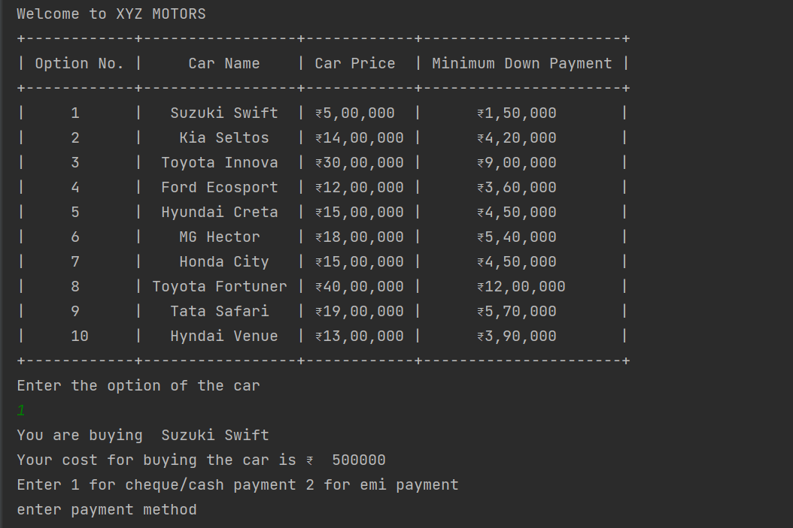

OUTPUT FOR EMI :

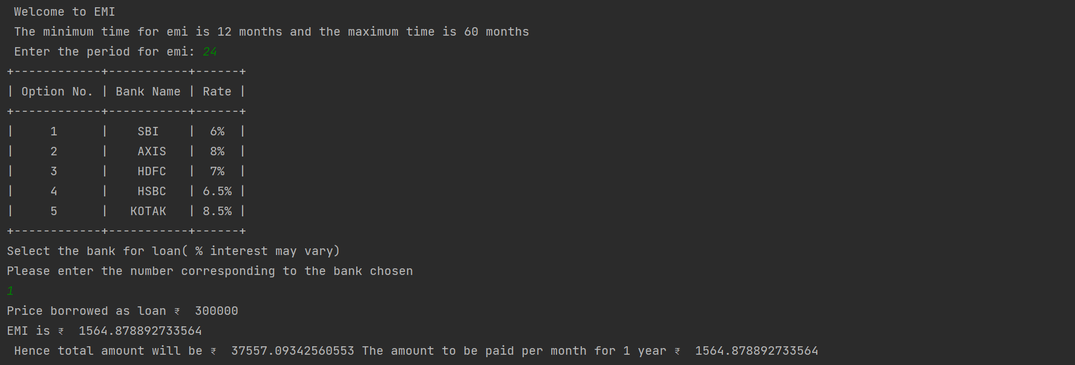

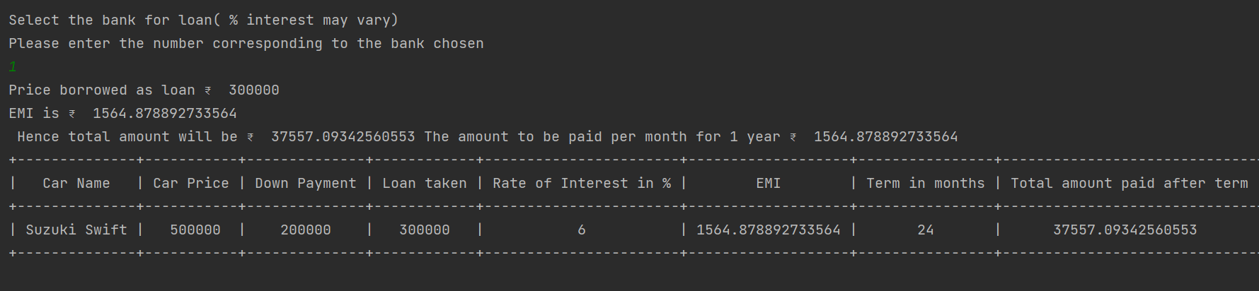

OUTPUT FOR CASH :

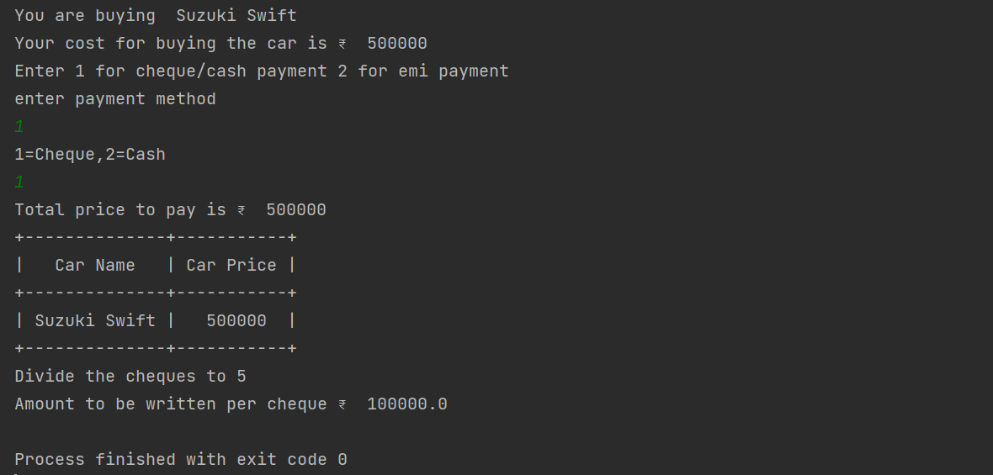

Conclusion:
Hence this program will help in simplifying the transactions for car dearship showrooms.

