Table of Contents

Abstract: 2

1. Executive Summary: 3

**1.1** **Project Overview:** **3**

1.1.1 Introduction: 3

1.1.2 Background: 3

1.1.3 Methodology: 3

1.1.4 Objectives: 4

1.1.5 Literature Review: 4

1.1.6 Scope of Work: 5

1.1.7 Feasibility Study: 5

2. Benefits: 7

2.0.1 Increased customer satisfaction: 7

2.0.2 Streamlined ordering processes: 7

2.0.3 Real-time order updates: 7

2.0.4. Enhanced data security: 7

2.0.5 Environmental Sustainability: 7

2.0.6 Adaptability to Future Technologies: 8

**2.1** **Risk Assessment:** **8**

2.1.1 Integration Challenges: 8

2.1.2 Security Concerns: 8

2.1.3 User Adoption Challenges: 8

2.1.4 Technical Issues and Downtime: 9

**2.2** **Tools:** **9**

2.2.1 Implementations tools 9

2.2.2 Hardware Requirement 9

2.2.3 Software Requirement 9

**2.3** **Team Member:** **9**

3. Level 0 & 1 DFD diagram of the Food delivery system. 10

**3.1** **ER- Diagram of Food delivery system** **11**

**3.2** **Timeline & Gantt Chart:** **11**

4. Conclusion: 12

**4.1 Next Step: …...…………………………………………………………………………. 12**

# Abstract:

The proposed project aims to develop and implement an innovative online platform dedicated to simplifying food delivery services. In a world increasingly driven by technological advancements, the food delivery sector is on the brink of a transformative journey.

This proposal represents a proactive initiative to reshape customer interactions with food delivery services, leveraging technology to create a seamless, efficient, and customer-centric ecosystem. The project focuses on establishing a secure online payment system, enhancing order accuracy, and ensuring a user-friendly interface.

With a comprehensive methodology, the project aims to streamline processes, improve accessibility, and contribute to a sustainable future. The implementation timeline, team structure, benefits, risk assessment, and next steps are outlined to guide the successful realization of this transformative project.

**Chapter-1**

# Executive Summary:

Our BCA Team group B is excited to propose the development and implementation of a cutting-edge online platform dedicated to simplifying and enhancing the process of food delivery. Recognizing the increasing demand for seamless and user-friendly solutions, our proposed website aims to revolutionize the way customers interact with food delivery services. By harnessing the power of technology, we aspire to create a digital ecosystem that not only facilitates convenient online orders but also optimizes order accuracy, streamlines administrative processes, and ultimately elevates overall customer satisfaction.

## **1.1 Project Overview:**

### 1.1.1 Introduction:

In an era propelled by unprecedented technological advancements, the food delivery sector stands poised at the cusp of a transformative journey. Our proposal emerges not merely as a response to the evolving landscape but as a proactive initiative to reshape the contours of customer interaction with food delivery services. As societies embrace the digital age, our vision extends beyond the confines of routine transactions; it envisions a paradigm where the intersection of technology and food services gives rise to a seamless, efficient, and customer-centric ecosystem.

### 1.1.2 Background:

The traditional paradigms governing food delivery have, for too long, been entrenched in manual processes and paperwork. This archaic approach, marked by its inherent inefficiencies and time-consuming nature, has compelled us to re- imagine the very foundations of customer interactions with food delivery services. In this backdrop, our proposal seeks to usher in a new era of convenience, leveraging technology to streamline processes, enhance accessibility, and contribute to a sustainable future.

### 1.1.3 Methodology:

Our approach to realizing these objectives is strategic and comprehensive. Commencing with an in-depth requirements analysis, we will collaboratively define the project's scope and functionalities. Subsequent phases will include meticulous design and development, informed by continuous client feedback, ensuring the resultant website aligns seamlessly with your food delivery service requirements. Rigorous testing and quality assurance protocols will follow, guaranteeing the website's functionality across diverse devices and platforms. Finally, the implementation phase will involve careful integration with existing systems, user training, and ongoing support to ensure a smooth transition and sustained operational excellence.

### 1.1.4 Objectives:

The primary objectives of this transformative project are threefold. Firstly, we aim to establish a secure and efficient online ordering system that allows customers to effortlessly place and track their food orders from the comfort of their homes or workplaces. Secondly, our focus is on improving the precision and efficiency of the order process through the seamless integration of our proposed website with existing food delivery management systems. Thirdly, we are dedicated to crafting a user-friendly interface that transcends age and technical backgrounds, ensuring a positive and accessible experience for all users.

### 1.1.5 Literature Review:

The literature review reveals a notable evolution in food delivery systems, emphasizing the rising importance of online solutions for enhanced customer experience and operational efficiency. Studies highlight the imperative for seamless integration of technology in food delivery, echoing the proposed project's objectives. Insights into user experience underscore the critical role of a user-friendly interface, aligning with the project's goal of accessibility. Security concerns in online transactions are addressed through the proposed "sha256" military-level security, reflecting established best practices. Environmental sustainability is a key theme, with research supporting the project's commitment to reducing paper-based transactions. Challenges in user adoption and integration are acknowledged, with the proposed project incorporating strategies such as user training programs and phased implementation to mitigate potential issues. In summary, the literature review provides a foundation for the proposed project, aligning its objectives with industry trends and best practices in food delivery systems, technological integration, user experience, security measures, environmental impact, and challenges in online ordering adoption.

### 1.1.6 Scope of Work:

The scope of our proposed project encompasses multifaceted components crucial to its success. Central to this initiative is the design and development of a responsive website with an intuitive interface, placing user experience at the forefront. Furthermore, our approach includes the integration of the website with the pre-existing food delivery management system, aiming to automate and enhance order processes. To fortify the digital infrastructure, we are committed to implementing advanced security measures, ensuring the protection of customer data and financial transactions. Complementing this, we will introduce a notification system to keep customers informed about order confirmations, delivery updates, and any relevant updates, contributing to an informed and engaged user base.

### 1.1.7 Feasibility Study:

The feasibility study for the proposed online food delivery platform assesses its viability from technical, operational, and economic perspectives.

#### 1.1.7.1 Technical Feasibility:

From a technical standpoint, the proposed platform envisions seamless integration with existing food delivery management systems. Compatibility and interoperability will be ensured through rigorous testing and collaboration with relevant stakeholders. The deployment of "sha256" military-level security measures addresses potential concerns, providing a robust framework for secure transactions. The technological infrastructure will be designed to accommodate future updates and advancements, ensuring long-term sustainability.

#### 1.1.7.2 Operational Feasibility:

Operational feasibility centers on the practicality of implementing the proposed platform. The phased integration approach outlined in the project timeline mitigates potential disruptions, allowing for a gradual transition. User training programs will be instrumental in overcoming any resistance to change, ensuring that both customers and staff are adept at utilizing the new system. Additionally, a dedicated support system will be in place to address operational issues promptly, enhancing overall system reliability.

#### 1.1.7.3 Economic Feasibility:

Economic feasibility evaluates the financial viability of the project. The upfront investment in development, testing, and implementation is justified by the anticipated benefits. The streamlined ordering processes and increased operational efficiency are expected to result in cost savings for the food delivery service. Increased customer satisfaction and engagement contribute to a positive economic impact, as satisfied customers are more likely to continue using the service. The reduction in paper usage aligns with environmental sustainability goals and may result in long-term cost savings.

**Chapter-2**

# 2. Benefits:

## 2.0.1 Increased customer satisfaction:

Offering an online food delivery platform enhances customer convenience, providing a seamless and user-friendly experience. This convenience contributes to heightened satisfaction among customers who can effortlessly place and track their orders from anywhere, fostering a positive relationship with the food delivery service.

## 2.0.2 Streamlined ordering processes:

The proposed website integrates with existing ordering systems, automating processes and reducing manual intervention. This streamlining of ordering procedures leads to increased efficiency, minimized errors, and a more effective utilization of resources within the food delivery service, ultimately benefiting both the service provider and the customers.

## 2.0.3 Real-time order updates:

Through the implementation of the online platform, customers receive real-time updates on their order information. This instant access to payment statuses and delivery details ensures transparency and empowers customers to stay informed about their culinary commitments, contributing to a more informed and engaged user base.

## 2.0.4. Enhanced data security:

This commitment to enhanced data security assures customers that their sensitive information is protected during online transactions, fostering trust in the security of the online food delivery system. This not only meets industry standards but also addresses customer concerns about data privacy.

## 2.0.5 Environmental Sustainability:

By transitioning to online food orders, the proposed website aligns with environmentally sustainable practices. The reduction in paper usage for traditional order forms and receipts contributes to a greener operation. This aligns with the growing societal emphasis on sustainability and positions the food delivery as a responsible and environmentally conscious service provider.

## 2.0.6 Adaptability to Future Technologies:

The introduction of a notification system as part of the online platform is designed to foster improved customer engagement. Customers will receive timely alerts about order confirmations, delivery updates and relevant updates. This proactive communication not only keeps customers informed but also enhances their overall experience, contributing to increased satisfaction and a positive perception of the food delivery service.

## **2.1 Risk Assessment:**

As with any significant project, a comprehensive risk assessment is imperative to proactively identify potential challenges and implement mitigation strategies. The following risks have been identified, along with corresponding mitigation approaches:

### 2.1.1 Integration Challenges:

One potential risk involves the seamless integration of the proposed online ordering platform with existing food delivery management systems. To mitigate this risk, our development team will conduct thorough compatibility testing, working closely with the members to address any integration challenges promptly. Additionally, a phased implementation approach will be adopted to allow for gradual system integration and minimize potential disruptions.

### 2.1.2 Security Concerns:

The security of customer data and financial transactions is of paramount importance. To address potential security concerns, our team will implement "sha256" military level security and regular security audits. We will also collaborate with cyber security experts to ensure that the online ordering platform adheres to industry best practices and standards, providing a secure environment for users.

### 2.1.3 User Adoption Challenges:

The success of the online food delivery platform relies on user adoption. To mitigate potential challenges related to user acceptance, a comprehensive user training program will be implemented. This program will include informative guides, tutorial videos, and a dedicated support system to assist users in navigating the new platform.

### 2.1.4 Technical Issues and Downtime:

Technical issues or unexpected downtime can impact the usability of the online platform. Additionally, if it happens then the regular maintenance schedules will be established to address potential technical issues before they become critical, ensuring a high level of system reliability.

## **2.2 Tools:**

### 2.2.1 Implementations tools

* HTML
* CSS
* JS
* Python(django)
* Whitenoise
* eSewa Merchant API
* Sqlite database
* Chartjs
* Kommunicate
* DialogFlow

### 2.2.2 Hardware Requirement

* Basic 2 core processor
* 2 GB of Random-access memory

### 2.2.3 Software Requirement

* Browser
* eSewa

## **2.3 Team Member:**

a. Aayush Dhakal

b. Aayam Awal

c. Swostik Dhungel

d. Rohan Bista

**Chapter-3**

# 3. Level 0 & 1 DFD diagram of the Food delivery system.

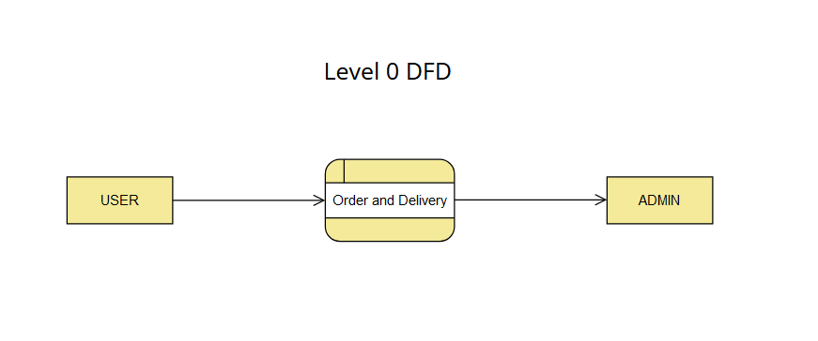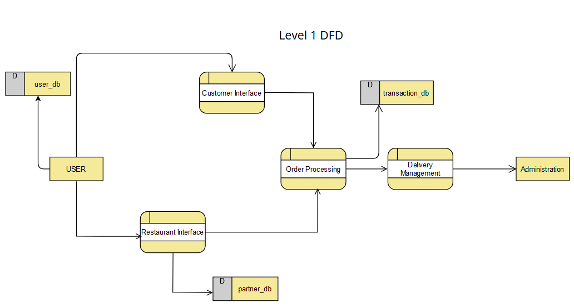

## **3.1 ER- Diagram of Food delivery system**

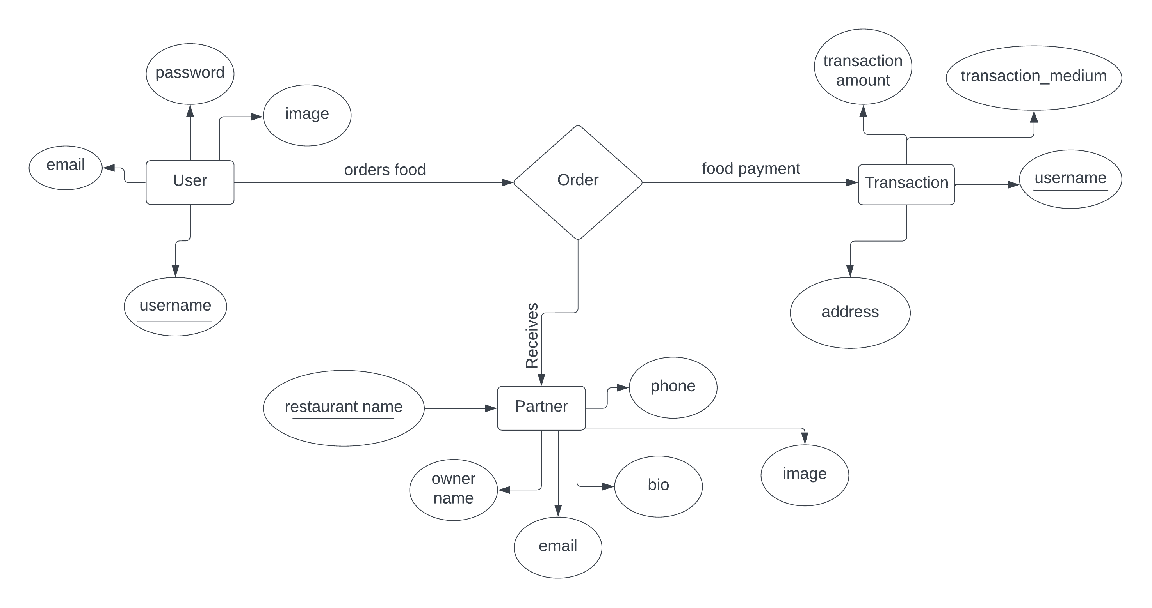

## **3.2 Timeline & Gantt chart:**

a. Requirements Analysis: [1 month]

b. Design and Development: [1 to 3 months]

c. Testing and Quality Assurance: [1 month]

d. Implementation: [1 month]

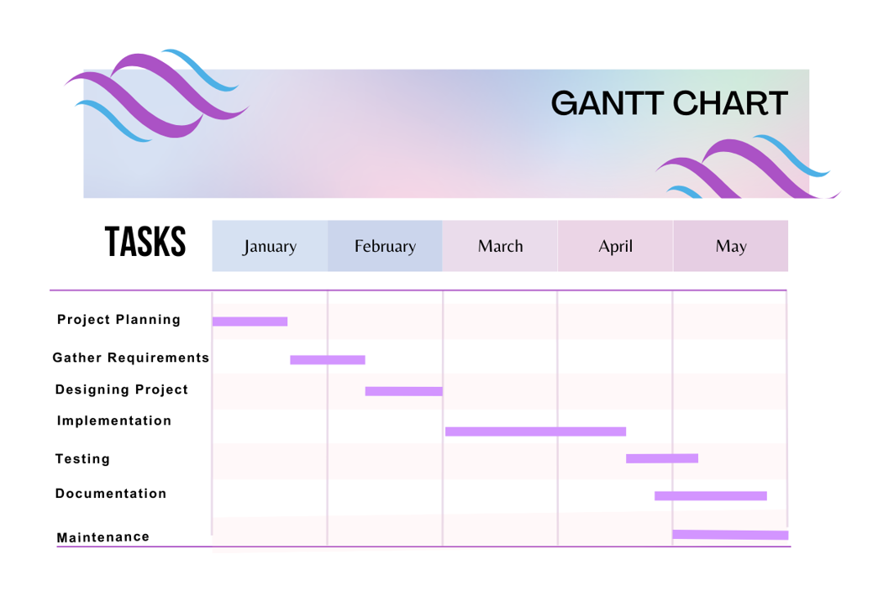

**Chapter-4**

# 4. Conclusion:

In conclusion, the proposed online food delivery website by Our BCA Team B is positioned to bring about a transformative shift in the way food delivery services are delivered and experienced. Through increased customer satisfaction, streamlined ordering processes, real-time order updates, and enhanced data security, this digital solution promises to elevate the overall efficiency and effectiveness of our food delivery services. The comprehensive risk assessment outlined in this proposal reflects our commitment to foresee and address potential challenges, ensuring a smooth and successful implementation. As we embark on this journey toward modernization, we are confident that the benefits of the proposed online platform will not only meet but exceed the expectations of both the food delivery service management and the valued customers we serve.

**4.1 Next Steps:**

The project will progress towards the finalization of contractual agreements. This step will formalize the project scope, budget, and any additional terms necessary for a successful collaboration. Clarity in contractual agreements is pivotal in providing a clear framework outlining expectations, responsibilities, and deliverables. Simultaneously, the project team will undergo an on boarding process, introducing them to their respective roles and responsibilities. This phase will ensure that the team is well-prepared and equipped with the necessary knowledge and skills for the tasks at hand. As the groundwork is laid, the development phase will commence, marking the crafting of the online food delivery website. Regular testing will follow, ensuring the functionality, security, and reliability of the system. The subsequent implementation phase will see a gradual integration of the new system to minimize disruptions. Concurrently, user training sessions for both customers and staff will be initiated, ensuring a seamless transition and maximizing the benefits of the new platform. Additionally, we will monitor the system's performance and gather user feedback to identify opportunities for optimization. This iterative approach ensures the platform evolves in tandem with user needs and technological advancements. Embarking on these next steps in a collaborative and strategic manner is key to the success of this endeavor.