Submitted by : Aayush Ranjan

BANKING KAFKA COMMANDS
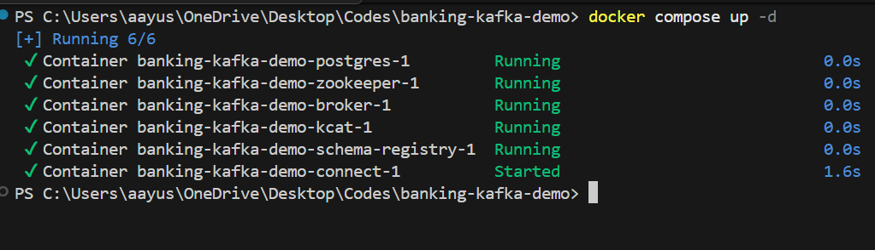

Commands:

docker compose exec connect kcat –version
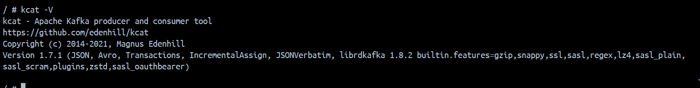

curl -s http://localhost:8083/connector-plugins | jq
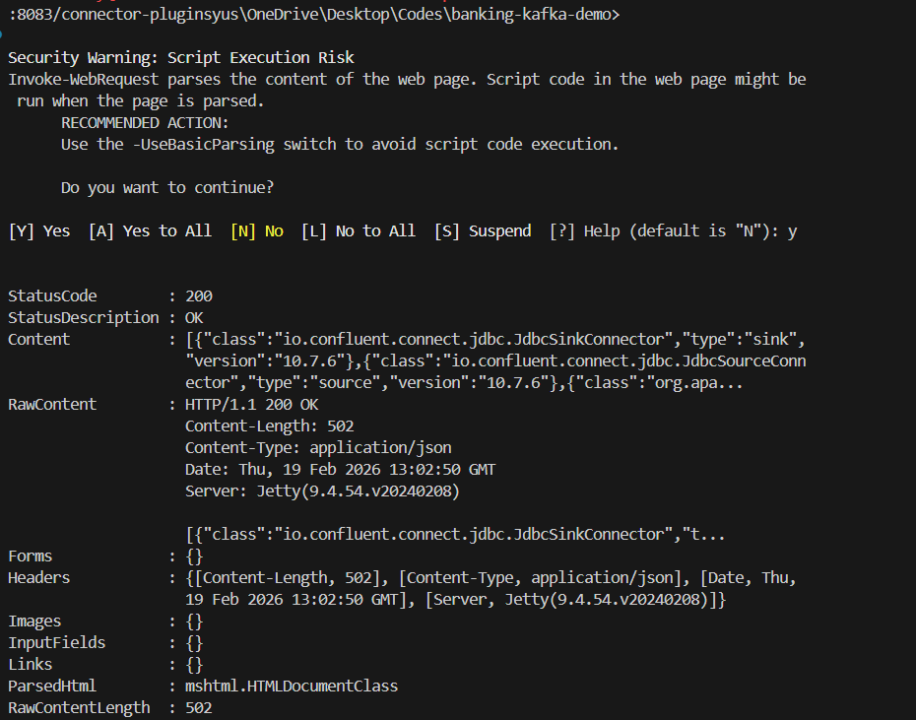

Open a shell in the broker container and create topics:

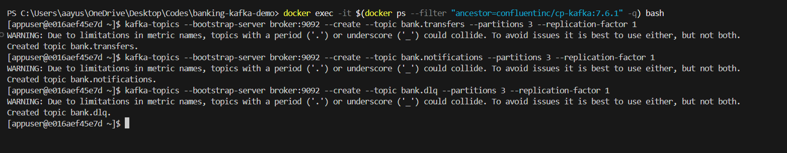

List Topics:
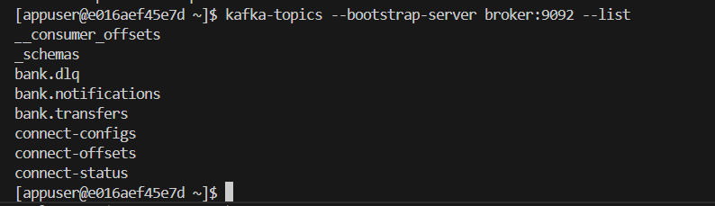
List topics and metadata:
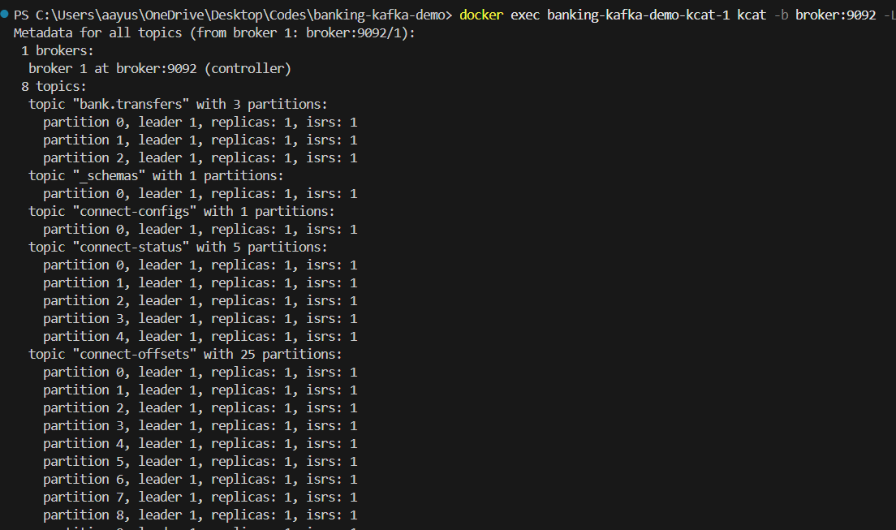
Produce messages to a topic:
Consume messages from a topic:
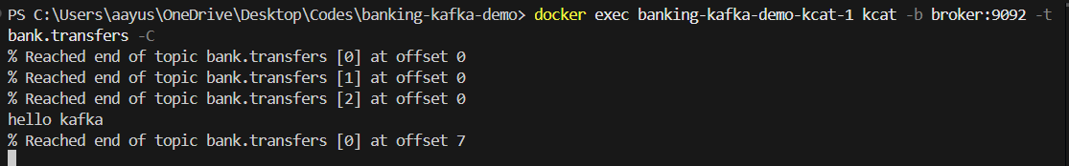
Consume from beginning:
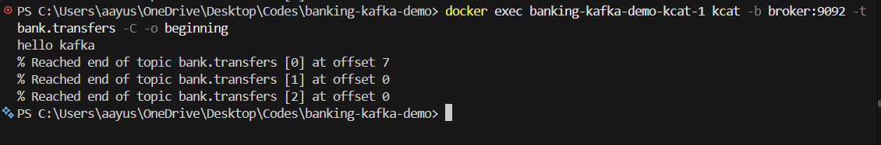

# Create input file
# Create source connector

1. Create a transfers table in PostgreSQL:

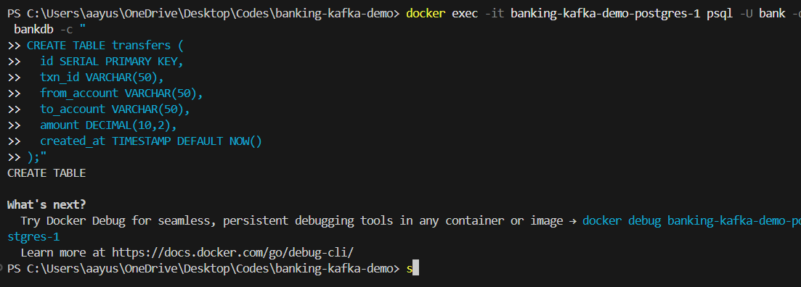

2. Insert test data:

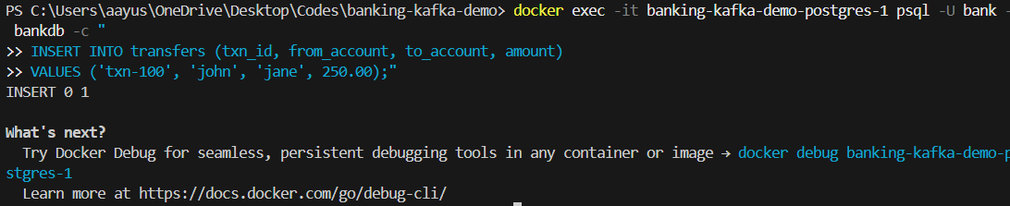

3. Create JDBC Source Connector:

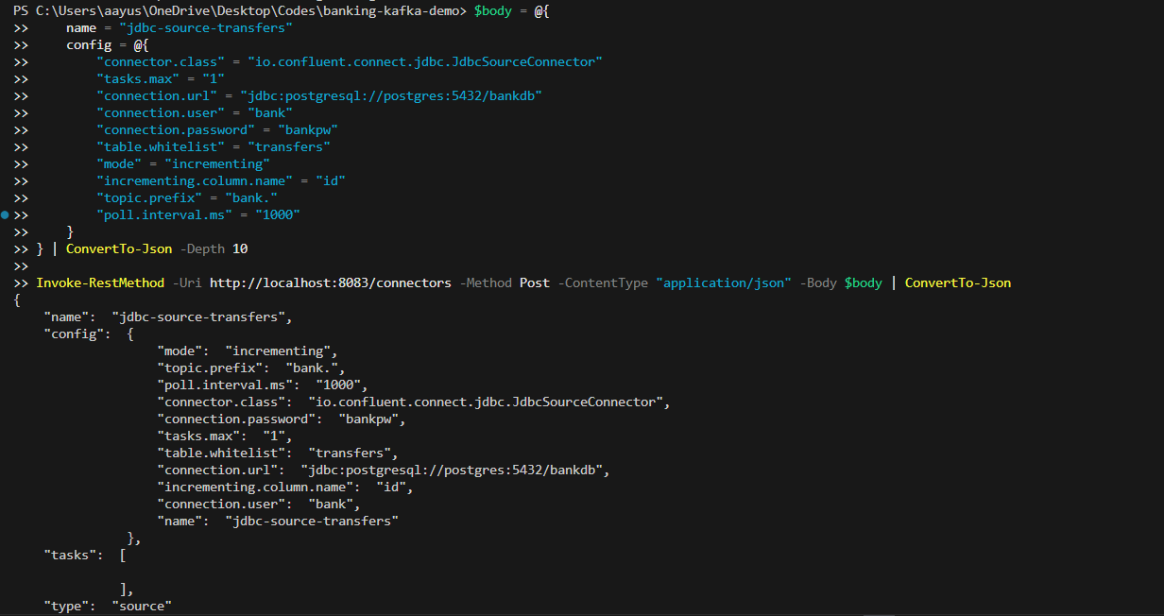
4. Verify the connector is running:
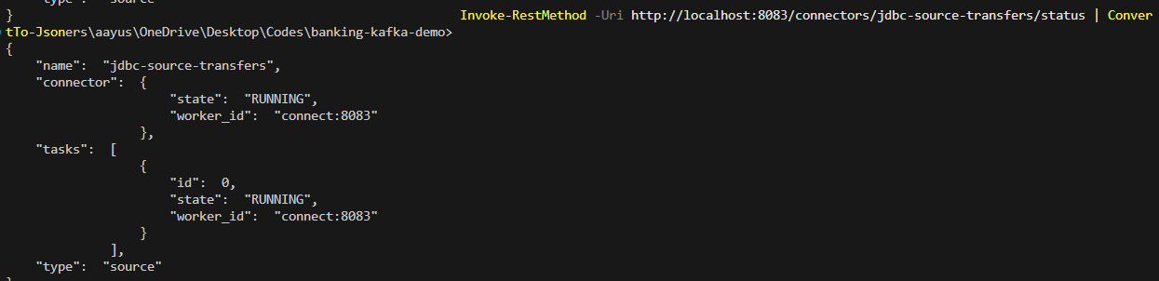

For the sink connection
- Insert new data into PostgreSQL:
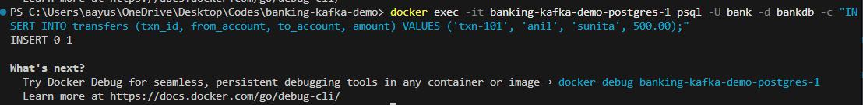
- Verify messages in Kafka topic:
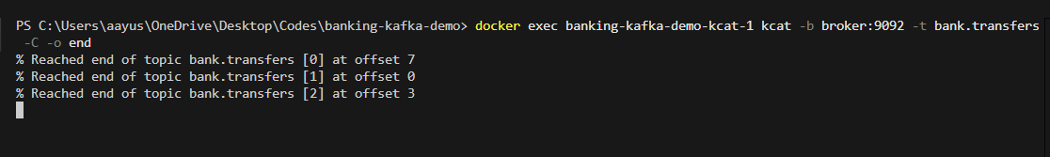
- Create JDBC Sink Connector (writes to another PostgreSQL table):
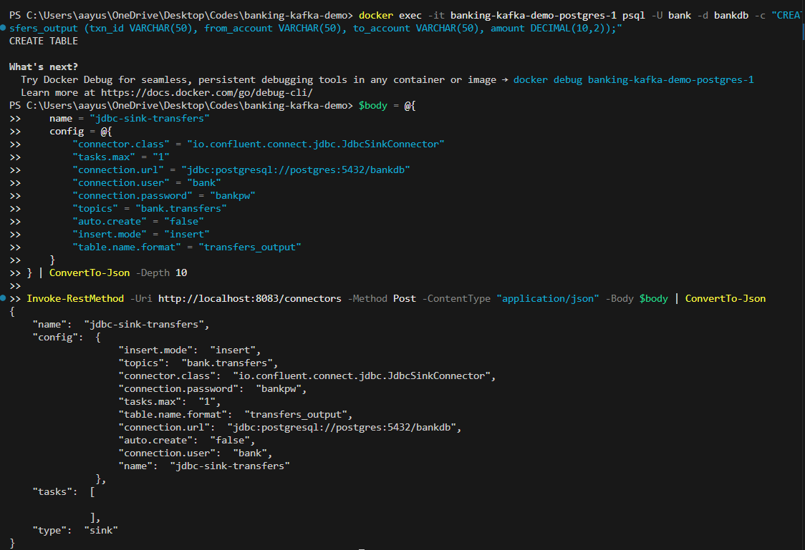
- Verify sink output:

