DB-LAB-1

Roll No: 24P-0706 | Dept: BS-CS
Name: Aazan Noor Khuwaja | Section: 4B

Downloaded sqlite3:
Sudo apt install sqlite3

Downloaded sqlitebrowser:
Sudo apt install sqlitebrowser

Terminal Execution
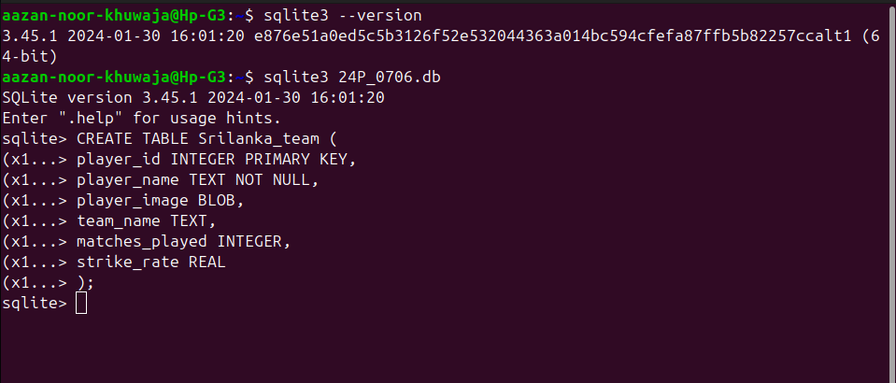
Figure 1 Created Table with Columns

Explanation:
Here as you can see the version of sqlite3,
Step1:
First i created database with my roll no: first command sqlite3 24P_0706.db
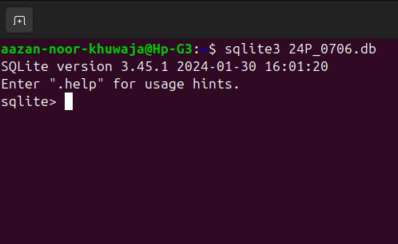
Step2:
Now I created cricket team table with name srilanka_team and then parenthesis starts.
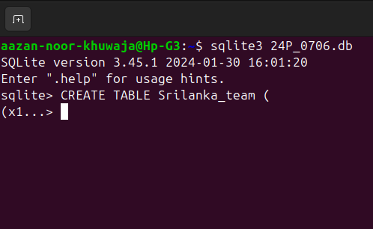
Step3:
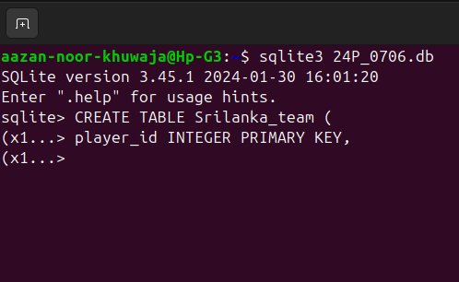
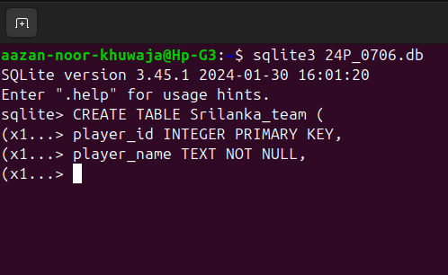
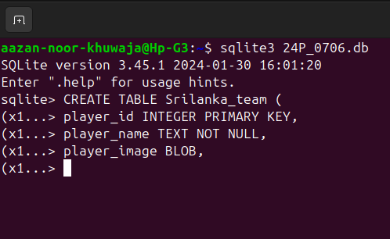

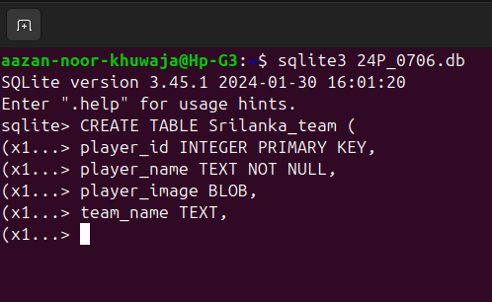
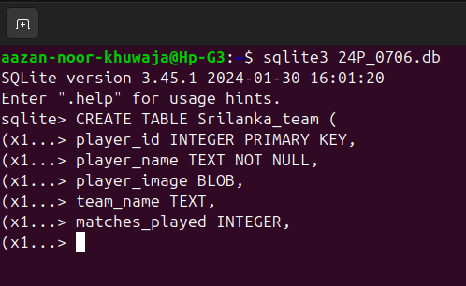

and then added columns with its integer type and then along added constraints where needed and after each column “ , “ must except last one.
Step4:
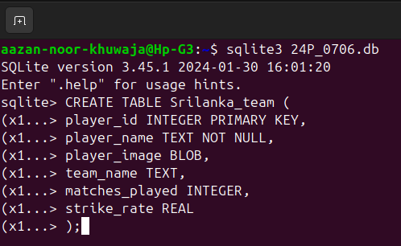
then ended with ending parenthesis according to syntax.

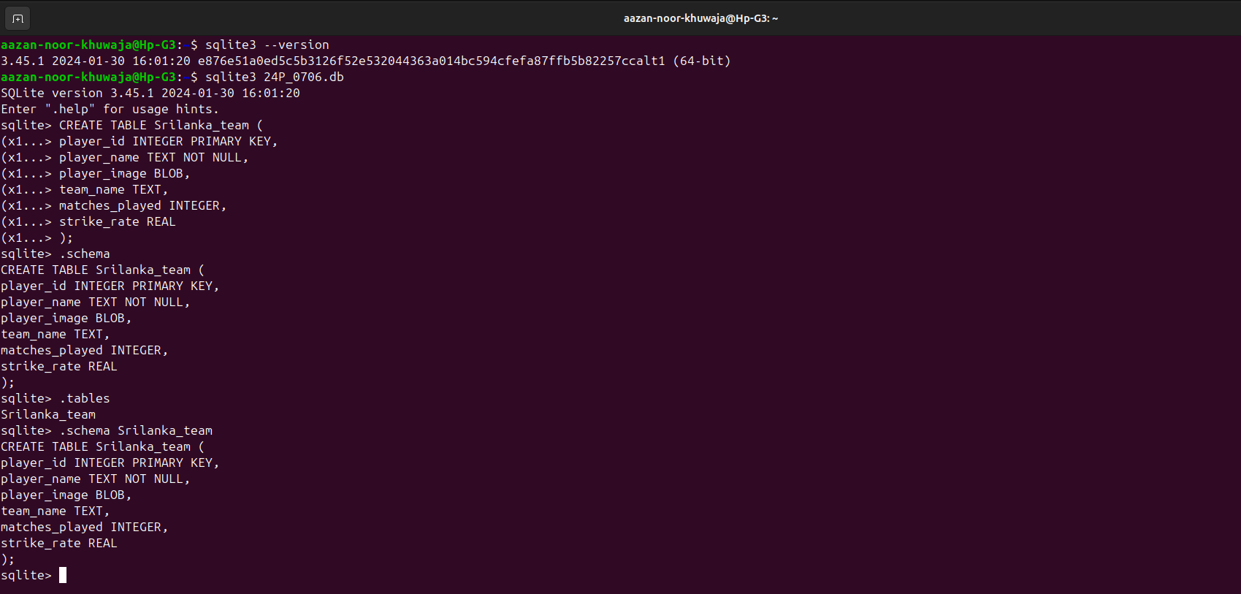
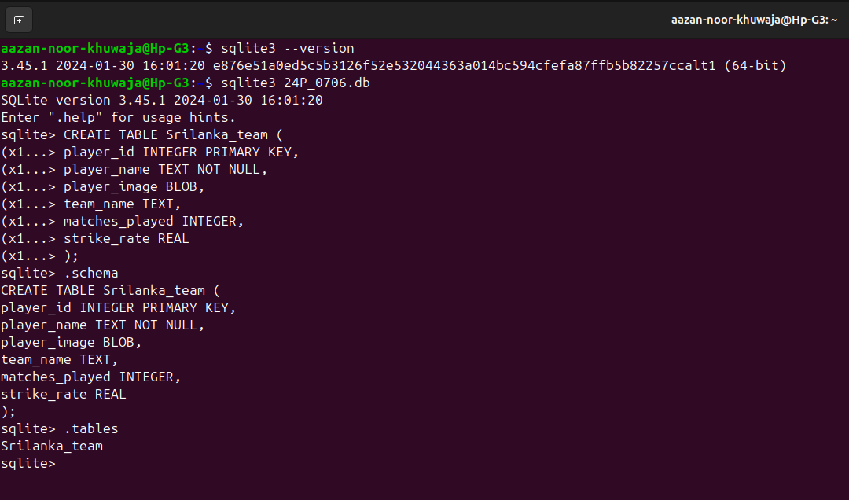
Figure 2 Used Schema to show the Structure of table

Showing On DB Browser GUI
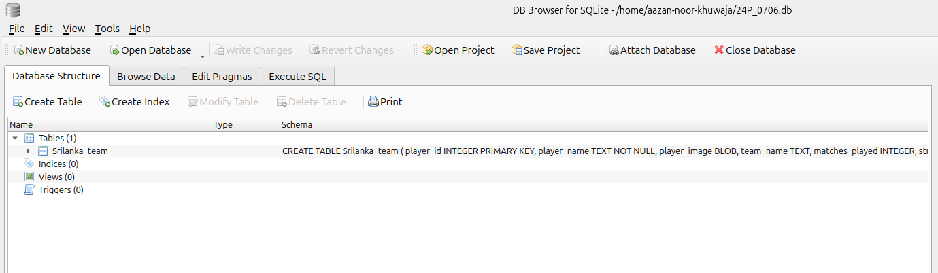
Figure 3 Interface of Srilankan team data base

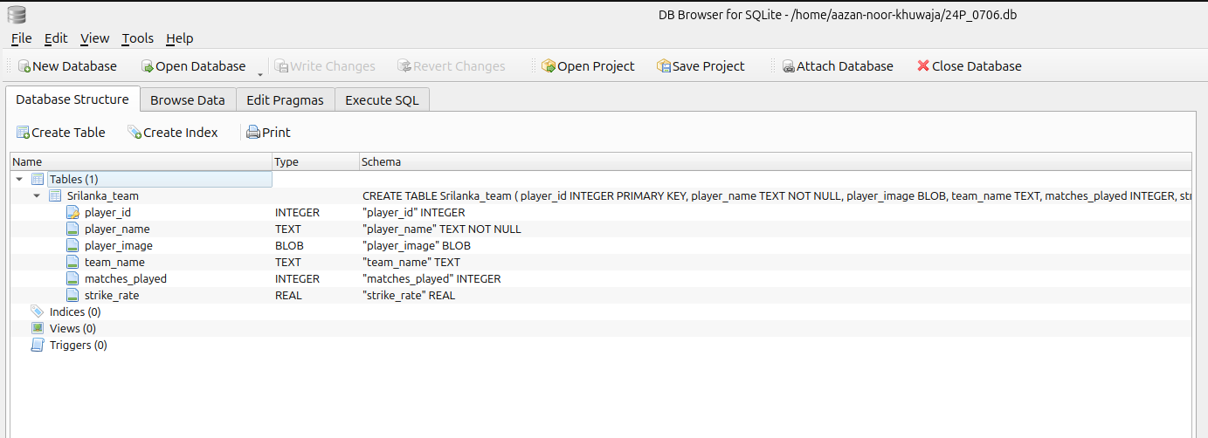
Figure 4 Columns which we created are there also

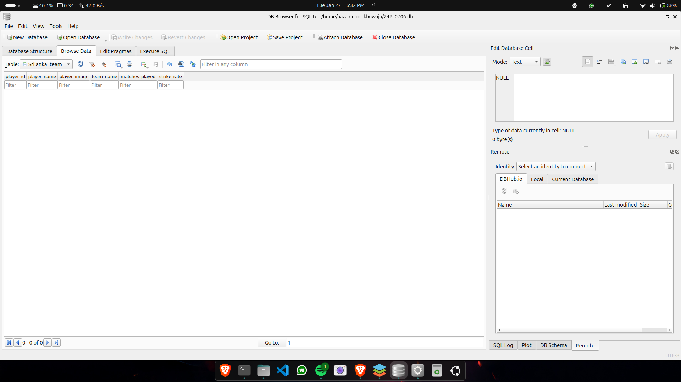
Figure 5 Final Data which we created in table form is this.

