DB-LAB-TASK-3

Roll No: 24P-0706 | Dept: BS-CS
Name: Aazan Noor Khuwaja | Section : 4B

1. Display all developer records:
Command:
SELECT * FROM dev_survey
Output:
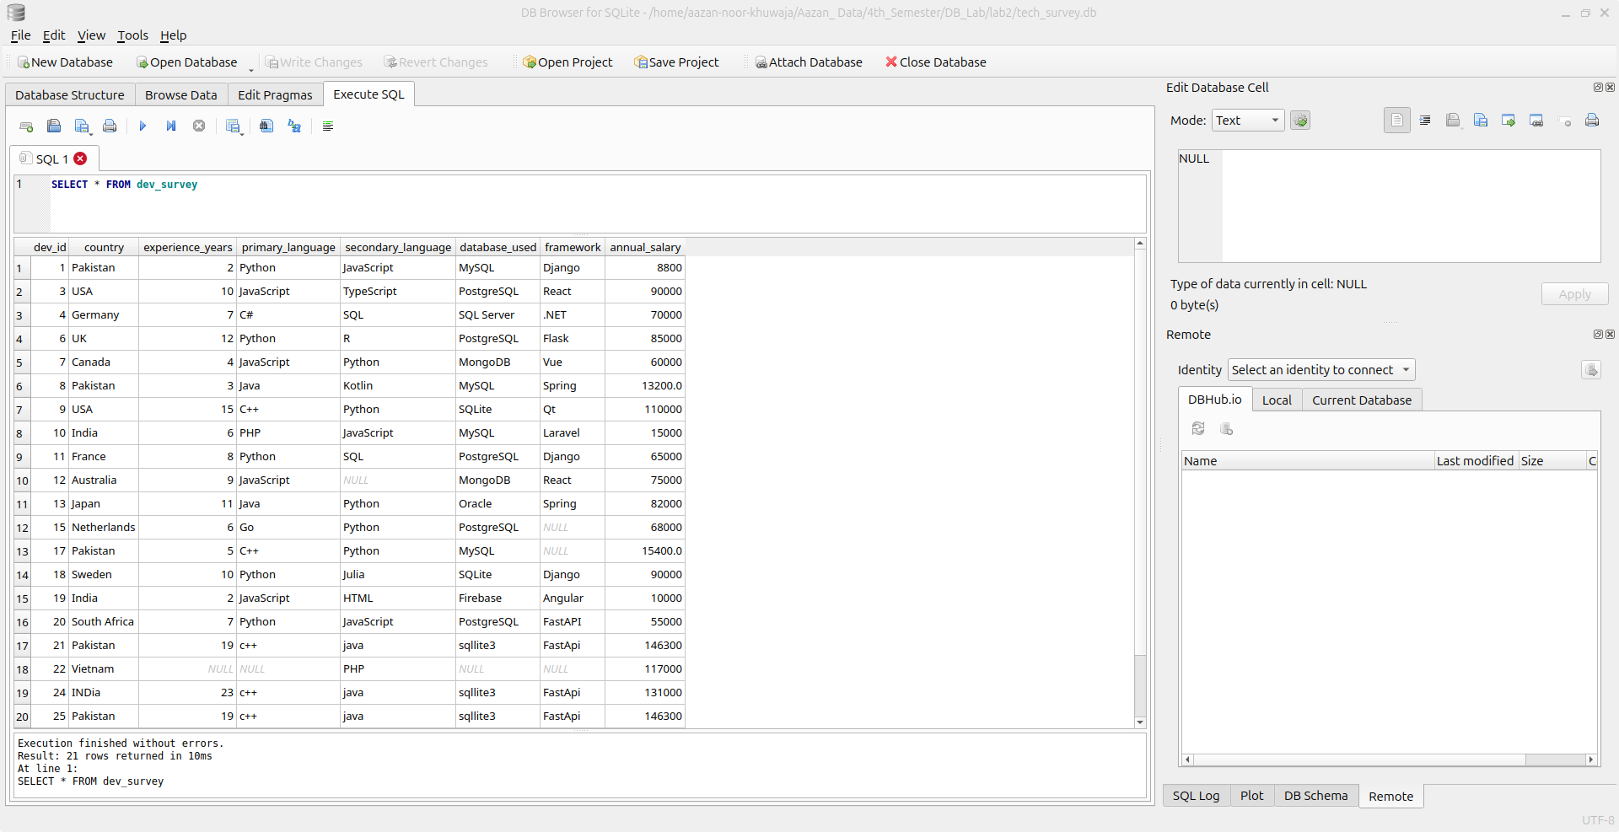

2. Display only country, primary_language, annual_salary:
Command:
SELECT country,primary_language,annual_salary FROM dev_survey;
Output:
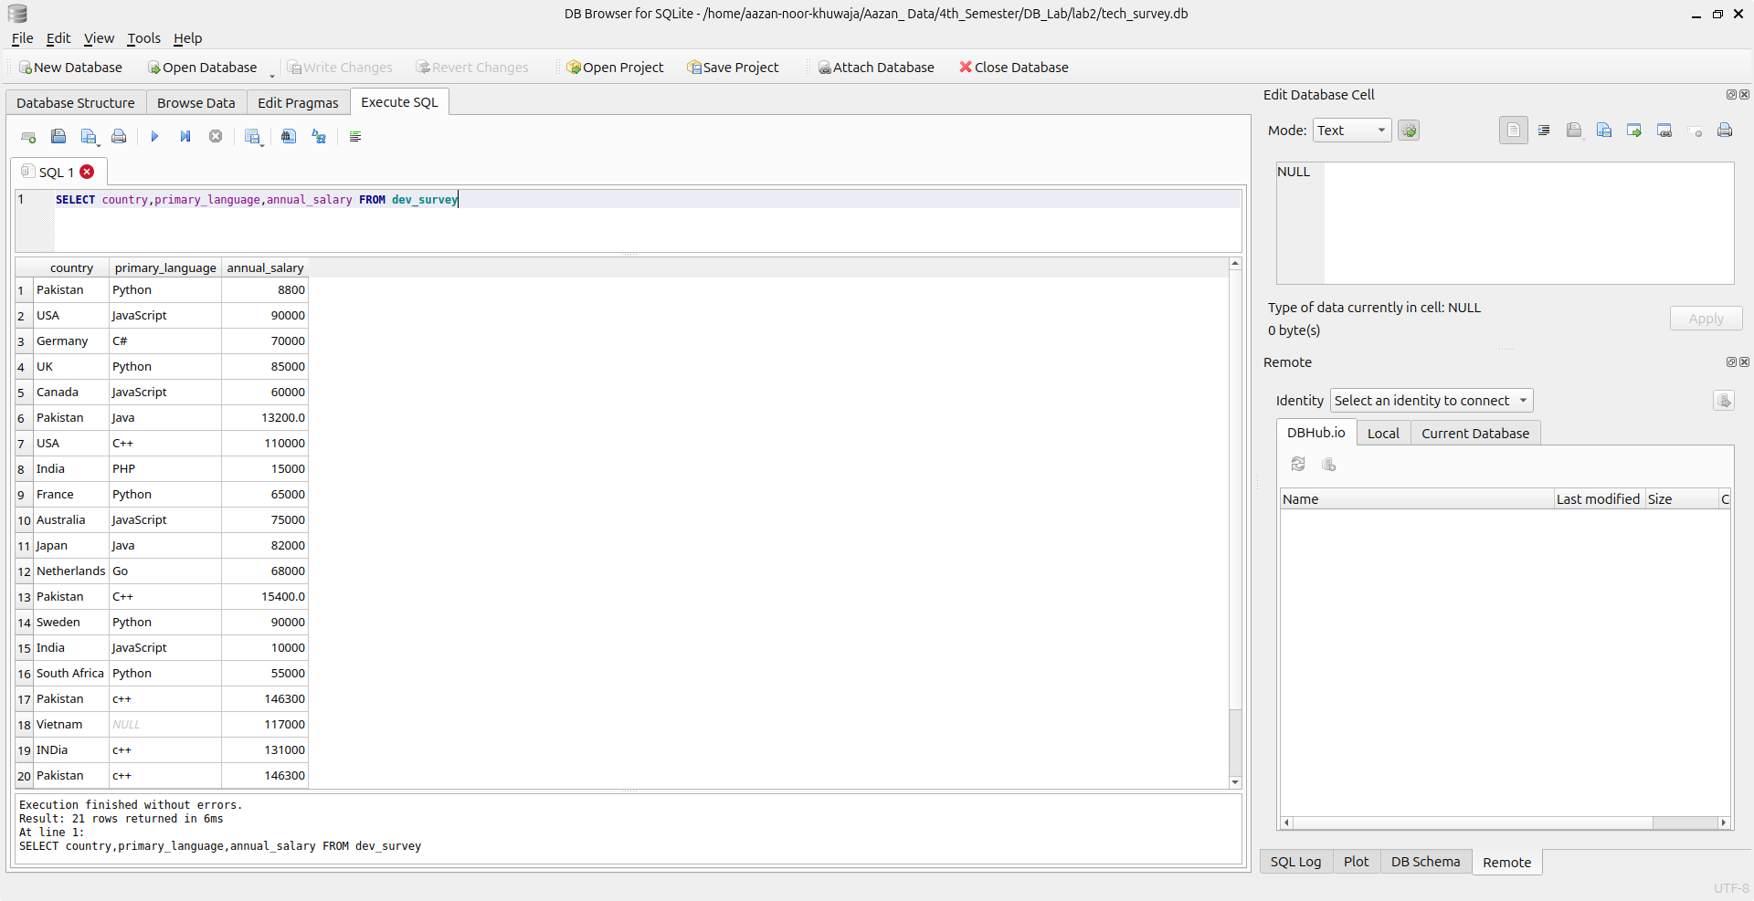

3. List developers earning more than 50,000 USD:
Command:
SELECT * FROM dev_survey
WHERE (annual_salary>50000);
Output:
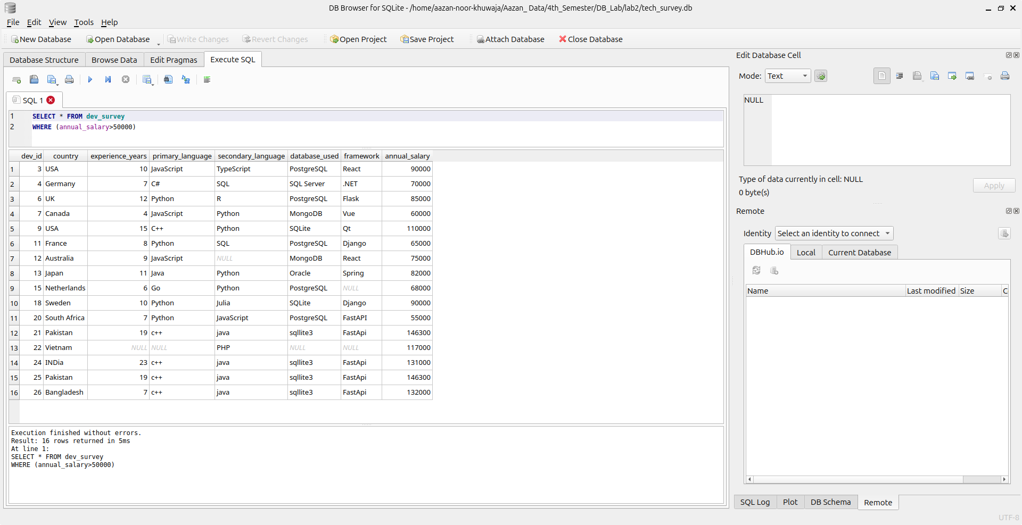

4. Show developers from Pakistan earning less than 20,000 USD:
Command:
SELECT * FROM dev_survey
WHERE country='Pakistan' AND annual_salary<20000;
Output:
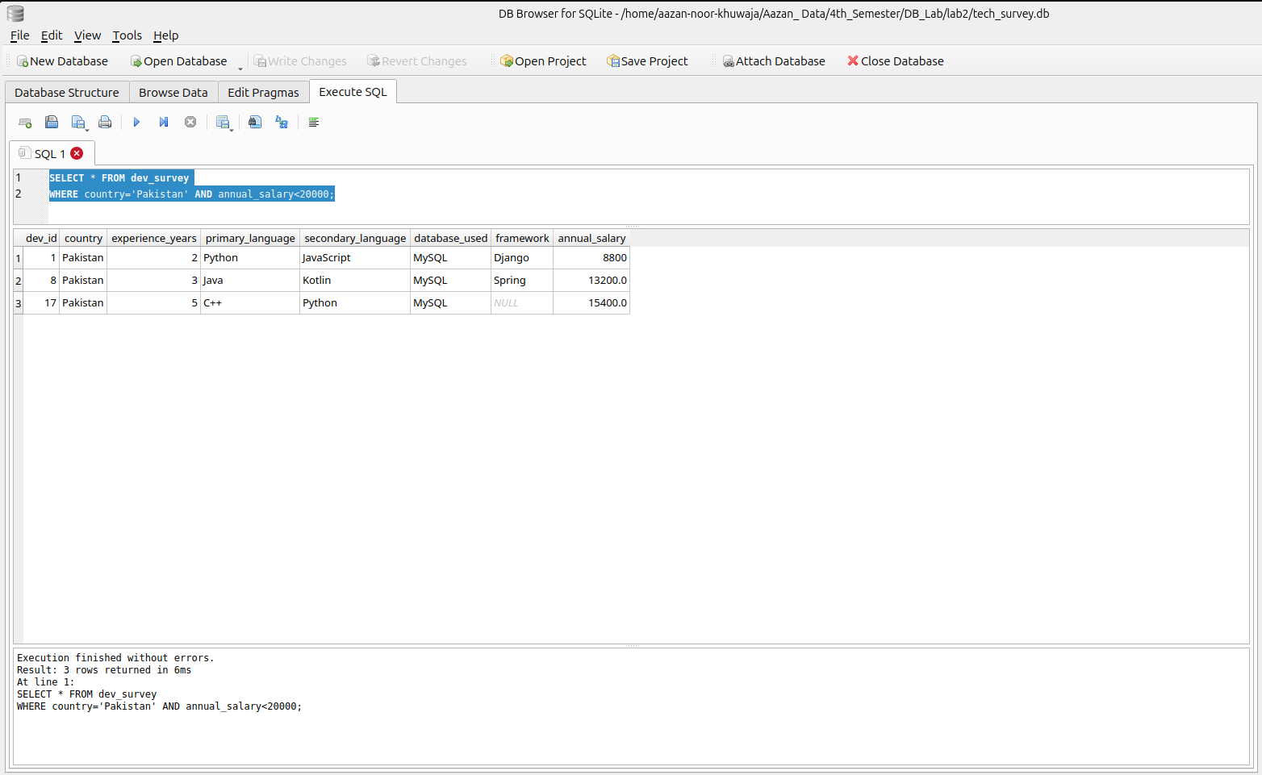
5. Show developers who use Python and PostgreSQL:
Command:
SELECT *
FROM dev_survey
WHERE primary_language = 'Python' AND database_used = 'PostgreSQL';
Output:
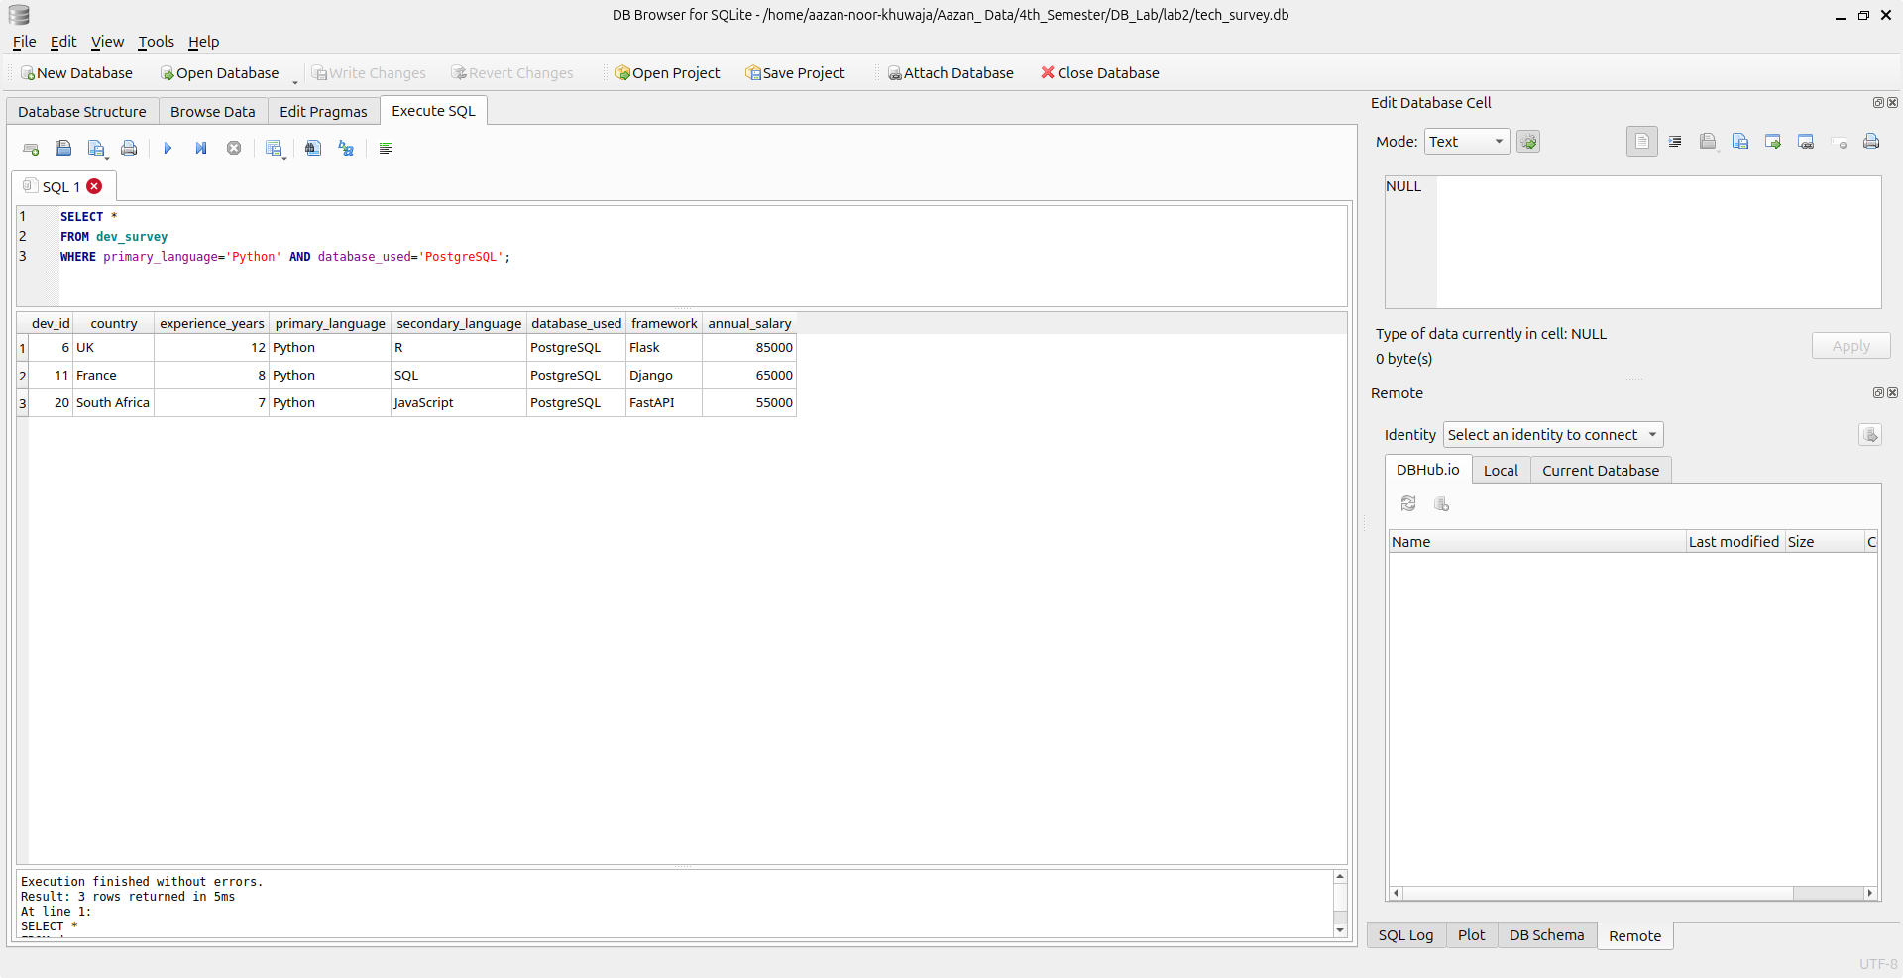
6. Show developers from USA or Germany earning above 60,000 USD:
Command:
SELECT *
FROM dev_survey
WHERE country = 'USA' OR country = 'Germany' AND annual_salary>60000;
Output:
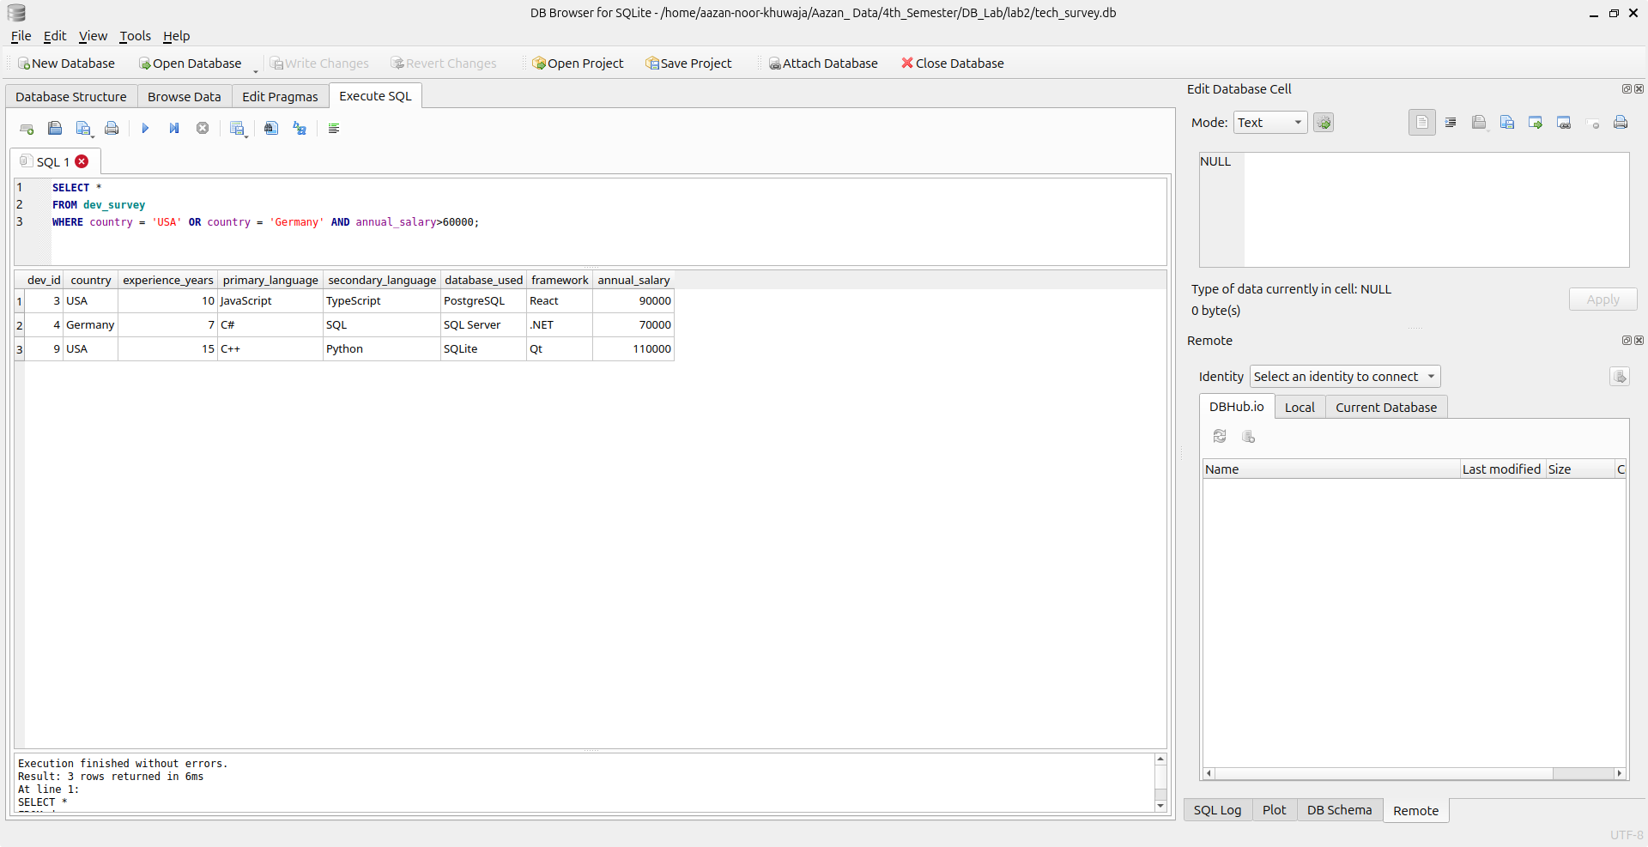
7. Show developers who do not use JavaScript:
Command:
SELECT *
FROM dev_survey
WHERE primary_language!='JavaScript';
Output:
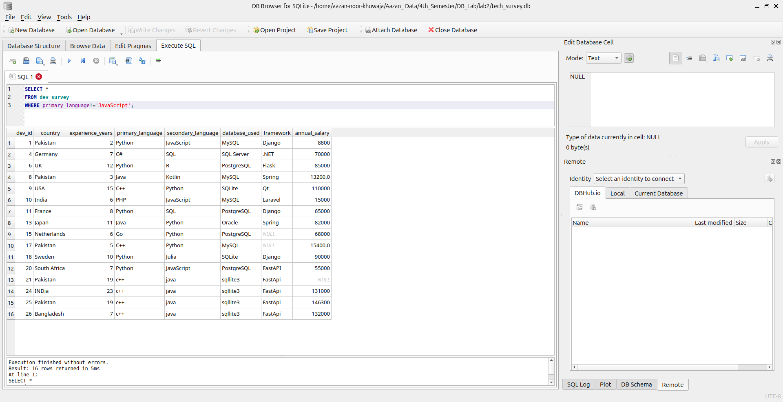
8. Show developers with experience between 5 and 10 years:
Command:
SELECT *
FROM dev_survey
WHERE experience_years BETWEEN 5 AND 10;
Output:
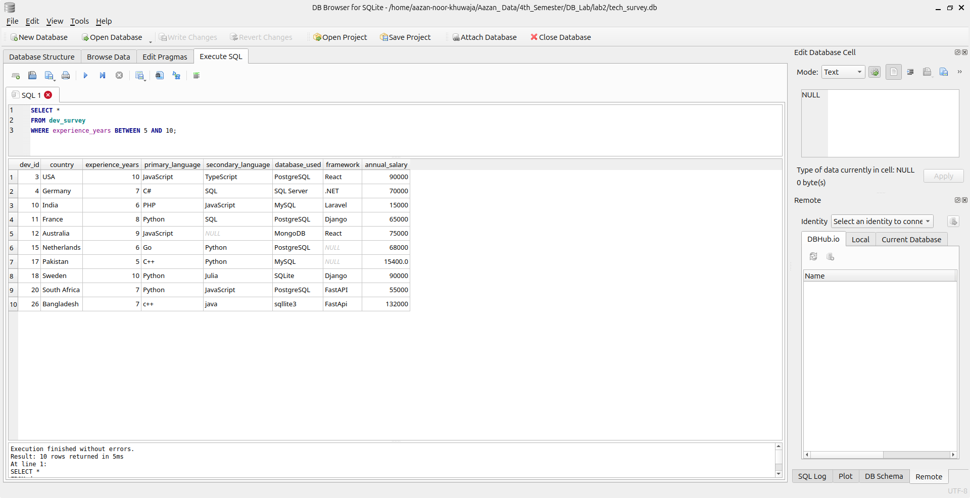
9. Show developers whose primary language is either one of Python, Java, C++,PHP:
Command:
SELECT *
FROM dev_survey
WHERE primary_language IN ('Python','Java','C++','PHP');
Output:
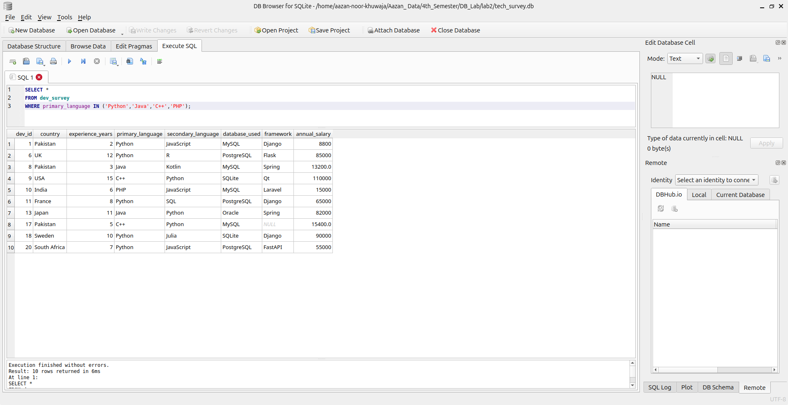
10. Show developers whose framework starts with S:
Command:
SELECT *
FROM dev_survey
WHERE framework LIKE 'S%';
Output:
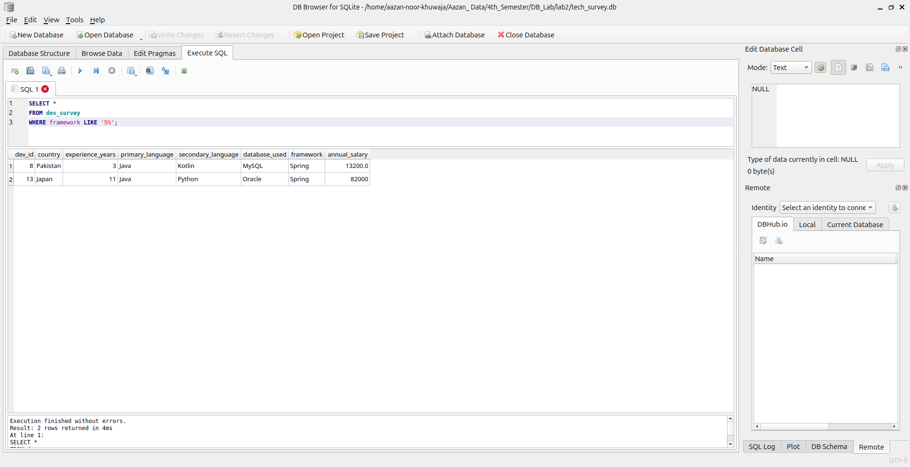
11. Show developers whose database contains the word SQL:
Command:
SELECT *
FROM dev_survey
WHERE database_used LIKE '%SQL%';
Output:
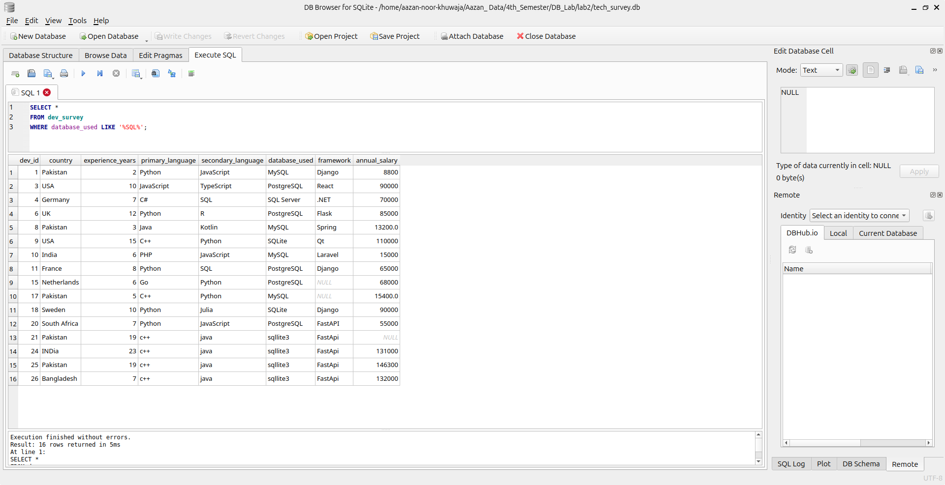
12. Show the top 5 highest-paid developers:
Command:
SELECT *
FROM dev_survey
ORDER BY annual_salary DESC
LIMIT 5;
Output:
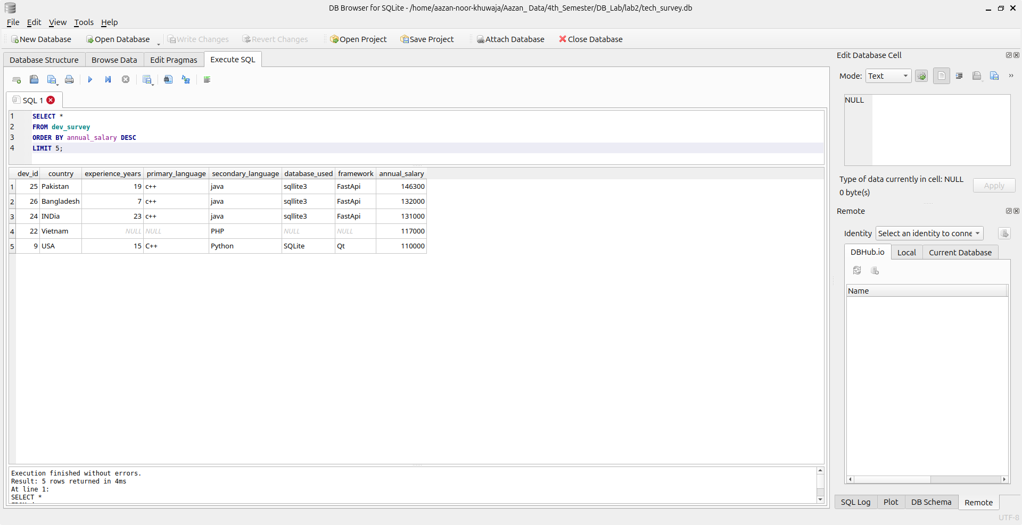
13. Show the lowest-paid developers sorted by salary:
Command:
SELECT *
FROM dev_survey
ORDER BY annual_salary ASC;
Output:
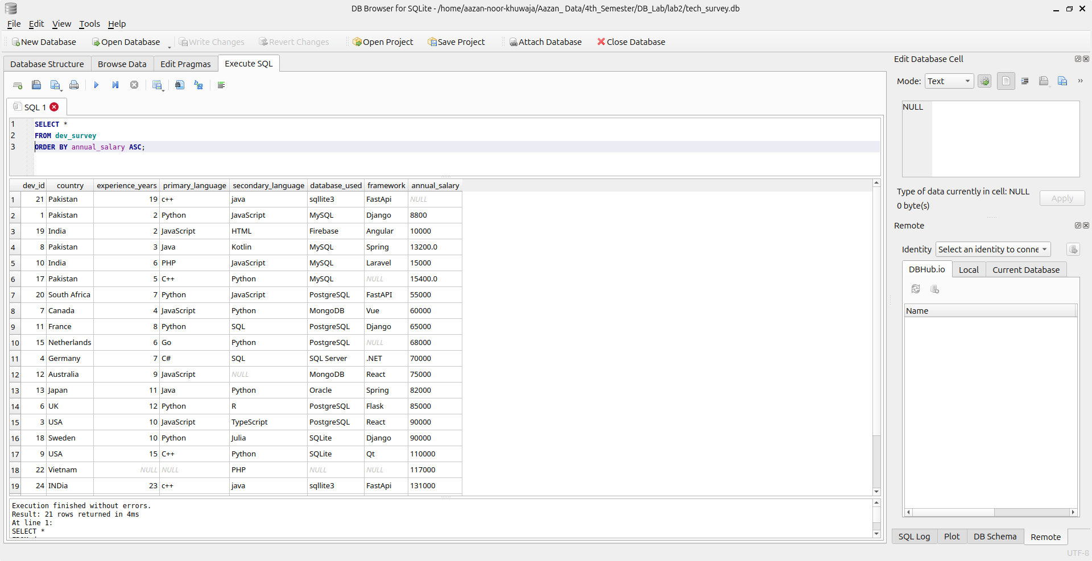
14. Show the only developer with the most experience:
Command:
SELECT *
FROM dev_survey
ORDER BY experience DESC
LIMIT 1;
Output:
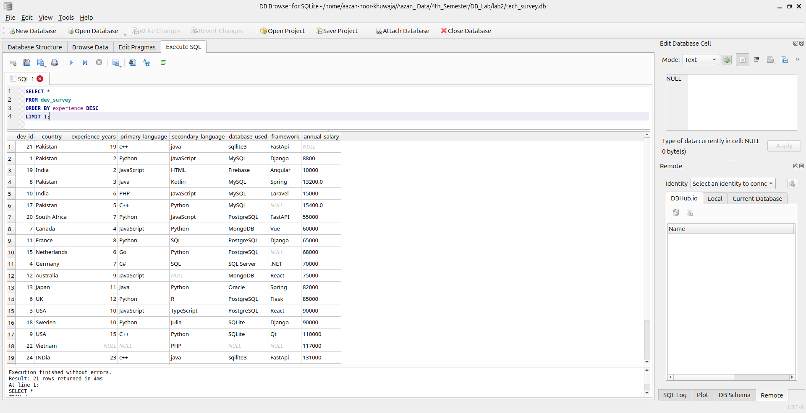
15. Show the developer with the 4th highest salary.
Command:
SELECT *
FROM developers
ORDER BY annual_salary DESC
LIMIT 1
OFFSET 3;
Output:
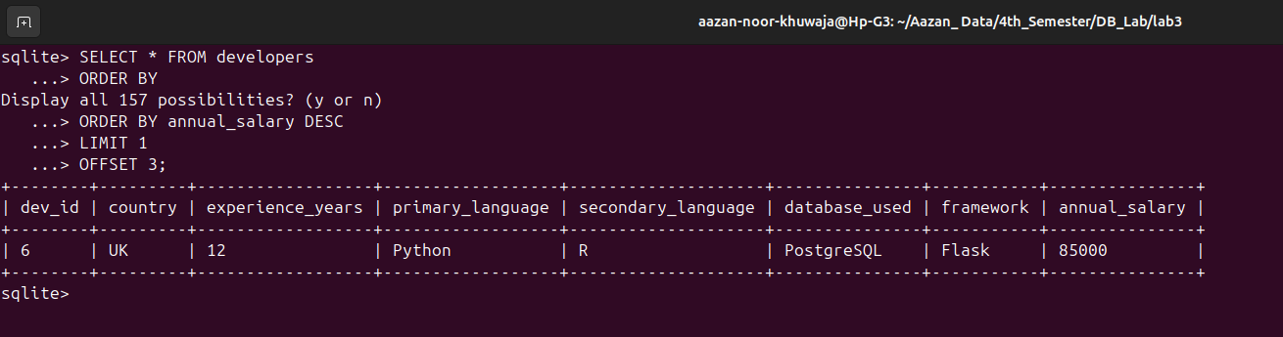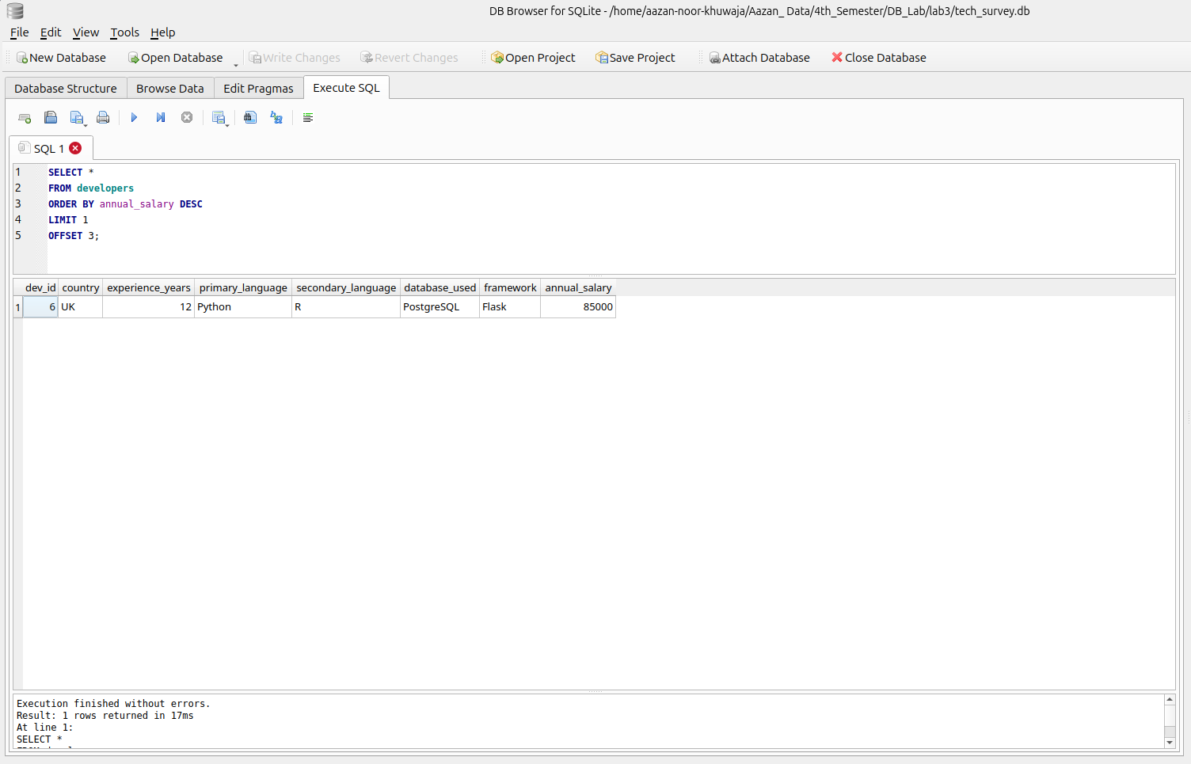

16. Show developers who use both primary and secondary languages.
Command:
SELECT *
FROM developers
WHERE primary_language IS NOT NULL AND secondary_language IS NOT NULL;
Output:
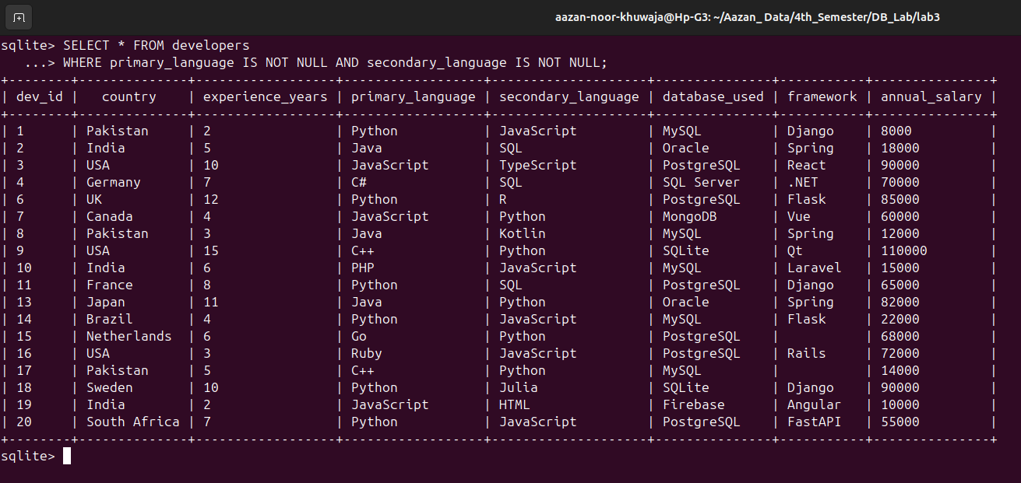
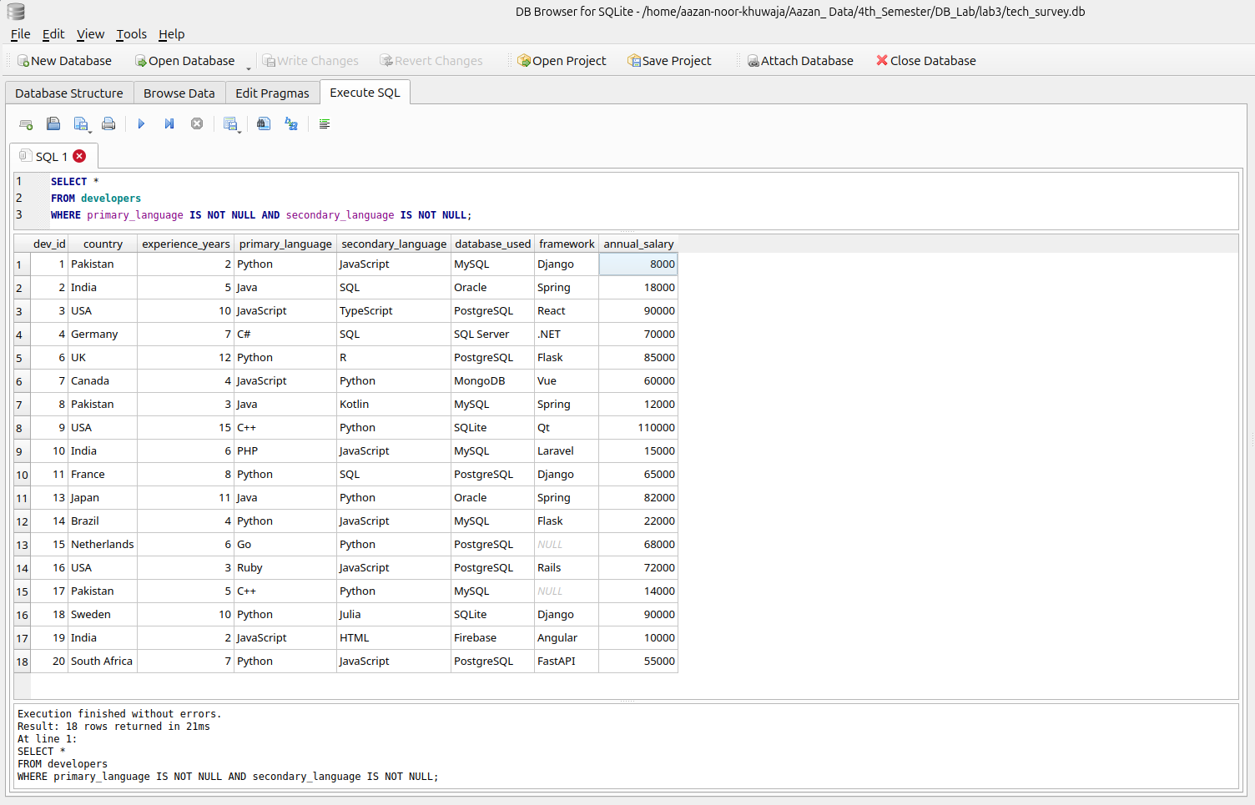

17. Show developers where salary information is not provided.
Command:
SELECT *
FROM developers
WHERE annual_salary IS NULL;
Output:
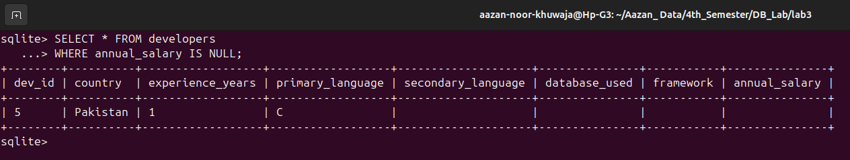
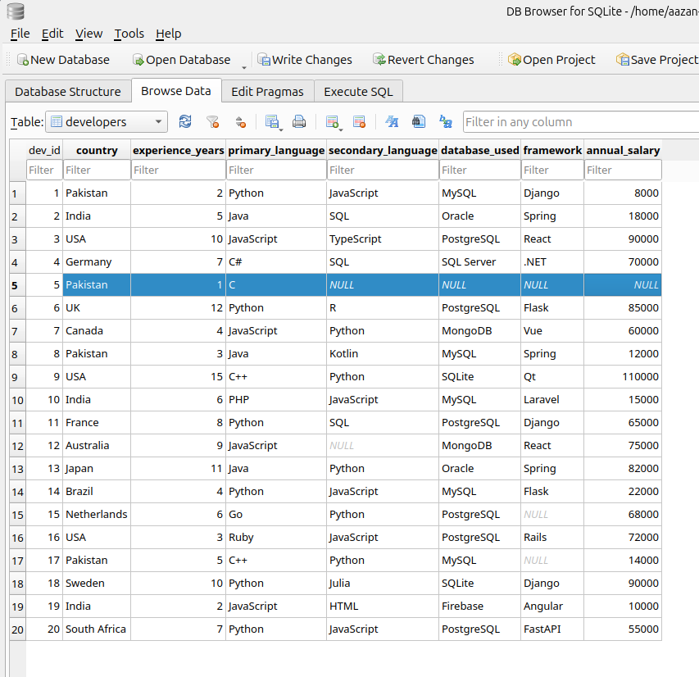
Figure 1 There was no null in annual salary so for that i added one with null to show some output .
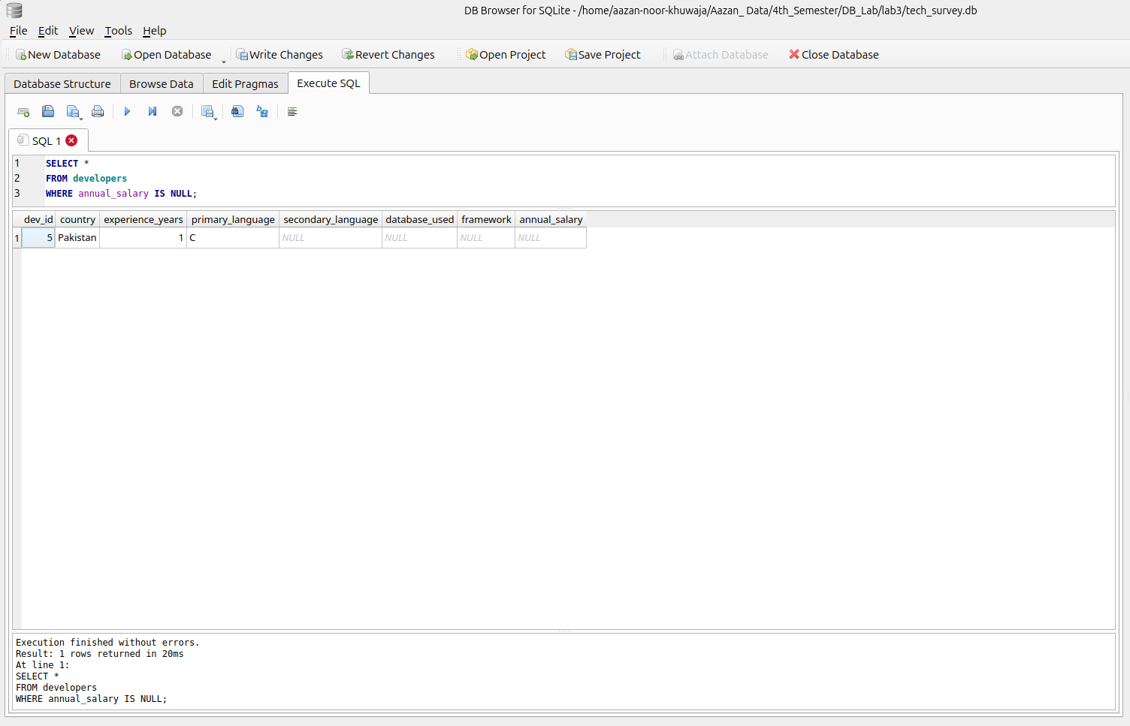
18. For each country (ordered alphabetically), rank developers from highest to lowest salary.
Command:
SELECT *
FROM developers
ORDER BY country ASC,
annual_salary DESC;
Output:
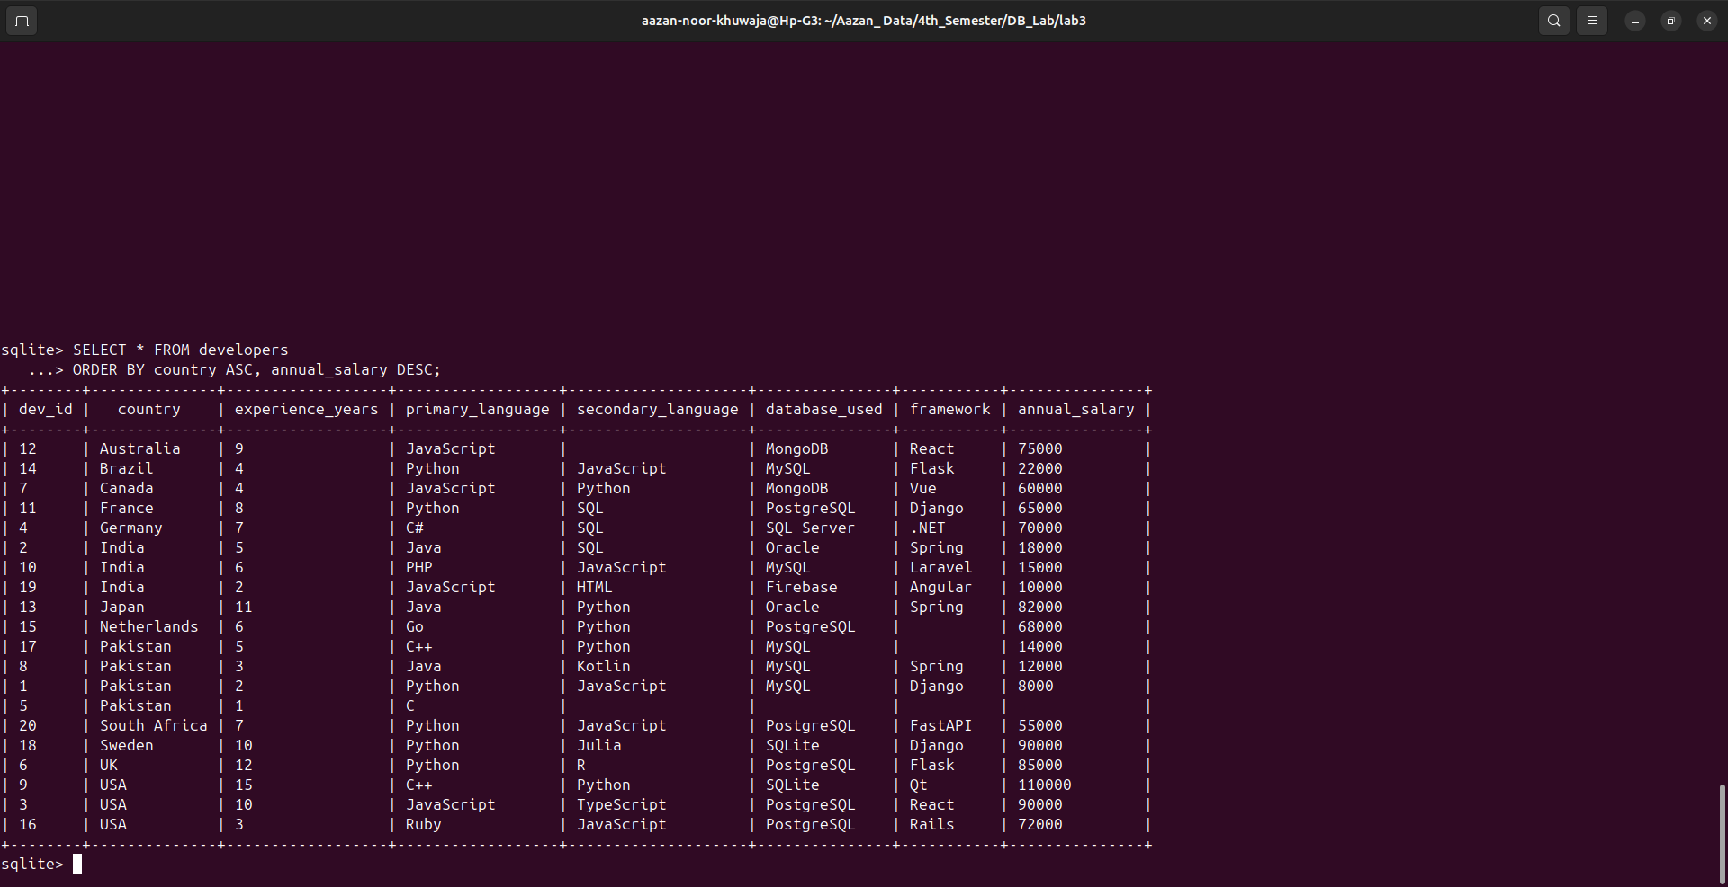
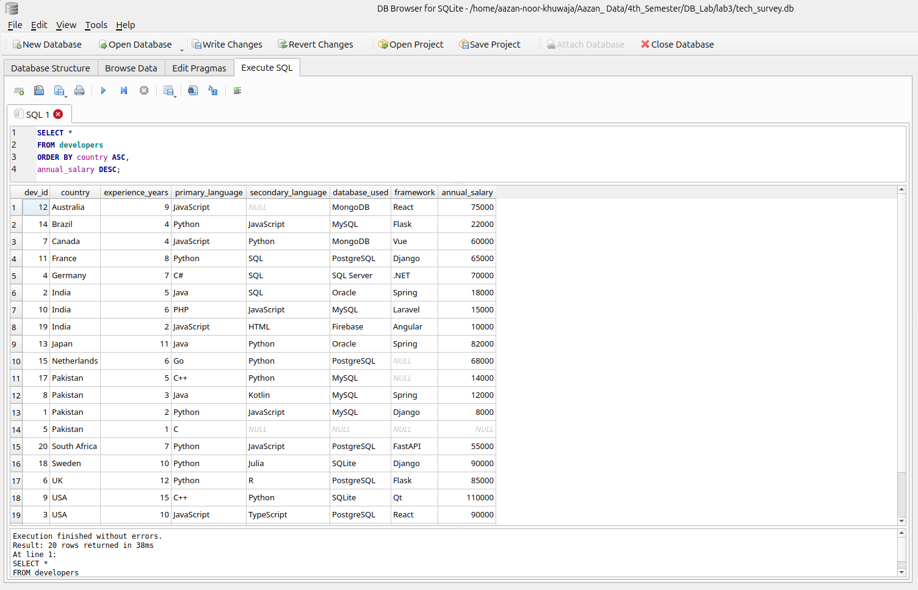

19. Display the total number of unique primary programming languages used by all developers.
Command:
SELECT COUNT(DISTINCT primary_language)
FROM developers;
Output:
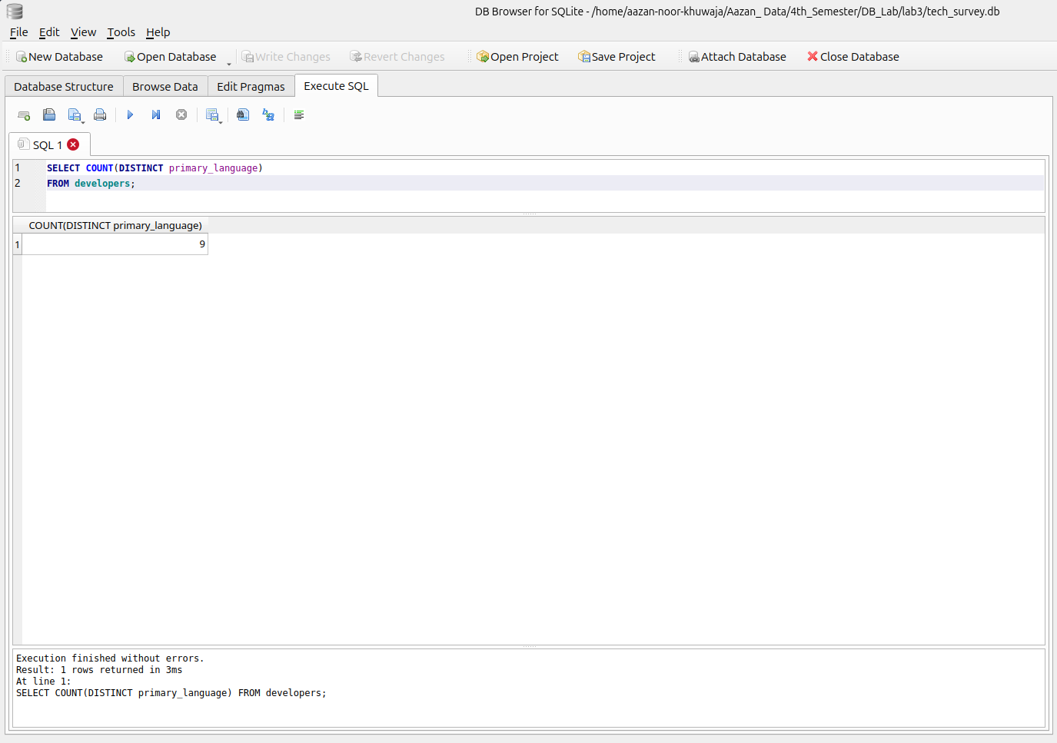
20. Display developers ranked 6th to 10th by salary, where rank 1 corresponds to the highest
salary overall.
Command:
SELECT *
FROM developers
ORDER BY annual_salary DESC
LIMIT 5
OFFSET 5;
Output:
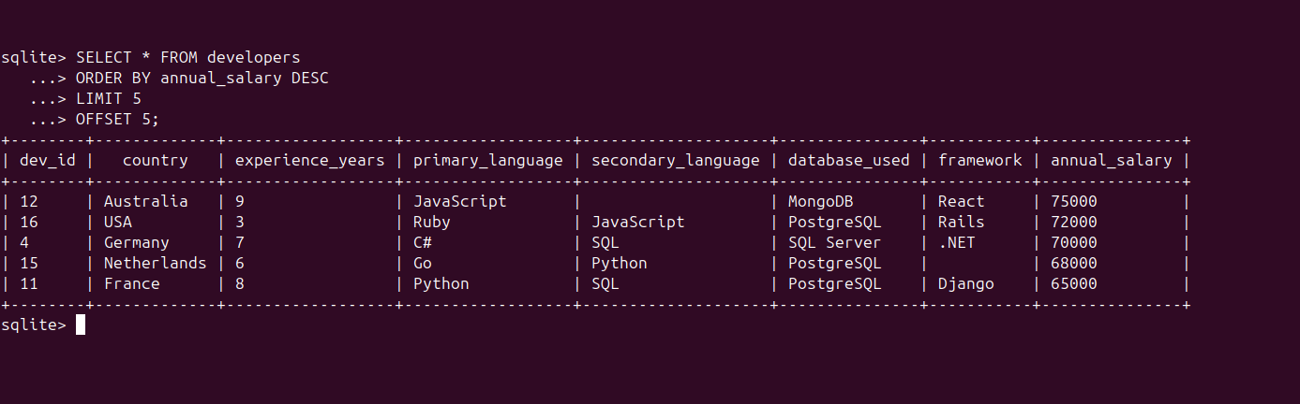
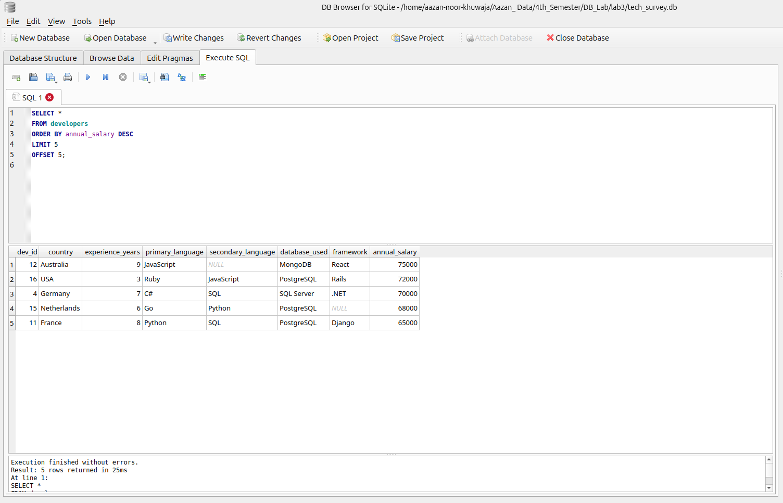
21. Display the average annual salary of developers whose primary programming language is Java and whose database is Oracle.
Command:
SELECT AVG(annual_salary)
FROM developers
WHERE primary_language='Java' AND database_used= 'Oracle';
Output:
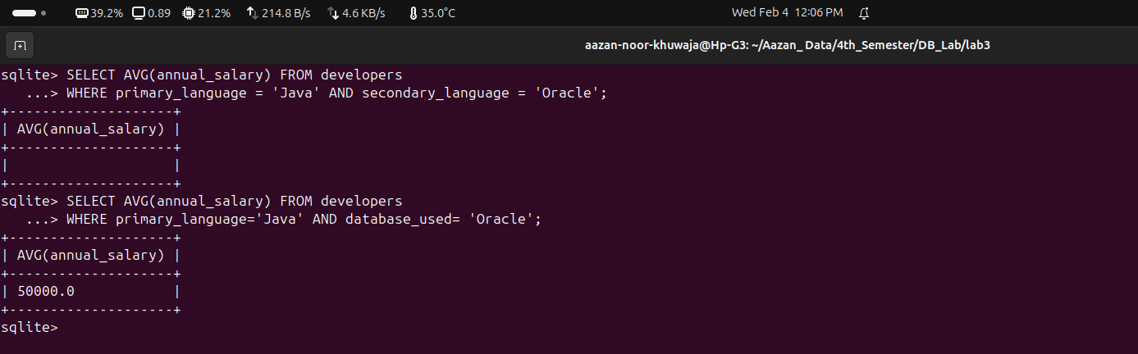
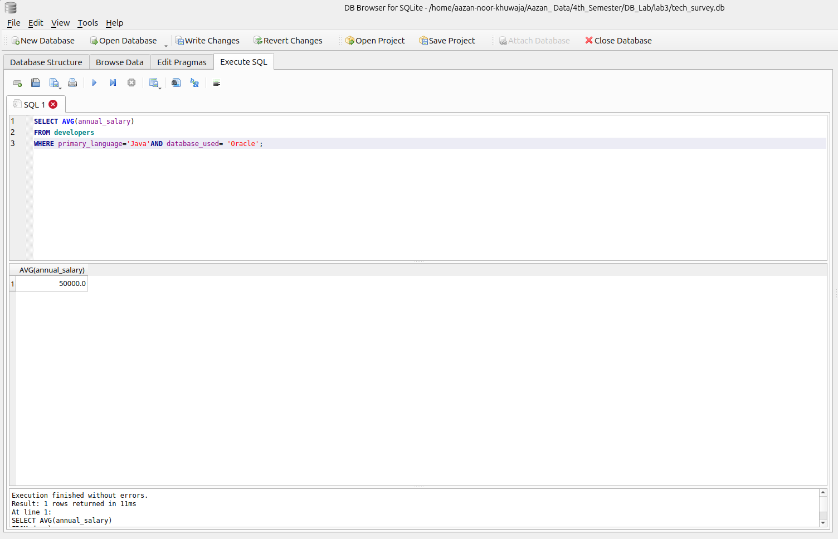

22. Display a new calculated column named bonus, where the bonus is computed for each developer as : bonus = annual_salary + (1000 × experience_years).
Command:
SELECT *,annual_salary+(1000*experience_years) AS bonus
FROM developers;
Output:
