DB-LabTask-4

Roll No: 24P-0706 | Dept: BS-CS
Name: Aazan Noor Khuwaja | Section: 4B

- Using a CASE expression, create a new column in the result set that categorizes each game
based on its rating as:
a. Excellent (rating ≥ 90)
b. Good (rating 80–89)
c. Average (rating < 80)

Query:
SELECT title, rating,
CASE
WHEN rating>=90 THEN 'Excellent'
WHEN rating BETWEEN 80 AND 89 THEN 'Good'
WHEN rating<80 THEN 'Average'
END AS BASED_ON_RATING
FROM games;

OUTPUT:
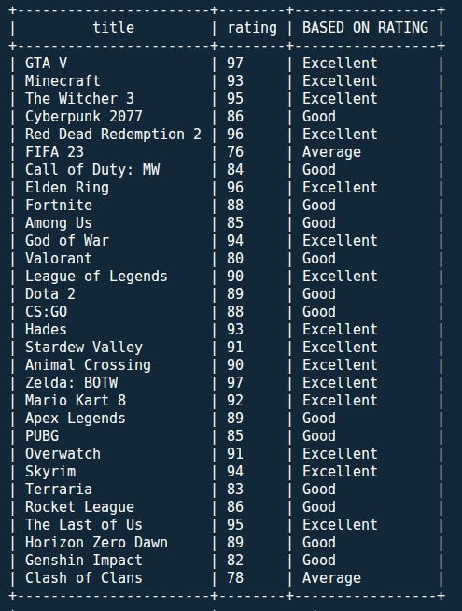

- Using a CASE expression, create a new column that labels each game based on its price as:
a. Free ($0)
b. Budget (≤ $15)
c. Premium (> $15)

Query:
SELECT title , price_usd,
CASE
WHEN price_usd=0 THEN 'Free'
WHEN price_usd<=15 THEN 'Budget'
WHEN price_usd>15 THEN 'Premium'
END AS Price_Categories
FROM games;

OUTPUT:

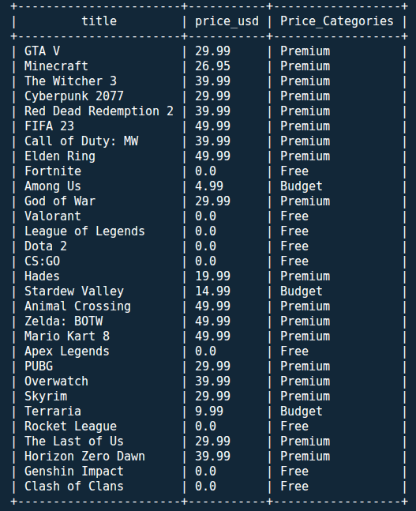

- Find how many games belong to each genre.

Query:
SELECT genre, COUNT(*) AS Total_Games
FROM games
GROUP BY genre;

OUTPUT:
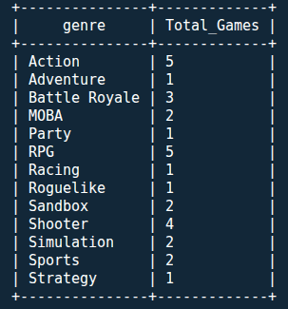

- Compute average critic rating for each platform.

Query:
SELECT platform,AVG(rating) AS AVG_Rating
FROM games
GROUP BY platform;

OUTPUT:
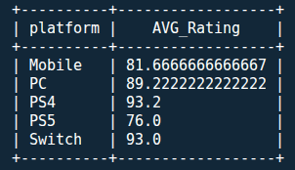

- For each genre, find the maximum global sales.

Query:
SELECT genre, MAX(global_sales_million) AS MAX_Global_Sales
FROM games
GROUP BY genre;

OUTPUT:
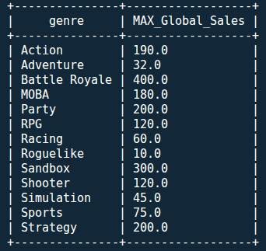

- Display the names of publishers whose average game rating is greater than 90.

Query:
SELECT publisher,AVG(rating) AS Avg_Rating
FROM games
GROUP BY publisher
HAVING Avg_Rating>90;

OUTPUT:
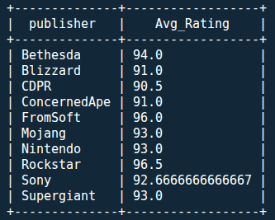

- Using a CASE expression, create a new column that categorizes games based on their global sales into:
a. Blockbuster (>100M)
b. Hit (30–100M)
c. Flop (<30M)

Query:
SELECT title,
CASE
WHEN global_sales_million>100 THEN 'Blockbuster'
WHEN global_sales_million BETWEEN 30 AND 100 THEN 'Hit'
WHEN global_sales_million<30 THEN 'Flop'
END AS Games_Based_On_Global_Sales
FROM games;

OUTPUT:
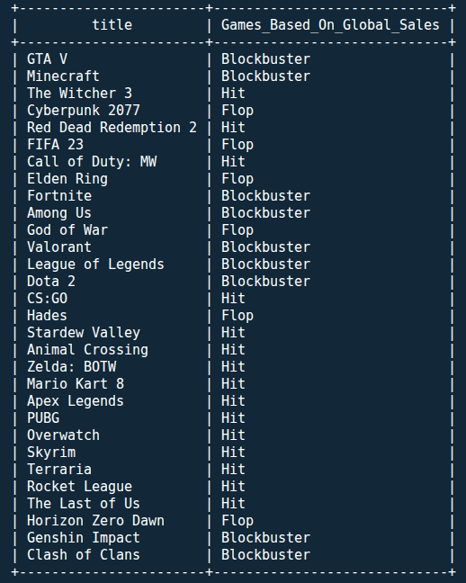

- Count how many games each platform has released since 2016.

Query:
SELECT platform,COUNT(*) AS Total_Games_By_Platform
FROM games
WHERE release_year>=2016
GROUP BY platform;

OUTPUT:
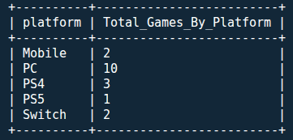

- Display the names of genres whose total global sales exceed 100 million units.

Query:
SELECT genre,sum(global_sales_million) AS Total_Global_Sales
FROM games
GROUP BY genre
HAVING Total_Global_Sales>100;

OUTPUT:
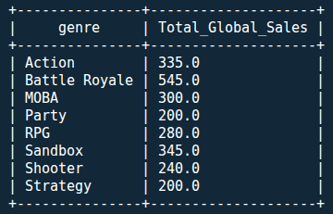

- Display the average rating of both free and paid games.

Query:
SELECT AVG(rating) AS Avg_Rating,
CASE
WHEN price_usd=0 THEN 'Free'
ELSE 'Paid'
END AS Price_Category
FROM games
GROUP BY Price_Category;

OUTPUT:
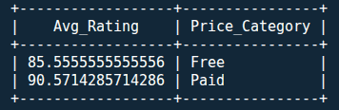

- Show publishers that have released more than 2 games.

Query:
SELECT publisher,COUNT(*) AS TOTAL_GAM
FROM games
GROUP BY publisher
HAVING TOTAL_GAM>2;

OUTPUT:
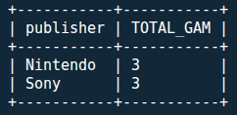

- Find average rating per platform per genre.

Query:
SELECT platform,genre,AVG(rating) AS AVG_Rating
FROM games
GROUP BY platform,genre;

OUTPUT:
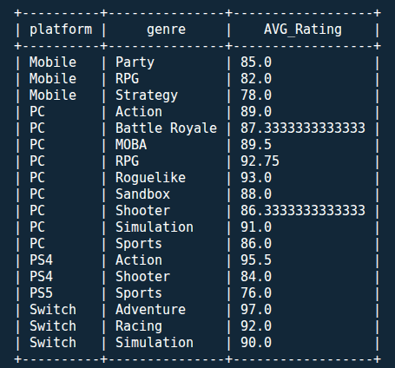

- Display the top three highest-rated games along with their titles and ratings.

Query:
SELECT title,rating
FROM games
ORDER BY rating DESC
LIMIT 3;

OUTPUT:
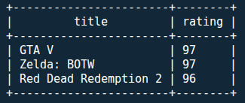

- Which platform has the lowest average global sales?

Query:
SELECT platform,AVG(global_sales_million) AS AVG_GLOBAL_SALES
FROM games
GROUP BY platform
ORDER BY AVG_GLOBAL_SALES ASC
LIMIT 1;

OUTPUT:
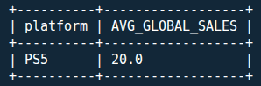

- Identify the most common platform and genre combinations.

Query:
SELECT platform,genre, COUNT(*) AS common
FROM games
GROUP BY platform,genre
ORDER BY common DESC
LIMIT 1;

OUTPUT:
