OOP-LAB Task 3

Roll No: 24P-0706 | Dept: BS-CS
Name: Aazan Noor Khuwaja | Section : 2D

Qns1:
#include<iostream>
using namespace std;

struct address{
string city;
string country;

};
struct contact_info{
string name;
long long int phone_no;
address a1;

};

void display_contacts(contact_info c1[10]){
for(int i=0;i<10;i++){
cout <<"\nContact "<<(i+1)<<":\n";
cout <<"Name: "<<c1[i].name<<endl;
cout <<"Phone NO: "<<c1[i].phone_no<<endl;
cout<< "City Name: "<<c1[i].a1.city<<endl;
cout<<"Country Name: "<<c1[i].a1.country<<endl;
}
}

int main(){

contact_info contacts[10];
for(int i=0;i<10;i++){
cout <<"\nEnter details for contact "<<(i+1)<<":\n";
cout <<"Enter your name: "<<endl;
cin>>contacts[i].name;
cout <<"Enter your Phone Number: "<<endl;
cin>>contacts[i].phone_no;
cout<< "Enter Your City Name: "<<endl;
cin>>contacts[i].a1.city;
cout<<"Enetr your Country Name: "<<endl;
cin>>contacts[i].a1.country;
}
display_contacts(contacts);
return 0;
}

Output: 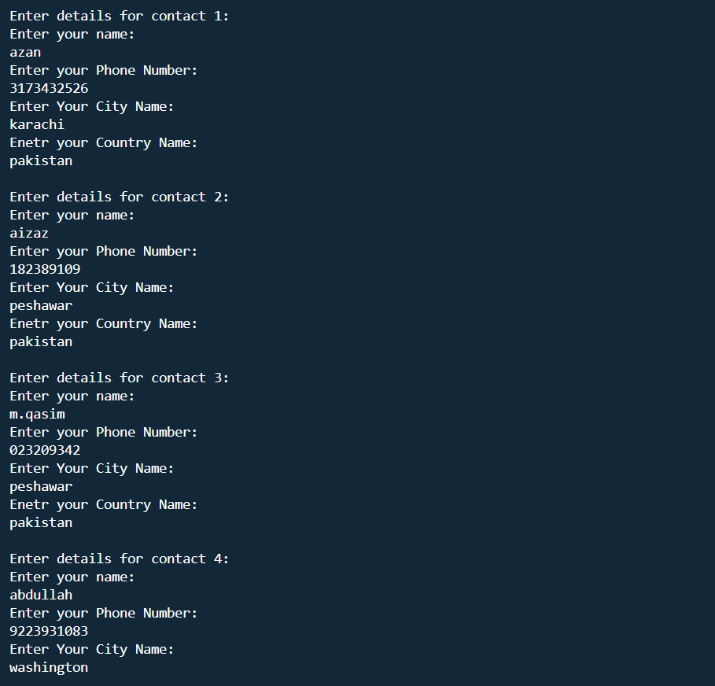
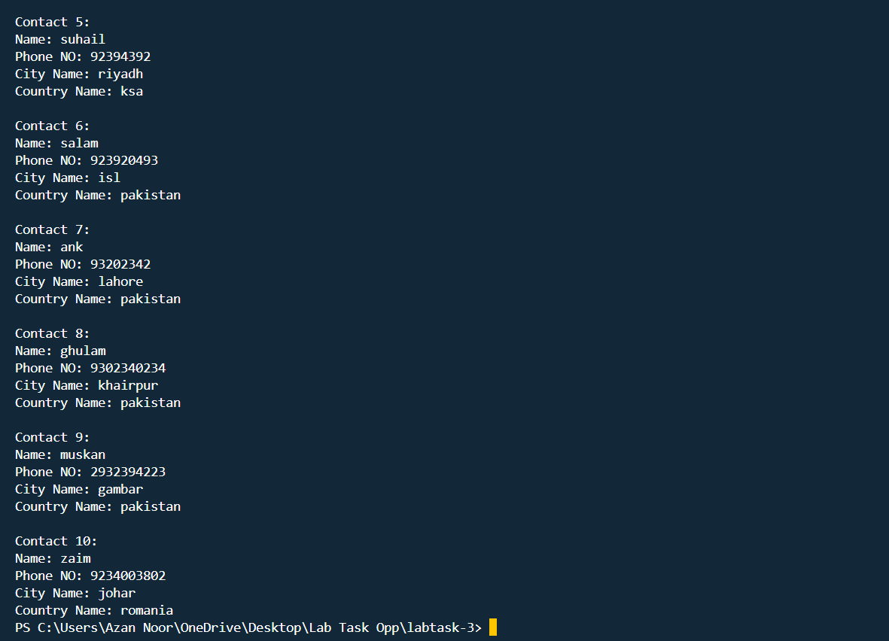

Qns 2:
#include <iostream>
using namespace std;
struct address{
string city;
string state;
int pincode;
};
struct student{
string name;
int roll_no;
int marks[5];
address a1;
};

student s_1 = {"Aazan Noor",706,{90,80,70,60,50},{"Karachi","Sindh",12345}};
student s_2;

int main(){
s_2 = s_1;
cout <<"------------------------------------------------"<<endl;
cout<<"Student-1:\n";
cout<<"Name: "<<s_1.name<<endl;
cout<<"Roll NO: "<<s_1.roll_no<<endl;
cout<<"Marks: ";
for(int i=0;i<5;i++){
cout<<s_1.marks[i]<<" ";
}
cout<<endl;
cout<<"City Name: "<<s_1.a1.city<<endl;
cout<<"State Name: "<<s_1.a1.state<<endl;
cout<<"Pincode: "<<s_1.a1.pincode<<endl;
cout <<"----------------------------------------------"<<endl;
cout<<"Student-2:\n";
cout<<"Name: "<<s_2.name<<endl;
cout<<"Roll NO: "<<s_2.roll_no<<endl;
cout<<"Marks: ";
for(int i=0;i<5;i++){
cout<<s_2.marks[i]<<" ";
}
cout<<endl;
cout<<"City Name: "<<s_2.a1.city<<endl;
cout<<"State Name: "<<s_2.a1.state<<endl;
cout<<"Pincode: "<<s_2.a1.pincode<<endl;
cout <<"----------------------------------------------"<<endl;
cout <<"Modify student-2 marks: "<<endl;
cout<<"Enter marks :"<<endl;
for(int i=0;i<5;i++){
cin>>s_2.marks[i];
}
s_1=s_2;
cout <<"----------------------------------------------"<<endl;
cout<<"student-1 details after modifying: "<<endl;
cout<<"Name: "<<s_1.name<<endl;
cout<<"Roll NO: "<<s_1.roll_no<<endl;
cout<<"Marks: ";
for(int i=0;i<5;i++){
cout<<s_1.marks[i]<<" ";
}
cout <<endl;
cout<<"City Name: "<<s_1.a1.city<<endl;
cout<<"State Name: "<<s_1.a1.state<<endl;
cout<<"Pincode: "<<s_1.a1.pincode<<endl;
return 0;

}

Output:
