OS-Lab-1

Roll No: 24P-0706 | Dept: BS-CS
Name: Aazan Noor Khuwaja | Section: 4B

UBUNTU INSTALLATION:
Ubuntu in a dual-boot setup alongside Windows.
Step 1: Prepare for Installation
1. Backup Your Data
- Important: As I have already both Windows and Arch in Dual, I created a backup for both on my cloud then first erased my arch Linux from disk now going for UBUNTU installation.
2. Create Free Space for Ubuntu
- Booted into Windows.
- Opened Disk Management:
  - By Pressing Win + X and select Disk Management.
  - Shrinked a partition to free up space for Ubuntu by Right-click the partition, choosing Shrink Volume, and allocated space almost 87Gb.
  - Leave the space as unallocated.
3. Download Ubuntu
- Then I Downloaded Ubuntu From Ubuntu's website and downloaded the ISO file.

4. Create a Bootable USB Drive
- Used a tool like Rufus (Windows) for this:
  - Insert a USB drive (at least 8 GB).
  - Open Rufus, select the Ubuntu ISO file, and create the bootable drive.
  - And here it's your Choice What Partition method you Choose Either MBR or GPT but I Choosed GPT Because my partitioning scheme is GPT.
  - Then just started and waited!

Step 2: Disable Secure Boot (If Necessary)
- Restart your computer and enter the BIOS/UEFI setup (usually by pressing F2, F12, Del, or Esc during boot).
- Locate Secure Boot in the BIOS settings and disable it.
- Saved changes and exited.

Step 3: Boot from USB
- Inserted the bootable USB drive into PC.
- Restarted PC and enter ed into the boot menu (usually by pressing F12, F9, or a similar key).
- Selected USB drive as the boot device.

Step 4: Install Ubuntu
- Choose "Try Ubuntu":
  - From the GRUB menu, I selected Try Ubuntu to boot into the live environment.
- Start the Installer:
  - Double-click the Install Ubuntu icon on the desktop.
- Installation Setup:
  - Keyboard Layout: Here I Selected my keyboard layout and click Continue.
  - Updates and Software: Choose Normal Installation and check options to download updates and install third-party software.
- Partitioning:
  - Here Simply I choosed Install Ubuntu Alongside Windows Boot Manager. This will auto detect an unallocated space of 87gb from my Disk and will create a home and Efi partition itself and will auto arrange grub so later we don't need to worry.
- User Setup:
  - Here I Inserted username, password, and computer name.
- Install Ubuntu:
  - Reviewed changes and then clicked Install Now.

Step 5: Finalize and Boot
- At end I Removed the USB drive when process completed and restarted PC.
- Entered in GRUB menu at boot, allowing me to choose between Ubuntu and Windows.

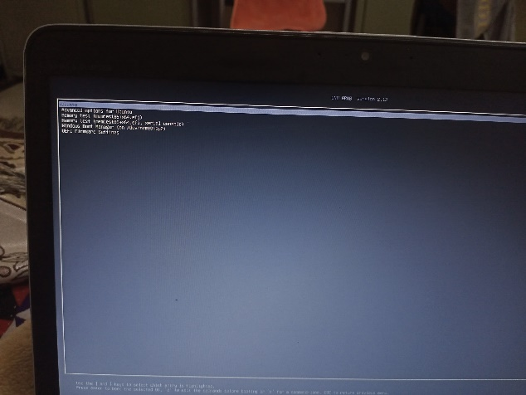
Figure 12 Dual Boot
Figure 13 Ubuntu Information
Figure 14 Terminal

