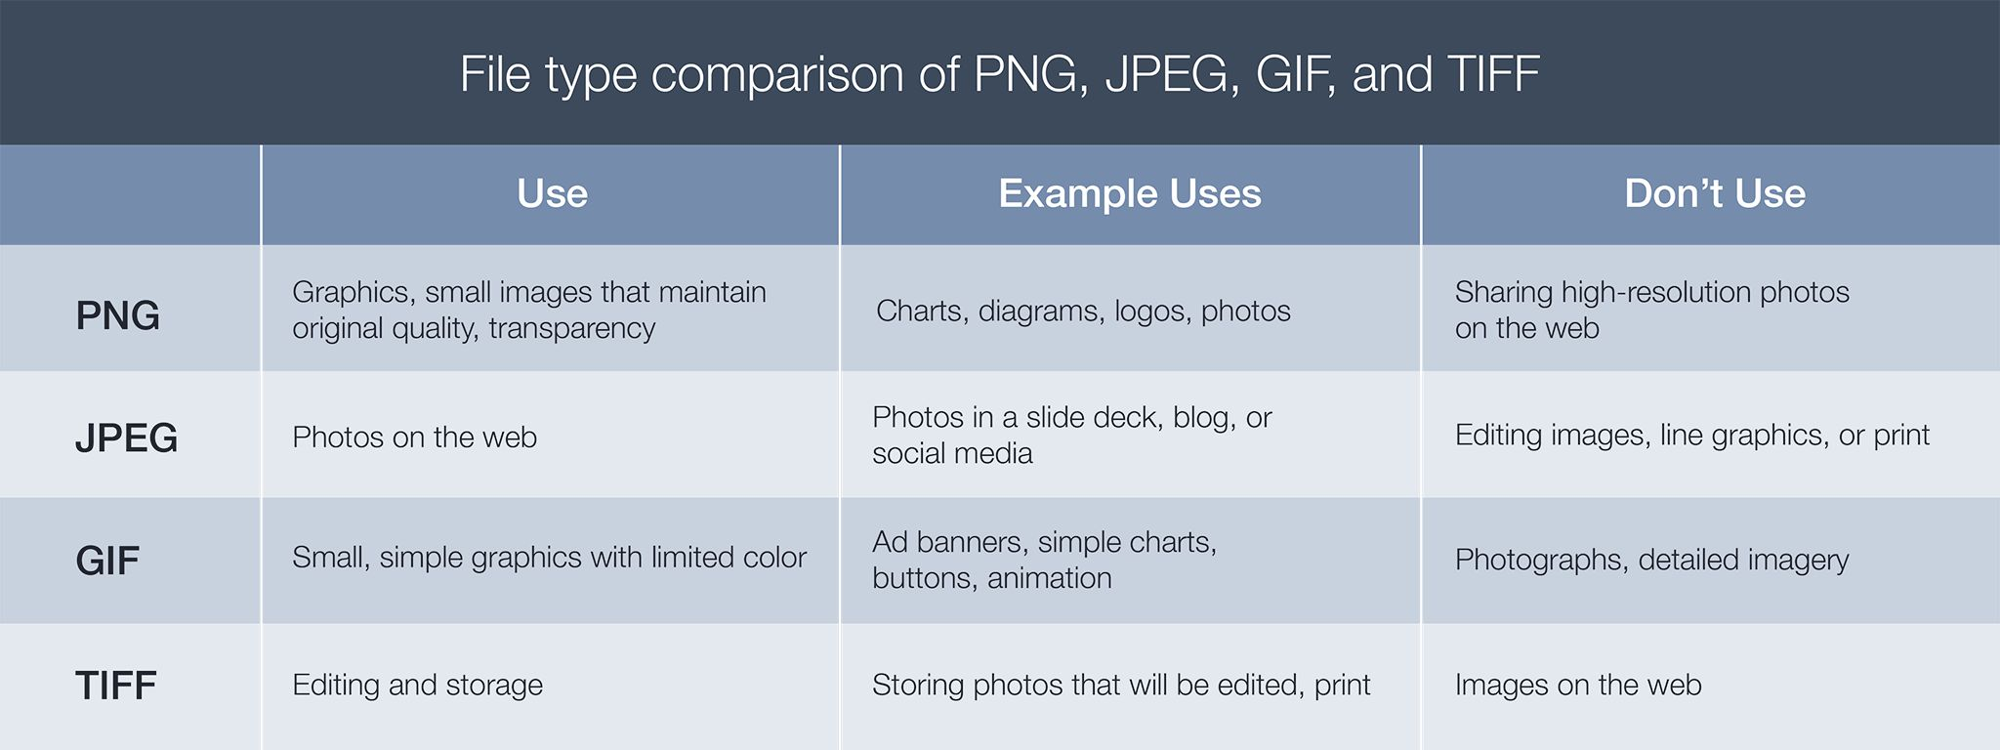

The quality of your images on social media, websites, blogs, and presentations influences the perception of your personal and corporate brand. Not all image formats are the same. Some are meant for charts and diagrams, while others are intended for eye-catching photographs. Knowing which file format to use when will keep your images looking their best.

PNG files

Choose PNG when you need a small file that maintains its original quality. PNG files support millions of colors, plus varying degrees of transparency — so they’re perfect for graphic image files, like logos, charts, and infographics.

PNGs maintain their original quality when compressed. When you need to make a PNG smaller, it will look as clear as the original file. Note that PNGs are typically larger files than JPEGs and GIFs, and the larger the file size, the longer it takes to load on the web.

PNG is similar to BMP and TGA in that it is "lossless". If you save your image as a PNG, it will look EXACTLY the same in the future. No data will be lost. Like TGA, it also supports transparency. The key difference is that it's a more modern format and is always compressed. This means it will take SUBSTANTIALLY less space than BMP or TGA under default settings.

**GOOD as a format for “working images”,**

JPEG files

**WORST as a format for “working images”, good for storing pics of your cat.**

JPEG is the go-to format for online photos. It supports a full spectrum of colors, and almost all devices and programs can open and save to the JPEG format — making it the most universal of the four. JPEG files are ideal when you want to keep file size down and don’t mind giving up a little quality to create a very small file. That said, JPEG quality drops when images are edited and saved. If you plan to continually edit your files, JPEG is not the format for the job. But if you need to display photos online, JPEGs are just right.

In addition to losing quality in compression, JPEGs don’t support transparency. So, don’t use JPEGs for line-based graphics, especially over another image or background color.

JPG is the "lossy" image storage format. Saving an image as a JPG will always lose data - even if you already have a JPG, and change only a small item - after re-saving it, you will lose more data. It works by telling the computer "I want an image that looks like this". The computer then decides what the best approximation of that image would be to the human eye, and how best to save that without taking up too much space. It then saves the approximation to disk. This means the image will ALWAYS lose data

GIF files

**NOT a format for “MOST working images”, has many “case” uses though.**

Use GIF for simple web graphics with limited colors. GIF files are the smallest of the four because they are always reduced to 256 colors, making for fast-loading visuals. That said, GIF files aren’t recommended for files with a large range of colors, like photographs or other detailed imagery. But if you’re working with small graphics, like banners, charts, and buttons, GIF is the best format for the job.

TIFF files

**BEST as a format for “working images”,**

TIFF is best for any bitmap images that you intend to edit. TIFF files don’t compress to make for smaller files, because they are meant to preserve quality. They offer options to use tags, layers, and transparency and are compatible with photo manipulation programs like Photoshop. If you’re looking for a small file or a web-friendly format, TIFF isn’t recommended. But if you plan to edit digital images in a working storage format, consider TIFF your go-to.

PNG, JPEG, GIF, and TIFF files are designed for different graphic needs. Chances are, you won’t settle on just one but will use a combination of all of these formats, depending on the task at hand.

Tagged Image File Format. This is one of the most complex image formats, and it can hold more kinds and depth of information than almost any other format. ***The standard is owned and maintained by Adobe.***

*Both TGA & TIFF support transparency, and TIFF has better metadata support and it can handle higher bitdepths. TGA or TARGA files are actually still somewhat useful in very specific cases*

TGA = TARGA. There's little reason to use this format now, ***unless you need compatibility with an app that only accepts TARGA***

DDS files

DDS is used by Unity when you need a “load” an image file, It’s a compresed format that maintains “almost all” its original quality. PNG, TGA & TIFF files supporting millions of colors, plus varying degrees of transparency, in various “DDS file types” or “DXT Containers/Headers” — so they’re perfect for graphics image files, like logos, heads, and suits, etc. to maintain the best image quality with the least “memory” or RAM use.

DDSs maintain their original quality when compressed. When you need to make a PNG, TGA & TIFF file “smaller in memory”, it will look as clear as the original file. Note that DDSs are typically larger files than PNG, TGA & TIFF files, this is NORMAL, its how DDS is handled by Unity that causes them to use less memory.

DDS is similar to PNG, TGA & TIFF file, but is typically ONLY used in applications, not day to day use. If you export, convert or save your image as a DDS, it will look “ALMOST EXACTLY” the same in the in game. No “viewable quality” will be lost. Do not edit DDS files directly unless you understand them well.

**THE MAIN USED format(s) for “Game Accessed Images”.**