CUSTOMER
Operation, Maintenance and Parts Manual
MODEL: MODEL
SERIAL NUMBER: 2X-4XXX
MMMM-YYYY

Copyright © 2025 Polypack, Inc.
All rights reserved. No part of the contents of this document may be reproduced or transmitted in any form without the written permission of Polypack, Inc.
The information contained in this document is subject to change without prior notice. Although Polypack, Inc. has attempted to ensure accuracy of the contents of this document; this document may include errors and omissions. The examples, pictures, and procedures are for illustration purposes only and may not be suited for your purpose. You should verify the applicability of any example, picture, or procedure before incorporating them into any operating or maintenance procedure. This document, including without limitation the examples, pictures, and procedures, is supplied “As-Is.”
www.polypack.com
MECHANICAL | ELETRICAL | SOFTWARE | SERVICE
DOCUMENT REVISION HISTORY
DATE | DESCRIPTION OF REVISION

CONTACT INFORMATION
MAIN HEADQUARTERS | SERVICE | PARTS
 Polypack, Inc. 3301 Gateway Centre Blvd Pinellas Park, FL 33782   (727) 578-5000   (727) 578-1300   info@polypack.com |  (727) 578-5000x221   service@polypack.com |  (727) 578-5000x245   parts@polypack.com
To request a hardcopy of this manual, please contact the Polypack Service Department.
TABLE OF CONTENTS
1.0 INTRODUCTION AND SAFETY PRECAUTIONS 5
1.1. SAFETY ALERT SYMBOLS 5
1.2. POLYPACK EQUIPMENT SPECIFIC SAFETY 5
1.3. HAZARDOUS ENERGY STATEMENT 6
1.4. LOCK OUT TAG OUT (LOTO) PROCEDURE 7
2.0 CONTROLS, GAUGES, AND INDICATORS 8
2.1. MAIN ELECTRICAL PANEL 8
2.2. MAIN ELECTRICAL DISCONNECT 9
2.3. HMI PANEL 10
2.4. PUSHBUTTON STATIONS/REMOTE HMI 11
2.5. ADDITIONAL DISCONNECTS 12
2.6. EMERGENCY STOP (E-STOP) 13
2.7. SAFETY DOOR SWITCHES 13
2.8. SAFETY DOOR SWITCHES 14
3.0 PNEUMATICS 15
3.1. MAIN PNEUMATIC SUPPLY ASSEMBLY 15
3.2. PRESSURE FILTER REGULATOR 15
3.3. PRESSURE SENSOR (Low Air Switch) 16
3.4. SLOW -START/SAFETY EXHAUST VALVE 16
3.5. LINES 16
4.0 HMI, OPERATOR INTERFACE 17
4.1. MAIN SCREEN 17
4.2. ALARM SCREEN 18
4.3. RECIPE SCREEN 19
4.4. SETUP SCREEN 20
4.5. MANUAL SCREEN 24
4.6. INPUT/OUTPUT SCREEN 24
4.7. DOORS SCREEN 25
4.8. LOGIN SCREEN 26
5.0 MACHINE SPECIFICATIONS 27
5.1. SALES DRAWING 28
5.2. TOP LEVEL MACHINE 29
5.3. SEQUENCE OF OPERATION 30
5.4. FILM-THREADING DIAGRAM 31
5.5. xXxMODULExXx 32
5.6. INFEED CONVEYOR 33
5.7. FILM CRADLE 34
5.8. FILM SPLICE 35
5.9. FLYBAR 36
5.10. FILM FEED ASSEMBLY 39
5.11. FILM FEED DEADPLATE ASSEMBLY 44
5.12. TRANSFER CONVEYOR 55
5.13. FILM WRAP ARM 56
5.14. HEAT SHRINK TUNNEL 57
5.15. TUNNEL CONVEYOR 58
5.16. DISCHARGE CONVEYOR 59
5.17. FILM CRADLE 60
5.18. FILM CRADLE 61
5.19. FILM FEED 62
5.20. FORMING HEAD 63
5.21. SEALBAR 64
5.22. TUNNEL CONVEYOR 67
5.23. TUNNEL CONVEYOR 68
5.24. HEAT SHRINK TUNNEL 69
5.25. DISCHARGE CONVEYOR 70
5.26. xXxTEMPLATExXx 71
6.0 OPERATIONAL PROCEDURE 72
6.1. STARTUP (SEAL BAR MACHINE) 72
6.2. STARTUP (WRAP-ARM MACHINE) 72
6.3. AUTOMATIC RUN 72
6.4. MANUAL/TROUBLESHOOTING 72
6.5. SHUTDOWN 72
6.6. CRASH RECOVERY 73
7.0 CHANGE OVER PARTS AND PROCEDURES, ADJUSTMENTS 74
7.1. PRODUCT LIST 74
7.2. CHANGEPARTS 74
7.3. CHANGEOVER PROCEDURE 75
7.4. CHANGEOVER PROCEDURE 76
8.0 MACHINE SETTINGS 93
8.1. VFD SETTINGS 93
8.2. PHYSICAL SETPOINTS 93
8.3. HMI SETTINGS 93
9.0 CLEANING & MAINTENANCE 94
9.1. PRECAUTIONS 94
9.2. MAINTENANCE REQUIREMENTS 94
9.3. RECOMMENDED PREVENTATIVE MAINTENANCE/LUBRICATION SCHEDULE 95
9.4. LUBRICATION MAP 102
10.0 DIAGNOSTICS & FAULTS 103
10.1. FAULTS LIST 103
11.0 TROUBLESHOOTING 104
11.1. FILM TROUBLESHOOTING 107
11.2. CARDBOARD TROUBLESHOOTING 108
12.0 MECHANICAL PARTS LIST 110
12.1. xXxMODULExXx 111
12.2. xXxMODULExXx 112
12.3. xXxMODULExXx 113
12.4. xXxMODULExXx 114
12.5. xXxMODULExXx 115
12.6. xXxMODULExXx 116
12.7. xXxMODULExXx 117
12.8. xXxMODULExXx 118
12.9. xXxMODULExXx 119
12.10. xXxMODULExXx 120
13.0 ELECTRICAL PARTS LIST 121

- INTRODUCTION AND SAFETY PRECAUTIONS

SAFETY ALERT SYMBOLS
The following safety alert symbols and signal words are used throughout this manual to alert the reader to personal safety hazards or to identify conditions that may result in damage to equipment or property. Comply with all safety information that follows the signal word.
A Note is an informational message containing an operational or maintenance procedure, condition, or statement.

 | WARNINGS Indicate that failure to follow the safety messages, recommendations, and hazard avoidance procedures provided in this document can result in personal injury, including death, or damage to equipment or property.

POLYPACK EQUIPMENT SPECIFIC SAFETY
The Polypack machine is equipped with many electrical and mechanical safety features. However, always take these precautions:
 | Anytime work is to be performed on the machine, turn the power off at the Main Disconnect. Lockout and Tag-out per safety regulations.

 | NEVER MANUALLY OPERATE ANY SOLENOID WHEN THE MACHINE IS IN AUTOMATIC. DOING SO CAN CAUSE DAMAGE TO THE MACHINE AND POSSIBLE INJURY TO THE OPERATOR.

 | NEVER DEFEAT OR BYPASS MACHINE DOOR INTERLOCKS  OR SERIOUS PERSONAL INJURY CAN RESULT.

 | The Shrink Tunnel can be extremely hot!  Keep hands clear of this assembly when the Shrink Tunnel is heating.

HAZARDOUS ENERGY STATEMENT
Workers may be exposed to hazardous energy in several forms and combinations during installation, maintenance, service, or repair work. A comprehensive hazardous energy control program should address all forms of hazardous energy [NIOSH 83-125]:
- Kinetic (mechanical) energy in the moving parts of mechanical systems.
- Potential energy stored in pressure vessels, gas tanks, hydraulic or pneumatic systems, and springs (potential energy can be released as hazardous kinetic energy). Objects that are raised and lowered may store a potential energy if paused in a raised position as it could fall unexpectedly.
- Electrical energy from generated electrical power, static sources, or electrical storage devices (such as batteries or capacitors).
- Thermal energy (high or low temperature) resulting from mechanical work, radiation, chemical reaction, or electrical resistance.
Review of the NIOSH FACE data (1982-1997) indicates that three related factors contributed to most injuries and deaths that occurred when workers performed installation, maintenance, service, or repair work near hazardous energy sources:
- Failure to completely de-energize, isolate, block, and/or dissipate the hazardous energy source.
- Failure to lockout and tagout energy control devices and isolation points after the hazardous energy source has been de-energized.
- Failure to verify that the hazardous energy source was de-energized before beginning work.
These injuries could have been prevented if comprehensive hazardous energy control procedures had been implemented and followed.

LOCK OUT TAG OUT (LOTO) PROCEDURE
This procedure outlines the steps required to safely isolate hazardous energy sources associated with the Shrink Wrapping and Packaging Equipment before any maintenance, servicing, cleaning, or repair work is performed. This procedure is in compliance with the principles of hazardous energy control, including lockout and tag out using typical lockout devices such as padlocks, hasps, circuit breaker lockouts, valve lockouts
- Follow the normal shutdown procedure. This typically involves:
  - Stopping the machine operation.
  - Allowing all moving parts (e.g., conveyors, pusher) to come to a complete stop
  - See SHUTDOWN for additional details
- Main electrical disconnect switch
  - Turn the main disconnect switch to the "OFF" position
  - Lock the main disconnect switch using an appropriate lockout device
  - See MAIN ELECTRICAL DISCONNECT for additional details
- Pneumatic shut-off valve (if present and accessible) for the machine.
  - Close the shut-off valve
  - Lock it in the closed position using an appropriate lockout device
  - See MAIN PNEUMATIC SUPPLY ASSEMBLY for additional details
- For specific conveyor motors that may have individual control switches, locate the conveyor motor disconnect switches. If work is only being performed on these components, these disconnects can be used in addition to or instead of the main disconnect, following the same lockout procedures. See ADDITIONAL DISCONNECTS for additional details if applicable
- If maintenance requires preventing movement of specific components (e.g., seal bar), consider using mechanical blocks or pins to physically restrain movement after the energy source has been isolated
- For work on or near the HOT components such as shrink tunnel or seal bar heating elements, allow sufficient time for these components to cool down to a safe temperature after the electrical power to the heating elements has been disconnected
- Once the isolation is verified, perform the necessary maintenance, servicing, cleaning, or repair work.
    - UPPER SEALBARS (SEALBAR MACHINE)
- The seal bar assembly is a heavy object. The upper seal bar contains heating elements within the seal bar assembly and can be EXTREMELY HOT, potentially causing burns if touched.
- Even if the air is dumped, the seal bar could remain in a partially raised or fully raised position due to mechanical friction or obstructions, despite the lack of pneumatic pressure actively holding it. In this scenario, the seal bar could still retain a significant amount of residual thermal energy due to its heated operation.
  - The hot surface poses a burn hazard.
  - The potential energy due to its weight is still present, meaning it could unexpectedly fall at a later time if disturbed or if the obstruction is removed, leading to a pinch point hazard in addition to the burn risk.
- The potential for the seal bar to move unexpectedly due to gravity after the pneumatic pressure is removed constitutes a risk of uncontrolled kinetic energy, and the residual heat is a direct thermal hazard.
Any maintenance, servicing, cleaning, or repair work on or near the seal bar assembly must include verifying the dissipation of residual energy, such as ensuring the seal bar has cooled down and is mechanically secured if necessary and/or in the lowered position, is crucial for preventing injuries

CONTROLS, GAUGES, AND INDICATORS

MAIN ELECTRICAL PANEL
The Main Electrical Enclosure is a water-resistant cabinet mounted on the side of the shrink tunnel. It contains the Main Disconnect, Circuit Breakers, Motor Control Overloads, Motor Starters, a DC Power Supply, Solid State Relays, a Communication Switch, Control Circuit Relays, Motor Control Drives (VFDs), a Safety Controller and PLC.
The Main Operator Panel is typically mounted on the front of the electrical enclosure.


MAIN ELECTRICAL DISCONNECT
The Main Electrical Disconnect is located on the Electrical Enclosure next to the panel door. When in the OFF (lowered) position, the Polypack Main Electrical Disconnect removes power only to all components connected to the output (bottom) of the main circuit breaker, which the disconnect is mechanically linked to. An electrical hazard still exists at the top of the main circuit breaker, unless customer is able to disconnect electrical power that supplies the Polypack main circuit breaker. An interlock system has been designed into the Electrical Enclosure so that when the door is opened, the Main Disconnect cannot be powered on. Also, the interlock prevents the enclosure doors from being opened when the machine is powered on.
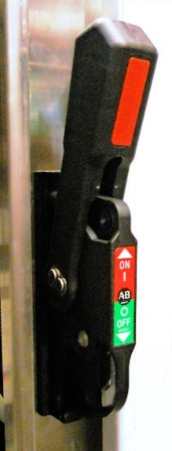

HMI PANEL
Main Emergency Stop (RED)
Master Start (GREEN)
Reset (BLUE)
Temperature Controller
Touchscreen HMI
Infeed power on
(RED pilot light)

Press the screen lightly with your fingertip to activate the desired control.
Do not use any sharp objects or any other instruments on the touchscreen face, as it will damage the surface and may void your warranty.
Do not use excessive pressure when pressing the buttons on the screen face; doing so can cause damage to the device.

PUSHBUTTON STATIONS/REMOTE HMI


ADDITIONAL DISCONNECTS


EMERGENCY STOP (E-STOP)


SAFETY DOOR SWITCHES
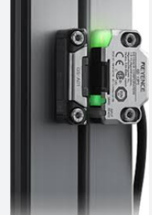
The equipment is safeguarded using GS-11PC Keyence safety switches integrated with a dedicated safety controller. All access doors are magnetically latched to prevent unintended opening during operation. Each door is linked to the safety circuit: pulling any handle initiates an immediate E-Stop condition. This configuration ensures that any unauthorized or accidental access results in a rapid shutdown.

SAFETY DOOR SWITCHES
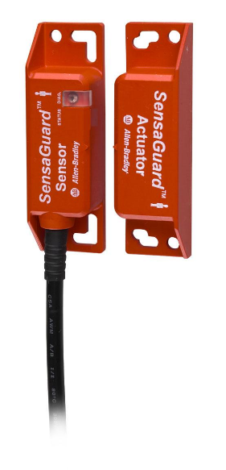
The equipment is safeguarded using 440N Rockwell Automation safety switches integrated with a dedicated safety controller. All access doors are magnetically latched to prevent unintended opening during operation. Each door is linked to the safety circuit: pulling any handle initiates an immediate E-Stop condition. This configuration ensures that any unauthorized or accidental access results in a rapid shutdown.

PNEUMATICS

MAIN PNEUMATIC SUPPLY ASSEMBLY
The Pneumatic disconnect and air supply connection is located on the left side of the pneumatic enclosure, just below the electrical enclosure. The red disconnect handle is on top of the pneumatic shut-off valve that is on the far-left valve of the pneumatic assembly. Rotate the red disconnect handle to disconnect the supplied pneumatic air to the machine. A lock and tag can be applied on the red handle when in the lockout position. The gauge on the filter/regulator, the low air pressure sensor and the gauge on the soft-start/exhaust valve will confirm machine pneumatic air is exhausted.

PRESSURE FILTER REGULATOR
The filter cleans and dries the air being supplied to the machine. The accumulated water drains automatically when a set level is reached.
The pressure regulator should be set between 70 and 75 psi. The air pressure can be adjusted by turning the knob directly above the pressure gauge. Turn the knob clockwise to increase or counterclockwise to decrease pressure. The filter/regulator should be supplied with a line capable of handling 15 CFM at 75 psi.


PRESSURE SENSOR (Low Air Switch)
The pneumatic sensor acts as an indicator display for the pneumatic air pressure supplied from the Filter/Regulator to the Slow-Start/Safety Exhaust valve. It also is set up to indicate a warning to the operator when there the air pressure is too low (low air warning is set for 70PSI). The LED display will turn red when the pressure is too low, and green when the pressure is acceptable. Refer to manufacturer instructions for detailed information about this valve.

SLOW -START/SAFETY EXHAUST VALVE
The slow-start/safety exhaust valve has two main purposes – when control system starts and valve is turned on, to slowly ramp up the pressure from 0 PSI to the set pressure of the regulator and safely exhaust the air supply the machine’s pneumatic valves when the valve is off. The ramp adjustment of pressure can be controlled by rotating the small screw located on bottom of the valve, to the right of the exhaust muffler. Refer to manufacturer instructions for detailed information about this valve.

LINES
All BLACK airlines are used for live air (return/hold at retracted/home position). All BLUE air lines are used when a solenoid valve is energized/fire to extend an air-cylinder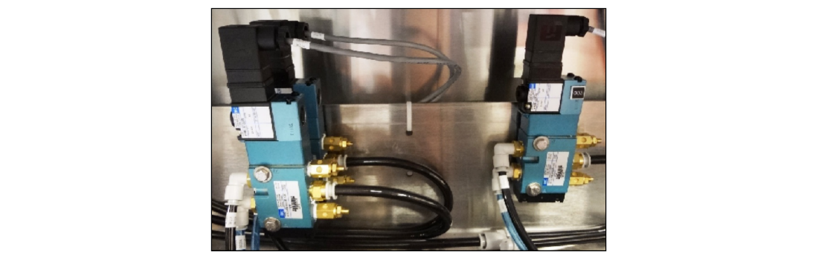

HMI, OPERATOR INTERFACE

MAIN SCREEN

OPTION | DESCRIPTION
MAIN | Displays the Main Menu Screen (Auto/Manual Controls)
ALARM | Displays the Alarm Screen where the alarm faults can be viewed and reset. The display also gives the time the fault occurred.
SETUP | Displays the Setup Menu Screen (Machine Variables)
MANUAL | Displays the Manual Function Screen where the different machine modules may be cycled manually
LOGIN | Displays the Login Menu Screen (Security Controls)
COUNT | This displays the number of bundles that have been produced since the last time the timer was cleared.
AUTOMATIC | This button is used to select the machine Automatic Mode.
MANUAL | This button is used to select the machine Manual Mode.
MANUAL SEAL | This button is used to manually cycle the seal bar to cut the film. (Used with machine in Manual Mode.)
INFEED ON/OFF | This button turns the infeed belt on or off.
FAULT RESET | This will reset all faults once the problem has been resolved that caused the fault.
MESSAGE DISPLAY | Displays current fault conditions, if present.

ALARM SCREEN

OPTION | DESCRIPTION
MESSAGE DISPLAY BOX | Displays fault messages and the time they occurred. The top half displays the current fault. The lower half displays message history. The up and down arrow keys at the right side can be used to scroll up or down the fault history.
HISTORY DISPLAY BOX | Displays the history of the alarm that occurred.

RECIPE SCREEN

OPTION | DESCRIPTION
CURRENT PRODUCT NUMBER | This displays the current selected product number.  Note: This button is static and is for display only.
OPEN PRODUCT NUMBER | This button provides two options:  Option 1: to save parameters for current product, change this number to match Actual Product Number (i.e., if Actual Product Number is 1, then Open Product Number should also be 1), then save using SAVE function.  Option 2: to open a new product number, change Open Product Number to desired number then press and hold OPEN button until it turns red, and the number displays as ”Actual.”
SAVE | When saving the current parameters, the Open Product Number must be changed to match the Actual Product Number or the values will not be saved. This button also allows the user to copy the current values to a new product number if desired. To choose this option, select the product number you want to save to, then press and hold SAVE button until it says SAVED. Once it has saved the values, the Actual Product Number will read the new number.
OPEN | First select the chosen Product Number by selecting on the Open Product Number button, then press and hold OPEN until it turns red and number changes.

SETUP SCREEN

OPTION | DESCRIPTION
PRODUCT NUMBER | This button indicates the current product to be processed. Press this button to gain access to the Actual Product Number, as well as options to save parameters and create or open new product parameters.
#2 CYCLE RATE | Sets the machine cycle rate.
#3 BUNDLE LENGTH (mm) | Specifies the length of the bundle in millimeters.
#4 BUNDLE HEIGHT (mm) | Specifies the height of the bundle in millimeters.
#5 FILM OVERLAP (mm) | Amount of film overlap in millimeters.
#6 transfer gap | Anable the transfer gap
#7 tunnel gap | Anable the tunnel gap
#8 RUN-OUT FOR XL PRODUCT = 1 | Enables run-out for extra-large products.
#9 RUN-OUT STOP POSITION | Position at which run-out stops.


OPTION | DESCRIPTION
PRODUCT NUMBER | This button indicates the current product to be processed. Press this button to gain access to the Actual Product Number, as well as options to save parameters and create or open new product parameters.
#2 CYCLE RATE | Sets the machine cycle rate.
#3 BUNDLE LENGTH (mm) | Specifies the length of the bundle in millimeters.
#4 BUNDLE HEIGHT (mm) | Specifies the height of the bundle in millimeters.
#5 FILM OVERLAP (mm) | Amount of film overlap in millimeters.
#6 transfer gap | Anable the transfer gap
#7 tunnel gap | Anable the tunnel gap
#8 RUN-OUT FOR XL PRODUCT = 1 | Enables run-out for extra-large products.
#9 RUN-OUT STOP POSITION | Position at which run-out stops.


OPTION | DESCRIPTION
PRODUCT NUMBER | This button indicates the current product to be processed. Press this button to gain access to the Actual Product Number, as well as options to save parameters and create or open new product parameters.
#2 CYCLE RATE | Sets the machine cycle rate.
#3 BUNDLE LENGTH (mm) | Specifies the length of the bundle in millimeters.
#4 BUNDLE HEIGHT (mm) | Specifies the height of the bundle in millimeters.
#5 FILM OVERLAP (mm) | Amount of film overlap in millimeters.
#6 transfer gap | Anable the transfer gap
#7 tunnel gap | Anable the tunnel gap
#8 RUN-OUT FOR XL PRODUCT = 1 | Enables run-out for extra-large products.
#9 RUN-OUT STOP POSITION | Position at which run-out stops.


OPTION | DESCRIPTION
PRODUCT NUMBER | This button indicates the current product to be processed. Press this button to gain access to the Actual Product Number, as well as options to save parameters and create or open new product parameters.
#2 CYCLE RATE | Sets the machine cycle rate.
#3 BUNDLE LENGTH (mm) | Specifies the length of the bundle in millimeters.
#4 BUNDLE HEIGHT (mm) | Specifies the height of the bundle in millimeters.
#5 FILM OVERLAP (mm) | Amount of film overlap in millimeters.
#6 transfer gap | Anable the transfer gap
#7 tunnel gap | Anable the tunnel gap
#8 RUN-OUT FOR XL PRODUCT = 1 | Enables run-out for extra-large products.
#9 RUN-OUT STOP POSITION | Position at which run-out stops.


OPTION | DESCRIPTION
PRODUCT NUMBER | This button indicates the current product to be processed. Press this button to gain access to the Actual Product Number, as well as options to save parameters and create or open new product parameters.
#2 CYCLE RATE | Sets the machine cycle rate.
#3 BUNDLE LENGTH (mm) | Specifies the length of the bundle in millimeters.
#4 BUNDLE HEIGHT (mm) | Specifies the height of the bundle in millimeters.
#5 FILM OVERLAP (mm) | Amount of film overlap in millimeters.
#6 transfer gap | Anable the transfer gap
#7 tunnel gap | Anable the tunnel gap
#8 RUN-OUT FOR XL PRODUCT = 1 | Enables run-out for extra-large products.
#9 RUN-OUT STOP POSITION | Position at which run-out stops.


OPTION | DESCRIPTION
PRODUCT NUMBER | This button indicates the current product to be processed. Press this button to gain access to the Actual Product Number, as well as options to save parameters and create or open new product parameters.
#2 CYCLE RATE | Sets the machine cycle rate.
#3 BUNDLE LENGTH (mm) | Specifies the length of the bundle in millimeters.
#4 BUNDLE HEIGHT (mm) | Specifies the height of the bundle in millimeters.
#5 FILM OVERLAP (mm) | Amount of film overlap in millimeters.
#6 transfer gap | Anable the transfer gap
#7 tunnel gap | Anable the tunnel gap
#8 RUN-OUT FOR XL PRODUCT = 1 | Enables run-out for extra-large products.
#9 RUN-OUT STOP POSITION | Position at which run-out stops.

MANUAL SCREEN


INPUT/OUTPUT SCREEN


DOORS SCREEN


LOGIN SCREEN

OPTION | DESCRIPTION
LOGGED IN | This button is a security function to protect the machine’s variable settings, when pressed a keypad will pop up and a security code will have to be entered. Once you have successfully logged in, you may proceed to the specific screens.
LOG OFF | This button is used to cut off permission of the person logged in and close off access to the machine variables so other users cannot change the machine variables.
DRY CYCLE | Turns the dry cycle function ON or OFF, allowing the machine to run without product.
RESET COUNTER | Resets the product count to zero.
ENGLISH | Press this button to display English-language HMI screens.
NOTE: AFTER THE CHANGES ARE MADE AND SAVED, LOG OFF TO PREVENT UNAUTHORIZED INDIVIDUALS FROM MAKING CHANGES.

MACHINE SPECIFICATIONS
ITEM | SPECIFICATION | COMMENT
FILM | Choose an item. Choose an item.  The roll diameter should not exceed Choose an item.” OD on a 3" core.  Up to Choose an item. MIL thickness | Film is matched to forming head (if applicable)
FILM WIDTH | This machine can run up to Choose an item.” wide Choose an item. film
FILM SHRINKAGE | POLYETHYLENE (SLEEVE “BULLSEYE”) POLYETHYLENE (TOTAL CLOSURE) POLYOLYFIN (TOTAL CLOSURE)  Parallel to the direction of product flow 50%-60% 50%-60% 50%-60%  Perpendicular to direction of flow 5%-10% 15% MIN 50%-60%
FILM SLIP | This machine uses a medium-slip film. This film should have a Coefficient of Friction (C.O.F.) between 0.25 and 0.30.
ANTISTATIC ADDITIVE | 2-3%

TOP LEVEL MACHINE


SEQUENCE OF OPERATION

All Polypack machines incorporate a “Film on Demand” supply system. This system consists of a drive motor, chain, sprockets, bearings, rollers, proximity sensor and a dancer bar assembly. The film is supported by motorized rollers with a dancer bar that moves when the roll of shrink wrap moves. From the roll the film goes around a 45° bar and is drawn in by the film feed rollers. The dancer bar after the film feed rollers triggers the film feed to run. The dancer bar is actuated by the film being pulled by the tension rollers and separation rollers that position the film under the package.

FILM-THREADING DIAGRAM


xXxMODULExXx
 | 


INFEED CONVEYOR
 | 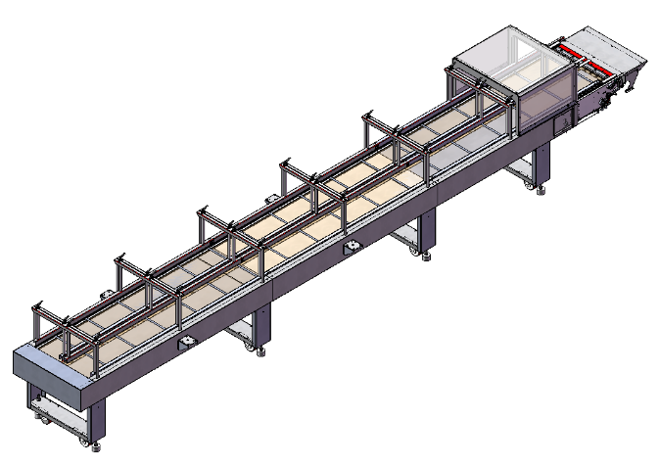
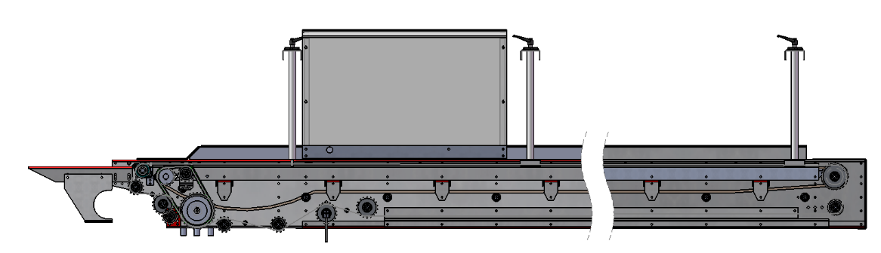
The infeed conveyor is equipped with flybars that collect and advance a full bundle’s worth of product into the machine. Products are placed on the mesh conveyor, while the flybars gather and push them forward. The system operates via the main drive motor, and the flybars cycle beneath the conveyor through a cam-timed trap-door mechanism.

FILM CRADLE
 | 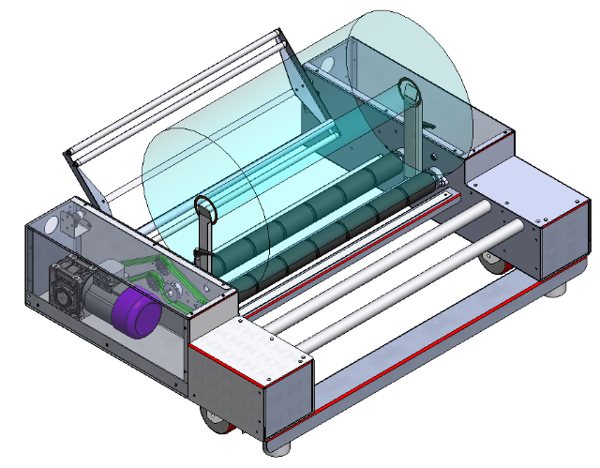
The Film Cradle holds the film roll on rollers and turns the roll to feed the Film Feed Rollers. It also facilitates splicing when the film rolls are changed. The Film Splice Unit, used to splice the beginning of a new roll of film to the end of the old one, is located above the dancer bar.
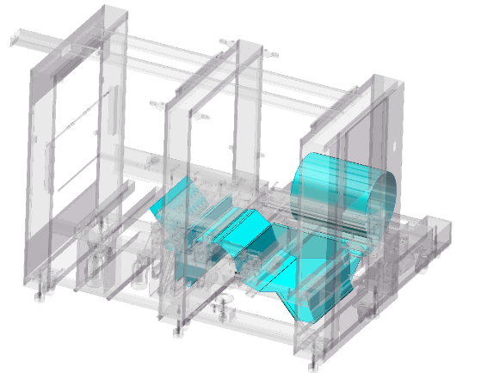 | 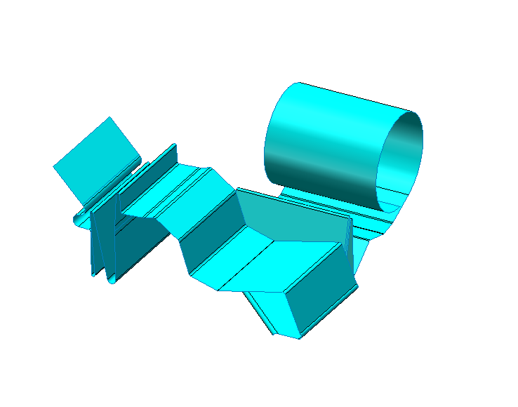

    - FILM
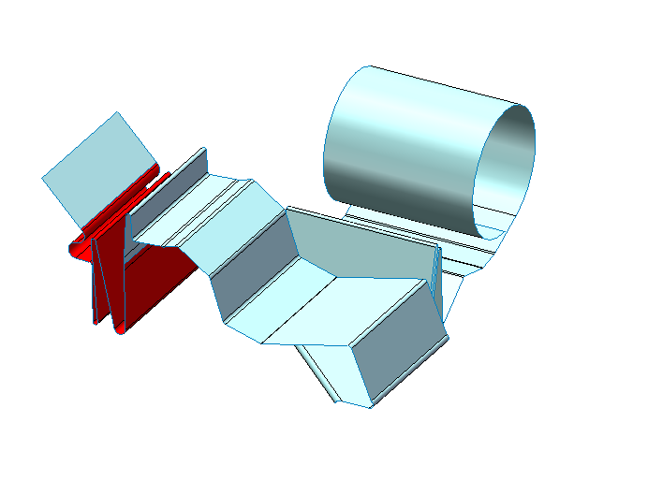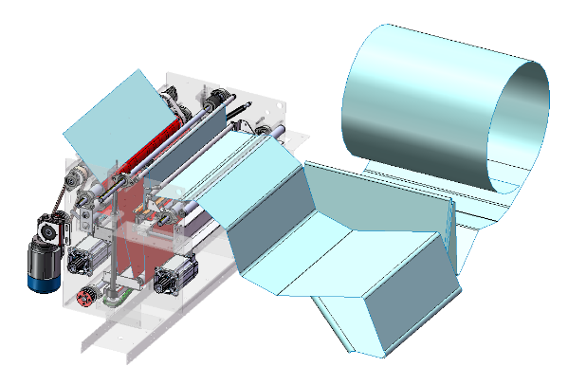


FILM SPLICE
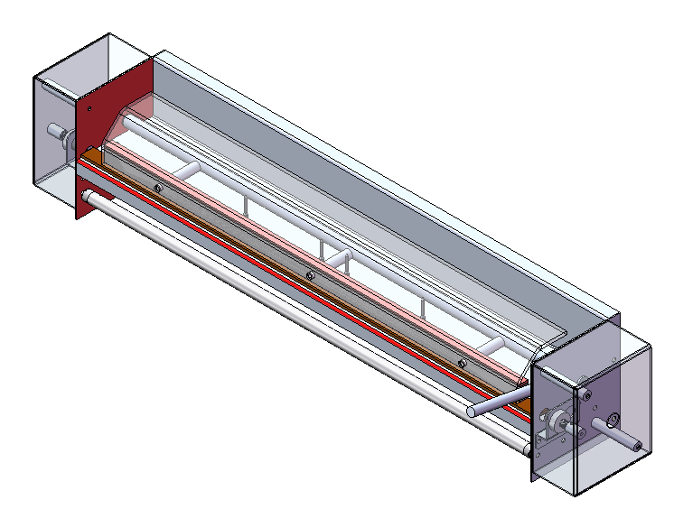
See CHANGE OVER PARTS AND PROCEDURES, ADJUSTMENTS for additional details on the usage of the FILM SPLICE


FLYBAR
 | 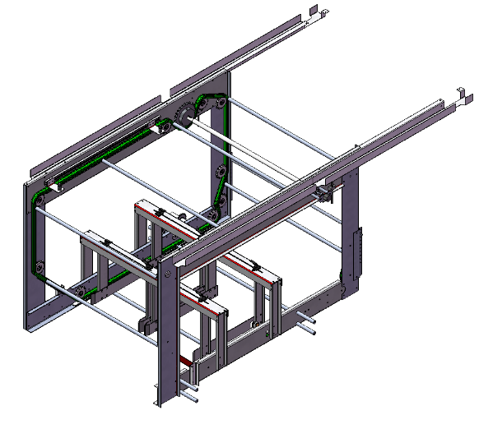
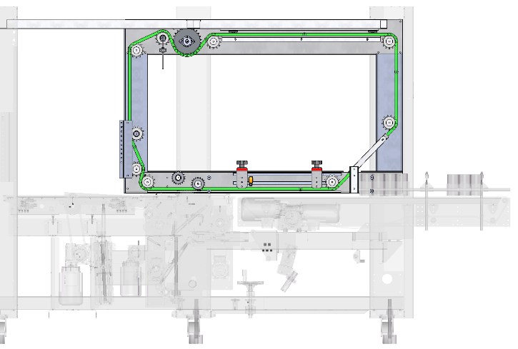  PRODUCT  FLYBAR CONVEYOR  FILM FEED  TRANSFER CONVEYOR | As the products reach the flybar area, the flybars approach the product at a 45° at a speed matching the FLYBAR CONVEYOR beneath until it reaches the horizontal section when the flybars are now traveling slightly faster. The flybars then take the product over the FILM FEED deadplate assembly until it can pass the product off onto the film that has been discharged onto the TRANSFER CONVEYOR  The flybars are synchronized via the MAIN DRIVE such that it moves in conjunction with the WRAP ARM.  There may be a spring-loaded flybar that is more-easily removable to allow for the Film-Feed deck to be opened  The Fly Bar rods push the product bundle onto the Transfer Conveyor.  Jogging the flybar will move the flybar forward a small amount

    - FLYBAR ADJUSTMENT
SPROCKET
WRAP ARM
FLYBAR POSITIONED BETWEEN SPROCKETS
When the Fly Bar is positioned as indicated (between the sprockets as shown), replace the Fly Bar motor chain to the Fly Bar Assembly (left side). Be careful not to move the Fly Bar Assembly position. Then jog the machine to verify that the Timing Belt procedure was satisfactory.
    - MAIN DRIVE
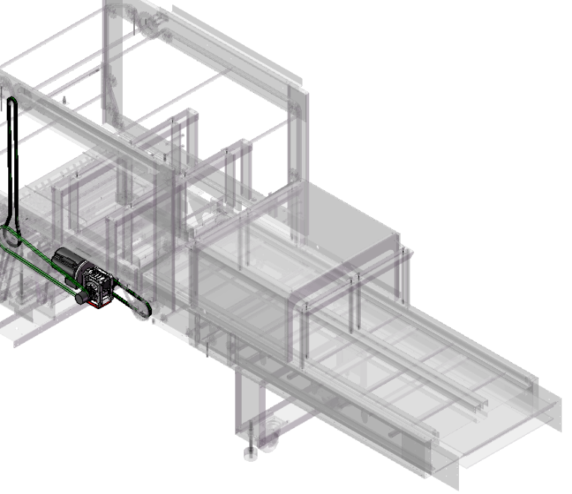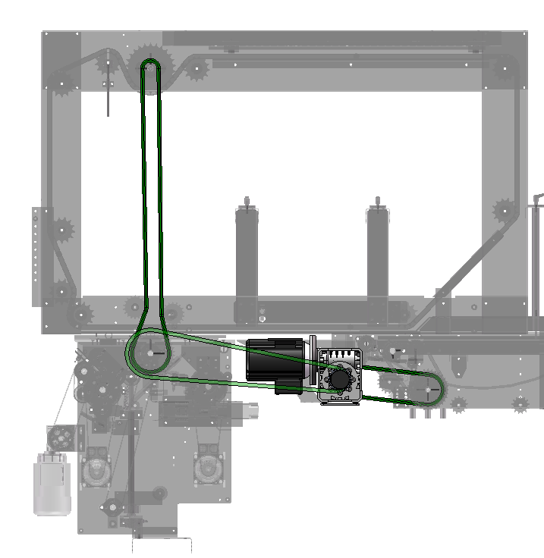

VFD
The Main Drive is a VFD-controlled motor that powers the infeed conveyor, flybar assembly, and film feed. These components are mechanically timed so their speeds remain synchronized. Power is transmitted through a gear reducer with chains connected to clutches for each assembly.

FILM FEED ASSEMBLY
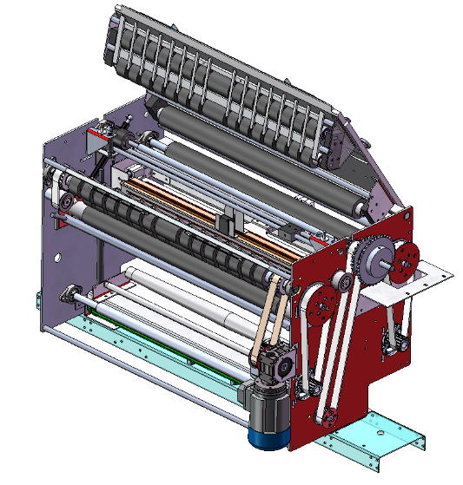
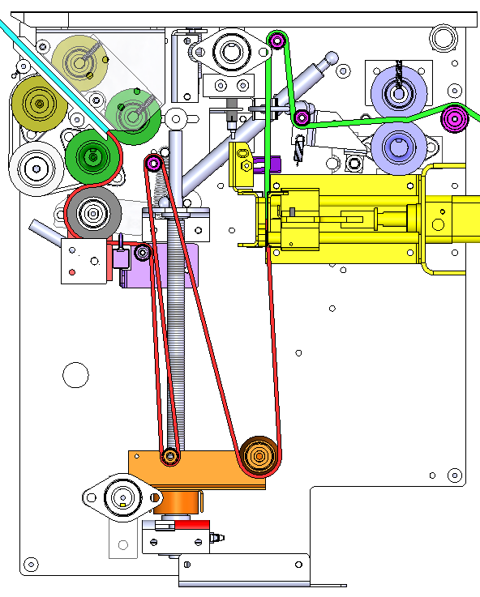
ANTISTATIC
QUEUED FILM
DRIVE ROLLERS
FILM-DISCHARGE ROLLERS
FILM-BREAK ROLLERS
TAPERED ROLLER
The FILM is pulled into the FILM FEED by the DRIVE ROLLERS and goes through the mini-dancer-bar, past the optional DUAL-LANE SPLITTER BLADE, through the PERFORATION UNIT down to the TAPERED ROLLER. The height-adjustable FILM-TAKEUP adjusts up/down to change the length of the film supplied to the bundle. The RED is the section of queued film sized for the current bundle between the BREAK ROLLER and the PERFORATION UNIT. This film should break just past the BREAK ROLLER atop the aluminum finger-guides while the FEED ROLLER discharges the section of film to the BUNDLE.
DUAL-LANE SPLITTER BLADE
PERFORATION UNIT
FILM-TAKEUP
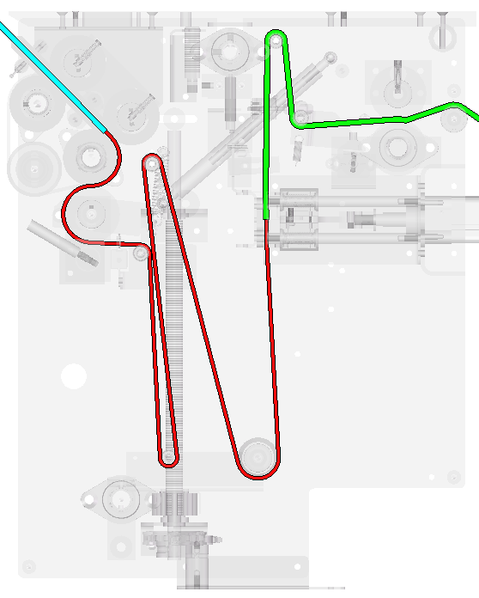  LONG REPEAT | 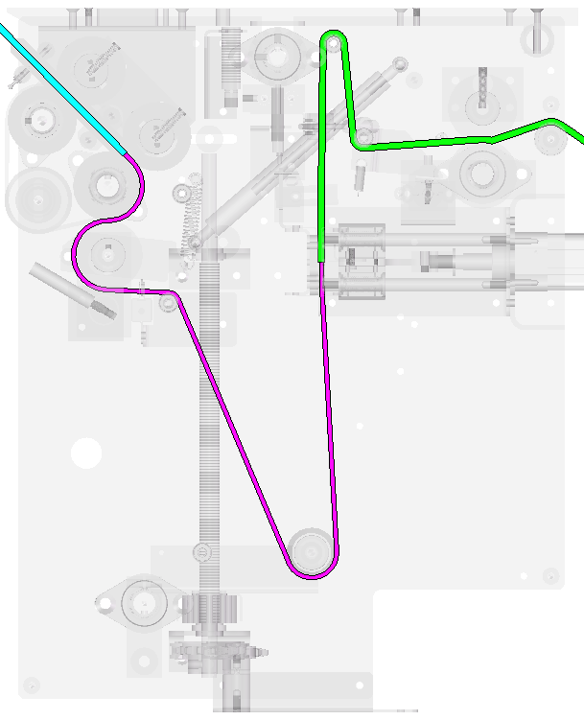  DOUBLE PERFORATION  SHORT REPEAT | 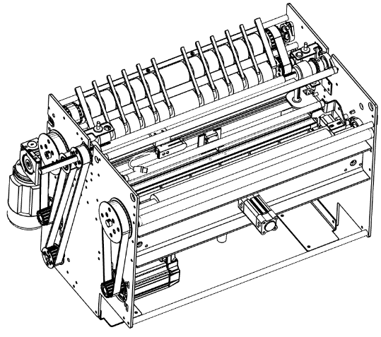  PERFORATION
The BLUE is the film currently being discharged to the BUNDLE. For shorter bundles, bypass rollers and take the PINK path shown below. Up to one additional perforation may be added exactly halfway along the RED portion of the film to achieve a “double-repeat” and create even shorter bundles.
LONG REPEAT | SHORT REPEAT
 | 262.5 MIN (Double Perf)
825 MIN | 525 MIN
1575 MAX | 1025 MAX
The Film Feed Section of the machine pulls the right amount of film either by print registration marks on the film or by a position defined in the Touchscreen. After the pull, it deposits perforations in the film where the next section will separate when it passes through the Separation Rollers. The product bundles are pushed by the Flybars across the Film Section Deadplate onto the Transfer Conveyor, where the Wrap Arm performs the film-wrapping process.

The film feeds from the film cradle to a 45-degree bar through a drive roller. There is a lever that disengages the drive roller; move the lever down to disengage the drive roller and the pinch roller to a second dancer bar after the film cradle. This dancer bar has a potentiometer arrangement like the film cradle configuration and senses the need for film. The film feed dancer bar and the film cradle dancer bar work in unison. As film is pulled into the perforation assembly, the tension on the film actuates the film feed dancer bar, then the film cradle dancer bar. Both feed film into the film feed system at the same time.
NOTE: Refer to FILM-THREADING DIAGRAM when reading the following section
Under the deadplate assembly, the film passes between the drive roller and the pinch roller of the first servo.
The film is fed underneath the servo dancer bar, over an aluminum bearing roller, down between the compression pads of the perforation assembly, down around a series of takeup rollers, down around another takeup roller, and up over another aluminum bearing roller. Move the lever down to disengage the drive roller and the pinch roller. From there the film is fed underneath and around the pinch roller for the front servo. Re-engage the drive roller and pinch roller by moving the lever up. Open the pinch roller, then feed film around the top of the drive roller, then lay it flat on the aluminum fingers of the perforation assembly. Spring-loaded pinch rollers for this idler roller and drive roller (separation rollers) are located on the underside of the deadplate and engage when the deadplate is closed.
The film break assembly runs constantly to spin the last roller of the film feed system during separation of the perforation. It turns only when machine is in Automatic Mode, or if a Manual Index & Cut Film is performed.
NOTE: Make sure both levers in the film feed path are engaged before operating the machine.
Items to consider during the Film Feed Setup:
- Film Delay: Film delay relates to timing and is calculated from the time the product is seen by the proximity sensor until the time the film begins moving through the perforation assembly. This delay setting is used to place the film underneath the product on the transfer conveyor. This function is called “film feed delay.” If this delay is increased, the leading edge of the film is placed more toward the back of the product. If the time is shortened, the leading edge of the film is more toward the front of the product.
- Slow Film Speed: Typically, the speed of the film is the same or a little slower than the transfer conveyor. If this parameter is too fast, the film will pile up under the product.
- Fast Flim Speed: If this parameter is too fast, the film could bunch up before the arm wraps the film around the product.
- Distance at Slow Film Speed: This is the distance in millimeters that the film runs in slow speed before it switches to fast speed. Moving into high speed too quickly can cause the film to pile up under the product.
- Film Repeat: Measure product circumference, add 50 mm for film overlap, then enter this reading into the touchscreen under “Film Repeat” on the Setup Screen.
  - The distance of film required should be measured starting at the point of separation (between the BREAK ROLLER and the Film Feed Roller) through the threaded rollers to the PERFORATION BLADE.

    - OPTICAL REGISTRATION
NOTE: An optical registration sensor is in the same area as the perforation assembly. This is used to align print-registered film for the repeat process.
If not using printed film, move the sensor out of the way so the sensor does not see the film. The machine dispenses the film in accordance with what is entered on the touchscreen.
If the machine is using print registered film, the machine automatically stops the film when the optical registration sensor sees the registration mark.
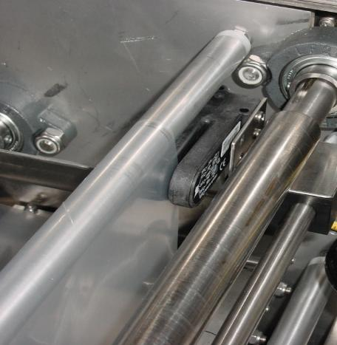  SENSOR | 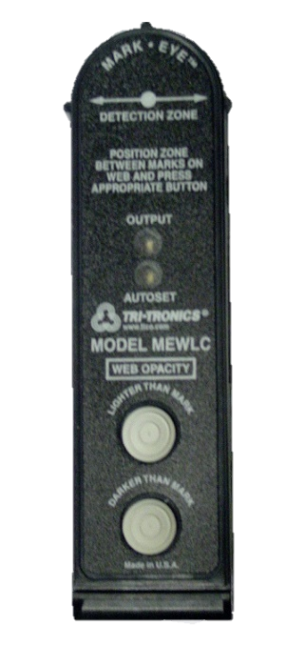  GREEN INDICATOR  RED INDICATOR

NOTE: Detection of a dark-colored mark on a light-colored background is impossible if the light source cannot penetrate through the light-colored background. If this condition occurs during a light-colored background AUTOSET routine, both the red and the green indicators flash twice.
With the film in the detection zone of the optical registration detector, press the “Darker Than Mark” button to start the AUTOSET™ routine. The green indicator blinks rapidly until the proper setting is achieved and set. The red indicator goes out. When the machine is running and the optical registration mark passes the detector, the red indicator lights for the duration of the time the registration mark is detected.

FILM FEED DEADPLATE ASSEMBLY
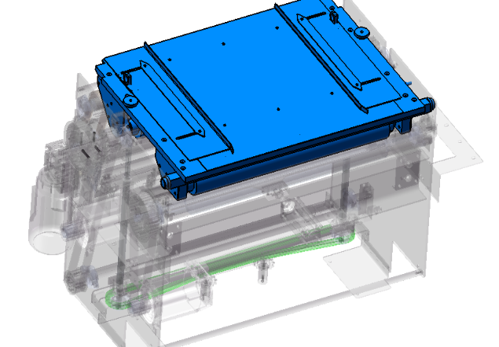  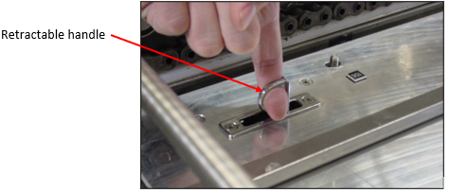 | 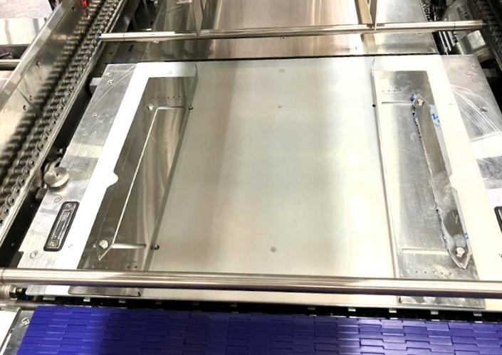  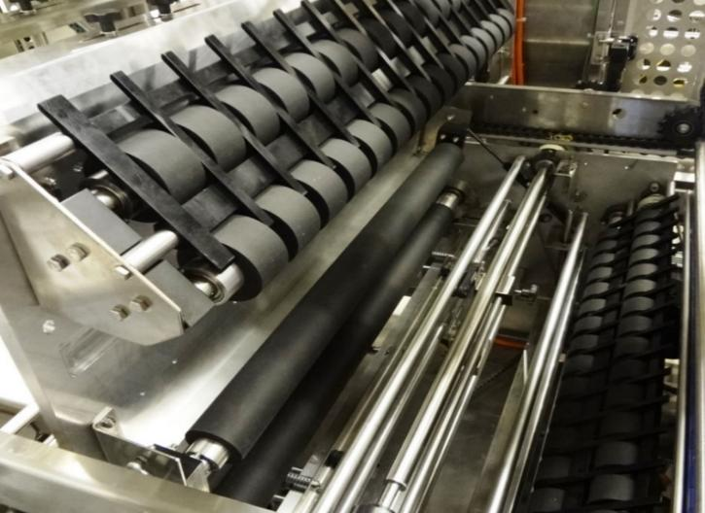
    - Lifting Deadplate Assembly
- Ensure no flybars are in the opening path of the deck
  - Utilize the JOG command to position the flybars and/or there is typically a spring-loaded flybar that may be easily removed prior to opening the deck
- Remove the two knurled knobs on the deadplate deck.
- Insert finger into one of the retractable handles and lift.
- Pull the retractable handle straight up. When fully extended, the Deadplate Assembly is held in place by retractable cylinders.
- Replace the knurled knobs.
 | The Deadplate Assembly is heavy and uses gas-filled cylinders for support when extended. These cylinders have enough motive force to fully extend the Deadplate from a partially extended position, quickly. Caution should be exercised when lifting the Deadplate.
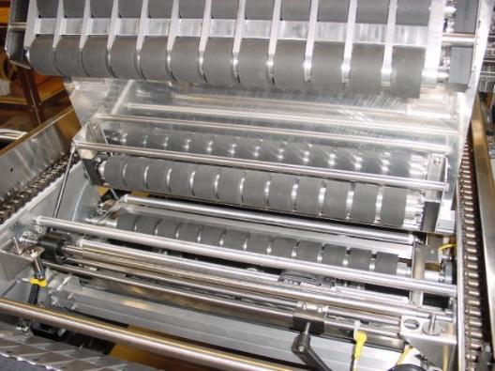 | 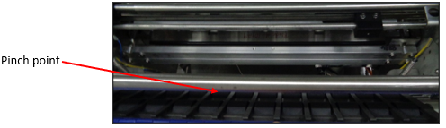

    - DRIVE CLUTCH
CLUTCH
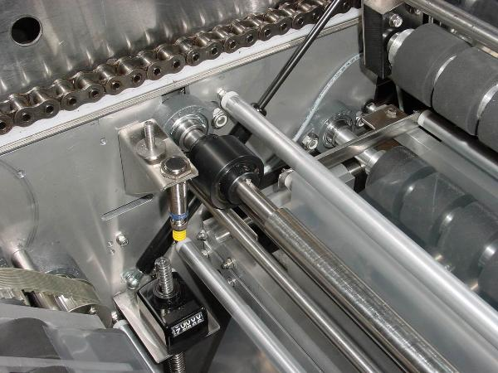
To reset the clutch:
- Move the wrap arm one revolution in either direction until the clutch engages (a resistance is felt or a click is heard).
- The clutch is open when the wrap arm rotates freely, without resistance.
NOTE: Do not grasp the wrap arm by the unsupported end. When pressure is applied, the arm may break.

    - FILM PERF

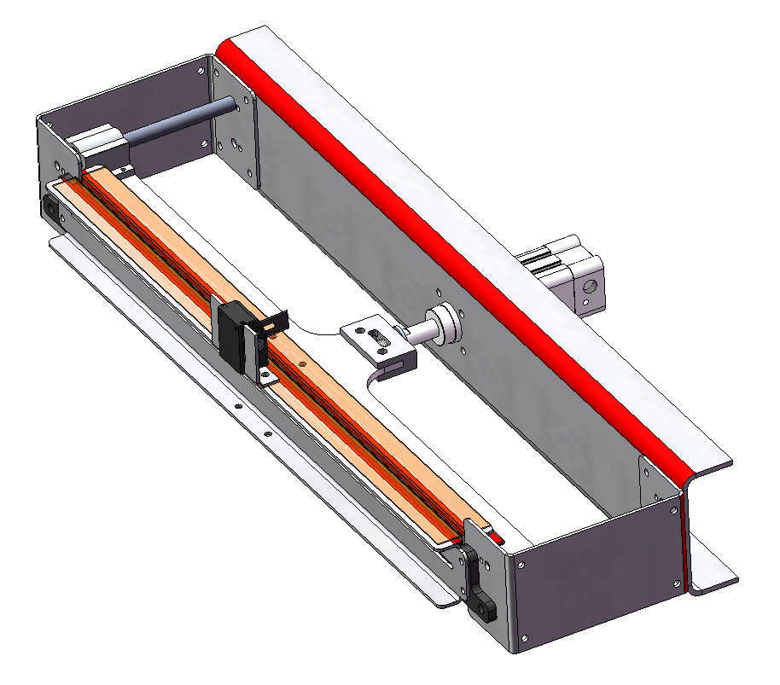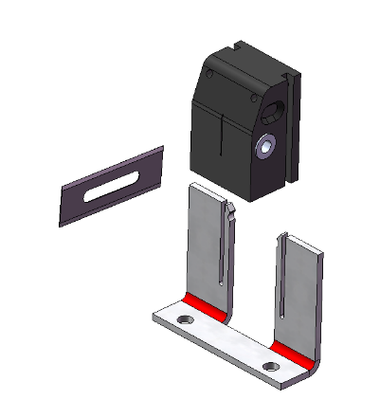

CYLINDER
The perforation unit uses a pneumatic cylinder to push a blade through the film into a silicone pad as it passes through the unit. This perforation is timed to trigger when the film has stopped moving. Both the blade and the silicone pad along with the tape that covers the pad must be replaced regularly as they wear.
Optionally on machines running dual-lane, the FILM-SPLITTER-BLADE assembly contains a razor blade that cuts the film in half. This blade may be swapped to utilize up to four edges but then must be replaced.
    - FILM TAKEUP
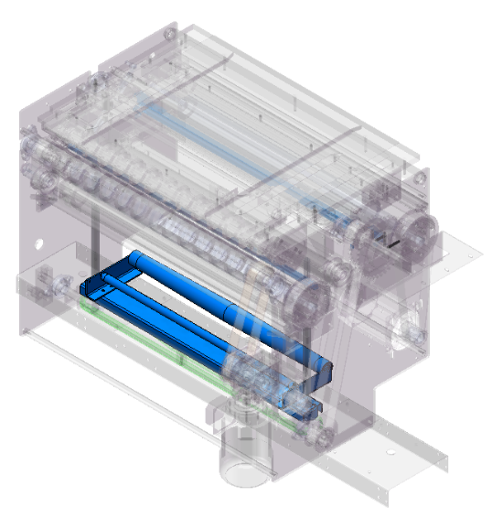
Adjust the handle to raise/lower the film takeup which will result in a different length of film being ejected at the bundle.
    - HEIGHT ADJUSTMENT
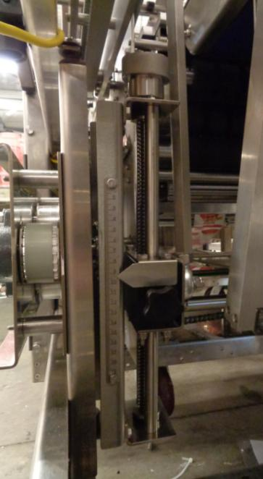
PLACEMENT POINTER/SCALE
ADJUSTMENT KNOB
- Loosen the adjustment knob on side of the adjustment arm.
- Slide pointer to move arm to appropriate height for product being run.
- Once position is confirmed, tighten knurled knob until secure.
    - MECHANICAL TIMING – MECHANICAL METHOD
CLUTCH ASSEMBLY

- All shafts are keyed to their position.
- A clutch is located on the Main Drive Shaft. This clutch opens when resistance is encountered by the Elliptical Arm.
- To reset the clutch, move the Elliptical Arm one revolution in either direction until the clutch engages (a resistance is felt or a click is heard). The clutch is open when the Elliptical Arm rotates freely, without resistance.
NOTE: Do not grasp the Elliptical Arm by the unsupported end. When pressure is applied, the arm may break.
- Jog the Fly Bar to position Transfer Shaft Cam at the 3/9 o’clock position by using the “Jog Fly Bar” control on the Touchscreen. Refer to Figure below.
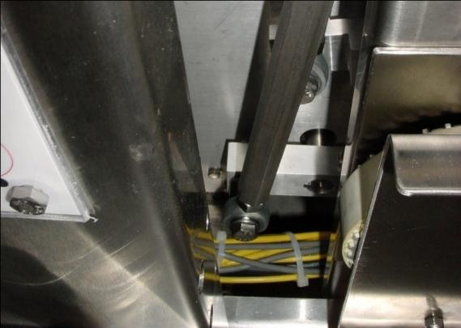
Transfer Shaft Cam at 3/9 o’clock
Transfer Shaft
NOTE: ‘Jog Fly Bar’ at the Touchscreen control will continuously nudge the Fly Bar for two or three seconds then shifts to a high speed jog.
Confirmation of Correct Timing - When the Transfer Shaft Cam is at the 3/9 o’clock position, verify that the Oscillating Arm is at the 12 o’clock position. Refer to the Figures below. If the Oscillating Arm is not vertical, indicating the machine is not timed correctly, perform the Timing Belt Adjustment procedure again.
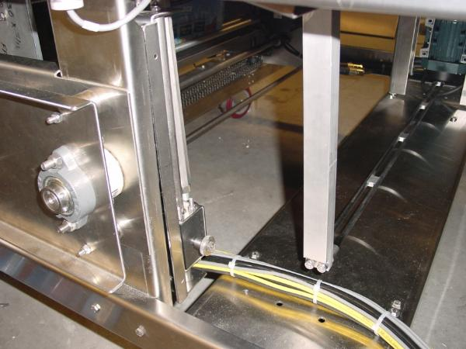
OSCILLATING ARM
Oscillating Arm in the 0° position
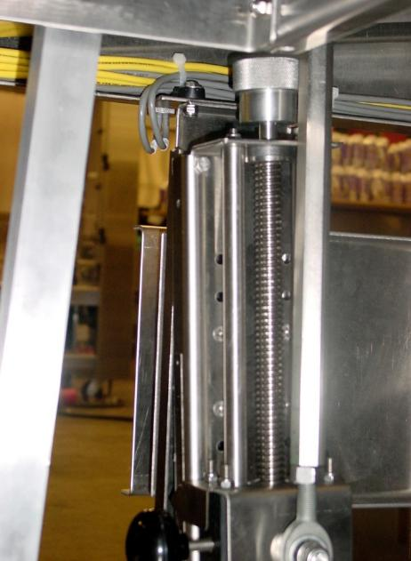
Confirm the Oscillating Arm is Vertical
OSCILLATING ARM
When the Timing has been confirmed correct, continue with the procedure. Jog the machine, using the ‘Jog Fly Bar’ control on the Touchscreen, to place the Elliptical Arm Oscillating Support at its highest position. Then measure the height of its transit, refer to the Figure below, by measuring the distance between the chassis of the machine ① and the top of the Elliptical Arm Oscillating Support ②
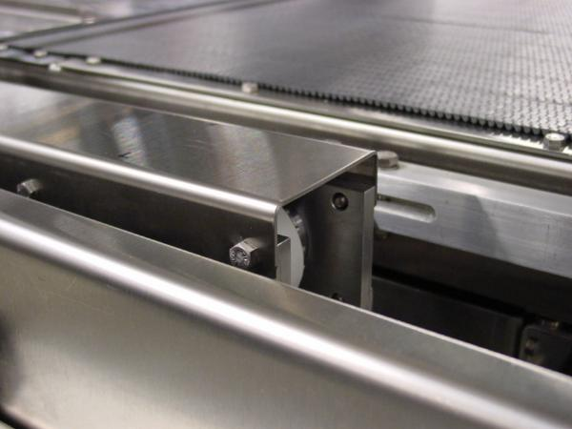
②
①
Confirm the Oscillating Arm is Vertical
ELLIPTICAL ARM OSCILLATING SUPPORT
Jog the machine using the Jog Fly Bar control on the Touchscreen to place the Elliptical Arm Oscillating Support at its highest position 180° from the last recorded position. Then measure the height of its transit (refer to the Figure above) by measuring the distance between the chassis of the machine ① and the top of the Elliptical Arm Oscillating Support ②.
NOTE: When taking this measurement notice that the Elliptical Arm Support is at 0˚ or parallel to the Transfer Conveyor.
Compare the two readings. The difference in these two readings should be less than 5 mm. If the difference is 6 mm or more, perform the Timing Belt Adjustment procedure.
NOTE: The difference between these measurements should be no more than 5 mm (difference between the 0 and the 180 positions). If the difference is more than this value, perform the Timing Belt Adjustment procedure.

    - TIMING BELT ADJUSTMENT
NOTE: When adjusting the tension on the Adjustment Pulleys, ensure that the pulleys are moved in the same direction, the same distance.
The Primary Timing Sprocket is a drive sprocket, so its movement does not change unless the drive mechanism parameters change. The Secondary Timing Sprocket is a driven sprocket so its movement is dependent on the movement of the timing belt driven by the Primary Timing Sprocket.
ELLIPTICAL ARM OSCILLATING SUPPORT
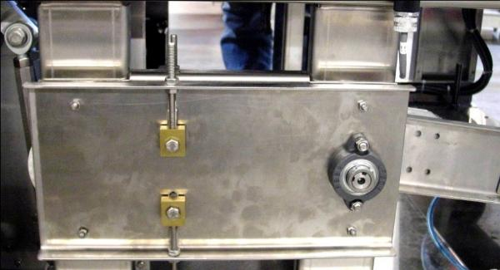
Moving the Adjustment pulleys up increases the tension on the bottom portion of the belt and decreases the tension on the top portion of the belt. This increases the angular movement of the Secondary Timing Sprocket to the right (See white arrows below). Hence the Oscillation Arm moves more to the right and below horizontal. Moving the pulleys down decreases the tension on the bottom portion of the belt and increases the tension on the top portion of the belt. This increases the angular movement of the Secondary Timing Sprocket to the left. Hence the Oscillation Arm moves more to the left above horizontal.
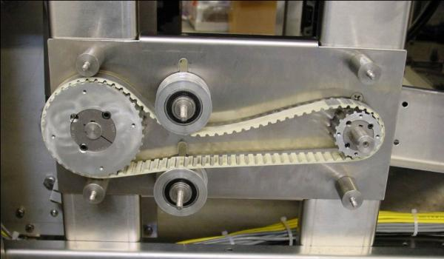
OSCILLATION ARM
TIMING BELT ADJUSTMENT PULLEYS
PRIMARY TIMING SPROCKET
SECONDARY TIMING SPROCKET
The figure above is for illustration purposes only.
NOTE: It is not necessary to remove the pulley cover for these adjustment procedures. This should only be done when the belt needs to be replaced.
If the Adjustment pulleys are at the extreme position in their respective adjustment slots and cannot be moved any further, loosen the adjustment nuts and move the pulleys to the middle of the their slots. Then slip the Timing Belt in the direction that tensions the bottom portion of the belt (CCW) for below horizontal movement, or that tensions the top portion of the belt (CW) for above horizontal movement. Tighten the Adjustment Nuts and start the timing procedure from the beginning.
When this procedure is complete, re-measure the “Timing High Point Measurement”.

TRANSFER CONVEYOR

VFD
 | 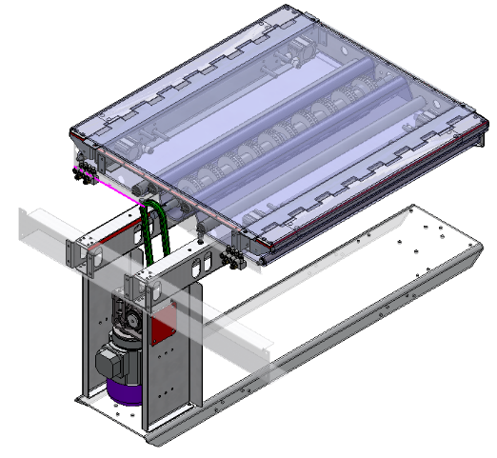
The Flybar Assembly’s Flybars push product bundles onto the Transfer Conveyor, which moves them forward, pulling the leading edge of the film from the Film Section along with it. After the Wrap Arm performs the film-wrapping process as the bundles move along the Transfer Conveyor, the film-wrapped bundles advance from the Transfer Conveyor to the Tunnel Conveyor.

FILM WRAP ARM

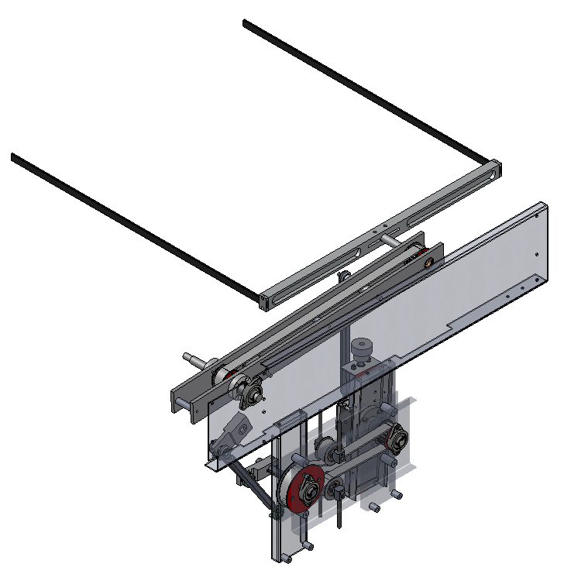
The Wrap Arm wraps film around the product bundles as they pass across the Transfer Conveyor and cuts the film between bundles. The height of the arm can be adjusted, if needed, to accommodate products of different height. After the bundles are wrapped in film, the Transfer Conveyor transports them to the Tunnel Conveyor.


HEAT TUNNEL

VFD
 | 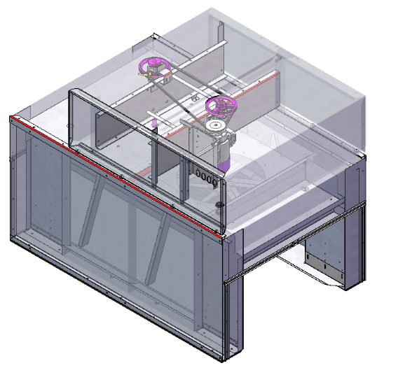
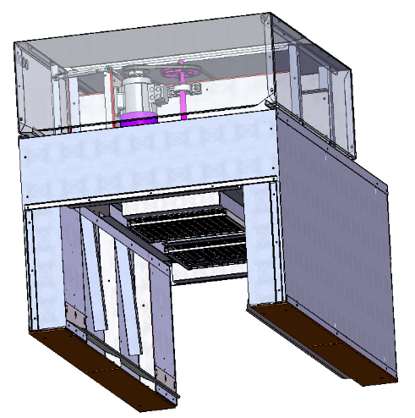  BAFFLES  HEATER BANKS | The motor that drives the tunnel fan is located on top of the heat tunnel is. This motor is connected to a variable-frequency drive (VFD) that can be adjusted to increase or decrease the speed of the tunnel fan.  There are adjustable baffles inside the tunnel that significantly impact the quality of the shrink on the product bundles. There are both slots as well as bendable portions to these baffles and once a good quality shrink has been achieved they should not be adjusted.  Heat is supplied from above such that if the case were that the tunnel were to stop, the product should not increase in temperature beyond that of the ambient within the tunnel as the heat will rise as it cools off. Volatile/Flammable/Pressurized products may require additional safety equipment retrofits that exhaust the air in a power-loss situation.


HEAT SHRINK TUNNEL
AIR FLOW CONTROLS
HEATER BANKS

VFD
 | 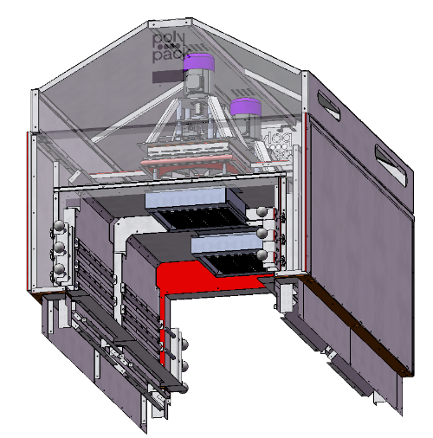
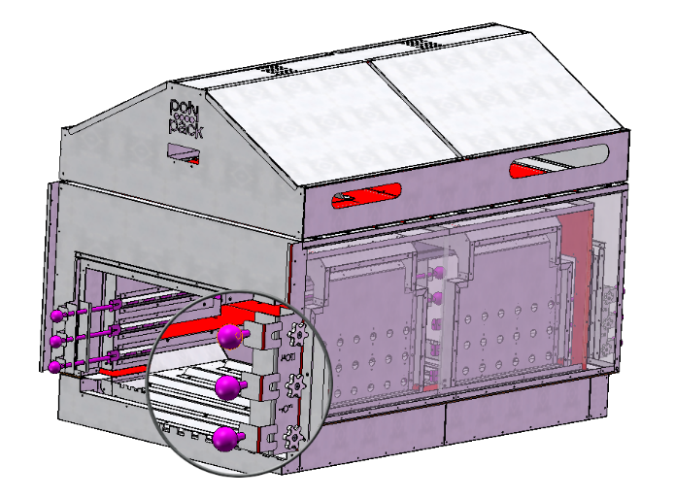 | The motor that drives the tunnel fan is located on top of the heat tunnel is. This motor is connected to a variable-frequency drive (VFD) that can be adjusted to increase or decrease the speed of the tunnel fan.  There are adjustable baffles inside the tunnel that significantly impact the quality of the shrink on the product bundles. There are air flow control KNOBS to adjust to these baffles and once a good quality shrink has been achieved they should not be adjusted.  Heat is supplied from above such that if the case were that the tunnel were to stop, the product should not increase in temperature beyond that of the ambient within the tunnel as the heat will rise as it cools off. Volatile/Flammable/Pressurized products may require additional safety equipment retrofits that exhaust the air in a power-loss situation.

TUNNEL CONVEYOR

VFD
 | 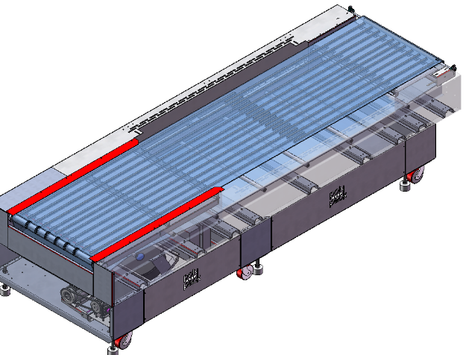
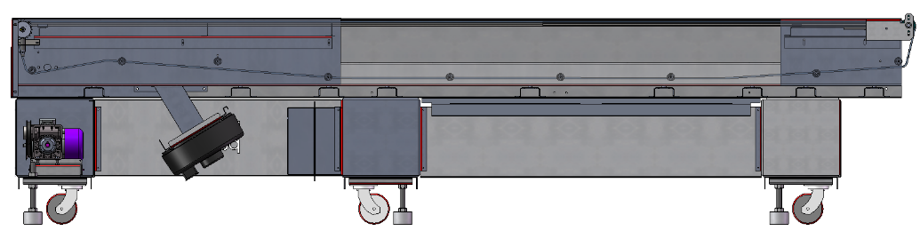

The Tunnel Conveyor transports the film-wrapped product bundles through the Shrink Tunnel. The Tunnel Conveyor is indexed, with the timing programmed at the HMI. The Tunnel Conveyor is driven by Torque Limiter which is intended to prevent damage in the case of a jam; this Torque Limiter is located on the LEFT-DISCHARGE end of the conveyor assembly

DISCHARGE CONVEYOR

VFD

The discharge conveyor transports finished, film-wrapped bundles from the shrink tunnel to the next stage of handling. It is VFD-controlled, allowing adjustable speed for smooth product flow. An optional changepart—the end-stop—can be installed to prevent product from progressing beyond the conveyor when required for accumulation or manual removal.

FILM CRADLE
 | 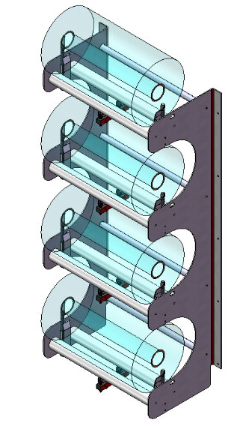
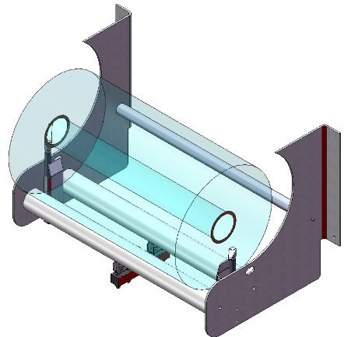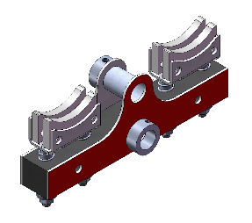 | The film cradle is designed to securely hold and dispense shrink film rolls during operation. It incorporates an inertial brake system that applies consistent resistance to the film roll, preventing free-spooling and ensuring smooth, controlled film feed.

FILM CRADLE
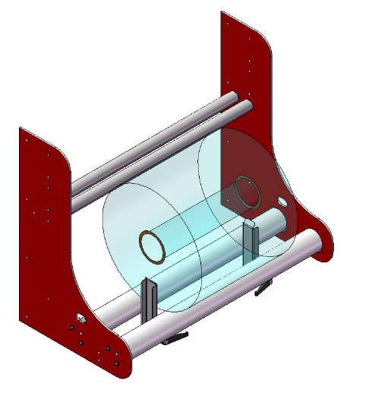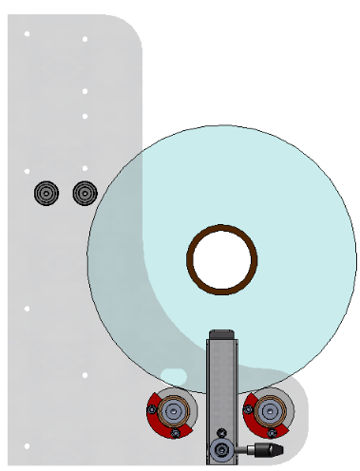
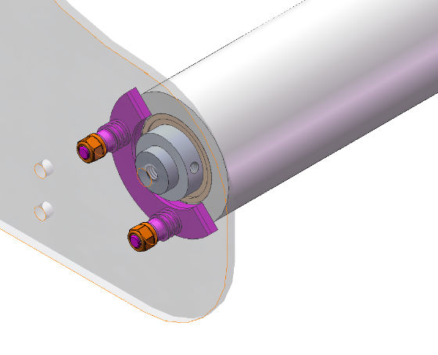 | The film cradle is designed to securely hold and dispense shrink film rolls during operation. It incorporates an inertial brake system that applies resistance to the film roll, preventing free-spooling and ensuring smooth, controlled film feed.  The brakes are tightened/loosened by tightening/loosening the nuts (contracting the springs)  To adjust the film-guides, loosen the handles and position the guide to the desired position | 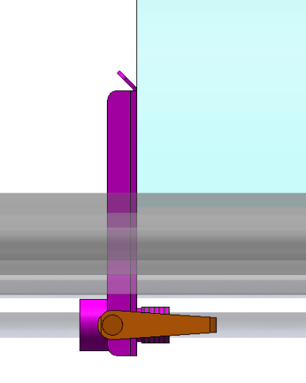

FILM FEED
 | 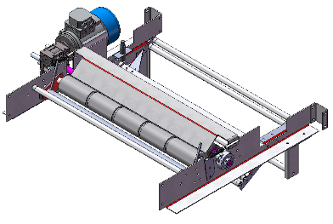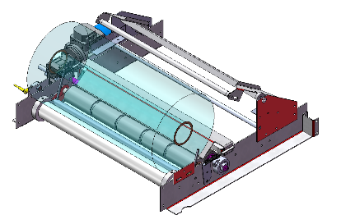    VFD    VFD
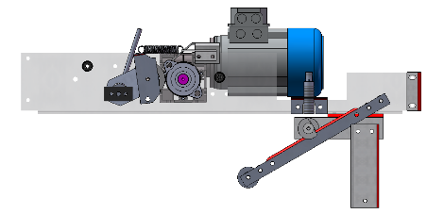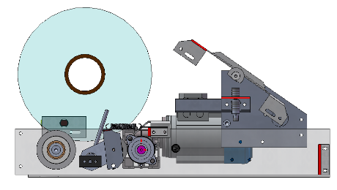 | The upper/lower film feed system uses rubberized drive motors to pull film from the cradle, creating slack for smooth operation. As bundles move through the film, the pivoting dancer bar rollers absorb tension fluctuations, allowing all motors to run at a consistent pace and maintain steady film flow.

FORMING HEAD
 | 
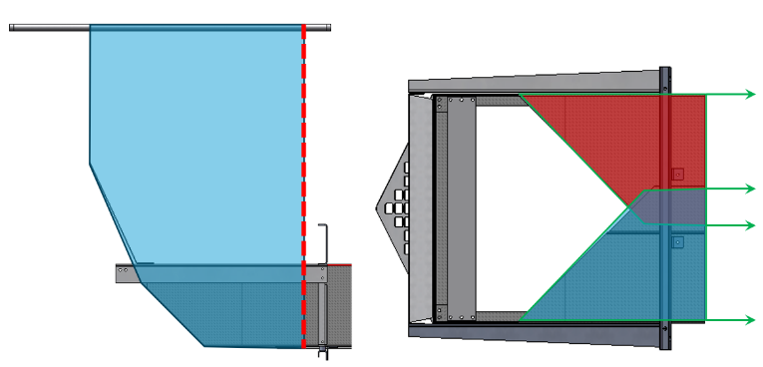
FILM SHOULD NOT RUN OFF EDGE OF OVERLAP
PARALLEL

    SEALBAR   |     CYLINDER
SEALBAR BLADE | 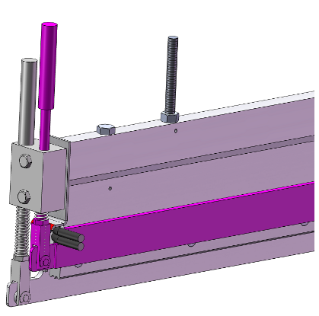  PRESSURE PADS


CYLINDER

CHECK WEAR

LOWER SEALBAR
    - SEALBAR FUNCTION
The Seal Bar Assembly consists of an Upper Seal Bar and a Lower Seal Bar. The Upper Seal Bar is a thermostatically controlled hot bar that closes against the Lower Seal Bar when running product configurations that are shrink-wrapped. The Lower Seal Bar is a silicone pad covered with Teflon tape that, when closed against the Upper Seal Bar, simultaneously seals and cuts the film after the product moves past the Seal Bar. The Seal Bar Assembly is actuated when the products or product-filled trays break the photoelectric sensor located after the Seal Bar. After being wrapped in film, the trays are transported from the Infeed Conveyor to the Transfer Conveyor.
    - MAXIMUM SETTINGS
The seal bar temperature must not exceed 500 degrees Fahrenheit to prevent damage to the components of the assembly’s components, including a loss of strength in the aluminum alloy, which would weaken the assembly and affect its performance. Though the PTFE coating can withstand temperatures of 550 degrees continuously or 600 degrees briefly, Polypack has determined that 500 degrees is the maximum operating temperature to protect the integrity of the entire seal bar assembly.
    - ADJUSTMENT
When assembling the seal bar, do not tighten the lower bolt head down to the bronze guide block. There should be a gap of 2 mm (1/16 in) between the bolt head and the bronze guide block when the lock nut is tight against the aluminum knife support.  Be sure after the assembly is together that the pressure pads do not stick when pressure is applied to the bottom of the pressure pads. If the guide rods stick when actuated, loosen the bronze guide blocks and adjust as needed. Refer to Reference Drawing below: | 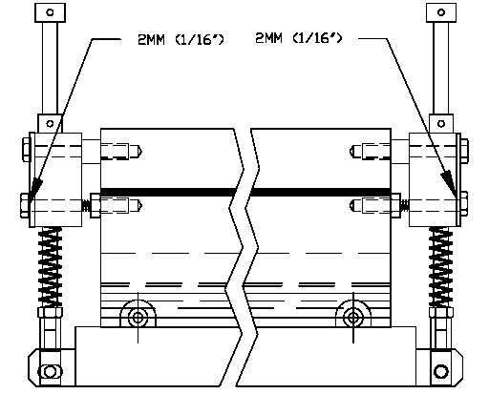
    - PRESSURE PAD ASSEMBLY
When assembling the pressure pad assemblies, be sure the two flat washers are on the inside of the pressure pads and the milled ends are facing away from the seal bar assembly. | 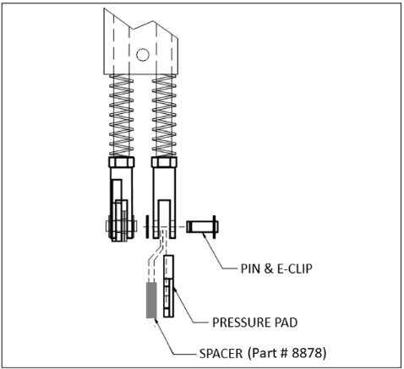
 | If the Pressure Pads are assembled incorrectly, they may rub and stick on the Seal Bar assembly causing them to be ineffective.

HOLD DOWN
LOWER SEALBAR
 |  | 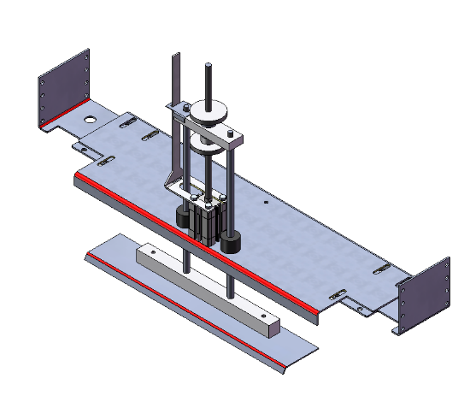
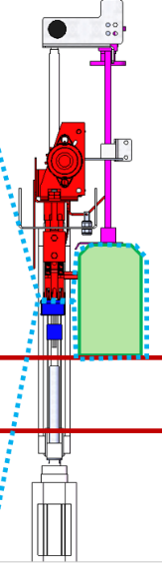  HOLD DOWN  FILM  PRODUCT  UPPER SEALBAR | The Product Hold Down stabilizes the product bundle, and is programmed to release products at a predetermined frequency through the Film Curtain, holding the next product bundle in place to repeat the cycle.

TRANSFER CONVEYOR
 | 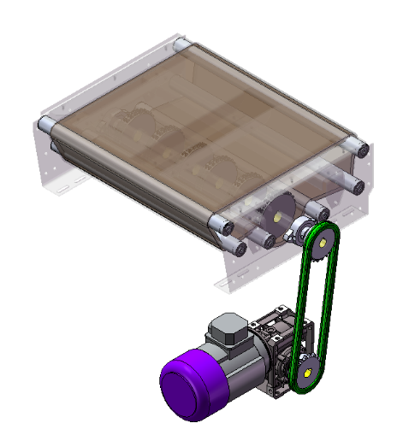
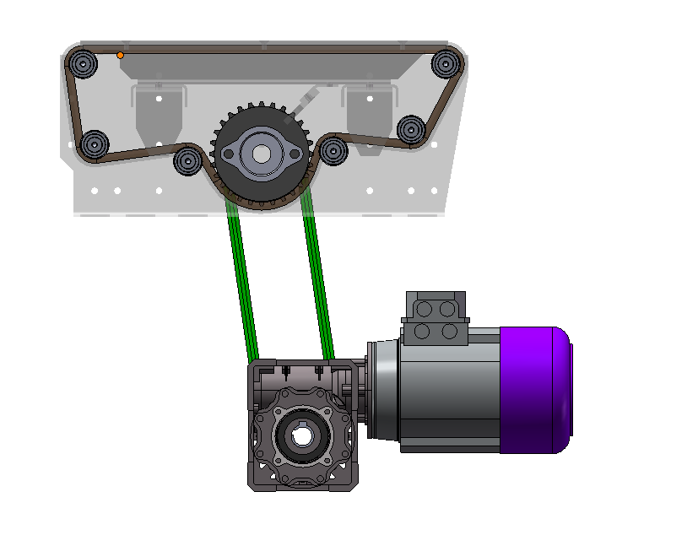    VFD | The Transfer Conveyor is a chain-driven, VFD-powered conveyor designed to positively pull product bundles away from the sealing area and deliver them smoothly into the shrink-tunnel infeed.

TUNNEL CONVEYOR
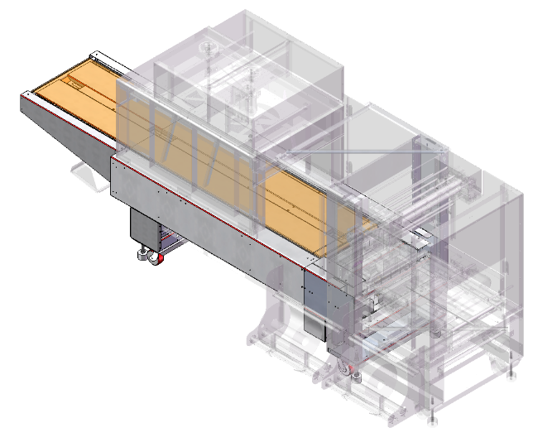 | 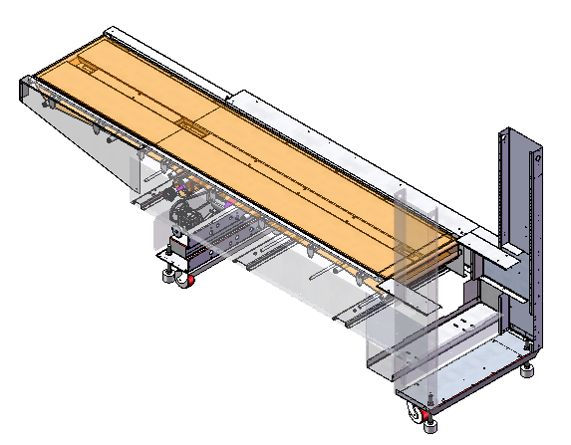
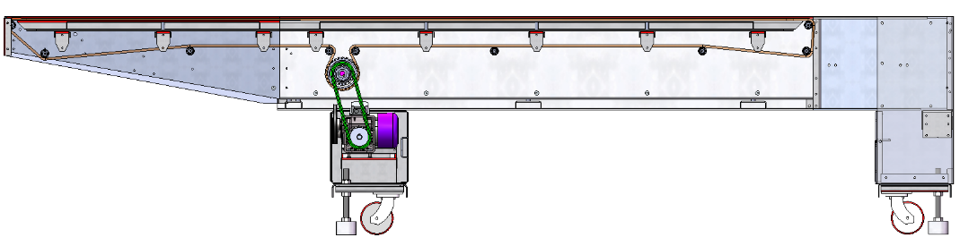

VFD
The Tunnel Conveyor transports the film-wrapped product bundles through the Shrink Tunnel. The Tunnel Conveyor is indexed, with the timing programmed at the HMI. The Tunnel Conveyor is driven by Torque Limiter which is intended to prevent damage in the case of a jam; this Torque Limiter is located on the LEFT-DISCHARGE end of the conveyor assembly


TUNNEL CONVEYOR

VFD
 | 
 | The Tunnel Conveyor transports the film-wrapped product bundles through the Shrink Tunnel. The Tunnel Conveyor is indexed, with the timing programmed at the HMI. The Tunnel Conveyor is driven by Torque Limiter which is intended to prevent damage in the case of a jam; this Torque Limiter is located on the LEFT-DISCHARGE end of the conveyor assembly


HEAT SHRINK TUNNEL

VFD

VFD
 | 
  BAFFLES  HEATER BANKS | The motor that drives the tunnel fan is located on top of the heat tunnel is. This motor is connected to a variable-frequency drive (VFD) that can be adjusted to increase or decrease the speed of the tunnel fan.  There are adjustable baffles inside the tunnel that significantly impact the quality of the shrink on the product bundles. There are both slots as well as bendable portions to these baffles and once a good quality shrink has been achieved they should not be adjusted.  Heat is supplied from above such that if the case were that the tunnel were to stop, the product should not increase in temperature beyond that of the ambient within the tunnel as the heat will rise as it cools off. Volatile/Flammable/Pressurized products may require additional safety equipment retrofits that exhaust the air in a power-loss situation.

DISCHARGE CONVEYOR
 | 


xXxTEMPLATExXx

CHECK WEAR

POSITION ADJUSTMENT

VFD







HEATER BANKS

CYLINDER
1

CHANGE PART
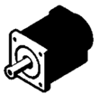
SERVO

LUBRICATE

CHECK TENSION

REPLACE REGULARLY

OPERATIONAL PROCEDURE

STARTUP (SEAL BAR MACHINE)
- Switch the main disconnect in the main electrical panel to the ON position.
- Check the machine operating air pressure (it should be 70-75 psi).
- Check the film supply. Change film roll if needed.
- Close all safety doors on the machine
- Ensure all Emergency Stop buttons are pulled out.
- Press the RESET (blue) button on the main electrical panel
- Press the Start (green) button on the main operator panel. The red “Power On” indicator lights will illuminate. The tunnel conveyor and tunnel fans will start to run, and the machine will begin to heat the tunnel heaters and seal bar.
- Supply the infeed conveyor with the necessary product to begin the production run.
- Wait until seal bar temperature, tunnel temperature and sealing belt temperature readouts are up to the required operating temperature. (This should take 15-25 minutes.)
- Then, if required, pull film through seal bar assembly and make a manual seal with the Manual Seal button.
- Remove any excess film.
NOTE: The machine must be in Manual Mode for the manual seal to operate.
- Press the Automatic and Infeed On buttons on the HMI Main Screen.
- If the Alarm Screen indicates faults, correct the condition, then press fault reset button and continue as above.

STARTUP (WRAP-ARM MACHINE)
- Switch the main disconnect to the ON position.
- Check the machine’s operating air pressure (it should be a minimum of 75 psi).
- Check the film supply for an adequate amount of film. Ensure film is threaded properly.
- Pull out the E-Stop button on the operator panel and auxiliary E-Stops if applicable.
- Press the Master Start button on the operator panel. (The white Power On light illuminates.)
- From the HMI, select the recipe (product number) for the product to be run.
- Wait until the tunnel temperature is up to the required operating temperature. (This should take about 25 minutes.) When complete, the heating alarm will reset.
Press the Automatic button on the touchscreen; the machine will start and run. If machine does not go into Automatic Mode, check alarm status on HMI. If an active alarm or fault exists, correct the condition then press the Fault Reset button on Main HMI Screen.

AUTOMATIC RUN

MANUAL/TROUBLESHOOTING

SHUTDOWN
 | TO PREVENT FIRE AND DAMAGE TO THE MACHINE,  MAKE SURE ALL PRODUCT HAS EXITED THE TUNNEL
- Press the Manual button on the HMI Main Screen to remove the machine from Automatic Mode.
- Wait for all the products to exit the tunnel.
- Push the emergency stop button on the main operator panel.
- Switch the main disconnect on the main electrical panel to the OFF position.

CRASH RECOVERY
- Press the Emergency Stop to immediately halt all machine motion and prevent further damage or injury.
- Inspect all machine zones for misaligned, jammed, or partially wrapped product.
- Manually remove all product from conveyors, lugs, diverters, and seal/tunnel areas. Assume product counts and memory are invalid.
- Clear any film obstructions from the seal bar or tunnel. If film is tangled or partially sealed, cut and remove it. Re-thread as needed.
- Reset all counters and alarms via the HMI to clear corrupted memory states and restore system logic.
- Check pneumatic actuators and diverters for proper home position. Manually cycle if necessary to confirm free movement.
- Inspect tunnel conveyor and fan system for debris or jams. Confirm torque limiter and VFD status are normal.
- Re-thread film and perform a manual seal to confirm film feed and sealing integrity. This must be done in Manual Mode.
- Close all safety doors to exit E-Stop conditions and re-enable Automatic Mode.
- Wait for tunnel and seal bar temperatures to reach operational setpoints before resuming production.
- Optionally run a dry cycle to verify mechanical synchronization before reintroducing product, especially for oriented or indexed bundles.

CHANGE OVER PARTS AND PROCEDURES, ADJUSTMENTS

PRODUCT LIST

CHANGEPARTS
There are no changeparts for the machine given the products listing at the time of this document’s creation


CHANGEOVER PROCEDURE
    - INFEED GUIDES
- Loosen handles and adjust as needed for product diameter changes.
- Ensure to avoid clamping too tightly or allowing undesired nesting.
- Retighten handles.
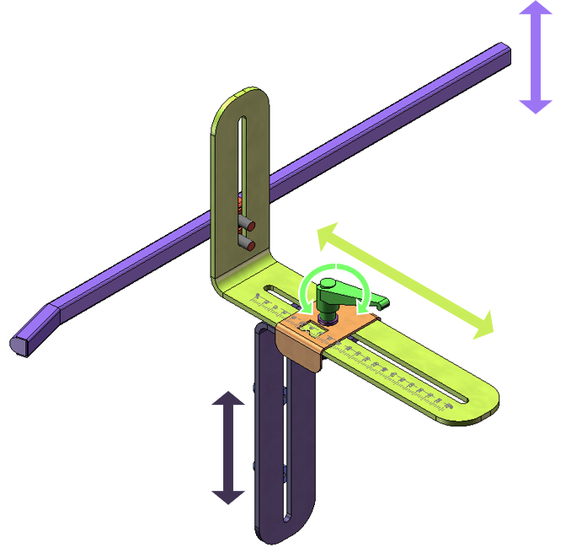
    - INFEED GUIDES
- Loosen handles and adjust as needed for product diameter changes.
- Ensure to avoid clamping too tightly or allowing undesired nesting.
- Retighten handles.
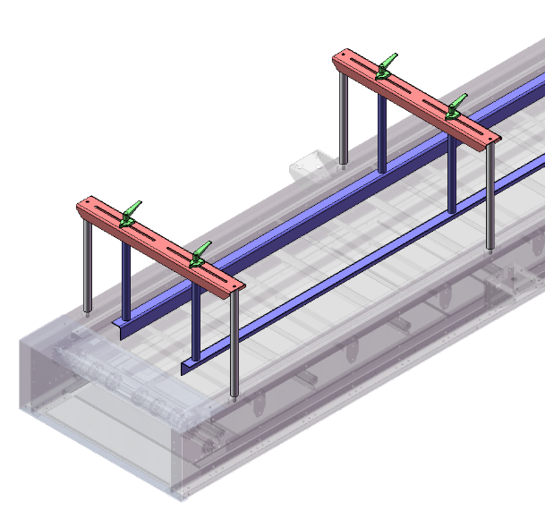
    - FILM TAKEUP
- Turn the handwheel, as shown in the photo, until the value displayed on the counter matches the value recorded for the product to be run
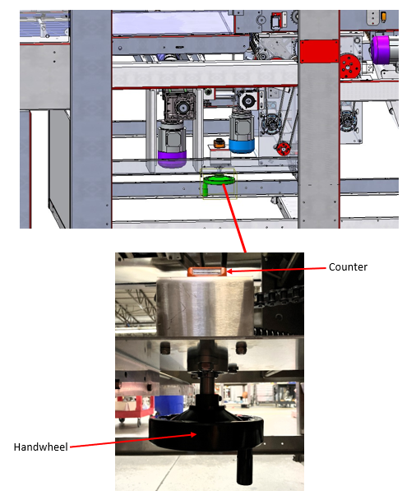
    - DEADPLATE SIDE GUIDES
- Loosen the two hex bolts on each pointer plate (4 total), the positions of which are circled in red in the left photo above.
- Adjust the deadplate side guides to the correct positions for the product to run, so that the values on the etched scales at the measurement points, as shown in the right photo above, match the values recorded
- When the positions are confirmed, tighten the hex bolts until secure.
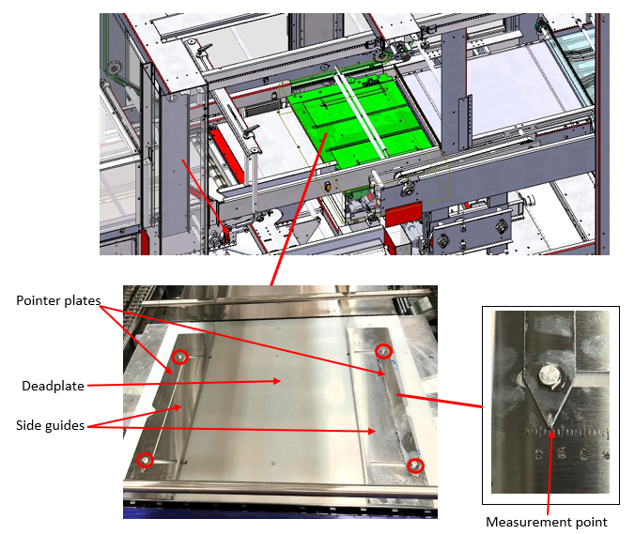
    - WRAP ARM HEIGHT
- Loosen the adjustment knob next to the measurement pointer, as shown in the right photo above.
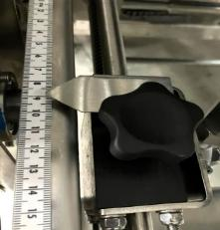
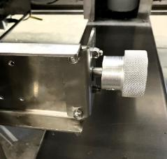
- Turn the knurled knob until the value at the measurement point on the scale matches the value recorded for the product to be run
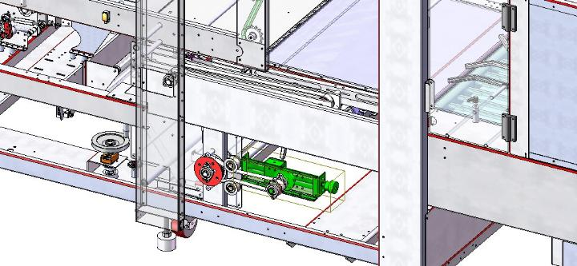
    - FILM CHANGE AND SPLICING
(JUST BEFORE FILM ROLL RUNS OUT)
- Press Manual on Main HMI screen to stop machine cycling. Loosen the ratcheting handles on each side of the film roll, as shown in the photos below, and slide the roll guides slightly to the outsides.
- Place the new roll in the atop the rubber drive rollers, then adjust the roll guides so the values on the scale at the measurement points – the tips of the attached pointers – as shown in the photos above, match the values recorded for the product to be run
- Ensure that the edges of the film roll are flush with the roll guides.
- Tighten ratcheting handles until secure.
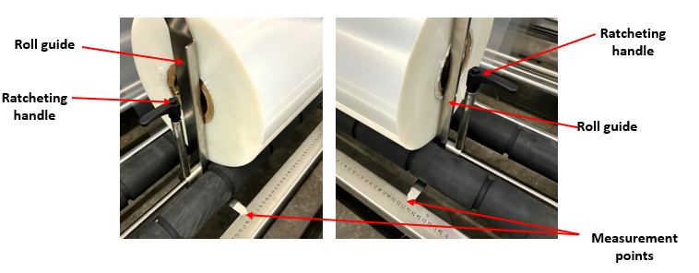
NOTE: When replacing the empty roll with a new roll, make sure the new roll of film unwinds in the same direction as the film roll being removed.
Refer to the Film Threading Diagram

    - FILM CHANGE AND SPLICING
(JUST BEFORE FILM ROLL RUNS OUT)
- Press Manual on Main HMI screen to stop machine cycling.
- Starting with upper film supply, cut film in front of film rolls, ensuring that film remains threaded through the film feed assembly if possible.
- Remove existing film rolls.
- Loosen film roll guide setscrews on outer side of the film rolls, as shown in the photo below, and move roll guides slightly to the outside, leaving enough space for new roll.
- Place new film roll onto the roller between the roll guides and move roll guides inward until side of roll guides are flush with the side of the film roll.
- Tighten setscrews.
- Splice the beginning of the new roll of film to the end of the old roll with clear cellophane tape. Be certain to lay the beginning of the new film over (on top of) the end of the old roll for better threading performance.
- Pull the film between the upper and lower seal bars, close all safety doors, and restart machine. Then perform a manual seal using button on Main Screen.
- Repeat process for lower film supply.
- If seals are intact, place the machine back into production.
NOTE: When replacing the empty roll with a new roll, make sure the new roll of film unwinds in the same direction as the film roll being removed.
Refer to the Film Threading Diagram

    - FILM SPLICING AND LOADING PROCEDURE USING FILM SPLICING UNIT
- Raise the lever to open the splice unit cover, and lock the lever in place.
- If machine is not powered on, reset E-Stop (if needed) and press Master Start to power on machine so that splice unit can function.
- Bring both ends of the film together (overlap a minimal distance).
- Apply the ends to the heating element base. (Overlap enough so the ends can be pressed down on the film capture pins near the heating element and make sure the film has no wrinkles before starting the sealing process.)
- Move the lever down over the film and press the Start button, then release. (The red light on the stack pole will flash.)
- The lever sensor “sees” the lever and turns on the heating element.
- Hold the lever down for the amount of time the red light flashes on the stack pole. (Refer to touchscreen.) The heating element seals and cuts the film.
- Release the lever and pull up the film.
- Discard waste.
LEVER
HEATING ELEMENT
FILM CAPTURE PINS
START BUTTON

    - MECHANICAL TIMING
MECHANICAL METHOD
- Open Door to access machine components
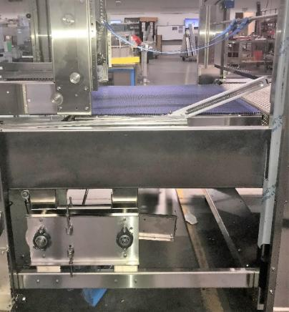
- Loosen the tensioner for the oscillating arm adjustment pulleys.
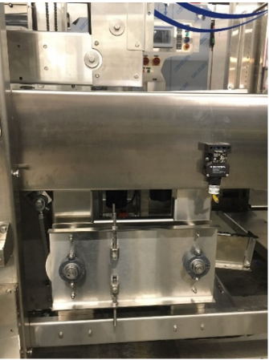
- With the oscillating arm adjustment knob in the 12 o’clock position, clamp the arm in place.
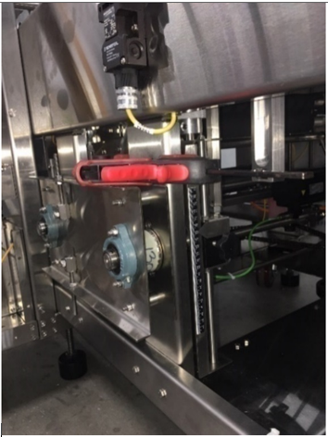 | 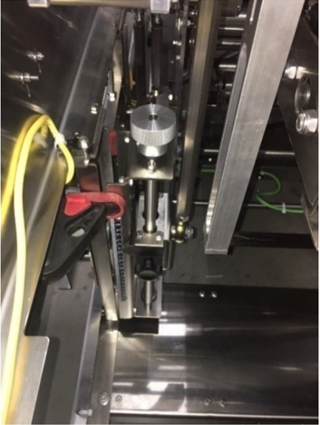
- Follow transfer cam rod to find the upper rod pivot block. Check the upper rod pivot block to make sure the rod end is facing the direction of the oscillator adjustment knob as pictured. If the rod end is facing the other direction it is incorrect. (If incorrect, remove the rod end and reassembly as pictured.)
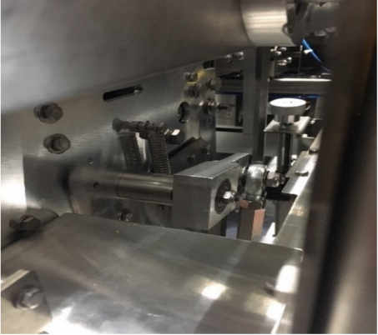
NOTE: The lower transfer shaft cam is located to the left of the oscillator tension adjustment.

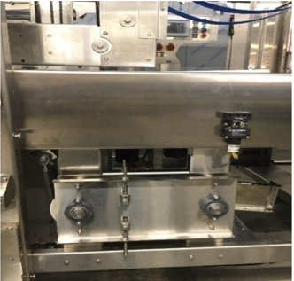 | 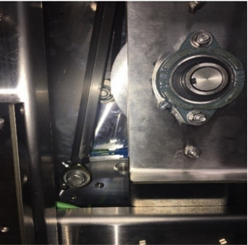
With the oscillator clamped and tensioner loose, begin rotating the lower square block (transfer shaft cam) by letting teeth of the pulley skip. The transfer shaft cam should be placed into the 3 or 9 o’clock position. Use the upper and lower oscillator tension adjustment to tension the belt so that the transfer shaft cam remains level.
    - FILM SPLICING AND LOADING PROCEDURE
USING FILM SPLICING UNIT
- Raise the lever to open the splice unit cover, and lock the lever in place.
- If machine is not powered on, reset E-Stop (if needed) and press Master Start to power on machine so that splice unit can function.
- Bring both ends of the film together (overlap a minimal distance).
- Apply the ends to the heating element base. (Overlap enough so the ends can be pressed down on the film capture pins near the heating element and make sure the film has no wrinkles before starting the sealing process.)
- Move the lever down over the film and press the Start button, then release. (The red light on the stack pole will flash.)
- The lever sensor “sees” the lever and turns on the heating element.
- Hold the lever down for the amount of time the red light flashes on the stack pole. (Refer to touchscreen.) The heating element seals and cuts the film.
- Release the lever and pull up the film.

- Discard waste.
START BUTTON
LEVER
FILM CAPTURE PINS
HEATING ELEMENT
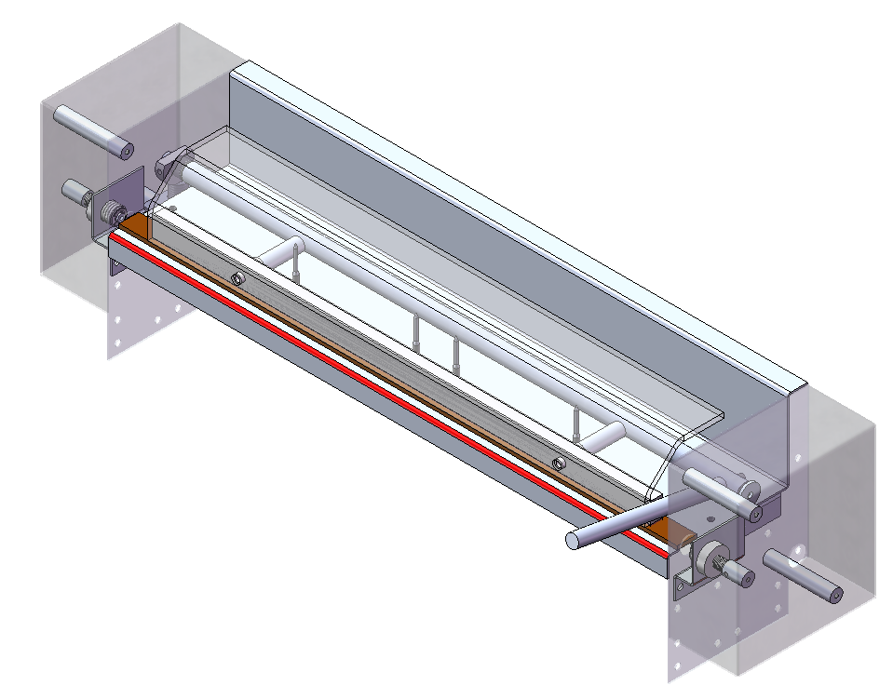
    - SCREW DRIVE – HEIGHT
- Loosen the handles on the support sections
- Rotate the adjustment handle
- Retighten the handles
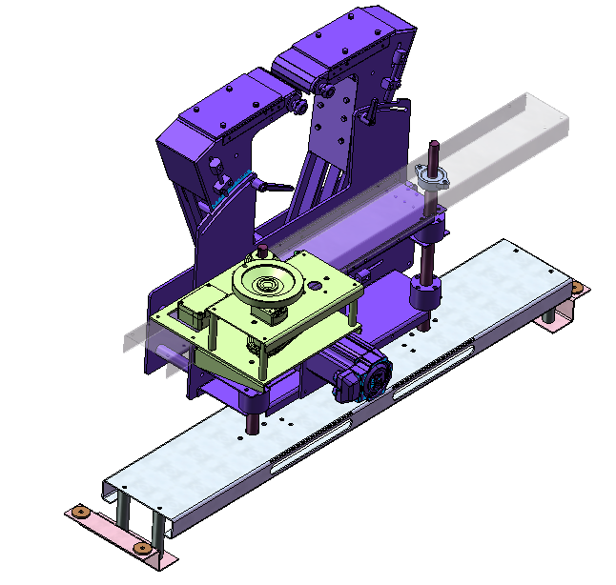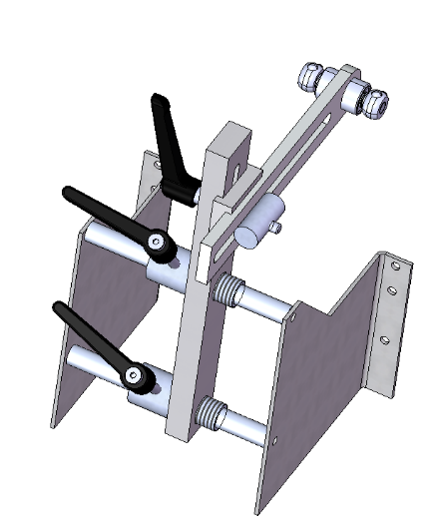
HANDLE
EDGE DATUM
HANDLE W/ COUNTER
SCALED SURFACE
    - SCREW DRIVE
WIDTH
- Loosen the handles on the drive portion
- Loosen the handles on the support sections
- Set to desired width
- Retighten the handles
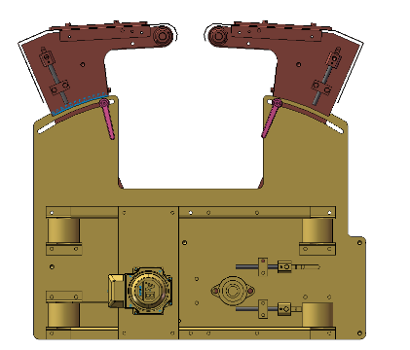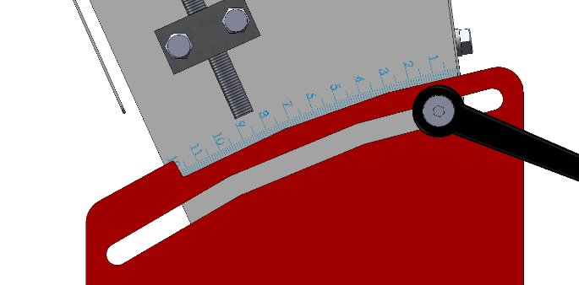
HANDLES

SCALED
SURFACE
EDGE DATUM
HANDLE
    - SWAPPING SCREWS
- Loosen the two handles on each of the support sections. The furthest section must be pulled furthest
- Pull the screws out away from the drive section then up out of the machine
- Apply lubrication/grease to all of the knuckles before re-application
- Replace the screw; align the inner slot at the base of the screw with the setscrew. Ensure that the lead-in into the screws will form a “V” as the product enters the screws.
- Retighten the handles

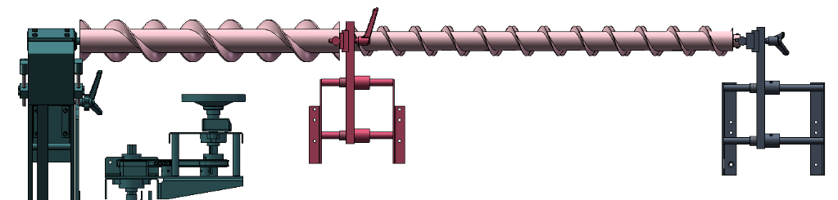
HANDLES
HANDLES
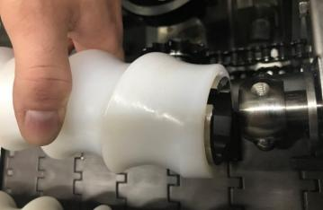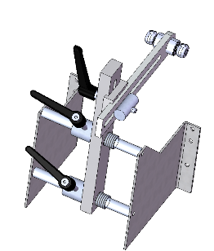
SET SCREW
SLOT
HANDLES
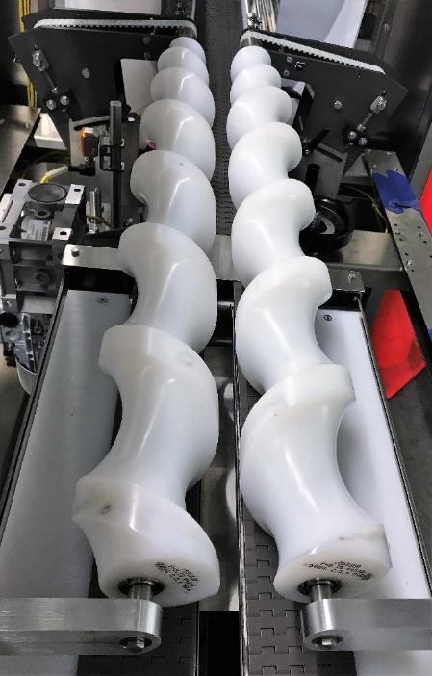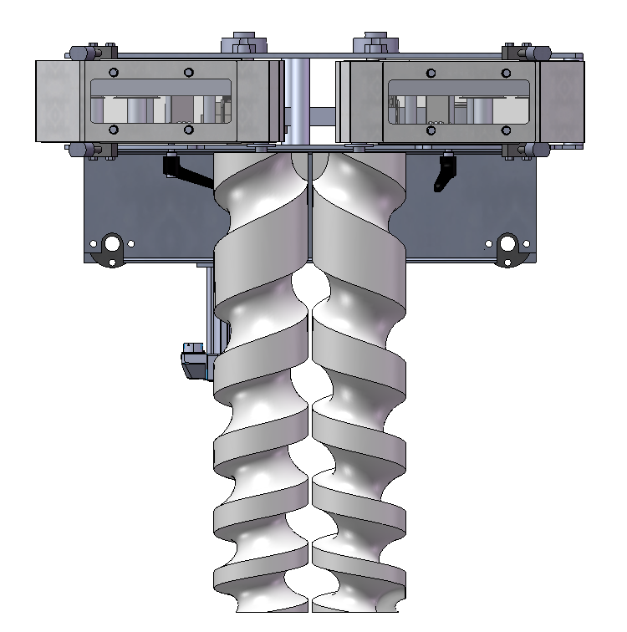
DIRECTION OF FLOW
LEAD-IN “V”
    - PRODUCT HOLD DOWN
- Loosen knurled KNOBS
- Move the product hold down to correct position for product to be run, ensuring the value on the scale at the measurement point
- When the position is confirmed, tighten knurled KNOBS until the product hold down does not move.
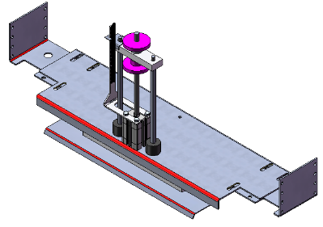
    - ROKH GRIPPER PLATES
- Loosen the four ratcheting handles, two of which are shown in the photo above, connecting the ROKH gripper plates to the ROKH change-over hubs.
- Slide out the ROKH gripper plates to the inside of the hubs.
- Select the correct set of four ROKH gripper plates for the product to be run
- Slide the two mounting rods on each ROKH gripper plate into the corresponding holes in the change-over hubs so that the end of the rods are even with the end of the hubs
- When the gripper plates are positioned correctly, tighten all ratcheting handles until secure.
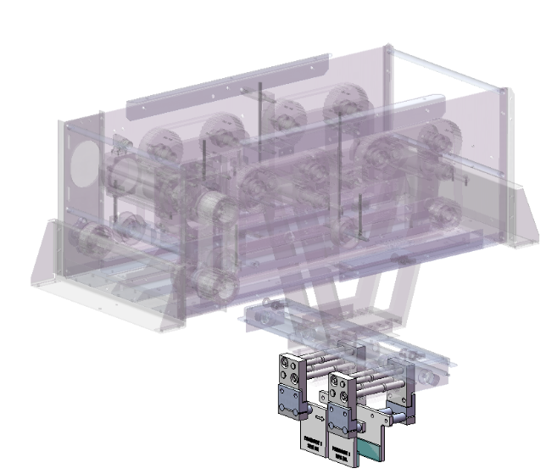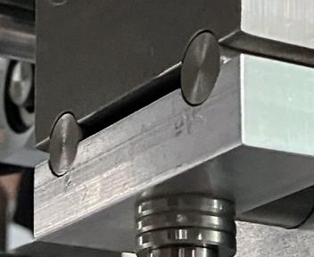
    - INFEED GUIDES
- Loosen handles and adjust as needed for product diameter changes.
- Ensure to avoid clamping too tightly or allowing undesired nesting.
- Retighten handles.
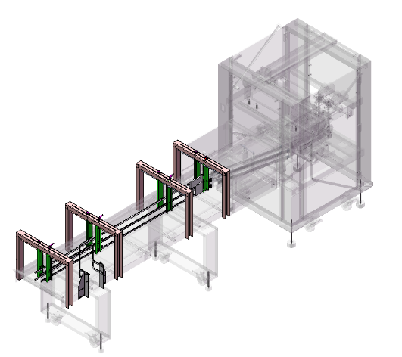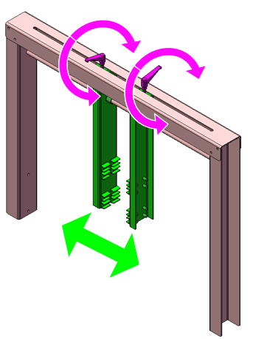
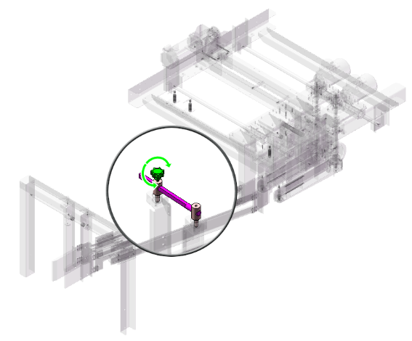
    - DIVERTER WIDTH ADJUSTMENT
- Loosen the locking handle
- Rotate the hand-wheel to the desired adjustment point on the counter
- Retighten locking handle.
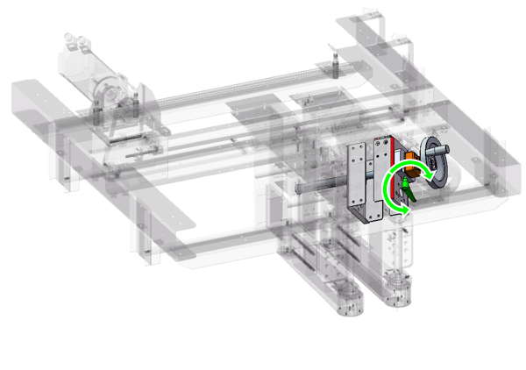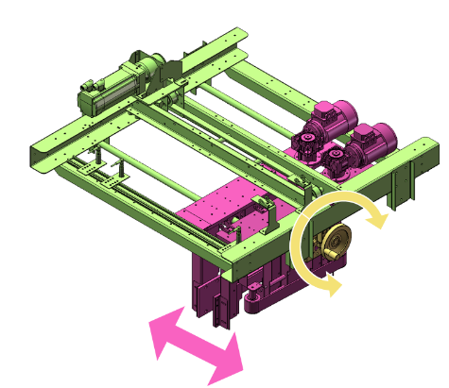
    - STAGING LANES
- Loosen the handles on the stiffening posts
- Rotate the hand-wheel to the desired adjustment point on the counter
- Push the stiffening posts up against the staging lane side
- Retighten locking handle on the stiffening post
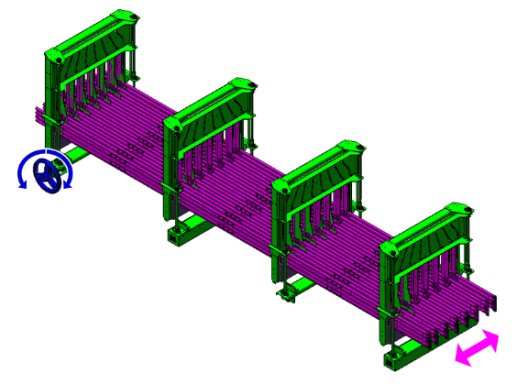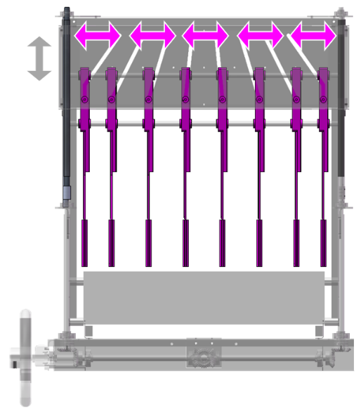

MACHINE SETTINGS

VFD SETTINGS

PHYSICAL SETPOINTS

A
SETPOINTS GENERALLY LABELED ALPHABETICALLY FROM INFEED TO DISCHARGE, LEFT TO RIGHT
SETTING | TAG | 1 | 2 | 3 | 4
INFEED GUIDE | A1

HMI SETTINGS
SEE SETUP SCREEN FOR INDIVIDUAL SETTING DETAILS

CLEANING & MAINTENANCE
While the Polypack machine frame and panels are essentially unaffected by water, steam, or humidity, it is advised to keep water directly off the control panel, motors, gear boxes, pulleys, drive chains and HMI Touchscreen.

PRECAUTIONS
- Keep water off the shrink tunnel heater elements, especially when hot.
- Avoid wetting the film rolls since wet film does not feed or seal properly.

MAINTENANCE REQUIREMENTS
Polypack machines are designed to be as maintenance-free as possible, but inspection and maintenance procedures should be followed to keep the machine in top working order.
 | THE MACHINE SHOULD BE E-STOPPED BEFORE PERFORMING ANY CLEANING OR MAINTENANCE PROCEDURES.

RECOMMENDED PREVENTATIVE MAINTENANCE/LUBRICATION SCHEDULE
ITEM | TASK |  | FREQUENCY
GLUE | - Remove any glue spillage/build up  - Ensure there’s not undesired leakage from the nozzle |  |   DAILY
TIMING SCREW KNUCKLE | - Apply grease to both sides of the knuckle joint before reassembly |  |   CHANGEOVER
BOX FUNNEL | - Inspect condition of BOX FUNNEL to determine if it is in functioning order and all tabs are present and undamaged |  |   CHANGEOVER
FILM PERF/CUTTING BLADES | - Visually inspect blade edges for dullness, chips, or uneven wear—look for clean, sharp cutting surfaces.  - Replace blades if cuts appear incomplete or jagged |  |   DAILY
SEAL BLADE | - Inspect condition of seal blade twice per shift. Clean the sealing edge of the seal bar blade by wiping the blade with a water-moistened non-abrasive cotton cloth.  - If damage is noted that would affect seal integrity (e.g., nicks, cracked, producing incomplete seal), it should be replaced. |  |   DAILY
CLEARPRINT WRAP ARM | - Inspect condition of wrap arm to ensure it has not been bent/fractured. |  |   DAILY
FILM THREADING | - Ensure proper film threading per diagram per FILM-THREADING DIAGRAM  - Ensure all dancer rollers are straight and spin freely.  - Ensure film and rollers are free of dust or water. |  |   DAILY
SEAL BLADE | - Clean the sealing edge of the seal bar blade by wiping the blade with a water-moistened non-abrasive cotton cloth.  - CAUTION: SHARP and/or HOT  - DO NOT CLEAN THE BLADE WITH ANY TYPE OF CLEANING SOLUTION OR  - ABRASIVE MATERIALS. DOING SO CAN DAMAGE THE BLADE’S NON-STICK COATING. |  |   DAILY
SUCTION CUPS | - Visually inspect each suction cup through the belt perforations for signs of wear, tears, or cracks.  - Replace any damaged suction cups by removing the retaining hardware and installing new units. |  |   WEEKLY
SEALING BAR SILICONE & TEFLON CLOTH STRIP | - If damage is noted that would affect seal integrity (e.g., nicks, cracked, producing incomplete seal), either reverse the strip or replace it.  - (If strip cannot be reversed because this procedure has already been done with this strip once, it must be replaced.) |  |   WEEKLY
TUNNEL CONVEYOR CHAINS | - Ensure proper tension.  - Tighten if needed.  - Inspect the torque limiter for worn pads.  - Check tightness of bolts on motor mount/gear box mount. |  |   WEEKLY
MOTOR DRIVE CHAINS | - Ensure proper tension.  - Tighten if needed.  - Check for proper alignment of primary and secondary sprockets.  - Check for tightness of setscrews on keyed sprockets. |  |   WEEKLY
FORMING HEAD | - Examine for any damage that could affect smooth film feeding, such as bent pieces or sharp edges.  - Check the proper placement of the nose plate on the slots.  - Inspect bottom tongue to ensure it is free of obstructions and not pinched.  - Ensure forming head is set at correct height in relation to conveyor. |  |   WEEKLY
METERING BELT | - Ensure proper tension.  - Tighten if needed.  - Inspect the belt for excess wear. |  |   WEEKLY
ELECTRICAL ENCLOSURE AIR CONDITIONER FILTER | - Clean the Electrical Enclosure air conditioner filter weekly by removing from compartment and either blowing off with compressed air or rinsing with water.  - Ensure filter is completely dry before reinstalling. |  |   WEEKLY
CONVEYORS | - Clean any Conveyors weekly by wiping with a moist cloth to remove any debris.  - Ensure conveyor is dry before running product.  - Check free rollers and inspect the bearings. |  |   WEEKLY
FORMING HEAD | - Clean the Forming Head weekly by wiping with a lint free cloth dipped in alcohol.  - Remove any product debris or corrugate dust. |  |   WEEKLY
VERTICAL SEALBAR BUSHINGS | - Ensure proper lubrication is applied on stainless shafts for seamless movement through bushings. |  |   WEEKLY
MISTER SYSTEM | - A Kool Mist™ mister system is installed at the Infeed Conveyor.  - The interval of the spray is controlled by the HMI. Refill the mister tank as needed with approved lubricant mixture.  - Refer to KoolMist Startup/Troubleshooting guide if nozzle flow requires adjustment |  |   WEEKLY
TUNNEL ROD-CONVEYOR CHAINS | - Access lubrication points from rear of machine.  - Mark the chain where lubrication is started.  - Apply lubricant to the left- and right-side chain at the end of the Tunnel Conveyor, near the idler sprocket. |  |   WEEKLY
UPPER FILM FEED ROLLER DRIVE CHAIN | - Access the drive chains  - Remove safety covers as needed.  - Apply lubricant to the entire chain.  - Once lubrication is complete, reinstall safety covers. |  |   MONTHLY
INFEED CONVEYOR DRIVE CHAIN | - Access the drive chains  - Remove safety covers as needed.  - Apply lubricant to the entire chain.  - Once lubrication is complete, reinstall safety covers. |  |   MONTHLY
FLYBAR CHAIN | - Access the drive chains  - Remove safety covers as needed.  - Apply lubricant to the entire chain.  - Once lubrication is complete, reinstall safety covers. |  |   MONTHLY
TUNNEL CONVEYOR DRIVE CHAIN | - Access the drive chains  - Remove safety covers as needed.  - Apply lubricant to the entire chain.  - Once lubrication is complete, reinstall safety covers. |  |   MONTHLY
FLYBARS | - Check to see that all fly bars are in their proper position on the chain  - Inspect all fly bars for straightness  - Check for proper spring tension to keep them in place. |  |   MONTHLY
HIGH-FRICTION BELTS | - If belt shows wear, it should be replaced.  - If damage is noted that would interfere with proper performance of the belt (e.g. excessive wear) replace belt |  |   MONTHLY
BELTS ON MAIN PUSHER | - If belt shows wear, it should be replaced.  - If damage is noted that would interfere with proper performance of the belt (e.g., cracking), replace belt.  - Inspect white wheels. If damaged or bearings seem sticky, replace them. |  |   MONTHLY
BELTS ON TRANSFER PUSHER | - If belt shows wear, it should be replaced.  - If damage is noted that would interfere with proper performance of the belt (e.g., cracking), replace belt.  - Inspect white wheels. If damaged or bearings seem sticky, replace them. |  |   MONTHLY
LOWER SEAL BAR CYLINDER NUT | - Ensure it is tight and secure.  - If nut is loose, tighten until snug on surface. |  |   MONTHLY
FILM SUPPLY RUBBER ROLLERS | - Inspect for powderlike residue caused by film as it passes through the film supply assembly.  - Appearance of this residue will differ based on machine model, film type and operating conditions.  - Refer to Section Cleaning Requirement and Precautions if residue is noted. |  |   MONTHLY
OVERALL MACHINE INSPECTION | - Inspect Air lines  - Inspect Sensor cables.  - Check for chafing |  |   MONTHLY
DRAG SEAL | - Check coating hasn’t worn off.  - Check cylinder shaft is not bent.  - Verify threaded adjustment rod and knobs are free of damage. |  |   MONTHLY
TUNNEL CHAIN AUTO-LUBRICATION | - The setting on the auto-lubrication system is set to be maintenance-free from 1-12 months; the higher the number the less frequent maintenance should be required  - Ensure properly filled will lubricant, replace if run dry.  - Check brushes are set to the correct height and contacting the chain. |  |   MONTHLY
RUBBER FILM ROLLERS | - Clean rubber film rollers monthly using a soft cloth moistened and warm, soapy water  - Note: This cleaning process may not be required if residue is not present.  - Do not use any chemicals on rubber rollers. This may cause dryness and cracking. |  |   MONTHLY
ELECTRICAL ENCLOSURE | - Clean air circulation filters  - Remove any debris from inside the panel. |  |   MONTHLY
TUNNEL FAN PILLOW BLOCK BEARINGS | - Remove safety cover on top of tunnel to access pillow block bearings.  - Access pillow block bearings grease manifold. GREASE MANIFOLD  - Attach grease gun dispensing nozzle onto grease fitting.  - Dispense 1 pump from grease gun into grease fitting. (The “1 pump” refers to a lever-style manual grease gun.)  - Remove dispensing nozzle, then attach nozzle to next grease fitting until all have been lubricated.  - NOTE: Wipe grease fittings to remove dirt/debris before attaching grease gun.  - Check for any cracks on pillow bock bearings. If damage is noted, replace bearing. |  |   QUARTERLY
SPLICE HOTWIRE | - Check for proper operation  - Verify spring is not overextended  - Verify wire doesn’t show signs of burned or shorted areas or connections  - Inspect Teflon tape for any burnt through areas. Replace if damage is noted. |  |   BI-ANNUALLY
SENSORS | - Check for proper operation  - Verify that all cables are secure and in good working condition  - Verify orientation and position on any sensors that may have been unintentionally moved  - Replace any damaged cables |  |   BI-ANNUALLY
TUNNEL FAN V-BELTS | - If belt shows wear, it should be replaced.  - If damage is noted that would interfere with proper performance of the belt (e.g., cracking), replace belt.  - Ensure proper tension. |  |   BI-ANNUALLY
TUNNEL CONVEYOR | - Do a comprehensive inspection of the entire tunnel conveyor including chain, mesh belt, wear strips, rollers and bearings.  - Replace any damaged components.  - Remove any debris or loose film from all components. |  |   BI-ANNUALLY
TUNNEL CONVEYOR V-BELTS | - If belt shows wear, it should be replaced.  - If damage is noted that would interfere with proper performance of the belt (e.g., cracking), replace belt.  - Ensure proper tension. |  |   BI-ANNUALLY
TUNNEL EVAC SPRINGS & CYLINDERS | - Do a inspection of the cylinders and springs.  - Replace any damaged components.  - Remove any debris or loose film from all components. |  |   BI-ANNUALLY
DELRIN ROLLER WHEELS | - Check for excessive wear and/or flat-spot  - Ensure bearings appear properly embedded in the plastic |  |   BI-ANNUALLY
METERING BELTS | - If belt shows wear, it should be replaced.  - If damage is noted that would interfere with proper performance of the belt (e.g., cracking), replace belt. |  |   BI-ANNUALLY
FLY BAR CHAINS | - Automatic oilers (filled with a food grade lubricant) are installed on the Fly Bar Chains  - Ensure adequate lubrication is present at all times.  - Refer to manufacturer’s instructions for adjustment/replacement. |  |   QUARTERLY
E-STOPS | - Ensure they are all functioning properly.  - Activate and reset each E-stop, ensuring that it will remove power from machine. |  |   ANNUALLY
DOOR SAFETY SWITCHES | - While machine is in Automatic Mode, attempt to open each safety door. The machine should shut down if any safety door is opened. |  |   ANNUALLY
TUNNEL CURTAIN | - Ensure that they are in good condition.  - Replace if torn. |  |   ANNUALLY
TUNNEL HEATER | - Inspect for contamination  - Clean if necessary |  |   ANNUALLY
TUNNEL CHAIN AUTO-LUBRICATION | - Replace lubricant |  |   QUARTERLY
LUBE-FOR-LIFE | Some components do not require a lubrication schedule:  - Conveyor Belts - Air Cylinders - Sealed Bearings - Motors / Gear Boxes - Hand Wheels - Door Hinges |  | 
NOTE: Harsher products/cleaning agents can reduce the lifespan and/or decrease the recommended maintenance interval. Residual granulates increase wear, sticky products from spills can increase friction etc.

LUBRICATION MAP


DIAGNOSTICS & FAULTS
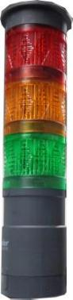 | STATUS | DESCRIPTION | RESPONSE
 | MAJOR | Solid or a flashing RED light  E-Stop condition that releases the machine from the Automatic Mode | - Correct the problem that caused the fault  - Press the Master Start button  - Press the Fault Reset button
 | MINOR | Flashing AMBER light  Automatic mode stop condition | - Correct the problem that caused the fault  - Press the Master Start  - Finish the task and conduct an orderly shutdown
 | LOW | Solid AMBER light indicates  Low film/cardboard sensors have been triggered | - Reload the consumable  - Press the Master Start button  - Press the Fault Reset button
 | AUTOMATIC RUN | Solid GREEN light indicates  Automatic Run Mode | No action required

FAULTS LIST

TROUBLESHOOTING
ISSUE | OBSERVATION | SOLUTION
PUSHER JAM | - The sealing operation is halted.  - Automatic Mode is shut off. | - Check for any products in the way.  - Make sure the pusher is free of obstructions in the forward and reverse strokes.  - Ensure sesnors did not move causing a false jam fault.  - Check white wheels are free of damage and moving seamlessly by hand.
SEAL BAR JAM | - The sealing operation is halted.  - Automatic Mode is shut off. | - Check for any products in the way.  - Make sure the spring-loaded pins triggering the pressure pad sensors are free (lubricate if necessary).  - Check the top seal bar down sensor, as it sends information to the PLC.  - If Servo driven, verify HMI parameters are set correctly.  - Ensure chain is properly tensioned and not kinked up, halting the upper seal barf rom coming down.
SEAL BAR OVER TEMPERATURE | - The power is shut off | - Check the alarm setting on the temperature controller.  - Check to see if the thermocouple wires are broken.  - Check the relay to see if the contacts are stuck.
TUNNEL OVER TEMPERATURE | - The power is shut off | - Check the alarm setting on the temperature controller.  - Check to see if the thermocouple wires are broken.  - Check the contactor to see if the contacts are stuck.
LOW AIR PRESSURE | - Automatic Mode is shut off | - Check the plant air supply (supply should be 65-75 psi).  - Check the air regulator of the Polypack machine.  - Check if the pressure switch setting is too high.  - Verify regulator is not locked in the off position.  - Check the air flow set screw was not turned in restricting air flow to the machine.
NO FILM | - Automatic Mode is shut off | - Check the film feed unit (did not deliver film for the past three seals).  - Check to see if the film is broken or jammed.  - Check the film feed proximity sensor.  - Check if HMI has a pre-feed film function and ensure it is not set too high.
LOW FILM | - Automatic Mode is shut off. | - Check to see if the film roll is exhausted.  - Check to see if the low film sensor is faulty.  - Note: Pressing the Fault Reset button bypasses the fault until a new roll is in place.
SAFETY RELAY TRIPPED | - The main air supply is shut off.  - The machine will not go into Automatic Mode.  - If the machine is in Automatic mode, the power is shut off. | - Check to see if the safety doors are closed properly.  - Check for a faulty door switch.
MOTOR OVERLOAD TRIPPED | - The machine is shut off | - Check the circuit breakers and motor overloads.  - Check the overload setting.  - Check for any lodged debris in conveyor belt or drive chain.
MACHINE HEATING | - The machine will not go into Automatic Mode. | - The tunnel or seal bar temperature has not reached the set point.  - Verify contacts are pulling in when machine is powered on.
MASTER STOP PRESSED (E-STOP) | - The machine stops. | - The Master Stop button has been pressed.
VFD FAULT | - The machine stops. | - Check for faulted drives. Refer to the drive manufacturer’s manual for a more detailed description of the problem.
SERVO FAULT | - The machine stops. | - Check rollers for free rotation  - Verify cable connection to Servo motor.
FILM FAULT | - Automatic Mode is shut off. | - Ensure all dancer bars are free to move.  - Check all film feed sensors.  - Check weight on dancer bars.
DEADPLATE OPEN | - Machine will not go into Automatic Mode. | - Close deadplate over film perforation section.  - Check to see if the proximity sensor is made when plate is down.
FILM ARM JAM | - Automatic Mode is shut off. | - Check to see if the film arm is in the detent of its clutch.
TUNNEL CONVEYOR JAM | - The sealing operation is halted.  - Automatic Mode is shut off. | - Check the tunnel conveyor motor/belt (fuses).  - Check the cam on the side of the tunnel.  - Check to see if the tunnel conveyor chain needs to be lubricated.  - Remove any lodged debris from drive chain.  - Verify torque limiter is not loose and pads are in good working condition.
LOWER SEAL BAR REMAINS STUCK IN THE UP POSITION |  | - First, try to perform a manual seal.  - If that does not resolve the issue, turn the pneumatic valve that corresponds with the lower seal bar, shown in the photo below, a quarter-turn counterclockwise.  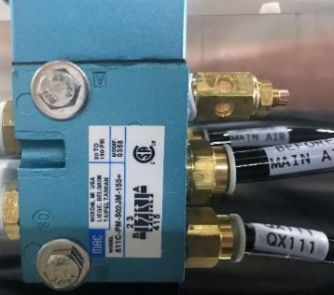
FILM FEED FAULT |  | - Ensure all dancer bars are free to move.  - Check all film feed sensors for proper operation.
FAN JAM |  | - Check that fans are turning in correct direction.  - Check for faulty sensors.

FILM TROUBLESHOOTING
OBSERVATION | SOLUTION
FILM CURTAIN NOT CENTERED | - Loosen the roll guides.  - Shift the roll right or left to center the film with the product.  - Tighten the setscrews and check the alignment.
NOT SEALING OR CUTTING FILM | - Seal bar knife is not up to temperature.  - Ensure that seal bar has had sufficient time to heat to operating temperature. (It takes 10 to 15 minutes to achieve operating temperature.)  - Heating element is burned out.  - Check heating element for proper function.  - Heating element fuse is burned out.  - Check heating element fuse.  - Thermocouple or heat controller is not functioning.  - Verify that thermocouple and/or temperature controller are functioning properly.
SEALING BUT NOT CUTTING FILM | - Seal bar knife is not up to temperature.  - Ensure that seal bar has had sufficient time to heat to operating temperature. (It takes 10 to 15 minutes to achieve operating temperature.)  - Pressure is insufficient.  - Check air supply for 65-75 psi. Check solenoid mufflers for proper functioning.  - Seal time is too short.  - Check and adjust seal time on touchscreen as needed.  - Seal blade is damaged.  - Examine blade for damage and replace if any damage noted.
CUTTING BUT NOT SEALING FILM | - The seal time is too long.  - Check and adjust seal time on touchscreen as needed.  - Seal bar knife is too hot.  - Check the seal bar temperature and reduce if needed.  - Seal bar is coming down too quickly.  - Adjust solenoid speed control screw.  - There is too much tension on the film.  - Check the dancer bar counterweight.  - Check to see if the film is slipping between drive rollers.  - Check pressure pad springs.
FILM SEAL AND CUT ARE INCONSISTENT | - There are intermittent breaks in knife thermocouple leads.  - Replace the wires (use stranded). Maintain polarity.  - Seal bar knife temperature controller is defective.  - Verify that temperature controller is functioning properly. Replace if malfunctioning.
ENTIRE FILM SEAM AND CUT ARE GOOD EXCEPT FOR SMALL AREA | - The seal bar knife is nicked.  - Check seal bar knife for damage and replace if damaged.
ENTIRE FILM SEAM AND CUT ARE GOOD EXCEPT FOR LARGE AREA | - Pressure is insufficient.  - Check air supply for 65-75 psi.  - Check solenoid mufflers for proper functioning.  - Pressure is uneven.  - Check the lower seal bar jackscrew.  - There is not enough tension on the film.  - Check the dancer bar counterweight.  - Check to see if the film is slipping between drive rollers.  - Check pressure pad springs.
NO FILM SHRINK AT ALL | - The fan belt is broken.  - Check tunnel fan V-belt for damage and replace if needed.  - The tunnel thermocouple is defective.  - Verify that the thermocouple is functioning properly. Replace if malfunctioning.  - The tunnel temperature controller is defective.  - Verify that the tunnel temperature controller is functioning properly. Replace if malfunctioning.
SHRINK GOOD ON TOP BUT NOT ON SIDES | - There is too little air circulation.  - Adjust diameter of the motor pulley to allow for more air circulation.  - The tunnel air baffles need adjusting.  - Adjust tunnel air baffles as needed to provide proper air flow.  - The tunnel motor fan is rotating in the wrong direction.  - Verify that the fan is rotating in a clockwise direction (as viewed from the top).
SHRINK GOOD ON SIDES BUT NOT ON TOP | - There is too little air circulation.  - Adjust diameter of the motor pulley to allow for more air circulation.  - The shrink tunnel is too hot.  - Reduce tunnel temperature on temperature controller. Verify that temperature controller is functioning properly. Replace if malfunctioning.
SHRINK FILM NOT CLOSING, STICKING TO CONVEYOR RODS | - Film is to one side or is not centered.  - Adjust film placement to proper position.  - The shrink tunnel is too hot.  - Reduce tunnel temperature on temperature controller. Verify that temperature controller is functioning properly. Replace if malfunctioning.  - The tunnel baffles need adjusting.  - Adjust tunnel air baffles as needed to provide proper air flow.

CARDBOARD TROUBLESHOOTING
OBSERVATION | SOLUTION
CARDBOARD DELIVERY JAM | - Inspect and Remove Jammed Cardboard: Power down the system and manually remove the jammed material.  - Check Alignment: Ensure the cardboard stack is aligned properly and not overfilled.  - Adjust Feeder Tension: Reduce or increase the pressure of rollers or guides so cardboard feeds evenly.
CARDBOARD FOLDING ISSUE | - Check Scoring  - Adjust Folding Guides: Modify the guides to ensure precise folding.  - Optimize Machine Speed: Reduce speed if folds are inconsistent.
GLUE DISPENSING | - Inspect Nozzles: Clean or replace clogged glue nozzles  - Adjust Glue Viscosity: Ensure the adhesive is at the correct consistency  - Check Pump Pressure: Regulate glue flow to prevent over- or under-dispensing
CARDBOARD COMING UNGLUED | - Verify Adhesive Quality: Use high-quality glue suitable for cardboard bonding  - Increase Pressing Time: Allow more time for glue to set before moving to the next stage  - Optimize Temperature: Ensure the glue is applied at the correct temperature for proper adhesion
DOUBLE-PICKING CARDBOARD | - Overfilled hoppers  - Use Anti-static Solutions: Cardboard can stick due to static; install anti-static brushes or use ionized air.
CARDBOARD BOWED | - Humidity Control: Maintain ideal humidity (around 40-55%) to prevent warping.

MECHANICAL PARTS LIST
DISCHARGE CONVEYOR
LOWER SEALBAR
UPPER SEALBAR
FILM FEED
FILM SUPPLY
HEAT TUNNEL
INFEED CONVEYOR


xXxMODULExXx

    - BILL OF MATERIALS

xXxMODULExXx

    - BILL OF MATERIALS

xXxMODULExXx

    - BILL OF MATERIALS

xXxMODULExXx

    - BILL OF MATERIALS

xXxMODULExXx

    - BILL OF MATERIALS

xXxMODULExXx

    - BILL OF MATERIALS

xXxMODULExXx

    - BILL OF MATERIALS

xXxMODULExXx

    - BILL OF MATERIALS

xXxMODULExXx

    - BILL OF MATERIALS

xXxMODULExXx

    - BILL OF MATERIALS

ELECTRICAL PARTS LIST

