1. INTRODUCTION

1.1 INSTITUTE’S PROFILE



TATA INSTITUTE OF FUNDAMENTAL RESEARCH
(TIFR)

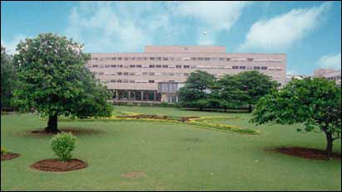
The first step in the founding of TIFR was a letter written in 1943 by Homi Bhabha to J.R.D. Tata. In this historic letter, Bhabha expressed his vision for a fundamental research institute in India, and sought JRD's support for its creation. Encouraged by JRD, Bhabha sent a formal proposal to Sir Sorab Saklatvala, Chairman of the Sir Dorabji Tata Trust, which resulted in support from the Trust and from the Government of Bombay Presidency. The Institute started functioning on June 1, 1945, at the Cosmic Ray Research Unit which had earlier been set up for Dr. Bhabha, on the campus of the Indian Institute of Science in Bangalore, after his return from England.

In 1955, the Government of India signed a new Tripartite Agreement with the Government of Bombay Presidency and the Sir Dorabji Tata Trust, as a result of which the Institute acquired its present official designation as the "National Centre of the Government of India for Advanced Study and Fundamental Research in Nuclear Science and Mathematics". This agreement envisaged extensive financial support from the Government of India, and today the Government provides most of the funding for the Institute.

On the technological side, TIFR pioneered activity in the field of Computer Technology by designing India's first computer (TIFRAC). Groups working in other emerging fields such as Accelerators, Microwave Communications, Software Technology, Semiconductor Technology and Educational Research were also set up at the Institute. Some of these later became the nucleus of dedicated organizations.


The Institute celebrated its Golden Jubilee year in 1996. A number of conferences and public lectures by distinguished scientists took place during the year. The Institute has acquired the status of a Deemed University as of June, 2003.

In addition to the research laboratories, the facilities of TIFR include:
- A large library in India with more than one hundred thousand books and journals in its collection. The library is fully computerized and provides microfilm, microfiche, audio - video and compact disk reading facilities.
- A powerful central computing facility together with individually assigned personal computers and workstations for computation, control and monitoring of experiments and data analysis.
- A network connected to the world grid through high speed communication networks.
- A liquid helium facility for very low temperature experimental studies.
- A large workshop and glass blowing section for manufacturing high precision instruments. Pioneering work done in the Institute in several areas has resulted in the establishment of new National organizations such as the Society for Applied Microwave Electronics Engineering and Research (SAMEER) and the National Centre for Software Technology (NCST). In addition, several projects for which technology was developed at the Institute, were transferred to the industry and other departments of the Government of India.
Mission of the School of Technology and Computer Science
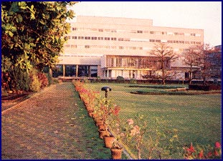
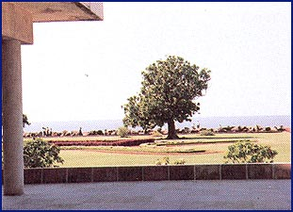
Computer Science and Information Technology have revolutionized computation, and communication expanded the basic models/paradigms of a spectrum of disciplines of Science & Technology. Information technology has become complex, easily accessible and omnipresent leading to new principles for unifying/integrating technologies and theories.

Mission of the school is to provide a:
- World-class environment for research in all areas of Technology & Computer Science for exploring theoretical foundations, applications and long-range speculative research.
- Creative environment for multidisciplinary work underpinning futuristic technologies.
- Integrated environment for researchers to interact with industry and government agencies to take on the challenges and opportunities for improving/developing the economy and quality of life in the country.
Current themes of research are:
- Algorithmics: Design and analysis of algorithms, probabilistic/ approximation algorithms, cryptography.
- Computational Mathematics: Algorithmic/Combinatorial Optimization, Scientific Computing.
- Distributed and Mobile Computing: Network Security, Distributed computing over Internet, Telepresence.
- Logics of Programs: Concurrency, Category Theory, Process Algebra, Logic programming.
- Robot Motion Planning and Robot Vision: Algorithms for robotics, collision-free path planning, motion planning.
- Software Engineering and Formal Methods: Specification, verification, safety critical systems, hybrid systems, synchronous programming languages.
- Speech and Signal processing
Growth in the following areas in addition to the above areas are contemplated in the years to come:
- Computer Networks and Architectures: High Speed Communication Networks, Ultra fast high performance architectures, VLSI Architectures
- Data Mining, Data Warehousing
- Multimedia Applications and Virtual Reality
- Automated Reasoning, Knowledge Representation, and Reasoning
- Computers and Science
- Exploratory & Futuristic Technology: Electronic, non-electronic, biological and optical computing superscalar computing technologies.

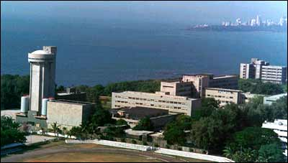
Figure 1 Top View of TIFR
1.2 RUN TIME MONITORING SYSTEMS

1.2.1 Introduction to Run Time Monitoring Systems.

Computer systems are often monitored for performance evaluation and enhancement, debugging and testing, control or to check for the correctness of the system. Monitors are used to detect violations of timing , a logical property of a program , a constraint on a language construct and so on Recently, the problem of designing monitors to check for the correctness of the system implementation has received increased attention from the research community. Traditionally, verification has been used to increase confidence that a system will be correct by making sure that a design specification is correct. However, even if a design is formally verified, it still does not ensure the correctness of an implementation of the design. This is because the implementation often is much more detailed, and may not strictly follow the formal design. So, there is a possibility for introduction of errors into an implementation of a design that has been verified.

1.2.2 Advantages of run time monitoring systems over static analysis and testing.

Traditionally, to bridge the gap between design and implementation; testing of the implementations behavior on a pre-determined set of input sequences is done. This approach, however, fails to provide guarantee about the correctness of the implementation on all possible input sequences. Consequently, when a system is running, it is hard to guarantee whether the current execution of the system is correct or not using the two traditional methods. Therefore, the approach of continuously monitoring a running system has received much attention , as it attempts to overcome the difficulties encountered by the two traditional methods for checking the correctness of the current execution of the system. These two approaches, namely static analysis and testing try to ensure that all possible executions of the system is correct , this approach, that is, run time monitoring , ensures that only the current execution of the system is correct.
Therefore, the approach of continuously monitoring of a running system has received much attention, as it attempts to overcome the difficulties encountered by the two traditional methods for checking the correctness of the current execution of the system.

1.2.3 Goal of Monitoring System
Typically, the monitoring system will work in the background while the program is being executed. The monitoring system will monitor the program for the occurrences of a particular set of events to occur. The moment the events occur the monitoring system will perform its tasks which can be categorized into two:
1. Ensure that the system is being executed as per the requirements laid down for the system.
2. Obtain additional information about the internal working of the program. The additional information can comprise of logging activity, performance evaluation, ensuring security among others.

1.2.4 Need for Run Time Monitoring
The reason for increased interest in correctness monitors is that it is becoming more and more difficult to test or verify software’s because software sizes are increasing and its functionality is becoming more complicated. With increasing size of the software’s, it is infeasible to completely test the entire system because there are too many possibilities. Also, as the functionality and structure of software’s becomes complex in order to satisfy a broad range of needs , testing needs to be sophisticated enough to check the program according to diverse criteria. For example, for testing a numerical application , it is enough to check output with the given input. However, when we test a real- time application like traffic control system , we also have to check the timing behavior.
(Typically, a monitoring script is used when the system is complex and they have cross cutting concerns. A cross cutting concern is when the code is scattered across different modules. In such a scenario upgrading the code becomes difficult. Since the code gets tangled hence, a change made in one module effects various other modules, which are difficult to track using traditional Object Oriented Programming Languages.)

1.2.5 Goal of our Project :

In this paper, we describe a framework of monitoring and checking a running system with the aim of ensuring that it is running correctly. The salient aspect of our approach is the use of formal requirements specification to decide what properties to assure. Since our goal is to check an implementation against requirements specification at run-time, we assume that we are given both requirement specification and an implementation. Our project will concentrate on the following two issues:

1> How to map high level requirement specification to low level activities of a running system.
2> How to instrument code to extract and detect necessary low level activities.

1.2.6 What characteristics of the system are monitored?

Performance : This is monitored to check the latency and the response time in various transactions and event sequences in embedded systems. This is monitored by the monitoring system events and keeping a record about their timing to detect violation of timing constraints. A recovery action should be taken on occurrence of performance degradation.

A typical example of this in an ATM system, is to monitor the time difference between a request submitted by the user and the completion of transaction. If the user is idle for more than 1 min , the transaction is aborted and the card is ejected.

Behavioral : This is monitored so as to ensure that the system behaves in the way it is expected to. This characteristic of the monitoring system ensures that a complex systems performs their core and other system level functionalities as they are expected to.

A typical example of this in a Lift Control System is that the door is open only when the lift is not moving.

Timing : This is monitored in real time systems where timing is what decides whether the system fails or succeeds.

A typical example of this in a lift control system is when you want to monitor the following : If the lift is at a floor and the door open button is pressed no more than 3 times and the total amount of time for which the door is open is no more than 30 sec's.

1.3 PROTOTYPING MODEL

The Prototyping Model is a systems development method (SDM) in which a prototype (an early approximation of a final system or product) is built, tested, and then reworked as necessary until an acceptable prototype is finally achieved from which the complete system or product can now be developed. This model works best in scenarios where not all of the project requirements are known in detail ahead of time. It is an iterative, trial-and-error process that takes place between the developers and the users.
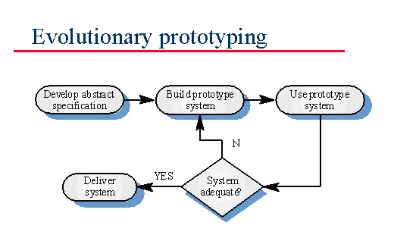
Fig. 1.3.1 Prototyping Model

There are several steps in the Prototyping Model:

1. The new system requirements are defined in as much detail as possible. This usually involves interviewing a number of users representing all the departments or aspects of the existing system.
2. A preliminary design is created for the new system.
3. A first prototype of the new system is constructed from the preliminary design. This is usually a scaled-down system, and represents an approximation of the characteristics of the final product.
4. The users thoroughly evaluate the first prototype, noting its strengths and weaknesses, what needs to be added, and what should to be removed. The developer collects and analyzes the remarks from the users.
5. The first prototype is modified, based on the comments supplied by the users, and a second prototype of the new system is constructed.
6. The second prototype is evaluated in the same manner as was the first prototype.
7. The preceding steps are iterated as many times as necessary, until the users are satisfied that the prototype represents the final product desired.
8. The final system is constructed, based on the final prototype.
9. The final system is thoroughly evaluated and tested. Routine maintenance is carried out on a continuing basis to prevent large-scale failures and to minimize downtime.

2. PROBLEM DEFINITION

SYSTEMS TO MONITOR:-

2.1. AUTOMATIC TELLER MACHINE (ATM) SYSTEM
The software to be designed will control a simulated automated teller machine (ATM) having a magnetic stripe reader for reading an ATM card, a customer console (keyboard and display) for interaction with the customer, a slot for depositing envelopes, a dispenser for cash (in multiples of $20), a printer for printing customer receipts, and a key-operated switch to allow an operator to start or stop the machine.
The ATM will service one customer at a time. A customer will be required to insert an ATM card and enter a personal identification number (PIN) - both of which will be sent to the bank for validation as part of each transaction. The customer will then be able to perform one or more transactions. The card will be retained in the machine until the customer indicates that he/she desires no further transactions, at which point it will be returned - except as noted below.
The ATM must be able to provide the following services to the customer:-
1) Customer must be able to make a cash withdrawal from any suitable account linked to the card, in multiples of $20.00. Approval must be obtained from the bank before cash is dispensed.
2) Customer must be able to make a deposit to any account linked to the card, consisting of cash and/or checks in an envelope. The customer will enter the amount of the deposit into the ATM, subject to manual verification when the envelope is removed from the machine by an operator. Approval must be obtained from the bank before physically accepting the envelope.
3) Customer must be able to make a transfer of money between any two accounts linked to the card.
4) Customer must be able to make a balance inquiry of any account linked to the card.
A customer must be able to abort a transaction in progress by pressing the Cancel key instead of responding to a request from the machine.
The ATM will communicate each transaction to the bank and obtain verification that it was allowed by the bank. Ordinarily, a transaction will be considered complete by the bank once it has been approved. In the case of a deposit, a second message will be sent to the bank indicating that the customer has deposited the envelope. (If the customer fails to deposit the envelope within the timeout period, or presses cancel instead, no second message will be sent to the bank and the deposit will not be credited to the customer.)
If the bank determines that the customer's PIN is invalid, the customer will be required to re-enter the PIN before a transaction can proceed. If the customer is unable to successfully enter the PIN after three tries, the card will be permanently retained by the machine, and the customer will have to contact the bank to get it back.
If a transaction fails for any reason other than an invalid PIN, the ATM will display an explanation of the problem, and will then ask the customer whether he/she wants to do another transaction.
The ATM will provide the customer with a printed receipt for each successful transaction, showing the date, time, machine location, type of transaction, account(s), amount, and ending and available balance(s) of the affected account ("to" account for transfers).
The ATM will have a key-operated switch that will allow an operator to start and stop the servicing of customers. After turning the switch to the "on" position, the operator will be required to verify and enter the total cash on hand. The machine can only be turned off when it is not servicing a customer. When the switch is moved to the "off" position, the machine will shut down, so that the operator may remove deposit envelopes and reload the machine with cash, blank receipts, etc.
Entries will be made in the log when the ATM is started up and shut down, for each message sent to the Bank (along with the response back, if one is expected), for the dispensing of cash, and for the receiving of an envelope. Log entries may contain card numbers and dollar amounts, but for security will never contain a PIN.
2.2. LIFT CONTROL SYSTEM
A lift control system basically is a simulation of the lift controller that controls the movement of the lifts present in the building. This product is to be installed to control elevators in a building with m floors. The lift control system basically involves the simulation of the lifts present in the building, the doors of the lifts, the floors between which the movement needs to be carried out, various buttons pertaining to each floor in the lift, buttons to call lift to a particular floor on the floor itself and a certain kind of illumination when the lift reaches the floor.
The problem concerns the logic required to move elevators between floors according to the following constraints:
1. Each elevator has a set of m buttons, one for each floor. These illuminate when pressed and cause the elevator to visit the corresponding floor. The illumination is canceled when the elevator visits the corresponding floor.
2. Each floor, except the first floor and top floor has two buttons, one to request and up-elevator and one to request a down-elevator. These buttons illuminate when pressed. The illumination is canceled when an elevator visits the floor and then moves in the desired direction.
3. When the passenger presses a button on the floor a signal is send to lifts present within the building to which the lift reacts and visits the floor .
4. When an elevator has no requests, it remains at its current floor with its doors closed.

3. LITERATURE SURVEY

3.1 MAC: A FRAMEWORK FOR RUN-TIME CORRECTNESS ASSURANCE OF REAL-TIME SYSTEMS

NOTE: The above literature survey is an extract which is published in MAC publications section of the University of Pennsylvania website. For the complete literature survey you can refer to the following URL : http://repository.upenn.edu/cis_reports/77/

Abstract
The framework describe is the Monitoring and Checking (MaC) framework which provides assurance on the correctness of program execution at run-time. The approach complements the two traditional approaches for ensuring that a system is correct, namely static analysis and testing. Unlike these approaches, which try to ensure that all possible executions of the system are correct, our approach concentrates on the correctness of the current execution of the system.
The MaC architecture consists of three components: filter, an event recognizer, and a run-time checker. The filter extracts low-level information, e.g., values of program variables and function calls, from the system code, and sends it to the event recognizer. From this low-level information, the event recognizer detects the occurrence of abstract requirements-level events, and informs the run-time checker about them. The run-time checker uses these events to check that the current system execution conforms to the formal requirements specification of the system.
This paper overviews the MaC prototype implementation, which uses JAVA as the implementation language and our Monitoring Script language as the requirements language.

3.1.1. Introduction
We develop a framework for run-time monitoring of correctness of real-time systems based on a formal specification of system requirements. Computer systems are often monitored for performance evaluation and enhancement, debugging and testing, control or to check of correctness [Sch95]. Recently, the problem of designing monitors to check for the correctness of system implementation has received increased attention from the research community [CG92, SM93, ML97, Sch98]. Such monitors can be used to detect violations of timing [ML97], a logical property of a program [CG92], a constraint on a language construct SM93], and so on.
The reason for increased interest in correctness monitors is that it is becoming more difficult to test or verify software because software size is increasing and its functionality is becoming more complicated. The most common way to validate a software system is testing. However, testing cannot be used to guarantee that the system is error-free, since it is infeasible to completely test the entire system due to the large number of possible behaviors. Also, as the functionality and structure of software becomes complex in order to satisfy a broad range of needs, testing itself needs to be sophisticated enough to check the program according to diverse criteria. For example, for testing a numerical computation, it is enough to check output with given input. However, when we test a real-time application like traffic control system, we also have to check the timing behavior.
Formal verification has been used to increase the confidence that a system will be correct by making sure that a design specification is correct. However, even if a design has been formally verified, it still does not ensure the correctness of an implementation of the design. This is because the implementation often is much more detailed, and may not strictly follow the formal design. So, there are possibilities for introduction of errors into an implementation of a design that has been verified. One way to overcome this gap between the design and the implementation is to resort to testing the implementation's behavior on a set of input sequences derived from the specification. This approach, however, suffers from the same drawback as testing in general and does not provide guarantees about the correctness of the implementation on all possible input sequences. Consequently, we cannot guarantee, using the two traditional methods prior to the execution of the system, that its run-time behavior will be correct. Therefore, the approach of continuously monitoring a running system has received much attention.

In this paper, we describe a framework of monitoring and checking a running system with the aim of ensuring that it is running correctly. The salient aspect of our approach is the use of formal requirements specification to decide what properties to assure. Since our goal is to check an implementation against requirements specification at run-time, we assume that we are given both requirement specifications and an implementation. To be able to monitor satisfaction of requirements, we have to correlate low-level observations with high-level notions used in the requirements specification. Therefore, the primary concerns of our presentation are the following two issues:

1. How to map high-level abstract requirement specification to low-level activities of a running system?

2. How to instrument code to extract necessary low-level activities?

The framework consists of the three phases: the design phase, the implementation and instrumentation phase, and the run-time phase. During the design phase, the requirements on the system are specified. Optionally, a formal system specification may also be written down and in this case we assume that verification is done to ensure that the system specification satisfies the requirements. During the implementation phase the system is implemented. Based on the requirements specification and the implementation, the user provides a monitoring script that contains instructions for instrumenting the code so that low-level information about program state can be passed on to the monitor. In addition, it also contains information that can be used to produce an event recognizer that transforms this low-level information into high-level events.
Our run-time MaC architecture consists of three components: filter, event recognizer, and run-time checker. The filter extracts low-level information (such as values of program variables and time when variables change their values) from the running code. In order to achieve this, we instrument the code of the system to be monitored. The filter sends this information to an event recognizer. It is the job of the event recognizer to map this low level information about the running code to high-level information that the run-time checker understands. Based on the values of the monitored variables it receives from the filter, the event recognizer detects the occurrence of events that are described in the requirement specification, and sends them to the run-time checker. The run-time checker then checks the correctness of the system thus far, according to a requirement specification of the system, based on the information of events it receives from the event recognizer, and on the past history. It checks the correctness of a sequence of events seen by stepping through the requirements specification and the correctness of a numerical computation by executing a program checker BK95] for that function. This is one of the main advantages that our approach over other approaches to monitoring: it provides an integrated framework to check general requirements both for control during execution and for numerical computation.
The current prototype implementation of the MaC architecture, monitors programs that are in JAVA byte code and uses a new language called MEDL which is related to linear temporal logic to describe the formal requirements. Although MEDL is used for requirements specification, it is possible to use other formal languages like [ACSR BGLG93], temporal logic, or Petri nets, by making only minor modification to the existing framework. Section 2 summarizes related research.
3.2 AN OVERVIEW OF ASPECTJ

NOTE : The above literature survey is an extract of the lecture notes on AspectJ. For the complete lecture notes visit the following URL : http://portal.acm.org/citation.cfm?id=680006

3.2.1. THE ASPECTJ LANGUAGE

AspectJ extends Java with support for two kinds of crosscutting implementation. The first makes it possible to define additional implementation to run at certain well defined Points in the execution of the program. We call this the dynamic crosscutting Mechanism. The second makes it possible to define new operations on existing types. We call this static crosscutting because it affects the static type signature of the Program. This paper only presents dynamic crosscutting.

Dynamic crosscutting in AspectJ is based on a small but powerful set of constructs. Join points are well-defined points in the execution of the program; pointcuts are a means of referring to collections of join points and certain values at those join points; advice are method-like constructs used to define additional behavior at join points; and aspects are un its of modular crosscutting implementation, composed of pointcuts,Advice, and ordinary Java member declarations. This section of the paper presents the main elements Of the dynamic crosscutting support in the language. The presentation is informal and example-based.

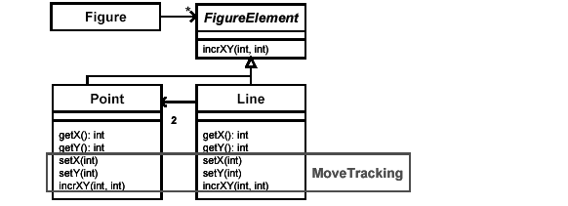

Fig. 3.2.1.1. UML description of a simple figure editor.

The box labeled “Move Tracking” shows an aspect that crosscuts methods in the Point and Line classes.

3.2.2 JOINT POINT MODEL
The join point model is a critical element in the design of any aspect-oriented language mechanism. This model provides the common frame of reference that make sit possible for execution of a program’s aspect and non-aspect code to be properly coordinated.

In previous work, we have used several different kinds of join point model, including primitive application nodes in a dataflow graph [13, 18, 23, 27] and method bodies [27, 28]. Early versions of AspectJ used a model in which the join points were principled places in the source code. The dynamic crosscutting elements of AspectJ are now based on a model in which join points are certain well-defined points in the execution of the program. This model gives us important additional expressive power,
discussed in Section 3.9. In this model join points can be considered as nodes in a simple runtime object call graph. These nodes include points at which an object receives a method call and points at which a field of an object is referenced. The edges are control flow relations between the nodes. In this model control passes through each join point twice, once on the way in to the sub-computation rooted at the join point, and once on the way back out. We illustrate join points using a simple figure editor, the kernel of which is shown in Figure 1, and which also serves as a running example. (Complete code from the paper is at aspectj.org/doc/papers/ecoop2001.) Based on these classes, executing the first three lines of code in Figure 2 builds the objects shown below. In this picture large circles represent objects, square boxes represent methods and small numbered circles represent join points. Executing the last line starts a computation that proceeds through the join points labeled below. In each case the join point is first reached just before the action described begins executing. Control passes back through the join point when the action described returns.
Point pt1 = new Point(0, 0);
Point pt2 = new Point(4, 4);
Line ln1 = new Line(pt1, pt2);
ln1.incrXY(3, 6);

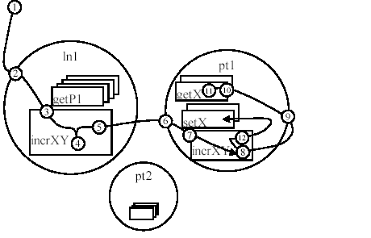
Fig 3.2.2.1 Joint Point Model

1. A method call join point corresponding to the incrXY method being called on the
object ln1.
2. A method call reception join point at which ln1 receives the incrXY call.
3. A method execution join point at which the particular incrXY method defined in
the class Line begins executing.
4. A field get join point where the _p1 field of ln1 is read.
5. A method call join point at which the incrXY method is called on the object pt1.
...
8. A method call join point at which the getX method is called on the object pt1.
...
11. A field get join point where the _x field of point pt1 is read.Control returns back through join points 11, 10, 9 and 8.
12. A method call join point at which the setX method is called on p1.
… and so on, until control finally returns back through 3, 2 and 1
3.3 RUN-TIME MONITORING FOR DEPENDABLE SYSTEMS: AN APPROACH AND A CASE STUDY

NOTE: The following literature survey is an extract of an IEEE paper. For the complete paper visit the following URL : http://www2.computer.org/portal/web/csdl/doi/10.1109/RELDIS.2004.1353002

Abstract
This paper describes a run-time monitoring system designed for same functionality systems installed in different places that use equivalent hardware configurations, but with slightly different implementations. These systems exhibit common characteristics. They are large software systems, they depend on hardware to execute theirs functions, and they are usually adjusted to meet new user needs. In this scenario it is unreasonable to assume that software testing will uncover all latent errors. Besides gathering information about a target program as it executes the run-time monitoring, system proposed provides information about the target operating system and the target hardware in order to improve availability by reducing time to diagnose failures and provide a system with the reactive capability of reconfiguring and reinitializing after the occurrence of a failure. A case study for an Automatic Teller Machine system is discussed as an application of the run-time monitoring system and the results from this application are presented.

3.3.1. Introduction

Reliability and availability are essential characteristics for computer systems operation. A runtime monitoring system contributes for improving reliability and availability, respectively, by continuous failure detection and by reducing time to diagnose failures. In most systems, the savings in ground support and maintenance costs offset the initial cost of hardware and software monitoring system in a year [2].Savings in ground support costs are achieved by reducing manual diagnostic costs. The run-time monitoring system will automatically identify failures as they happen in normal operation. Thus, support personnel spend less time and money in troubleshooting failures. This also results in reduced turn-around times and improved system availability.

3.3.2. Background

Monitoring gathers information about a computational process as it executes and can be classified by its functionality. Dependability includes fault tolerance and safety. Performance enhancement includes dynamic system configuration, dynamic program tuning, and on-line steering. Correctness checking is the monitoring of an application to ensure consistency with a formal specification. It can be used to detect run-time errors or as a verification technique. Security monitoring attempts to detect security violations such as illegal login or attempted file access. Debugging and testing employs monitoring techniques to extract data values from an application being tested. Performance evaluation uses monitoring to extract data from a system that is later analyzed to assess system performance. We focus on two of these six functional areas: dependability, and debugging and testing. Furthermore, we can classify the monitoring approaches as hardware, software, and hybrid monitoring . Hardware monitoring requires an instrumentation of the hardware platform on which the target program runs. The monitoring system consists of the monitoring hardware and a software monitoring control module and is separated from the target system. The execution of the target program is monitored directly via the monitoring hardware, which is connected to the system buses without any embedded instrumentation code. The monitoring system and the target system do not share any computational resources. Consequently, the hardware monitoring approach causes no intrusion or minimum monitoring intrusion on the execution of the target program and is the most suitable approach for systems with stringent real-time constraints. The disadvantage of hardware monitoring is the cost and the inherent limitations of hardware. Hardware monitoring is usually machine dependent or at least processor architecture dependent. Software monitoring requires an instrumentation of the application source code. The instrumentation code is inserted into the target program by means of instrumentation software. The generated events of interest are detected as well as processed by the target system. Because the monitoring system is part of the target system, software monitoring will introduce an overhead on the target system’s processing time and memory space, as a result of the execution of additional instrumentation code and the execution of event detection and processing. This intrusion may change the event ordering and timing of the target program, which is unacceptable in many hard real-time systems. The advantage of the software monitoring approach is that it is flexible and requires no additional hardware [1]. In hybrid monitoring both software and hardware are used to perform monitoring activities. Hybrid monitoring approach employs software to specify the events to be detected in the monitored target program in conjunction with dedicated hardware devices to identify and to process these events. Hybrid monitoring approach brings together the non-intrusive nature of hardware monitoring approach and the flexibility of software monitoring approach. In this approach, the instrumentation code is executed as a part of the of the target system, while event detection and processing are performed by a separate monitoring hardware [6].

3.3.3. Run-time monitoring system
Monitoring target systems that do depend on hardware to execute theirs functions and must present high availability degree is the goal of the run-time monitoring system described in this paper. The monitored information includes the run-time behavior of the monitored program and pertinent information from the operating system, from the hardware platform and from the computing resource consumption. Thus, the run-time monitoring system must attend to the following requirements: to monitor the target program execution, to collect target hardware platform information, to monitor the computing resource consumption, to increase the target system availability, and to be a flexible monitoring framework.

3.3.3.1. Monitoring approach selecting

Event detection and processing can be performed in a number of different ways, each of them causing a different amount of interference with the system under monitoring. The optimal solution for monitoring with respect to interference is a hardware monitor that is able to detect events without affecting the activity of the system under monitoring. This is accomplished usually by passively monitoring the target processor’s data, address, and control buses. However, most state changes of the software are not reflected by signals on externally accessible signal lines, but they result only in some on-chip operations. Often, a lot of different logical events are mapped to the same measurable physical event, for example, access to the same memory location from different contexts. If the internal state of the system context must be known to detect an event, software monitoring approach is needed. To overcome these problems a hybrid monitoring approach could be used. This approach suffers the same architecture adaptability limitations as the hardware monitoring approach, though. So, the monitoring system ends up being target specific and therefore very expensive in most cases. Besides that, the observations will be on a very low level of detail. In order to test and debug a system at satisfactory levels of reliability we fundamentally need to observe the system. Including instrumentation code in the software (application and kernel), we can observe significantly more than possible with hardware monitoring approaches. Also, to properly execute this function, the monitoring system must be an integral part of the target system. Thus, for most application domains, pure software monitoring seems to be the better solution. Different from hardware monitoring systems, software monitoring systems are easier to change, and many changes can be made without adding new components. When a system is replicated or located in a physical place that is hard to reach, it is far easier to make changes in software than in hardware. Besides that, software monitoring approach flexibility makes it possible to provide more information to programmers and to provide information in a more useful form.

3.3.3.2. Monitoring framework contributions
The monitoring framework intend to present the following main contributions:

1) To outline the run-time monitoring utilization importance: Besides being a useful testing and debugging tool, to improve availability by reducing time to diagnose failures and provide a system with the reactive capability of reconfiguring and reinitializing after the occurrence of a failure is the main goal of the run-time monitoring system

2) To collect hardware platform information :Sometimes a software error arises from a hardware failure. The more hardware technologies evolve the more difficult to reproduce all the system’s combinations of hardware components. In this context, hardware platform information can be valuable debugging information.

3) To monitor the computing resource consumption: During its execution, a system can face abnormal resources consumption and can fail in these stress conditions. Such conditions are hardly reproduced in laboratory. Incorrect use of resources, especially memory, can compromise the target system availability. Information obtained from the monitoring log files can be used to implement program mechanisms to treat these situations.

3.3.3.3. Architecture overview

The run-time monitoring system architecture presented in Figure 1 consists of five major
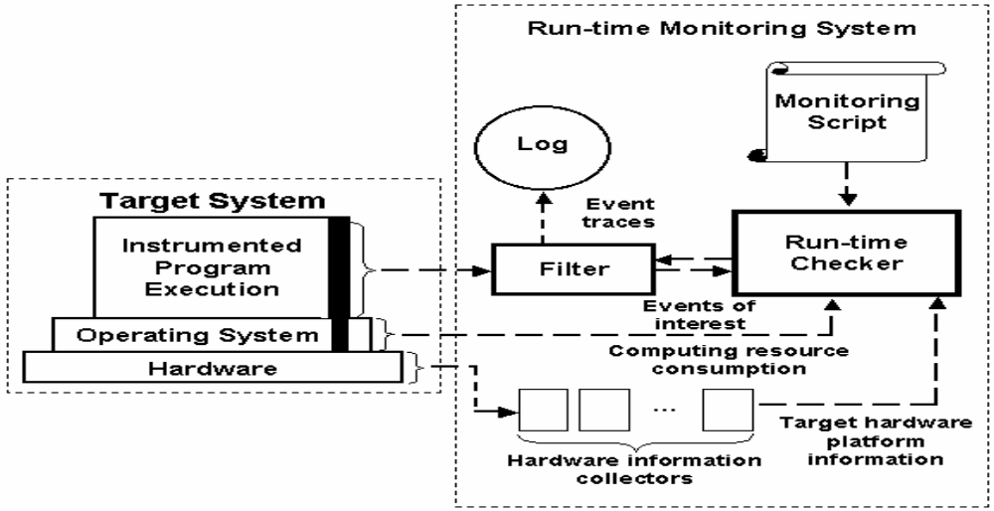
Figure 3.3.3.3.1 Run Time Monitoring System Architecture

components and some interactions among them. In the following, we identify the functionality of each component and describe the interactions among them. Figure 3.3.3.3.1. Run-time monitoring system architecture The hardware information collectors are responsible for obtaining target hardware platform information. Every hardware subsystem (CPU, memory, disks, etc) has a specific hardware information collector module. From this information we can improve the hardware management process, what means to evaluate the impact caused by an obsolete or faulty hardware component replacement, to follow up hardware component replacement, to determine the amount of equipment that supports new capabilities or enhancements like higher video monitor resolution and power energy save, to detect the use of hardware components not homologated, and to verify if hardware components are not being replaced for others with lower levels of performance and capacity. The sensors represent the instrumentation code, they are small code stretches inserted in the target program in order to detect events of interest. Each sensor observes the behavior of a small part of the target program state space and is activated by a change on the entity it is observing such program variables, functions calls, interruptions occurrence, etc. Thus, the sensors are placed in the points where changes in the entities under observation can occur. The run-time monitoring system adopts the statically and manual instrumentation. That is, the programmer reads the program source code and inserts the sensors before the system is executed [7, 9]. Concerning target operating system events detection, as long as the source code of the operating system kernel is available, e.g. Linux, the code can be analyzed and the sensors can be placed at the right locations. Thus, this new-instrumented kernel can be used as the target operating system. As long as the kernel provides hooks, that means, debugging API, e.g. Vx Works, the operating system instrumentation can be done by using this API. If neither approach is available, e.g. Windows NT, the operating system instrumentation must be done by using kernel device drivers. The filter receives the events detected by the sensors and it is responsible for selection, reduction and storage of trace data pertinent to the events of interest. Event record descriptions and selection rules are used to specify the criteria for data selection and reduction. Thus, users can save only the events that match certain criteria. For example, one user may only want to save events generated by a specific process, or events generated at a specific time interval. The filter interprets the selection criteria and decides which event traces are to be kept and which are to be discarded. Among the information associated to the events we can mention the following: source code file name, line number in the source code file, event occurrence time, event type (error, warning, or information), process identification, and specific information like variable values and control flow information. The monitoring script describes how the target system requirements are monitored. In order to monitor and to verify the fulfillment of the target system requirements, referring information about the events that occur in the target system and about the states covered for the target system execution, and the relations between the events and the states must be explicitly specified in the monitoring script. For example, a system execution can be expressed in terms of its processes execution. So, one form to monitor the system execution is to verify if its processes are being executed correctly.

Figure 3.3.3.3.2 shows a system composed of three processes Pa, Pb, and Pc that must execute in a specific sequence. In this sequence of execution, the regions R1, R2, R3, and R4 represent states that must be covered by the system inside specifics intervals of time: t1, t2, t3, and t4, respectively. If the system remains in some of the states represented by regions R1, R2, R3, and R4 for an interval of time bigger than the biggest value in the set t1, t2, t3, and t4, that means an error in the system execution. Figure 3.3.3.2. System execution example Thus, monitoring the system execution with a sample period bigger than the biggest value in the set t1, t2, t3, and t4 is enough to verify the system execution. Figure 3.3.3.3 represents a monitoring script stretch used to verify the example discussed above.

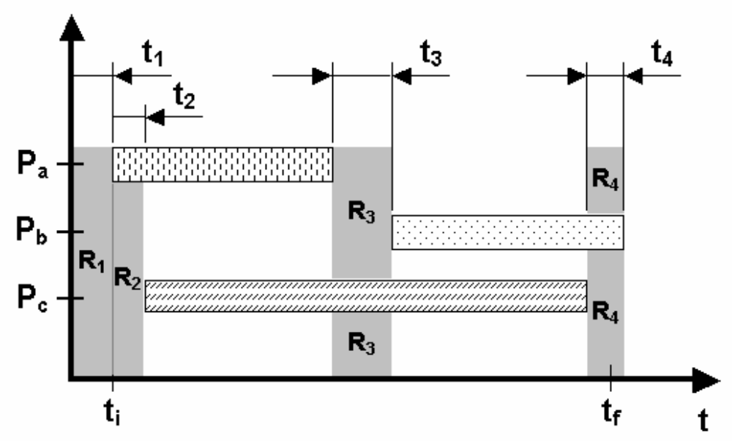

Figure 3.3.3.3.2 System Execution Example

As shown in Figure 3.3.3.3, the sample period value for the state represented by region R1 is 40 seconds and the error code for this situation is E0h.

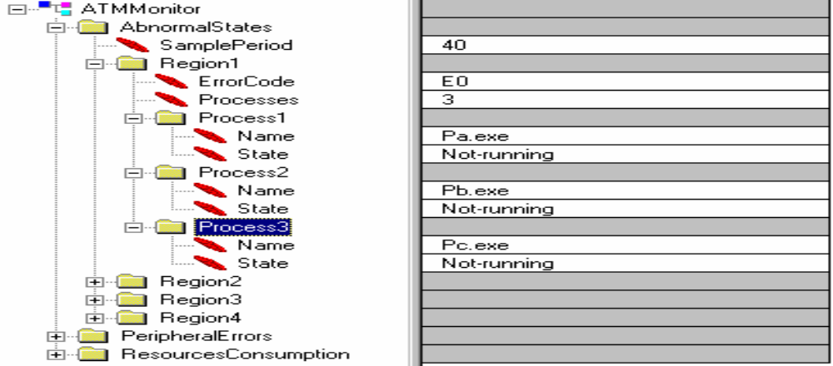

Figure 3.3.3.3 Monitoring Script Stretch
Figure 3.3.3.3. Monitoring script stretch Based on requirements specification the run-time checker verifies if a system execution belongs to a set of acceptable behaviors. This component congregates the information about event occurrence generated by the target system execution, the hardware platform information, and computing resource consumption information in order to check the target system execution. The log information repository is responsible for the event occurrence information storage. It can be as simple as a buffer or a queue or as sophisticated as a relational database.

3.3.4. Case study

This case study presents the run-time monitoring system utilization for an Automatic Teller Machine (ATM) system. The ATM system has been chosen as the target system because it must present high availability levels, it must be a reliable system, it depends on hardware to execute its functions, and it is usually adjusted to meet new user needs. As shown in Figure 4, the monitoring system comprises the run-time monitoring system, a TCP/IP communication infrastructure (one instance per monitored ATM), and a remote monitoring user console.

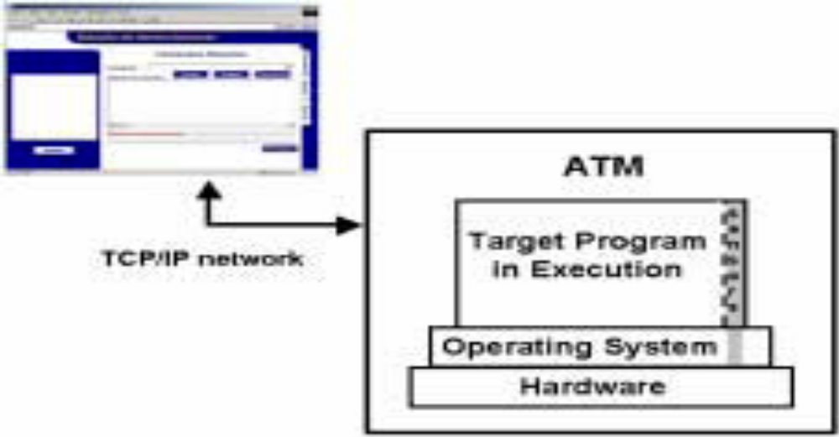
Figure 3.3.4.1 Monitoring System Components.

Figure 3.3.4.1 Monitoring system components The remote communication infrastructure represented in Figure 3.3.4.1 allows transferring log files from each monitored ATM system to the central monitoring console, transferring a specific monitoring script from the central monitoring console to a particular ATM system, and ATM remote initialization.

3.3.4.1. Target system description

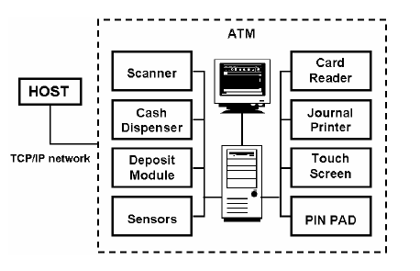
Figure3.3.4.1.1.ATM System Diagram

As shown in Figure 3.3.4.1.1, an ATM system can be seen as a computer attached to some peripherals (journal printer, magnetic stripped card reader, cash dispenser, etc). The ATM system described in this case study uses Intel x86 architecture as hardware platform and Microsoft Windows 2000 as software platform. From the technical point of view, Windows 2000 can be considered one of the most difficult target operating system for instrumentation, as its monitoring tools are not sufficient to provide detailed traces of system events with accurate time-stamps, it does not include predefined hooks for installing sensor code (like VxWorks), and it is not available in source code (like Linux). As the ATM system depends on hardware to execute their functions, the system design is based on WOSA/XFS (Windows Open Services Architecture Extensions for Financial Services) that defines a general architecture for access to service providers from Windows-based applications. The focus of the WOSA/XFS architecture has been on providing access to peripheral devices that are unique to financial institutions. Since these devices are often complex, difficult to manage, and proprietary, the development of a standardized interface between them and both Windows-based applications and Windows operating systems can offer for financial institutions and their solution providers immediate enhancements to productivity and flexibility

3.3.4.2. Target system monitoring requirements
In the target system requirements specification phase the following requirements have been chosen to be monitored: ATM system availability, peripherals reliability, hardware configuration, and resources consumption (CPU, memory, and disk space). The ATM system availability can be measured by monitoring some events: abnormal processes sequence execution, time out from peripherals, deadlock, endless loop, abnormal use behaviors, lost events and messages, etc. Peripherals reliability can be measured by monitoring relating peripherals firmware versions to the errors presented by each peripheral model. Thus, adjusting maintenance efforts, peripherals reliability can be improved. Besides that, this function guarantees that only homologated peripherals are being used. The hardware configuration monitoring aims to guarantee the quality of service to the ATM system’s users, that is, to offer a satisfactory system.

3.3.5 Run-time monitoring system interference
Another important result is the run-time monitoring system applicability. The goal in the run-time monitoring system design and implementation was the interference minimization as far as possible. However, as shown in Table 1, a benchmark realized on a 733 MHz Pentium III with 128 Mb of RAM and 10 Gb disk, outlined that the interference is significant Despite this interference, the run-time monitoring system architecture proposed can be an attractive monitoring tool in order to support development and maintenance activities. Mainly for Windows 2000 equivalent operating systems that are not available in source code neither provides sufficient debugging API, but are an attractive software platform solution for many soft real-time and embedded systems solutions. Besides that, the run-time monitoring system contributes to increase the overall system availability and reliability [4].

3.4 A Lift Simulation Prototype
NOTE: The following is a literature survey taken from http://citeseerx.ist.psu.edu/viewdoc/summary?doi=10.1.1.14.6677 . For the complete paper visit the above URL

ABSTRACT
We present a simple simulation of lift (or elevator) operation that has been developed as a prototype to address the need for the development of such systems. We first define the type of simulation that has been developed as a discrete-event, dynamic, stochastic simulation. To do this, we present an overview of pertinent research in computer simulation, and identify some ambiguity in the use of terminology. We then describe the system that we have developed. Next we discuss the decisions taken in its realization, which are related to our research overview, and end by identifying some areas that we feel warrant further development. We believe that such a simulation can provide an important tool for the designers of lift systems. This prototype demonstrates its feasibility.

3.4.1 INTRODUCTION
A bank of lifts is a physical system whose behavior can greatly affect the day-today lives of many individuals. If it is possible to model this behavior, the provision of a simulation that can be used to examine the effects of different scheduling policies becomes feasible. This paper describes a prototype that was developed to demonstrate that such a simulation can be created.

Although it is not physically possible, at least at the present time, to have a lift system that provides service the instant it is requested to every user, it is certainly possible to avoid the situation where lifts make many unnecessary trips. In other words, what we wish to achieve is a situation that ‘pleases most of the people most of the time’. This relates directly to the objective function we have found in Reference [1] (presented in the section on ‘Traffic generation and statistics’) which forms the basis of the model that we have constructed. The ultimate goal is to have a tool whereby it can be determined what sorts of lift behavior, for any given configuration of lifts in a building, will achieve the desired situation. This is done by choosing a lift scheduling system and testing it over a period of time to obtain values for the objective function.

What we describe in this paper is an attempt to provide a system that will simulate a (configurable) lift bank that services requests from users. Described simplistically, the requests are made by generating a signal (pushing a button) at the floor at which the lift is required, and once the lift has arrived, details of the service required are indicated by the choice of a destination floor

3.4.2 SIMULATION AND LIFTS
We present a brief general discussion of some important aspects of computer simulation, primarily to clarify the use of terminology and also to locate the context of the implementation presented in later sections of this paper. We also discuss issues particular to lift simulation. The view we take of simulation is a generally accepted one, according to that of Bratley et al.,[2] Roberts et al.,[3] Law and Kelton4 and others. It focuses on the concept of a model, which is a description of a system that is intended to predict what happens if certain actions are taken. The prototype we have developed is a discrete event, fixed increment, stochastic simulation.

3.4.2.1 Categorization of simulation
1. Discrete-event or continuous. Lift systems can be viewed as discrete-event systems in the sense that the changes that are significant can be seen as occurring at discrete instants.

2. Fixed-time increment (synchronous) or variable-time increment (asynchronous).In our simulation we have used a fixed-time increment where the length of the interval is based on the time taken for a lift to move between consecutive floors. Katz10 and Sakai and Nagao11 give examples of the use of fixed-time increment in simulation.

3. Static or dynamic. A static simulation is a representation of a system at a particular time.[4]

4. Stochastic (probabilistic) or deterministic. The system is a stochastic simulation since there is a random component in the system, which is the behavior of lift users. (The behavior of the lifts is deterministic, depending only on requests for service and scheduling policies. However, the model is driven by random input, in the form of the distribution of lift users. Thus we see the model as being deterministic, but the simulation itself as being stochastic, where we are interested in the use of lifts rather than the lifts themselves.)

3.4.2.2 Use of simulation in lift operation design
The paper provides a good discussion of lift operating policies, and we have used their categorization of external calls and their search policies. The actual realization of the simulation is not discussed by them, though the general operation of the simulation is also described. Adler[12] gives some general guidelines regarding computer simulation of lifts. These are given in the context of a general discussion of lifts as transportation systems, and include the interaction of various components of lift systems (such as mechanical, electrical, operation, installation). Adler also stresses the value of such simulations.

Mocek and McDermid[14] describe the use of formal specification(Milner’s CCS[15])for implementing a lift control system. This uses CCS to specify a particular operation of a lift system, while avoiding the details of scheduling. The system is seen as a method of switching off lights that have been switched on by an external agent (much in the way we see servicing requests from lift users). They focus on the use of communicating agents for achieving their logic, and see the lift model primarily as a good example to illustrate the use of formal specification as an aid to software implementation. Expert system technology has been useful in the design of lift systems from the point of view of their mechanical and electrical operation.[16].

3.4.3 PROTOTYPE IMPLEMENTATION
The program is a simulation of a bank of lifts containing a number of variables that the user can specify. The user can choose the number of lifts, the number of floors and the volume or capacity of each individual lift. The system is executed under an operating policy which consists of a search policy and a routing policy. Search policies decide which floor the lift should go to if it is empty, and routing policies decide which floors each lift can service. A floor is said to be blocked for a particular lift if the lift cannot serve it.

The user is required to specify the arrivals of traffic to a floor and the departures of traffic from a lift at a floor, as percentages of the arrivals and departures to all floors. This defines the traffic pattern of the lift system, and the accuracy with which this is done will directly affect the validity of the simulation run. There are two types of simulation run—a statistical run with no animated display but where a report can be printed, and a graphics run with an animated display but with no report facilities.

The simulation uses a fixed-time increment. [4,6–9] The basic time-unit of a simulation run is the time taken for a lift to travel between two consecutive floors. (We have assumed that this is the same for both upwards and downwards travel, and that there is no difference in time taken whether the lift stops or not.) All other variables concerning time are defined in terms of this basic time-unit. They are the number of arrivals per time-unit and the length of an individual run in time-units. The user can specify the number of individual runs to be done with the same variables.

3.4.4 Traffic generation and statistics
The user specifies the percentage arrivals of all traffic at each floor and the percentage departures from each floor. This is the real data that the user of the simulation must collect to ensure that the simulation gives an accurate reflection of the lift system being studied. The percentage arrivals (and departures) sum to 100 per cent and the cumulative sum is used to allocate floors with a pseudo-random generator.6,7 When traffic is generated, a random number is obtained between 1 and 100 and, depending on the cumulative percentages, a floor at which to start is chosen. Similarly a floor at which to end is chosen. This floor is checked to ensure that it is a different floor to the start floor and that there actually is a lift that serves those two floors. The program retains a record of the travel between floors and in the report an analysis of the traffic pattern is given and can be compared with the figures that the user specified. A number of statistics are calculated on a statistical run and these are printed in the report.

The objective function
The most important statistic is the objective function which is taken from Reference
1. It is described as follows:

ΣaΣb w_{ab}E(tab)/tab

where wab is the average time to travel between floors a and b, E(tab) is the percentage of travel between floors a and b, and tab is the minimum time to travel between floors a and b . This is summed across all pairs of floors a and b. Note that this function is dimensionless—it is a measurement of performance that we wish to minimize. This is done by choosing appropriate operating policies for the lift system under consideration. By weighting the average travel time by the percentage travel, we try to ‘please most of the people most of the time’. By dividing by the minimum travel time (the time taken to travel from a to b without any waiting time), we do not penalize pairs of floors that are far from each other.

When a passenger enters the system, a note of the time is made. Then when a passenger enters the lift, the total journey time including the waiting time can be calculated. The number of journeys made from the start floor, a, to the destination floor, b, is incremented. This allows us to calculate the average time taken to travel from the start floor to the destination floor, across all journeys. The percentage travel between a and b is calculated from the number of journeys between a and b and the total number of journeys. The minimum travel time is the time the lift takes to go from floor a to floor b without waiting. An objective function is calculated for each individual run and the mean and standard deviation of these are calculated across all runs.

3.4.5 ANALYSIS
The animation and the simulation were done in stepped fashion with fixed-time increments.[4,6–9] Therefore, instead of using an event-oriented simulation where the clock is updated to the time of the next event, the clock is updated every time-unit, at fixed time intervals. Law and Kelton [4] note that fixed-time advance is a special case of variable-time advance. The events that can occur are the arrival of more passengers to the system and the actions of the lifts which involve loading and unloading of passengers and moving between floors, and the events are handled at the end of the intervals in which they occur.

There are some disadvantages and advantages to this approach. Law and Kelton[4] say that disadvantages of fixed-time increment advance are that error is introduced by processing events at the end of the time interval and that one must decide how to order events. The first disadvantage is a problem in that it can coarsen the simulation if the time interval is not small enough. It also imposes some assumptions: first that the lifts move between floors all at exactly the same time instant and secondly that when people arrive at a floor to call a lift, they all arrive simultaneously. We feel that this approach does make the model slightly coarser than one using variable time increments. The second disadvantage is less significant as a lift can serve a number of people simultaneously.

Bratley et al.2 list the disadvantages as follows: it is hard to program—although the clock mechanism is simple there is a problem of deciding how to schedule the non-simultaneous events at the interval—and the interval often has to be small for reasons of accuracy and this causes the simulation to be slower. As mentioned above, the fact that events can be treated as simultaneous because a lift can serve multiple passengers, removes the problem of scheduling events at the interval. Therefore, since the clock mechanism is simple to implement and there is no scheduling problem, the fixed-time increment approach is easier to implement.

3.5 Validation and Optimization of an Elevator
Simulation Model with Modern Search Heuristics

NOTE : Following is a literature survey taken from the following URL http://lwww.cs.uni-dortmund.de/people/tom/ci158 . For the complete paper visit the above URL

Abstract

Elevator supervisory group control (ESGC) is a complex combinatorial optimization task that can be solved by modern search heuristics. To reduce its complexity and to enable a theoretical analysis, a simplified ESGC model (S-ring) is proposed. The S-ring has many desirable properties: Fast evaluation, reproducibility, scalability, and extensibility. It can be described as a Markov decision process and thus be analyzed theoretically and numerically. Algorithm based validation (ABV), as a new methodology for the validation of simulation models, is introduced. Based on ABV, we show that the S-ring is a valid ESGC model. Finally, the extensibility of the S-rin
g model is demonstrated.

3.5.1 Introduction
Today’s urban life cannot be imagined without elevators. The central part of an elevator system, the elevator group controller, assigns elevator cars to service calls in real-time while optimizing the overall service quality, the traffic throughput, and/or the energy consumption. The elevator supervisory group control (ESGC) problem can be classified as a combinatorial optimization problem [1, 2, 3]. It reveals the same complex behavior as many other stochastic traffic control problems, i.e. materials handling systems with automated guided vehicles (AGVs). Due to many difficulties in analysis, design, simulation, and control, the ESGC problem has been studied for a long time. First approaches were mainly based on analytical methods derived from queuing theory, whereas currently computational intelligence (CI) methods and other heuristics are accepted as state of the art [4, 5].

1 The Elevator Supervisory Group Controller Problem
Fig. 3.5.1.1 shows the key role of an elevator group controller: It determines the floors where the cars should go to. The elevator controllers handle the functions inside the car, such as door control, measurement of the car load, and car calls. Since the group controller is responsible for the allocation of elevators to hall calls, a control strategy to perform this task in an optimal manner is required. The main goal in designing a better controller is to minimize the time passengers have to wait until they can enter an elevator car after having requested service.This time-span is called the waiting time. The so-called service time additionally includes the time a passenger stays within the

An important aspect is the changing traffic pattern we can observe throughout the day in an office building [8]. There is ‘up-peak’ traffic in the morning when people start to work and symmetrically we observe ‘down-peak’ traffic in the evening. Most of the day there is ’balanced’ traffic with much lower intensity than at peak times. ‘Lunchtime’ traffic consists of two often overlapping - phases where people first leave the building for lunch or head for a restaurant floor, and then get back to work. The ESGC problem subsumes the following problem: How to assign elevators to passengers in real-time while optimizing different elevator configurations with respect to overall service quality, traffic throughput, energy consumption etc.

. 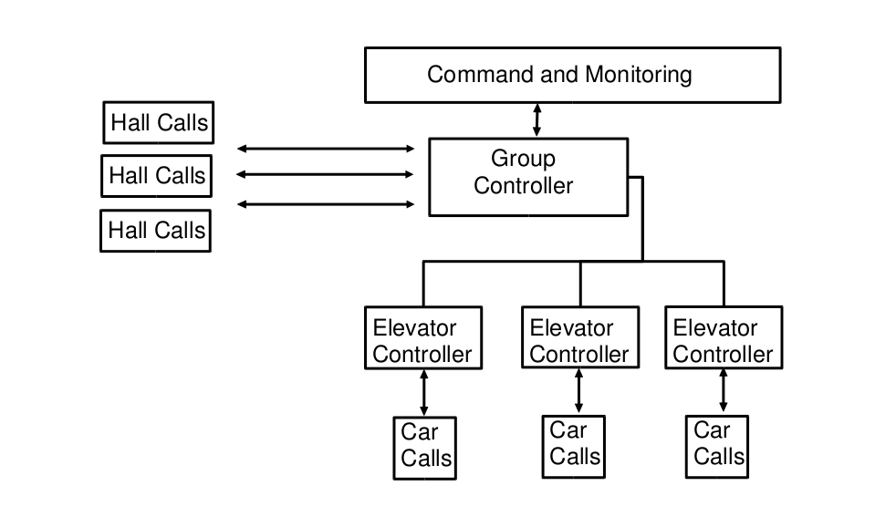
Figure 3.5.1.1: Elevator Group Controller Architecture

Fujitec, one of the world’s leading elevator manufacturers, developed a controller that is trained by use of a set of neuro-fuzzy controllers. Each controller represents control strategies for different traffic situations [8]. The NN structure and the neural weights determine a concrete control strategy. The network structure as well as many of the weights remain fixed, only some of the weights on the
output layer can be modified and optimized. A discrete-event based elevator group simulator permits computing the controller’s performance.

4. POLICIES TO MONITOR

4.1 Embedded Real Time Lift Control System

1. If a lift passes a floor and there are pending request to go in the same direction then the lift will stop.

2. If one or more lifts are idle and a new request arrives, then one of the lifts will move to service the request (Criteria for lift selection: That lift that is closest will service the request)

3. Once a request is send the lift should arrive within 2 minutes.

4. Doors of the lift should be closed while the lift is moving.

5. Doors of the lift should open only when the lift is stationary, or when the desired floor or requested floor is reached.

6. Monitor the time taken for the doors of the lifts to open and close.

7. Whenever a floor is pressed then in that case light corresponding to that floor should be illuminated on the side from where the lift is called. We have to monitor that this light glows whenever a call is made.

8. Properties related to Scheduling policies for lift will be formulated and these will be monitored.

9. The lift should service all pending request in the direction of its motion (up or down)

10. The total load inside the lift should not exceed the maximum limit. If such an event occurs then the lift should remain stationary.

4.2 Multi User Transaction Processing ATM (Automatic Teller Machine) System.

1. If customer ejects his ATM card then the card should be dispensed within 30 sec.

2. If the customer is idle for a certain period then the card should automatically be ejected.

3. Only if approval is obtained from the bank to withdrawn cash then only the system should dispense cash (Involves bank)

4. In the event of a transfer transaction the amount transferred from one account should be equal to the amount credited in the other account. ( i.e. consistency of in transfer should be maintained ).

5. Atomicity of transaction should be maintained.

6. If the cancel key is pressed before the transaction completes then the transaction must be aborted. If the cancel key is pressed after the transaction is complete then no effect of the cancel key. Priority should be given to cancel key .

7. If the PIN is entered wrongly 3 times then card should be made invalid. ( Also whether the pin is entered wrongly 3 times should also be monitored. )

8. Performance monitoring ( e.g : time taken by ATM to respond to customer request for withdrawal of cash , or depositing cash or time taken to transfer funds from one account to another )

9. Monitoring the access to the ATM machines , and recording number of users accessing it at different intervals of time during the day, so as to dispense cash reserve in those ATM's where access is frequent.

10. If an account is a joint account of a number of customers and if there are various instances of the ATM machines such that the customers related to the account access it from various other machines then consistency and mutual exclusion needs to be maintained.

11. Alert message should be sent if more than 5 transactions are (successfully) attempted from the same card within a day.

12. If a day’s withdrawn amount exceeds 3 times the average daily withdrawn amount then raise an alarm.

13. Total amount of cash withdrawn should be less than maximum limit.
5. PROPOSED SYSTEM

5.1 FRAMEWORKS

5.1.1 GENERAL WORKING OF MAC FRAMEWORK

Block diagram:
System
Specifications
Requirement
Specifications
Formal verification
Design
System
Implementation
Monitoring
Script
Implementations
Checker/
Corrector
System
Filter
Communication
Run-time Check
Event
Handler
Corrector
Checker

Figure 5.1.1.1 MaC Framework

The above figure shows the framework, which consists of the three phases:

1. Design phase.
2. Implementation/instrumentation phase.
3. Run-time phase.

During the design phase, the requirements on the system are specified. Optionally, a formal system specification may also be written down and in this case we assume that verification is done to ensure that the system specification satisfies the requirements.

During the implementation phase the system is implemented. The other main task of this phase is to write down a script called the monitoring script that contains instructions for instrumenting the code so that low-level information about program state can be passed on to the monitor. In addition, it also contains information that can be used to produce an event recognizer that can transform this low-level information into high-level events.

During the run time phase the monitor checks for the occurrences of high level events and on the occurrences of these events checks whether they are satisfying the requirement specifications specified in the design phase. If they are not satisfying the requirements then necessary action which is specified in the design phase is taken.

Our run-time MaC architecture consists of three components: filter, event recognizer, and run-time checker. The filter extracts low-level information (namely, values of program variables and time when variables change their values) from the running code. In order to achieve this, we instrument the code of the system to be monitored. The filter sends this information to an event recognizer. It is the job of the event recognizer to map this low-level information about the running code to high-level information that the run-time checker (RTC) understands. As the instructions for instrumenting the program as well as for producing an event recognizer are contained in the monitoring script. Based on the values of the monitored variables it receives from the filter, the event recognizer detects the occurrence of events that are described in the requirement specification, and sends this to the run-time checker. The run-time checker then checks the correctness of the system thus far, according to a requirement specification of the system, based on the information of events it receives from the event recognizer, and on the past history. It checks the correctness of a sequence of events seen by stepping through the requirements specification and the correctness of a numerical computation by executing a program checker for that function. This is one of the main advantages that our approach offers over past approaches to monitoring: that is, it provides an integrated framework to check general requirements both for transfer of control during execution and for numerical computation.

The current prototype implementation of the MaC architecture monitors programs that are in JAVA bytecode and uses a new language called ASPECTJ which is the implementation of Aspect Oriented Programming in JAVA to describe the formal requirements. ASPECTJ is a monitoring language used to monitor JAVA programs.

5.1.2 PROPOSED FRAMEWORK:

5.1.2.1 GENERAL WORKING OF QDDC-LOC-JAVA FRAMEWORK

In our project work we propose a framework for monitoring temporal, quantitative timing and statistical properties of the systems. The properties are specified in an expressive real-time logic called QDDC-LOC-JAVA (Quantified Discreet-time Duration Calculus with Located Constraints). QDDC-LOC-JAVA basically allows specification of events which are monitored and extraction of observable system state.

A specification in QDDC-LOC-JAVA is translated into a java aspect which specifies inlining of the monitor code. At compile time this code is weaved efficiently into the source code by aspect weaver to produce an instrumented code ready for monitoring during runtime.

Specification
System to be monitored
Aspect Weaver
Aspect
Network of Mealy Machines
Instrumented Code

Figure 5.1.2.1.1 QDDC-LOC-JAVA Framework

In the above figure 5.1.2.1.1 the dark line basically indicates the offline procedure while the dotted line indicates online with Evaluate() as the method call to the Network of Mealy Machines.

  - SOFTWARES REQUIRED



5.2.1 JAVA

Java is a Object Oriented Programming Language originally developed by Sun Microsystems and released in 1995 as a core component of Sun Microsystems' Java platform. The language derives much of its syntax from C and C++ but has a simpler object model and fewer low-level facilities. Java applications are typically compiled to byte code that can run on any Java virtual machine (JVM) regardless of computer architecture.

Features of Java

Java has many features which make it a powerful tool for software development. Some of which are mentioned below.

1. Portability
2. Security
3. Platform Independence
4. Object Oriented
5. Interpreted
6. Robust
7. Distributed
8. High Performance
9. Dynamic
10. Simple

But that feature of Java that is an integral part of our project and which requires special mention is Concurrency. The reason being, that testing and monitoring of concurrent multithreaded programs is hard because here we have to monitor a number of threads. As a result of which Monitoring of Concurrent applications is a subject of research.

Java Concurrency

Computer users take it for granted that their systems can do more than one thing at a time. They assume that they can continue to work in a word processor, while other applications download files, manage the print queue, and stream audio. Even a single application is often expected to do more than one thing at a time. For example, that streaming audio application must simultaneously read the digital audio off the network, decompress it, manage playback, and update its display. Even the word processor should always be ready to respond to keyboard and mouse events, no matter how busy it is reformatting text or updating the display. Software that can do such things is known as concurrent software.
The Java platform is designed from the ground up to support concurrent programming, with basic concurrency support in the Java programming language and the Java class libraries. Since version 5.0, the Java platform has also included high-level concurrency APIs.
5.2.2 JAVA ECLIPSE

Introduction to Java Eclipse

Eclipse is a software platform comprising of extensible application framework, tools and runtime library for software development and management. Eclipse is open source software as well as free software. It is being developed by Eclipse Foundation which is a Free Software Community which is initiated by a consortium of companies, led by IBM.

Eclipse is written primarily in Java hence it was initially created for Java Developers, but it allows users to extend its capabilities by installing plug-ins written for the Eclipse software framework such as development toolkits for other programming languages, and it allows programmers to write and contribute their own plug-in modules. Consequently, its IDE can be used by multiple programming languages.

Why use Eclipse?

The main feature of Eclipse is that it supports plug-ins due to which different applications can be run by installing new features. . As a result, it allows customization of the software in accordance with the users requirements. In comparison other software’s have their applications hard-coded.

With the exception of a small run-time kernel, everything in Eclipse is a plug-in. Examples of plug-in include UML plug-in for Sequence and other UML diagrams, plug-in for Database explorer, etc.

Due to plug-ins , Eclipse can be used for networking applications such as telnet , database management systems , typesetting languages like LaTex. Hence, due to plug-ins desired extensions such as configuration management can be made to the environment.

Features of Eclipse

- Eclipse has a workspace which is a directory on our system where all our eclipse files will be saved.

- Eclipse is used predominantly to create projects hence; the first thing we have to do is to create a Java project. Java project contains source code and related files for building a Java program.

- Also when you are writing the source code, it includes the start and end parenthesis. Show initial start parenthesis and then hit enter key and automatically the end parenthesis will be showed. Hence it has the ability to anticipate futuristic errors

- Whenever you type in the code eclipse predicts what you are going to write based on the code that you has already written. If the choice is right go to the choice and click enter.

- The Eclipse desktop is called the workbench and it is comprised of 4 regions. Each of these regions can hold one or more views. Eclipse has a number of views. Each view is a window in Eclipse ( e.g. : Editor , Package Explorer , Error , Outline ,and Task List ).

- It has another feature called Java Perspectives which is a set of predefined views and layouts for a specific task (e.g.: Java Coding, Debugging etc.). Layout for a particular view depends on the task which is to be performed.

Advantages of Eclipse

- Eclipse checks the code as we type it. So if any errors are made then it shows it immediately there and then. For example: If u write the class name starting with a lower case character then eclipse shows the errors immediately.

- Java Eclipse provides the code assist facility, which predicts the code that the programmer is typing, thereby reducing typos.

- It helps in organizing views or windows depending on the task at hand using Java Perspectives.

- Eclipse is capable of automatically formatting of the code. For example in Eclipse the programmer, need not keep track of the indentation.

5.2.3 AspectJ

AspectJ is the implementation of Aspect Oriented Programming in Java. Aspect Oriented Programming has been proposed as a technique for modularization of cross-cutting concerns in software’s.

Need for AspectJ

The main objective of AspectJ is the modularization of cross-cutting concerns (system level concerns) for Java programs. A concern is a particular goal, concept, or area of interest. Any software system typically comprises of two types of concerns

1. Core Level Concerns
2. System-level concerns.

For example, a credit card processing system's core concern would be to process payments, while its system-level concerns would be to handle logging, transaction integrity, authentication, security, performance, and so on. Many such concerns -- known as crosscutting concerns -- tend to affect multiple implementation modules.

In computer science, cross-cutting concerns are aspects of a program which affect (crosscut) other concerns. These concerns often cannot be cleanly decomposed from the rest of the system in both the design and implementation as they have to be implemented across several modules of the system, resulting in either scattering or tangling of the program, or both.

Another instance of cross cutting concern is when writing an application for handling medical records, the bookkeeping and indexing of such records is a core concern, while logging a history of changes to the record database or user database, or an authentication system, would be cross-cutting ( or system level ) concerns since they touch more parts of the program.

Using current programming methodologies, crosscutting concerns span over multiple modules, resulting in systems that are harder to design, understand, implement, and evolve.

AspectJ separates these concerns (for Java programs) better than previous methodologies, thereby providing modularization of crosscutting concerns and a software which can be easily maintained and easier to evolve.

Features of AspectJ

Join Points: In a typical program a join point can be a function call, a constructor, initialization of variables etc. A join point can be any well defined Java statement. They are well defined points in the execution of the program.

Point Cuts : They are that part of the aspect that point to those Java statements which we want to monitor or where we want to perform some additional functionality. They are the means of referring to a collection of join points and obtaining values at those join points, which is to be used by the aspect.

Advice: Once the statements pointed by the point cut are being implemented we can perform any additional functionality which is to be performed. This functionality is present in a method like construct called advice. So, advice is a method like constructs used to define additional behavior at join points.

Aspects: They are units of modular crosscutting implementation, composed of pointcuts, advice and ordinary java member declarations.

Aspect Weaver

The main work of any AOP language implementation is to ensure that aspect and non-aspect code run together in a properly coordinated fashion. The coordination process is called aspect weaving 1and involves making sure that applicable advice runs at the appropriate join points.

Parts of the program that are unaffected by advice are compiled just as they would be by a standard Java compiler. Parts of the program where advice applies are transformed to insert static points corresponding to the dynamic join points.

6 WORK DONE

6.1 ALGORITHMS TO BE USED

6.1.1 Algorithm for ATM System

6.1.1.1 An Atomicity Algorithm
The first step in a correct atomicity algorithm is keeping a journal. (The term "log" is used in the transaction processing literature. Writers of journaling file systems have done the same.)
The journal for a transaction is a record of all the actions that have been taken under the transaction. (In this scheme, each transaction has its own journal. In traditional systems, there is a single journal for all transactions.) Armed with a journal, the recovery process knows what happened, and in what order, before the crash, and can reconstruct the original state from the information in the journal plus the backup files.
The algorithm has four parts:
- Action execution
- Commit
- Rollback
- Recovery
The execution phase performs the actions as they are requested, writing enough information in the journal to undo each action, should that become necessary. The commit phase cleans up and deletes the journal. Rollback plays back the journal in reverse order, undoing the actions, then cleans up and deletes the journal. Recovery looks for existing journal files and cleans up after them, undoing uncommitted transactions.

6.1.1.2 Execution
Let's look at each part in detail, beginning with execution. The algorithm for executing a single action under a transaction first writes undo information to the journal, then performs the action:
E1. Write the action's name, its arguments (the file to delete) and any other necessary undo information (the name of the backup file) into the journal.
E2. Flush the journal's contents to disk.
E3. Write any backup files needed to undo the action.
E4. Perform the action.
E5. If there is an error performing the action, erase its entry from the journal.
Step E5 guarantees that every journal entry represents a successful action, except possibly the last.
To analyze the correctness of this algorithm with respect to crashes, you would have to consider every possible crash point, and show that all transactions are still atomic. I undertake this task in the appendix.

Commit
Now let's turn to the commit portion of the algorithm. When commit occurs, all the actions have been executed and the program is happy with the results, so there is little to do.
C1. Write in the journal that the transaction has committed.
C2. Delete the backup files for the transaction.
C3. Delete the journal.
The actual commit occurs when C1 completes successfully. Deleting the backup files and the journal is just cleanup. We delete the journal last because it is the only place that contains the locations of the backups.

Rollback
The rollback algorithm undergoes the actions in reverse order, then cleans up and deletes the journal. The basic algorithm is complicated by the possibility of crashes before or during rollback:
R1. For each journal entry that has not already been undone, in reverse order:
R1.1 If the action needs to be undone, undo it.
R1.2 Record in the journal that the action has been undone.
R2. Delete the backup files for the transaction.
R3. Delete the journal.
In the absence of crashes, R1.2 would be unnecessary, and in R1.1 all of the information to determine whether an action needed to be undone would be in memory, since the system could keep track of the success or failure of each action. But if a crash occurs, then rollback will be run as part of recovery, and only the file system (including the saved journal information) will be available to determine whether the action needs to be undone. That is why step R1.2 keeps track in the journal of which actions have been undone. See the appendix for a detailed analysis.

Recovery
Recovery happens when the system is restarted after a crash. If it finds no journals in the Transaction Manager’s directory, then it has nothing to do. Otherwise, for each journal:
RE1. If the journal ends in a commit marker, perform steps C2 and C3.
RE2. Otherwise, perform rollback.
At the end of a successful recovery, all uncommitted transactions will have been rolled back, and all backup and journal files will have been deleted.
Reference : http://www.onjava.com/pub/a/onjava/2002/02/06/atomic.html?page=1

Algorithm for Lift Control System

Fitness Algorithm (for Lift System)
We have used an approximate function (in s) to estimate the individual fitness. The fitness function returns the expected time in which the elevator group would serve the entire allocated hall calls and cabin calls. Obviously, it will be estimation because of the incapability of predicting the passenger future behaviour. The passenger arrival to the floor is random and their destinations are unknown.
The fitness estimation procedure depends on the elevator state (going up, down or stopped). However, in every case it can be calculated by means of four peak values that we will note as P1, P2, P3 and P4.
Every time, the procedure has in account the overall allocated hall calls stating each new hall call to be allocated. Fig. 6.1.2.1 shows the options depending on the up or down traffic.
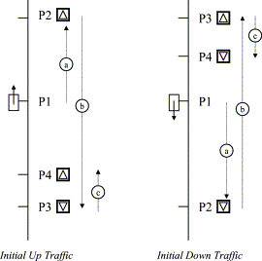

Fig. 6.1.2.1. Possible elevator streams to estimate the fitness.

The elevator is stopped or going up
• P1. Current floor.
• P2. Highest floor to take passengers up. In Fig. 6.1.2.1: displacement a.
• P3. Lowest floor to take passengers down. In Fig. 6.1.2.1: displacement b.
• P4. The highest floor among the floors lower than P1 to take passengers up, always P4<P1. In Fig. 6.1.2.1: displacement c.
Fitness=[(P2?P1)+(P2?P3)+(P4?P3)]×[estimated inter floor trip time]
It includes the maximum known upward trip plus the maximum known downward trip plus the subsequent maximum known not-served upward trip in the first up traffic because P4<P1. We have to note that the mathematical expression do not include the passenger destination trips because we unknown it until the passengers come into the cabin.
The elevator is going down
• P1. Current floor.
• P2. Lowest floor to take passengers down. In Fig. 6.1.2.1: displacement a.
• P3. Highest floor to take passengers up. In Fig. 6.1.2.1: displacement b.
• P4. The lowest floor among the floors higher than P1 to take passengers down, always P4>P1. In Fig. 6.1.2.1: displacement c.
Fitness=[(P1?P2)+(P3?P2)+(P3?P4)]×[estimated inter floor trip time]
It includes the maximum known downward trip plus the maximum known upward trip plus the subsequent maximum known not-served downward trip in the first down traffic because of P4>P1.
Additionally, we have to consider a series of delays to estimate the total process times. All them are associated to the cabins and include the deceleration process in the elevator travel speed, the opening doors delay, the passenger incoming/outcoming process, the closing doors delay and the acceleration process in the elevator travel speed until taking the cruiser speed. Usual values are 2 s for every delays excepting for the incoming/outcoming time (taking 5 s for this delay). Moreover, we are taking 5 s as estimated inter floor trip time at cruiser speed.

6.2 TIMELINE CHART

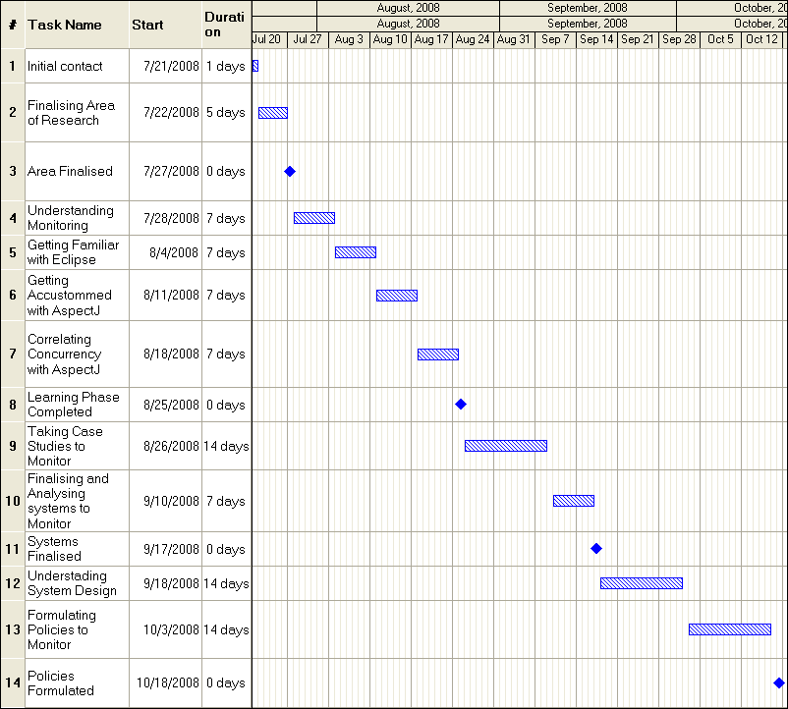
Fig.6.2.1 First half of Time Line chart
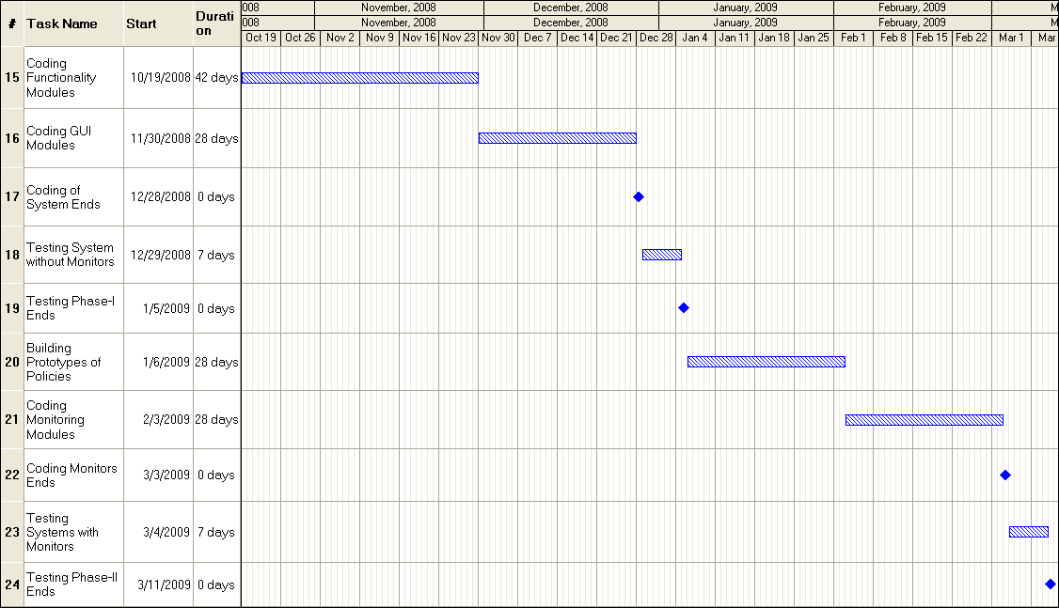
Fig.6.2.2 Second half of Time Line chart

  - Data Flow Diagram(ATM System)

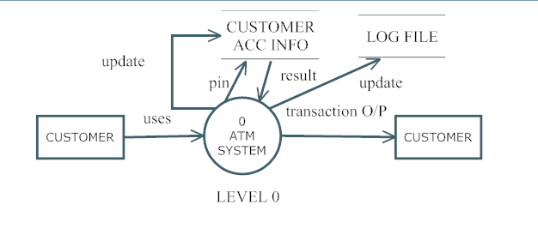
Fig.6.3.1 Level 0 DFD

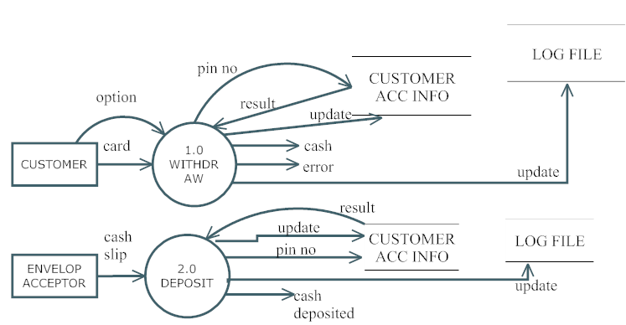
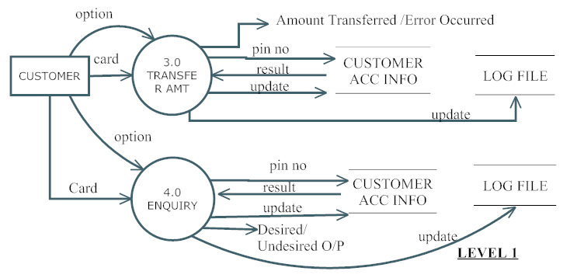
Fig. 6.3.2 Level 1. DFD
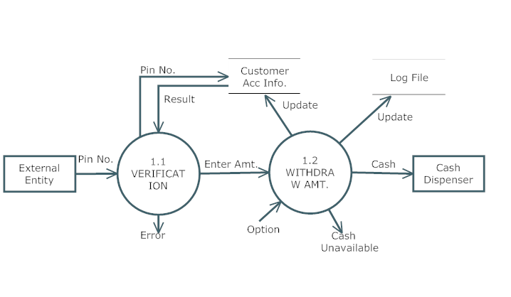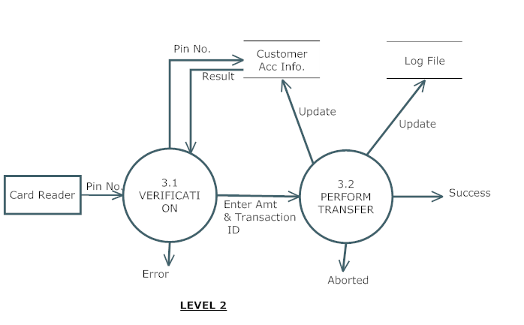
Fig 6.3.3 Level 2 DFD
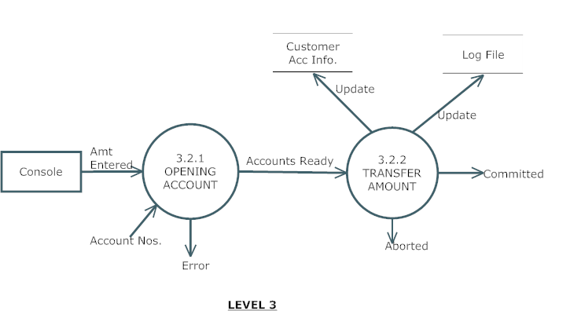
Fig 6.3.4 Level 3 DFD

  - Entity relationship Model (ATM System)

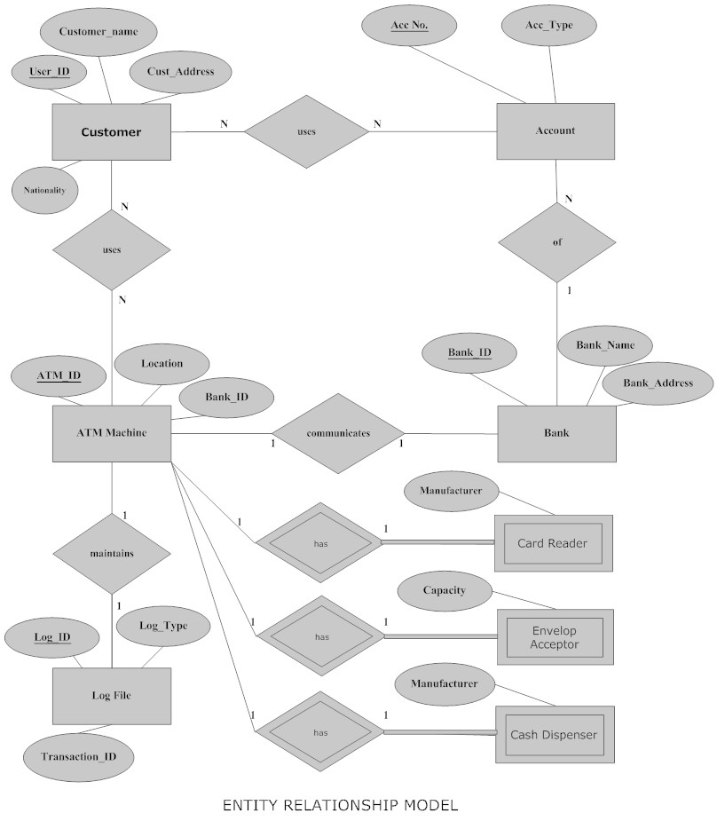
Fig 6.4.1 Entity Relationship Model
  - UML Diagrams

6.5.1. ATM SYSTEM

USE CASE DIAGRAM:-

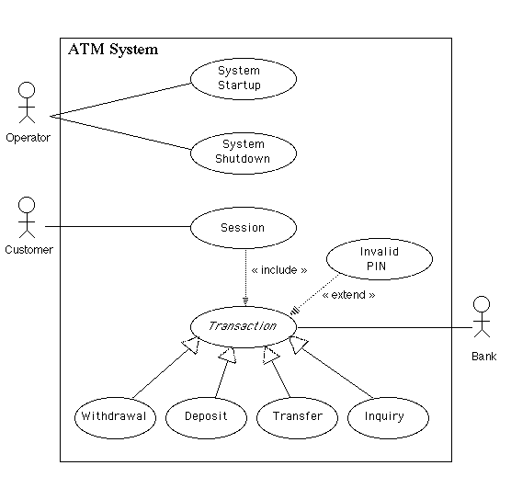
Fig 6.5.1.1 Use Case Diagram Of ATM System

SEQUENCE DIAGRAMS:-

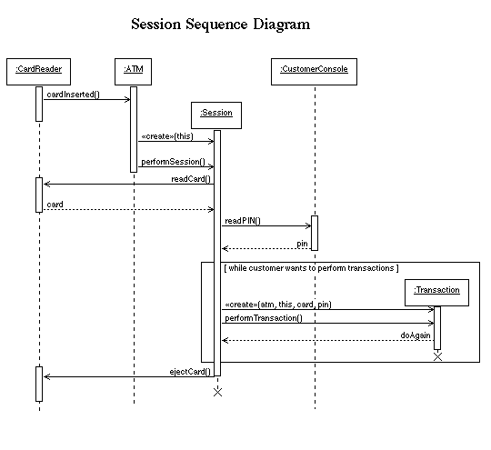
Fig 6.5.1.2 Sequence Diagram of an ATM Session
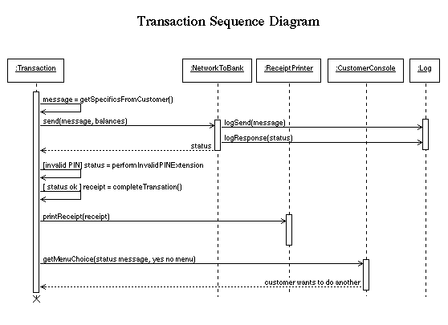
Fig 6.5.1.3 Diagram of an ATM Session
CLASS DIAGRAM (PRELIMINARY DESIGN):-

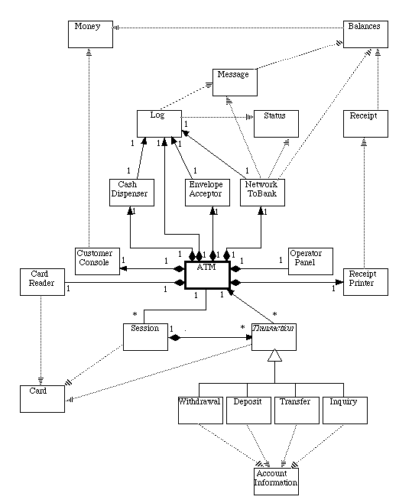

Fig 6.5.1.4 Class Diagram of ATM System
STATE CHART DIAGRAM:-

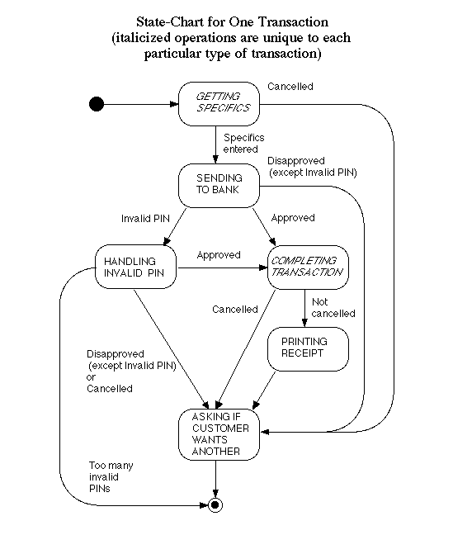
Fig 6.5.1.5 State Chart Diagram of a Transaction

6.5.2. LIFT CONTROL SYSTEM

CLASS DIAGRAM:-
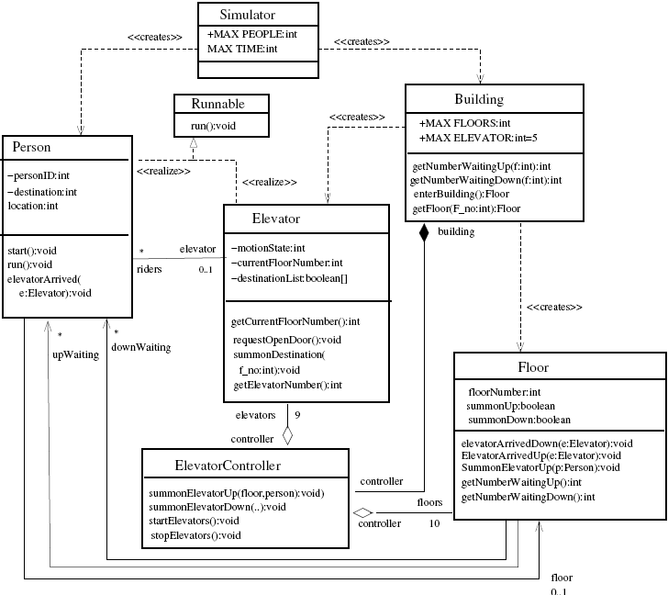

Fig 6.5.2.1 Class Diagram for Lift Control System
6.6 Screen Layout

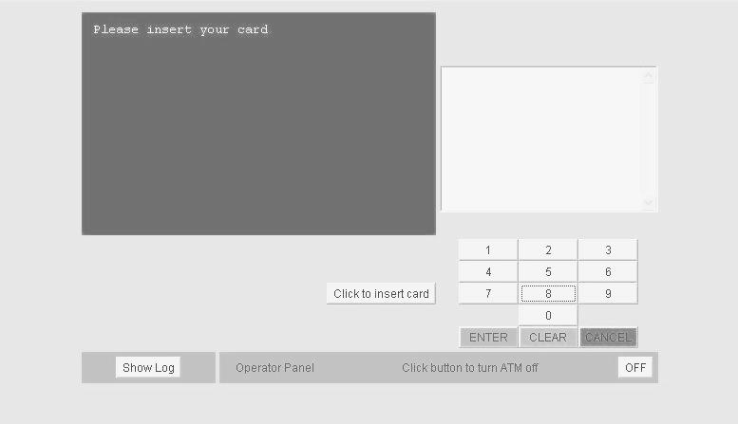
Figure 6.6.1 Screen Layout for ATM System
7.CASE STUDY

7.1 MONITORING SORTING ALGORITHMS
Let us consider a system of sorting algorithms which takes as an input an unsorted list and with the help of any one of the sorting algorithm present within it gives a sorted list as an output. The main feature of this system is one can enter or add as many sorting algorithm as possible at the later stage. Suppose a user wants to sort an unsorted list. The system build has all the arms and ammunition to sort it and generate the desired output. but there may be one in N users curious to know as to which sorting algorithm has carried out the sorting procedure as we know that the functioning is taking place at the backend. This is when MONITORING comes into picture. What if some runtime monitors are developed in such a way that before system gives final output the iterations are displayed on the screen with the help of which the user may identify the algorithm being used. Considering this aspect we have build a MONITOR to monitor the iterations of the algorithm with the help of AspectJ.

To do so we have developed a small aspect-java code which will monitor the iterations. In this case we have taken two algorithms:
- Bubble Sort
- Sequential Sort.
In Bubble sort the largest element is placed at the end of the array in the first iteration while in sequential sorting algorithm the smallest element is placed at the first place of the array. Our aspect will monitor the system and will print each iteration. Knowing each iteration one can easily find out which sorting algorithm has been used. Technically, we have used an interface that will have two methods: 1. sort() and 2. swap(). All sorting algorithms will implement this interface. Aspect will be implicitly called after the execution of swap() function and will display the list of that particular iteration.
This case study consist of 3 classes, 1 interface and 1 aspect file.
Following is the implementation of the system The Code for the specified case study is given below :
7.2 CODE FOR THE SYSTEM
INTERFACE:
package sorting;
public interface SortInterface{
public void sort(int[] a,int n);
public int[] swap(int[] a,int n,int pass);}

CLASSES:
package sorting;
public class Sorting1 implements SortInterface
{
public void sort(int a[],int n)
{
for (int pass=1; pass < n; pass++)
a=swap(a,n,pass);
System.out.print("Final o/p: ");
for(int i=0;i<n;i++)
System.out.print(a[i]+" ");
}

public int[] swap(int a[],int n,int pass)
{
for (int i=0; i < n-pass; i++) {
if (a[i] > a[i+1])
{
int temp = a[i]; a[i] = a[i+1]; a[i+1] = temp;
}}
return a;}
}

package sorting;

public class Sorting2 implements SortInterface {
public void sort(int a[],int n){
for (int i=0; i<(n-1); i++)
a=swap(a,n,i);
System.out.print("Final o/p: ");
for(int i=0;i<n;i++)
System.out.print(a[i]+" ");
}
public int[] swap(int a[],int n,int pass){
for (int i=pass+1; i < n; i++) {
if (a[pass] > a[i]){
int temp = a[pass];a[pass] = a[i]; a[i] = temp;
}}return a;
}}

package sorting;
import java.io.BufferedReader;
import java.io.IOException;
import java.io.InputStreamReader;
import java.util.Random;
public class SortMain {
public static void main(String args[]){
int a[]=new int[20];
int n;
System.out.println("Enter the no. of Elements");
BufferedReader br1 = new BufferedReader(new InputStreamReader(System.in));
try{
String sno1 = br1.readLine();
int no1 = Integer.parseInt(sno1);
n=no1;
for(int i=0;i<n;i++){
System.out.print("Enter the Element #"+ (i+1)+ ": ");
BufferedReader br2 = new BufferedReader(new InputStreamReader(System.in));
String sno = br2.readLine();
int no = Integer.parseInt(sno);
a[i]=no;}
Random r = new Random();
int randint = Math.abs(r.nextInt()) % 100000000;
randint=randint%2;
if(randint==0){
Sorting1 s1=new Sorting1();
s1.sort(a,n);}
else{
Sorting2 s2=new Sorting2();
s2.sort(a,n);}}
catch(IOException e){}
}}

ASPECT
package sorting;
public aspect SortAspect {
int p=1;
after(SortInterface w,int[] x,int y,int z): target(w)&& args(x[],y,z) && execution (int[] SortInterface.swap(int[],int,int))
{
try {
Thread.sleep(600);}
catch(InterruptedException ex) {}
System.out.print("Iteration #"+p+"\n ");
for(int m=0; m<y ;m++){
try {Thread.sleep(200);}
catch(InterruptedException ex) {}
System.out.print(x[m]+" ");}
try {Thread.sleep(150);}
catch(InterruptedException ex) {}
System.out.println("\n");
System.out.println();
p++;}
}

OUTPUT

Enter the no. of Elements
7
Enter the Element #1: 9
Enter the Element #2: 4
Enter the Element #3: 7
Enter the Element #4: 6
Enter the Element #5: 8
Enter the Element #6: 2
Enter the Element #7: 1
Iteration #1: 4 7 6 8 2 1 9
Iteration #2: 4 6 7 2 1 8 9
Iteration #3: 4 6 2 1 7 8 9
Iteration #4: 4 2 1 6 7 8 9
Iteration #5: 2 1 4 6 7 8 9
Iteration #6: 1 2 4 6 7 8 9
Final o/p: 1 2 4 6 7 8 9
Comment: Bubble Sort was used as the largest element is placed at the last position in 1st iteration
Enter the no. of Elements
7
Enter the Element #1: 9
Enter the Element #2: 4
Enter the Element #3: 7
Enter the Element #4: 6
Enter the Element #5: 8
Enter the Element #6: 2
Enter the Element #7: 1
Iteration #1: 1 9 7 6 8 4 2
Iteration #2: 1 2 9 7 8 6 4
Iteration #3: 1 2 4 9 8 7 6
Iteration #4: 1 2 4 6 9 8 7
Iteration #5: 1 2 4 6 7 9 8
Iteration #6: 1 2 4 6 7 8 9
Final o/p: 1 2 4 6 7 8 9
Comment: Selection Sort was used as the lowest element is placed at the first position in 1st iteration.
CONCLUSION

At last we arrive at the end of the presentation of our project synopsis. Hopefully, we have tried our best to present our research oriented project in a lucid, explanatory and convincing manner. We started with an introductory part on runtime monitoring to give a slight glimpse of our thesis. Then we presented a healthy discussion on current monitoring areas of the existing systems and took an inference from the subject. We made this inference clearly reflected in formulating the policies to monitor in our own finalized system. Though we kept talking of our keyword ‘MONITORING’ throughout our project , we have made all the efforts to highlight this abstract back end phenomena not only in the introductory part of our discussion but also in the literature survey and the s/w and language section where we put forward one of the most exciting language (Atleast we found it!) Aspectj carrying the entire burden of monitoring. But one thing is for sure basking something abstract is different (may be vague!) and to implement and show it is altogether different. Keeping this in mind (as we knew it already) we also mentioned and presented a small case study to express the real power of monitoring in a stylish manner. Last but not the least (as a formality) looking back it seems we have covered everything but nothing is perfect in this world, there has to be some loopholes, HOW ABOUT MONITORING IT!

Current Work: Our current monitoring system will ensure that the concurrent programs are functioning as per the high level specifications (that is, policies) laid down for the system. It will also obtain additional information about the internal working’s of the program. The properties of the system that will be monitored are logging activity, performance evaluation, ensuring security, behavioral evaluation among others.

Future Work: In future we intend to investigate on other issues that deal with the extension of the QDDC LOC JAVA paradigm to distributed monitoring. For example, in distributed system environment, how can we capture the global state by each local monitor that knows only local information? This requires communication between local monitors in real time.

REFERENCES

- AspectJ References

1. An Overview of AspectJ by Gregor Kiczales, Erik Hilsdale, Jim Hugunin, Mik Kersten,
Jeffrey Palm and William G. Griswold

2. Aspect Oriented Programming by Gregor Kiczales, John Lamping, Anurag Mendhekar, Chris Maeda, Cristina Lopes, Jean-Marc Loingtier and John Irwin
at Xerox Palo Alto Research Center in June 1997.

3. Language Support for Evolvable Software : An Initial Assessment of Aspect- Oriented Programming by Gianpaolo Cugola , Carlo Ghezzi, Mattia Monga at Ploitecnico di Milano - Dipartimento di Elettronica e Informazione July 1999 .

4. Using AspectJ for Component Integration in Middleware by Adrian Colyer , Andy Clement from IBM UK Limited and Ron Bodkin from New Aspects of Security and Jim Hugunin from Palo Alto Research Center.

5. The AspectJ Team : http://www.eclipse.org/aspectj.doc/released/progguide/. The AspectJ Programming Guide 2003.

6. OOPSLA 2001 Aspect Oriented Programming with AspectJ by Erik Hilsdale , Gregor Kiczales at Xerox PARC / AspectJ.org

7. I want my AOP! Part 1,2,3 by Ramnivas Laddad, JavaWorld.com, 01/18/02.

8. AspectJ Project : www.eclipse.org/aspectj/

- Run Time Monitoring Systems References :

9. MaC : A framework for Run Time Correctness Assurance of Real Time Systems by Moonjoo Kim , Mahesh Viswanathan , Sampath Kannan, Insup Lee and Oleg Sokolsky from Department of Computer and Information Science at University of Pennsylvania on January 29 , 1999

10. Run Time Monitoring of Architecturally Significant Behaviours Using Behavioral Profiles and Aspects by Kimmo Kiviluoma , Johannes Koskinen and Tommi Mikkonen at Solita Oy, Software Systems Laboratory ( Tampere University of Technology ) respectively

11. Run-time Monitoring and Checking (MaC): http://rtg.cis.upenn.edu/mac/index.php3

- Lift Simulation References :

12. A Lift Simulation Prototype by V.C Galpin and S.T.Rock , Computer Science Department University of Witwatersrand , Johannesburg .

13. Validation and Optimization of an Elevator Simulation Model with Modern Search Heuristics by Mike Preuss, Universtität Dortmund, Sandor Markon

- Automatic Teller Machine References :

14 Run Time Monitoring for Dependable Systems : An Approach and a Case Study IEEE Xplore by Sergio Ricardo Rota and Jorge Rady de Almeida Jr Sao Paulo Brazil.

15 UML Diagrams of ATM system :
http://www.cs.gordon.edu/courses/cs211/ATMExample/

- Java References

16 Java: The Complete Reference, Seventh Edition (Complete Reference Series)
by Herbert Schildt

17 Java Tutorials: http://www.java.sun.com/docs/books/tutorial/

- Eclipse References

18 Eclipse Website : www.eclipse.org/

19 Eclipse Video Tutorials: http://www.eclipsetutorials.sourceforge.net/

