

Target market (End User Identification)
Deliverable 1

Urdu Sign Language Detection and Classification Using Custom Dataset

Group Members:
Abeeha Maryam(f2023-515)
Malaika Nasir(f2023-736)
Zukhruf Javaid(f2023-273)

Supervisor:
Ms. Noreen Khalid

Table of Contents

1. Purpose of the Document 3
2. Project Overview 3
3. Overall Market and Audience 4
4. Target Market Classification 4
5. Primary Users 5
6. Secondary Users 5
7. User Problems, Needs, and Expectations 5
8. Why This Target Market Is Suitable and Relevant 6
9. Alignment of Target Market with the Proposed Project Idea 6
10. Conclusion 7
11. Supervisor Discussion and Feedback 7

Purpose of the Document
The purpose of this document is to identify the intended users of the proposed system and understand their problems, needs, and expectations. This analysis will help the group understand the users better and guide the requirement engineering process toward addressing their communication problems.

Project Overview
The proposed project is a camera-based system for detecting and classifying Urdu Sign Language (USL). Users will perform Urdu Sign Language gestures in front of a webcam or mobile camera. The system will recognize hand gestures and facial expressions and provide the results as text and speech. The project will use a custom USL dataset, along with MediaPipe and OpenCV for feature extraction and CNN and LSTM models for gesture and emotion recognition. For consistency, this document uses the term Urdu Sign Language (USL), which is the main term used in the proposal.
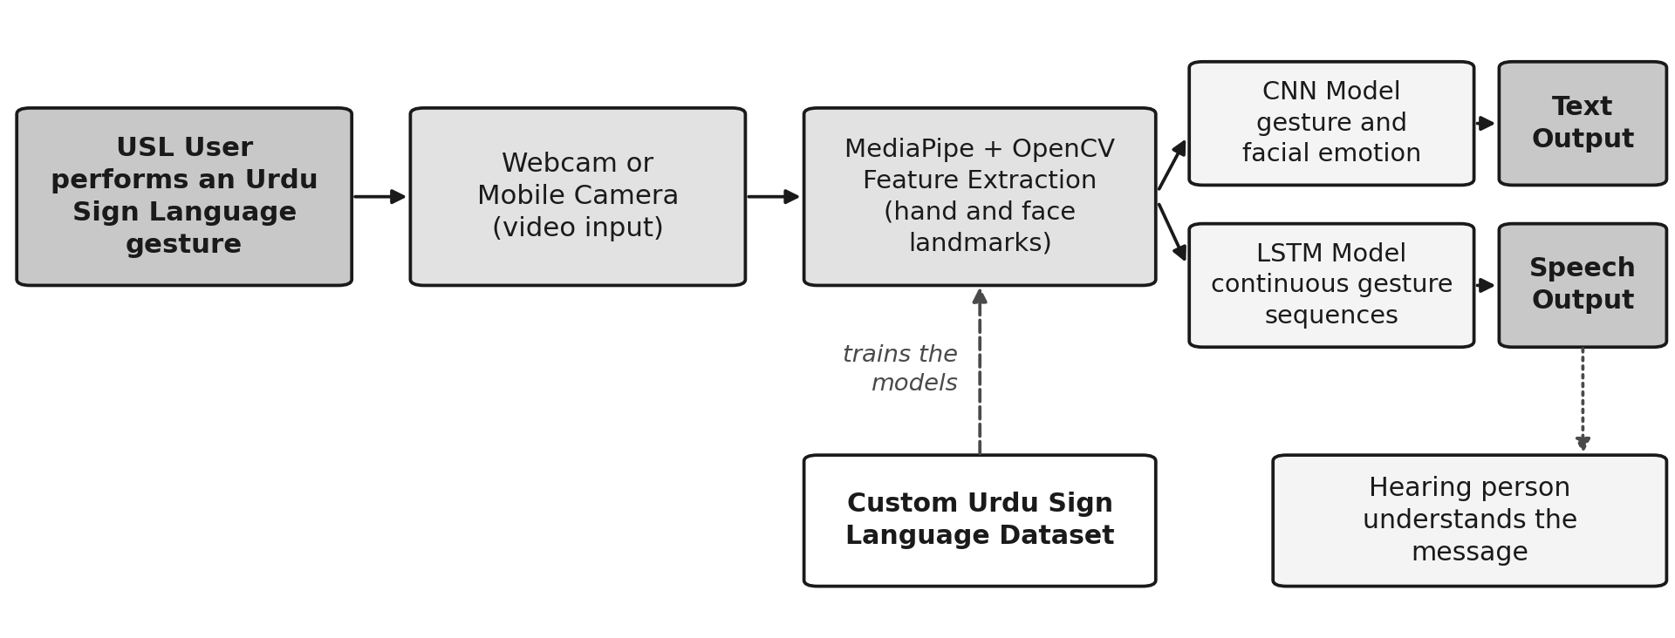
Fig 1: Working flow of the proposed USL detection and classification system

Overall Market and Audience
This solution is aimed at the assistive technology and accessibility market in Pakistan. It is designed for individuals and organizations that need a simple way to communicate with Urdu Sign Language users. Pakistan is the main target area because the proposed dataset and recognition model focus on local Urdu Sign Language gestures, words, common phrases, and facial expressions.
The main audience includes:
- Deaf and mute people who use Urdu Sign Language for daily communication.
- Family members, friends, and caregivers who communicate with USL users.
● Special education schools, teachers, students, and sign language interpreters.
- Hospitals, clinics, reception desks, customer service points, and public offices that may serve deaf users.
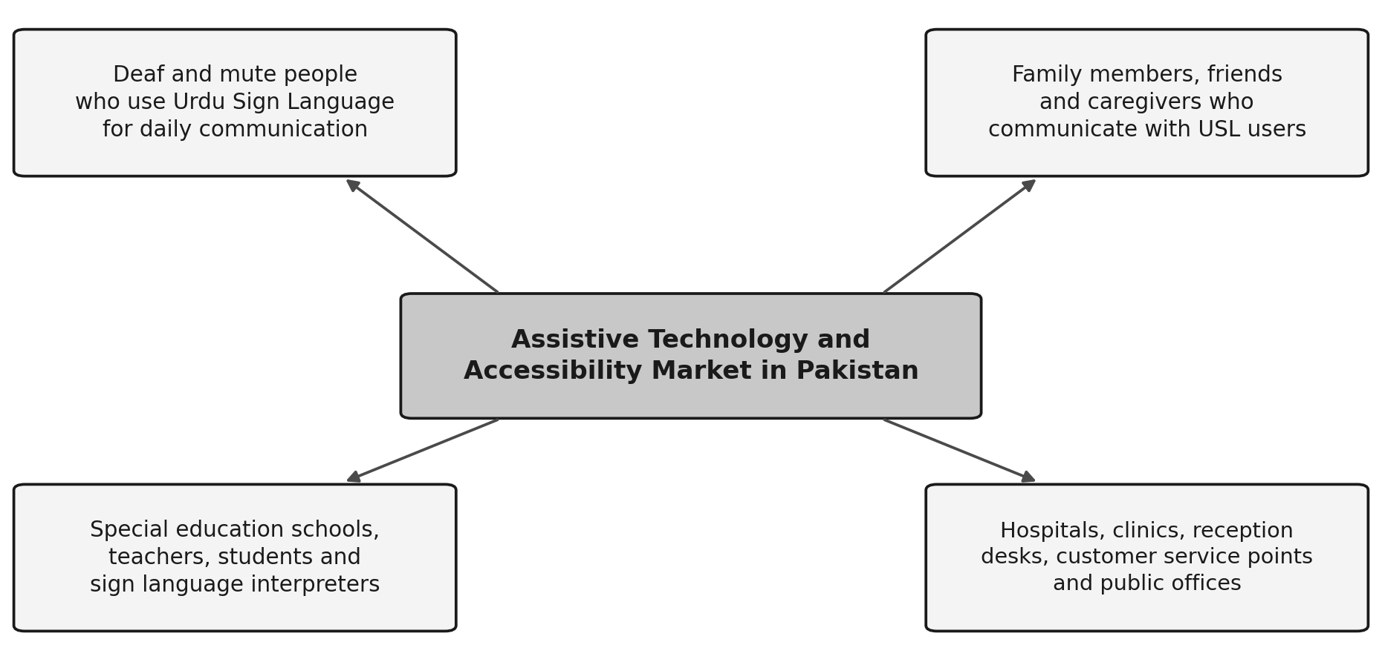
Fig 2: Overall market and the main audience groups of the proposed system

Target Market Classification

Industry | Market | Market Segment | End User
Assistive  Technology | Accessibility and  Communication | Urdu Sign Language translation | Deaf and mute USL users
Education | Special Education | Schools and learning centres for deaf students | Students, teachers, and interpreters
Healthcare | Accessible Patient  Communication | Hospitals, clinics, and reception areas | Patients, doctors, nurses, and front-desk staff
Public Services | Citizen Service Accessibility | Government offices and public help desks | Deaf citizens and service staff
Customer Service | Inclusive Service Delivery | Banks, shops, offices, and service counters | Customers and customer-service staff

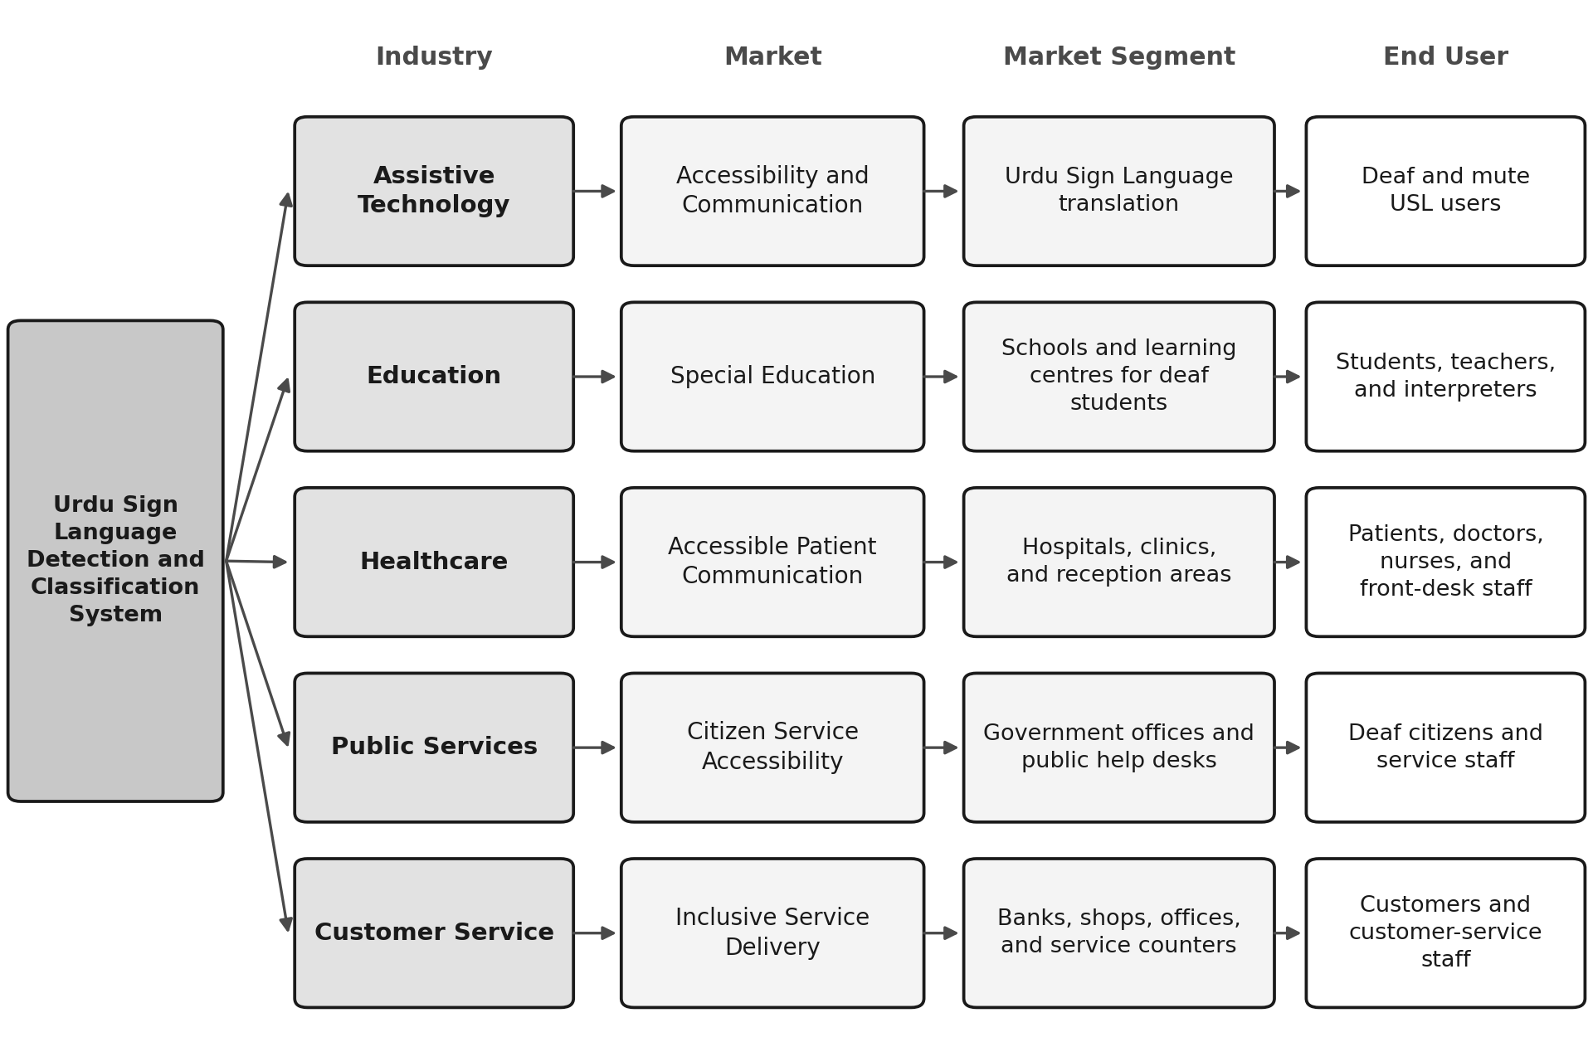
Fig 3: Target market classification from industry level down to end users

Primary Users
The primary users are deaf and mute people in Pakistan who use Urdu Sign Language. They will perform signs in front of the camera and use the system to express words, phrases, and emotions. They are the main users because the system is designed to convert their signs into text and speech so that other people can understand them. Some deaf users, native Urdu Sign Language users, and interpreters may also participate in dataset collection and system testing. Their participation will help the group collect real gestures, include different signing styles, and check whether the recognized results are correct.
Primary user needs and expectations include:
- Accurate recognition of Urdu sign language alphabets, words, and common phrases.
- Fast, real-time translation through a webcam or mobile camera.
- Clear text and speech output that can be understood by a hearing person.
- Recognition of facial expressions so that the emotional meaning is not lost.
- A simple interface that does not require advanced technical knowledge.
- Acceptable performance with different signers, hand positions, camera angles, backgrounds, and lighting conditions.

Secondary Users
Secondary users are people who may not perform Urdu signs as the main input, but they receive the translated text or speech, support communication, provide expert feedback, or use the system in an organization.
- Family members, friends, and caregivers: They can understand the translated text or speech and communicate more easily with a deaf family member.
- Teachers and students in special education institutes: They can use the system as a communication and learning support tool.
- Sign language interpreters and native USL speakers: They can help in dataset collection, gesture validation, and testing of the system.
- Doctors, nurses, receptionists, customer-service employees, and public-office staff: They can understand a deaf user without always requiring an interpreter for basic communication.
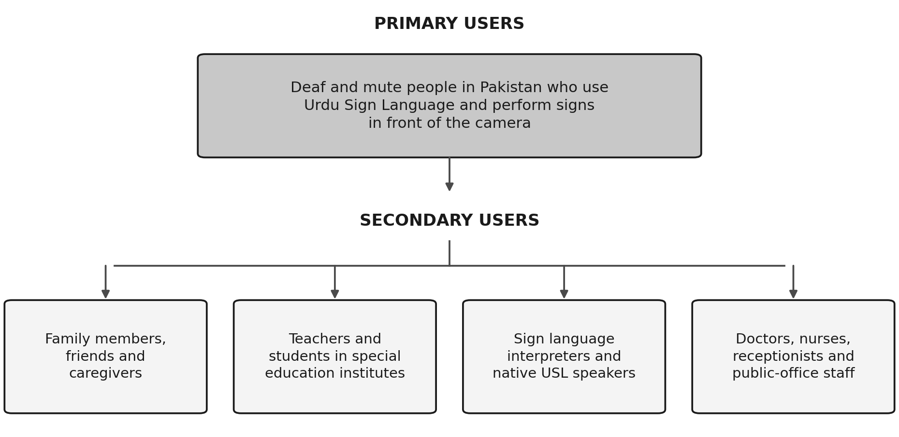
Fig 4: Primary and secondary users of the proposed system

User Problems, Needs, and Expectations

User Group | Main Problems and Needs | Expected Solution
Deaf and mute USL users | Most hearing people do not understand sign language. Users may struggle to share information, feelings, and requests. | This can help users communicate their signs through clear text and speech output.
Families and caregivers | Communication may depend on limited sign-language knowledge or another person acting as an interpreter. | The proposed solution would allow families and caregivers to communicate more easily during everyday interactions.
Teachers and students | Communication between teachers and students can be difficult when one party does not understand sign language. This may affect classroom interaction and participation. | The project can support the use of local Urdu Sign Language in learning and communication activities.
Healthcare and public-service staff | Staff may not know sign language, which can create delays and misunderstandings during basic interactions. | For these users, the main benefit would be quick translation of commonly used signs, words, and phrases.
Interpreters and native signers | Existing systems may focus on foreign sign languages or only static hand gestures. | A useful outcome would be a locally focused system that includes gesture sequences and facial expressions.
Employers and workplace colleagues | Communication with employees who use Urdu Sign Language can be difficult during meetings and daily work activities. | This feature is intended to make workplace communication easier by quickly converting Urdu Sign Language into text.

Why This Target Market Is Suitable and Relevant
- The target users are directly affected by the communication problems that this project is trying to address.
- Since the project focuses on Urdu Sign Language and uses a custom local dataset, users in Pakistan are the most relevant group for dataset collection and system testing.
- These users can provide realistic gestures, facial expressions, and feedback that can help during dataset development and system testing.
- Schools, families, healthcare centres, and public-service locations are suitable places where the system could help reduce everyday communication difficulties.
- The project also aims to deal with challenges such as limited local datasets, the need for real-time translation, and differences in lighting, hand orientation, and signing styles.

Alignment of Target Market with the Proposed Project Idea

Target-Market Need | Proposed Project Feature | Alignment
People need others to understand USL gestures. | Real-time USL gesture detection and classification. | The feature directly converts signs into understandable information.
Users need communication without typing every message. | Camera input with text and text-to-speech output. | The user can communicate by signing naturally in front of a camera.
Facial expressions can change or support the meaning of a sign. | CNN-based facial emotion recognition. | The system adds emotion information for better context.
Local signs are not fully represented in foreign datasets. | Custom Urdu Sign Language dataset. | The dataset is designed around  Pakistani users, Urdu alphabets, words, and phrases.
Real-world conditions can reduce recognition accuracy. | Testing with different signers, lighting, backgrounds, angles, and hand orientations. | The testing plan is based on the actual conditions faced by target users.
Continuous gestures require sequence understanding. | LSTM-based processing of time-series hand movement. | The model is intended to recognize movement over multiple video frames.

Conclusion
The main target market for the proposed system is the deaf and mute community in Pakistan that uses Urdu Sign Language. Family members, teachers, interpreters, healthcare workers, and public-service staff are important secondary users who may benefit from easier communication with USL users. Their needs are closely related to the proposed camera-based USL recognition, emotion detection, text output, and speech output features. The system aims to reduce communication barriers by providing a simple way to translate commonly used signs, words, and phrases into understandable text and speech. Overall, the selected target market is relevant to the project because these users directly experience the communication difficulties that the proposed system aims to address.

Supervisor Discussion and Feedback
Discussion Date
Supervisor Feedback
Changes Incorporated
Supervisor Approval/Signature

