
Deliverable 2

Urdu Sign Language Detection and Classification Using Custom Dataset

Group Members:
Abeeha Maryam(f2023-515)
Malaika Nasir(f2023-736)
Zukhrud Javaid(f2023-273)

Supervisor:
Ms.Noreen Khalid

Table of Contents

1. Problem Identification 4
1.1 Problem 4
1.2 Context of the Problem 4
1.3 Existing Communication Process 5
1.4 Existing Systems and Their Limitations 5
1.6 Evidence and Findings 6
1.7 Identified Research Gap 9
1.9 Problem Statement 9
2. Stakeholder Identification 10
2.1 Industry 10
2.2 Market 10
2.3 Market Segment 11
2.4 User Profile 12
Primary User Profile 12
Important User Characteristics 13
2.5 Persona 13
2.6 Stakeholder Identification 15
2.7 Stakeholder Analysis 16
2.8 Stakeholder Influence and Importance 18
2.9 Industry → Market → Market Segment → User Profile → Persona → Stakeholders 18
3. Requirement Elicitation 19
3.1 Requirement Elicitation Techniques Used 20
3.2 Initial Online Meeting with the Principal 21
Technique Used 21
Why This Technique Was Selected 21
Information Obtained 22
Requirements Derived from the Initial Meeting 22
3.3 On-Site Visit and Direct Interaction with Students 22
Technique Used 22
Why This Technique Was Selected 22
3.4 User Feedback on Communication Needs 23
Requirement Derived 24
3.5 User Feedback on Language and Output 24
3.6 Identification of Sign Language Characteristics 24
Requirements Derived 24
3.7 Facial Expression Requirement 25
Requirements Derived 25
Current Facial Expression Scope 25
3.8 Identification of Common Everyday Sentences 25
Requirements Derived 25
3.9 Urdu Alphabet Requirements 26
The project includes an Urdu alphabet recognition component covering 37 Urdu alphabet classes. These classes will be included in the custom dataset and used for training and evaluating the alphabet recognition model. 27
Requirements Derived 27
● FR-12: The alphabet recognition model shall recognise the selected Urdu alphabet signs. 27
● FR-13: The initial alphabet recognition model shall contain 37 Urdu alphabet classes. 27
● FR-14: The custom dataset shall contain labelled examples of the selected alphabet signs. 27
3.10 Existing System Analysis 27
Requirements Derived 27
3.11 Dataset Development Requirements 27
Requirements Derived 27
3.12 Dataset Scope 28
1. Urdu Alphabet Dataset 28
2. Sentence Dataset 28
3. Facial-Expression Dataset 28
3.13 Model Development Requirements 28
Requirements Derived 28
3.14 Wider Stakeholder Requirements 29
3.15 Conversion of Elicitation Findings into System Requirements 29
3.16 Summary 30
References 30
Appendix A — Interview Question Guide Used at DWAF 31
Institution Profile 31
Literacy and Technology Access 32
Communication Challenges 32
Existing Tools and Interpreters 32
System Requirements 32
Wider Stakeholders 32
Collaboration 32
Supervisor Discussion and Feedback 33

( PART A )

1. Problem Identification

1.1 Problem
The main problem identified for this project is the difficulty faced by people who use Urdu Sign Language (USL) when communicating with people who do not understand sign language. In everyday situations, USL users may struggle to express their information, requests, feelings, and messages to family members, teachers, healthcare staff, public-service workers, and others. Currently, communication may depend on family members, caregivers, interpreters, or others who understand sign language, which is not always possible when no one familiar with USL is available. The literature review also showed that most existing Urdu/Pakistani Sign Language research focuses on alphabet or character recognition, while sentence-level recognition is less explored. Publicly accessible datasets, especially for sentence recognition, are also limited. Therefore, there is a need for a system that recognizes USL at both alphabet and sentence levels and supports commonly used sentences for more practical communication.

1.2 Context of the Problem
The communication problem can occur in everyday situations when a person using Urdu Sign Language interacts with someone who does not understand USL. This may happen at home, in educational settings, hospitals, public offices, customer-service counters, and workplaces. The problem is also linked to the limited availability of local Urdu Sign Language resources. A recognition system needs to handle differences in signers, hand positions, camera angles, backgrounds, and lighting conditions. The proposed project focuses on Urdu Sign Language used in Pakistan. It aims to recognize hand gestures and facial expressions and provide the result as understandable text and speech.

1.3 Existing Communication Process
At present, communication between a USL user and a person who does not understand sign language may depend on another person who can interpret the signs. For example, a deaf user may communicate through a family member, caregiver, teacher, interpreter, or another person who understands Urdu Sign Language.
The general communication process can be described as:
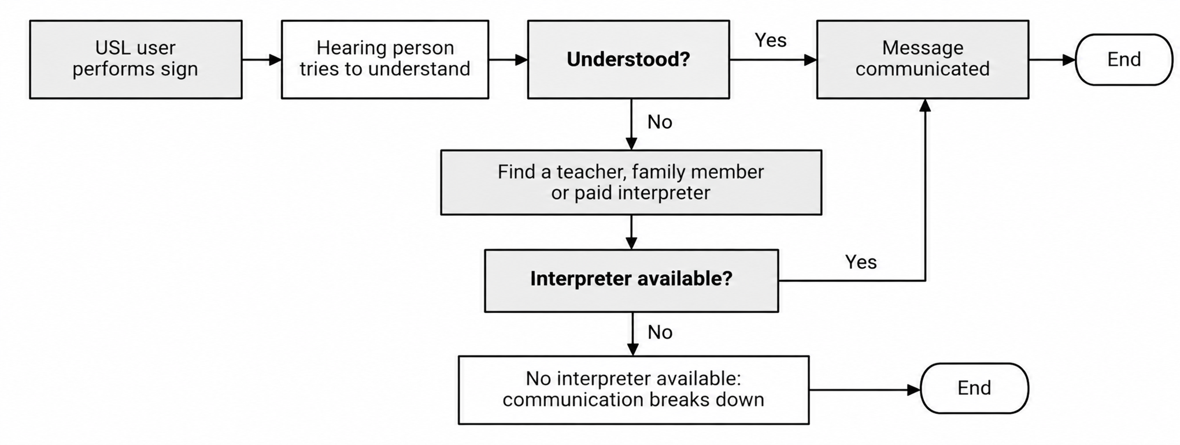
Fig 1: Existing Communication Process
This process can work when a suitable person is available, but it can make simple communication more difficult when no interpreter or knowledgeable person is present. The Target Market analysis identified this issue among families, educational institutions, healthcare and public-service staff, and workplace colleagues. For example, family communication may depend on someone who understands sign language, while healthcare and public-service staff may not know sign language and may therefore experience delays or misunderstandings during basic interactions.

1.4 Existing Systems and Their Limitations
Several studies have investigated sign language recognition using different approaches, including camera-based computer vision, deep learning, wearable sensors, radar sensing, and transfer learning. The reviewed studies cover several sign languages, including Pakistani Sign Language (PSL), American Sign Language (ASL), British Sign Language (BSL), Korean Sign Language (KSL), Bengali Sign Language, and Arabic Sign Language. The findings show that most existing systems focus on alphabet, numbers, or isolated signs, while relatively fewer studies address dynamic signs or sentence-level recognition. Some studies have also explored real-time recognition and communication through text and speech output. However, important limitations remain, particularly in sentence-level translation, support for Urdu/Pakistani Sign Language, emotion recognition, and integration of multiple recognition tasks into a single system. Therefore, the reviewed literature provides a useful foundation of datasets, preprocessing techniques, and machine/deep learning models, while also highlighting the need for a more comprehensive system that can combine alphabet recognition, sentence recognition, emotion detection, and text and speech output. A detailed comparison of the reviewed studies is presented in Section 1.7: Evidence and Findings.
1.5 Research Method Used to Identify the Problem
To identify and understand the problem, the group conducted literature research using Google Scholar. Nine research papers related to sign language recognition, particularly Urdu/Pakistani Sign Language and other relevant sign-language recognition systems, were reviewed.
The literature review focused on:
- Existing sign language recognition systems and whether they recognize alphabets, numbers, words, isolated signs, or sentences.
- The datasets, machine learning and deep learning models, and computer vision techniques used in previous studies.
- The approaches used for real-time recognition and communication, including text and speech output.
- The limitations and research gaps identified in existing systems.
- The availability and scope of existing sign language datasets, particularly for Pakistani/Urdu Sign Language.
The review showed that most of the selected studies primarily focus on alphabet, number, or isolated-sign recognition, while sentence-level recognition and translation are comparatively less explored. The reviewed papers also showed limitations related to dataset size, language-specific coverage, real-time translation, and integration of multiple recognition tasks. These findings were compared with the problems identified during the Target Market analysis, which helped the group better understand the existing challenges and define the specific problem areas that the proposed system aims to address.

1.6 Evidence and Findings
The nine research papers reviewed by the group provided several findings. The main findings were compared across the papers and are summarized below.
Author / Publication Year | Findings | Limitations / Gap | Machine or Deep Learning Model / Technique | Dataset | Accuracy
Saeed, U. et al. (2024)  [1] | Proposed a contactless BSL detection system using UWB radar sensing. Radar signals were converted into spectrogram representations and classified using deep-learning models. | Focuses on BSL and a limited number of signs. Requires specialized UWB radar hardware and does not address USL, sentence-level translation, or emotion recognition. | ResNet50, VGG16, InceptionV3; UWB radar sensing, signal processing and spectrogram generation | Custom BSL radar dataset; 10 final sign classes, 4 subjects, 1,300 prepared samples | 92%, 88%, 70% respectively
Paul, S. K. et al. (2024)  [2] | Developed a real-time ASL recognition system using CNN for static alphabet signs and recurrent models for dynamic signs. MediaPipe Holistic was used to extract landmark information. | Focuses on ASL. Dynamic dataset contains only three signs and does not provide large-scale sentence recognition or translation. | Improved ResNet-based CNN, LSTM, GRU; MediaPipe Holistic; Adam optimizer | DS-1: 3 dynamic signs; DS-2: 26 ASL alphabet classes with 28,600 images | CNN: 89.07%, LSTM: 94.3%, GRU: 79.3%
Patel, Milan (2023)  [3] | Developed machine-learning models for real-time recognition of individual ASL gestures/letters to facilitate communication between signers and non-signers. | Mainly focuses on individual letters. Future work can extend recognition to complete words and sentences. | R-CNN, MobileNet, YOLOv8 | American Sign Language | 78%, 81%, 95% respectively
Rahman, M. Z. et al. (2023)  [4] | Developed a real-time PSL classification system using a wearable smart glove. Flex sensors and MPU-6050 captured hand movement, followed by feature extraction and ML classification. | Requires a wearable sensor glove and focuses on only 10 PSL gestures. Does not provide camera-based or sentence-level recognition. | SVM, MLP, ANN, KNN; flex sensors, MPU-6050; statistical feature extraction | Custom PSL sensor dataset; 10 gestures, approximately 1,000 gesture samples | >96% overall real-time accuracy
Saleem, M. I. et al. (2023)  [5] | Developed a full-duplex communication system supporting ASL, PSL and SSL. Hand gestures are captured using a Leap Motion Device and processed using CNN and supervised ML, with output converted to speech. | Mainly evaluates letters and numbers rather than complete sentences. Requires Leap Motion hardware and has limited PSL vocabulary. | CNN + supervised ML; Leap Motion Device; full-duplex communication | Combined ASL, PSL and SSL datasets; PSL subset: 1,015 training + 435 testing images | ASL: 98.5%/98.9%; PSL: 93.1%/92.7%; SSL: 94.3%/93.8% for letters/numbers
Shin, J. et al. (2023)  [6] | Proposed a hybrid CNN–Transformer architecture that combines local visual features from CNN with long-range dependencies from a Transformer for KSL recognition. | Focuses on KSL and isolated word/sign recognition. Does not address USL/PSL, sentence translation, or emotion recognition. | CNN + Transformer multi-branch network, lightweight multi-head attention, GELU, Adam | KSL benchmark: 77 labels, 1,229 videos; proposed dataset: 20 KSL classes | 89.00% on 77-label KSL; 98.30% on proposed 20-class dataset
Azimi, S. et al. (2023)  [7] | Developed a real-time computer-vision framework for detecting the “Signal for Help” gesture. MediaPipe detects hands and MobileNet performs gesture classification. | Recognizes only a single gesture rather than a complete sign language. Does not address alphabet, sentence recognition, translation, or USL/PSL. | MediaPipe + MobileNet; transfer learning using Jester dataset | Custom dataset of approximately 200 videos; Jester dataset used for pretraining | ≈91.25%; 16 FPS on high-performance PC
Miah, A. S. et al. (2022)  [8] | Proposed BenSignNet, a CNN-based Bengali Sign Language alphabet recognition model. Combined segmentation and image augmentation were used to improve generalization across multiple datasets. | Focuses on static Bengali alphabet recognition and does not address sentence recognition, translation, or emotion detection. | BenSignNet CNN; YCbCr + HSV + Watershed segmentation; seven augmentation techniques | 38-BdSL, KU-BdSL and Ishara-Lipi datasets | 94.00%, 99.60%, 99.60% respectively
Zakariah, M. et al. (2022)  [9] | Developed an Arabic Sign Language alphabet recognition system using transfer learning with pretrained CNN architectures. EfficientNetB4 provided the best performance. | Focuses on static Arabic alphabet/sign recognition and does not address USL/PSL, sentence recognition, translation, or emotion detection. | Transfer learning; EfficientNetB4 and other pretrained CNN architectures; data augmentation | ArSL2018: 54,049 images, 32 classes, 40+ participants | 98% training, 95% testing

1.7 Identified Research Gap
Based on the review of the nine research papers, the main research gap identified by the group is the limited focus on sentence-level sign language recognition, particularly for Urdu/Pakistani Sign Language. Most of the reviewed studies focus on alphabets, numbers, individual characters, or isolated signs, while comparatively less work has focused on recognizing complete sentences for everyday communication.
The reviewed literature also indicates limitations in the availability of large and publicly available sentence-level datasets, particularly for Urdu/Pakistani Sign Language. Although some existing systems support real-time recognition and communication through text or speech, they generally focus on a limited vocabulary or a specific recognition task.

1.9 Problem Statement
People who use Urdu Sign Language may face communication difficulties when interacting with individuals who do not understand USL. Existing research mainly focuses on alphabet or character recognition, while sentence-level USL recognition remains less explored. Therefore, there is a need for an accessible system that can recognize common USL signs and sentences and provide understandable text and speech output.

(PART B)

2. Stakeholder Identification

2.1 Industry
The proposed project operates within the Artificial Intelligence (AI), Computer Vision, and Assistive Technology industry, focusing on accessibility and communication support. It uses computer vision and machine learning to recognize Urdu Sign Language and provide understandable output. The system will use a camera-based interface, allowing users to perform signs naturally in front of a webcam or mobile camera. It will internally include three specialized models:
- Alphabet recognition model for Urdu Sign Language alphabets.
- Sentence recognition model for commonly used everyday Urdu Sign Language sentences.
- Emotion detection model for identifying relevant facial expressions.
These models will work together as one integrated system from the user's perspective. The user will not need to manually select a model; the system will process the signs, identify whether the input is an alphabet or sentence, and consider facial expressions where applicable.

2.2 Market
The relevant market for the proposed solution is the assistive technology and accessibility market in Pakistan, with a focus on communication support for people who use sign language. The system addresses communication difficulties between USL users and people who do not understand sign language by providing a camera-based method to convert recognized USL into text and speech output.
The target market includes:
- Special education institutions
- Schools and learning centers
- Healthcare facilities
- Public-service offices
- Customer-service environments
- Workplaces
- Families and caregivers
The focus on Pakistan is important because the project will use a custom local Urdu Sign Language dataset rather than relying only on datasets developed for foreign sign languages.

2.3 Market Segment
The specific market segment targeted by the project is people in Pakistan who use Urdu Sign Language and the individuals or organizations that regularly communicate with them.
The market can be divided into the following segments:

Market Segment | Target Users | Relevance to the Project
Primary USL Users | People who use Urdu Sign Language | They are the main users who will perform signs in front of the camera.
Families and Caregivers | Family members, friends, and caregivers | They may receive the translated text or speech and communicate with USL users.
Education | Teachers, students, and sign language interpreters | They may use the system for communication and learning support.
Healthcare | Doctors, nurses, receptionists, and patients | The system could support basic communication where staff do not know USL.
Public Services | Government staff and USL users | It could help with basic communication at public-service counters.
Workplaces | Employers, colleagues, and USL-using employees | It may support basic workplace communication.
The primary market segment is people who use Urdu Sign Language because the system is designed around their communication needs. The other groups are considered secondary users or stakeholders because they may interact with the system, receive its output, provide feedback, or influence its development.

2.4 User Profile
The main user profile represents people who communicate using Urdu Sign Language in Pakistan.

Primary User Profile
Attribute | Description
User Type | People who use Urdu Sign Language
Location | Pakistan
Age | Can include students, young adults, adults, and other USL users
Communication Method | Urdu Sign Language, gestures, facial expressions, and other non-verbal communication
Main Goal | To communicate information, requests, feelings, and everyday messages with people who may not understand USL
Main Need | A simple way to translate signs into understandable text and speech
Technical Knowledge | May vary; therefore, the system should not require advanced technical knowledge
Expected Interaction | Perform signs naturally in front of a camera
Device Preference | Webcam/laptop or mobile camera
Behaviour | Uses signs and facial expressions during communication and may use the system during situations where the other person does not understand USL
Pain Points | Difficulty communicating with people who do not understand USL; dependence on interpreters or people familiar with sign language
Expectations | Fast, understandable, and accurate recognition
Accessibility Expectations | Simple interface, clear output, and minimal complicated controls
System Expectations | Recognition of alphabets, common sentences, and relevant emotional information
Output Expectations | Clear text and speech output

Important User Characteristics
Users may have different signing styles, hand positions, camera angles, and communication patterns. Therefore, the system should be designed and tested with different signers rather than relying on a single person's gestures. The custom dataset is important because it needs to represent local signs and variations used by Pakistani USL users.

2.5 Persona
A persona is a representative user created from the identified user profile. It helps the development team understand how a real user may interact with the proposed system.

Persona 1: Primary User
Name: Sehrish Ali
Age: 19
Role: Student
Location: Pakistan
Communication Method: Urdu Sign Language
Technical Knowledge: Basic smartphone and computer user

Goals
- Communicate more easily with people who do not understand Urdu Sign Language.
- Express everyday requests and information without depending on another person.
- Communicate with teachers, staff, and other people in situations where an interpreter is not available.
- Use a simple technology-based solution for everyday communication.

Needs
- Recognition of commonly used USL signs.
- Recognition of Urdu Sign Language alphabets.
- Recognition of common everyday sentences.
- Clear text output.
- Speech output that can be understood by a hearing person.
- A simple camera-based interface.
- Recognition that works under different normal lighting and background conditions.

Pain Points
- Many people around her do not understand Urdu Sign Language.
- Communication can become difficult when an interpreter or person familiar with USL is unavailable.
- Communicating longer messages through individual alphabets can be slow.
- Facial expressions and emotions may not always be communicated through basic text translation.

Behaviour
Sehrish normally communicates using Urdu Sign Language. When interacting with someone who does not understand USL, she may need to use gestures, writing, typing, or assistance from another person. She is comfortable using a smartphone and would prefer a system that requires minimal interaction beyond using the camera.

Expectations
Sehrish expects the system to:
- Recognize her signs without requiring complicated setup.
- Provide results quickly.
- Display understandable text.
- Provide speech output when needed.
- Recognize both individual alphabets and commonly used sentences.
- Provide useful emotional context through facial-expression recognition.
Persona 2: Secondary User
Name: Farhat Javed
Age: 32
Role: Teacher at a Special Education Institute
Technical Knowledge: Moderate

Goals
- Communicate more effectively with students who use Urdu Sign Language.
- Support classroom interaction.
- Help students communicate basic requests and responses.

Needs
- Easy-to-use communication support.
- Accurate recognition of common signs and sentences.
- Clear text and speech output.
- A system that can be used without extensive technical training.

Pain Points
- Not every teacher or staff member may have advanced USL knowledge.
- Communication can take longer when a teacher cannot understand a student's signs.
- Some existing recognition systems focus only on alphabets or isolated signs.

Behaviour
Farhat regularly interacts with students using sign language and may provide feedback about whether recognized signs and sentences are correct.

Expectations
She expects the system to be simple, reasonably accurate, fast, and useful for basic classroom communication.

2.6 Stakeholder Identification
The proposed system involves more than just the person performing the signs. Different stakeholders can influence the system, provide information, use its output, or be affected by its performance.
The major stakeholders identified for the project are:
- USL users
- Family members and caregivers
- Teachers and special education staff
- Sign language interpreters and native USL speakers
- Healthcare staff
- Public-service staff
- Employers and workplace colleagues
- FYP development team
- FYP supervisor
- University / academic department
- School or institution participating in data collection

2.7 Stakeholder Analysis
The following table identifies the role, interest, needs, and impact of each stakeholder on the proposed system.

Stakeholder | Role | Interest in the System | Needs / Expectations | Impact on the System
USL Users | Primary users who perform signs | Need easier communication with people who do not understand USL | Accurate, fast, simple recognition and clear text/speech output | Very High – their needs directly determine system requirements and dataset design
Family Members & Caregivers | Secondary users who receive the translated output | Want easier everyday communication with USL users | Understandable text and speech, simple interface | High – feedback can influence usability and output requirements
Teachers & Special Education Staff | Communicate with USL-using students | Want improved classroom communication | Recognition of common signs and sentences; easy operation | High – can provide real-world feedback and help identify useful sentences
Sign Language Interpreters / Native USL Speakers | Language experts and potential dataset contributors | Want accurate representation of USL | Correct signs, variations, sentence validation | Very High – important for dataset quality and validation
Healthcare Staff | Potential users of translated output | Need basic communication with USL users | Quick recognition of common requests and information | Medium-High – helps identify practical communication scenarios
Public-Service Staff | May interact with USL users | Need accessible communication at service counters | Fast and understandable translation | Medium – helps identify public-service use cases
Employers & Workplace Colleagues | Potential users in workplace situations | Want easier communication with USL-using employees | Quick translation of common workplace communication | Medium – provides additional use cases and requirements
FYP Development Team | Designs, develops, trains, and tests the system | Wants to create a functional and reliable solution | Clear requirements, suitable data, technical resources | Very High – directly responsible for implementation and decisions
FYP Supervisor | Provides academic and technical guidance | Wants the project to meet academic requirements | Progress, documentation, testing, and research quality | High – influences project scope, methodology, and deliverables
University / CS Department | Academic institution overseeing the FYP | Wants successful completion of the project | Proper documentation, ethical research, academic standards | High – defines academic and submission requirements
Participating School / Institution | Provides access to potential users and expert feedback | Interested in supporting research and communication accessibility | Appropriate interaction, privacy, and responsible data collection | High – can support user research, dataset collection, and requirement validation

2.8 Stakeholder Influence and Importance
Not all stakeholders have the same level of influence. USL users, interpreters/native USL speakers, the FYP development team, and the supervisor have particularly important roles. USL users are the most important stakeholders because the system is developed around their communication needs. Their feedback can influence the signs, sentences, interface, and expected output. Interpreters and native USL speakers can verify whether the collected gestures and sentences correctly represent Urdu Sign Language, affecting the dataset quality and model evaluation. The development team influences decisions about the models, dataset, interface, testing, and system integration, while the supervisor and university provide academic guidance and ensure academic and ethical standards. Other stakeholders, including family members, teachers, healthcare staff, and public-service employees, may receive or use the system's translated output.

2.9 Industry → Market → Market Segment → User Profile → Persona → Stakeholders
To summarize the stakeholder identification process, the project can be represented as follows:
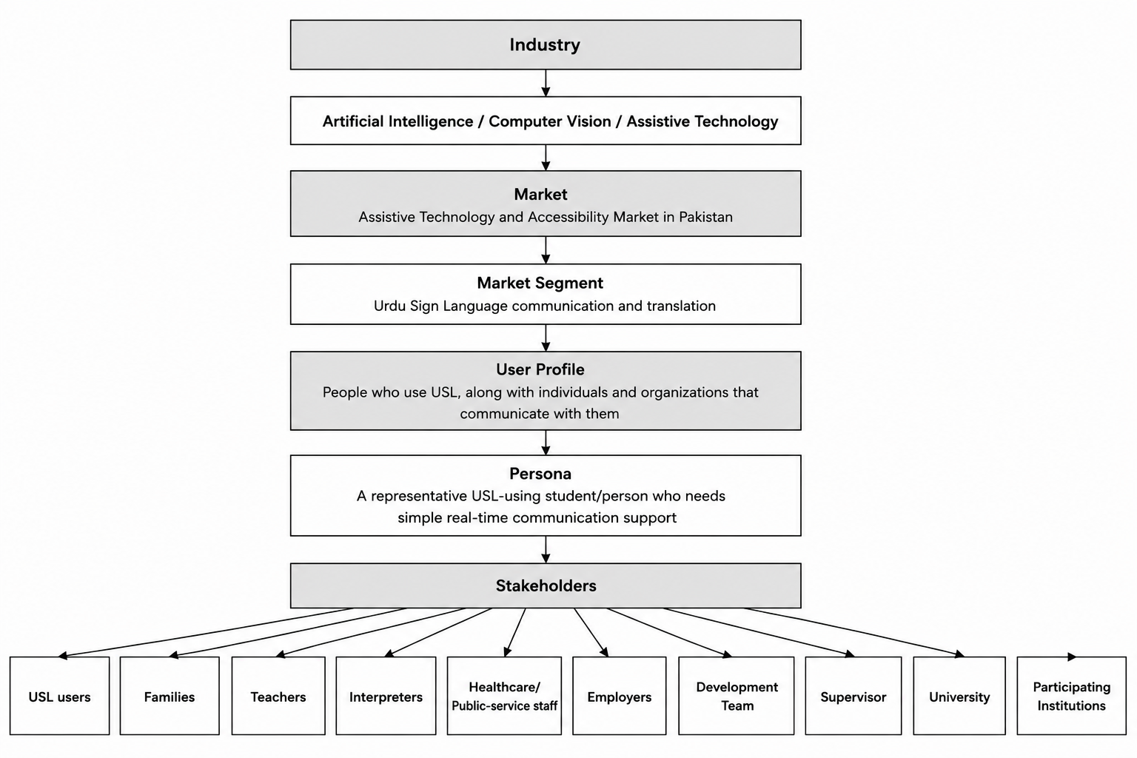
Fig 2: Industry → Market → Market Segment → User Profile → Persona → Stakeholders
This structure shows how the project moves from the broad industry and market to the specific users and stakeholders who influence the proposed system.

2.10 Stakeholder Identification Summary
The stakeholder analysis shows that the proposed system involves both direct users and supporting stakeholders. USL users are the primary stakeholders because their communication difficulties are the main problem being addressed. Families, teachers, interpreters, healthcare staff, public-service employees, and workplace colleagues are secondary stakeholders who may use or benefit from the system's output. The development team, FYP supervisor, university, and participating institutions are also important because they influence development, data collection, testing, and academic requirements. Understanding these stakeholders will help guide decisions about the dataset, alphabets and sentences, emotion detection, interface, text and speech output, usability, and testing. This analysis also provides a foundation for Requirement Elicitation, where stakeholder needs will be converted into specific functional and non-functional requirements.

(PART C)

3. Requirement Elicitation
Requirement elicitation was conducted to understand the communication needs of people who use Urdu Sign Language, the challenges they face, and the requirements relevant to developing a custom Urdu Sign Language dataset and recognition models. The process was carried out in two stages. First, an online meeting with the principal of DWAF was conducted to understand the institute, students, existing communication practices, major communication challenges, and characteristics of Urdu Sign Language. This was followed by an on-site visit, where the team interacted directly with students to understand their everyday communication, commonly used sentences, and sign-language characteristics. The collected information was then analysed and converted into requirements for the custom dataset and recognition models.
Requirement Elicitation Process
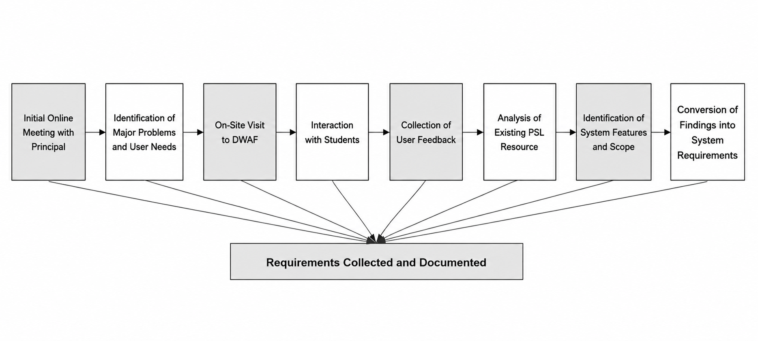
Fig 3: Requirement Elicitation Process

3.1 Requirement Elicitation Techniques Used
The following requirement elicitation techniques were used for the project:

Technique | How It Was Used in the Project Participants | Source
Semi-Structured Interview / Questionnaire | Questions were prepared to understand the institute, students, communication difficulties, literacy, technology access, existing resources and expected system features. | Principal/institute representative and students of DWAF
User Feedback | Students were asked about their everyday communication, commonly used sentences, preferred system output and usefulness of the proposed system. | Deaf students at DWAF
Existing System Analysis | Information about an existing PSL application/resource was collected to understand what is already available and where the proposed system could provide additional functionality. | Principal/institute representative
These techniques were selected because the proposed system is intended for use by deaf individuals. Therefore, it was important to collect requirements directly from the target users and the institute supporting them, rather than relying only on assumptions about their needs.

3.2 Initial Online Meeting with the Principal

Technique Used
The first stage of requirement elicitation consisted of an online meeting with the principal of the Deaf Welfare Awareness Foundation (DWAF). This meeting was conducted before the physical visit to gain an initial understanding of the target users, their communication challenges, educational background, technology access, and the environment in which the proposed system would be used.
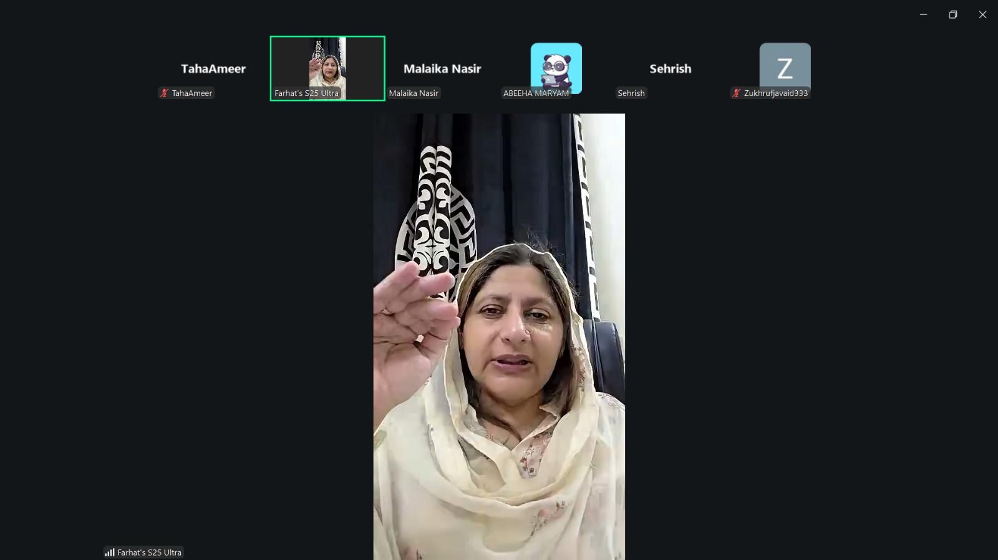
Fig 4: Initial Online Meeting with the Principal of DWAF

Why This Technique Was Selected
An initial discussion with the institute's principal was considered important because the principal has experience with the students and understands the communication difficulties they face both within and outside the institute.
The meeting helped the project team:
- Understand the target population.
- Identify major communication problems.
- Understand how communication is currently managed.
- Identify situations where interpreters are required.
- Understand the literacy level of students.
- Identify existing PSL resources.
- Identify relevant requirements for the recognition research.

Information Obtained
DWAF has approximately 82 students aged 18+, with varied educational backgrounds. Written Urdu is a major difficulty, while basic English words are more commonly used. The institute also explained that communication becomes more difficult outside the institute when interacting with people who do not know sign language.

Requirements Derived from the Initial Meeting
The initial meeting indicated that the research system should:
- Recognise selected Urdu Sign Language input.
- Support recognition of commonly used signs and sentences.
- Consider hand movement where required.
- Support signs involving one or both hands.
- Consider facial expressions where they contribute to sign meaning.
- Use data collected from the target users for model development.
- Include appropriate evaluation of the developed recognition models.

3.3 On-Site Visit and Direct Interaction with Students

Technique Used
After the initial online meeting, the team visited DWAF and interacted directly with the students. Their feedback helped refine the general findings into specific system requirements.

Why This Technique Was Selected
Direct interaction with the target users was selected because the students are able to describe their everyday communication needs from their own experience.
The visit allowed the project team to:
- Discuss real-life communication problems.
- Identify commonly used everyday expressions.
- Understand characteristics of the signs.
- Identify variations in signing.
- Discuss the role of facial expressions.
- Determine suitable sentence classes.
- Obtain information relevant to dataset development.

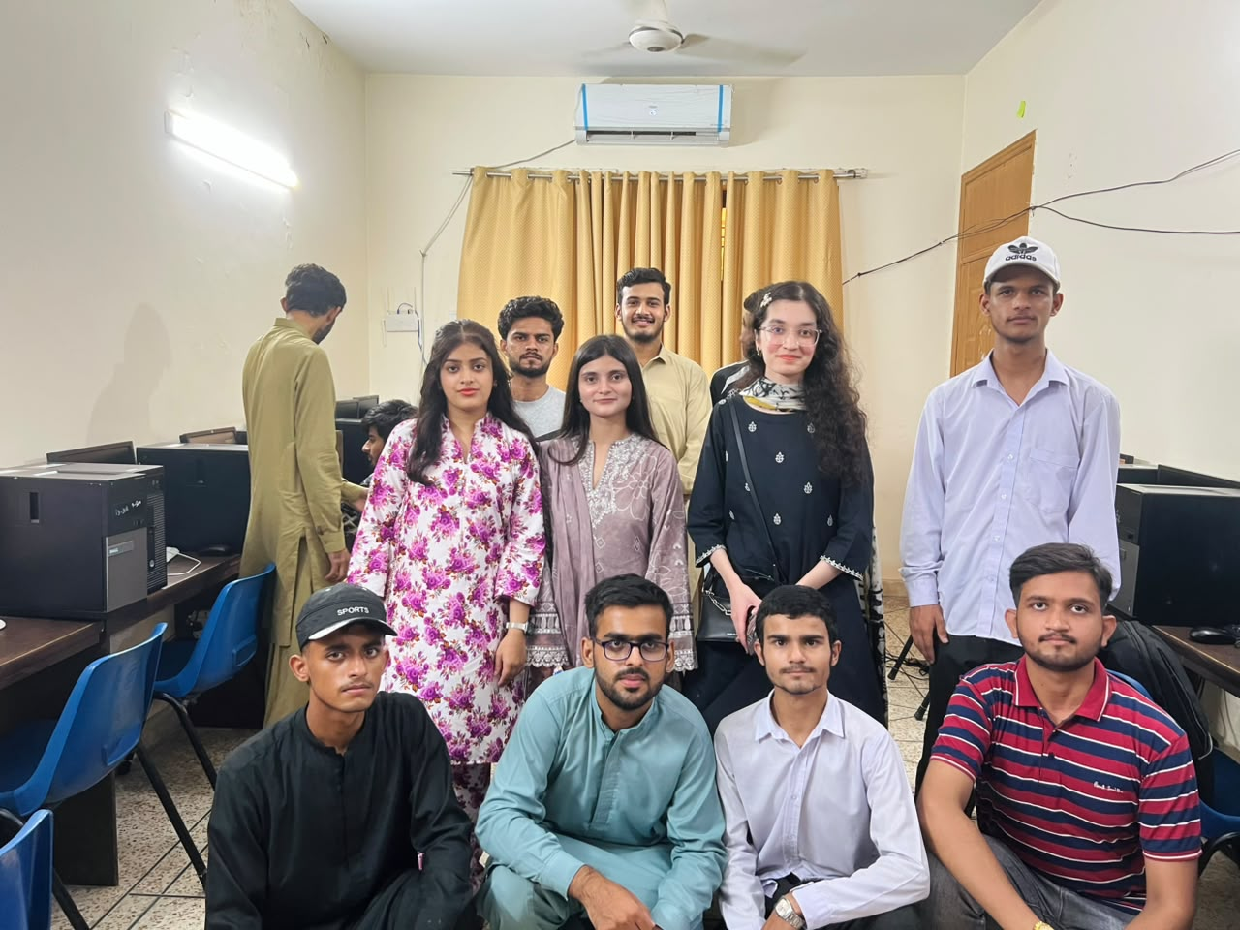

3.4 User Feedback on Communication Needs
During the visit, students and the institute representative discussed the communication difficulties faced by USL users when interacting with people who do not understand sign language. The feedback confirmed that communication difficulties are particularly noticeable outside the institute when teachers or interpreters are not available.
For the current research phase, this finding establishes the real-world motivation for developing a recognition system. The implementation focus, however, is currently on the dataset and recognition models rather than a complete communication application.

Requirement Derived
- The recognition models shall recognise selected Urdu Sign Language input.
- The research shall focus on recognition of signs and sentences relevant to everyday communication.

3.5 User Feedback on Language and Output
The interaction showed that written Urdu is difficult for many students, while basic English words are more commonly used. This information is relevant to understanding the target users and the language context of the dataset and recognition task.

3.6 Identification of Sign Language Characteristics
During the discussions, the project team obtained information about the characteristics of the signs that need to be recognised.
The institute explained that:
- Signs can involve one or both hands.
- Hand movement can be part of a sign.
- Signing is generally continuous.
- Users may not pause between individual signs.
- A sentence may take approximately 1–3 seconds, depending on the sentence.
- Sign language can vary significantly between different regions.
These findings are directly relevant to the design of the custom dataset and recognition models.

Requirements Derived
- FR-01: The dataset shall contain examples of signs involving one or both hands.
- FR-02: The dataset shall include movement-based signs where required.
- FR-03: The dataset shall include examples representing continuous signing where applicable.
- FR-04: The dataset shall represent relevant signing patterns of the target users.
- FR-05: The recognition models shall be developed to handle the selected sign characteristics.

3.7 Facial Expression Requirement
One important finding was the role of facial expressions in sign language. The institute explained that some signs may have similar hand configurations but different meanings depending on the accompanying facial expression, such as “fat” and “strong” or “cold” and “difficult.” This finding influenced the decision to include facial-expression recognition in the research scope.

Requirements Derived
- FR-06: The research system shall include facial-expression recognition.
- FR-07: The facial-expression model shall classify the selected facial-expression categories.
- FR-08: Facial-expression information shall be considered where it is relevant to distinguishing sign meanings.

Current Facial Expression Scope
The current facial-expression model contains five categories:
- Happy
- Sad
- Angry
- Neutral
- Surprise

3.8 Identification of Common Everyday Sentences
A particularly important outcome of the interaction with students was the identification of sentences commonly used in their daily lives. The sentences were selected through discussion with the students rather than being selected randomly.

Requirements Derived
- FR-09: The sentence recognition model shall recognise the selected everyday USL sentences.
- FR-10: The initial sentence recognition model shall support the 24 selected sentences.
- FR-11: The sentence classes shall be based on expressions identified as relevant to the target users.

# | Sentence | # | Sentence
1 | Alhamdulillah | 13 | Madad karo.
2 | Allah Hafiz | 14 | Main aapse mohabbat karti hoon.
3 | Aap kahan rehte ho? | 15 | Main aapse nafrat karti hoon.
4 | Aap kaise ho? | 16 | Main bemaar hoon.
5 | Aapka naam kya hai? | 17 | Main bol nahi sakti.
6 | Aapse mil kar khushi hui. | 18 | Main sun nahi sakti.
7 | Assalam-o-Alaikum | 19 | Main theek hoon.
8 | Baad mein milte hain. | 20 | Mera naam...
9 | Bohat achay. | 21 | Mujhe maaf kar do.
10 | Ghabrana nahi. | 22 | Shukriya
11 | JazakAllah | 23 | Wa Alaikum Assalam
12 | Khushamdeed | 24 | Ye bohat zaroori hai.

3.9 Urdu Alphabet Requirements

The project includes an Urdu alphabet recognition component covering 37 Urdu alphabet classes. These classes will be included in the custom dataset and used for training and evaluating the alphabet recognition model.

Requirements Derived

FR-12: The alphabet recognition model shall recognise the selected Urdu alphabet signs.

FR-13: The initial alphabet recognition model shall contain 37 Urdu alphabet classes.

FR-14: The custom dataset shall contain labelled examples of the selected alphabet signs.

3.10 Existing System Analysis
During requirement elicitation, the team also asked about existing PSL digital resources. The institute reported that an existing PSL application/resource covers alphabets and sentences and mainly serves as a dictionary/reference.
For the current research project, this finding helps establish the difference between existing resources and the proposed research work. The project focuses on developing a custom dataset and machine-learning/deep-learning recognition models, rather than developing another dictionary or application.

Requirements Derived
- FR-15: The research shall focus on automatic recognition of selected USL input.
- FR-16: The developed models shall be trained using the project's custom dataset.
- FR-17: The research shall evaluate the recognition performance of the developed models.

3.11 Dataset Development Requirements
The requirement elicitation process directly influenced the development of the custom dataset. The institute agreed to allow the team to record standard signs for training, helping create a dataset relevant to the target users. The institute also agreed that a teacher could assist in validating prototype/model outputs.

Requirements Derived
- FR-18: The project shall develop a custom dataset for the selected USL signs.
- FR-19: The dataset shall include labelled examples of the selected alphabet classes.
- FR-20: The dataset shall include labelled examples of the selected sentence classes.
- FR-21: The dataset shall include labelled examples of the selected facial-expression classes.
- FR-22: The dataset shall represent variations among the selected target users.
- FR-23: Model predictions shall be validated with assistance from an institute teacher/user representative.

3.12 Dataset Scope
Based on the requirement elicitation findings, the custom dataset will cover three main recognition components:

1. Urdu Alphabet Dataset
37 Urdu alphabet classes

2. Sentence Dataset
24 commonly used everyday sentences

3. Facial-Expression Dataset
5 categories:
- Happy
- Sad
- Angry
- Neutral
- Surprise
These three datasets/components will provide the data required to develop the corresponding recognition models.

3.13 Model Development Requirements
Since the current project is primarily research-based, the main implementation focus is the development and evaluation of recognition models using the custom dataset.

Requirements Derived
- FR-24: An alphabet recognition model shall be developed using the custom dataset.
- FR-25: A sentence recognition model shall be developed using the custom dataset.
- FR-26: A facial-expression recognition model shall be developed using the custom dataset.
- FR-27: The models shall be trained using appropriately labelled data.
- FR-28: The models shall be evaluated using suitable evaluation metrics.
- FR-29: The research shall compare model performance across the selected recognition tasks where appropriate.
- FR-30: The recognition components shall be designed to work as part of the overall proposed USL recognition system.
The three components remain alphabet recognition, sentence recognition, and facial-expression recognition, as established by the elicitation findings.

3.14 Wider Stakeholder Requirements
The institute also identified communication difficulties involving parents and employers. These findings remain relevant because they explain the real-world motivation for developing USL recognition technology. However, since the current project phase is research-focused, they are not converted into application/interface requirements.
The current research instead focuses on developing recognition technology that can potentially contribute to reducing these communication barriers in future system development.

3.15 Conversion of Elicitation Findings into System Requirements
After collecting the information through the online meeting and physical visit, the project team analysed the findings and converted the identified user needs into system requirements.
The conversion process can be summarised as follows:
Evidence / Finding | Identified Need | Research Requirement
Communication difficulties outside the institute | Automatic recognition | Develop USL recognition models
Students identified common daily expressions | Relevant vocabulary | 24 everyday sentence classes
37 Urdu alphabet signs are required | Alphabet-level recognition | 37 alphabet classes
Signs may involve both hands | Different sign configurations | One- and two-hand data
Hand movement is part of signs | Motion information | Movement-based sign samples
Signing is continuous | Continuous input | Continuous-sign samples where applicable
Facial expression can change meaning | Context-aware recognition | Facial-expression model
Five relevant expressions were selected | Defined facial-expression scope | 5 expression classes
Sign language varies by region | Local representation | Custom local dataset
Existing PSL resource mainly acts as a dictionary | Automatic recognition research | Recognition models
Institute permitted sign recording | Real-world data | Custom dataset development
Teacher agreed to validate outputs | Reliable evaluation | Teacher-assisted model validation

3.16 Summary
The requirement elicitation process involved an online meeting with the DWAF principal, an on-site visit, and direct interaction with students. The findings helped identify communication difficulties, common sentences, sign characteristics, regional variations, and the importance of facial expressions. Based on these findings, the project focuses on developing a custom dataset with 37 Urdu alphabet classes, 24 everyday sentence classes, and 5 facial-expression classes, along with alphabet, sentence, and facial-expression recognition models and their evaluation and validation.

References
[1] U. Saeed, S. A. Shah, Y. Y. Ghadi, H. Hameed, S. I. Shah, J. Ahmad, and Q. H. Abbasi, “British sign language detection using ultra-wideband radar sensing and residual neural network,” IEEE Sensors Journal, vol. 24, no. 7, pp. 11144–11151, 2024, doi: 10.1109/JSEN.2024.3364389.
[2] S. K. Paul, M. A. A. Walid, R. R. Paul, M. J. Uddin, M. S. Rana, M. K. Devnath, I. R. Dipu, and M. M. Haque, “An Adam based CNN and LSTM approach for sign language recognition in real time for deaf people,” Bulletin of Electrical Engineering and Informatics, vol. 13, no. 1, pp. 499–509, 2024, doi: 10.11591/eei.v13i1.6059.
[3] M. Patel, “American sign language detection,” Ph.D. dissertation, California State Univ., Northridge, CA, USA, 2023.
[4] M. Z. U. Rahman, M. A. Akbar, M. Usman, M. H. Tahir, Shahzaib, M. T. Riaz, and M. A. Khan, “A real-time system for classification of Pakistan sign language using machine learning,” in Proc. 17th Int. Conf. Open Source Syst. Technol. (ICOSST), 2023, pp. 1–5, doi: 10.1109/ICOSST60641.2023.10414200.
[5] M. I. Saleem, A. Siddiqui, S. Noor, M.-A. Luque-Nieto, and E. Nava-Baro, “A machine learning based full duplex system supporting multiple sign languages for the deaf and mute,” Applied Sciences, vol. 13, no. 5, Art. no. 3114, 2023, doi: 10.3390/app13053114.
[6] J. Shin, A. S. M. Miah, M. A. M. Hasan, K. Hirooka, K. Suzuki, H.-S. Lee, and S.-W. Jang, “Korean sign language recognition using transformer-based deep neural network,” Applied Sciences, vol. 13, no. 5, Art. no. 3029, 2023, doi: 10.3390/app13053029.
[7] S. Azimi, C. De Sio, F. Carlucci, and L. Sterpone, “Fighting for a future free from violence: A framework for real-time detection of ‘Signal for Help’,” Intelligent Systems with Applications, vol. 17, Art. no. 200174, 2023, doi: 10.1016/j.iswa.2022.200174.
[8] A. S. M. Miah, J. Shin, M. A. M. Hasan, and M. A. Rahim, “BenSignNet: Bengali sign language alphabet recognition using concatenated segmentation and convolutional neural network,” Applied Sciences, vol. 12, no. 8, Art. no. 3933, 2022, doi: 10.3390/app12083933.
[9] M. Zakariah, Y. A. Alotaibi, D. Koundal, Y. Guo, and M. M. Elahi, “Sign language recognition for Arabic alphabets using transfer learning technique,” Computational Intelligence and Neuroscience, vol. 2022, Art. no. 4567989, 2022, doi: 10.1155/2022/4567989.

Appendix A — Interview Question Guide Used at DWAF

Institution Profile
- Number of deaf students and age range?
- Typical education level on leaving?
- Differences in how younger and older students sign?

Literacy and Technology Access
- How well can students read and write Urdu? Proportion who can write a full sentence?
- Smartphone access and use?

Communication Challenges
- How is communication managed when a non-signing visitor, parent or official comes?
- Biggest difficulty students face once they leave?
- How often is a teacher pulled away to translate?
- What happens when no signer is available?

Existing Tools and Interpreters
- Has the institute tried any app, device or software?
- Are professional interpreters available? Cost and lead time?
- Can the same hand sign mean something different with a different facial expression?
- Is signing here the same as Karachi or Islamabad?
- Two-handed signs, or signs involving movement?
- How long does one sentence take to sign?
- Do students pause between signs?

System Requirements
- Direction of translation?
- Is text on screen enough, or must it speak aloud?
- Urdu, English, or both?
- Where would it be most useful?
- Useful as a teaching tool for practising signs?

Wider Stakeholders
- How much sign language do parents know?
- Do employers contact you about hiring? What problems come up?

Collaboration
- Permission to record videos of standard signs for training?
- Will a teacher validate prototype output?

The 37 Urdu Alphabet Signs
The alphabet class list covers the Urdu alphabet from Alif to Bari Ye, consistent with the 37-class set used in the published PSL alphabet dataset (2021).
# | Letter | Name | # | Letter | Name | # | Letter | Name
1 | ا | Alif | 14 | ر | Re | 27 | ق | Qaaf
2 | ب | Be | 15 | ڑ | Re (retroflex) | 28 | ک | Kaaf
3 | پ | Pe | 16 | ز | Ze | 29 | گ | Gaaf
4 | ت | Te | 17 | ژ | Zhe | 30 | ل | Laam
5 | ٹ | Te (retroflex) | 18 | س | Seen | 31 | م | Meem
6 | ث | Se | 19 | ش | Sheen | 32 | ن | Noon
7 | ج | Jeem | 20 | ص | Suad | 33 | و | Wao
8 | چ | Che | 21 | ض | Zuad | 34 | ہ | Choti He
9 | ح | Bari He | 22 | ط | Toe | 35 | ء | Hamza
10 | خ | Khe | 23 | ظ | Zoe | 36 | ی | Choti Ye
11 | د | Daal | 24 | ع | Ain | 37 | ے | Bari Ye
12 | ڈ | Daal (retroflex) | 25 | غ | Ghain
13 | ذ | Zaal | 26 | ف | Fe

Supervisor Discussion and Feedback
Item | Details
Discussion Date
Supervisor Feedback
Changes Incorporated
Supervisor Approval / Signature

