**ChessPad V 0.3**

Load, browse, modify, delete PGN files, possibly inside zip files. You can get detailed information about PGN at <https://en.wikipedia.org/wiki/Portable_Game_Notation> and about FEN at [https://en.wikipedia.org/wiki/Forsyth%E2%80%93Edwards_Notation](https://en.wikipedia.org/wiki/Forsyth–Edwards_Notation) . This is the picture of Game view:

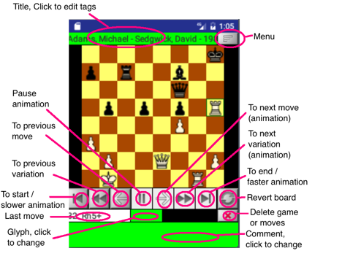

ChessPad creates a sample file ChessPad/sample.pgn so the user can get an idea of ChessPad features. Note that all modifications to this file will be lost after ChessPad is restarted.

To make a move click on the piece on the board (the square will be selected like h5 on the picture) and click on the square where you want to move to. ChessPad does not allow illegal moves.

Using Menu button you can load another game, save your changes, append game to the existing PGN file or create a new PGN file containing the opened game.

When appending to a PGN file the path format is:

…/dir1/dir2/save.pgn

or

…/dir1/zipped_pgn.zip/save1.pgn

Limitation. Zip file can contain several PGN files but not directories which are ignored.

By clicking on the title line you get to the screen where you can modify PGN tags.

All tag values can be modified and the tags not included in STR can be deleted. You can also add new tags using the last line:

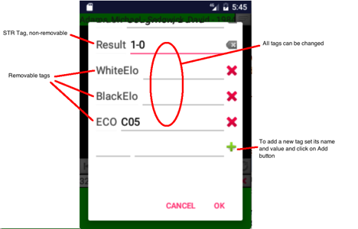

Using menu item Setup you can switch to Setup screen. The position will be copied from Game screen.

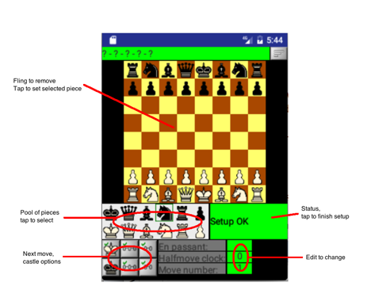

To place a piece on the board tap on it on the pool set, then tap on board where you want to place it as many times as you want. To remove a piece from the board fling it.

Setup can de finished and ChessPad returns to Game screen only if the position does not have errors, e.g no King, more than one King, etc.

To abandon Setup and return to Game screen user Menu ‘Cancel Setup’. The position will be lost in this case.

**Merging variations**. ChessPad V0.3 merges variations once they create the same position. Example:

**1.e4 e5 2.Nf3 {main} (2.Bc4 {v1} Nc6 {v1} 3.Nf3 {v1} Nf6 {v1} $4 4.c3{v1} $7) 2. ... Nc6 {main} 3.Bc4{main} Nf6{main} $5 4.c3{main}**

Note that positions after 3.Nf3 {v1} and 3.Bc4{main} are the same. As a result ChessPad changes the pgn above to:

1. e4 e5 2. Nf3 {main} (2. Bc4 {v1} Nc6 {v1} 3. Nf3 {v1} ) 2. ... Nc6 {main} 3. Bc4 {main} Nf6 $5 {main; v1} 4. c3 $7 {main; v1}

Some important implications:

1. If 4. c3 is deleted, it disappears from both main line and variation.

2. If 3. Bc4 {main} move is deleted, its following moves are not deleted, but moved to the variation, resulting:

1. e4 e5 2. Nf3 {main} (2. Bc4 {v1} Nc6 {v1} 3. Nf3 {v1} Nf6 $5 {main; v1} 4. c3 $7 {main; v1} ) 2. ... Nc6 {main}