**Declaration of Number of Words for Masters by Research Dissertation**

This form should be signed by the candidate and the candidate’s supervisor and submitted to [doctoralschool@royalholloway.ac.uk](mailto:doctoralschool@royalholloway.ac.uk) together with the electronic copy of the dissertation.

The Royal Holloway Research Degree Regulations for the Degrees of Masters by Research state that the dissertation will be a maximum of 40,000 words including references, footnotes and endnotes, but excluding the bibliography and appendices, etc. In many cases, however, your department will recommend a lower word count as appropriate to your discipline.

Candidate’s name: Thomas Bass

Dissertation title: **Comparative Analysis of Simulations and Experimental Outcomes: Slow Extraction Driven by RF Transverse Excitation at the CERN Proton Synchrotron**

I confirm that the word length of:

1. the dissertation including footnotes is **11,505**
2. the bibliography is **1,336**

and, if applicable,

1. the appendices are **0**

Candidate’s signature: Date: 11 September 2023

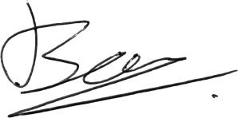

Supervisor’s signature: Date: 31 August 2023



Please submit to [doctoralschool@royalholloway.ac.uk](mailto:doctoralschool@royalholloway.ac.uk) at the same time as your dissertation.