Cybersecurity Incident Report:

Network Traffic Analysis

Scenario
Review the scenario below. Then complete the step-by-step instructions.
You are a cybersecurity analyst working at a company that specializes in providing IT services for clients. Several customers of clients reported that they were not able to access the client company website www.yummyrecipesforme.com, and saw the error “destination port unreachable” after waiting for the page to load.
You are tasked with analyzing the situation and determining which network protocol was affected during this incident. To start, you attempt to visit the website and you also receive the error “destination port unreachable.” To troubleshoot the issue, you load your network analyzer tool, tcpdump, and attempt to load the webpage again. To load the webpage, your browser sends a query to a DNS server via the UDP protocol to retrieve the IP address for the website's domain name; this is part of the DNS protocol. Your browser then uses this IP address as the destination IP for sending an HTTPS request to the web server to display the webpage The analyzer shows that when you send UDP packets to the DNS server, you receive ICMP packets containing the error message: “udp port 53 unreachable.”

Tcpdump: Captured Logs

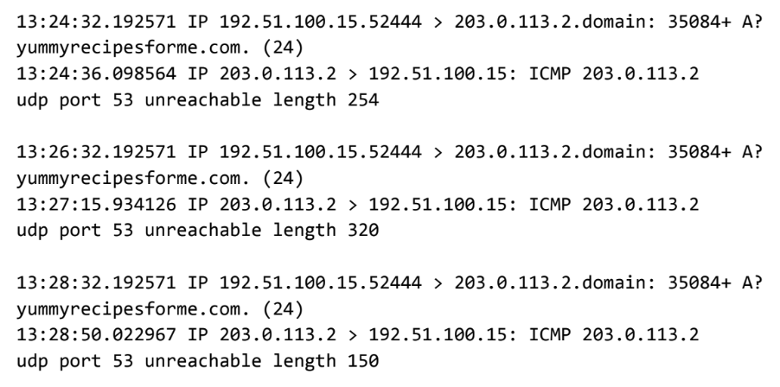

Analysis

Part 1: Provide a summary of the problem found in the DNS and ICMP
traffic log.

The UDP protocol reveals that: The website/domain name is inaccessible.

This is based on the results of the network analysis, which show that the ICMP echo reply returned the error message: “udp port 53 unreachable”.

The port noted in the error message is used for: DNS Service.

The most likely issue is: DDoS attack or DNS server is down.

Part 2: Explain your analysis of the data and provide at least one cause of the incident.
Time incident occurred: Afternoon, at 1:24 p.m., 32.192571 seconds.

Explain how the IT team became aware of the incident: Several customers reported that the www.yummyrecipesforme.com website is inaccessible and they saw the error “destination port unreachable” and the page does not load.

Explain the actions taken by the IT department to investigate the incident: I, as part of the the network security team responded immediately, tried loading the webpage again and started running tests with the network protocol analyzer tool tcpdump to troubleshoot the issue. The captured log shows that port 53, which is used for DNS service, is not listening on this DNS port. So, the UDP request for an IP address of the domain is not going through the DNS server. I am continuing my investigation to find the root cause of this issue and determine how I can restore the website access. My next steps include checking the firewall configuration to check if port 53 is blocked and contacting the system administrator for the DNS server to have them check the system for signs of a DoS/DDoS attack.

Note key findings of the IT department's investigation (i.e., details related to the port affected, DNS server, etc.): Port 53 is used for DNS service where every query for the domain name is handled by this DNS port. As there is an “A” flag attached to this log file, it is likely that the A record of the DNS is misconfigured or the DNS server is down or DoS/DDoS on port 53.

Note a likely cause of the incident: Regular web traffic.

