File Permissions in Linux

Project description
The research team needed their access controls updated in the projects directory to make sure permissions align with actual authorization levels and the principle of least privilege. To keep the system secure, I took the following steps:

Check file and directory details
Before modifying any access controls, I ran the following Linux commands to audit the existing permission settings and ownership details for the target directory:
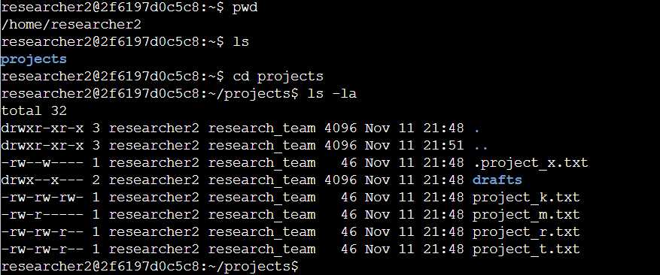

I navigated to the projects directory and executed ls -la to display a detailed listing of all directory contents, including hidden files. The command output reveals one subdirectory (drafts), one hidden file (.project_x.txt), and four project files (project_k.txt, project_m.txt, project_r.txt, and project_t.txt). The 10-character string at the beginning of each line specifies the current permission settings for that file or directory.

Describe the permissions string
The 10-character string breaks down the file type and access rights for three distinct ownership levels:
- 1st character: Indicates file type (“d” for directory, “-” for a regular file).
- 2nd–4th characters: Represent user (owner) permissions for read (r), write (w), and execute (x). A hyphen (-) means the permission is denied.
- 5th–7th characters: Represent group permissions (r, w, x). A hyphen (-) means the permission is denied.
- 8th–10th characters: Represent other (everyone else on the system) permissions (r, w, x). A hyphen (-) means the permission is denied.
For example, project_t.txt displays the string -rw-rw-r--. The leading hyphen confirms it is a standard file. The r characters at positions 2, 5, and 8 mean the user, group, and others all have read access. The “w” characters at positions 3 and 6 grant write privileges strictly to the user and group, while no execute permissions are set for anyone.

Change file permissions
Based on the permissions listed earlier, I identified that project_k.txt had write permissions enabled for “others.” To align with the organization's policy that “others” should not have write access to any files, I removed this permission.
The following code demonstrates how I used Linux commands to make this update:
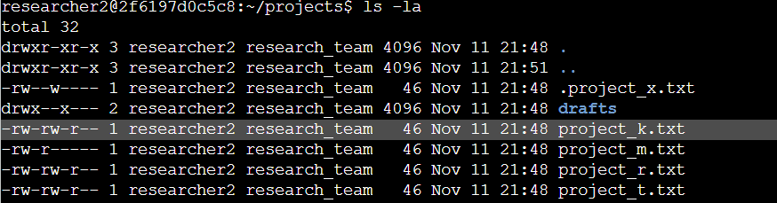
The chmod command modifies file and directory permissions. The first argument (g-o) defines the permission changes to apply, while the second specifies the target file or directory. In this instance, I ran chmod o-w project_k.txt to remove write permissions for "other." Afterwards, I executed ls -la to verify that the permission string was updated to -rw-rw-r--.

Change file permissions on a hidden file
The research team recently archived project_x.txt. According to their security requirements, no one should have write access to this file, though the user and group still need read access.
The code below demonstrates how I used Linux commands to update these permissions:
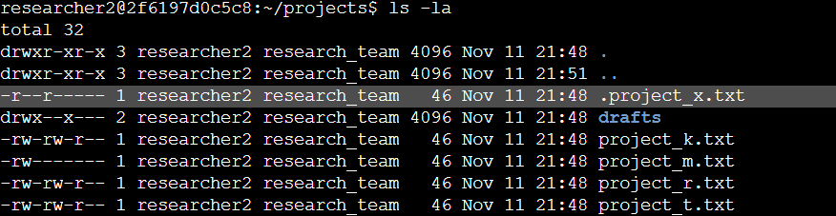

I identified .project_x.txt as a hidden file because its name begins with a period (.). In this step, I removed write access from both the user (u-w) and group (g-w), while adding read permissions to the group (g+r) using a single chmod command (chmod u-w,g-w,g+r .project_x.txt). Running ls -la confirmed that the permissions updated to -r--r-----.

Change directory permissions
My organization specified that only the researcher2 user should have access to the drafts directory and its contents, meaning no one other than the owner should have execute permissions.
The following code demonstrates how I used Linux commands to update these permissions:
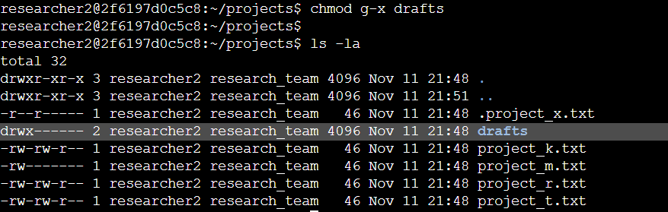

This output confirms the updated permissions across the directory. Lines 1 and 2 refer to the current and parent directories, line 3 shows .project_x.txt, and line 4 reflects the updated drafts directory. I used the chmod g-x drafts command to strip execute privileges from the group. Since researcher2 already retained execute rights, no owner modifications were necessary, effectively restricting access strictly to researcher2.

Summary
I updated the access controls for files and subdirectories within the projects directory to match the organization's required authorization levels. First, I ran ls -la to audit the existing permissions and establish a baseline for the required changes. Based on those findings, I used the chmod command to modify the permissions across specific files and directories, ensuring the system remains secure and aligned with access policy.

Reference: Lab History
researcher2@2f6197d0c5c8:~$ pwd
/home/researcher2
researcher2@2f6197d0c5c8:~$ ls
projects
researcher2@2f6197d0c5c8:~$ cd projects
researcher2@2f6197d0c5c8:~/projects$ ls -la
total 32
drwxr-xr-x 3 researcher2 research_team 4096 Nov 11 21:48 .
drwxr-xr-x 3 researcher2 research_team 4096 Nov 11 21:51 ..
-rw--w---- 1 researcher2 research_team 46 Nov 11 21:48 .project_x.txt
drwx--x--- 2 researcher2 research_team 4096 Nov 11 21:48 drafts
-rw-rw-rw- 1 researcher2 research_team 46 Nov 11 21:48 project_k.txt
-rw-r----- 1 researcher2 research_team 46 Nov 11 21:48 project_m.txt
-rw-rw-r-- 1 researcher2 research_team 46 Nov 11 21:48 project_r.txt
-rw-rw-r-- 1 researcher2 research_team 46 Nov 11 21:48 project_t.txt
researcher2@2f6197d0c5c8:~/projects$
researcher2@2f6197d0c5c8:~/projects$ chmod o-w project_k.txt
researcher2@2f6197d0c5c8:~/projects$
researcher2@2f6197d0c5c8:~/projects$ ls -la
total 32
drwxr-xr-x 3 researcher2 research_team 4096 Nov 11 21:48 .
drwxr-xr-x 3 researcher2 research_team 4096 Nov 11 21:51 ..
-rw--w---- 1 researcher2 research_team 46 Nov 11 21:48 .project_x.txt
drwx--x--- 2 researcher2 research_team 4096 Nov 11 21:48 drafts
-rw-rw-r-- 1 researcher2 research_team 46 Nov 11 21:48 project_k.txt
-rw-r----- 1 researcher2 research_team 46 Nov 11 21:48 project_m.txt
-rw-rw-r-- 1 researcher2 research_team 46 Nov 11 21:48 project_r.txt
-rw-rw-r-- 1 researcher2 research_team 46 Nov 11 21:48 project_t.txt
researcher2@2f6197d0c5c8:~/projects$ chmod g-r project_m.txt
researcher2@2f6197d0c5c8:~/projects$
researcher2@2f6197d0c5c8:~/projects$ ls -la
total 32
drwxr-xr-x 3 researcher2 research_team 4096 Nov 11 21:48 .
drwxr-xr-x 3 researcher2 research_team 4096 Nov 11 21:51 ..
-rw--w---- 1 researcher2 research_team 46 Nov 11 21:48 .project_x.txt
drwx--x--- 2 researcher2 research_team 4096 Nov 11 21:48 drafts
-rw-rw-r-- 1 researcher2 research_team 46 Nov 11 21:48 project_k.txt
-rw------- 1 researcher2 research_team 46 Nov 11 21:48 project_m.txt
-rw-rw-r-- 1 researcher2 research_team 46 Nov 11 21:48 project_r.txt
-rw-rw-r-- 1 researcher2 research_team 46 Nov 11 21:48 project_t.txt
researcher2@2f6197d0c5c8:~/projects$
researcher2@2f6197d0c5c8:~/projects$ chmod u-w,g-w,g+r .project_x.txt
researcher2@2f6197d0c5c8:~/projects$ ls -la
total 32
drwxr-xr-x 3 researcher2 research_team 4096 Nov 11 21:48 .
drwxr-xr-x 3 researcher2 research_team 4096 Nov 11 21:51 ..
-r--r----- 1 researcher2 research_team 46 Nov 11 21:48 .project_x.txt
drwx--x--- 2 researcher2 research_team 4096 Nov 11 21:48 drafts
-rw-rw-r-- 1 researcher2 research_team 46 Nov 11 21:48 project_k.txt
-rw------- 1 researcher2 research_team 46 Nov 11 21:48 project_m.txt
-rw-rw-r-- 1 researcher2 research_team 46 Nov 11 21:48 project_r.txt
-rw-rw-r-- 1 researcher2 research_team 46 Nov 11 21:48 project_t.txt
researcher2@2f6197d0c5c8:~/projects$ chmod g-x drafts
researcher2@2f6197d0c5c8:~/projects$
researcher2@2f6197d0c5c8:~/projects$ ls -la
total 32
drwxr-xr-x 3 researcher2 research_team 4096 Nov 11 21:48 .
drwxr-xr-x 3 researcher2 research_team 4096 Nov 11 21:51 ..
-r--r----- 1 researcher2 research_team 46 Nov 11 21:48 .project_x.txt
drwx------ 2 researcher2 research_team 4096 Nov 11 21:48 drafts
-rw-rw-r-- 1 researcher2 research_team 46 Nov 11 21:48 project_k.txt
-rw------- 1 researcher2 research_team 46 Nov 11 21:48 project_m.txt
-rw-rw-r-- 1 researcher2 research_team 46 Nov 11 21:48 project_r.txt
-rw-rw-r-- 1 researcher2 research_team 46 Nov 11 21:48 project_t.txt
researcher2@2f6197d0c5c8:~/projects$

