

**LAB REPORT WEB TECHNOLOGIES**

**SUBMITTED BY:**

ABDUL MUNAF

FA19-BSE-093(6B)

Ali Kazim

Fa19-bse-100(6b)

**SUBMITTED TO:**

MA’AM SADIA MAQBOOL

Introduction:

The project is based on ecommerce website of accessories such as portable speakers, headphones and other music related products. The project has different product categories and based on these categories the sections have been made. Each section have specific kind of products. It has Home page showing the products in sections like new arrivals and best selling’s and on products page all different kind of products are displayed. It has form page where the admin can add products on the page, remove them and update them.

**Controllers:**

Controllers have been used to control the flow of processes and pages being rendered. Product Controller uses different functions to store data in a database and render data from there.

PRODUCTCONTROLLER:

Product Controller uses different functions to store data, save data in a database and render data from there.

<?php

namespace App\Http\Controllers;

use App\Models\product;

use Illuminate\Http\Request;

*class* StudentController *extends* *Controller*

{

*/\*\**

*\* Display a listing of the resource.*

*\**

*\* @return \Illuminate\Http\Response*

*\*/*

*public* *function* index()

    {

        $product = Product::all()->toArray();

        return view('frontend.products', compact('product'));

    }

*/\*\**

*\* Show the form for creating a new resource.*

*\**

*\* @return \Illuminate\Http\Response*

*\*/*

*public* *function* create()

    {

        return view('products2.create');

    }

*/\*\**

*\* Store a newly created resource in storage.*

*\**

*\* @param  \Illuminate\Http\Request  $request*

*\* @return \Illuminate\Http\Response*

*\*/*

*public* *function* store(Request $request)

    {

*$this*->validate($request, [

            'product_name' => 'required',

            'product_price' => 'required'

        ]);

        $product = new product([

            'product_name' => $request->get('product_name'),

            'product_price' => $request->get('product_price'),

        ]);

        $product->save();

        return redirect()->route('products2.index')->with('success', 'Data Added');

    }

*/\*\**

*\* Display the specified resource.*

*\**

*\* @param  int  $id*

*\* @return \Illuminate\Http\Response*

*\*/*

*public* *function* show($id)

    {

*//*

    }

*/\*\**

*\* Show the form for editing the specified resource.*

*\**

*\* @param  int  $id*

*\* @return \Illuminate\Http\Response*

*\*/*

*public* *function* edit($id)

    {

*//*

    }

*/\*\**

*\* Update the specified resource in storage.*

*\**

*\* @param  \Illuminate\Http\Request  $request*

*\* @param  int  $id*

*\* @return \Illuminate\Http\Response*

*\*/*

*public* *function* update(Request $request, $id)

    {

*//*

    }

*/\*\**

*\* Remove the specified resource from storage.*

*\**

*\* @param  int  $id*

*\* @return \Illuminate\Http\Response*

*\*/*

*public* *function* destroy($id)

    {

*//*

    }

}

Image Controller:

A controller to upload the image of product.

<?php

namespace App\Http\Controllers;

use App\http\Requests;

use Illuminate\Http\Request;

*class* uploadimagecontroller *extends* *Controller*

{

*function* index()

    {

        return view('products2.index');

    }

}

HomeController:

<?php

namespace App\Http\Controllers\frontend;

use App\Http\Controllers\Controller;

use Illuminate\Http\Request;

*class* HomeController *extends* *Controller*

{

*public* *function* index()

    {

        return view('frontend.index');

    }

}

AboutController:

<?php

namespace App\Http\Controllers\frontend;

use App\Http\Controllers\Controller;

use Illuminate\Http\Request;

*class* AbouttController *extends* *Controller*

{

*public* *function* index()

    {

        return view('frontend.about');

    }

}

MODEL:

The model has been made to show the structure of database.

<?php

namespace App\Models;

use Illuminate\Database\Eloquent\Factories\HasFactory;

use Illuminate\Database\Eloquent\Model;

*class* product *extends* *Model*

{

*protected* $fillable = ['product_name', 'product_price'];

    use HasFactory;

}

MIGRATION:

Migration for product description:

<?php

use Illuminate\Database\Migrations\Migration;

use Illuminate\Database\Schema\Blueprint;

use Illuminate\Support\Facades\Schema;

*class* CreateProductsTable *extends* *Migration*

{

*/\*\**

*\* Run the migrations.*

*\**

*\* @return void*

*\*/*

*public* *function* up()

    {

        Schema::create('products', *function* (Blueprint $table) {

            $table->increments('id');

            $table->string('product_name');

            $table->double('product_price');

            $table->timestamps();

        });

    }

*/\*\**

*\* Reverse the migrations.*

*\**

*\* @return void*

*\*/*

*public* *function* down()

    {

        Schema::dropIfExists('products');

    }

}

Migration for image:

<?php

use Illuminate\Database\Migrations\Migration;

use Illuminate\Database\Schema\Blueprint;

use Illuminate\Support\Facades\Schema;

*class* AddPhotoToProductsTable *extends* *Migration*

{

*/\*\**

*\* Run the migrations.*

*\**

*\* @return void*

*\*/*

*public* *function* up()

    {

        Schema::table('products', *function* (Blueprint $table) {

            $table->text('product_image')->after('id');

        });

    }

*/\*\**

*\* Reverse the migrations.*

*\**

*\* @return void*

*\*/*

*public* *function* down()

    {

        Schema::table('products', *function* (Blueprint $table) {

            $table->dropColumn('product_image');

        });

    }

}

FORM:

This is the form that allow user to upload the product.

@extends('master')

@section('content')

<div *class*="row">

    <div *class*="col-md-12">

        <br />

        <h3 *align*="center">Add data</h3>

        <br />

        @if (count($errors) > 0)

        <div *class*="alert alert-danger">

            <ul>

                @foreach($errors->all() as $error)

                <li>

                    {{$error}}

                </li>

                @endforeach

            </ul>

        </div>

        @endif

        @if(\Session::has('success'))

        <div *class*="alert alert-success">

            <p>{{\Session::get('success')}}</p>

        </div>

        @endif

        <form *method*="post" *action*="{{url('products2')}}" *enctype*="multipart/form-data">

            {{csrf_field()}}

            <div *class*="form-group">

                <label *for*="">choose product image</label>

                <input *type*="file" *name*="product_image">

            </div>

            <div *class*="form-group">

                <input *type*="text" *name*="product_name" *class*="form-control" *placeholder*="enter the name of product" />

            </div>

            <div *class*="form-group">

                <input *type*="numeric" *name*="product_price" *class*="form-control" *placeholder*="enter the price of product" />

            </div>

            <div *class*="form-group">

                <input *type*="submit" *class*="btn btn-primary" />

            </div>

        </form>

    </div>

</div>

@endsection

Views:

Home:

<html *lang*="en">

<head>

  <meta *charset*="UTF-8" />

  <meta *http-equiv*="X-UA-Compatible" *content*="IE=edge" />

  <meta *name*="viewport" *content*="width=device-width, initial-scale=1.0" />

  <title>Lab mid eccomerce</title>

  <link *rel*="stylesheet" *href*="{{url('frontend/css/style.css')}}" />

</head>

<body>

  <div *class*="container">

    <div *class*="navbar">

      <img *src*="{{url('frontend/logo1.png')}}" *alt*="" *class*="logo" />

      <ul>

        <li><a *href*="{{url('/')}}">Home</a></li>

        <li><a *href*="{{url('/about')}}">About</a></li>

        <li><a *href*="{{url('products2/create')}}">Form</a></li>

        <li><a *href*="{{url('/products')}}">Products</a></li>

        <li><a *href*="#">connect</a></li>

      </ul>

    </div>

    <div *class*="content">

      <div *class*="left-col">

        <h1>WELCOME,TO <br />SHOPEE.PK<br /></h1>

      </div>

      <div *class*="right-col">

        <p>Click here to listen</p>

        <img *src*="{{url('frontend/img/play.png')}}" *alt*="" *id*="icon" />

      </div>

    </div>

  </div>

  <audio *src*="{{url('frontend/cool_ringtone.mp3')}}" *id*="mysong"></audio>

  <script>

*var* mysong = document.getElementById("mysong");

*var* icon = document.getElementById("icon");

    icon.onclick = *function*() {

      if (mysong.paused) {

        mysong.play();

        icon.src = "{{url('frontend/img/pause.png')}}";

      } else {

        mysong.pause();

        icon.src = "{{url('frontend/img/play.png')}}";

      }

    };

  </script>

*<!--  links to import the tagss -->*

  <script *src*="https://code.iconify.design/iconify-icon/1.0.1/iconify-icon.min.js"></script>

  <script *src*="https://code.iconify.design/iconify-icon/1.0.1/iconify-icon.min.js"></script>

  <script *src*="https://code.iconify.design/iconify-icon/1.0.1/iconify-icon.min.js"></script>

  <script *src*="https://code.iconify.design/iconify-icon/1.0.1/iconify-icon.min.js"></script>

  <script *src*="https://code.iconify.design/iconify-icon/1.0.1/iconify-icon.min.js"></script>

  <script *src*="https://code.iconify.design/iconify-icon/1.0.1/iconify-icon.min.js"></script>

  <script *src*="https://code.iconify.design/iconify-icon/1.0.1/iconify-icon.min.js"></script>

  <section *class*="section benefits">

    <div *class*="benefit-center box">

      <div *class*="benefit">

        <span *class*="icon">

          <iconify-icon *icon*="bx:purchase-tag"></iconify-icon>

        </span>

        <h4>Free Shipping</h4>

        <span *class*="text">Free shipping Above 5000Rs</span>

      </div>

      <div *class*="benefit">

        <span *class*="icon">

          <iconify-icon *icon*="bx:bx-book-reader"></iconify-icon>

        </span>

        <h4>10-Day Returns</h4>

        <span *class*="text">Shop without any fear</span>

      </div>

      <div *class*="benefit">

        <span *class*="icon">

*<!-- <i class="bx bx-headphone"></i> -->*

          <iconify-icon *icon*="bx:bx-headphone"></iconify-icon>

        </span>

        <h4>24/7 Support</h4>

        <span *class*="text">We are always there to help you</span>

      </div>

    </div>

  </section>

*<!-- New Arrivals -->*

  <section *class*="section">

    <div *class*="h">

      <h1><span>New</span> Arrivals</h1>

    </div>

    <div *class*="ac-center box">

      <div *class*="ac">

        <div *class*="img-cover">

          <img *src*="{{url('frontend/headphone.jpg')}}" *alt*="" *width*="200px" />

        </div>

        <p>Sony WH-CH400 Wireless Headset</p>

        <div *class*="rating">

          <i *class*="bx bxs-star"></i>

          <i *class*="bx bxs-star"></i>

          <i *class*="bx bxs-star"></i>

          <i *class*="bx bxs-star"></i>

          <i *class*="bx bxs-star"></i>

        </div>

        <div *class*="price">PKR 5000</div>

      </div>

      <div *class*="ac">

        <div *class*="img-cover">

          <img *src*="{{url('frontend/remax.jpg')}}" *alt*="" *width*="200px" />

        </div>

        <p>Remax Handfree Metallic red RM-500</p>

        <div *class*="rating">

          <i *class*="bx bxs-star"></i>

          <i *class*="bx bxs-star"></i>

          <i *class*="bx bxs-star"></i>

          <i *class*="bx bxs-star"></i>

          <i *class*="bx bx-star"></i>

        </div>

        <div *class*="price">PKR 3000</div>

      </div>

      <div *class*="ac">

        <div *class*="img-cover">

          <img *src*="{{url('frontend/redmi-buds-3.jpg')}}" *alt*="" *width*="200px" />

        </div>

        <p>Redmi Buds 3 PRO</p>

        <div *class*="rating">

          <i *class*="bx bxs-star"></i>

          <i *class*="bx bxs-star"></i>

          <i *class*="bx bxs-star"></i>

          <i *class*="bx bxs-star"></i>

          <i *class*="bx bx-star"></i>

        </div>

        <div *class*="price">PKR 29000</div>

      </div>

      <div *class*="ac">

        <div *class*="img-cover">

          <img *src*="{{url('frontend/pocket-speaker.jpg')}}" *alt*="" *width*="200px" />

        </div>

        <p>Redmi Mi Pocket Speaker</p>

        <div *class*="rating">

          <i *class*="bx bxs-star"></i>

          <i *class*="bx bxs-star"></i>

          <i *class*="bx bxs-star"></i>

          <i *class*="bx bxs-star"></i>

          <i *class*="bx bx-star"></i>

        </div>

        <div *class*="price">PKR 4000</div>

      </div>

    </div>

  </section>

*<!--   productts -->*

  <section *class*="section">

    <div *class*="h">

      <h1><span>Our</span> Products</h1>

    </div>

    <div *class*="ac-center box">

      <div *class*="ac">

        <div *class*="img-cover">

          <img *src*="{{url('frontend/headphone.jpg')}}" *alt*="" *width*="200px" />

        </div>

        <p><strong>Headphones/Headset</strong></p>

        <div *class*="rating">

          <i *class*="bx bxs-star"></i>

          <i *class*="bx bxs-star"></i>

          <i *class*="bx bxs-star"></i>

          <i *class*="bx bxs-star"></i>

          <i *class*="bx bxs-star"></i>

        </div>

*<!-- <div class="price">PKR 5000</div> -->*

      </div>

      <div *class*="ac">

        <div *class*="img-cover">

          <img *src*="{{url('frontend/remax.jpg')}}" *alt*="" *width*="200px" />

        </div>

        <p><strong>Earphones</strong></p>

        <div *class*="rating">

          <i *class*="bx bxs-star"></i>

          <i *class*="bx bxs-star"></i>

          <i *class*="bx bxs-star"></i>

          <i *class*="bx bxs-star"></i>

          <i *class*="bx bx-star"></i>

        </div>

*<!-- <div class="price">PKR 3000</div> -->*

      </div>

      <div *class*="ac">

        <div *class*="img-cover">

          <img *src*="{{url('frontend/redmi-buds-3.jpg')}}" *alt*="" *width*="200px" />

        </div>

        <p><strong>EarBuds</strong></p>

        <div *class*="rating">

          <i *class*="bx bxs-star"></i>

          <i *class*="bx bxs-star"></i>

          <i *class*="bx bxs-star"></i>

          <i *class*="bx bxs-star"></i>

          <i *class*="bx bx-star"></i>

        </div>

*<!-- <div class="price">PKR 29000</div> -->*

      </div>

      <div *class*="ac">

        <div *class*="img-cover">

          <img *src*="{{url('frontend/pocket-speaker.jpg')}}" *alt*="" *width*="200px" />

        </div>

        <p><strong>Portable Pocket Speaker</strong></p>

        <div *class*="rating">

          <i *class*="bx bxs-star"></i>

          <i *class*="bx bxs-star"></i>

          <i *class*="bx bxs-star"></i>

          <i *class*="bx bxs-star"></i>

          <i *class*="bx bx-star"></i>

        </div>

*<!-- <div class="price">PKR 4000</div> -->*

      </div>

    </div>

  </section>

  <section *id*="footer">

    <div *class*="foot">

      <p>Links</p>

      <ul>

        <li><a *href*="index.html">HOME</a></li>

        <li><a *href*="">ABOUT US</a></li>

        <li><a *href*="">CONTACT US</a></li>

      </ul>

      <div *class*="social-links">

        <p>Follow us</p>

        <a *href*="">

          <iconify-icon *icon*="mdi:linkedin"></iconify-icon>

        </a>

        <a *href*="">

          <iconify-icon *icon*="fa6-brands:square-behance"></iconify-icon>

        </a>

        <a *href*="">

          <iconify-icon *icon*="ic:baseline-facebook"></iconify-icon>

        </a>

        <a *href*="">

          <iconify-icon *icon*="mdi:instagram"></iconify-icon>

        </a>

        <a *href*="">

          <iconify-icon *icon*="bi:twitter"></iconify-icon>

        </a>

      </div>

    </div>

  </section>

</body>

</html>

PRODUCT:

<head>

  <meta *charset*="UTF-8" />

  <meta *http-equiv*="X-UA-Compatible" *content*="IE=edge" />

  <meta *name*="viewport" *content*="width=device-width, initial-scale=1.0" />

  <title>Lab mid eccomerce</title>

  <link *rel*="stylesheet" *href*="{{url('frontend/product.css')}}" />

</head>

<body>

  <div *class*="container">

    <div *class*="navbar">

      <img *src*="{{url('frontend/logo1.png')}}" *alt*="" *class*="logo" />

      <ul>

        <li><a *href*="{{url('/')}}">Home</a></li>

        <li><a *href*="{{url('/about')}}">About</a></li>

        <li><a *href*="#">Specification</a></li>

        <li><a *href*="#">connect</a></li>

      </ul>

    </div>

    <div *class*="content">

      <div *class*="left-col">

        <h1>Select <br />By Category<br /></h1>

      </div>

      <div *class*="right-col">

        <p>Click here to listen</p>

        <img *src*="{{url('frontend/img/play.png')}}" *alt*="" *id*="icon" />

      </div>

    </div>

  </div>

  <audio *src*="{{url('frontend/cool_ringtone.mp3')}}" *id*="mysong"></audio>

  <script>

*var* mysong = document.getElementById("mysong");

*var* icon = document.getElementById("icon");

    icon.onclick = *function*() {

      if (mysong.paused) {

        mysong.play();

        icon.src = "{{url('frontend/img/pause.png')}}";

      } else {

        mysong.pause();

        icon.src = "{{url('frontend/img/play.png')}}";

      }

    };

  </script>

*<!--  links to import the tagss -->*

  <script *src*="https://code.iconify.design/iconify-icon/1.0.1/iconify-icon.min.js"></script>

  <script *src*="https://code.iconify.design/iconify-icon/1.0.1/iconify-icon.min.js"></script>

  <script *src*="https://code.iconify.design/iconify-icon/1.0.1/iconify-icon.min.js"></script>

  <script *src*="https://code.iconify.design/iconify-icon/1.0.1/iconify-icon.min.js"></script>

  <script *src*="https://code.iconify.design/iconify-icon/1.0.1/iconify-icon.min.js"></script>

  <script *src*="https://code.iconify.design/iconify-icon/1.0.1/iconify-icon.min.js"></script>

  <script *src*="https://code.iconify.design/iconify-icon/1.0.1/iconify-icon.min.js"></script>

  <script *src*="https://code.iconify.design/iconify-icon/1.0.1/iconify-icon.min.js"></script>

*<!-- Popular Products -->*

  <section *class*="section">

    <div *class*="h">

      <h1>Popular <span>Products</span></h1>

    </div>

    <div *class*="ac-center box">

      <div *class*="ac">

        <div *class*="img-cover">

          <img *src*="{{url('frontend/headphonepic/1.jpg')}}" *alt*="" *width*="200px" />

        </div>

        <p>Logitech G G635</p>

        <div *class*="rating">

          <iconify-icon *icon*="bxs:star"></iconify-icon>

          <iconify-icon *icon*="bxs:star"></iconify-icon>

          <iconify-icon *icon*="bxs:star"></iconify-icon>

          <iconify-icon *icon*="bxs:star"></iconify-icon>

          <iconify-icon *icon*="bxs:star"></iconify-icon>

        </div>

        <div *class*="price">PKR 29,000</div>

      </div>

      <div *class*="ac">

        <div *class*="img-cover">

          <img *src*="{{url('frontend/headphonepic/2.jpg')}}" *alt*="" *width*="200px" />

        </div>

        <p>HyperX Cloud Stinger</p>

        <div *class*="rating">

          <iconify-icon *icon*="bxs:star"></iconify-icon>

          <iconify-icon *icon*="bxs:star"></iconify-icon>

          <iconify-icon *icon*="bxs:star"></iconify-icon>

          <iconify-icon *icon*="bxs:star"></iconify-icon>

        </div>

        <div *class*="price">PKR 15,500</div>

      </div>

      <div *class*="ac">

        <div *class*="img-cover">

          <img *src*="{{url('frontend/headphonepic/3.jpg')}}" *alt*="" *width*="200px" />

        </div>

        <p>SADES Dazzle Gaming Headset</p>

        <div *class*="rating">

          <iconify-icon *icon*="bxs:star"></iconify-icon>

          <iconify-icon *icon*="bxs:star"></iconify-icon>

          <iconify-icon *icon*="bxs:star"></iconify-icon>

        </div>

        <div *class*="price">PKR 6,000</div>

      </div>

      <div *class*="ac">

        <div *class*="img-cover">

          <img *src*="{{url('frontend/headphonepic/4.jpg')}}" *alt*="" *width*="200px" />

        </div>

        <p>Havit H139D Wired</p>

        <div *class*="rating">

          <iconify-icon *icon*="bxs:star"></iconify-icon>

          <iconify-icon *icon*="bxs:star"></iconify-icon>

        </div>

        <div *class*="price">PKR 1,650</div>

      </div>

      <div *class*="ac">

        <div *class*="img-cover">

          <img *src*="{{url('frontend/airpodpic/1.jpg')}}" *alt*="" *width*="200px" />

        </div>

        <p>Airpods Pro Wireless</p>

        <div *class*="rating">

          <iconify-icon *icon*="bxs:star"></iconify-icon>

          <iconify-icon *icon*="bxs:star"></iconify-icon>

          <iconify-icon *icon*="bxs:star"></iconify-icon>

        </div>

        <div *class*="price">PKR 2,700</div>

      </div>

      <div *class*="ac">

        <div *class*="img-cover">

          <img *src*="{{url('frontend/airpodpic/2.jpg')}}" *alt*="" *width*="200px" />

        </div>

        <p>RAZOR Hammerhead True Pro</p>

        <div *class*="rating">

          <iconify-icon *icon*="bxs:star"></iconify-icon>

          <iconify-icon *icon*="bxs:star"></iconify-icon>

          <iconify-icon *icon*="bxs:star"></iconify-icon>

          <iconify-icon *icon*="bxs:star"></iconify-icon>

        </div>

        <div *class*="price">PKR 19,900</div>

      </div>

      <div *class*="ac">

        <div *class*="img-cover">

          <img *src*="{{url('frontend/airpodpic/3.jpg')}}" *alt*="" *width*="200px" />

        </div>

        <p>Asus ROG Cetra Earphones</p>

        <div *class*="rating">

          <iconify-icon *icon*="bxs:star"></iconify-icon>

          <iconify-icon *icon*="bxs:star"></iconify-icon>

          <iconify-icon *icon*="bxs:star"></iconify-icon>

          <iconify-icon *icon*="bxs:star"></iconify-icon>

          <iconify-icon *icon*="bxs:star"></iconify-icon>

        </div>

        <div *class*="price">PKR 13,000</div>

      </div>

      <div *class*="ac">

        <div *class*="img-cover">

          <img *src*="{{url('frontend/airpodpic/4.jpg')}}" *alt*="" *width*="200px" />

        </div>

        <p>Havit I98 True earbuds</p>

        <div *class*="rating">

          <iconify-icon *icon*="bxs:star"></iconify-icon>

          <iconify-icon *icon*="bxs:star"></iconify-icon>

          <iconify-icon *icon*="bxs:star"></iconify-icon>

        </div>

        <div *class*="price">PKR 3,990</div>

      </div>

*<!--  making the form as above -->*

      @foreach($product as $row)

      <div *class*="ac">

        <div *class*="img-cover">

          <img *src*="{{url('frontend/airpodpic/4.jpg')}}" *alt*="" *width*="200px" />

        </div>

        <p>{{$row['product_name']}}</p>

        <div *class*="rating">

          <iconify-icon *icon*="bxs:star"></iconify-icon>

          <iconify-icon *icon*="bxs:star"></iconify-icon>

          <iconify-icon *icon*="bxs:star"></iconify-icon>

        </div>

        <div *class*="price">{{$row['product_price']}}</div>

      </div>

      @endforeach

*<!--   inserting database file here  -->*

*<!-- <table class="">*

*<tr>*

*<th> produt name </th>*

*<th> product price </th>*

*<th>edit</th>*

*<th>delete</th>*

*</tr>*

*@foreach($product as $row)*

*<tr>*

*<td>{{$row['product_name']}}</td>*

*<td>{{$row['product_price']}}</td>*

*<td></td>*

*<td></td>*

*</tr>*

*@endforeach*

*</table> -->*

    </div>

  </section>

*<!-- footer -->*

  <section *id*="footer">

    <div *class*="foot">

      <p>Links</p>

      <ul>

        <li><a *href*="index.html">HOME</a></li>

        <li><a *href*="">ABOUT US</a></li>

        <li><a *href*="">CONTACT US</a></li>

      </ul>

      <div *class*="social-links">

        <p>Follow us</p>

        <a *href*="">

          <iconify-icon *icon*="mdi:linkedin"></iconify-icon>

        </a>

        <a *href*="">

          <iconify-icon *icon*="fa6-brands:square-behance"></iconify-icon>

        </a>

        <a *href*="">

          <iconify-icon *icon*="ic:baseline-facebook"></iconify-icon>

        </a>

        <a *href*="">

          <iconify-icon *icon*="mdi:instagram"></iconify-icon>

        </a>

        <a *href*="">

          <iconify-icon *icon*="bi:twitter"></iconify-icon>

        </a>

      </div>

    </div>

  </section>

</body>

</html>

About:

<html *lang*="en">

<head>

  <meta *charset*="UTF-8" />

  <meta *http-equiv*="X-UA-Compatible" *content*="IE=edge" />

  <meta *name*="viewport" *content*="width=device-width, initial-scale=1.0" />

  <title>About us</title>

  <link *rel*="stylesheet" *href*="{{url('frontend/style2.css')}}" />

</head>

<script *src*="https://code.iconify.design/iconify-icon/1.0.1/iconify-icon.min.js"></script>

<script *src*="https://code.iconify.design/iconify-icon/1.0.1/iconify-icon.min.js"></script>

<script *src*="https://code.iconify.design/iconify-icon/1.0.1/iconify-icon.min.js"></script>

<script *src*="https://code.iconify.design/iconify-icon/1.0.1/iconify-icon.min.js"></script>

<script *src*="https://code.iconify.design/iconify-icon/1.0.1/iconify-icon.min.js"></script>

<script *src*="https://code.iconify.design/iconify-icon/1.0.1/iconify-icon.min.js"></script>

<script *src*="https://code.iconify.design/iconify-icon/1.0.1/iconify-icon.min.js"></script>

<body>

  <div *class*="container">

    <div *class*="navbar">

      <img *src*="{{url('frontend/logo1.png')}}" *alt*="" *class*="logo" />

      <ul>

        <li><a *href*="{{url('/')}}">Home</a></li>

        <li><a *href*="#">Specification</a></li>

        <li><a *href*="{{url('/products')}}">Products</a></li>

        <li><a *href*="#">connect</a></li>

      </ul>

    </div>

    <div *class*="content">

      <div *class*="left-col">

        <h1>About us</h1>

        <p>

          Lorem, ipsum dolor sit amet consectetur adipisicing elit. <br />

          Iure illo alias dolore veniam repellendus est! Qui, facilis.

          Expedita iusto aspernatur libero laudantium sapiente!

        </p>

      </div>

      <div *class*="right-col">

        <p>Click here to listen</p>

        <img *src*="{{url('frontend/img/play.png')}}" *alt*="" *id*="icon" />

      </div>

    </div>

  </div>

  <audio *src*="{{url('frontend/cool_ringtone.mp3')}}" *id*="mysong"></audio>

  <script>

*var* mysong = document.getElementById("mysong");

*var* icon = document.getElementById("icon");

    icon.onclick = *function*() {

      if (mysong.paused) {

        mysong.play();

        icon.src = "{{url('frontend/img/pause.png')}}";

      } else {

        mysong.pause();

        icon.src = "{{url('frontend/img/play.png')}}";

      }

    };

  </script>

  <section *id*="footer">

    <div *class*="foot">

      <p>Links</p>

      <ul>

        <li><a *href*="index.html">HOME</a></li>

        <li><a *href*="">ABOUT US</a></li>

        <li><a *href*="">CONTACT US</a></li>

      </ul>

      <div *class*="social-links">

        <p>Follow us</p>

        <a *href*="">

          <iconify-icon *icon*="mdi:linkedin"></iconify-icon>

        </a>

        <a *href*="">

          <iconify-icon *icon*="fa6-brands:square-behance"></iconify-icon>

        </a>

        <a *href*="">

          <iconify-icon *icon*="ic:baseline-facebook"></iconify-icon>

        </a>

        <a *href*="">

          <iconify-icon *icon*="mdi:instagram"></iconify-icon>

        </a>

        <a *href*="">

          <iconify-icon *icon*="bi:twitter"></iconify-icon>

        </a>

      </div>

    </div>

  </section>

</body>

</html>

Form:

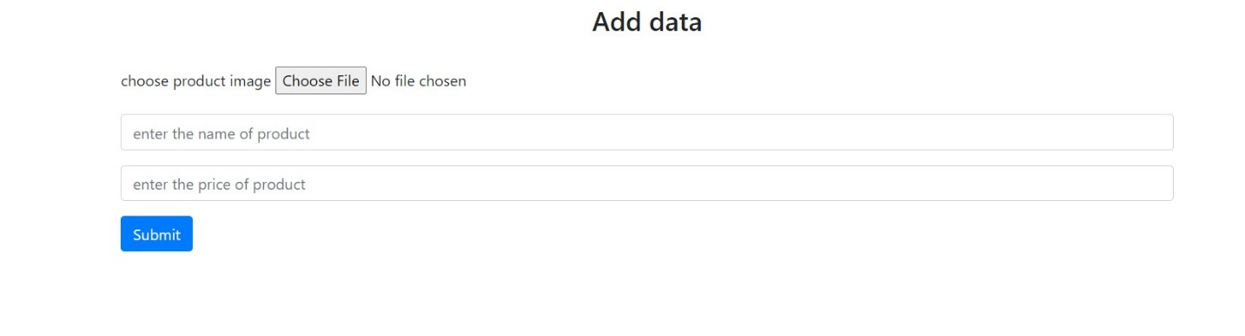

**Database:**

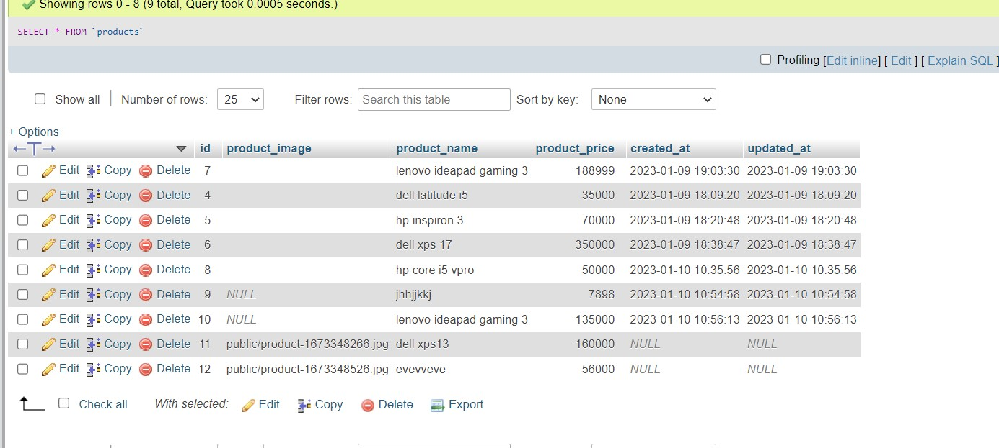

**Products added:**

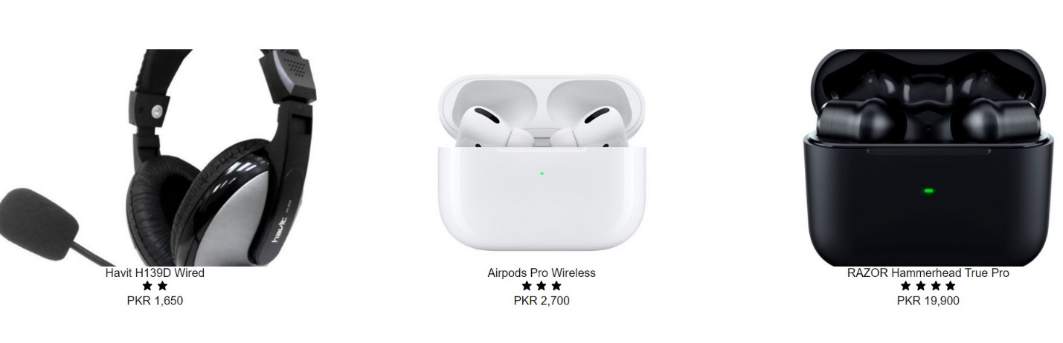

ROUTES:

<?php

use Illuminate\Support\Facades\Route;

use App\Http\Controllers\frontend\HomeController;

use App\Http\Controllers\frontend\AbouttController;

use App\Http\Controllers\frontend\ProductsController;

use App\Http\Controllers\StudentController;

*/\**

*|--------------------------------------------------------------------------*

*| Web Routes*

*|--------------------------------------------------------------------------*

*|*

*| Here is where you can register web routes for your application. These*

*| routes are loaded by the RouteServiceProvider within a group which*

*| contains the "web" middleware group. Now create something great!*

*|*

*\*/*

Route::get('/', [HomeController::class, 'index']);

Route::get('/about', [AbouttController::class, 'index']);

Route::get('/products', [ProductsController::class, 'index']);

Route::get('/products', [StudentController::class, 'index']);

Route::resource('products2', StudentController::class);