**Name**

**Abdullah khan**

**Section**

**A**

**Rollno**

**i170159**

**TASK**

**A**

**Username for codalab**

**i170159_Abdullahkhan**

**Commonsense Validation and Explanation (ComVE)**

**Introduction:**

Recently utilizing natural language understanding systems to common sense has received significant attention in research area. Nevertheless, this kind of tasks remains pretty complicated to solve because of the ambiguity which is a one of natural properties of language and yet to achieve performance compared with human understanding common sense. The task given is to differentiate natural language statements that make sense from those that do not make sense.

We are using transformers library which provides thousands of pretrained models to perform tasks on texts such as classification, information extraction, question answering, summarization, translation, text generation, etc. in 100+ languages. Its aim is to make cutting edge NLP easier to use for everyone. Transformers is backed by the two most popular deep learning libraries, PyTorch and TensorFlow, with a seamless integration between them, allowing you to train your models with one then load it for inference with the other.

**Approach:**

In the transformers library, We have Open-AI GPT model which was trained with a causal language modeling (CLM) objective and is therefore powerful at predicting the next token in a sequence.

First of all, we load the pretrained Open-AI GPT model then the Open-AI GPT tokenizer. The tokenizer tokenizes the sentences which are used as a parameter for tensor. We then use the Open-AI GPT model to calculate the variation of sentence.

The input is a csv file with three columns. The first one is the id whereas the second and third contains two sentences. The Open-AI GPT model calculates which of those two is against common sense by using perplexity scores. The perplexity score of the sentence means how this sentence doesn’t make any sense in some ways. The higher perplexity score, the less plausible the sentence and being against to common sense.

The output of the code is a csv file which has three columns. The first ne is the id, the second one contains the sentences while the third is the index indicating that the sentence is in accordance to the common sense.

**Results:**

The Open-AI GPT model accuracy on our test set is around 75%.

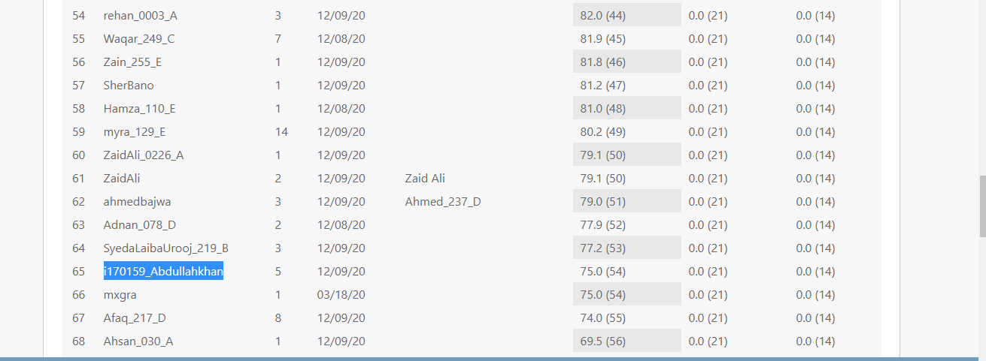

**References:**

<https://huggingface.co/transformers/model_doc/gpt.html>