**Home Page**

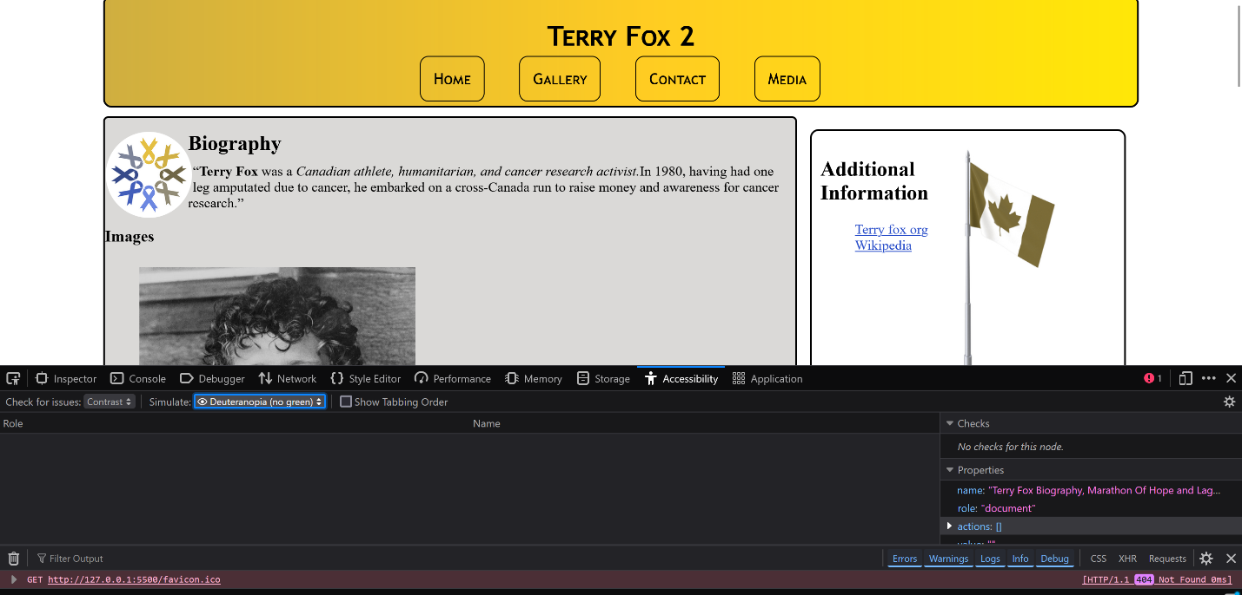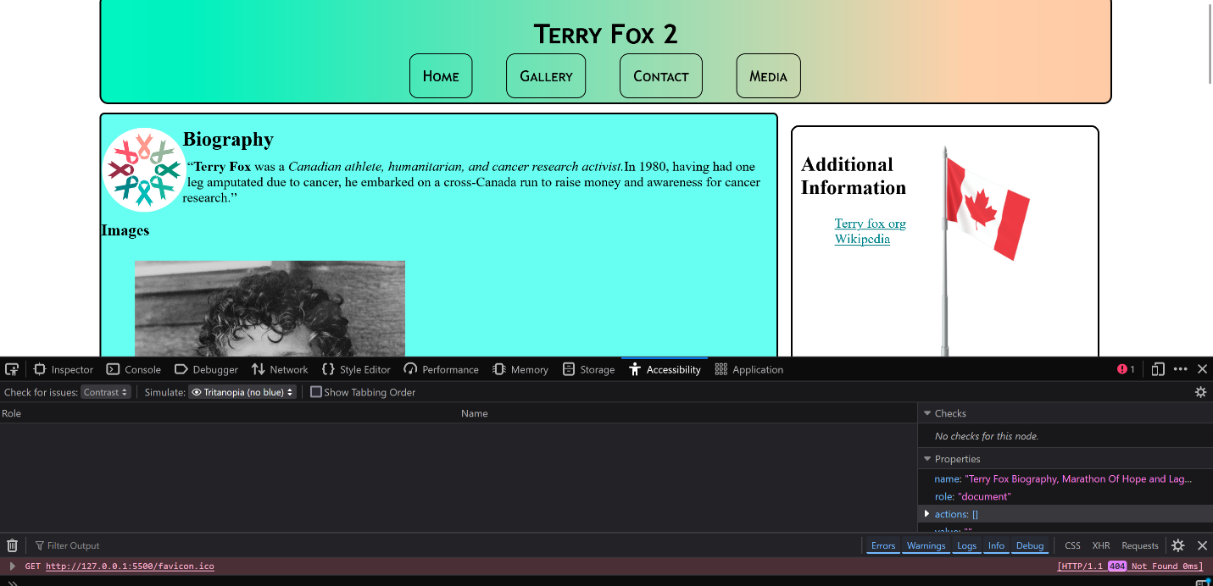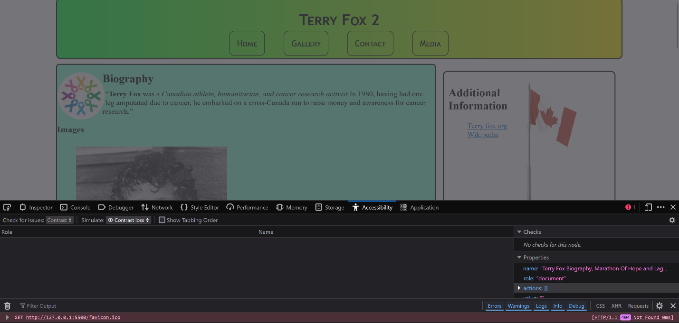

**Gallery page**

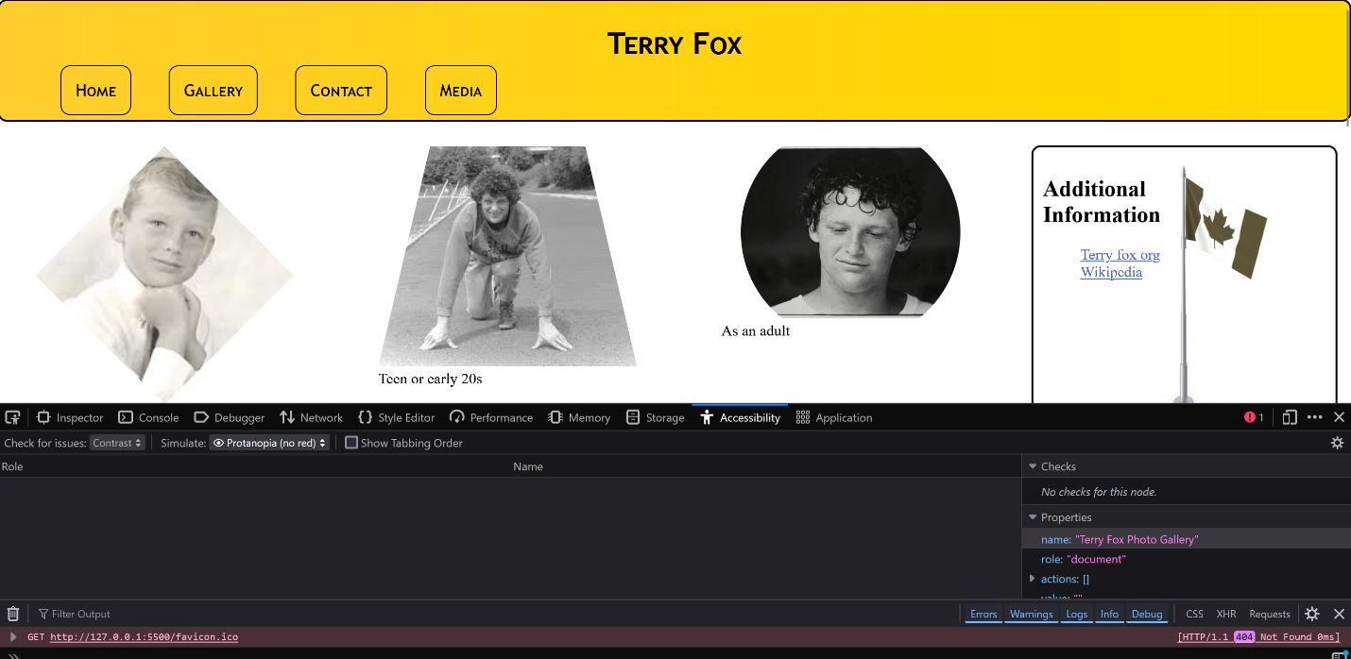

**Form Page**

**Media Page**

