1) Feature Scaling
- Is applied to columns and not to rows
- There are two types of feature scaling (Normalization and Standardization)
  - Normalization
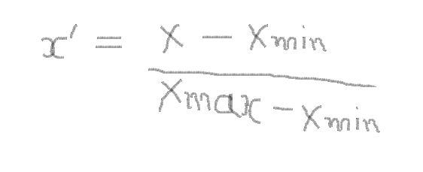
    - All the values will be between 0 and 1

  - Standardization
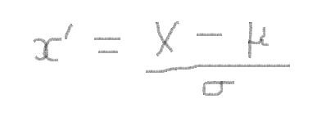
  - All values will be between 3 and -3

