Bootcamp Detailed Steps for Creating Challenge Project

- Create a brand new feature branch via Git Desktop
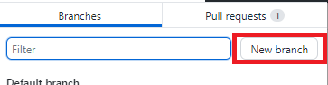
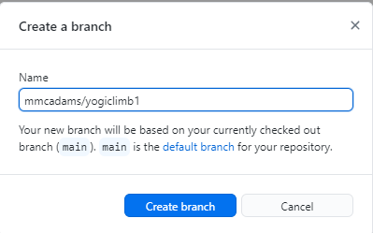
- Open 2023 WPILib VS Code (windows should have a desktop icon, if not search for “WPILib VS Code”)
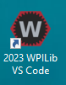
- Open Command Palette (WHEN IN DOBUT COME HERE)
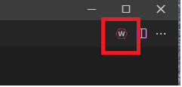
- Create a new project
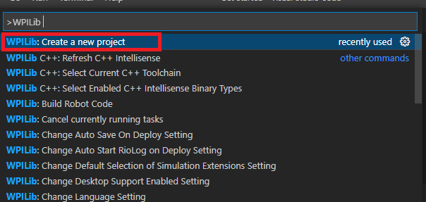
- Select Template -> Java -> Command
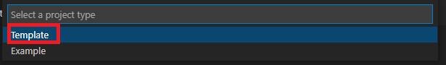
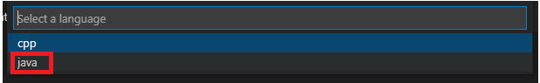
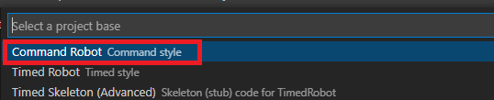
- Select the proper folder to create the project in
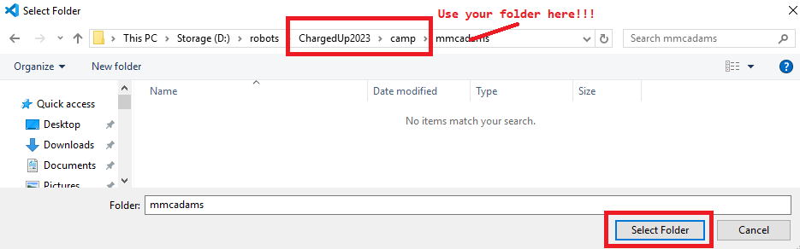
- Generate the project
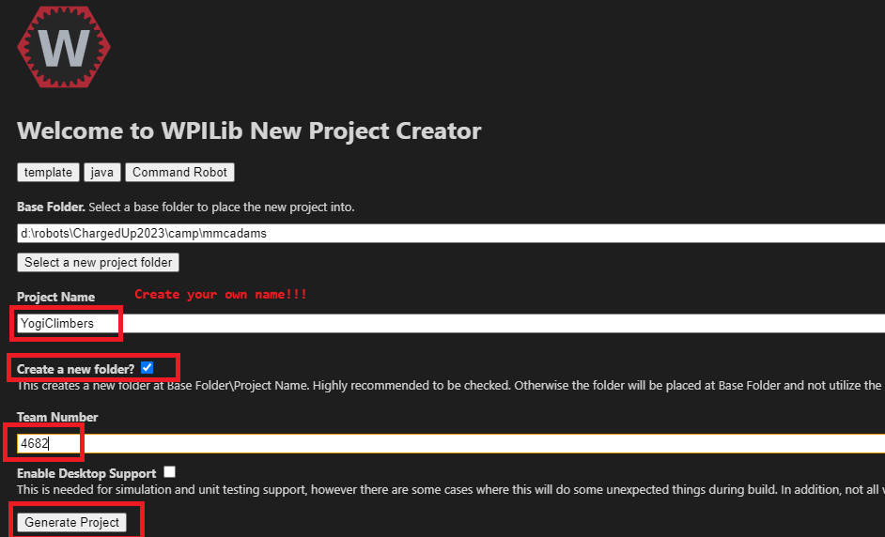
- Click ‘Yes’ to open the project
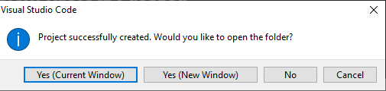
- Click on ‘Yes’ to trust them
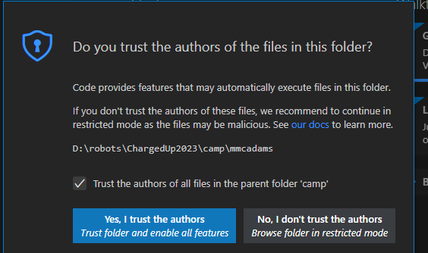
- After you open you project it should look something like:
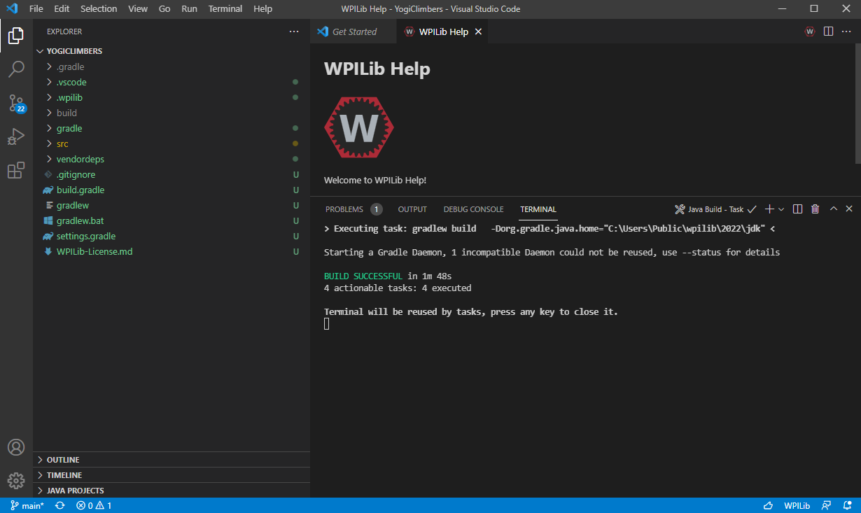

- Add your vendor libraries (reference see: https://docs.wpilib.org/en/stable/docs/software/vscode-overview/3rd-party-libraries.html#libraries)
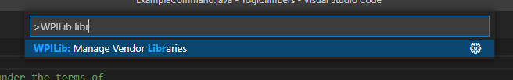
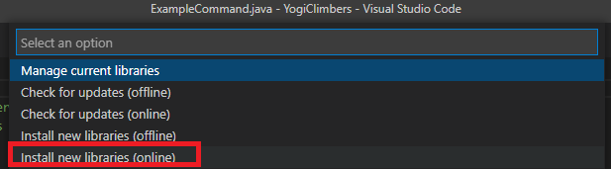
For REV …
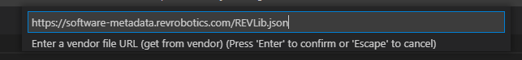
For CTRE/Phoenix …
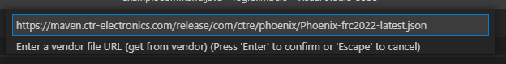
For Navx …
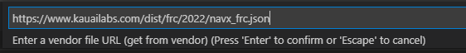
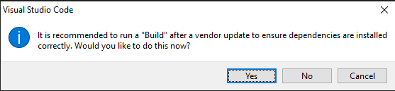

You should have a project where everything builds! Something like:
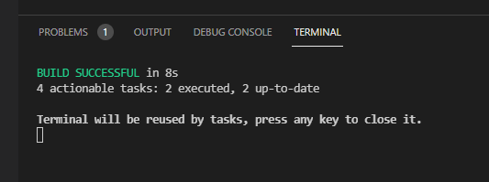

You should also see that vendor libs are now present:

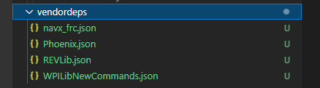
Lets actually add some code next!
- First add a subsystem (you could also choose to rename the ‘ExampleSubsystem.java’)
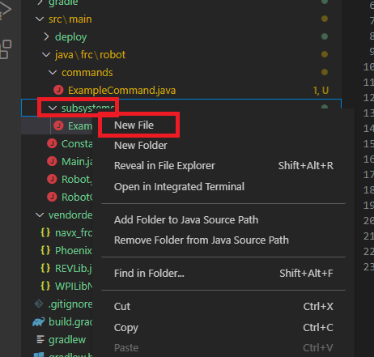
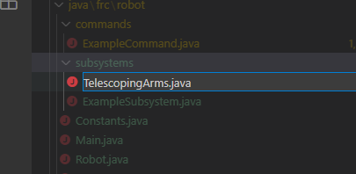
Your file should be a stub …
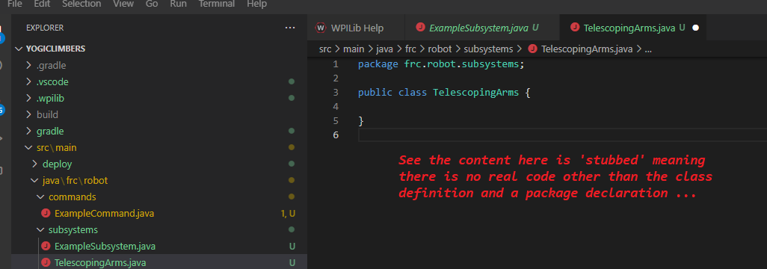
The next step is for you to add logic … expect this is where folks will have lots of freedom and will likely require help first time through …

- Next add a command
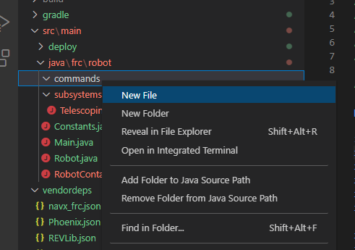
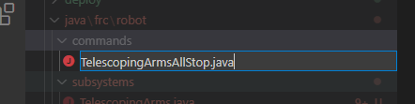
Again the file will be stubbed …
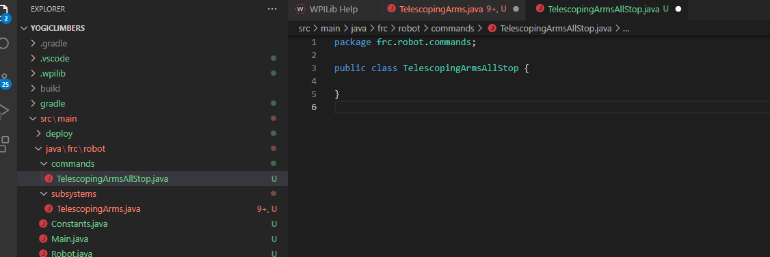
The next step is for you to add logic … expect this is where folks will have lots of freedom and will likely require help first time through …

- Next wire in the input – for the sake of this example that will happen in RobotContainer.java
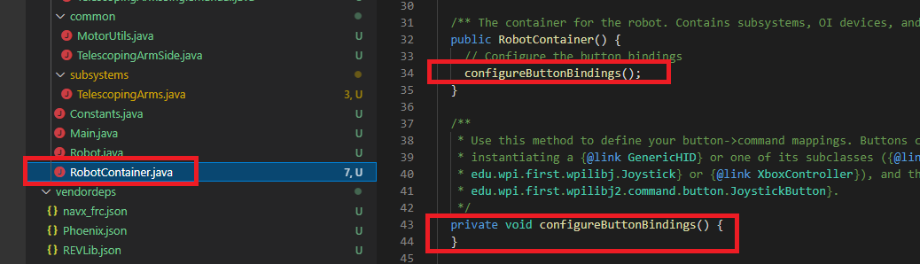
The next step is for you to add logic … expect this is where folks will have lots of freedom and will likely require help first time through …

