Report for Ishipz
Technologies & Element used to develop the website
1) Programming Language: - PHP
2) Framework Used: - Code ignitor
3) Widgets Used: -
a) Fonts Awesome
b) Google Font API
4) Scripts Used: -
a) Javascript
b) Angular.Js
5) Server: - Godaddy Server
6) Apache 2.2 Version
Ishipz Pages
• Home Page
• Contact page
• Terms & Conditions Page
• Privacy Policy.
• Refund & Cancellation
• Tracking Page
• Mobile App Links
• Admin Panel Links & User Panel Links
• Frond End Design
Modules & Users
1) User Panel
2) Admin Panel
3) Login Module
4) User Registration Module
1) Problem:- Page Speed Insight Screen Shots
Desktop View –
a) Page Speed: - Unavailable
b) Optimization Score :- 38/100 (Very Low Need to be at least 75)
Page Stats
Statistics show that the median page on the internet requires 4 render-blocking round trips and ~89 resources (1.3MB) to load. But this page appears to use fewer resources. PSI estimates this page requires 4 render-blocking round trips and 50 resources (2.6MB) to load. Fewer round trips and bytes results in faster pages.
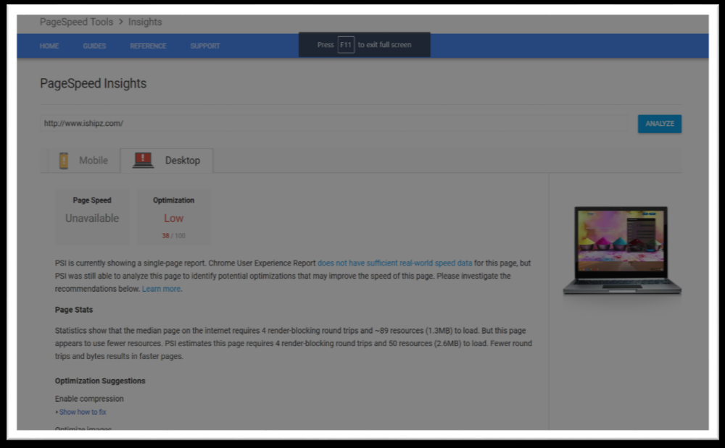
Optimization Suggestions
1) Enable compression - Compressing resources with gzip or deflate can reduce the number of bytes sent over the network.
Enable compression for the following resources to reduce their transfer size by 852KiB (75% reduction).

• Compressing http://www.ishipz.com/assets/css/main.css could save 203.1KiB (84% reduction).
• Compressing http://www.ishipz.com/js/tele/utils.js could save 165.9KiB (77% reduction).
• Compressing http://www.ishipz.com/js/select2.js could save 110.5KiB (78% reduction).
• Compressing http://www.ishipz.com/js/angular.min.js could save 77.6KiB (63% reduction).
• Compressing http://www.ishipz.com/assets/js/jquery.min.js could save 55.3KiB (65% reduction).
• Compressing http://www.ishipz.com/js/tele/intlTelInput.js could save 49KiB (72% reduction).
• Compressing http://www.ishipz.com/assets/js/bootstrap.min.js could save 33.8KiB (74% reduction).
• Compressing http://www.ishipz.com/js/sweetalert.js could save 25.4KiB (74% reduction).
• Compressing http://www.ishipz.com/ could save 21.3KiB (76% reduction).
• Compressing http://www.ishipz.com/js/telephonenumber/css/intlTelInput.css could save 18KiB (85% reduction).
• Compressing http://www.ishipz.com/assets/js/tether.min.js could save 17.1KiB (69% reduction).
• Compressing http://www.ishipz.com/css/select2.css could save 13.3KiB (81% reduction).
• Compressing http://www.ishipz.com/js/angular-ui-router.min.js could save 11.8KiB (61% reduction).
• Compressing http://www.ishipz.com/deliverytype/getcountries could save 10.9KiB (78% reduction).
• Compressing http://www.ishipz.com/css/sweetalert.css could save 10.4KiB (81% reduction).
• Compressing http://www.ishipz.com/js/src/select2.js could save 5.1KiB (72% reduction).
• Compressing http://www.ishipz.com/js/tele/betsol-ng-intl-tel-input.js could save 4.7KiB (70% reduction).
• Compressing http://www.ishipz.com/js/passwordRulesHelper.min.js could save 4.5KiB (78% reduction).
• Compressing http://www.ishipz.com/js/mainController.js could save 2.9KiB (73% reduction).

• Compressing http://www.ishipz.com/js/paging.min.js could save 2.3KiB (62% reduction).
• Compressing http://www.ishipz.com/js/userController.js could save 2.2KiB (66% reduction).
• Compressing http://www.ishipz.com/assets/js/custom.min.js could save 1.5KiB (69% reduction).
• Compressing http://www.ishipz.com/js/usersignupController.js could save 1.1KiB (64% reduction).
• Compressing http://www.ishipz.com/js/quoteController.js could save 1.1KiB (57% reduction).
• Compressing http://www.ishipz.com/js/trackorderController.js could save 999B (68% reduction).
• Compressing http://www.ishipz.com/js/profileController.js could save 935B (67% reduction).
• Compressing http://www.ishipz.com/js/contactusController.js could save 555B (53% reduction).
• Compressing http://www.ishipz.com/css/passwordRulesHelper.min.css could save 519B (56% reduction).
• Compressing http://www.ishipz.com/js/userloginController.js could save 214B (40% reduction).

2) Optimize images: - Properly formatting and compressing images can save many bytes of data.
Optimize the following images to reduce their size by 528.8KiB (91% reduction).
• Compressing and resizing http://www.ishipz.com/assets/images/about-02.jpg could save 207.6KiB (93% reduction).
• Compressing and resizing http://www.ishipz.com/assets/images/about-01.jpg could save 117.9KiB (93% reduction).
• Compressing and resizing http://www.ishipz.com/assets/images/about-03.jpg could save 114.1KiB (92% reduction).
• Compressing and resizing http://www.ishipz.com/assets/images/about-04.jpg could save 81.2KiB (90% reduction).
• Compressing and resizing http://www.ishipz.com/images/playstore.png could save 3.3KiB (53% reduction).
• Compressing http://www.ishipz.com/css/select2.png could save 2.6KiB (83% reduction).
• Compressing and resizing http://www.ishipz.com/images/appstore.png could save 2.2KiB (47% reduction).

3) Leverage browser caching: - Setting an expiry date or a maximum age in the HTTP headers for static resources instructs the browser to load previously downloaded resources from local disk rather than over the network.
Leverage browser caching for the following cacheable resources
• http://www.ishipz.com/assets/js/bootstrap.min.js (expiration not specified)
• http://www.ishipz.com/assets/js/custom.min.js (expiration not specified)
• http://www.ishipz.com/assets/js/jquery.min.js (expiration not specified)
• http://www.ishipz.com/assets/js/tether.min.js (expiration not specified)
• http://www.ishipz.com/js/angular-ui-router.min.js (expiration not specified)
• http://www.ishipz.com/js/angular.min.js (expiration not specified)
• http://www.ishipz.com/js/contactusController.js (expiration not specified)
• http://www.ishipz.com/js/mainController.js (expiration not specified)
• http://www.ishipz.com/js/paging.min.js (expiration not specified)
• http://www.ishipz.com/js/passwordRulesHelper.min.js (expiration not specified)
• http://www.ishipz.com/js/profileController.js (expiration not specified)
• http://www.ishipz.com/js/quoteController.js (expiration not specified)
• http://www.ishipz.com/js/select2.js (expiration not specified)
• http://www.ishipz.com/js/src/select2.js (expiration not specified)
• http://www.ishipz.com/js/sweetalert.js (expiration not specified)
• http://www.ishipz.com/js/tele/betsol-ng-intl-tel-input.js (expiration not specified)
• http://www.ishipz.com/js/tele/intlTelInput.js (expiration not specified)
• http://www.ishipz.com/js/tele/utils.js (expiration not specified)
• http://www.ishipz.com/js/trackorderController.js (expiration not specified)
• http://www.ishipz.com/js/userController.js (expiration not specified)
• http://www.ishipz.com/js/userloginController.js (expiration not specified)
• http://www.ishipz.com/js/usersignupController.js (expiration not specified)
• http://www.ishipz.com/assets/css/main.css (24 hours)
• http://www.ishipz.com/css/passwordRulesHelper.min.css (24 hours)
• http://www.ishipz.com/css/select2.css (24 hours)
• http://www.ishipz.com/css/sweetalert.css (24 hours)
• http://www.ishipz.com/js/telephonenumber/css/intlTelInput.css (24 hours)

4) Minify JavaScript: - Compacting JavaScript code can save many bytes of data and speed up downloading, parsing, and execution time.
Minify JavaScript for the following resources to reduce their size by 124.9KiB (45% reduction)
• Minifying http://www.ishipz.com/js/select2.js could save 64.1KiB (46% reduction).
• Minifying http://www.ishipz.com/js/tele/intlTelInput.js could save 36.8KiB (54% reduction).
• Minifying http://www.ishipz.com/js/sweetalert.js could save 9.2KiB (28% reduction).
• Minifying http://www.ishipz.com/js/tele/betsol-ng-intl-tel-input.js could save 4KiB (59% reduction).
• Minifying http://www.ishipz.com/js/src/select2.js could save 3.6KiB (50% reduction).
• Minifying http://www.ishipz.com/js/passwordRulesHelper.min.js could save 2.7KiB (48% reduction).
• Minifying http://www.ishipz.com/js/mainController.js could save 1.5KiB (40% reduction).
• Minifying http://www.ishipz.com/js/userController.js could save 774B (24% reduction).
• Minifying http://www.ishipz.com/assets/js/custom.min.js could save 592B (27% reduction).
• Minifying http://www.ishipz.com/js/usersignupController.js could save 405B (23% reduction).
• Minifying http://www.ishipz.com/js/quoteController.js could save 381B (21% reduction).
• Minifying http://www.ishipz.com/js/trackorderController.js could save 353B (25% reduction).
• Minifying http://www.ishipz.com/js/profileController.js could save 245B (18% reduction).
• Minifying http://www.ishipz.com/js/contactusController.js could save 200B (20% reduction).
• Minifying http://www.ishipz.com/js/userloginController.js could save 108B (21% reduction).

5) Eliminate render-blocking JavaScript and CSS in above-the-fold content: -
Your page has 7 blocking CSS resources. This causes a delay in rendering your page.
None of the above-the-fold content on your page could be rendered without waiting for the following resources to load. Try to defer or asynchronously load blocking
resources, or inline the critical portions of those resources directly in the HTML.
Optimize CSS Delivery of the following:
• https://fonts.googleapis.com/css?family=Lato:400,700|Roboto:400,700
• http://www.ishipz.com/assets/css/main.css
• http://www.ishipz.com/css/select2.css
• http://www.ishipz.com/css/sweetalert.css
• http://www.ishipz.com/css/passwordRulesHelper.min.css
• http://www.ishipz.com/js/telephonenumber/css/intlTelInput.css
• https://use.fontawesome.com/releases/v5.0.12/css/all.css

6) Minify CSS: - Compacting CSS code can save many bytes of data and speed up download and parse times
Minify CSS for the following resources to reduce their size by 45.5KiB (17% reduction).
• Minifying http://www.ishipz.com/assets/css/main.css could save 39.9KiB (17% reduction).
• Minifying http://www.ishipz.com/css/select2.css could save 2.9KiB (19% reduction).
• Minifying http://www.ishipz.com/css/sweetalert.css could save 2.4KiB (20% reduction).
• Minifying http://www.ishipz.com/css/passwordRulesHelper.min.css could save 159B (18% reduction).

7) Reduce server response time: - In our test, your server responded in 0.25 seconds. There are many factors that can slow down your server response time. Please read our recommendations to learn how you can monitor and measure where your server is spending the most time.
8) Minify HTML: - Compacting HTML code, including any inline JavaScript and CSS contained in it, can save many bytes of data and speed up download and parse times.
Minify HTML for the following resources to reduce their size by 3.3KiB (12% reduction).
• Minifying http://www.ishipz.com/ could save 3.3KiB (12% reduction).

Mobile View Report –
a) Page Speed: - Unavailable
b) Optimization Score :- 65/100 (Medium But Need to be atleast 75)
Page Stats
Statistics show that the median page on the internet requires 4 render-blocking round trips and ~75 resources (1MB) to load. But this page appears to use fewer resources. PSI estimates this page requires 4 render-blocking round trips and 49 resources (2.5MB) to load. Fewer round trips and bytes results in faster pages.

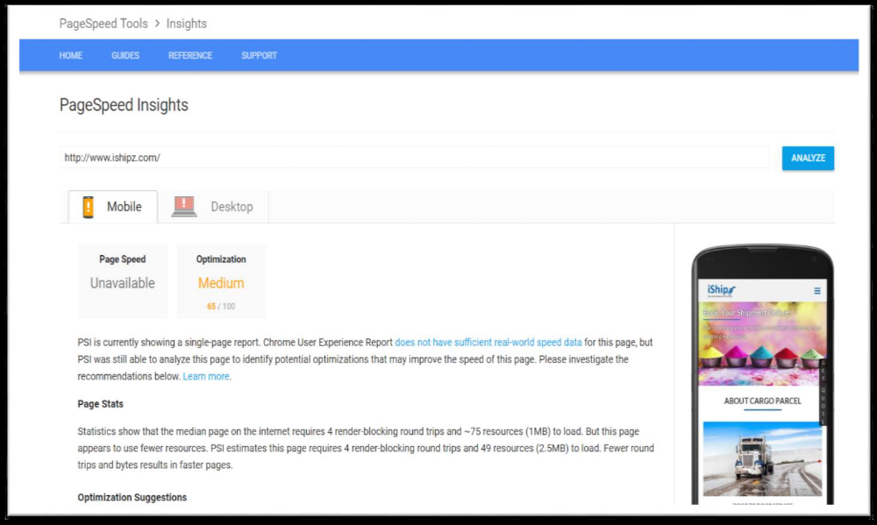
Optimization Suggestions
1) Eliminate render-blocking JavaScript and CSS in above-the-fold content: - Your page has 7 blocking CSS resources. This causes a delay in rendering your page.
None of the above-the-fold content on your page could be rendered without waiting for the following resources to load. Try to defer or asynchronously load blocking resources, or inline the critical portions of those resources directly in the HTML.
Optimize CSS Delivery of the following:
• https://fonts.googleapis.com/css?family=Lato:400,700|Roboto:400,700
• http://www.ishipz.com/assets/css/main.css
• http://www.ishipz.com/css/select2.css
• http://www.ishipz.com/css/sweetalert.css
• http://www.ishipz.com/css/passwordRulesHelper.min.css
• http://www.ishipz.com/js/telephonenumber/css/intlTelInput.css
• https://use.fontawesome.com/releases/v5.0.12/css/all.css

2) Enable Compression: - Compressing resources with gzip or deflate can reduce the number of bytes sent over the network.
Enable compression for the following resources to reduce their transfer size by 823.5KiB (75% reduction).
• Compressing http://www.ishipz.com/assets/css/main.css could save 203.1KiB (84% reduction).
• Compressing http://www.ishipz.com/js/tele/utils.js could save 165.9KiB (77% reduction).
• Compressing http://www.ishipz.com/js/select2.js could save 110.5KiB (78% reduction).
• Compressing http://www.ishipz.com/js/angular.min.js could save 77.6KiB (63% reduction).
• Compressing http://www.ishipz.com/assets/js/jquery.min.js could save 55.3KiB (65% reduction).
• Compressing http://www.ishipz.com/js/tele/intlTelInput.js could save 49KiB (72% reduction).
• Compressing http://www.ishipz.com/assets/js/bootstrap.min.js could save 33.8KiB (74% reduction).
• Compressing http://www.ishipz.com/js/sweetalert.js could save 25.4KiB (74% reduction).
• Compressing http://www.ishipz.com/ could save 21.3KiB (76% reduction).
• Compressing http://www.ishipz.com/js/telephonenumber/css/intlTelInput.css could save 18KiB (85% reduction).

• Compressing http://www.ishipz.com/assets/js/tether.min.js could save 17.1KiB (69% reduction).
• Compressing http://www.ishipz.com/css/select2.css could save 13.3KiB (81% reduction).
• Compressing http://www.ishipz.com/js/angular-ui-router.min.js could save 11.8KiB (61% reduction).
• Compressing http://www.ishipz.com/deliverytype/getcountries could save 10.9KiB (78% reduction).
• Compressing http://www.ishipz.com/css/sweetalert.css could save 10.4KiB (81% reduction).

3) Leverage browser caching: - Setting an expiry date or a maximum age in the HTTP headers for static resources instructs the browser to load previously downloaded resources from local disk rather than over the network.
Leverage browser caching For the following cacheable resources:
• http://www.ishipz.com/assets/js/bootstrap.min.js (expiration not specified)
• http://www.ishipz.com/assets/js/custom.min.js (expiration not specified)
• http://www.ishipz.com/assets/js/jquery.min.js (expiration not specified)
• http://www.ishipz.com/assets/js/tether.min.js (expiration not specified)
• http://www.ishipz.com/js/angular-ui-router.min.js (expiration not specified)
• http://www.ishipz.com/js/angular.min.js (expiration not specified)
• http://www.ishipz.com/js/contactusController.js (expiration not specified)
• http://www.ishipz.com/js/mainController.js (expiration not specified)
• http://www.ishipz.com/js/paging.min.js (expiration not specified)
• http://www.ishipz.com/js/passwordRulesHelper.min.js (expiration not specified)
• http://www.ishipz.com/js/profileController.js (expiration not specified)
• http://www.ishipz.com/js/quoteController.js (expiration not specified)
• http://www.ishipz.com/js/select2.js (expiration not specified)
• http://www.ishipz.com/js/src/select2.js (expiration not specified)
• http://www.ishipz.com/js/sweetalert.js (expiration not specified)
• http://www.ishipz.com/js/tele/betsol-ng-intl-tel-input.js (expiration not specified)
• http://www.ishipz.com/js/tele/intlTelInput.js (expiration not specified)
• http://www.ishipz.com/js/tele/utils.js (expiration not specified)
• http://www.ishipz.com/js/trackorderController.js (expiration not specified)
• http://www.ishipz.com/js/userController.js (expiration not specified)
• http://www.ishipz.com/js/userloginController.js (expiration not specified)
• http://www.ishipz.com/js/usersignupController.js (expiration not specified)

• http://www.ishipz.com/assets/css/main.css (24 hours)
• http://www.ishipz.com/css/passwordRulesHelper.min.css (24 hours)
• http://www.ishipz.com/css/select2.css (24 hours)
• http://www.ishipz.com/css/sweetalert.css (24 hours)
• http://www.ishipz.com/js/telephonenumber/css/intlTelInput.css (24 hours)

4) Reduce Server response time: - In our test, your server responded in 0.25 seconds. There are many factors that can slow down your server response time.
5) Minify CSS: - Compacting CSS code can save many bytes of data and speed up download and parse times.
Minify CSS for the following resources to reduce their size by 39.9KiB (17% reduction).
• Minifying http://www.ishipz.com/assets/css/main.css could save 39.9KiB (17% reduction).

6) Minify JavaScript: - Compacting JavaScript code can save many bytes of data and speed up downloading, parsing, and execution time.
Minify JavaScript for the following resources to reduce their size by 100.9KiB (49% reduction).
• Minifying http://www.ishipz.com/js/select2.js could save 64.1KiB (46% reduction).
• Minifying http://www.ishipz.com/js/tele/intlTelInput.js could save 36.8KiB (54% reduction).

7) Optimize Images: - Properly formatting and compressing images can save many bytes of data.
Optimize the following images to reduce their size by 21.4KiB (10% reduction)..
• Compressing http://www.ishipz.com/assets/images/about-02.jpg could save 21.4KiB (10% reduction)

Performance Score & Page Details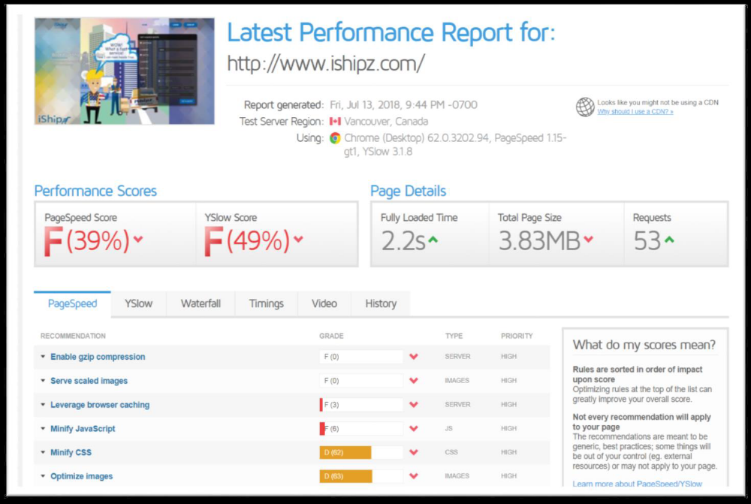

Android & IOS Builds
1) As discussed Redesigning needed for the app.
2) Kind of Guiding Screen must be added before login
3) Need to know the calculations for the shipment. (Currently showing no results for any added entries).
4) From where we are getting tracking details. Do we saving in our database or using any API for this
5) Images used should be professional.
6) What’s the functional structure of View Booking?

