Machine Learning 1, Summer Term 2025
Homework 1
Linear and Logistic Regression. Gradient Descent
Florian Scherer (12232933)
Linda Weiss (12108205)
Group Number: g234

- Linear Regression
  - Univariate Linear Regression
    - Calculation of b* and w*
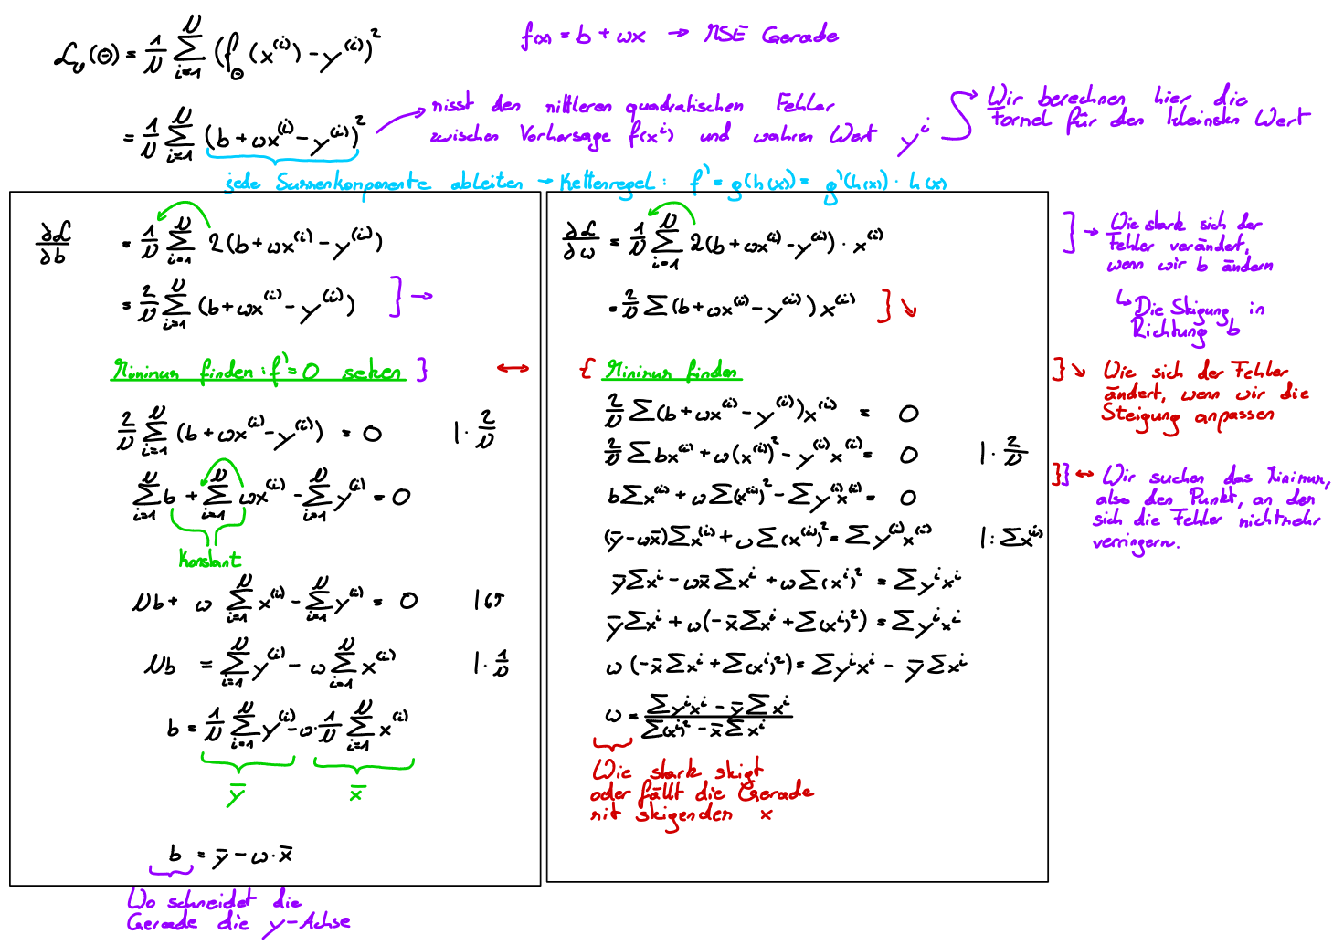

    - Finding 3 pairs of variables with linear dependency
- Calories and Duration
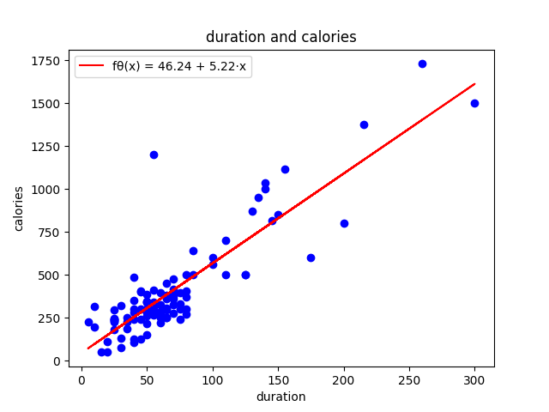
Pearson correlation coefficient:
r = 0.8689894608314118
Parameter vector:
θ* = [46.238685854472806, 5.2210941096132935]
Mean-squared error:
MSE = 21843.02631680113

- Calories and Fitness Level
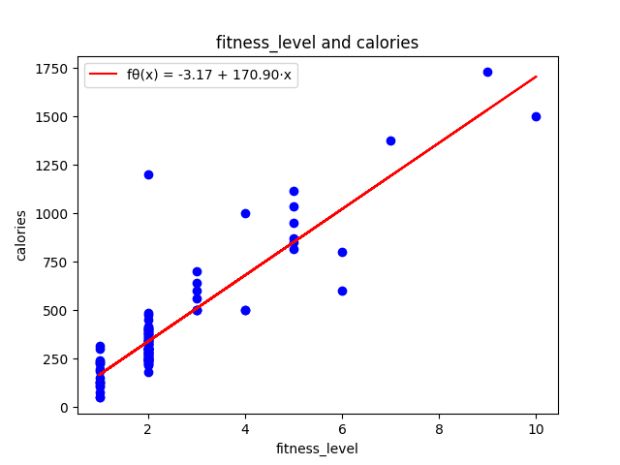
Pearson correlation coefficient:
r = 0.8907943516389095
Parameter vector:
θ* = [-3.1725532266049754, 170.9018814985971]
Mean-squared error:
MSE = 18419.978567420367
- Duration and Fitness Level
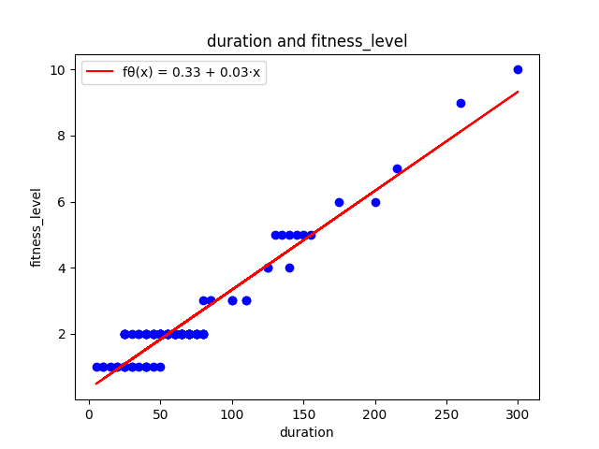
Pearson correlation coefficient:
r = 0.9582020994401034
Parameter vector:
θ* = [0.32695313487948585, 0.030007840360150737]
Mean-squared error:
MSE = 0.19836859809302215

    - Finding 3 pairs of variables with no linear dependency
- Average Pulse and Hours Sleep
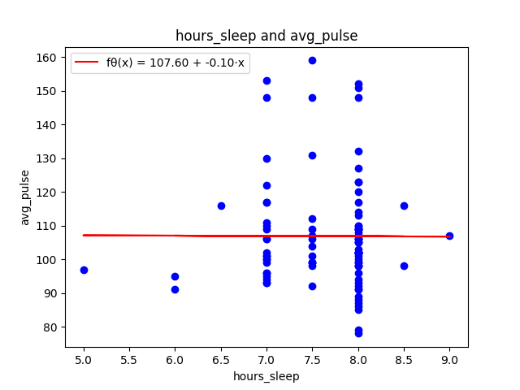
Pearson correlation coefficient:
r = -0.0034989567042002204
Parameter vector:
θ* = [107.60025053422963, -0.09564512563583866]
Mean-squared error:
MSE = 253.50999631567308
- Fitness Level and Max Pulse
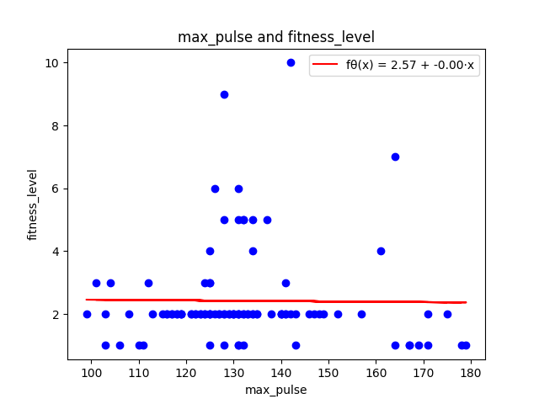
Pearson correlation coefficient:
r = -0.01225805435988659
Parameter vector:
θ* = [2.565966092115847, -0.001104214328737778]
Mean-squared error:
MSE = 2.423235830114382

- Duration and Max Pulse
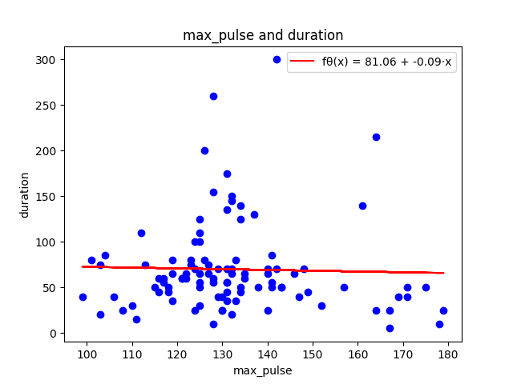
Pearson correlation coefficient:
r = -0.029742804142196353
Parameter vector:
θ* = [81.05927401088607, -0.08555317354479212]
Mean-squared error:
MSE = 2469.0014025329965

    - Comments on the scatter plots of 1.1.2 and 1.1.3
The fitted regression lines in the scatter plots for task 1.1.2 follow their respective datapoints closely. This indicates that the dependent and independent variables have a strong linear relation, which is also supported by the values of our computed Pearson correlation coefficients.
On the other hand, the datapoints in the scatter plots for task 1.1.3 are scattered more widely, with no direct connection to the fitted regression line. This would suggest that there is no linear relation between the two variables.

The Pearson correlation coefficient can range from – 1 to 1. A value close to -1 or 1 means that the two variables have a strong linear relation, while a value close to 0 means that there is no linear relationship between the two variables.

    - Nearly perfect Pearson correlation coefficient despite small slope?
It is possible that the Pearson correlation coefficient r can be close to 1 even if the slope w* is approximately 0, because the slope has no effect on the linear relationship of two given datasets and r only measures how well the datapoints follow a linear trend.

  - Multiple Linear Regression
    - Definition of Design Matrix
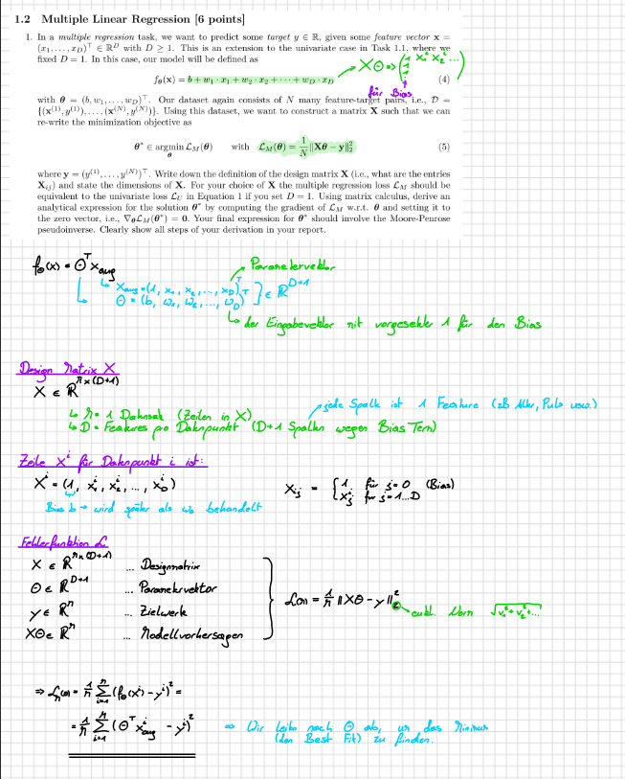
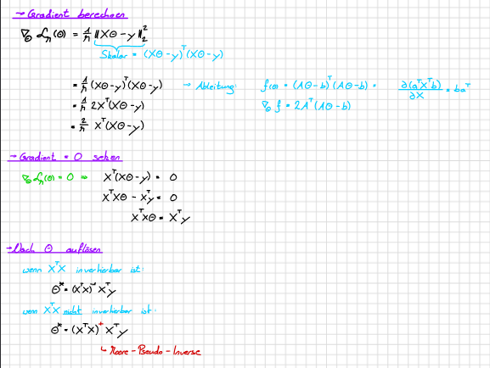

The design matrix X is defined as a matrix of shape M×(D+1), where M denotes the number of datapoints and D the number of features per datapoint.
Each row X_{i} corresponds to one datapoint and contains its feature values. A leading column of ones is added to X to account for the bias b, which allows us to express the linear model as a simple matrix–vector product with the parameter vector θ.

To compute the optimal parameter vector θ*∈R^{D+1}, we calculate the gradient of the error function L_{M} with respect to θ, using the identity
∇_{θ} (Aθ − b)⊤(Aθ − b) = 2A⊤(Aθ − b).
Setting the gradient to zero yields the normal equation:
X⊤(Xθ − y) = 0.
Solving this equation leads to the closed-form solution
θ* = (X⊤X)⁺X⊤y,
where (⋅)⁺ denotes the Moore–Penrose pseudoinverse, which generalizes the inverse in case X⊤X is not invertible.
    - <code>
    - Application
We applied multiple linear regression to the target ‘calories’ with the features ‘duration’, ‘avg_pulse’ and ‘max_pulse’. The corresponding design matrix
X ∈R^{M x (D + 1)}, for D = 3 as we got three features and + 1 for the bias.
The optimal parameter vector θ*_{M} was [-350.93, 5.28, 0.35, 2.69], which corresponds to the model
f_{θ*M} = -350.93 + 5.28 * duration + 0.35 * avg_pulse + 2.69 * max_pulse
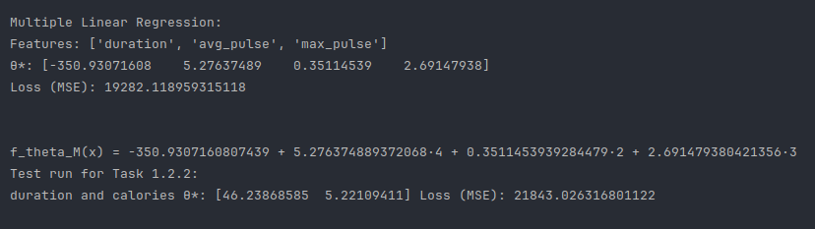
and the loss (mse) was 19282.12
Meanwhile, the univariate regression got the vector θ* = [36.24, 5.22]
and a loss (mse) of 21843.03

  - Polynomial Regression
    - <code>
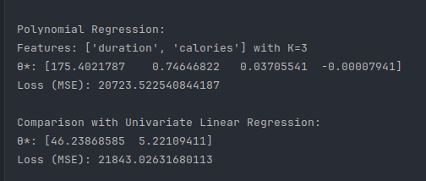
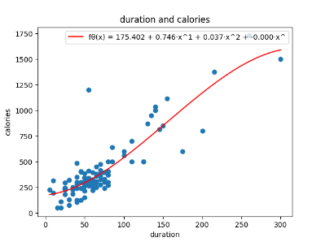
    - Pair of features with strong correlation
We’ve picked ‘duration’ and ‘calories’ as our feature pair of choice and found
K = 3 as a fitting polynomial degree which lead us to the following model:
f_{θ}(x) = 175.40 + 0.75 * x + 0.037 * x² – 0.000079 * x³, an parameter vector
θ = [175.40, 0.75, 0.0037, -0.000079] and the resulting loss (mse) of
L(θ) = 20723.52
Meanwhile the univariate version with the same feature pair got:
θ_{U} = [46.24, 5.22] with a loss L_{U}(θ_{U}) = 21843.03
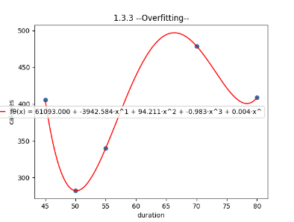
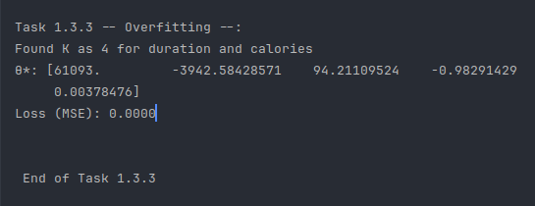
    - Overfitting
For the sake of demonstration of overfitting we’ve chosen a subset of 5 points from the same feature pair and with the help of the equation X θ*_{M} = y found the lowest possible K to reach a loss L_{M}( θ*_{M}) = 0. The K we found is 4 and results in the vector θ = {61093.0, -3942.58, 94.21, -0.98, 0.00378] and confirms that a degree of N – 1, where N is the number of data points, is enough to achieve an zero training loss. Or in other words, if K = N – 1, the resulting design matrix X will be square and if the rows of X are linearly independent, X is invertible. Which means, that Xθ = y will have an exact solution:
θ* = X⁻¹y
and the model satisfies f_{θ}(x_{i}) = y_{i} resulting in an error of zero.
- Logistic Regression
  - Finding the feature models for each dataset
Dataset 1: x1, x2, x1 * x2, x1 ** 2, x2 ** 2, (x1 – 10) * (x2 – 20)
As Fig.1 shows a rotated L shape without any major curves or waves, we tried to find an nearly linear model.
Dataset 2: x1, x2, x1**2, x2**2, x1 * x2
Fig. 2 shows a simple degenerating curve it had to be an quadratic combination of x1 and x2
Dataset 3: x1, x2, x1**2, x1**3, x1**4, x1**5, x1**6, x1*x2, x1**2 * x2, x1 * x2**2
Fig 3. shows a more complex wave which had to be modeled using a higher-degree polynomial
  - <code>
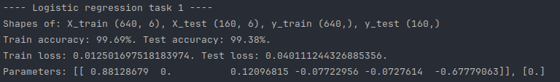
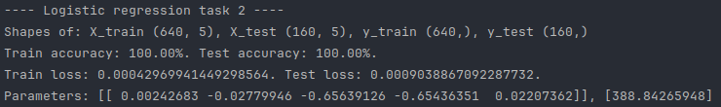
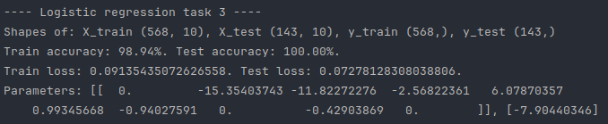
  - Tweaking design matrix:
design_matrix_dataset 1 (X₁): For X₁ we concluded the best combination of penalty, solver and weight was:
‘penalty’ : ‘l1’
‘solver’ : ‘liblinear’
‘C’ : 1.0
and lead to an Test accuracy of 99.38%
design_matrix_datase 2 (X₂): For X₂ we found an as simple as satisfying solution as the only thing we had to do was to set the penalty ‘l2’ and we got a stunning 100% on Test and Training.
design_matrix_dataset 3 (X₃): X₃ was quite similar to X₁ as we’ve found
‘penalty’ : ‘l1’
‘solver’ : ‘liblinear’
‘C’ : 1.0
to be the best fitting achieving a test accuracy of 100%.
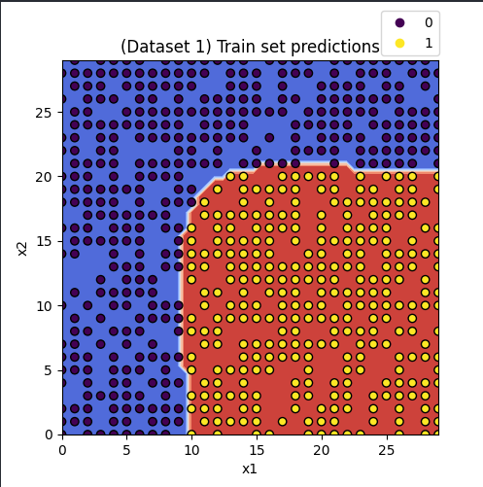
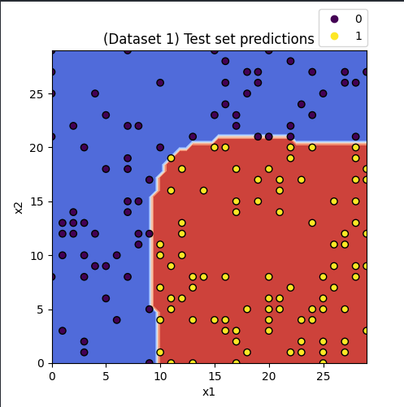
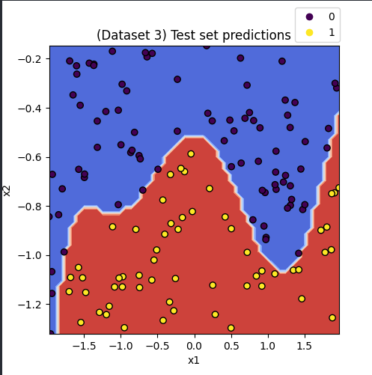
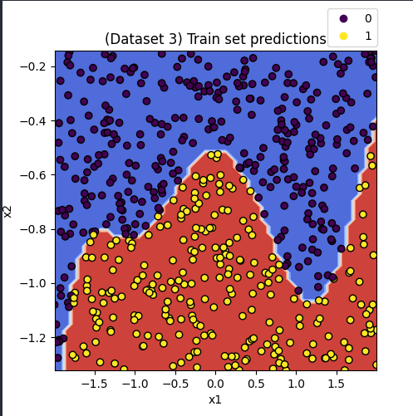
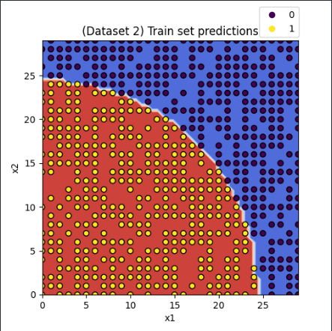
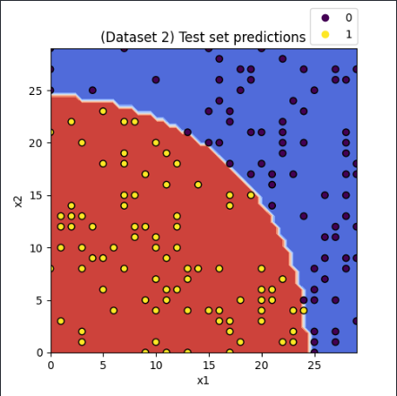
  - Plots
  - Parameters of model
Dataset 1:
The learned parameters were:
θ = [0.88120679, 0.0, 0.12096815, -0.07722956, -0.67779063]
b = 0.0
Training:
Acc: 99.69%
Loss: 0.012501697518183974
Test:
Acc: 99.38%
Loss: 0.040111244326885356
Dataset 2:
θ = [0.08242683, -0.02779946, -0.65639126, -0.65436351, 0.02207362]
b = 388.84265948
Training:
Acc: 100%
Loss: 0.00042969941449298564
Test:
Acc: 100%
Loss: 0.0009038867092287732
Dataset 3:
θ = [0.0, -15.35403743, -11.82272276, -2.56822361, 6.07870357
0.99345668, -0.94027591, 0.0, -0.42903869, 0.0]
b = -7.90440346
Training:
Acc: 98.94%
Loss: 0.09135435072626558
Test:
Acc: 100%
Loss: 0.07278128308038806
  - Accuracy vs Cross-Entropy Loss
No, the statement is not correct. A classifier can achieve 100% accuracy on a test while still having a loss greater zero. Because Loss and accuracy measure different aspects of model performance. As accuracy describes if a test-class-label is correct whilst loss takes the confidence of the prediction into account.

- Gradient Descent
  - Implementation of gradient descent function
Can be found in the gradient_descent.py file.

  - Implementation of Rastigrin function
Can be found in the gradient_descent.py file.

  - Partial derivatives of Rastigrin function
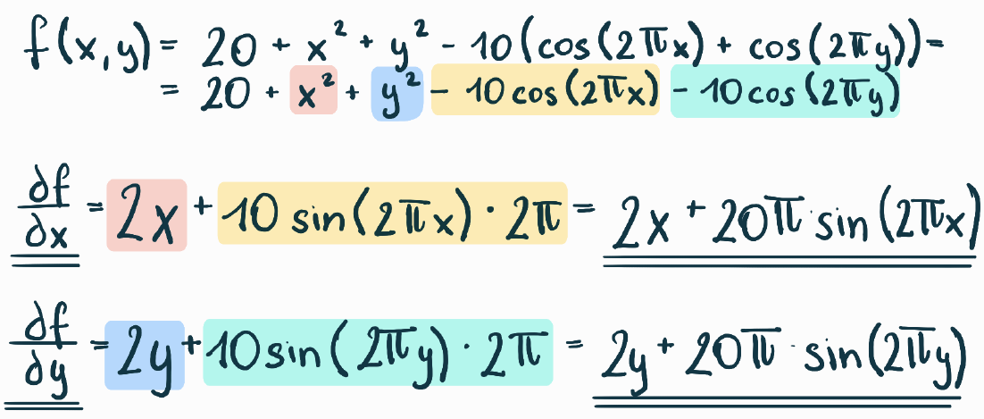

  - Choose initial points by sampling from standard normal distribution.
The initial points x0 and y0 are chosen in the main.py file, after the first TODO in task_3. The function np.random.randn()is used to draw one sample from a standard normal distribution N(0, 1).

