A

Mini Project Report

On

“Online Gadget mart and servicing”

Submitted to

SHRI-SHANKARACHARYA TECHNICAL CAMPUS
BHILAI

in partial fulfillment of the requirement of for the award of degree

Of

Bachelors of Technology

In
COMPUTER SCIENCE AND ENGINEERING
By
Abhinav Singh Bhardwaj


DEPARTMENT OF COMPUTER SCIENCE AND ENGINEERING
SHRI SHANKARACHARYA TECHNICAL CAMPU,
JUNWANI, BHILAI(C.G.)

SESSION 2021-2022

CERTIFICATE

This is to certify that the thesis report of the project submitted is an outcome of the project entitled “My Gadgets” carried out by Abhinav Singh Bhardwaj bearing Roll no.04 carried out under my guidance and supervision for the award of Degree in B.Tech in Computer Science and Engineering of Chhattisgarh Swami Vivekanand Technical university, Bhilai(C.G.),India.
To the best of my knowledge the report.

(1)Embodies the work of the candidates herself/himself.
(2)Fulfills the requirements of the ordinance relating to the B.Tech Degree of the University and ,
(3)Is up to the desired standard for the purpose of which is submitted.

(Signature of the Class Teacher)
Snehlata
Professor
Computer Science & Engineering Department
Shri ShankaraCharya Technical Campus
Junwani,Bhilai(C.G.)

The project work as mentioned above is hereby being recommended and forwarded for examination and evaluation.

(Signature of Head of Department with seal)

Acknowledgement
I would like to express my special thanks and gratitude to our Mrs. Snehlata Mandal (project incharge ) who gave me this opportunity to represent the mini-project on the topic of
‘online gadgets and servicing’ which helped me in enhancing my knowledge of web-development from basic implementation level .
I would also like to thank Mr. Haris Khan (codewithharry.com) in making my project .

Abstract
This project is based on HTML and CSS and creation of frontend of website. In daily life the gadgets being integral part to us , this website helps to search perfect smartphone for use .
This website also helps the wholesellers to get the bulky orders
from thetrusted sellers along with we can also buy the various \gadgets through it easily at one tip .
In addition with the servicing center near us this website in future helps the servicing centers to contact each other and collaborate to find the solution of the complex problems .
Introduction

“my gadgets ” website is created to manage the number of different brands of the smartphones arriving with the latest technology and with evolving technology the things must change acccordingly .
This website is designed in such way that a person can find the device they choose.
The website has four modules
- Which contains the information about the smartphones
- The dealing with the other gadgets .like headphones and speakers .
- The bulk order module which helps the retailer to contact the big sellers and get the order of there choice .
- The important module
This module deals with the repairing and servicing of the gadgets
If specialist were missing for particular problems then the module searches for the secondary options nearby .

Tools and Technology Used

Languages Used :

- HTML
- CSS

Code Editor Used :

- Visual Studio Code

Working With Project:
* Homepage:
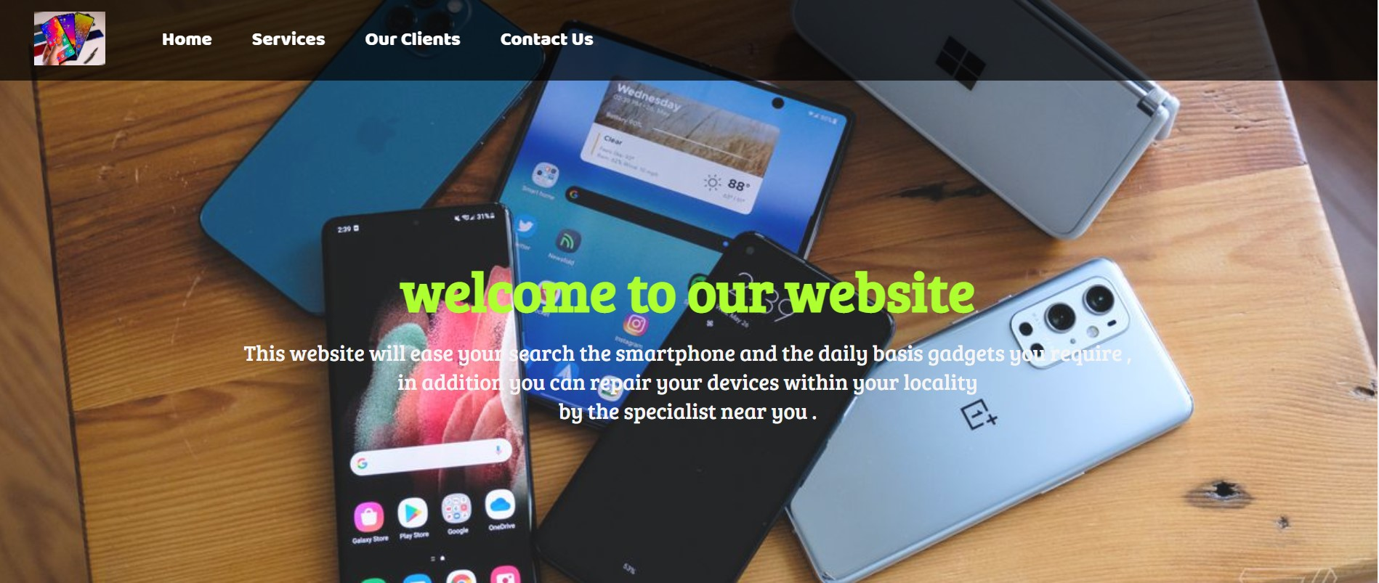

This is the home page of the “mygadgets” website.
The brief information of the whole website can be drawn from here and the navigation menu of the website helps us in navigating the worthy website.

* OUR SERVICES :
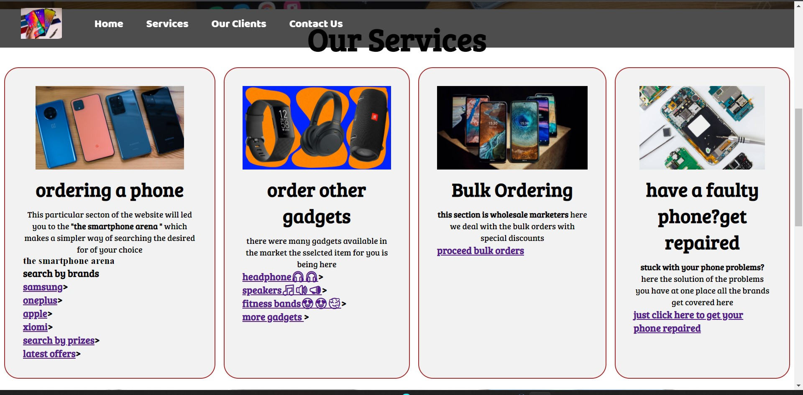
The services :
The modules have been given name in accordance to the performance of the task
- Ordering a phone
Having the options like search by prizes and search by brands which makes it easy to implement and detect the phone of our choice .and also the latest release can be found .
Same branding phone have been found after getting over the link

Sample for the next page opened after going through the link
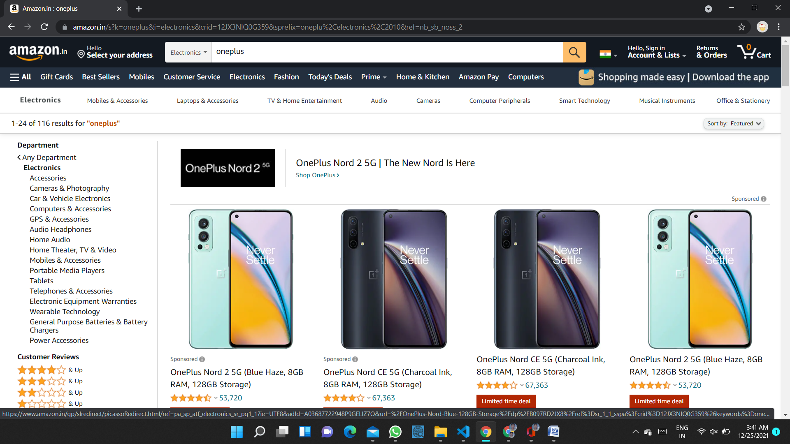

- This module deals with the other gadgets like headphone ,speakers and fitness band watches .
- The third module being designed especially for the wholesaler of the gadgets that they can now buy the bulk amount of gadgets with higher discount rates.
Our clients: sections the trusted brands have collaboration with us :-
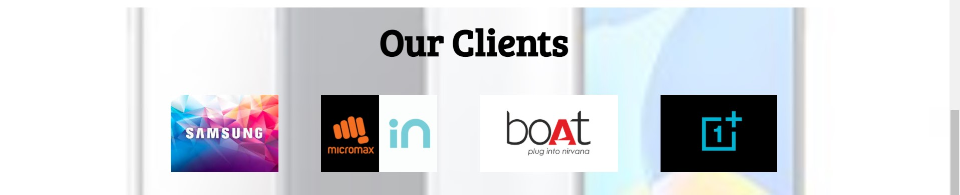

Contact us by dropping this information:

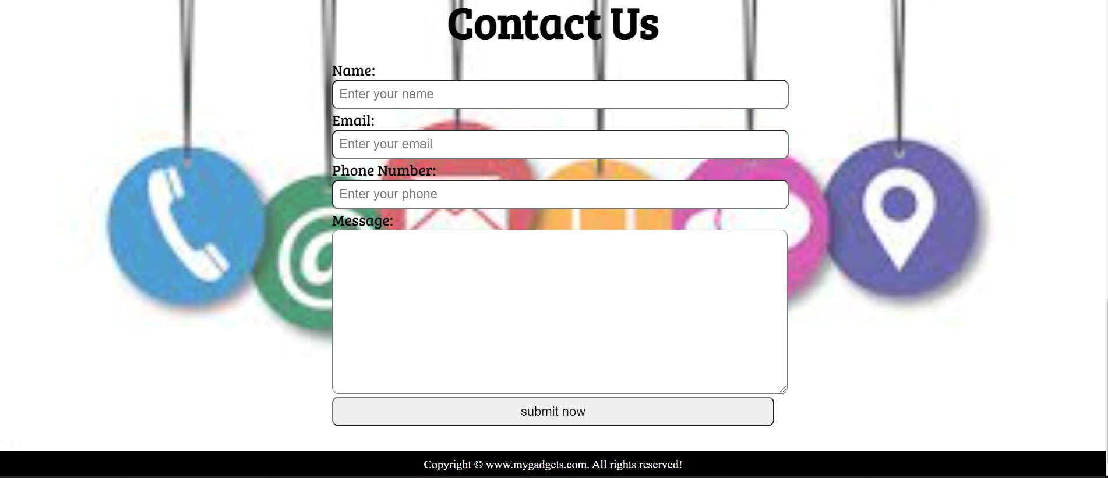

Conclusion
This project have a great impact on my skills of web-development which helped my skills to get implemented through this project .
The working of this project is now based on GUI and provides the beautiful & designed way of searching through the website .
The simple way to search the desired smartphone and gadgets here along with the bulk orders .
The future aspect of this website can help the real world entities as servicing modules to get collaborated when there is an added property of backend.

References
Video tutorials
- Web-development course by Haris khan codewithharry.com
- Front-end-development by udemy
Udemy.com
Books
- Mastering HTML,CSS &javascript
By Laura Lemay
- Javascript and jquery
By Jon Duckett

* HTML Code :
<!DOCTYPE html>
<html lang="en">

<head>
<meta charset="UTF-8">
<meta name="viewport" content="width=device-width, initial-scale=1.0">
<meta http-equiv="X-UA-Compatible" content="ie=edge">
<title>online gadget mart and sercing centre in central india|mygadgets.com</title>
<link rel="stylesheet" href="indexbyharry1.css">
<link rel="stylesheet" media="screen and (max-width: 1170px)" href="indexbyharry.css">
<link href="https://fonts.googleapis.com/css?family=Baloo+Bhai|Bree+Serif&display=swap" rel="stylesheet">
</head>

<body>
<nav id="navbar">
<div id="logo">
<img src="Smartphone.jpg" alt="MyOnlineMeal.com">
</div>
<ul>
<li class="item"><a href="#home">Home</a></li>
<li class="item"><a href="#services-container">Services</a></li>
<li class="item"><a href="#client-section">Our Clients</a></li>
<li class="item"><a href="#contact">Contact Us</a></li>
</ul>
</nav>

<section id="home">
<h1 class="h-primary">welcome to our website </h1>
<p>This website will ease your search the smartphone and the daily basis gadgets you require ,</p>
<p>in addition you can repair your devices within your locality </p>
<p>by the specialist near you .</p>
</section>

<section id="services-container">
<h1 class="h-primary center">Our Services</h1>
<div id="services">
<div class="box">
<img src="gadgets2.jpg" alt="">
<h2 class="h-secondary center">ordering a phone</h2>
<p class="center">This particular secton of the website will led you to the <b>"the smartphone arena "</b> which makes a simpler way of searching the desired for of your choice </p>
<h3>the smartphone arena <p>search by brands </p><h3>
<p><a href="https://www.flipkart.com/search?q=samsung%20&otracker=search&otracker1=search&marketplace=FLIPKART&as-show=on&as=off">samsung</a>></p>
<p><a href="https://www.amazon.in/s?k=oneplus&i=electronics&crid=12JX3NIQ0G359&sprefix=oneplu%2Celectronics%2C2010&ref=nb_sb_noss_2">oneplus</a>></p>
<p><a href="https://www.amazon.in/s?k=apple&i=electronics&crid=3L2VSHOJ07V24&sprefix=apple%2Celectronics%2C508&ref=nb_sb_noss">apple</a>></p>
<p><a href="https://www.flipkart.com/search?q=xiomi%20phones%20&otracker=search&otracker1=search&marketplace=FLIPKART&as-show=on&as=off">xiomi</a>></p>
<p><a href="https://www.flipkart.com/search?q=phone%20under%2015000&otracker=search&otracker1=search&marketplace=FLIPKART&as-show=on&as=off">search by prizes</a>></p>
<p><a href="https://www.amazon.in/s?k=latest+offers+on+smartphones&ref=nb_sb_noss">latest offers</a>></p>

</div>
<div class="box">
<img src="gadgets5normal.jpg" alt="">
<h2 class="h-secondary center">order other gadgets</h2>
<p class="center">there were many gadgets available in the market the sselcted item for you is being here </p>
<h3 ><p><a href="https://www.flipkart.com/search?q=headphones%20&otracker=search&otracker1=search&marketplace=FLIPKART&as-show=on&as=off">headphone🎧🎧</a>></p></h3>
<h3> <p><a href="https://www.flipkart.com/search?q=speakers%20&otracker=search&otracker1=search&marketplace=FLIPKART&as-show=on&as=off">speakers🎵🔊📣</a>></p></h3>
<h3> <p><a href="https://www.google.com/search?q=fitness+band&sxsrf=AOaemvLJc_MrgvwEbCOKrwIVhciejb5Xpg:1640409331504&source=lnms&tbm=shop&sa=X&sqi=
2&ved=2ahUKEwj34_X7mP70AhXwS_EDHYHCCogQ_AUoAXoECAIQAw&biw=1536&bih=714&dpr=1.25">fitness bands😍😍🥰</a>></p></h3>
<h3><p><a href="https://www.google.com/search?q=gadgets+in+daily+use+&sxsrf=AOaemvIoLJv_1MBnhNsIGNBGkyo-Rpu01w%3A1640357927600&ei=J-DFYbn8I6WE4
-EP3_GhwAM&ved=0ahUKEwj5q9C82fz0AhUlwjgGHd94CDgQ4dUDCA4&uact=5&oq=gadgets+in+daily+use+&gs_lcp=Cgdnd3Mtd2l6EAMyBggAEBYQHjIGCAAQFhAeMgYIABAWEB4yBggAEBYQHjIGCAAQFhAeOgcIABBHELADOgcIABCwAxBDOgQIIxAnOgoIABCABBCHAhAUOgUIABCABDoECAAQQzo
LCAAQgAQQsQMQgwE6BQgAEJECOgcIABACEMsBOgkIABDJAxAWEB46BAgAEA06CAgAEA0QBRAeOggIABAIEA0QHjoFCCEQoAE6BQgAEM0COgcIIRAKEKABOgQIIRAVSgQIQRgASgQIRhgAUKkHWKuFAWD-igFoDXACeAOAAeYEiAHmUZIBDTIuMC4xNy4xMy4zLjGYAQCgAQHIAQrAAQE&
sclient=gws-wiz">more gadgets </a>></p></h3>

</div>
<div class="box">
<img src="Nokia-FB.jpg" alt="">
<h2 class="h-secondary center">Bulk Ordering</h2>
<p class="center"><b>this section is wholesale marketers </b> here we deal with the bulk orders with special discounts</p>
<h3><p><a href="https://www.flipkart.com/mobile-accessories/e-wholesale~brand/pr?sid=tyy%2C4mr&page=3">proceed bulk orders</a></p> </h3>
</div>
<div class="box">
<img src="tools.jpg" alt="">
<h2 class="h-secondary center">have a faulty phone?get repaired</h2>
<p class="center"><b>stuck with your phone problems?</b>here the solution of the problems you have at one place all the brands get covered here</p>
<h3> <p><a href ="https://www.google.com/search?q=mobile+shops+near+me&oq=mobile+shops+near+me&aqs=chrome..69i57j0i10i457j0i402l2j0i10l6.8526j0j7&sourceid=chrome&ie=UTF-8">just click here to get your phone repaired </a></p></h3>

</div>
</div>
</section>
<section id="client-section">
<h1 class="h-primary center">Our Clients</h1>
<div id="clients">
<div class="client-item">
<img src="samsung.jpg" alt="Our Client">
</div>
<div class="client-item">
<img src="micromaxin.png" alt="Our Client">
</div>

<div class="client-item">
<img src="boat.png" alt="Our Client">
</div>
<div class="client-item">
<img src="oneplus.jpg" alt="Our Client">
</div>
</div>

</section>

<section id="contact">
<h1 class="h-primary center">Contact Us</h1>

<div id="contact-box">
<form action="">
<div class="form-group">
<label for="name">Name: </label>
<input type="text" name="name" id="name" placeholder="Enter your name">
</div>
<div class="form-group">
<label for="email">Email: </label>
<input type="email" name="name" id="email" placeholder="Enter your email">
</div>
<div class="form-group">
<label for="phone">Phone Number: </label>
<input type="phone" name="name" id="phone" placeholder="Enter your phone">
</div>
<div class="form-group">
<label for="message">Message: </label>
<textarea name="message" id="message" cols="30" rows="10"></textarea>
</div>
<div class="form-group">
<input type="submit" value="submit now">
</div>
</form>
</div>
</section>

<footer>
<div class="center">
Copyright &copy; www.mygadgets.com. All rights reserved!
</div>
</footer>
</body>

</html>

* *CSSode :
/* CSS Reset */
*{
margin: 0;
padding: 0;
}

html{
scroll-behavior: smooth;
}

/* CSS Variables */
:root{
--navbar-height: 59px;
}

/* Navigation Bar */
#navbar{
display: flex;
align-items: center;
position: sticky;
top: 0px;
}

#navbar::before{
content: "";
background-color: black;
position: absolute;
top:0px;
left:0px;
height: 100%;
width:100%;
z-index: -1;
opacity: 0.7;
}

/* Navigation Bar: Logo and Image */
#logo{
margin: 10px 34px;
}

#logo img{
height: 59px;
margin: 3px 6px;
}

/* Navigation Bar: List Styling */

#navbar ul{
display: flex;
font-family: 'Baloo Bhai', cursive;
}

#navbar ul li{
list-style: none;
font-size: 1.3rem;
}

#navbar ul li a{
color: white;
display: block;
padding: 3px 22px;
border-radius: 20px;
text-decoration: none;
}

#navbar ul li a:hover{
color: black;
background-color: white;
}

/* Home Section */
#home{
display: flex;
flex-direction: column;
padding:3px 200px;
height: 550px;
justify-content: center;
align-items: center;
}

#home::before{
content: "";
position: absolute;
background: url('background.jpg') no-repeat center center/cover;
height: 642px;
top:0px;
left:0px;
width: 100%;
z-index: -1;
opacity:0.89;
}

#home h1{
color:greenyellow;
text-align: center;
font-family: 'Bree Serif', serif;
}

#home p{
color:whitesmoke;
text-align: center;
font-size: 1.5rem;
font-family: 'Bree Serif', serif;
}
/* Services Section */
#services{
margin: 0px;
display: flex;
}
#services .box{
border: 2px solid brown;
padding: 34px;
margin: 2px 8px;
border-radius: 28px;
background: #f2f2f2;
margin-bottom: 20px;
}

#services .box img{
height: 160px;
margin: auto;
display: block;
}

#services .box p{
font-family: 'Bree Serif', serif;

}

/* Clients Section */
#client-section{
position: relative;
}

#client-section::before{
content: "";
position: absolute;
background: url('gadgets3normal.jfif') no-repeat center center/cover;
width: 100%;
height: 100%;
z-index: -1;
opacity: 0.3;
}

#clients{
display: flex;
justify-content: center;
align-items: center;
}

.client-item{
padding: 34px;
}

#clients img{
height: 124px;
}

/* Contact Section */
#contact{
position: relative;
}
#contact::before{
content: "";
position: absolute;
width: 100%;
height: 100%;
z-index: -1;
opacity: 0.7;
background: url('contact3.jpg') no-repeat center center/cover;

}
#contact-box{
display: flex;
justify-content: center;
align-items: center;
padding-bottom: 34px;
}
#contact-box input,
#contact-box textarea{
width: 100%;
padding: 0.5rem;
border-radius: 9px;
font-size: 1.1rem;
}

#contact-box form{
width: 40%;
}

#contact-box label{
font-size: 1.3rem;
font-family: 'Bree Serif', serif;

}

footer{
background: black;
color: white;
padding: 9px 20px;
}

/* Utility Classes */
.h-primary{
font-family: 'Bree Serif', serif;
font-size: 3.8rem;
padding: 12px;
}

.h-secondary{
font-family: 'Bree Serif', serif;
font-size: 2.3rem;
padding: 12px;
}

.btn{
padding: 6px 20px;
border: 2px solid white;
background-color: brown;
color: white;
margin: 17px;
font-size: 1.5rem;
border-radius: 10px;
cursor:pointer;
}

.center{
text-align: center;
}
p a:hover{background-color: aqua;
text-decoration: black;
border: 2px solid red;
border-radius: 20px;

}

