**Task 1**

/*>>>>>>>>>>>>>>>>>>>>>>>>>>>>>>>>>>>>>>>>>>>>>>>>>>>>>>>>>>>

; 1DT301, Computer Technology I

; Date: 2017-10-17

; Author:

; Student name 1: Ruth Dirnfeld

; Student name 2: Alexandra Bjäremo

;

; Lab number: 6

; Title: CyberTech Wall Display

;

; Hardware: STK600, CPU ATmega2560

;

; Function: Displaying a character on the CyberTech Wall Display

;

; Input ports: TX, RX on PIND2, respective PIND3.

;

; Output ports: CyberTech Wall Display connected to serial port RS232

;

; Subroutines: Initialization and transmission routines for the display

; Included files: m2560def.inc

;

; Other information: Clock set at 1,83MHz

;

; Changes in program: None.

;<<<<<<<<<<<<<<<<<<<<<<<<<<<<<<<<<<<<<<<<<<<<<<<<<<<<<<<<<<< */

#include<avr/io.h>

#include<stdio.h>

#include <stdlib.h>

//#define BAUD 2400

//#define UBRR_VAL 47

void uart_int(void);

void uart_trans(unsigned char data);

int main(void){

uart_int();

char towrite[50];

char* temp ="\rAO0001R"; //line 1 address

int i;

int checksum=0;

for (i=0;i<8;i++){

checksum+=temp[i];

}

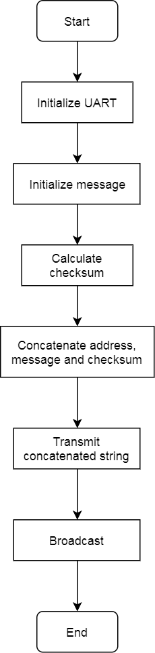

checksum=checksum%256;

sprintf(towrite,"%s%02X\n", temp, checksum);

for(i=0;i<11;i++){

uart_trans(towrite[i]);

}

//default command for broadcasting

temp ="\rZD0013C\n";

for(i=0;i<9;i++){

uart_trans(temp[i]);

}

return 0;

}

//initialization function

void uart_int(void){

UBRR1L=25;

UCSR1B =(1<<TXEN1) | (1<<RXEN1);

}

//transmission function

void uart_trans(unsigned char data){

while(!(UCSR1A & (1<<UDRE1)));

UDR1 = data;

}

/*Description

*A program that broadcasts a character to the CyberTech Wall Display.

*/

**Task 2**

/*;>>>>>>>>>>>>>>>>>>>>>>>>>>>>>>>>>>>>>>>>>>>>>>>>>>>>>>>>>>>

; 1DT301, Computer Technology I

; Date: 2017-10-17

; Author:

; Student name 1: Ruth Dirnfeld

; Student name 2: Alexandra Bjäremo

;

; Lab number: 6

; Title: CyberTech Wall Display

;

; Hardware: STK600, CPU ATmega2560

;

; Function: Displaying characters on all the CyberTech Wall Display lines.

;

; Input ports: TX, RX on PIND2, respective PIND3.

;

; Output ports: CyberTech Wall Display connected to serial port RS232

;

; Subroutines: Initialization and transmission routines for the display

; Included files: m2560def.inc

;

; Other information: Clock set at 1,83MHz

;

; Changes in program: None.

;<<<<<<<<<<<<<<<<<<<<<<<<<<<<<<<<<<<<<<<<<<<<<<<<<<<<<<<<<<< */

#include<avr/io.h>

#include<stdio.h>

#include <stdlib.h>

//#define BAUD 2400

//#define UBRR_VAL 47

void uart_int(void);

void uart_trans(unsigned char data);

int main(void){

uart_int();

char towrite[100];

char* temp ="\rAO0001Pizza1234567890123456789is";

int i;

//first two lines

int checksum=0;

for (i=0;i<34;i++){

checksum+=temp[i];

}

checksum=checksum%256;

sprintf(towrite,"%s%02X\n", temp, checksum);

for(i=0;i<37;i++){

uart_trans(towrite[i]);

}

//last line

checksum=0;

temp="\rBO0001life";

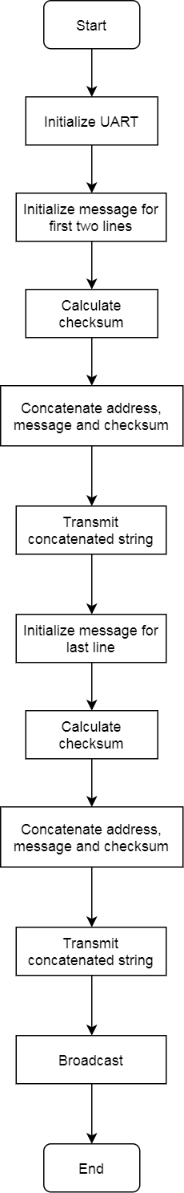 for (i=0;i<12;i++){

checksum+=temp[i];

}

checksum=checksum%256;

sprintf(towrite,"%s%02X\n", temp, checksum);

for(i=0;i<15;i++){

uart_trans(towrite[i]);

}

//default command for broadcasting

temp ="\rZD0013C\n";

for(i=0;i<9;i++){

uart_trans(temp[i]);

}

return 0;

}

//initialization function

void uart_int(void){

UBRR1L=25;

UCSR1B =(1<<TXEN1) | (1<<RXEN1);

}

//transmission function

void uart_trans(unsigned char data){

while(!(UCSR1A & (1<<UDRE1)));

UDR1 = data;

}

/*Description

*A program that broadcasts characters on all the lines of the

*CyberTech Wall Display.

*/

**Task 3**

/*;>>>>>>>>>>>>>>>>>>>>>>>>>>>>>>>>>>>>>>>>>>>>>>>>>>>>>>>>>>>

; 1DT301, Computer Technology I

; Date: 2017-10-17

; Author:

; Student name 1: Ruth Dirnfeld

; Student name 2: Alexandra Bjäremo

;

; Lab number: 6

; Title: CyberTech Wall Display

;

; Hardware: STK600, CPU ATmega2560

;

; Function: Displaying characters on all the CyberTech Wall Display lines

; and changing the last line after 5 seconds.

;

; Input ports: TX, RX on PIND2, respective PIND3.

;

; Output ports: CyberTech Wall Display connected to serial port RS232

;

; Subroutines: Initialization and transmission routines for the display

; Included files: m2560def.inc

;

; Other information: Clock set at 1,83MHz

;

; Changes in program: None.

;<<<<<<<<<<<<<<<<<<<<<<<<<<<<<<<<<<<<<<<<<<<<<<<<<<<<<<<<<<< */

#include<avr/io.h>

#include<stdio.h>

#include <stdlib.h>

#define F_CPU 1830000UL

#include <util/delay.h>

//#define BAUD 2400

//#define UBRR_VAL 47

void uart_int(void);

void uart_trans(unsigned char data);

int main(void){

uart_int();

char towrite[200];

//first two lines, faze 1

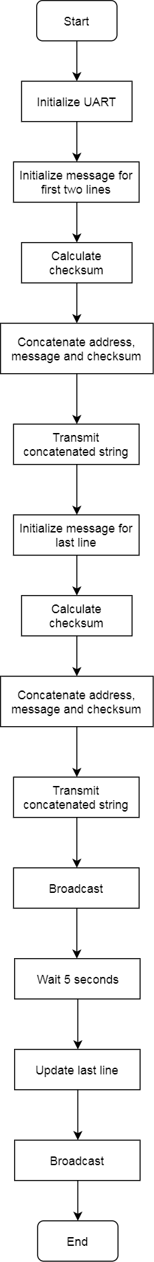 char* temp ="\rAO0001Computer Science,201712345678Computer Technology";

int i;

int checksum=0;

for (i=0;i<55;i++){

checksum+=temp[i];

}

checksum=checksum%256;

sprintf(towrite,"%s%02X\n", temp, checksum);

for(i=0;i<58;i++){

uart_trans(towrite[i]);

}

checksum=0;

//last line, faze 1

temp="\rBO0001Assignment#6";

for (i=0;i<20;i++){

checksum+=temp[i];

}

checksum=checksum%256;

sprintf(towrite,"%s%02X\n", temp, checksum);

for(i=0;i<23;i++){

uart_trans(towrite[i]);

}

//deafult broadcasting command

temp ="\rZD0013C\n";

for(i=0;i<9;i++){

uart_trans(temp[i]);

}

_delay_ms(5000);

//faze 2, changing last line

checksum=0;

temp="\rBO0001Ruth and Alex";

for (i=0;i<21;i++){

checksum+=temp[i];

}

checksum=checksum%256;

sprintf(towrite,"%s%02X\n", temp, checksum);

for(i=0;i<24;i++){

uart_trans(towrite[i]);

}

//default broadcasting command

temp ="\rZD0013C\n";

for(i=0;i<9;i++){

uart_trans(temp[i]);

}

return 0;

}

//initialization function

void uart_int(void){

UBRR1L=25;

UCSR1B =(1<<TXEN1) | (1<<RXEN1);

}

//transmission function

void uart_trans(unsigned char data){

while(!(UCSR1A & (1<<UDRE1)));

UDR1 = data;

}

/*Description:

*A program that broadcasts characters on all the lines of the CyberTech Wall Display

*and changing the last line after 5 seconds.

*/