**Task 1**

;>>>>>>>>>>>>>>>>>>>>>>>>>>>>>>>>>>>>>>>>>>>>>>>>>>>>>>>>>>>

; 1DT301, Computer Technology I

; Date: 2017-09-25

; Author:

; Student name 1 Ruth Dirnfeld

; Student name 2 Alexandra Bjäremo

;

; Lab number: 3

; Title: Interrupts.

;

; Hardware: STK600, CPU ATmega2560

;

; Function: Turning ON and OFF a LED with a push button.

;

; Input ports: On-board switches connected to DDRD.

;

; Output ports: On-board LEDs connected to DDRB.

;

; Subroutines: interrupt_0, interrupt_1

; Included files: m2560def.inc

;

; Other information: Clock set at 1 MHz

;

; Changes in program: None.

;

;<<<<<<<<<<<<<<<<<<<<<<<<<<<<<<<<<<<<<<<<<<<<<<<<<<<<<<<<<<<

.include"m2560def.inc"

.org 0x00

rjmp start

.org INT0addr

rjmp interrupt_0

.org INT1addr

rjmp interrupt_1

.org 0x72

start:

ldi r16, HIGH(RAMEND) ; MSB part av address to RAMEND

out SPH, r16 ; store in SPH

ldi r16, LOW(RAMEND) ; LSB part av address to RAMEND

out SPL, r16 ; store in SPL

ldi r20, 0x00

out DDRD, r20 ; all zero's to DDRD, input

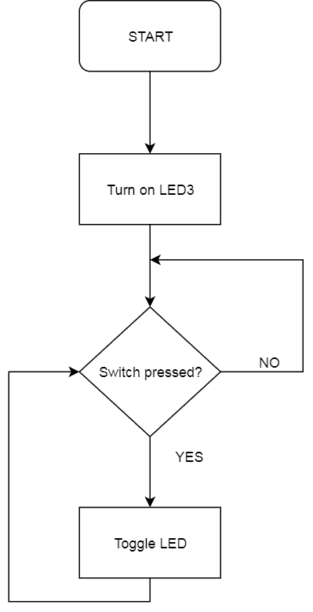

ldi r20, 0xFF

out DDRB, r20 ; all one's to DDRB, outputs

ldi r20, 0x03 ; INT0 and INT1 enabled

out EIMSK, r20

ldi r20, 0x08 ; INT1 falling edge, INT0 rising edge

sts EICRA, r20

sei ; global interrupt enable

ldi r20, 0xF7

out PORTB, r20

main:

nop

rjmp main

interrupt_0:

interrupt_1:

andi r20, 0x08 ; isolating the bit corresponding to LED3

com r20 ; inverting the bit

out PORTB, r20 ; outing to LED3

reti ; return from interrupt

|  |
| --- |
|  |

|  |
| --- |
|  |

/* Description:

* The program will start with lighting up a LED that will alternatively turn Off/On when

* when using the interrupt (pressing the designated switch)

*/

**Task 2**

;>>>>>>>>>>>>>>>>>>>>>>>>>>>>>>>>>>>>>>>>>>>>>>>>>>>>>>>>>>>

; 1DT301, Computer Technology I

; Date: 2017-09-25

; Author:

; Student name 1 Ruth Dirnfeld

; Student name 2 Alexandra Bjäremo

;

; Lab number: 3

; Title: Interrupts.

;

; Hardware: STK600, CPU ATmega2560

;

; Function: A program that switches between Ring counter and Johnson counter

; by using Interrupts

; Input ports: On-board switches connected to DDRD.

;

; Output ports: On-board LEDs connected to DDRB.

;

; Subroutines: interrupt_0, interrupt_1

; Included files: m2560def.inc

;

; Other information: Clock set at 1 MHz.

;

; Changes in program: 2017-09-26.

;

;<<<<<<<<<<<<<<<<<<<<<<<<<<<<<<<<<<<<<<<<<<<<<<<<<<<<<<<<<<<

.include "m2560def.inc"

.org 0x00

rjmp start

.org INT0addr

rjmp interrupt_0

.org INT1addr

rjmp interrupt_1

.org 0x72

start:

; Initialize SP, Stack Pointer

ldi r20, HIGH(RAMEND) ; R20 = high part of RAMEND address

out SPH,r20 ; SPH = high part of RAMEND address

ldi R20, low(RAMEND) ; R20 = low part of RAMEND address

out SPL,R20 ; SPL = low part of RAMEND address

ldi r20, 0xFF

out DDRB, r20 ; All one's to DDRB, outputs

ldi r16, 0xFE ; starting with LED0

ldi r17, 0x00 ; temp register to help with sloop

ldi r23, 0x00

out DDRD, r23

ldi r22, 0x00 ; keep track of counters, if 0 then ring, else johnson

;could not test with SW0 because there were no available microcontrollers that had a functioning SW0

ldi r24, 0x03 ; INT0 and INT1 enabled

out EIMSK, r24

ldi r24, 0x08 ; INT1 falling edge, INT0 rising edge

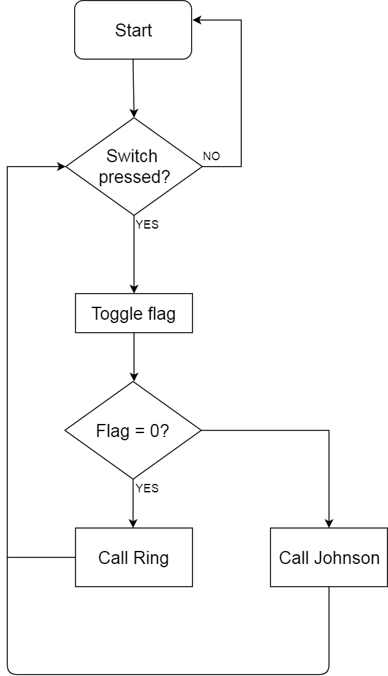sts EICRA, r24

sei ; global interrupt enable

main:

cpi r22, 0x00

breq ring

rjmp johnsonLeft

rjmp main

ring:

cpi r16, 0xFF ; checking if all LEDs are off

breq equal

out PORTB, r16 ; write in PORTB, turning on LEDs

com r16 ; inverting the bits of r16

lsl r16 ; pushing a 0 to the left

com r16 ; inverting the bits of r16 again

rcall delay

rjmp ring

johnsonLeft:

cpi r22, 0x00

breq ring

cpi r16, 0x00 ; check if all LEDs are on

breq johnsonRight

out PORTB, r16 ; write to PORTB

lsl r16 ; pushing 0 to the left to turn on next light aswell

rcall delay

rjmp johnsonLeft

johnsonRight:

out PORTB, r16 ; write to PORTB

cpi r16, 0xFF ; check if all LEDs are off

breq johnsonLeft

mov r17, r16 ; move r16's bits to r17

com r17 ; invert r17's bits

lsr r17 ; pushing 0 to the right

com r17 ; invert r17's bits again

mov r16, r17 ; move r17's bits to r16

rcall delay

rjmp johnsonRight

equal:

ldi r16, 0xFE

rjmp main

; Generated by delay loop calculator

; at http://www.bretmulvey.com/avrdelay.html

;

; Delay 500 000 cycles

; 500ms at 1 MHz

delay:

ldi r18, 3

ldi r19, 138

ldi r21, 86

L1: dec r21

brne L1

dec r19

brne L1

dec r18

brne L1

rjmp PC+1

ret

interrupt_0:

interrupt_1:

ldi r16, 0xFF

out PORTB, r16 ; turn off all LEDs, to stop the counter

com r22 ; invert r22 to change counter

reti

/*Description

* The program switches between a Ring and a Johnson counter each time

*the interrupt has been used.

*/

**Task 3**

;>>>>>>>>>>>>>>>>>>>>>>>>>>>>>>>>>>>>>>>>>>>>>>>>>>>>>>>>>>>

; 1DT301, Computer Technology I

; Date: 2017-09-25

; Author:

; Student name 1 Ruth Dirnfeld

; Student name 2 Alexandra Bjäremo

;

; Lab number: 3

; Title: Interrupts.

;

; Hardware: STK600, CPU ATmega2560

;

; Function: A program that simulates the blinking lights of a vehicle

; when trying to turn right/left

;

; Input ports: On-board switches connected to DDRD.

;

; Output ports: On-board LEDs connected to DDRB.

;

; Subroutines: interrupt_1, interrupt_2

; Included files: m2560def.inc

;

; Other information: Clock set at 1MHz.

;

; Bouncing issues regarding the pressing of the

; switches when trying to activate the turn signals

;

; Changes in program: 2017-09-26, 2017-09-28, 2017-09-29

; 2017-10-01 Different updates and changes to code to get it

; to work properly

;

;<<<<<<<<<<<<<<<<<<<<<<<<<<<<<<<<<<<<<<<<<<<<<<<<<<<<<<<<<<<

.include"m2560def.inc"

.org 0x00

rjmp start

.org INT1addr

jmp interrupt_1

.org INT2addr

jmp interrupt_2

.org 0x72

start:

ldi r16, HIGH(RAMEND) ; MSB part av address to RAMEND

out SPH, r16 ; store in SPH

ldi r16, LOW(RAMEND) ; LSB part av address to RAMEND

out SPL, r16 ; store in SPL

ldi r20, 0xFF

out DDRB, r20 ; all one's to DDRB, output

ldi r20, 0x00

out DDRD, r20 ; all zero's to DDRD, input

ldi r30, 0x00 ; help register for interrupt_1

ldi r31, 0x00 ; help register for interrupt_2

ldi r20, 0x06 ; INT0 and INT1 enabled

out EIMSK, r20

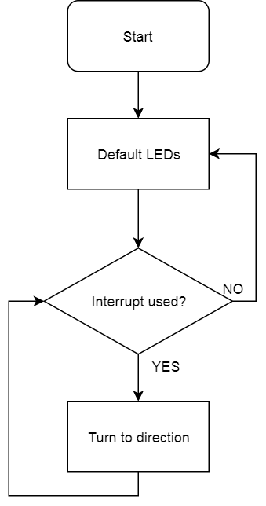

ldi r20, 0x28 ; INT1 falling edge, INT0 rising edge

sts EICRA, r20

sei ; global interrupt enable

main:

ldi r24, 0x3C

out PORTB, r24 ; default

rjmp main

start_turning_right:

clr r16 ; clear Stack

sei ; enable Interrupt

cpi r30, 0xFF ; check if interrupt was used again

brne main

ldi r22, 0x37 ; 00xx 0xxx

out PORTB, r22

ldi r23, 0xA0 ; help register

tright:

out PORTB, r22 ; outputting first to not skip initial position

cpi r22, 0x3F ; checking if the ring is complete

breq equal2

com r22 ; inverting the bits

lsr r22 ; pushing one's from the left side

com r22 ; inverting again

eor r22,r23 ; XOR to get higher nibble back to 0011

rcall delay

rjmp tright ; loop it

equal2:

ldi r22, 0x37 ; reset to initial position

rjmp tright

start_turning_left:

clr r16 ; clear Stack

sei ; enable interrupts

cpi r31, 0xFF ; check if interrupt was used

brne main

ldi r25, 0xEC ; xxx0 xx00

out PORTB, r25

ldi r17, 0x05 ; help register

tleft:

out PORTB, r25 ; outputting first to not skip initial position

cpi r25, 0xFC ; checking if the ring is complete

breq equal

com r25 ; inverting the bits

lsl r25 ; pushing one's from the right side

com r25 ; inverting again

eor r25,r17 ; XOR to get lower nibble back to 1100

rcall delay

rjmp tleft ; loop it

equal:

ldi r25, 0xEC ; reset to initial position

rjmp tleft

interrupt_1:

com r30 ; inverting r30

rjmp start_turning_right

reti ; return from interrupt

interrupt_2:

com r31 ; inverting r31

rjmp start_turning_left

reti ; return from interrupt

; Generated by delay loop calculator

; at http://www.bretmulvey.com/avrdelay.html

;

; Delay 500 000 cycles

; 500ms at 1 MHz

delay:

ldi r18, 3

ldi r19, 138

ldi r21, 86

L1: dec r21

brne L1

dec r19

brne L1

dec r18

brne L1

rjmp PC+1

ret

/*Description

*The program simulates the turning signals a car uses. It starts with the lights in default position *0x3C, that will change depending which interrupt is being used. If interrupt1 is used then the left side of the upper nibble will remain in position 00xx, while the lower nibble will be doing a ring *counter to the right. When interrupt2 is used then the right side of the lower nibble will remain in *position xx00, while the upper nibble will be doing a ring counter going to the left.

*Reusing the same interrupt while in the respective sequence will return the LEDs to the default *position of 00xx xx00.

*/

**Task 4**

;>>>>>>>>>>>>>>>>>>>>>>>>>>>>>>>>>>>>>>>>>>>>>>>>>>>>>>>>>>>

; 1DT301, Computer Technology I

; Date: 2017-09-25

; Author:

; Student name 1 Ruth Dirnfeld

; Student name 2 Alexandra Bjäremo

;

; Lab number: 3

; Title: Interrupts.

;

; Hardware: STK600, CPU ATmega2560

;

; Function: A program that simulates the blinking lights of a vehicle

; when trying to turn right/left

;

; Input ports: On-board switches connected to DDRD.

;

; Output ports: On-board LEDs connected to DDRB.

;

; Subroutines: interrupt_1, interrupt_2

; Included files: m2560def.inc

;

; Other information: Clock set at 1MHz.

;

; Bouncing issues regarding the pressing of the

; switches when trying to activate the turn signals

;

; Changes in program: 2017-09-26, 2017-09-28, 2017-09-29

; 2017-10-01,2017-10-10 Different updates and changes to code to get it

; to work properly

;

;<<<<<<<<<<<<<<<<<<<<<<<<<<<<<<<<<<<<<<<<<<<<<<<<<<<<<<<<<<<

.include"m2560def.inc"

.org 0x00

rjmp start

.org INT1addr

jmp interrupt_1

.org INT2addr

jmp interrupt_2

.org INT3addr

jmp interrupt_3

.org 0x72

start:

ldi r16, HIGH(RAMEND) ; MSB part av address to RAMEND

out SPH, r16 ; store in SPH

ldi r16, LOW(RAMEND) ; LSB part av address to RAMEND

out SPL, r16 ; store in SPL

ldi r20, 0xFF

out DDRB, r20 ; all one's to DDRB, output

ldi r20, 0x00

out DDRD, r20 ; all zero's to DDRD, input

ldi r30, 0x00 ; help register for interrupt_1

ldi r31, 0x00 ; help register for interrupt_2

ldi r29, 0x00 ; help register for interrupt_3

ldi r23, 0xA0 ; help with eor right

ldi r17, 0x05 ; help with eor left

ldi r26, 0x11 ; help with eor left 2

ldi r28, 0x88 ; help with eor right 2

ldi r20, 0x0E ; INT0 and INT1 enabled

out EIMSK, r20

ldi r20, 0xE8 ; INT2, INT1 falling edge, INT3 both rising and falling

sts EICRA, r20

sei ; global interrupt enable

main:

ldi r24, 0x3C

out PORTB, r24 ; default

rjmp main

start_turning_right:

clr r16 ; clear Stack

sei ; enable Interrupt

cpi r30, 0xFF ; check if interrupt was used again

brne main

ldi r22, 0x37 ; 00xx 0xxx

out PORTB, r22

tright:

out PORTB, r22 ; outputting first to not skip initial position

cpi r22, 0x3F ; checking if the ring is complete

breq equal2

com r22 ; inverting the bits

lsr r22 ; pushing one's from the left side

com r22 ; inverting again

eor r22,r23 ; XOR to get higher nibble back to 0011

rcall delay

rjmp tright ; loop it

equal2:

ldi r22, 0x37 ; reset to initial position

rjmp tright

start_turning_left:

clr r16 ; clear Stack

sei ; enable interrupts

cpi r31, 0xFF ; check if interrupt was used

brne main

ldi r25, 0xEC ; xxx0 xx00

out PORTB, r25

tleft:

out PORTB, r25 ; outputting first to not skip initial position

cpi r25, 0xFC ; checking if the ring is complete

breq equal

com r25 ; inverting the bits

lsl r25 ; pushing one's from the right side

com r25 ; inverting again

eor r25,r17 ; XOR to get lower nibble back to 1100

rcall delay

rjmp tleft ; loop it

equal:

ldi r25, 0xEC ; reset to initial position

rjmp tleft

breaks:

clr r16 ; clear Stack

sei ; enable interrupts

cpi r29, 0xFF

breq checkpos

; not sure

checkpos:

cpi r30, 0xFF ; check if it's turning right

breq break_right

cpi r31, 0xFF ; check if it's turning left

breq break_left

rjmp break_def ; check if it's in default state

; break in default state

break_def:

clr r16 ; clear Stack

sei ; enable interrupts

ldi r24, 0x00

out PORTB, r24 ; turn on all LEDs

rjmp checkpos

; break when turning right

break_right:

clr r16 ; clear Stack

sei ; enable Interrupt

/*cpi r29, 0xFF ; check if interrupt was used again

breq start_brk_right*/

start_brk_right:

ldi r22, 0x07 ; 0000 0xxx

out PORTB, r22

breakright:

out PORTB, r22

cpi r22, 0x0F ; checking if the ring is complete

breq equal2brk

com r22 ; inverting the bits

lsr r22 ; pushing one's from the left side

com r22 ; inverting again

eor r22,r28 ; XOR to get higher nibble back to 0000;

rcall delay

rjmp breakright ; loop it

equal2brk:

ldi r22, 0x07 ; reset to initial position

rjmp breakright

break_left:

clr r16 ; clear Stack

sei ; enable interrupts

/*cpi r29, 0xFF ; check if interrupt was used

breq start_brk_left

rjmp main*/

start_brk_left:

ldi r25, 0xE0 ; xxx0 0000

out PORTB, r25

breakleft:

out PORTB, r25

cpi r25, 0xF0 ; checking if the ring is complete

breq equalbrk

com r25 ; inverting the bits

lsl r25 ; pushing one's from the right side

com r25 ; inverting again

eor r25, r26 ; XOR to get lower nibble to 0000

rcall delay

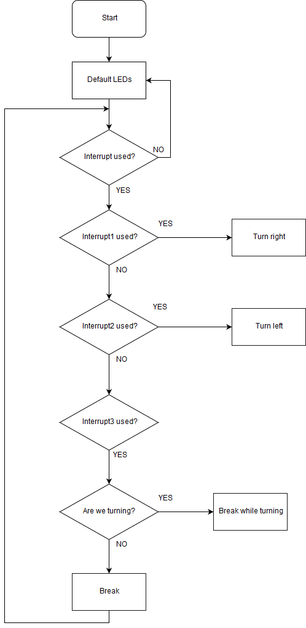 rjmp breakleft ; loop it

equalbrk:

ldi r25, 0xE0 ; reset to initial position

rjmp breakleft

interrupt_1:

com r30 ; inverting r30

rjmp start_turning_right

reti ; return from interrupt

interrupt_2:

com r31 ; inverting r31

rjmp start_turning_left

reti

interrupt_3:

com r29

rjmp breaks

reti ; return from interrupt

; Generated by delay loop calculator

; at http://www.bretmulvey.com/avrdelay.html

;

; Delay 500 000 cycles

; 500ms at 1 MHz

delay:

ldi r18, 3

ldi r19, 138

ldi r21, 86

L1: dec r21

brne L1

dec r19

brne L1

dec r18

brne L1

rjmp PC+1

ret

/*Description

*The program simulates the lights on a car, when turning to left/right, breaking and breaking while *turning left/right.

*The default LEDs are in position 00xx xx00. When interrupt1 or interrupt2 is used the LEDs will start *to blink in a ring counter going right, respectively left. However, if interrupt3 is used then it will turn *on all LEDs on the upper, respective lower nibble (upper if turning right, lower if turning left). If the *LEDs are in default position and interrupt3 is used then all 8 LEDs will light up.

*/