;>>>>>>>>>>>>>>>>>>>>>>>>>>>>>>>>>>>>>>>>>>>>>>>>>>>>>>>>>>>

; 1DT301, Computer Technology I

; Date: 2016-09-05

; Author:

; Student name 1 Ruth Dirnfeld

; Student name 2 Alexandra Bjäremo

;

; Lab number: 1

; Title: How to use the PORTs. Digital input/output. Subroutine call.

;

; Hardware: STK600, CPU ATmega2560

;

; Function: Describe the function of the program, so that you can understand it,

; even if you're viewing this in a year from now!

;

; Input ports: Describe the function of used ports, for example on-board switches

; connected to PORTA.

;

; Output ports: Describe the function of used ports, for example on-board LEDs

; connected to PORTB.

;

; Subroutines: If applicable.

; Included files: m2560def.inc

;

; Other information:

;

; Changes in program: (Description and date)

;

;<<<<<<<<<<<<<<<<<<<<<<<<<<<<<<<<<<<<<<<<<<<<<<<<<<<<<<<<<<<

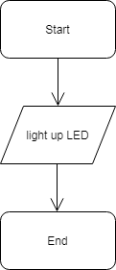

Task1

.include "m2560def.inc" ;include file for Atmega 2560

ldi r16, 0b00000100

out DDRB, r16

/\*

\*Description:

\*Using the only corresponding LED as input through

\*Register 16

\*Minimum instructions used in this case: 2

\*/

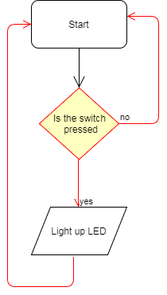

Task2

.include "m2560def.inc"

ldi r16, 0xFF

out DDRB, r16

ldi r16, 0b00000000

out DDRA, r16

loop:

in r16, PINA

out PORTB, r16

rJmp loop

/\*Description:

\*Using DDRB as output and DDRA as input, so that when pressing one of the switches the \*corresponding LED will be lighted up

\*/

Task3

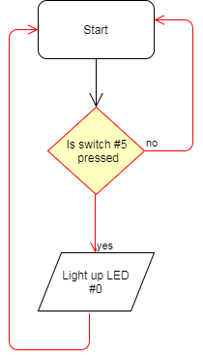

.include "m2560def.inc"

ldi r16, 0b00000001

out DDRB, r16

ldi r16, 0b11011111

out DDRA, r16

loop:

ldi r16, 0b11111111

out PORTB, r16

in r16, PINA

cpi r16, 0

brne loop

ldi r16, 0b11111110

out PORTB,r16

rJmp loop

/\*Description:

\* Using only the first LED (LED0) as output and switch 5(SW5) as input.

\* Checking if the correct switch is pressed and if it is, light up LED0, otherwise does nothing.

\*/

Task 5

.include "m2560def.inc"

; Initialize SP, Stack Pointer

ldi r20, HIGH(RAMEND) ; R20 = high part of RAMEND address

out SPH,r20 ; SPH = high part of RAMEND address

ldi R20, low(RAMEND) ; R20 = low part of RAMEND address

out SPL,R20 ; SPL = low part of RAMEND address

ldi r20, 0xFF

out DDRB, r20

ldi r16, 0xFE

floop:

cpi r16, 0xFF

breq equal

out PORTB, r16

com r16

lsl r16

com r16

rjmp delay

rjmp floop

equal:

ldi r16, 0xFE

rjmp floop

; Generated by delay loop calculator

; at http://www.bretmulvey.com/avrdelay.html

;

; Delay 500 000 cycles

; 500ms at 1 MHz

delay:

ldi r18, 3

ldi r19, 138

ldi r21, 86

L1: dec r21

brne L1

dec r19

brne L1

dec r18

brne L1

rjmp PC+1

rjmp floop

Task 6

.include "m2560def.inc"

; Initialize SP, Stack Pointer

ldi r20, HIGH(RAMEND) ; R20 = high part of RAMEND address

out SPH,r20 ; SPH = high part of RAMEND address

ldi R20, low(RAMEND) ; R20 = low part of RAMEND address

out SPL,R20 ; SPL = low part of RAMEND address

ldi r20, 0xFF

out DDRB, r20

ldi r16, 0xFE

ldi r17, 0x00

floop:

cpi r16, 0x00

breq sloop

out PORTB, r16

lsl r16

rcall delay

rjmp floop

sloop:

out PORTB, r16

cpi r16, 0xFF

breq floop

mov r17, r16

com r17

lsr r17

com r17

mov r16, r17

rcall delay

rjmp sloop

; Generated by delay loop calculator

; at http://www.bretmulvey.com/avrdelay.html

;

; Delay 500 000 cycles

; 500ms at 1 MHz

delay:

ldi r18, 3

ldi r19, 138

ldi r21, 86

L1: dec r21

brne L1

dec r19

brne L1

dec r18

brne L1

rjmp PC+1

ret

/\*ldi r20, 0x00

out DDRB, r20

ldi r17, 0x00

ldi r16, 0x01

floop:

out PORTB, r20

add r17, r16

out PORTB, r17

lsl r16

breq sloop

;rcall delay

rjmp floop

sloop:

inc r20

lsr r17

out PORTB, r17

inc r20

;rcall delay

rjmp sloop

; Generated by delay loop calculator

; at http://www.bretmulvey.com/avrdelay.html

;

; Delay 500 000 cycles

; 500ms at 1 MHz

delay:

ldi r18, 3

ldi r19, 138

ldi r21, 86

L1: dec r21

brne L1

dec r19

brne L1

dec r18

brne L1

rjmp PC+1

rjmp floop

\*/