**Task 1**

;>>>>>>>>>>>>>>>>>>>>>>>>>>>>>>>>>>>>>>>>>>>>>>>>>>>>>>>>>>>

; 1DT301, Computer Technology I

; Date: 2017-09-12

; Author:

; Student name 1: Ruth Dirnfeld

; Student name 2: Alexandra Bjäremo

;

; Lab number: 2

; Title: Subroutines

;

; Hardware: STK600, CPU ATmega2560

;

; Function: Switching between the Ring and the Johnson counters when pressing SW0

;

; Input ports: On-board switches connected to PORTA.

;

; Output ports: On-board LEDs connected to PORTB.

;

; Subroutines: Delay of approximately 0,5 sec in between each count.

; Included files: m2560def.inc

;

; Other information: Clock set at 1MHz

;

; Changes in program: File updates: 2017-09-16, 2017-09-18, 2017-09-19

;

;<<<<<<<<<<<<<<<<<<<<<<<<<<<<<<<<<<<<<<<<<<<<<<<<<<<<<<<<<<<

.include "m2560def.inc"

; Initialize SP, Stack Pointer

ldi r20, HIGH(RAMEND) ; R20 = high part of RAMEND address

out SPH,r20 ; SPH = high part of RAMEND address

ldi R20, low(RAMEND) ; R20 = low part of RAMEND address

out SPL,R20 ; SPL = low part of RAMEND address

ldi r20, 0xFF

out DDRB, r20 ; All one's to DDRB, outputs

ldi r16, 0xFE ; starting with LED0

ldi r17, 0x00 ; temp register to help with sloop

ldi r23, 0x00

out DDRA, r23

ldi r22, 0x00 ; keep track of counters, if 0 then ring, else johnson

main:

ring:

ldi r23, 0x00

cpi r16, 0xFF ; checking if all LEDs are off

breq equal

out PORTB, r16 ; write in PORTB, turning on LEDs

com r16 ; inverting the bits of r16

lsl r16 ; pushing a 0 to the left

com r16 ; inverting the bits of r16 again

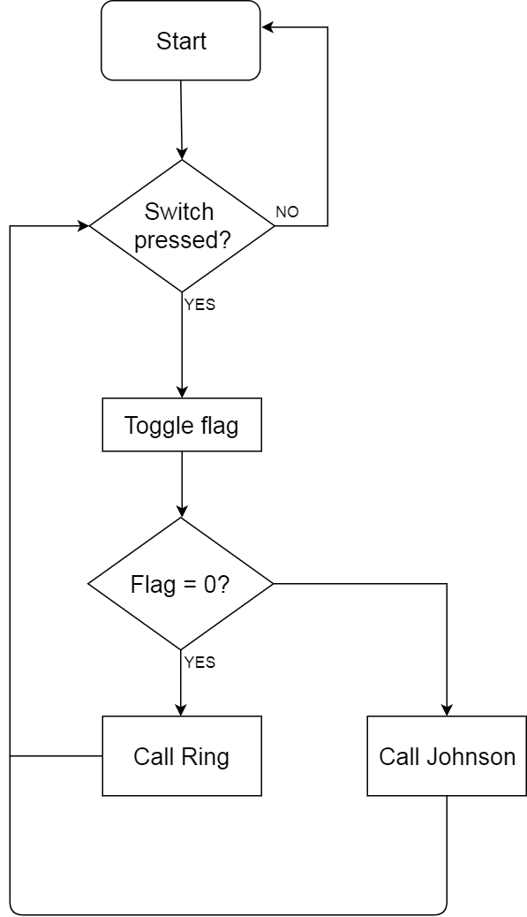 rcall delay

rjmp ring

equal:

ldi r16, 0xFE

rjmp main

; Generated by delay loop calculator

; at http://www.bretmulvey.com/avrdelay.html

;

; Delay 500 000 cycles

; 500ms at 1 MHz

delay:

ldi r18, 3

ldi r19, 138

ldi r21, 86

L1: dec r21

brne L1

dec r19

brne L1

dec r18

brne L1

in r23, PINA ; read PINA

cpi r23, 0xFE ; check if button is pressed

breq pressed

rjmp PC+1

ret

;;;;;;;;;;;;;;;;;;;;;;;;;;;TASK6

johnsonLeft:

ldi r23, 0x00

cpi r16, 0x00 ; check if all LEDs are on

breq johnsonRight

out PORTB, r16 ; write to PORTB

lsl r16 ; pushing 0 to the left to turn on next light aswell

rcall delay

rjmp johnsonLeft

johnsonRight:

ldi r23, 0x00

out PORTB, r16 ; write to PORTB

cpi r16, 0xFF ; check if all LEDs are off

breq johnsonLeft

mov r17, r16 ; move r16's bits to r17

com r17 ; invert r17's bits

lsr r17 ; pushing 0 to the right

com r17 ; invert r17's bits again

mov r16, r17 ; move r17's bits to r16

rcall delay

rjmp johnsonRight

pressed:

com r22 ; invert r22 to change counter

cpi r22,0x00 ; check if counter is set to Ring counter

breq jumpToRing

rjmp jumpToJohnsonLeft

jumpToRing:

ldi r16, 0xFF

out PORTB, r16 ; turn off all LEDs

rjmp ring

jumpToJohnsonLeft:

ldi r16, 0xFF

out PORTB, r16 ; turn off all LEDs

rjmp johnsonLeft

/*Description:

*Starting the main program with the Ring counter, while in the delay phase the switch is checked. If *the switch has been pressed, then the program the flag is toggled (from 0 to 1 or 1 to 0) so that the *next counter will start. However, it will turn off all the LEDs before starting the counter.

*/

**Task 2**

;>>>>>>>>>>>>>>>>>>>>>>>>>>>>>>>>>>>>>>>>>>>>>>>>>>>>>>>>>>>

; 1DT301, Computer Technology I

; Date: 2017-09-16

; Author:

; Student name 1 Ruth Dirnfeld

; Student name 2 Alexandra Bjäremo

;

; Lab number: 2

; Title: Subroutines

;

; Hardware: STK600, CPU ATmega2560

;

; Function: Rolling the electronical dice by randomly generating the number

; with the switch

;

; Input ports: On-board switches connected to PORTA.

;

; Output ports: On-board LEDs connected to PORTB.

;

; Subroutines: Loops to help with the rolling of the dice and outputting.

; Included files: m2560def.inc

;

; Other information: Clock set at 1MHz

;

; Changes in program: None

;

;<<<<<<<<<<<<<<<<<<<<<<<<<<<<<<<<<<<<<<<<<<<<<<<<<<<<<<<<<<<

.include "m2560def.inc"

ldi r16, 0xFF

out DDRB, r16 ; All one's to DDRB, output

ldi r16, 0x00

out DDRA, r16 ; All zero's to DDRA, input

ldi r17,1 ; r17 to help with output

loop:

in r18, PINA ; read PINA

cpi r18, 0xFF ; check if button is pressed

breq output

inc r17 ; increment r17

cpi r17, 7 ; check if value is 7

brne jmpLoop

ldi r17, 1

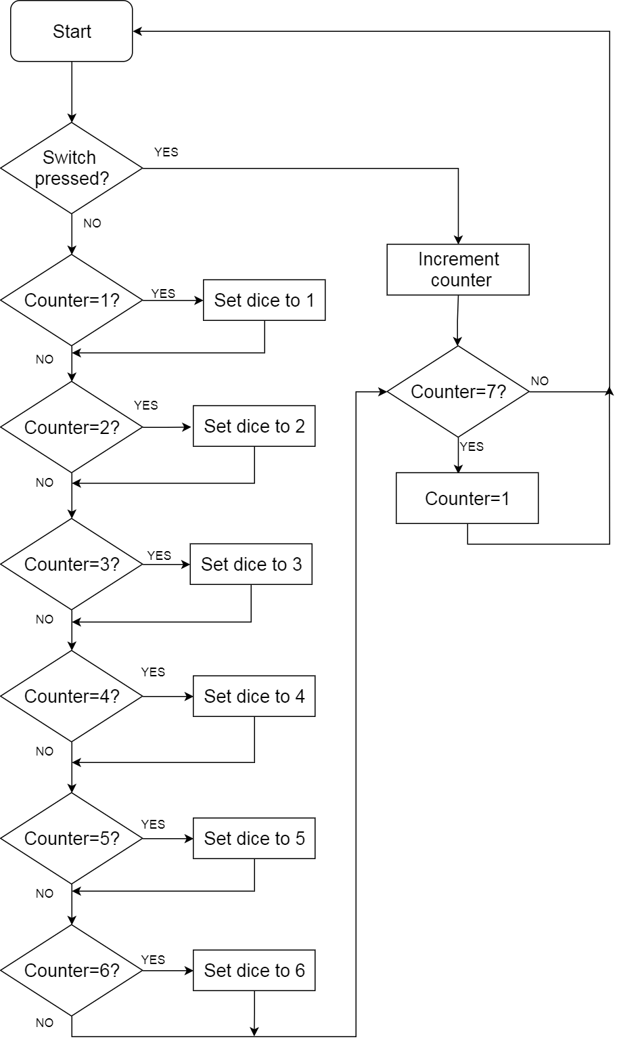jmpLoop:

rjmp loop

;Checking which value is registered

output:

cpi r17, 1

breq one

cpi r17, 2

breq two

cpi r17, 3

breq three

cpi r17, 4

breq four

cpi r17, 5

breq five

cpi r17, 6

breq six

; Depending on the value

;turn on corresponding LEDs

one:

ldi r16, 0b0001_0000

out DDRB, r16

rjmp loop

two:

ldi r16, 0b0100_0100

out DDRB, r16

rjmp loop

three:

ldi r16, 0b0101_0100

out DDRB, r16

rjmp loop

four:

ldi r16, 0b1100_0110

out DDRB, r16

rjmp loop

five:

ldi r16, 0b1101_0110

out DDRB, r16

rjmp loop

six:

ldi r16, 0b1110_1110

out DDRB, r16

rjmp loop

/*Description:

*Checking if the switch is pressed, then incrementing the counter until it reaches 7 then resetting it *to 1 and turning on the corresponding LEDs. This will generate a visual effect that resembles two *dice.

*/

**Task 3**

;>>>>>>>>>>>>>>>>>>>>>>>>>>>>>>>>>>>>>>>>>>>>>>>>>>>>>>>>>>>

; 1DT301, Computer Technology I

; Date: 2017-09-17

; Author:

; Student name 1 Ruth Dirnfeld

; Student name 2 Alexandra Bjäremo

;

; Lab number: 2

; Title: Subroutines

;

; Hardware: STK600, CPU ATmega2560

;

; Function: A program that is able to count the number of changes on a switch.

;

; Input ports: On-board switches connected to PORTA.

;

; Output ports: On-board LEDs connected to PORTB.

;

; Subroutines: None.

;

; Included files: m2560def.inc

;

; Other information: Using a loop to make the counter work infinitely.

; Clock set at 1MHz.

;

; Changes in program: File created - 2017-09-18.

;

;<<<<<<<<<<<<<<<<<<<<<<<<<<<<<<<<<<<<<<<<<<<<<<<<<<<<<<<<<<<

.include "m2560def.inc"

.def counter = r17

ldi counter, 0x00

rjmp main

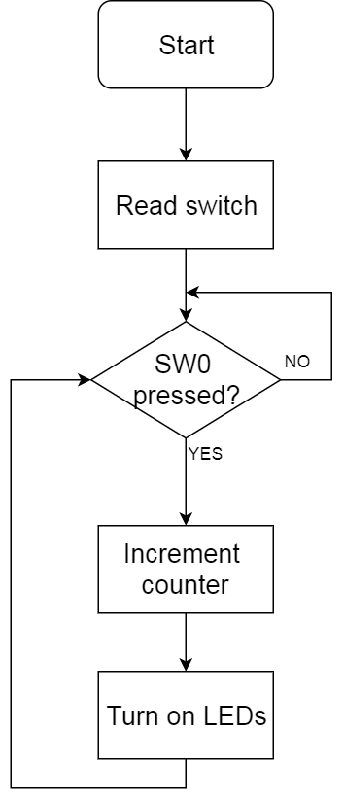switch:

inc counter ; pushed

loop:

in r16, PINA ; read PINA

cpi r16, 0xFF ; release all switches

brne loop

inc counter ; released

out DDRB, counter

main:

in r16, PINA ; read PINA

cpi r16, 0xFE ; switch 0 is pushed

breq switch

rjmp main

/*Description:

*Reading the switch 0 to see if it is pressed. If it is

*pressed the counter increases by one and is then ported to the LEDs. Otherwise it waits.

*/

**Task 4**

;>>>>>>>>>>>>>>>>>>>>>>>>>>>>>>>>>>>>>>>>>>>>>>>>>>>>>>>>>>>

; 1DT301, Computer Technology I

; Date: 2017-09-18

; Author:

; Student name 1 Ruth Dirnfeld

; Student name 2 Alexandra Bjäremo

;

; Lab number: 2

; Title: Subroutines.

;

; Hardware: STK600, CPU ATmega2560

;

; Function: Adaptation of Ring counter, in which the delay is changeable depending

; on the decided input

;

; Input ports: None.

;

; Output ports: On-board LEDs connected to PORTB.

;

; Subroutines: Delay that is changeable.

; Included files: m2560def.inc

;

; Other information: Clock set at 1MHz.

;

; Changes in program: None.

;

;<<<<<<<<<<<<<<<<<<<<<<<<<<<<<<<<<<<<<<<<<<<<<<<<<<<<<<<<<<<

.include "m2560def.inc"

; Initialize SP, Stack Pointer

ldi r20, HIGH(RAMEND) ; R20 = high part of RAMEND address

out SPH,r20 ; SPH = high part of RAMEND address

ldi R20, low(RAMEND) ; R20 = low part of RAMEND address

out SPL,R20 ; SPL = low part of RAMEND address

ldi r20, 0xFF

out DDRB, r20 ; All one's to DDRB, outputs

ldi r16, 0xFE ; starting with LED0

floop:

cpi r16, 0xFF ; checking if all LEDs are off

breq equal

out PORTB, r16 ; write in PORTB, turning on LEDs

com r16 ; inverting the bits of r16

lsl r16 ; pushing a 0 to the left

com r16 ; inverting the bits of r16 again

ldi r24, low(600) ; Loading integer to register pair r25:r24

ldi r25, high(600)

rcall wait_milliseconds ; Call the wait_milliseconds subroutine

rjmp floop

equal:

ldi r16, 0xFE

rjmp floop

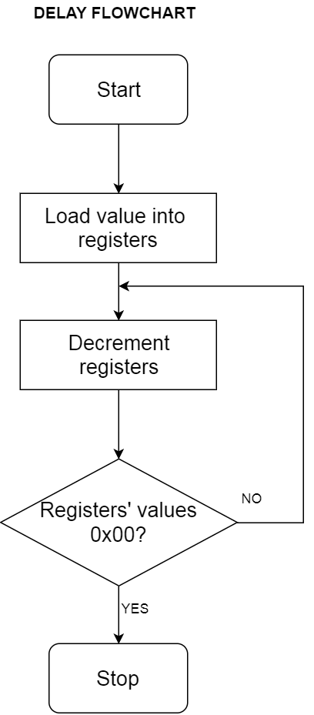

; Depending on the integer value set in the registers the

; delay will either increase or decrease

wait_milliseconds:

L:

ldi r20, low(600) ; loading part of the integer

ldi r21, high(600) ; loading part of the integer

L1:

dec r20 ; decrement r20

nop

brne L1

dec r21 ; decrement r21

nop

brne L1

sbiw r25:r24, 1 ; substract immediate from word

brne L

ret

/*Description:

*The program starts a Ring counter that will be turning on one LED at a time, while turning off the *previous one. The speed with which this will be done depends on the value set in the delay. In the *delay the value is split into two registers and then the registers are being decremented until their *values are 0x00 at which point the program returns to the ring counter loop.

*/