The Battle of Praxis Bay
Please forgive the fonts but I had to
Abdullah Bouteldja
H00501983, ab4085@hw.ac.uk
Contents
Game Overview 0
Gameplay 0
Story Progression 0
Program Design 0
Game Rules 0

Game Overview
The Battle of Praxis Bay is a text-adventure game following the story of an Age of Sail pirate who unluckily finds himself face-to-face with a battle-ready ship of the line and must fight his way to freedom. The player must make choices for how the pirate will battle his enemy, as well as for decisions made by certain other members of the crew during the battle. The decisions available changed depending on previous choices. There are multiple variations of the ending that can be achieved, as well as decisions that can lead to the player dying. Each ending has associated with it a rank, which varies from S (good) to D (bad). Whilst it is not explicitly stated in the game, a death constitutes a rank F.
The game also includes self-produced artwork (hastily self-produced, might I add), which is displayed on the left of the window and shows an image relevant to the current point the story.

Gameplay
The game is played using just a mouse to select the options on the bottom right on the screen, or you can click anywhere in the window to progress if there is no current choice to be made. On the start screen, there is an option to view the credits at the top. Clicking again on the credits screen takes the player back to the start screen. Clicking anywhere on the death screen or the final rank screen also takes the player back to the start screen.

Story Progression
The story features a number of choices for the player, some of which vary depending on the current battle state (either winning or losing), which itself is dependent on the player’s choices.
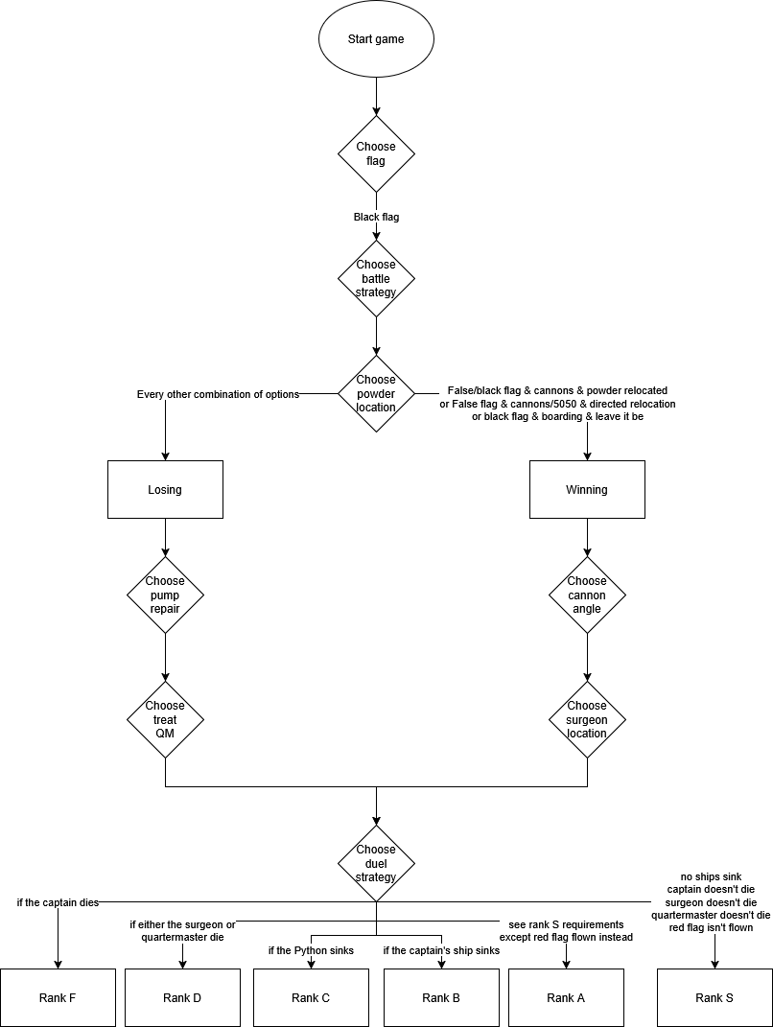
Graph 1: Flowchart of options and resulting ranks

Game Design
The game is a simple black and white interface, split in two pieces down the centre (not in the middle), with the image shown on the left, and the story text and choices shown on the right. Text is displayed using the One Forty Seven font designed by Matthew Welch under license (the license for which is located in the font folder alongside the .ttf font file itself).
All images are also in black and white in the .bmp file format and are of a square aspect ratio of 410 pixels. If you are thinking that the reason I’ve drawn them in black and white and at such a low resolution to cover up how awful an artist I am, you can get that thought out your head because I haven’t covered up shit. They still look terrible.

Program Design
The program is contained a single enourmous main.c file, as I had insufficient time to both organise the program into separate files and link them together.
The program was developed using the SDL3 library (specifically SDL3.4.2) and also makes use of the SDL3_ttf library for handling text and fonts.
The program uses does not have anywhere a main function as most C programs tend to, as it makes use of main callbacks, a feature in SDL3 designed to improve the portability of programs between devices and operating systems. This system acknowledges the design of most game programs and replaces main with four functions: Init, Iterate, Event and Quit.

Main Callbacks

Init
Init, short for initialise, runs once on startup. It is where, surprise surprise, app initialisation occurs. In The Battle of Praxis Bay, it is where the window, renderer, textures and surfaces are created and initialised, along with the struct values holding the game data.

Iterate
Iterate is the game loop that runs for the duration that the game is running. It deals with updating the textures

