**3.1 Account Creation/Verification (Frank)**

Account Creation

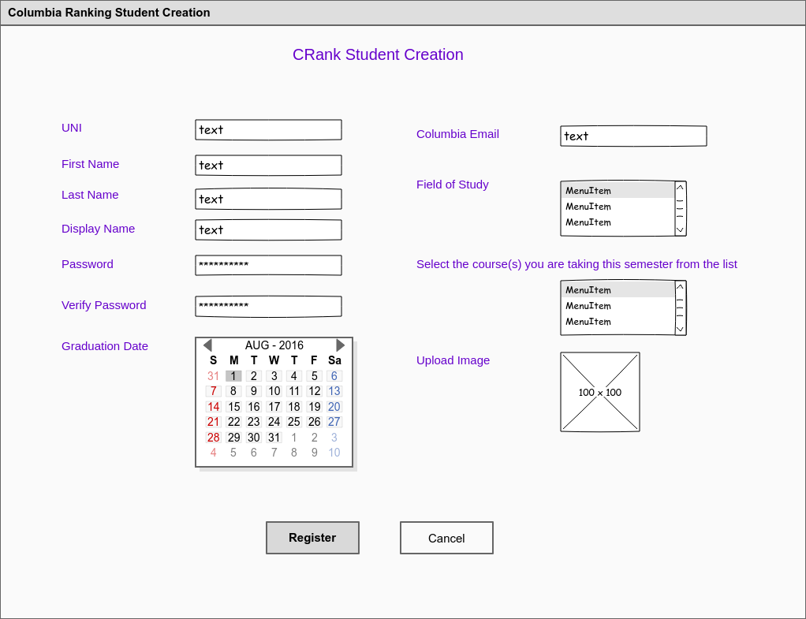

Account Verification

*Step One - Student Receives Email Verification*

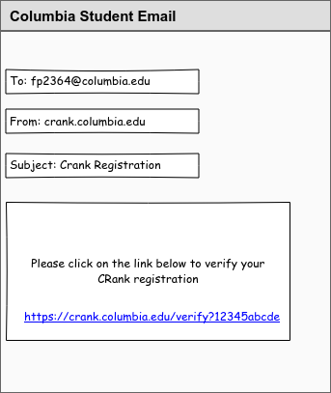

*Step Two - Student clicks on verification link and goes to CRank verification page*

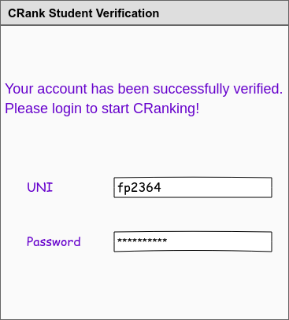

**3.2 User Login (Juwan):**

<https://wireframe.cc/JTb4c7>

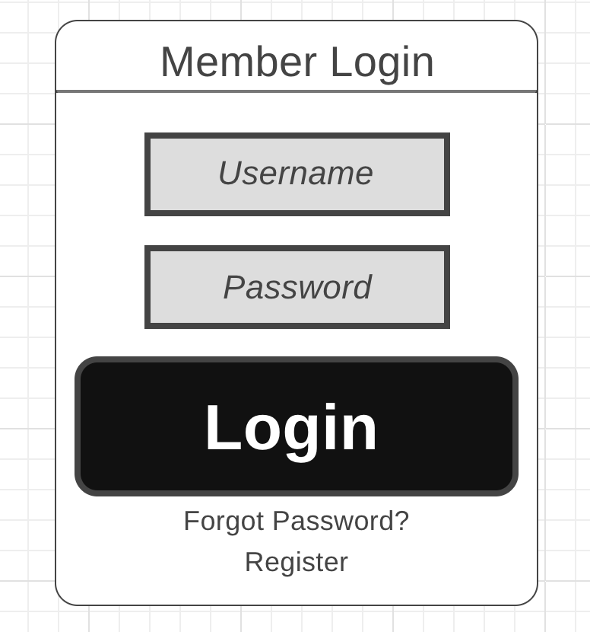

**3.3 User Logout (Yousef):**

<https://wireframe.cc/UqxUJu>

**3.4 Class Entry/Selection and Rating submit (Peter):**https://wireframe.cc/RrXKUP

**3.5 Display Ratings with associated Filters (Tony) :**

<https://wireframe.cc/IdXoPS>

