|  |
| --- |
| **EECS 2070 02 Digital Design Labs 2019**  **Lab 8** |
| **學號：107062140 姓名：廖玉燕** |

1. 實作過程

Upon the reset, the player should not play any tone until the **Play/Paused** is switched to the “Play” mode. By switching the **Play/Paused** to “Pause” while playing, the player should pause immediately right at the moment you turn it off. The player should be able to resume the playing from where it paused by switching to” Play” mode again.

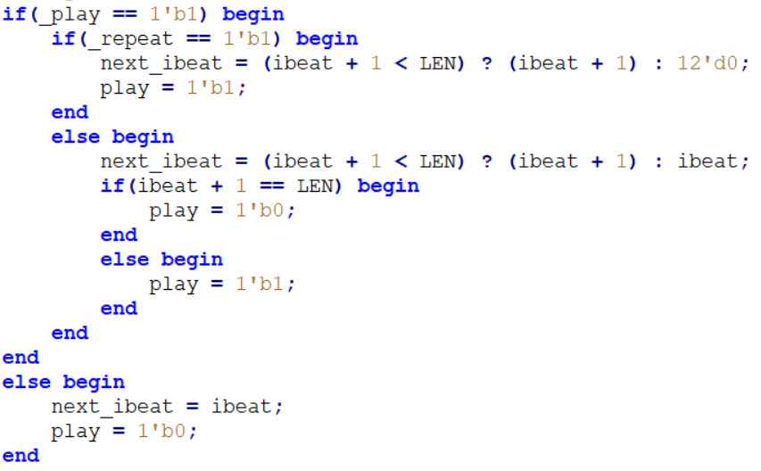

Also, reset the volume level to 3.

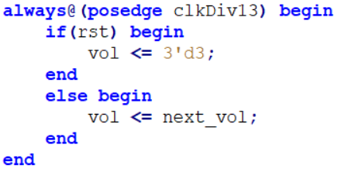

Choose 2 pieces of music(Frere Jacques and template), the player plays one of them when the **Music** switch is 1, and the other when the switch is 0.



play the first song



play the second song

Every time after the Music switch is changed, the player starts playing the corresponding song from the beginning.

1. 學到的東西與遇到的困難

// Any problems encountered and solved

// ex. 學會如何分辨wire & reg

1. 想對老師或助教說的話

// Any suggestions to the course

// ex. 對課程或lab課的建議

// ex. 提供笑話給老師

// ex. 想對老師或助教告白(?)