# ACS221 –Control System Design Assignment

## Question 1

**A unity feedback servo system has a plant with the transfer function given by:**

**Question A: Using the frequency domain approach, determine the gain K required to give an  
overshoot, in response to a step input, of approximately 20%. Explain how you  
achieved your result.**

**The plant is a third order system which has 82.86% overshoot with unity feedback, and the target is lower the overshoot to 20%.**

**To get the 20% overshoot, the following equation is used during the calculation, the maximum overshoot can be obtained by using to get** and then work out the phase margin using the equation below that, and use the bode diagram to find out the gain crossover frequency for that phase margin. Then use the property of the |K*G(jw)|= 0dB=1, plug in the w inside the equation to work out the K. And the K is required proportional gain compensator.



In practical, the  **is considered a bit lower than the requirement, in this case, it was set to 14% overshoot, which is 0.14 in equivalent of ,**



And the phase margin will be:



Therefore the gain crossover frequency is located at phase angle -180+48.73, which is -131.27. The frequency can be worked out by following calculation

The response of the plant with calculated k compensator shown as below using

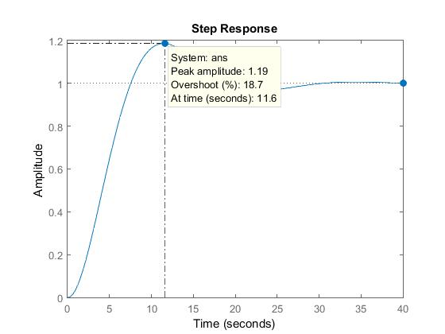

The peak overshoot with K=0.043 is 18.7%. It is close to required 20% with less than 10% error.

**B. Using frequency domain approach, design a lead compensator to achieve a  
velocity error constant that is at least 35 and a step response overshoot that is  
no greater than 20%. Describe each stage of your design. If performance  
specifications are not met first time, perform additional design iterations (i.e.  
refine the lead compensator or design additional compensators/pre-filter).  
Write down the final compensated open- and closed-loop transfer functions and  
use MATLAB to evaluate the performance of your final design in the time and  
frequency domain.  
Use MATLAB to plot the response of the control system to a unit ramp, showing  
both system output and ramp input, and evaluate the percentage steady state  
error to the ramp input signal.  
Summarize the performance indices of your final design in a table – see Table 1 -  
and provide a written conclusion for your design.**

First, the k can be calculated by using Kv given in the question and the Kv is 35

K=4.62

The feedback of the plant is G*k

The peak overshoot can be satisfied by finding from equation,



And the phase margin is 

The plant currently has -4.82 degree phase margin, which means another 52.97 degree of phase margin

To find alpha, the equation used in the calculation is

And the α is 11.11

However, when implanting lead compensator, the gain and phase margin increases, so we need to find new gain crossover frequency to compensate new added gain.

Gain = 0.942

With this lead compensator,

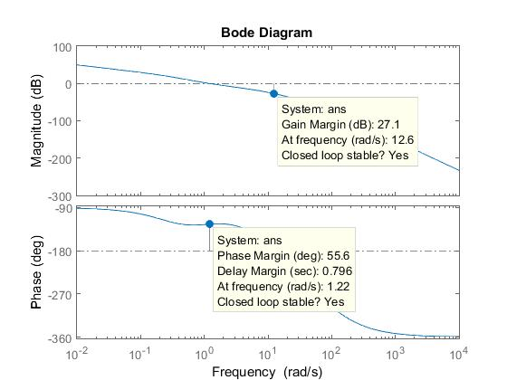

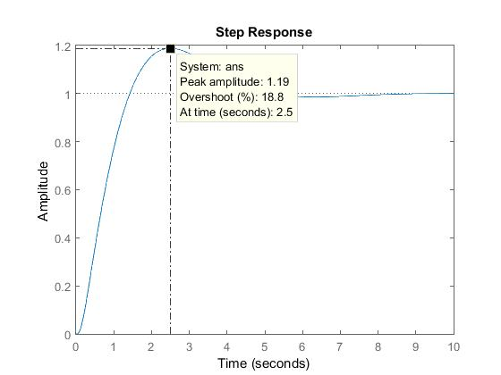

It satisfies all requirements

Steady state error to a unit ramp 0  
Rise Time 0.981  
Settling Time 4.79  
Percentage Overshoot 18.8%  
Phase Margin 55.6  
Gain Margin 27.1dB  
Bandwidth 1.59 rad/s  
Peak Magnitude 410dB = 3.16*10^20  
Resonant frequency

**2. [35 marks] Consider again the unity feedback servo system with a plant transfer function given by:  
𝐺(𝑠) =5000/𝑠(𝑠 + .3)(𝑠 + 22)(𝑠 + 100)**

**a. Using the root locus approach, design a phase lead compensator to meet the following performance specifications:  
• The settling time resulting from a step input to be less than 4s  
• The overshoot is less than 15% Describe clearly each stage of your design. If performance specifications are not met first time try to refine the lead compensator.**

**Picked peek overshoot as 10%**



**Ts=2s**

**Damping ratio =0.59**

**Phase margin around 60**

**Wn=2.26**

**Desired roots:r1,2 =**

**Angle (r+1.33)=119.27**

**Angle(r)=126.158**

**Angle(r+0.3)=119.50**

**Angle(r+22)=5.032**

**Angle(r+100)=1.06**

**Angle(r+P)=47.52**

**K=11419.28**

**b. Design a phase lag compensator in series with the lead compensator designed in a. such that the steady state error resulting from a ramp input should be no greater than 3.5% of the ramp magnitude. Describe each stage of your design. If performance specifications are not met first time, perform additional design iterations (i.e. refine the lag compensator or design additional compensators/pre-filter). Write down the final compensated open- and closed-loop transfer functions and use MATLAB to evaluate the performance of your final design in the time and frequency domain. Use MATLAB to plot the response of the control system to a unit ramp, showing both system output and ramp input, and evaluate the percentage steady state error to the ramp input signal. Summarize the performance indices of your final design in a table – see Table 1 - and provide a written conclusion for your design.**

**Ess=lim sG(s), s->0**