Computer Aided Control Systems Analysis and Design Using MATLAB

# Introduction

The design of the continuous domain transfer function can be achieved in multiple ways to achieve the design criteria. In this report, the main method used is frequency response method. The given transfer function representing a unity feedback system which is critically damped in the s domain is given by:

$G\left(s\right)=\frac{684}{s(s^{2}+12s+57)}$

The design of compensators should satisfy requirements given below:

i. Percentage overshoot < 15%.

ii. Rise-time < 100 msec.

iii. Settling time < 500 msec.

iv. Zero steady-state error to a step.

**To get the 15% overshoot, the following equations will be used during the calculation, the maximum overshoot can be obtained by setting $Omax$ to get ** by using Equation 1, then work out the phase margin using the equation 2, next use the bode diagram to find out the gain crossover frequency for that phase margin. plug in the ω inside the equation to work out the K. Finally the K is required proportional gain compensator.



Equation : Overshoot/safety factor of plant’s damping ratio



Equation : Phase Margin of current plant by damping ratio

In practice, the $Omax$ **is considered a bit lower than the requirement, in this case, it was set to 10% overshoot, which is equivalent 0.10 in $Omax$,**

**In this lab practice, to fit the purpose of computer aid design, the function was made by using Matlab. The function is shown below**

function [ r ] = over2damp( po )

%OVERSHOOT transfer the desired overshoot to damping ratio

r=sqrt((log(po/100)^2)/(pi^2+(log(po/100)^2)))

% r is the damping ratio, and po is the overshoot input.

return

end

**and to use this function, the overshoot of 10% was chosen for design purpose,**

damp=over2damp(10)

This shall return required damping ratio required, which is 0.5912,

For the design purpose the Ts (settling time) was chosen at 0.2

$$ω_{B}=\frac{4}{T_{s}ζ}\sqrt{\left(1-2ζ^{2}\right)+\sqrt{4ζ^{4}-4ζ^{2}+2}}$$

Equation

# TASK A

This design is intended to add lead-lag compensator to increase phase-margin in order to obtain desired rise speed and overshoot.

The script used in the design process is shown below with detailed explanation

G=tf(684,[1 12 57 0])

po=10;

[dp]=dampingratio(po)

figure(1)

bode(G)

[Gm,Pm,Wcg,Wcp] = margin(G);

This code is to generate the original plant and initial plot of the bode diagram to find plant phase margin and gain.

To find a lead compensator, the process starts from looking for required phase margin. The ideal phase margin is 60 degree in general, therefore the required phase margin is 60 due to the plant’s phase margin of 0.

Pm=60-Pm

The alpha value was chosen from table below

**Phase-Lead Table**

|  |  |  |  |  |  |  |  |
| --- | --- | --- | --- | --- | --- | --- | --- |
| ** | 0.05 | 0.1 | 0.2 | 0.24 | 0.3 | 0.5 | 1 |
| *G dB* | 13 | 10 | 7 | 6 | 5 | 3 | 0 |
| *m*  (deg.) | 65 | 55 | 42 | 38 | 33 | 19 | 0 |

Table

alpha=1/0.05

From the table, 0.05 is the value for this phase margin and because of different equation was used in later calculation, the alpha is the inverse of alpha on the table.

$$20\log\left|G\left(jω\right)\right|=20\log{\frac{1}{\sqrt{α}}}$$

Equation

The gain of future plant can be derived from equation 4, this gives the value of magnitude needed.

GM=1/sqrt(alpha)

From the bode diagram, magnitude of the obtained frequency is straightforward, however, to satisfy the computer participation, a method was developed to squeeze out the value of the bode and match them with known variables. The phase and frequency can be matched from our known magnitude.

[MAG,PHASE,W] = bode(G)

phase= interp1( squeeze(MAG), squeeze(PHASE), GM)

w= interp1( squeeze(MAG), W, GM)

$$Z=\frac{w}{\sqrt{α}}$$

$$P=α×Z$$

Equation

Now, the lead compensator can be written down according to equation 5

Z=w/sqrt(alpha)

P=alpha*Z

Because of the magnitude shift, the value of alpha is the coefficient for this lead compensator

Klead=tf([1 Z],[1 P])*alpha

GKlead=G*Klead

figure(2)

GKleadc=feedback(G*Klead,1);

step(GKleadc)

[Gm2,Pm2,Wcg2,Wcp2] = margin(GKlead)

figure(4)

bode(GKlead)

From the plot above, the performance of this lead compensator does not meet the requirement and the phase margin is still way below the desired value, hence another lead compensator should be considered. In order to extract the peak values for value check, following equations are used to check peak values, and they are not a part of main body.

GKleadcs=step(GKleadc)

figure(3)

findpeaks(GKleadcs)

PKS=findpeaks(GKleadcs);

This method of finding peaks can store the peak value into variable, which is a good way to monitor the system performance.

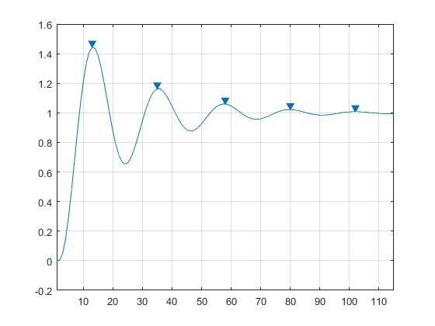

Figure

This is the design of second compensator to increase phase margin and other specification

Pm=60-Pm2;

alpha2=3.33

[MAG,PHASE,W] = bode(GKlead)

GM2=(1/sqrt(alpha2))

phase2= interp1( squeeze(MAG), squeeze(PHASE), GM2)

w2= interp1( squeeze(MAG), W, GM2)

Z2=w2/sqrt(alpha2)

P2=alpha2*Z2

Klead2=tf([1 Z2],[1 P2])*alpha2

G2Klead=GKlead*Klead2;

% % % % % % % % % % % %

G2Kleadc=feedback(G2Klead,1)

figure(5)

step(G2Kleadc)

figure(6)

bode(G2Klead)

figure(7)

G2KleadK=GKlead*Klead2*(1/1.28);

G2KleadKc=feedback(G2KleadK,1);

step(G2KleadKc)

Table : Closed Loop feedback performance of Compensated Plant

|  |  |
| --- | --- |
| Specification | GKlead1Klead2K |
| Percentage Overshoot | 12.7 |
| Settling Time | 0.4867s |
| Rise Time | 0.1145s |

This shows the good response of step input with 2 Klead and a proportional compensator

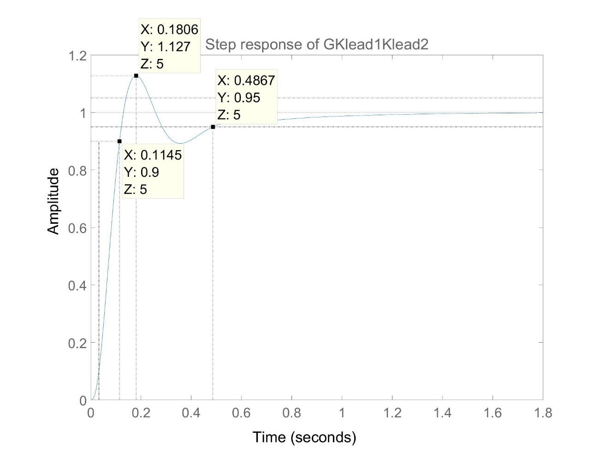

Figure

# Task B

By Shannon -Nyquist theory, the proper sampling frequency is 20 times bandwidth frequency, though in theory it is only 2 times.

$$ω_{s}=20ω_{B}$$

The sampling frequency should be neither too big nor too small, due to the compromise of performance and interference (aliasing). A big sampling time could result lack of detail which leads to lack of accuracy, and the small value will result interference with noise of the system, which also leads to losses of information

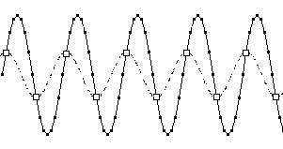

Figure the sampling frequency and time difference

(http://www.daqarta.com/alias1.PNG,2016)

The Shannon-Nyquist theorem provides a reasonable sampling frequency and time.

By given damping ratio and settling time, bandwidth can be obtained from equation3 and sampling frequency as well. Therefore, sampling time can be calculated by using following equation.

Ts=(2*pi)/Ws

To have good result of the discrete system, more accurate parameters are required, hence the number format is changed to long to have more digits in order to improve accuracy.

format long

This command changes single to double-precision accuracy.

Design process in discrete system is similar to Continuous domain, however, due to discrete system approximation, the response will be very different in general or dramatically changes at critical point, therefore, a new intermedium domain cross continuous and discrete domain is necessary 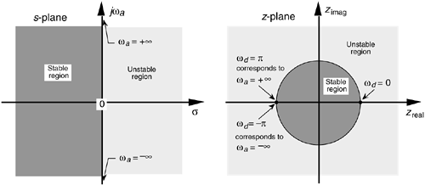

Figure Difference of stability region of s-plane and z-plane (<http://flylib.com/books/2/729/1/html/2/images/0131089897/graphics/06fig31.gif,2016>)

To obtain a suitable compensator for z-domain, a intermedium domain is introduced called w-domain. This can be achieved by using a self-made function Gz2Gw

function [ Gw ] = Gz2Gw( Gz,Ts )

%This function is to transfer a Z-domain transfer function into a w-domain transfer function

% By using pre-set steps below, it should convert a 3rd order z-domain

denz=Gz.den{1,1}

numz=Gz.num{1,1}

dent=denz.*[-1 1 -1 1]

numt=numz.*[-1 1 -1 1]

[numx denx]=bilinear(numt,dent,0.5)

% Gx=tf(numx,denx)

xpara=(Ts/2)*-1

numw=[numx].*[xpara^3 xpara^2 xpara 1]

denw=[denx].*[xpara^3 xpara^2 xpara 1]

Gw=tf(numw,denw)

End

It is designed for this plant only but can be quickly transfer into a new plant with minimal modification

This is initial setup of the original plant, which is same procedure as section3(Task A), by using code below

G=tf(684,[1 12 57 0])

Gc=feedback(G,1)

damp=over2damp(10)

T=0.2

Wb=(4/(T*damp))* sqrt((1-2*damp^2 )+sqrt(4*damp^4-4*damp^2+2))

Ws=20*Wb

Ts=(2*pi)/Ws

format long

Gz=c2d(G,Ts,'zoh')

Gzc=feedback(Gz,1)

figure(1)

step(Gzc)

hold on

step(Gc)

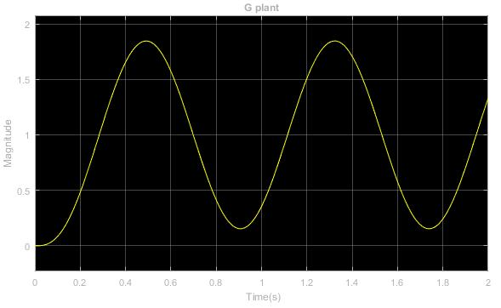

Figure The G plant

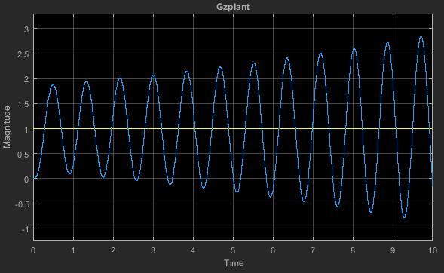

Figure The Gz plant

The design of compensator in w-domain is similar to s-domain, however, due to the error caused by sampling, the plant is not exactly same as before, and from figure 5, Gz plant shows divergent behaviour compared to original G plant in figure 5

Gw=Gz2Gw(Gz,Ts)

Gwc=feedback(Gw,1)

figure(2)

bode(Gw)

The bode diagram is used to identify the system and make sure the system’s error is in considerable range, and from figure above, it is a good match of original system. After the w-domain transfer function is calculated, the same way of finding lead and lag can be applied to w-domain

figure(3);

step(Gwc);

This figure shows that uncompensated G in w domain, and process below calculates the lead compensator

[Gm,Pm,Wcg,Wcp] = margin(Gw);

Pm=(60-Pm)+0.1*(60-Pm)

alpha=1/0.05

GM=1/sqrt(alpha)

[MAG,PHASE,W] = bode(Gw)

phase= interp1( squeeze(MAG), squeeze(PHASE), GM);

w= interp1( squeeze(MAG), W, GM);

Z=w/sqrt(alpha)

P=alpha*Z

Klead=tf([1 Z],[1 P])*alpha

GwKlead=Gw*Klead

figure(2)

GwKleadc=feedback(Gw*Klead,1);

step(GwKleadc)

GwKleadcs=step(GwKleadc);

figure();

findpeaks(GwKleadcs);

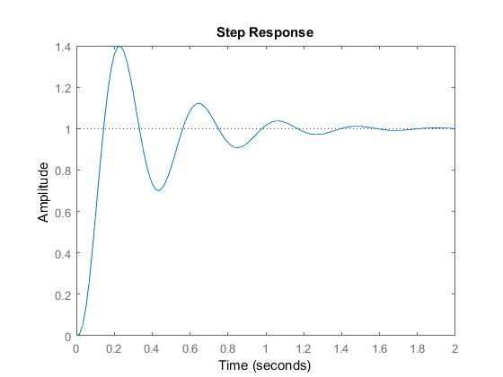PKS=findpeaks(GwKleadcs);

Figure : G*Klead close loop feedback

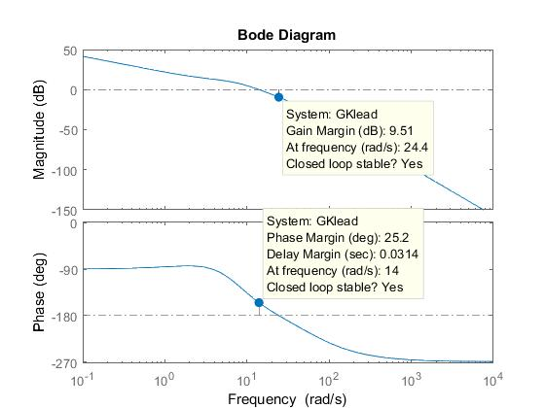

Figure

However, from the response above does not meet design criteria hence another lead compensator is required to increase both settling time and phase margin, the following code perform the second lead compensator design process.

[Gm2,Pm2,Wcg2,Wcp2] = margin(GwKlead)

figure(4)

bode(GwKlead)

Pm=(60-Pm2)+0.1*(60-Pm2 )

alpha2=1/0.3

[MAG,PHASE,W] = bode(GwKlead);

GM2=(1/sqrt(alpha2))

phase2= interp1( squeeze(MAG), squeeze(PHASE), GM2)

w2= interp1( squeeze(MAG), W, GM2)

Z2=w2/sqrt(alpha2)

P2=alpha2*Z2

Klead2=tf([1 Z2],[1 P2])*alpha2

Gw2Klead=GwKlead*Klead2;

Gw2Kleadc=feedback(Gw2Klead,1)

figure(5)

step(Gw2Kleadc)

figure(6)

bode(Gw2Klead)

step1=step(Gw2Kleadc)

P1=findpeaks(step1)

K1=1/P1(1)

figure(7)

% The K1 was found by using the inverse of the previous step response's peak value

Gw2KleadK1=GwKlead*Klead2*K1;

Gw2KleadKc=feedback(Gw2KleadK1,1);

step(Gw2KleadKc)

Gz2KleadK1=c2d(Gw2KleadK1,Ts,'zoh')

Gz2KleadK1c=feedback(Gz2KleadK1,1)

figure(8)

step(Gz2KleadK1c)

step2=step(Gz2KleadK1c)

P2=findpeaks(step2)

K2=1/P2(1)

% The K2 was found by using the inverse of the previous step response's peak value

Gz2KleadK1K2=GwKlead*Klead2*K1*K2;

Gz2KleadK1K2c=feedback(Gz2KleadK1K2,1)

% % % % % % % % % % % %

By using 2 lead compensator and 2 proportional compensators to adjust response, the plant in w-domain meets all the requirement, however, to verify if it is the same performance, the inverse transfer of w-domain is needed.

To achieve that, $W=\frac{2}{Ts}\left[ \frac{z-1}{z+1} \right]=\frac{2}{0.008}\left[ \frac{z-1}{z+1} \right]=250\left[ \frac{z-1}{z+1} \right]$

$$Klead1×Klead2×K1×K2=1.01×0.722×\frac{20w+63.02}{w+63.02}×\frac{3.333w+35.15}{w+35.15}=$$

$$\frac{5000\left(z-1\right)+63.02\left(z+1\right)}{250\left(z-1\right)+63.02\left(z+1\right)}×\frac{833.25\left(z-1\right)+35.15\left(z+1\right)}{250\left(z-1\right)+35.15\left(z+1\right)}=$$

$$Klead in z=\frac{20w+63.02}{w+63.02}=\frac{5063.02z-4936.98}{313.02-186.98}$$

Equation

Equation

In next part of script, it shows the different manipulation effect on the plant, Gz2KleadK1K2 is the direct multiplication of Gw plant and 2 lead compensators with 2 K, and GzKzlead1Kzlead2K1K2 is the multiplication of Gz plant with lead compensators which has been already transferred into z-domain.

Gz2KleadK1K2=c2d(Gw2KleadK1K2,Ts,'zoh')

Gz2KleadK1K2c=feedback(Gz2KleadK1K2,1)

Kzlead1=tf([5063.02 -4936.98],[313.02 -186.98],Ts)

Kzlead2=tf([868.4 -798.1],[285.15 -214.85],Ts)

GzKzlead1Kzlead2=Gz*Kzlead1*Kzlead2

GzKzlead1Kzlead2K1K2c=feedback(GzKzlead1Kzlead2*K1*K2,1)

figure (8)

step (Gw2KleadK1K2c,Gz2KleadK1K2c,GzKzlead1Kzlead2c)

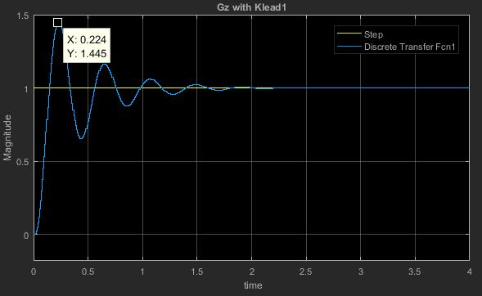

Figure Gz with Klead1

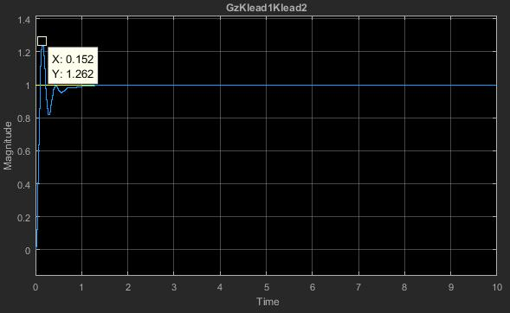

Figure Gz with Klead1 and Klead2



# Conclusion

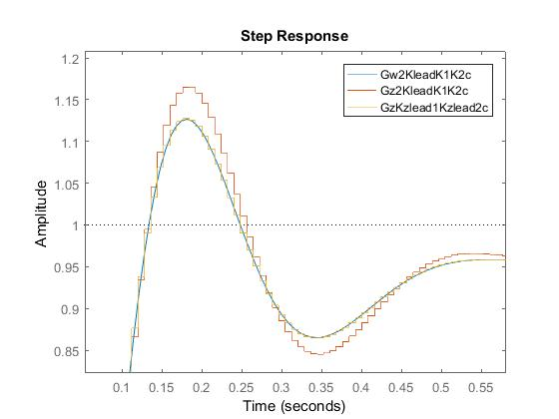

Figure

This picture above shows the comparison of G in w-domain and compensated by 2 lead compensators and 2 K, and the matched z-domain transfer by using two different methods. The result shows the embedded function, c2d, actually gives inaccurate result of the response, and it also induces higher percentage overshoot. The inverse w-domain transform is an accurate way of connecting discreet and continuous system.

Table

|  |  |  |  |
| --- | --- | --- | --- |
| Specification | w-domain | C2d method | Inverse w-domain |
| Percentage Overshoot | 12.7 | 16.5 | 12.8 |
| Rise Time | 0.0812 | 0.0783 | 0.0816 |
| Settling Time | 0.494 | 0.475 | 0.489 |
| Offset | 0 | 0 | 0 |

The digital system is alternative form tothe analogue system, which provides better energy efficacy, and it is much easier for transforming without losing lots of detail if the resolution is suitable for current analogue system. Also, the digital system is more reliable under electromagnetic interference, its signal is more distinguishable than the analogue signal, however less detail if the sampling time is too long. The short sampling time can provide much detail of analogue plant but may induce noise when overlapping happened.