|  |  |
| --- | --- |
|  | Aerospace Engineering. |

BEng Aerospace

Individual Research Report

Identifying the Position of Small Airborne Vehicle by Using Radio Technology

Hao, Xu

8th May 2017

Supervisor: Mr Eddie Ball

**Dissertation submitted to the University of Sheffield in partial fulfilment of the requirements for the degree of**

**Bachelor of Engineering**

# Abstract

This paper aims to develop a radio navigation system for an airborne vehicle to obtain vehicle’s direction (heading) and speed. It uses the Very High Frequency Omnidirectional Ranging (VOR) principle to determine the bearing of the vehicle and obtain its speed by analysing Doppler frequency shift of the signal. The approach uses Software Defined Radio (SDR) to carry out the research of the signal and uses MATLAB for signal producing and processing.

The system consists of a Red Pitaya as a SDR for transmission and uses a RTL-SDR receiver only system as the terminal for drones. The method proposes a low-cost navigation implementation for drones and other micro vehicles, in the fact that RTL-SDR is cheap to obtain.

It also covers the potential ability to be a Global Navigation Satellite System (GNSS) compatible navigation solution by developing its Pseudolite potential of combing GPS navigation mechanism with the system proposed in this paper.

Table of Contents

Abstract i

Glossary v

Acknowledgement vii

Table of Figures viii

1. Introduction, aims, and objectives - 1 -

1.1. Introduction - 1 -

1.2. Aims - 1 -

1.3. Objectives - 1 -

2. Literature review - 2 -

2.1. Existing Systems - 2 -

2.1.1. Radio navigation - 2 -

2.1.2. VOR navigation - 2 -

2.1.3. Beam systems - 4 -

2.1.4. Global Navigation Satellite System - 4 -

2.1.5. Pseudolites - 5 -

2.1.6. Distance Measuring Equipment - 5 -

2.1.7. Other systems - 6 -

2.2. Advanced Technics for radio - 6 -

2.2.1. Multiplexing - 6 -

2.2.2. Software Defined Radio - 7 -

3. Methodology - 8 -

3.1. Introduction - 8 -

3.2. Method - 9 -

3.2.1. RTL-SDR as the receiver - 9 -

3.2.2. Red Pitaya as the signal source - 9 -

3.2.3. Understanding VOR - 9 -

3.2.4. FM and AM and radio background - 10 -

3.2.5. Doppler Effect - 11 -

3.3. Prototypes - 12 -

3.3.1. First Prototype - 12 -

3.3.2. Second Prototype - 13 -

3.3.3. System design and practical implementation - 15 -

4. Experiments and Set up - 17 -

4.1. First Prototype - 17 -

4.1.1. Experiment equipment: - 17 -

4.1.2. Experiment target - 17 -

4.1.3. Procedures - 17 -

4.2. Second Prototype - 18 -

4.2.1. Experiment equipment - 18 -

4.2.2. Experiment target - 18 -

4.2.3. Procedures - 18 -

4.3. Red Pitaya Signal Generation and Acquisition - 19 -

4.3.1. Experiment equipment - 19 -

4.3.2. Experiment target - 19 -

4.3.3. Procedures: - 19 -

5. Results and Discussions - 21 -

5.1. Results - 21 -

5.1.1. Prototype 1 - 21 -

5.1.2. Prototype 2 - 23 -

5.1.3. Bearing examples - 27 -

5.1.4. Red Pitaya data - 31 -

5.2. Discussion - 32 -

6. Conclusion - 38 -

7. Recommendations for future work - 38 -

7.1. Learning GPS signal and algorithms - 38 -

7.2. Antennas for directional signal - 39 -

7.3. Testing Rig - 39 -

7.4. Radio instrument technical training - 39 -

7.5. Network potential of Red Pitaya - 39 -

8. References - 40 -

Appendix I MATLAB Signal Generator Code - 41 -

Appendix II MATLAB code of Lowpass Filter - 43 -

Appendix III MATLAB script of bearing - 44 -

Appendix IV RED Pitaya code for signal generation - 45 -

Appendix V The Prototype 1 MATLAB Code - 47 -

9. Project management - 48 -

9.1. Summary - 48 -

Tasks for semester 1 - 48 -

Tasks for semester 2 - 48 -

9.2. Project Phases - 49 -

9.2.1. Initiating Stage - 49 -

9.2.2. Planning Stage - 49 -

9.2.3. Research Stage - 49 -

9.2.4. Implementation Stage - 50 -

9.3. Gantt chart 51

10. Self-review 53

# Glossary

AD Analog to Digital

ADF Automatic Direction Finder

CDMA Code Division Multiple Access

DA Digital to Analog

DSP Digital Signal Processing

DME Distance Measuring Equipment

FFT Fast Fourier Transfer

FPGA Field-programmable Gate Array

GNSS Global Navigation Satellite System

GPS Global Positioning Service

ILS Instrumental Landing System

LFR Low Frequency Range

LPF Low Pass Filter

MEO Medium Earth orbit

MS/s Mega samples per second

NDB Non-directional Beacon

PCB Printed Circuit Board

RF Radio Frequency

RX Receiver

SCPI Standard Commands for Programmable Instruments

SDR Software Defined Radio

TACAN Tactical Air Navigation

TX Transmitter

USAF United State Air Force

USRP Universal Software Radio Peripheral

VOR Very High Frequency Omnidirectional Ranging

Acknowledgement

I would like to express my greatest thankfulness to Mr Eddie Ball for this great opportunity to do the project and special thanks for his great patience throughout this project.

I would like to thank Ahmed Albadi for his help on the instruments and Sylvain Azarian for his support.

I would like to acknowledge Miss Yinuo Liu for her encouragement.

# Table of Figures

[Figure ‎2‑1 The VOR signal (Beck, 1971) - 3 -](https://d.docs.live.net/eeb194b9d6d81b55/Final_report_day_0.docx#_Toc481982106)

Figure ‎2‑2 A VOR station (photo taken by FARHAN FAROOQ ) - 4 -

Figure ‎3‑1 Red Pitaya Hardware (Ibrahim, 2016) - 9 -

Figure ‎3‑2 Baseband Signal - 12 -

Figure ‎3‑3 Receiver design - 13 -

Figure ‎3‑4 Prototype 2 Signal - 14 -

Figure ‎3‑5 Prototype 2 Receiver - 14 -

Figure ‎3‑6 the further development of the system - 15 -

Figure ‎4‑1 TX for Prototype 1 - 18 -

Figure ‎4‑2 Red Pitaya Set up - 20 -

Figure ‎5‑1 Sine wave extracted from Mixed Signal - 21 -

Figure ‎5‑2 FFT of 1.54GHz signal - 22 -

Figure ‎5‑3 Sine wave comparison of phases - 23 -

[Figure ‎5‑4 FM and AM Waveform and Frequency Spectrum - 24 -](https://d.docs.live.net/eeb194b9d6d81b55/Final_report_day_0.docx#_Toc481982119)

Figure ‎5‑5 Baseband of Prototype 2 in Frequency Domain - 25 -

Figure ‎5‑6 yfinal signal in time domain - 25 -

Figure ‎5‑7 fmdemod and amdemod in Frequency Domain - 26 -

Figure ‎5‑8 Phase difference and the Bearing of 90 degree - 27 -

Figure ‎5‑9 Signal captured from Red Pitaya - 31 -

Figure ‎5‑10 Comparison for the effect of filter - 33 -

Figure ‎5‑11 Filter issue - 33 -

Figure ‎5‑12 Ideal Combined signal - 34 -

Figure ‎5‑13 The oscilloscope screen display - 34 -

Figure ‎5‑14 AM demodulated comparing with AM Demod with 30 Hz Low Pass Filter - 35 -

Figure ‎5‑15 FM demodulated comparing with FM Demod with 30 Hz Low Pass Filter - 36 -

[Figure ‎5‑16 The comparison of Baseband, AM and FM - 37 -](https://d.docs.live.net/eeb194b9d6d81b55/Final_report_day_0.docx#_Toc481982131)

# Introduction, aims, and objectives

## Introduction

Radio positioning is an older method for navigation compared to the state-of-the-art global navigation satellite system (GNSS) such as Global Positioning Service (GPS) and Beidou Navigation Satellite System. However, in the past two hundred years of aviation, radio has proved to be a reliable approach to navigation. At the same time, radio navigation has been continuously evolving to meet contemporary requirements of modern aviation and playing a more important role as one of the alternative methods when GNSS malfunctions. This project focuses on a compatible solution bridging the Very High Frequency Omnidirectional Range (VOR)/Tactical Air Navigation (TACAN)-like system and the GNSS system. In this study, the VOR-like signal was implemented at a GNSS signal frequency, which was simulated using MATLAB and Simulink. During the project, two different prototypes were examined with MATLAB and Simulink, and one prototype was implemented in the Red Pitaya platform (Ibrahim, 2016) and RTL-SDR (Stewart et al., 2015).

Meanwhile, preliminary theories of the two prototypes were developed. The first evaluation investigated the signal modulation of the original VOR system. The second evaluation tested a combined signal of AM and FM at the same frequency. The final tests were carried out with signal simulations of the navigation station and receivers at a different angle.

## Aims

This project aims to achieve a radio navigation system that provides bearing and speed information.

## Objectives

1. The principle of the navigation theory related to VOR are proved using MATLAB

2. The algorithms of solving directions are explored and examined with MATLAB

3. The system prototype is tested in a real situation or a suitable simulation environment.

4. The system can obtain the speed of the vehicle

5. The system can obtain the relative direction of the vehicle

# Literature review

The history of radio navigation dates to the late 19th century before the First World War (Bauss, 1963). Before the radio invented, compasses and stars had already been used for thousands of years. However, radio was a game changer, which overcame major difficulties of the old navigation methods. In the past century, it has been developed from analogue to digital, from ground to space, from inaccurate to accurate, from immobile to portable and from specialised to daily uses.

## Existing systems

### Radio navigation

The first ever radio relative system was a radio direction finder (Watson & Wright, 1971), which is tuned to the frequency of a certain station and pointed at its direction using an antenna. The radio allows the pilots to determine the bearing of the station, which enables aircrafts or ships to drive forwards or backwards from it. By hearing from two stations, the captains or pilots can draw an intersection of two radio station on the map and thus, determine its position. However, it requires a rather long antenna to provide good angle information, which is not practical for small aircrafts. In the later development, ADF (Automatic Direction Finder) was a significant progress, which benefited from contemporary electronic transistors. It works with NDB, i.e. non-directional beacon as an update of radio direction finder, and uses phase comparison technic to determine the bearing of the aircraft (Watson & Wright, 1971). However, the accuracy of the system is a critical issue for the usage of modern aviation. Again, it is not suitable for small scale aircraft due to its huge antenna size. The bearing information obtained from NDB is only relative to the station and does not show the real heading of the aircraft.

### VOR navigation

VOR exhibited a significant improvement from ADF and NDB, featured with the better accuracy of absolute bearing and a voice channel that can be used for communication. It works at the frequency range of 108MHz to 117.975MHz with 50kHz spacing (Federal navigation system, 2001), and consists of three parts: the voice, the Morse code identifier, the navigation signal, which is a reference sine wave at 30Hz frequency modulated at 9960 Hz and the directional signal, which is produced by mechanical or electronically rotating at 30Hz, using different phases corresponding to the azimuth angle of the observer (LAMB, 1948). By comparing the phase difference between the reference and the directional signals, as explained in Figure 2-1, a bearing can be worked out easily. It has an advanced version named Tactical Air Navigation (TACAN), which implies a higher frequency carrier and more divisions of phases, with the distance measuring feature.

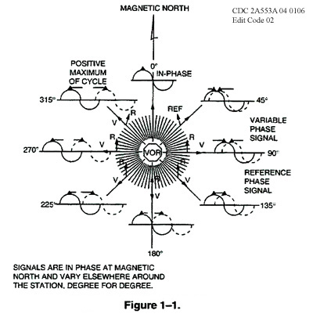

Figure ‑ The VOR signal (Beck, 1971)

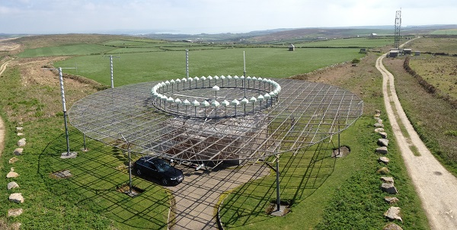

Figure ‑ A VOR station (photo taken by FARHAN FAROOQ)

In Figure 2-2, the circle of antennas can be found on the VOR station; they are used to transmit VOR carrier with the electronically scanned phase varied baseband.

### Beam systems

Beam systems, for example, the Adcock by Macaroni and known as Low Frequency Range (LFR), is also a good practice of navigation (Beck, 1971). However, it requires that the object remains in the coverage of the beam that is used for navigation, and therefore has little value for projects such as detecting the positions of aircrafts. However, it was later adopted by Instrumental Landing System (ILS) equipment. Adcock system remains active in terms of military and police uses. It requires manual operations by listening to Morse code or sound pitches to determine the object location relative to the beam. It has an inspiration of using radio, whereas, it can only tell the relative directions when the object is within the covered range and width of beams, or in other words, it is a directional system. Thus, it has limited uses for a general-purpose navigation.

### Global Navigation Satellite System

GNSS is the best system regarding both precision and feasibility (Staff, 1990). The GPS system, as one of the best GNSS system, remains the most popular option for navigation since it has been operational. Meanwhile, there were many systems, such as those mentioned above, dying or died because of the widely-spread usage of GPS. GPS was the system designed and operated by United State Air Force (USAF), and its huge military potential was well recognised by US military. Therefore, the system had two different ranging modes for civil uses and military uses at the beginning. The civil code, however, is less accurate compared to the military code. It works with simple logic using trigonometry. GPS system has multiple satellites on low earth orbits to guarantee that most of the surface areas of the earth can reach at least four satellites in the sky. It was so well designed that during most of the time there were more than four, which provides a potential opportunity to increase the accuracy. The algorithm relays on three known satellite positions and signal’s time of arrival. An additional satellite is needed for time reference in case of wave propagation error. By knowing the time taken during the propagation, the distances from the vehicle to station can be worked out. Using the three relative distances and satellite locations, a matrix can be introduced to provide multiple solutions, whereas only one of them is the correct position. Furthermore, the result needs to be transferred from the polar form into panel form and should be projected on the map with the coordinates provided. The problem with GNSS in general is the time to first fix, which usually takes three to four minutes from a cold Start Up, and GPS systems are very power hungry.

### Pseudolites

Pseudolite application implies simulating satellite signals with a ground or aerial station, which can be deployed to blind zones of GPS (Wang, 2002). It has a huge potential in warfare or special circumstance, for instance, mining or cave exploring where GPS signal may not be viable. Therefore, it is an excellent system to study for this project. It is possible to make it compatible with current GNSS systems and adapt it to a new system. This will significantly improve the efficiency and accuracy of the system as it will be discussed in the further study. In this project, Pseudolite Signal is the further objective, and it is intended to be compatible with this project proposal.

### Distance Measuring Equipment

To know the bearings of the vehicle is not enough to determine its specific position. Thus, a distance from station and object is crucial for the navigation (Lo & Enge, 2012). A Distance Measuring Equipment (DME) is capable for this, though this capacity is limited. A DME system is a transponder-based distance measuring equipment by solving the propagation delay of the radio wave. It uses certain pattern pulse signal to determine the time delay of propagation. For example, the aircraft first interrogates the DME station by sending a series pulse pairs, and the ground station receives the interrogation from the aircraft and waits 50ms precisely. The station replies the aircraft with the same identical sequence of pulse pairs and the aircraft receives the signal. The timing is critical in this interrogation process. Once the aircraft receiver matches the pattern the station sends, the time for delay can be figured out easily. In this project, the system is intentionally designed as a receiver only onboard equipment. Therefore the adaptation of DME has to be carried out in another method.

To explore the potential opportunity of improving the system, the pseudolite technique can adapt the situation that DME is required, where the bearing and angle are obtained by radio, and pseudolite signal determines distance use the principle of DME but in this case, the timing is sync with the station and onboard device. In this case, the time delay is determined from the time information modulated in the signal rather than the real timing of the signal propagation.

### Other systems

Due to the limitation of this project, the study does not include hyperbolic navigation systems due to the performance and size issues. Since most of the hyperbolic systems work at a lower frequency to achieve wider coverage, their precision is much inferior to the required specifications of this project; they need a much longer antenna in the scale of meters, which does not meet the project requirement.

## Advanced technics for radio

### Multiplexing

The multiplexing technic is reviewed due to its ability to transmit multiple signals over a shared medium, i.e. the same frequency carrier. It is a process of combing many slow devices’ signals onto a faster line of communication. The device used to multiplex the signal is called multiplexor, and the device that gathers the signal and restores them back to original signals is called demultiplexor. The multiplexing can be achieved in several aspects of the signal, for example, by dividing it by time or frequency. The multiplexing technics enables the possibility of combining server signal together, including VOR, DME and GNSS, if they are carefully prepared for it. The purpose of the multiplexing in this system is to improve the navigation performance with all sources of navigation aid in a simpler way.

### Software Defined Radio

Software Defined Radio is a new way of planting and testing the design RF applications, which was used to require individual transmitters or receivers in the past (Seo et al., 2011). Software defined radio (SDR) can be operated easily by using MATLAB and Simulink for signal generation and signal receiving (Lo, Enge, & Narins, 2015). A cheap RTL-SDR kit can be found on the market with a price of £5 with relatively good performance. RTL-SDR is a receiver only SDR equipment working from 24 MHz to 1766 MHz, which is a great range of frequency for the study. This project requires the signal working at GPS frequency, roughly 1540MHz.

# Methodology

## Introduction

Radio navigation evolved from analogue to digital, and GNSS shows its dominance for the navigation industry. Nowadays, a few previously deployed systems such as Loran-C, NDB, Omega, etc., were decommissioned and replaced by GNSS navigation. However, VOR/TACAN retained their necessity for modern aviation, though they are not compatible with the newly booming trends in aviation, such as drones.

The main reasons for developing VOR to a further stage to offer navigation to drones were considered as follow:

The drones are unmanned vehicles whose movements are relying highly on the navigation system on board. Due to safety concerns, currently, most drones have to follow the flying rule, which restricts drones cannot operate outside drone pilots’ view range, even with GPS and live feed video or first person view. Despite the regulation, the reliability of GPS is a potential disadvantage of self-driving drones. Therefore, multiple solutions have been worked out in the past few years, such as computer vision, inertial navigation, etc. Thus, alternative navigations should be maintained during the flight, and a good solution is to improve VOR considering its advantages.

A potential solution as proposed in this project is to operate a VOR-like system at GNSS frequency and transmit both Pseudolites and the VOR-like signal at GNSS frequency with the help of time divisions to increase system reliability and compatibility. The benefit of operating VOR at a higher frequency can be proved in several aspects. Firstly, the size of the antenna is much smaller due to the shorter wavelength, and it makes it more feasible for small drones, and a higher frequency signal can be used to carry more information including GNSS navigation information, which can be used to increase accuracy. In addition, it can minimise the error caused by multipath effect because it works in short range and behaves much more directional.

Furthermore, the speed of the vehicle can be worked out with Doppler Effect of radio propagation. In this study, the Doppler effect on the velocity change is certain, and there will be no experiment about it.

## Method

### RTL-SDR as the receiver

RTL-SDR is an excellent tool to obtain the signal at GPS frequency. It is important to study this instrument to deal with future tasks. The RTL-SDR comes with USB interface and works with MATLAB. The RTL-SDR is used as the receiver in the first prototype because of the frequency is in coverage, though the bandwidth may not be enough in the future study.

### Red Pitaya as the signal source

Red Pitaya is a Field-programmable Gate Array (FPGA) based development board that integrates many features including Radio Frequency (RF) input and output at 125 MS/s (Mega samples per second) and 10 bits Analog to Digital (AD) and Digital to Analog (DA) converters. It also features oscilloscope and spectrum analyser from its built-in functionality. With the help of RF features of Red Pitaya, it can be easily used as a SDR device that transmits and receives RF signal in a convenient way. In this study, the Red Pitaya is used to generate a required signal and measures the output from itself.

The configuration (Ibrahim, 2016) of Red Pitaya, two inputs and two outputs

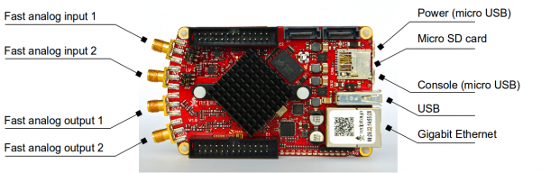

Figure ‑ Red Pitaya Hardware (Ibrahim, 2016)

It needs to be set up using Network interface, and the board will communicate with the desktop using Ethernet.

### Understanding VOR

VOR is a short-range radio navigation for aircraft, which operates from 108 – 118 MHz (Beck, 1971). It has three components in the signal: The Voice, the Morse code and the FM modulated 30Hz sinewave, with an AM modulated phased shifted 30Hz sine wave. However, in this study, the voice and Morse code are ignored because they are irrelevant. The remaining components are a 30Hz phase-varied signal, which is amplitude modulated by the carrier, and the reference 30Hz signal modulated into the 9960Hz subcarrier first then modulated on the main carrier. The amplitude modulated 30Hz signal is then phase varied via a mechanically rotated or electronically scanned directional antenna. On the receiver side, it receives signals at designated frequency, then a 30 Hz filter will pick up a directional signal at 30 Hz, and a 9960 Hz filter will get reference signal, which is frequency modulated inside the 9960 Hz subcarrier. Then the directional signal can be compared with the reference signal, to work out phase difference and solve the bearing of the course. The 9960 Hz signal plays an important role to carry reference signal. Without it, the reference signal is mixed with the directional phase-varied signal, leading to ambiguity. Hence the receiver cannot tell which is the reference and which is the directional signal. The bearing is worked out by comparing phase difference of two 30Hz signals.

### FM, AM and radio background

#### Frequency Modulation

The frequency modulation is used to carry reference signal in this study. The principle of frequency modulation is encoding the message by varying the instantaneous frequency of the carrying wave. The deviation in the frequency modulation is the gap between the carrier and its centre frequency. The sinusoid signal used for reference can be described by Equation 1 below

Equation

#### Amplitude Modulation

The amplitude modulation uses the amplitude of the carrier wave to describe the message. The carrier usually has two sidebands with a distance of twice message frequency on the frequency domain. The modulation index *h* shows the relationship between the modulation excursions and unmodulated carrier, described as Equation 2

Equation

In this study, it is set to be 1, so that message and carrier have the same amplitude.

The amplitude modulation of the sinusoid waveform for this study can be achieved using Equation 3 below:

Equation

Where the t is the time, and A is the amplitude.

#### Frequency Mixing

The mixer is introduced to help the secondary carrier to be able to transmit with the primary carrier at the same frequency. The mixer produces a new signal from two signals of different frequency, f1 and f2, and the new signal will be the sum of f1 and f2 and the difference between f1 and f2. The local frequency can be removed for transition if the receiver has a local oscillator to generate the carrier at the f2 frequency.

### Doppler effect

The speed is commonly determined using Doppler shift phenomenon of the radio propagation. When the observer and source have relative velocity, the frequency of received signal will shift accordingly. Doppler frequency is defined as Doppler frequency = speed/wavelength.

The terminal used on the vehicle can obtain the receiving frequency of the carrier and work out the frequency shift directly. The speed can be worked out with frequency shift using Equation 4 below.

Equation

Where is Doppler frequency, v is the moving speed and f is the carrier frequency and c is the speed of light.

In this project, Doppler frequency to speed was planned to use MATLAB internal function, which can be called by using the following command by Mathworks, Inc.:

Doppler to Speed: velocity = dop2speed (Doppler shift, wavelength);

## Prototypes

### First prototype

The first prototype is a higher frequency VOR system, where the carrier frequency is increased to 1.54GHz. The reason for this is to verify the capacity for the VOR to work at a higher frequency and to test the principle of VOR. VOR requires two baseband signals, one for reference and another for direction.

The signal simulation of the first prototype is based on original VOR, where the 30 Hz navigation signals remain the same, and subcarrier is set at the same frequency as the VOR. 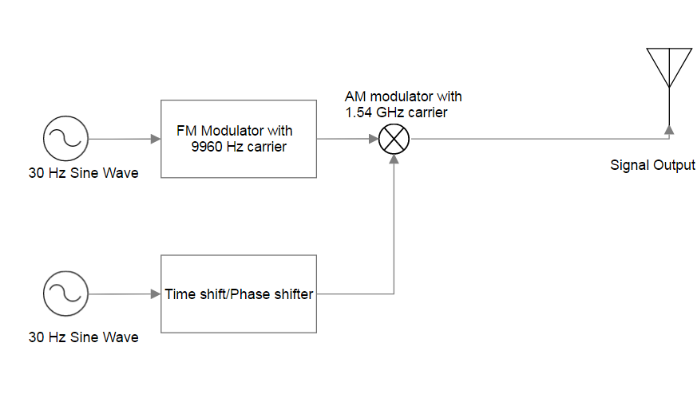

Figure ‑ Baseband Signal

First prototype receiver design features a mixer of much higher frequency. It has no other changes rather than shifting the signal to 1.54GHz to show the feasibility of VOR-like signal in higher frequency. It also can be considered as a super-heterodyne receiver.

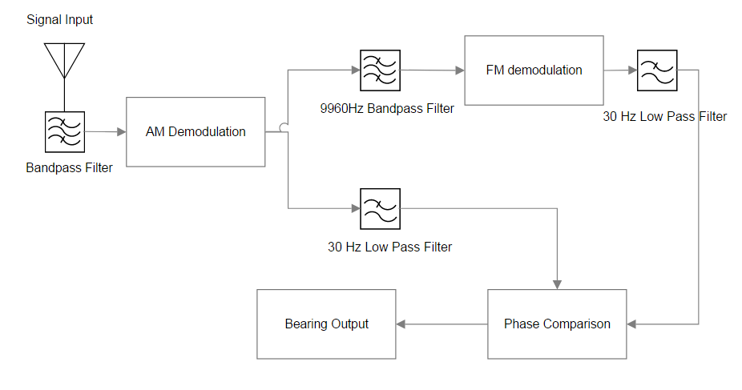

Figure ‑ Receiver design

### Second prototype

The second prototype made two improvements to the first prototype. Firstly, the signal is now combining the AM and FM basebands and then fed into the higher frequency mixer for ease of transmission and simpler receiver design. The signal of the baseband is a sum of an FM and AM signals, which were both modulated at the same frequency.

The signal component can be found in Figure 3-3 below:

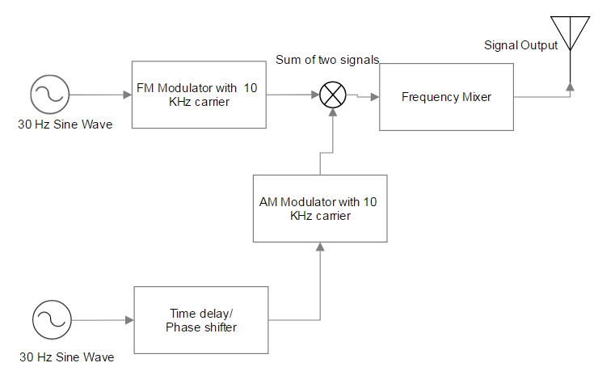

Figure ‑ Prototype 2 Signal

The receiver is simplified with only one baseband frequency. The receiver picks up the carrier at the designated frequency, then demodulates the signal. This improves the usage of bandwidth.

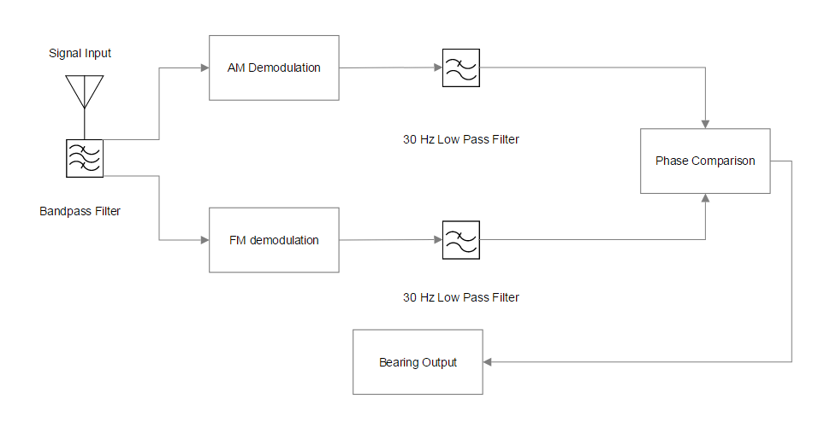

Figure ‑ Prototype 2 Receiver

### System design and practical implementation

This system as a prototype focuses on replacing carrier frequency with a higher one. It will examine the possibility of other subcarrier frequencies in the next stage. The signal will be generated using a baseband generator and fed into a mixer of higher frequency; then, as a direct input, the signal will be fed into the RTL-SDR to simplify the antenna design at this stage. The receiver will be simulated using MATLAB and Simulink.

#### Full scope of the system

The prototype shown below is an improvement on the original VOR system and can be used for the next stage of research. The entire proposed system is a stand-alone pseudolite based VOR system, combining the feature of GNSS and VOR with higher accuracy and better usability, fully digitalized, providing bearing, distance, absolute position, and reliable timing so has an enormous potential as an alternative navigation tool.

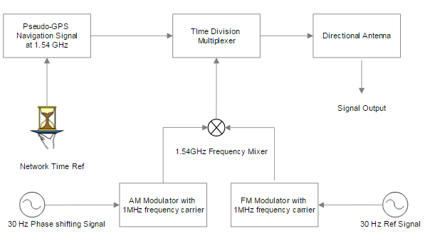

Figure ‑ the further development of the system

From Figure 3-6, the time reference is obtained via the internet or local time source, and the pseudolite system can generate navigation message with its known position and time. The navigation message is then fed into the multiplexor and transmit in different time division with the additional VOR-like signal. Due to the limitation of the project, only the VOR-like system is validated and simulated.

#### Implementation of the system

The system was initially planned to be implemented on the real-time system, and finally, on customised Printed Circuit Board (PCB) to have all functions ready to use. However, the time and knowledge required for this proposal were dramatically underestimated so the implementation could not be completed during the project period.

Thus, the implementation uses a Red Pitaya, a ready to use SDR RX (Receiver) and TX (Transmitter) terminal, to satisfy the project objectives. Though, a few issues delayed practical usage of the system where the hardware parameters are hard to manipulate through SCPI (Standard Commands for Programmable Instruments).

# Experiments and Set up

The system was simulated using a signal generator, and the resulting signal was received by Red Pitaya to analyse and obtain the baseband signal. Two prototypes were experimented using MATLAB and Simulink.

The first lab intended to examine the VOR-like signal working at a higher frequency, i.e. 1.54GHz GPS frequency. The second lab experimented the novel design of the system. Finally, a set of bearing outcome is included.

## First prototype

The first prototype was examined using Simulink. However, a MATLAB solution is also included. A computer with more than 200GB RAM was recommended.

### Experiment equipment:

MATLAB, Simulink, Amazon Web Service EC2 Instance r4.8xlarge with Windows Server 2016

### Experiment target

To determine the signal restoration quality of 30 Hz sine wave components.

### Procedures

#### Signal Generation using MATLAB:

Generate two sine waves with different phase as and both at 30 Hz

The was fed into a FM modulator with 9960Hz carrier produces

The was fed into a AM modulator with 1.54GHz carrier produces

The and were added together to produce

The signal of was processed on the receiver side:

Signal was fed into AM demodulator using corresponding parameters, the 9960Hz band pass filter was then applied to the output to get FM subcarrier. The 30 Hz low-pass filter was then applied to the output of AM demodulator to extract the 30 Hz directional component. The FM subcarrier was fed into FM demodulator using corresponding parameters, and a 30 Hz Low-pass filter was then used to pick up 30 Hz reference signal.

By working out the phase difference of two sine wave, a bearing can be determined.

#### Simulink Model:

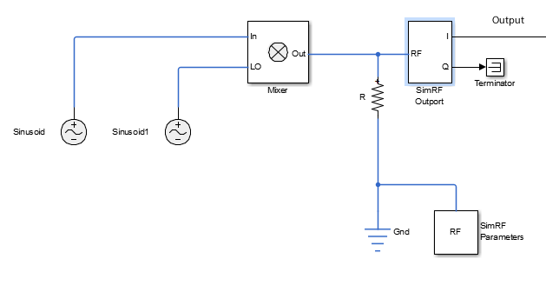

Figure ‑ TX for Prototype 1

The sinusoid on the left played the part as a FM signal, , modulated at 9960 Hz, and the second sinusoid block, sinusoid1, was used to simulate the AM signal, Fc, at 108MHz. The Mixer mixed the two signal together and produced , and .

## Second prototype

### Experiment equipment

MATLAB, Laptop with Windows

### Experiment target

To determine the bearing of 90-degree from the initial 90-degree phase difference of 30 Hz sine wave.

### Procedures

Two sine waves were produced:

1. 30 Hz with no shift phase, called .
2. 30 Hz with phase shift at a certain angle, in this case, 90 degrees towards the right, called .

FM and AM modulations:

1. as the omnidirectional component was frequency modulated with 1MHz carrier, the result was called .
2. as the directional component was amplitude modulated with 1MHz carrier, called .
3. Two signals were added together as .

Demodulation of combined signal:

1. Applied the FM and AM demodulator to with corresponding parameters, the products were called and .
2. A 30Hz low-pass filter was applied to sift out 30Hz sine wave signal, the products were called as and .

Compared the phase difference of and and figure out the bearing of it.

## Red Pitaya signal generation and acquisition

### Experiment equipment

Red Pitaya, Oscilloscope, Laptop

### Experiment target

To capture baseband signal of Prototype 2

### Procedures:

Connected Red Pitaya to Laptop through Network Interface using RJ45 port

Connected Red Pitaya to Power source via micro-USB port.

Connected Red Pitaya Out 1 port to IN 1 port using SMA connector.

The SCPI server of Red Pitaya was started from the console on the Web.

Started the Oscilloscope function of Red Pitaya

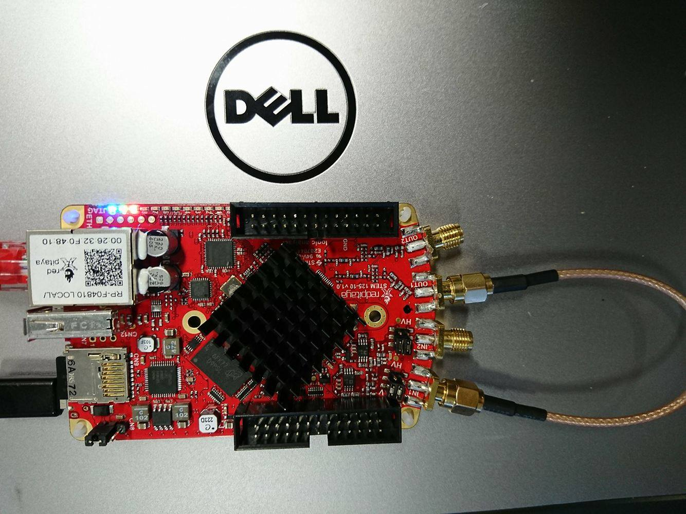

Figure ‑ Red Pitaya Set up

The red pitaya hardware was set up like the picture of Figure 4-2 above.

Ran MATLAB script to generate the signal, the script is attached in the appendix, the Out 1 is FM subcarrier, and Out 2 is the combined signal.

Recorded the data on the PC screen, and exported it as a CSV file.

Changed the connection from Out1 to Out2, and recorded the signal again in CSV format.

# Results and Discussions

## Results

Results of Prototype 1 and Prototype 2 were obtained using MATLAB simulations. Red Pitaya result was captured from itself in real-time. The hardware limitation resulted that the signal processing of captured data was hard.

### Prototype 1

This Prototype demonstrates the signal restoration from a high-frequency carrier using Simulink. The carrier is 1.54 GHz. The message signal is a 30Hz sine wave and mixed with a local oscillator of 1.54GHz to shift the frequency to the desired signal.

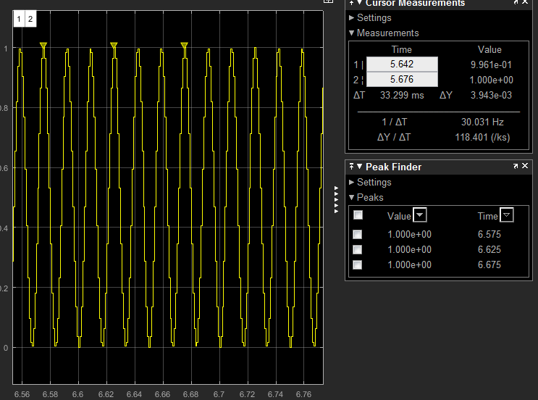

Figure ‑ Sine wave extracted from Mixed Signal

Figure 5-1 above shows the signal restoration from the high-frequency carrier of 1.54GHz is successful. The sampling rate is 10 MHz.

The frequency spectrum is obtained using MATLAB simulation, the code can be found in Appendix V. The sampling rate is 10GHz, and the plot is not very smooth.

The spectrum of prototype 1 is shown in Figure 5-2, where the peaks are located at 1.54GHz + 9960Hz and 1.54GHz -9960 Hz. The Fast Fourier Transfer (FFT) was used to help process the signal in frequency domain. It is a typical frequency mixer spectrum, where the sidebands are allocated at carrier frequency plus or minus the modulating frequency.

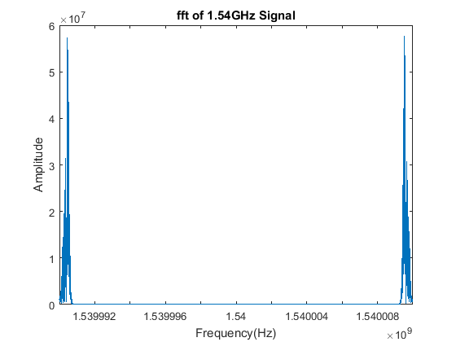

Figure ‑ FFT of 1.54GHz signal

### Prototype 2

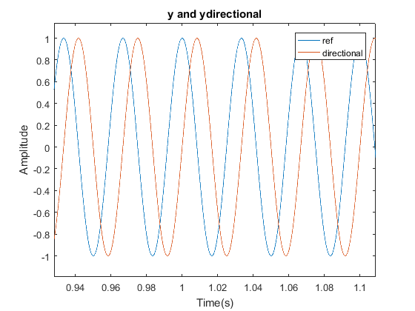

Figure ‑ Sine wave comparison of phases

Figure 5-3 shows 2 sine waves in different phases, where ref indicates 0 initial phase and directional is 90 degrees towards the right.

Figure 5-4 illustrates the Spectrum of the baseband signal in the lower plots, where the FM deviation of 480Hz can be spotted on the subplot in bottom right corner, and the 30 Hz component in the AM waveform in the bottom left plot. The upper plots draw the waveform of the AM and FM signal in time domain.



Figure ‑ FM and AM Waveform and Frequency Spectrum

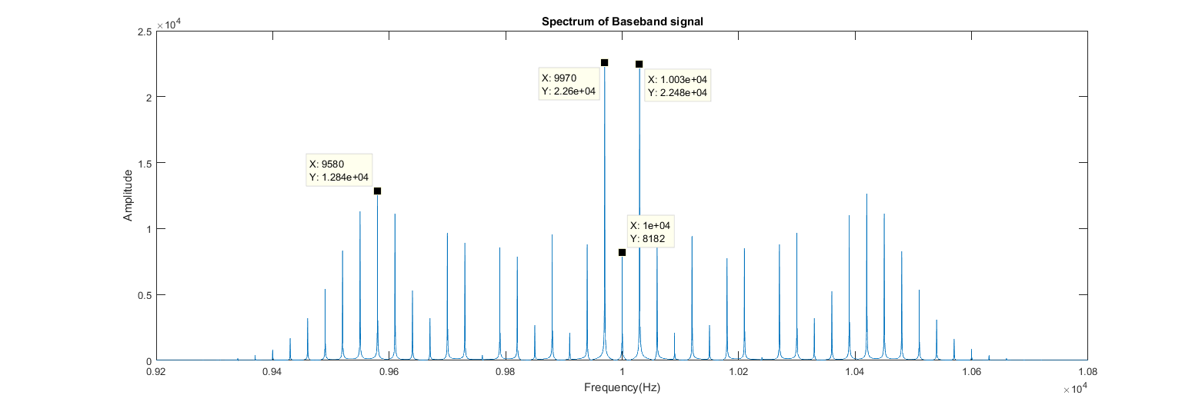

Figure ‑ Baseband of Prototype 2 in Frequency Domain

The plot of Figure 5-5 shows the component of the combined signal and the amplitude of it. From the highest points, the two AM component can be spotted, and the FM subcarrier can be found on the left, the first data point. The bandwidth for this signal is efficiently used, but the sidebands are more causing noises to the signal.



Figure ‑ yfinal signal in time domain

Figure 5-6 shows the characteristics of the combined signal in time domain. The waveform has the FM feature with amplitude change over the time. It has two type of modulation combined. Therefore, a further study of the signal can be carried to out to reveal the information carried.



Figure ‑ fmdemod and amdemod in Frequency Domain

In Figure 5-7, the demodulation worked on the baseband signal and has the positive result of signal restoration. In the upper subplot, the phase difference survived from multiple signal manipulations and maintained stable through the signal. The lower subplot indicates the frequency component remained in the signal, and the 30 Hz components of AM and FM are overlapped on the spectrum, which suggests the high feasibility of restoration.

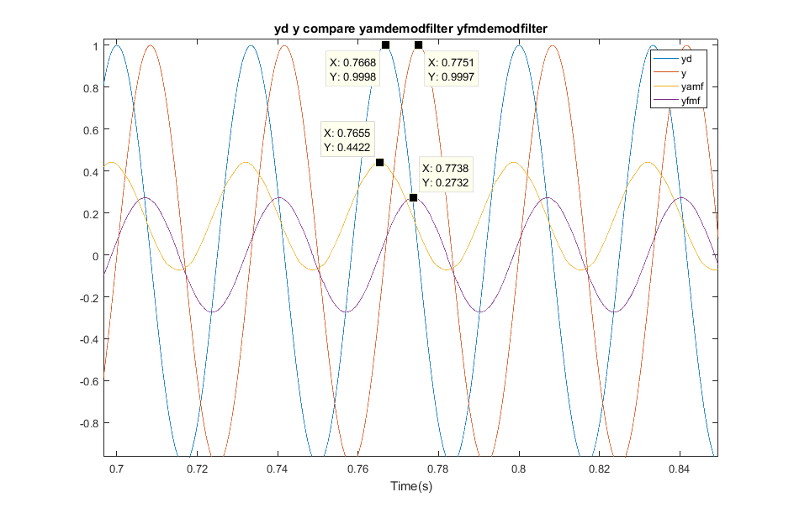

Figure ‑ Phase difference and the Bearing of 90 degree

Figure 5-8 is the final processing of the signal. The phase difference of two sine wave was successfully extracted and restored from modulated signals after the filter was applied to it. The sampling rate of the filter applied to the modulated signal is the same. Therefore the delay of the filter is same. The phase difference matched the bearing worked out from demodulated signal from Figure 5‑3 Sine wave comparison of phases. The Equation 5 shows the composition of a sine wave.

Equation

Where the frequency is 30Hz and period is 1/30 second.

The two sine waves’ peaks have a time difference of 0.083s, which equals a quarter of 1/30 second, in another word, the time delay is a quarter of the period and the phase of 90 degrees.

### Bearing examples

The bearing is obtained from Prototype 2, with different initial phase.

The following phase differences are going to be examined in the experiment.

Table Bearing output with given input

|  |  |  |
| --- | --- | --- |
| Phase Difference (deg) | Bearing Output (deg) | |
| 45 | 46.44 | |
| 90 | 90 | |
| 135 | 134 | |
| 180 | 180 | |
| 270 | 269 | |
| 315 | 317 |

The bearing was worked out by using Equation 6 and 7 below:

Equation

Equation

where the period of the sine wave is second. The script was made to calculate this and included in Appendix III.

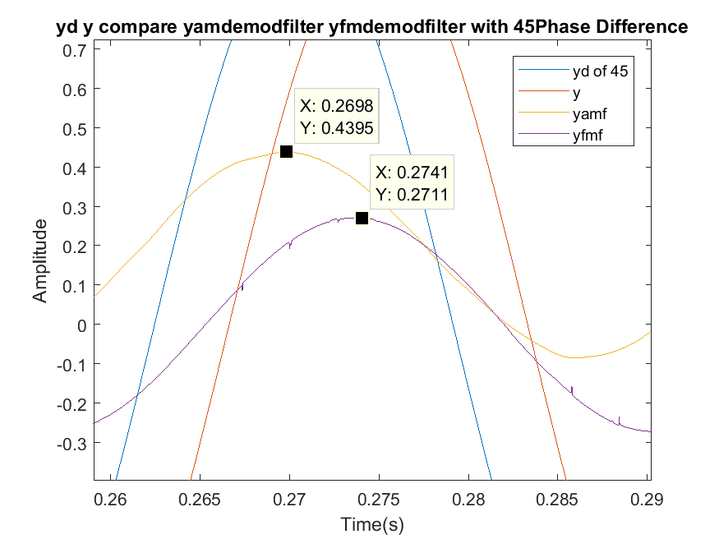

Figure 5-8 Comparison of bearing of 45 degree

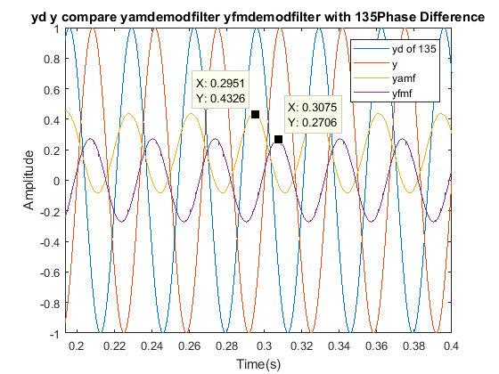

Figure 5-8 Comparison of bearing of 135 degree

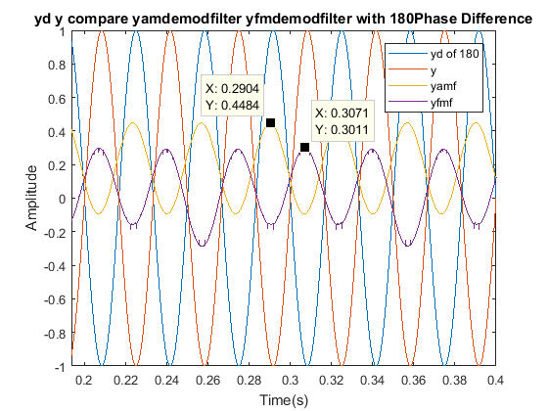

Figure 5-8 Comparison of bearing of 180 degree

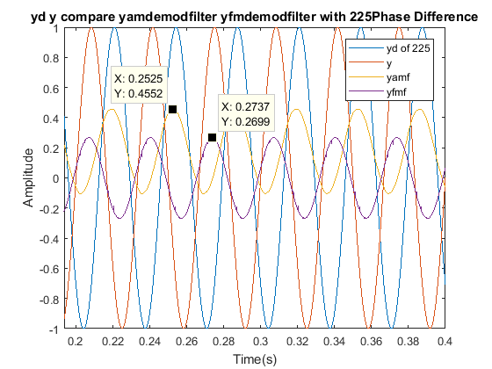

Figure 5-8 Comparison of bearing of 225 degree

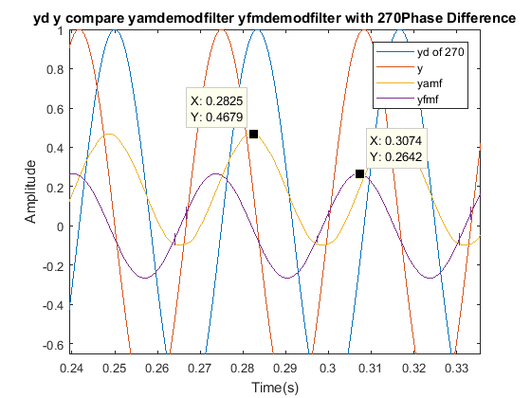

Figure 5-8 Comparison of bearing of 270 degree

The Figure series from 5-8 a to 5-8 e, demonstrated the demodulated signal remains the phase difference with the original signal from degree 45 to 315. The bearing information is obtained successfully.

### Red Pitaya data

Figure ‑ Signal captured from Red Pitaya

The data acquired from Red Pitaya is hard to process. The plot above, Figure 5-9, shows the signal captured of the prototype 2 design. The signal above was , which was described in section 4 as a complex signal of AM and FM, running at 1MHz, with 1024 samples in total, during the period of 100ms. The plot is not smooth due to its limited samples, and the amplitude was halved during the post processing of data.

## Discussion

The Prototype 1 shows the consistency of the signal. It used the principle that developed for super-heterodyne radio. The signal illustrated in figure 5-1, has a little distortion but is consistent with the original waveform. Thus it can be used to determine the bearing. One thing needs to be mentioned in this simulation that the AM part was not directional because, in the VOR, it was modulated because of antenna rotation.

The mixer plays the important role to shift the lower frequency to the higher one, and the one used in this study was ideal. Its performance is doubtful when it is implemented using the real RF component.

Because of the high computational power of the Cloud Computing, extreme high sampling frequency could be applied to simulation. The computation took a long time due to its high sampling rate, which is not necessary for theory, but essential for the real application. The issue with this is the analogue system works continuously, but the simulation is digital. The computing was conducted on Amazon Web Service (AWS), and it was very expensive to use.

The link between the Prototype 1 and Prototype 2 is that the prototype 1 paves the technical difficulty of frequency mixing, and it is important to see the waveform was preserved during the high-frequency transmission.

Prototype 2 results were positive and proving the frequency modulation could work together with amplitude modulation. The accuracy of the bearing output was slightly low due to the fact that all the points were selected manually. improvements need to be made on the data processing in the future work, including a function to find the peak and compare the time difference. This will improve the accuracy.



Figure ‑ Comparison for the effect of filter

Figure 5-10 is the compassion for the filtered signal and original demodulated signal, the filter eliminated the higher frequency sidebands of demodulation, however, there are some low frequency response because of filter, since the filter took a longer time to start working and hence distorted signal was produced at the beginning, as shown in Figure 5-11. In the black box area, the signal was not stable, since the filter just started working.



Figure ‑ Filter issue

Red Pitaya has a limited memory depth of the output data, which is 16 thousand sample in total. Comparing signal and Figure 5-9, the timescales are the same, but Red Pitaya result was lacking detail. The sampling rate of Red Pitaya is sufficient, but the software interface limited the size of data export.

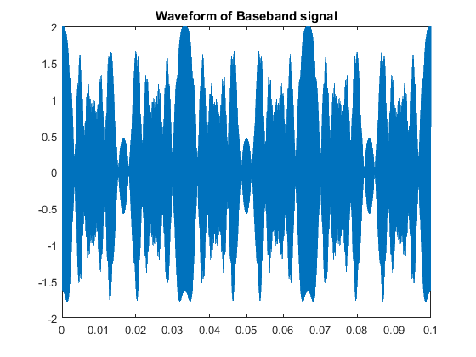

Figure ‑ Ideal Combined signal

In general, Red Pitaya is a proper equipment for this project, whereas the limited memory made it hard to be used for data gathering. The software that comes with the Red Pitaya was not useful if more customised needs are required.

The plot of Figure 5-13 shows another example of Red Pitaya signal acquisition, where the wave from could be displayed, but further study of the signal was limited by the export quality.

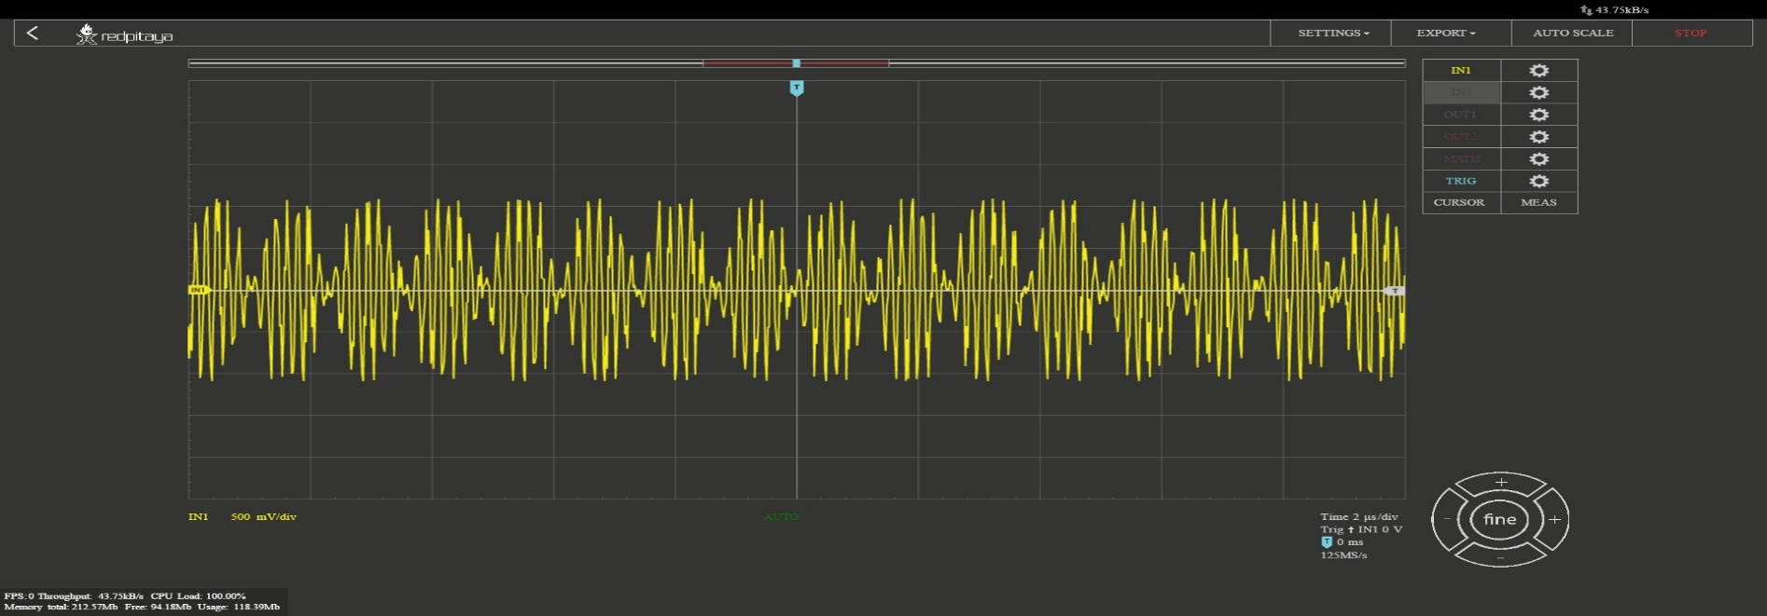

Figure ‑ The oscilloscope screen display

The human factor is another critical factor to this issue, which the experience with hardware affect the project difficulty dramatically. The experienced RF engineer can spot the problem and solve it easily, but inexperienced personnel require much more effort. For the Red Pitaya data export issue, the potential solution is using MATLAB drives the SCPI interface, and acquire the data directly with a very good quality.



Figure ‑ AM demodulation comparing with AM demodulation with 30 Hz Low Pass filter

The interesting phenomenon of prototype 2 signal is the coexist modulation. From Figure 5‑14 AM demodulation comparing with AM demodulation with 30 Hz Low Pass filter, the AM demodulated signal has its sine wave demodulated, but the frequency modulation component is still in the demodulated signal. The low pass filter removes the high-frequency component from AM demodulated signal and restores the signal to a sine wave. It happened reversely in the FM signal demodulation, where the amplitude component remains, as shown in Figure 5‑15 Comparing FM demodulated signal with FM demodulated Signal with 30 Hz low pass filter.



Figure ‑ Comparing FM demodulated signal with FM demodulated Signal with 30 Hz low pass filter

The comparison plot of Figure 5‑16 The comparison of Baseband, AM and FM shows the difference of frequency range, where the AM is a narrow band signal, and FM is a wider band signal. The baseband covers the AM and FM frequency and improves the usage of the bandwidth, in another word, carries more information.



Figure ‑ The comparison of Baseband, AM and FM

# Conclusion

The experiments of Prototype 1 and 2 are successful, and results are obtained. The experiment on the Red Pitaya was partially successful, whereas the data was not able to be processed.

The bearing output from the prototype 2 shows the capability of navigation. The implantation of prototype 2 is possible.

The signal generation using Red Pitaya was tested and successfully produced the result. The code for the Red Pitaya is included in Appendix IV. The successful data acquisition using Red Pitaya paves the way for RTL-SDR, since the operational principle is similar to each other.

The Doppler effect is obtained only on the receiver side. Therefore, the Doppler simulation does not make sense to the project. However, the script to work out the speed using frequency difference is developed through the project, and stated in section 3.2.5.

The aim of the project was achieved successfully, and all the design objectives were met, except the hardware was not fully implemented.

# Recommendations for future work

## Learning GPS signal and algorithms

The GPS is the abbreviation of Global Positioning System using satellites. The system has 32 satellites operating on Medium Earth orbit (MEO) transmit at two bands around 1.54GHz frequency, L1 and L2. The signal is in Code Division Multiple Access (CDMA) format and contains five frames of data. However, this information is only useful if there is enough background knowledge of Geoscience and Astronomy, which is obviously beyond the scope of the project. Thus, a clear, achievable goal is to determine whether the original signal will be distorted during the secondary modulation. GPS research will remain at the signal level for this project though a higher-level study was planned initially. It is recommended to have a thorough understanding of Geoscience and Communication technology.

## Antennas for directional signal

The signal produced from VOR system needs to be transmitted from a directional antenna in order to cover the sky above it. The study of the antenna is proposed for future development. The system was designed to use an array of antennas to transmit, though it was not mentioned in this report because it is out of the coverage. However, if the project allows more time and budget, it will be taken into account.

## Testing rig

The limitation of this project was that the project was completely built from scratches. The simulation shows positive results but the lack of the field test data to verify the reliability of the system. The important thing required for this task is a testing rig that has transceiver and antenna equipped. The testing rig can use a red pitaya with an extra frequency mixer, which is used to lower the receiving frequency or to have a Universal Software Radio Peripheral (USRP) device for the best result and convenience. The rig can also have a raspberry pi as the console and programming platform.

## Radio instrument technical training

The training of radio frequency measurement equipment is essential for completing the required tasks. During this project, inadequate experience induced many difficulties for the experiment. It is recommended to have some experience of RF equipment even the person had a background in Electrics.

## Network potential of Red Pitaya

The Red Pitaya requires the network interface to work, which is difficult to manage. However, the operating system of Red Pitaya gives it potential to operate the device through the router, in another word, can be used online if the internet was configured. This enables more interesting research direction of software defined radio, where the mobile network can be integrated into the system and operates the cluster of SDR device on the cloud. The potential uses of this are to utilise the much stronger computational power from cloud servers and unleashed the computational power to Digital Signal Processing(DSP).

# References

Bauss, W. (1963). *Radio navigation systems for aviation and maritime use* (1st ed.). Oxford: Pergamon Press; [distributed in the Western Hemisphere by Macmillan, New York].

Beck, G. (1971). *Navigation systems: a survey of modern electronic aids* (1st ed.). London: Van Nostrand Reinhold.

Federal navigation system. (2001). 1st ed. Washington, D.C.: National Academy Press.

Ibrahim, D. (2016). *Red Pitaya for test and Measurement*. 1st ed.

LAMB, J. (1948). Very High-Frequency Techniques. *Nature*, *162*(4107), 83-84. http://dx.doi.org/10.1038/162083a0

Lo, S. & Enge, P. (2012). Capacity Study of Multilateration (MLAT) based Navigation for Alternative Position Navigation and Timing (APNT) Services for Aviation. *Navigation*, *59*(4), 263-279. http://dx.doi.org/10.1002/navi.25

Lo, S., Enge, P., & Narins, M. (2015). Design of a Passive Ranging System Using Existing Distance Measuring Equipment (DME) Signals & Transmitters. *Navigation*, *62*(2), 131-149. http://dx.doi.org/10.1002/navi.83

Seo, J., Chen, Y., De Lorenzo, D., Lo, S., Enge, P., Akos, D., & Lee, J. (2011). A Real-Time Capable Software-Defined Receiver Using GPU for Adaptive Anti-Jam GPS Sensors. *Sensors*, *11*(12), 8966-8991. http://dx.doi.org/10.3390/s110908966

Staff, N. (1990). *Global Positioning System* (1st ed.). Washington: National Academies Press.

Stewart, R., Barlee, K., Atkinson, D. and Crockett, L. (2015). *Software defined radio using MATLAB & Simulink and the RTL-SDR*. 1st ed.

Wang, J. (2002). Pseudolite Applications in Positioning and Navigation: Progress and Problems. *Journal Of Global Positioning Systems*, *1*(1), 48-56. http://dx.doi.org/10.5081/jgps.1.1.48

Watson, D. & Wright, H. (1971). *Radio direction finding* (1st ed.). London: Van Nostrand-Reinhold.

# Appendix I MATLAB Signal Generator Code

%Baseband Generator

fcfm=1e4;%secondary carrier used for fm

fcam=1e4;%secondary carrier used for am

fs = 5e4;%sampling rate

t = 0:1/fs:2;%signal length

D = 480;%Deviation for the first carrier

Dc = 5e3; %Deviation for the second carrier

fc2=1e6;%Primary carrier frequency 1MHz (Not in use)

bin = fs/length(t);

xaxis = 0:bin:bin*(length(t)-1);

%%%%%%%%%IQ baseband%%%%%%%%

yc = [];

ys = [];

idata = [];

qdata = [];

IQData=[];

for r = 1:length(t)

% loop

y(r) = sin(2*pi*30*t(r));

ys(r) = cos(2*pi*(fcfm+D*y(r)))*t(r); %subcarrier contain ref sig

%yc(r) = cos(2*pi*(fc2+Dc*ys(r))*t(r)); %carrier

idata(r)=sin(2*pi*fcfm*t(r))*ys(r);

qdata(r)=cos(2*pi*fcfm*t(r))*ys(r);

IQData(r)=idata(r)+j.*qdata(r);

end

%%%%%%%%%%%%%%%%%%%%%%%%%%%%

%The signal generator using MATLAB function

%%%%%%%%%%%%%%%%%%%%%%%%%%%%

yofm = fmmod(y,fcfm,fs,D);% yo is omnidirectional

yofmdemod=fmdemod(yofm,fcfm,fs,D);%fmdemod is the demodulator

yd=sin(2*pi*30*t+degtorad(90));%yd is directional

ydam=ammod(yd,fcam,fs);%am modulator

yfinal=yofm+ydam;%yfinal is the final product after sinal mixing

yfinalamdemod=amdemod(yfinal,fcam,fs);%am demodulator

yfinalfmdemod=fmdemod(yfinal,fcfm,fs,480);%fm demodulator

yfinalamdemodfilter=filter30hz(yfinalamdemod);%30 Hz Low-pass Filter

yfinalfmdemodfilter=filter30hz(yfinalfmdemod);%30 Hz Low-pass Filter

%%%%%%%%%%%%%%%%%%%%%%%%%%

%Figure plotting

%%%%%%%%%%%%%%%%%%%%%%%%%

figure(1)

subplot(211)

plot(t,yfinalamdemod,t,yfinalfmdemod);

title('fmdemod and amdemod in Time Domain');

legend('amdemod','fmdemod')

subplot(212)

plot(xaxis,abs(fft(yfinalamdemod)),xaxis,abs(fft(yfinalfmdemod)));

title('fmdemod and amdemod in Frequency Domain');

legend('amdemod','fmdemod')

figure(2)

plot(t,yd,t,y)

title('y and ydirectional');

legend('directional','ref');

figure(3)

plot(t,yfinalamdemod,t,yfinalamdemodfilter);

figure(4)

plot(xaxis,abs(fft(yfinalamdemod)),xaxis,abs(fft(yfinalamdemodfilter)))

title('fft of yamdemod and yamdemod with filter');

figure(5)

plot(t,yfinalamdemod,t,yfinalamdemodfilter);

title('yamdemod compare yamdemodfilter');

legend('amdemod','amdemodfliter')

figure(6)

plot(t,yd,t,y,t,yfinalamdemod,t,yfinalfmdemod)

title('yd y compare yamdemod yfmdemod');

legend('yd','y','yam','yfm');

figure(7)

plot(t,yd,t,y,t,yfinalamdemodfilter,t,yfinalfmdemodfilter)

title('yd y compare yamdemodfilter yfmdemodfilter');

legend('yd','y','yamf','yfmf');

figure(8)

plot(xaxis,abs(fft(yfinal)))

title('Spectrum of Baseband signal');

figure(9)

plot(t,yfinal)

title('Waveform of Baseband signal');

figure(10)

subplot(221)

plot(t,ydam);

title('ydam in Time Domain');

subplot(222)

plot(t,yofm);

title('yofm in Time Domain');

subplot(223)

plot(xaxis,abs(fft(ydam)))

title('ydam in Frequency Domain');

subplot(224)

plot(xaxis,abs(fft(yofm)))

title('yofm in Frequency Domain');

figure(11)

subplot(211)

plot(t,yfinalamdemodfilter,t,yfinalfmdemodfilter);

title('amdemodfiltered and fmdemodfiltered in Time Domain');

legend('amdemodfilter','fmdemodfilter')

subplot(212)

plot(xaxis,abs(fft(yfinalamdemodfilter)),xaxis,abs(fft(yfinalfmdemodfilter)));

title('amdemodfiltered and fmdemodfiltered in Frequency Domain');

legend('amdemodfilter','fmdemodfilter')

# Appendix II MATLAB code of Lowpass Filter

function y = doFilter(x)

%DOFILTER Filters input x and returns output y.

% MATLAB Code

% Generated by MATLAB(R) 9.0 and the DSP System Toolbox 9.2.

% Generated on: 24-Mar-2017 01:19:17

persistent Hd;

if isempty(Hd)

Fpass = 25; % Passband Frequency

Fstop = 35; % Stopband Frequency

Apass = 1; % Passband Ripple (dB)

Astop = 60; % Stopband Attenuation (dB)

Fs = 5e4; % Sampling Frequency

h = fdesign.lowpass('fp,fst,ap,ast', Fpass, Fstop, Apass, Astop, Fs);

Hd = design(h, 'equiripple', ...

'MinOrder', 'any', ...

'StopbandShape', 'flat');

set(Hd,'PersistentMemory',true);

end

y = filter(Hd,x);

# Appendix III MATLAB script of bearing

function [degree] = t2d(t1,t2 )

%t2d convert the time difference to phase difference

% t1 is ref peak time

% t2 is phase shifted peak time

delta=t1-t2;

period=1/30;

degree=(delta/period)*360;

end

# Appendix IV RED Pitaya code for signal generation

%% Define Red Pitaya as TCP/IP object

IP= '192.168.0.15'; % Input IP of your Red Pitaya...

port = 5000;

tcpipObj=tcpip(IP, port);

tcpipObj.InputBufferSize = 16384*64;

tcpipObj.OutputBufferSize = 16384*64;

flushinput(tcpipObj)

flushoutput(tcpipObj)

%% Open connection with your Red Pitaya and close previous

x=instrfind;

fclose(x);

fopen(tcpipObj);

tcpipObj.Terminator = 'CR/LF';

%% Calculate arbitrary waveform with 16384*2 samples

% Values of arbitrary waveform must be in the range from -1 to 1.

N=16383;

t=0:(2*pi)/N:2*pi;

bin = N/length(t);

xaxis = 0:bin:bin*(length(t)-1);

x=fmmod(sin(2*pi*30*t),10e3,125e6,480);

x1=ammod(sin(2*pi*30*t+degtorad(90)),10e3,125e6);

y=x+x1;

plot(t,x,t,y)

grid on

%% Convert waveforms to string with 5 decimal places accuracy

waveform_ch_1_0 =num2str(x,'%1.5f,');

waveform_ch_2_0 =num2str(y,'%1.5f,');

% latest are empty spaces

waveform_ch_1 =waveform_ch_1_0(1,1:length(waveform_ch_1_0)-3);

waveform_ch_2 =waveform_ch_2_0(1,1:length(waveform_ch_2_0)-3);

%%

fprintf(tcpipObj,'GEN:RST') % Reset to default settings

fprintf(tcpipObj,'SOUR1:FUNC ARBITRARY'); % Set function of output signal

fprintf(tcpipObj,'SOUR2:FUNC ARBITRARY'); % {sine, square, triangle, sawu, sawd}

fprintf(tcpipObj,['SOUR1:TRAC:DATA:DATA ' waveform_ch_1]) % Send waveforms to Red Pitya

fprintf(tcpipObj,['SOUR2:TRAC:DATA:DATA ' waveform_ch_2])

fprintf(tcpipObj,'SOUR1:VOLT 1'); % Set amplitude of output signal

fprintf(tcpipObj,'SOUR2:VOLT 1');

fprintf(tcpipObj,'SOUR1:FREQ:FIX 7.6923e3'); % Set frequency of output signal

fprintf(tcpipObj,'SOUR2:FREQ:FIX 7.6923e3');

fprintf(tcpipObj,'OUTPUT1:STATE ON');

fprintf(tcpipObj,'OUTPUT2:STATE ON');

fclose(tcpipObj);

# Appendix V The Prototype 1 MATLAB Code

fcfm=9960;%secondary carrier used for fm

fcam=1540e6;%carrier frequency

fs = 10000e6;%sampling rate

t = 0:1/fs:0.1;%signal length

D = 480;%Deviation for the FM carrier

%%%%%%%%%%%%%%%%%%%%%%%%%%%%

bin = fs/length(t);

xaxis = 0:bin:bin*(length(t)-1);

%%%%%%%%%%%%%%%%%%%%%%%%%%%%

y_ref = sin(2*pi*30*t);

y_ref_fm = fmmod(y_ref,fcfm,fs,D);% y is omnidirectional

y_ref_fm_demod=fmdemod(y_ref_fm,fcfm,fs,D);

y_directional=sin(2*pi*30*t+degtorad(180));

y_d_am=ammod(y_directional,fcam,fs);

yfinal=y_ref_fm.*y_d_am;%yfinal is the final product after sinal mixing

figure(1)

plot(xaxis,abs(fft(yfinal)));

axis([1.54e9-10000 1.54e9+10000 0 1.2e8]);

title('fft of 1.54GHz Signal');

xlabel('Frequency(Hz)')

ylabel('Amplitude')

# Project management

## Summary

The plan is divided into two parts according to semesters. In the first semester, most of the work are preparation work for the further study of the project. The project itself is a different field for an aerospace engineering student. Therefore a more thorough study on the basis is required before proceeding to the next stage of study and lab work.

To the date of the submission of this report, the theory of this navigation system is completed and the lab works proposed were conducted with limited approaches. The initial project plan did not reflect the real progress of the project due to the changes in the scope and objectives. Therefore, the plan was updated through the execution and modified to fit the needs.

Tasks were distributed to 2 semesters as shown in the table below, and a more detailed scheduling can be found on the attached Gantt Chart.

Table Tasks for semesters (Not in order)

|  |
| --- |
| Tasks for semester 1 |
| Define project equipment |
| plan of deliverable content |
| Plan for lab works |
| Finishing the interim report |
| Combining the navigation algorithms with hardware system |
| Prototyping of models on the hardware platform |
| Researching Hardware |
| Developing algorithms |
| Modelling of the system |
| Radio fundamental studies |
| Literature research |
| Tasks for semester 2 |
| Implement system on PCB |
| Oral presentation preparation |
| Demodulation using the development board |
| Prototyping on hardware (Red Pitaya) |
| Final Report |
| Field Test |
| Test running through the Prototyping |
| Keep Prototyping the models (MATLAB & Simulink) |
| Combing algorithms with systems |

## Project Phases

The project had four steps of development

### Initiating stage

In this stage, I spent the time to gather information for the project, defined the purpose of the project. I looked for the resources relevant to study and checked if they would be available during the project. The objectives and aims were developed to demonstrate the direction of research. The timing and budget were briefly discussed with the supervisor, but the result was limited due to the lack of information and knowledge.

### Planning stage

The planning stage for this project emphasised the plan for future work. It involved the plan for resources and equipment. The plan guided the future activities, for example, the lab schedule and deliverable content. In my plan, there was a critical component, which is the project plan reflection. The reflection gave the chance to improve the plan on week basis. A careful risk assessment was made during the planning stage relay on the activities specified in the plan.

### Research stage

The project is a research driven project since the knowledge was not learned before the project. The research played the most important role in the whole project. The content of literature review was evolving through the process. As a part of execution, the progress once went slow and resulted in the delay of progress. The budget went clear while the research work had been done, and by the start of the second semester, the red pitaya hardware was finally purchased for the project. The adjustment of the project was made during the research stage since the more knowledge was learned, the more challenging problem was found. The weekly reflection played the role to optimise the project outcome.

### Implementation stage

Implementation of the project was the final step, it asked for the outcome that apparently out of the capacity of the project. The project was initially suggesting the intensive hardware work, which was then realised that the hardware took a long time to get familiar with. Thus, the implementation was then altered to software aspect, which focused on the simulation and principle of the system.

The project schedule worked in the first three stages, but it became more uncontrollable in the implementation stage. The deliverable was produced successfully, even though the time allocated for this was very limited. The quality of the report was ensured by the frequently updated project management. The failure of the project was the human factor, where the workforce was imagined to be highly professional personnel, but in fact, a very inexperienced undergraduate student.

## Gantt chart

The Gantt chart below shows the tasks scheduling in four different phases.



# Self-review

The overall progress is matching up with scheduled. However, the realistic simulation met significant difficulty.

I spent more time than expected to understand the principle of radio navigation. The major problem for me is the fundamental comprehension of radio and electronics. However, after a short period of catching up, I understood how the system works and initiated my design.

A significant amount of time was spent on the GPS system at the beginning to find out the mechanism of GNSS. However, the tremendous gap of knowledge stopped the further research of it. It requires a higher level of understanding of geoscience and orbit mechanism. From my point of view, it is too beyond my ability to integrate enough GPS knowledge into this project. Therefore the target was modified to suit my knowledge.

The interim report has several mistakes on the conceptual design, and it is believed caused by lack of understanding in the early stage of research. The comment from the one of the marker was that the report lacking in detail and vague in the description, hence the effort was made to ensure the design is explained as clear as possible.

In addition to the literature review, a more comprehensive understanding of other modern navigation system is included to explain why the VOR system was chosen compared to other systems.

The progress was slow in the first semester, so the work was pushed harder in the later stage to ensure the quality and the progress; the project management helped the quality control of this project to be within the standard that it required. I need to be more careful about the project planning and should develop time management skill.

I am satisfied with this project’s result, but it will be better, if more time was allowed for this project.