**CS 535: Homework 1**

**Teammates:**

Achyut Shukla (5094-4697-08)

Aparna Anand (6420-3322-89)

Madhusudhan Krishnamachari (7332-1858-33)

**Answer 1:**

Verbal and nonverbal behavior of a person helps us in determining whether their opinion is positive, negative or neutral. In the study of the videos, several variations in these behaviors were observed for each class of opinion.

Positive opinions of people were reflected both in their verbal and nonverbal behaviors. Verbal behaviors including usage of words like “love” and “happiness” expressed positive opinions. These words were observed to not be used in a sarcastic sense, and hence heavily biased the opinion to a positive one. People also exhibited several nonverbal cues to express their positive opinions. People usually tend to laugh or smile when expressing positive opinions and this idea was observed in most, though not all of the videos. In some cases, people stressed on some word syllables, trying to enunciate words better, while expressing positive opinions. In many videos, it was observed that subject’s eyes widened and their eyebrows got raised when they expressed positive opinions. Change in voice pitch was also observed to express positive opinions. Voice pitch increased when people wanted to express a positive opinion. Sometimes, people spoke faster expressing positive opinions.

Verbal behavior for negative opinions involved usage of certain words like “hate”. Again, just as in positive opinions, they weren’t used sarcastically and conveyed the true negative opinion of the speaker. We observed that speakers used profanity to express their negative opinion. Nonverbal behavior for negative opinions of anger or annoyance included frowning, closing of both eyes, clenching of teeth, eyebrows moving inward and inhaling deeply. In one video, while expressing a negative opinion, the speaker hand gestures the quotes symbol to express sarcasm. Increase in voice pitch and speech rate were also observed when people expressed negative opinions.

While expressing neutral opinions, there was no significant rise or fall in pitch. They seemed to maintain their natural voice pitch. In a couple of videos people had a smile on their face when expressing neutral opinions. No variation in pitch, speech rate and overall, maintaining a monotonous voice were the most significant nonverbal cues observed for neutral opinions.

We also observed that hand gestures, face up down movements and fillers like “um”, “ah”, “mm”, etc. were used to accompany speech across all classes of polarities and hence, weren’t of much significance in disambiguating a positive/negative/neutral opinion.

**Answer 2:**

The calculated nominal Krippendorff’s Alpha value is 0.5845. In general, if the alpha value is >= 0.8, it is considered as reliable; if 0.8 > alpha >= 0.667, we can draw tentative conclusions about agreement. Anything less than 0.667 should be discarded as per the general rule of thumb. So, if we go with the general guideline, this calculated alpha value is not reliable. However, we feel that our alpha value still provides some information about inter-rater agreement. We observed that at least two of the raters agree for most segments. However, there are times when all three of them completely disagree with each other or all three of them completely agree with each other.

**Answer 3:**

We picked five behavioral cues from our observations in 1. The visual cues picked were smile intensity, mouth openness, right eye openness and face up down level. The acoustic cue picked was NAQ.

**Smile Intensity**: As per our observations in 1, people tend to smile more while expressing positive opinions than negative and neutral opinions. Thus, we hypothesize that smile intensity is highest for positive polarity and lower for negative and neutral polarities.

|  |  |  |  |
| --- | --- | --- | --- |
|  | Mean | Median | Standard Deviation |
| Negative | 16.6267396671 | 10.370967742 | 17.4276427225 |
| Neutral | 18.8199177626 | 11.6955733443 | 20.2555756551 |
| Positive | 18.6873589274 | 6.34848484848 | 21.4802324126 |

The ANOVA test gives a p value of 0.685063. As this value is greater than 0.05, this means that smile intensity level is not a good feature in distinguishing between the three classes of opinions (positive, neutral and negative), which doesn’t correlate with our observation.

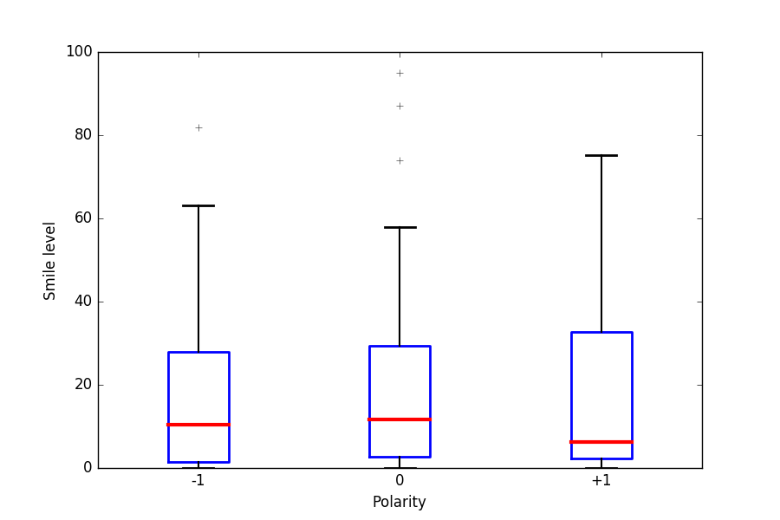

On analyzing the boxplots we observe that the median value for positive is lowest, higher for negative and highest for neutral, which contradicts our observation. However, the positive polarity class contains some smile intensity values that are higher than negative and neutral, and the maximum smile intensity value is highest for positive. This is in line with our observation that high smile intensity correlates with positive opinions.

**NAQ:** NAQ refers to tenseness in voice. This is associated with how much a person stresses on syllables while talking. As observed in 1, people tend to stress on syllables more while expressing positive opinions. So, we expect higher NAQ values to express positive opinions, than to express negative and neutral opinions.

|  |  |  |  |  |
| --- | --- | --- | --- | --- |
|  | Mean | Median | Standard Deviation | ANOVA (p-value) |
| Negative | 0.12662599622 | 0.1273002973 | 0.0337036098269 | 0.000266 |
| Neutral | 0.146717109915 | 0.1458568375 | 0.045402865404 |
| Positive | 0.148368989718 | 0.1501200442 | 0.0437494255297 |

From the ANOVA test, we obtain a p value of 0.000266. This value is less than 0.05, which means we can reject the null hypothesis that there is no difference in the means of the three classes. So, NAQ is a really good feature for disambiguating the opinion of the speaker, as observed by us.

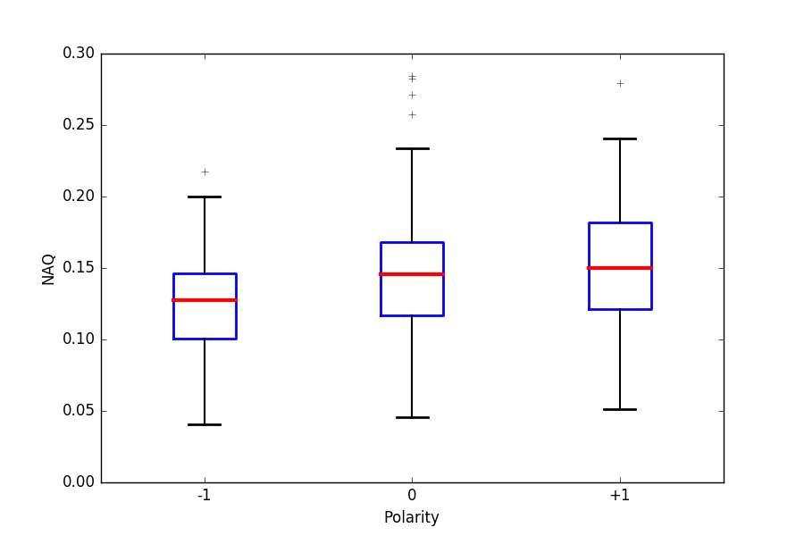

From the boxplots we find that the median value for negative is lowest, higher for neutral and highest for positive. Also, the highest NAQ value was observed for positive opinions. This highly agrees with our observation that tenseness of voice increases for positive opinions.

**Mouth openness**: Mouth openness refers to how open a speaker’s mouth is while speaking. We observed in 1 that speakers with positive opinion would laugh a lot and also enunciate words more, which both require the mouth to be open. From this, we think that mouth openness should be highest for positive opinions.

|  |  |  |  |  |
| --- | --- | --- | --- | --- |
|  | Mean | Median | Standard Deviation | ANOVA (p-value) |
| Negative | 114.159210582 | 105.297536733 | 47.9977275796 | 0.007821 |
| Neutral | 134.781714393 | 125.181372549 | 62.8046034602 |
| Positive | 138.223543491 | 129.786363636 | 62.2622024005 |

We notice that ANOVA gives a p value of 0.007821, which is less than 0.05. This means that mouth openness is a good feature to distinguish between positive, negative and neutral opinions, as per our observation.

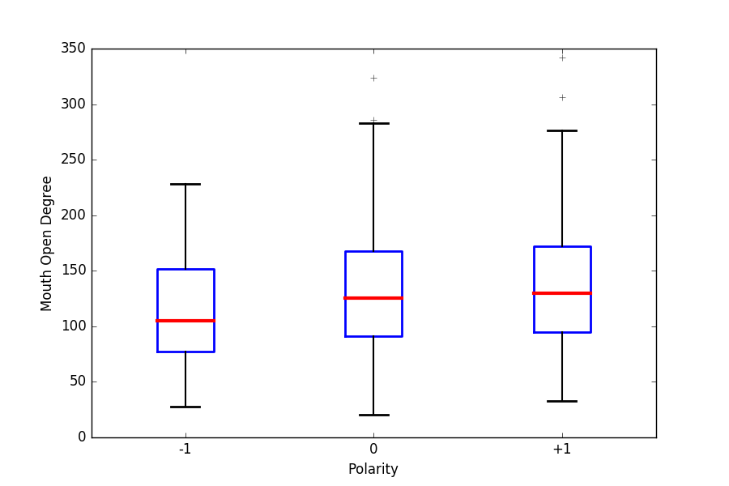

Analyzing the boxplots, we find that positive opinion has the highest median value, followed by neutral and then by negative. Further, the mean and median values for positive opinions are higher than those for neutral and negative, meaning that data in the positive class is more concentrated over higher values. This agrees with our observation from the videos.

**Right-eye openness**: We took into consideration eyes in general and observations from 1 show that eyes tend to be widened/opened while exhibiting more positive opinions and closed while exhibiting negative opinions like anger. Thus we hypothesize that right-eye openness would have high values for positive opinions and low values for negative opinions.

|  |  |  |  |  |
| --- | --- | --- | --- | --- |
|  | Mean | Median | Standard Deviation | ANOVA (p-value) |
| Negative | 304.538557857 | 297.536262893 | 70.3992461279 | 0.154573 |
| Neutral | 312.565552244 | 315.25341615 | 76.6613865528 |
| Positive | 327.922000675 | 315.010638298 | 75.4039415391 |

The p value from the ANOVA test is 0.154573. As it is not lesser than 0.05, the ANOVA result means that right eye openness has no effect on the opinion of the speaker. This disagrees with our observation that wider eyes correlate with positive opinions.

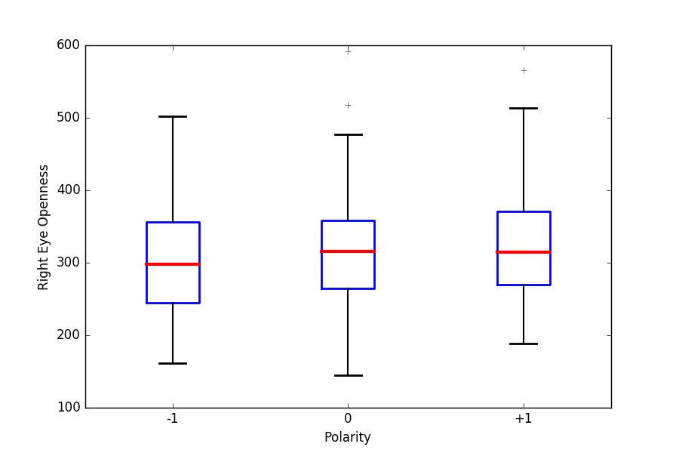

The boxplot shows that neutral opinions have a marginally higher median value than positive, while negative has the lowest median value. This again doesn’t validate our observation.

|  |  |
| --- | --- |
|  | T-Test (p-value) |
| Negative-Neutral | 0.45313466121694079 |
| Neutral-Positive | 0.20860161787997261 |
| Positive-Negative | 0.034285261078931498 |

Interestingly though, the t-test between positive and negative polarities results in a p value of 0.034285 (less than 0.05). This means that right eye openness is a good feature in differentiating between positive and negative polarities. Also, the mean and median values are higher for positive opinions than negative. This highly agrees with our observation.

**Face up down**: Finally, from 1, we see that face up down is not particularly associated with any one class. We thus expect face up down feature values to not be a discriminatory measure among classes.

|  |  |  |  |  |
| --- | --- | --- | --- | --- |
|  | Mean | Median | Standard Deviation | ANOVA (p-value) |
| Negative | 5.15425079948 | 4.22069964349 | 8.86304757541 | 0.921035 |
| Neutral | 4.99621639675 | 5.78043478261 | 8.96326660281 |
| Positive | 4.62930737113 | 3.88990825688 | 9.17178909358 |

P value of ANOVA test is 0.921035, which is much higher than 0.05. This means that face up down is a bad feature to help identify the opinion of a person, which correlates with our observation.

|  |  |
| --- | --- |
|  | T-Test (p-value) |
| Negative-Neutral | 0.90316327432608723 |
| Neutral-Positive | 0.72169347044247267 |
| Positive-Negative | 0.62151880108602453 |

Further looking at the t-test’s p values, which are all greater than 0.05, we see that this feature is bad to distinguish between any two classes.

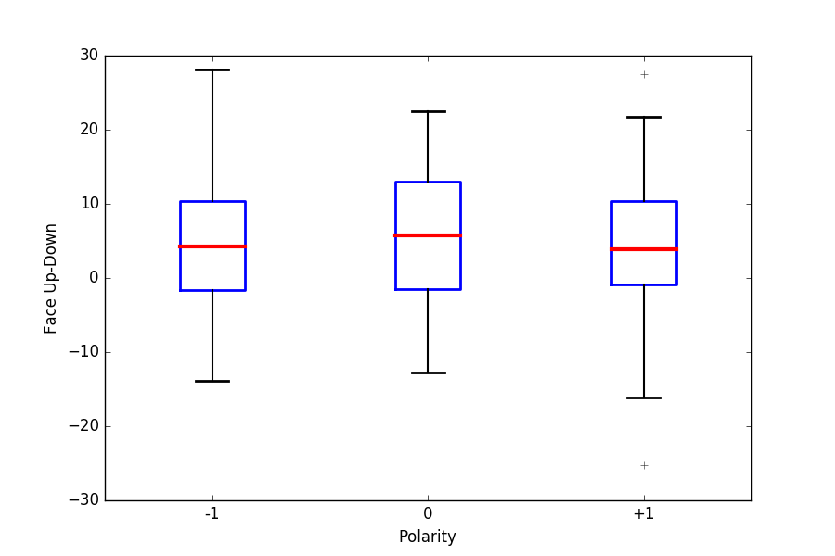

Looking at the boxplots, we observe that the median value for neutral is the highest, positive has the lowest face up down value and negative has the highest face up down value. This variation in the data agrees with our initial observation.

As NAQ, mouth openness and right eye openness gave very good values to validate our observations in 1, we conclude that they are good features that can be used to distinguish and identify emotions of the speaker well. But with smile intensity and face up down, we can’t say anything about the state of emotion as they have no effect on the polarity and cannot individually be used to distinguish between classes.