**CSE-411- Simulation and Modeling - July 2017**

Assignment 2:

Simulating a Dry Cleaner (*ex-2.26*)

Event graph, Random numbers streams, Performance metrics, and Language for coding

**Submitted by:**

**Abdullah Al Mamun (1305003)**

**Md. Imranur Rahman (1305015)**

**1. Description**

We will simulate a dry cleaner. Two-piece suits are processed by a dry cleaner. Suits can get damaged during the process.

**2. Event Graph**

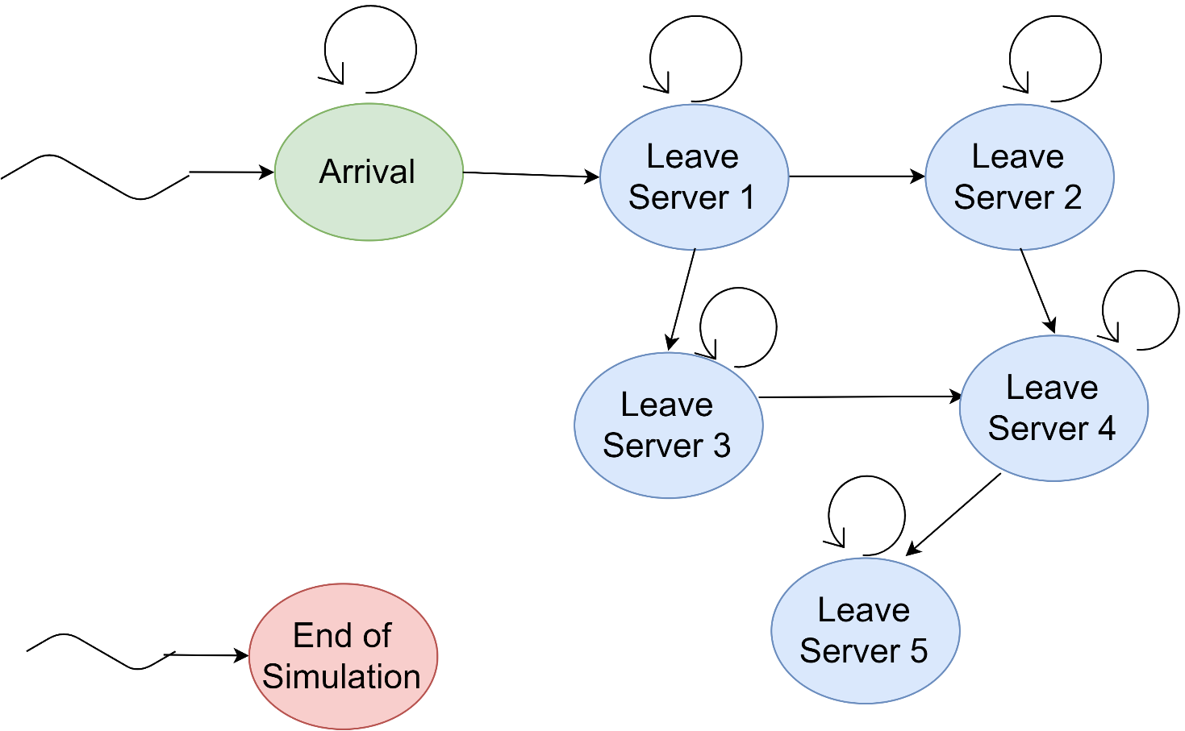

**3. Random Numbers Streams**

*The time variables are given in minutes.

|  |  |  |  |
| --- | --- | --- | --- |
| **Stream** | **Description** | **Distribution** | **Mean Value** |
| 1 | Server 1 service time | Exponential | 6 |
| 2 | Server 2 service time | Exponential | 4 |
| 3 | Server 3 service time | Exponential | 5 |
| 4 | Server 4 service time (undamaged) | Exponential | 5 |
| 5 | Server 4 service time (damaged) | Exponential | 8 |
| 6 | Server 5 service time | Exponential | 12 |
| 7 | Interarrival time | Exponential | 10 |
| 8 | Jacket damaged | Bernoulli | 0.05 |
| 9 | Pants damaged | Bernoulli | 0.1 |

**4. Performance Metrics**

We will compute the following performance metrics:

* 1. Average time to process suits
  2. Average length of each queue
  3. Utilization of each server

**5. Language for coding**

Python