Performance Comparison of Existing and Modified Version of NS-2



**Prepared by:**

**Abdullah Al Mamun (1305003)**

**CSE 3-2**

**Section- A**

**Prepared for:**

**CSE-322- Computer Networks Sessional - January 2017**

**1. Task Assigned**

We were assigned to simulate two different networks with two different MAC layer protocols 802.11 and 802.15.4. We simulated an 802.11 wireless mobile network and then 802.15.4 wireless static network. We varied the number of nodes, number of flows, number of packets per second, and speed for the mobile network and covorage area for the static network.

At first we simulated them with the existing code of ns2. Then we changed some protocols and then simulated again. We did a comparison between the performances with existing and modified version.

**2. Changes and Motivation**

We have modified the DROPTail algorithm. We had a motivation that a packet in the end of the queue is vulnerable in this algorithm. So, it is very likely that the packet in the end of the queue will drop after some time. Or some packets in that region may bounce front and rear for some time and then get dropped. As they are vulnurable and likely to drop, we drop them in a bulk when the queue is full. We remove about 20% packets of the queue when the queue gets full. So, then for a long time the queue will not be full, and almost all the packets passing through the queue are likely to not getting dropped. We did so expecting reduction in delay, better delivery rate, and congestion control.

**3. Performance Comparison**

3.1 Comparison in 802.15.4 wireless static

We noticed a significant improvement in the 802.15.4 wireless mobile version. When we varied the number of flows, we found 100% increase in throughput, 42% reduce in propagation delay, 4.6 times higher delivery rate, and 50% energy consumption. Let’s have a look over the comparison graphs.

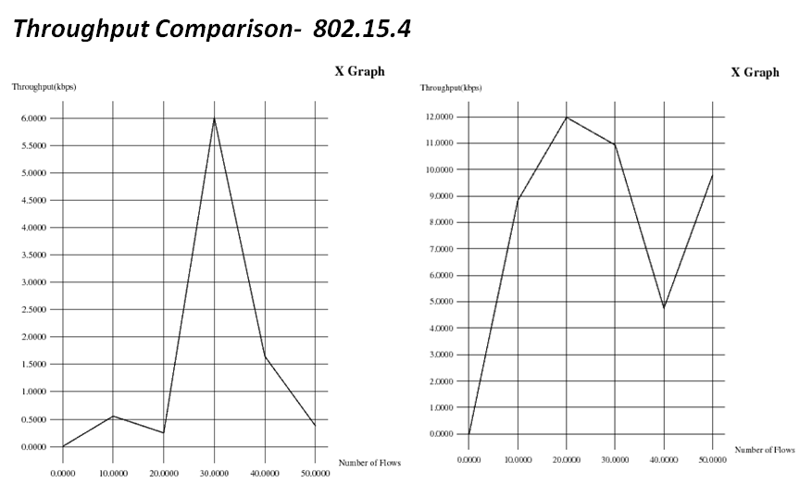

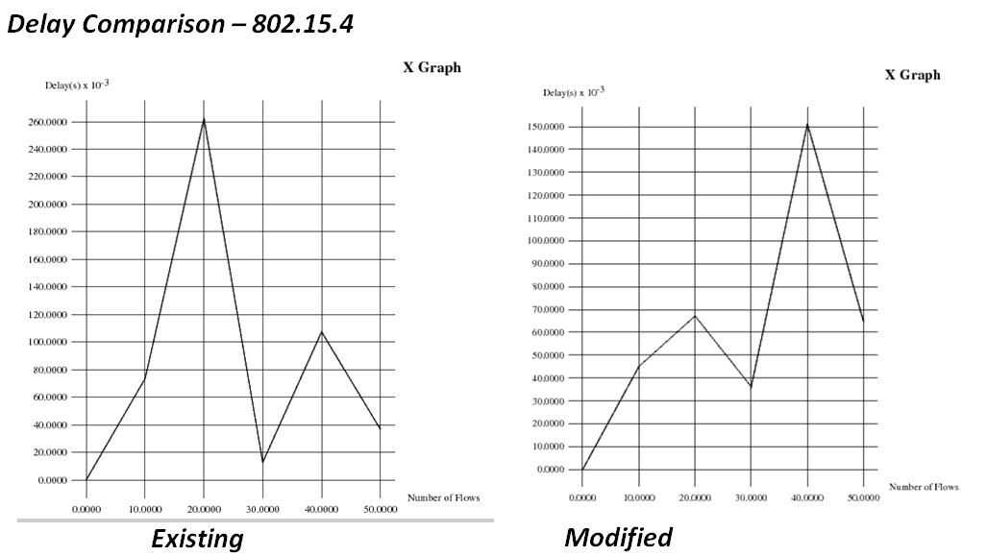

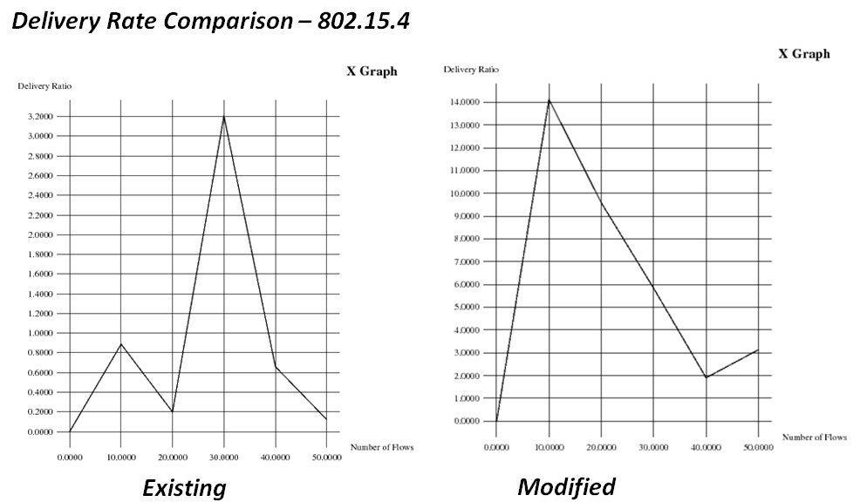

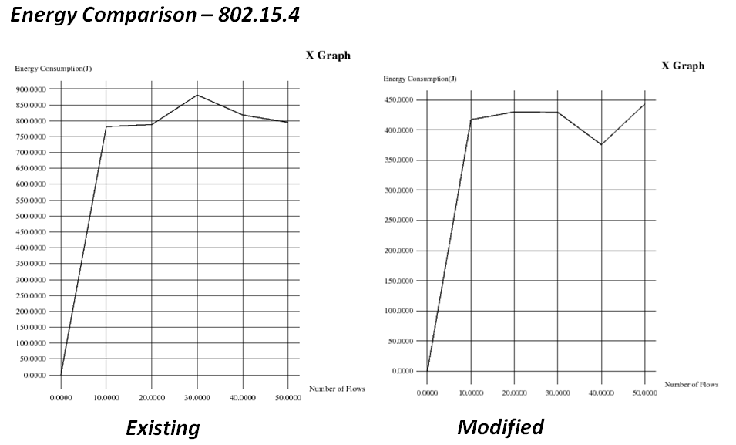

3.2 Comparison in 802.11 wireless mobile

Surprisingly we didn’t notice any significant difference in the 802.11 version. Almost all the output parameters were almost same.

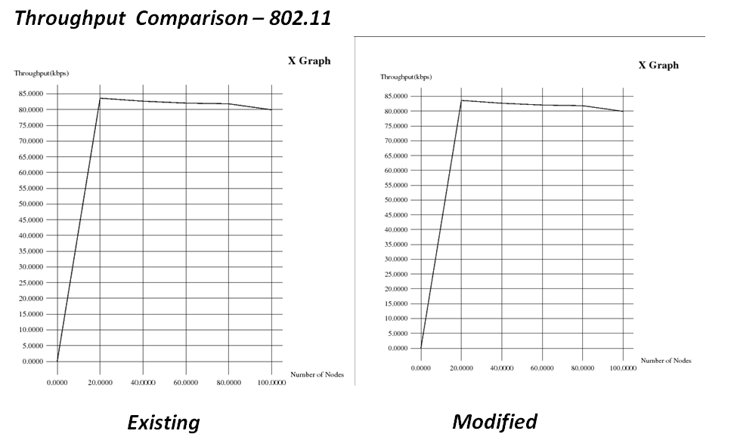

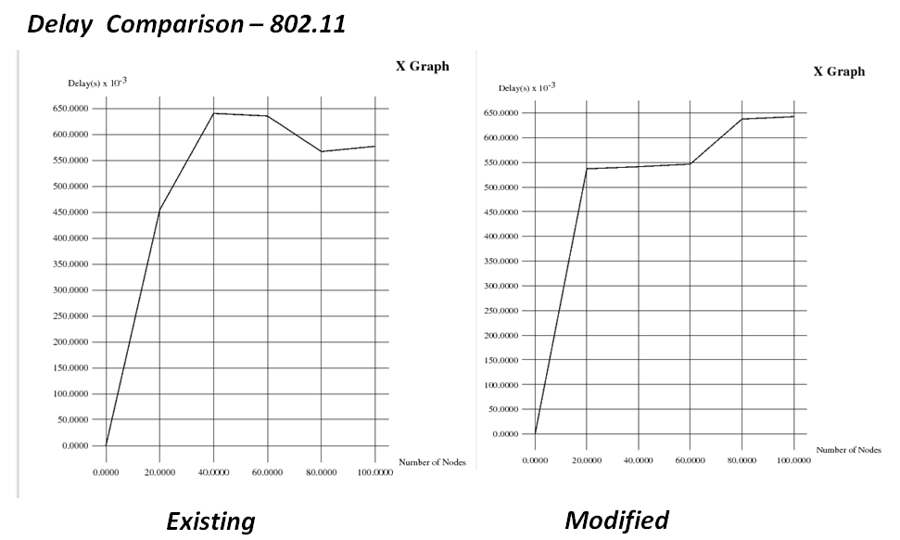

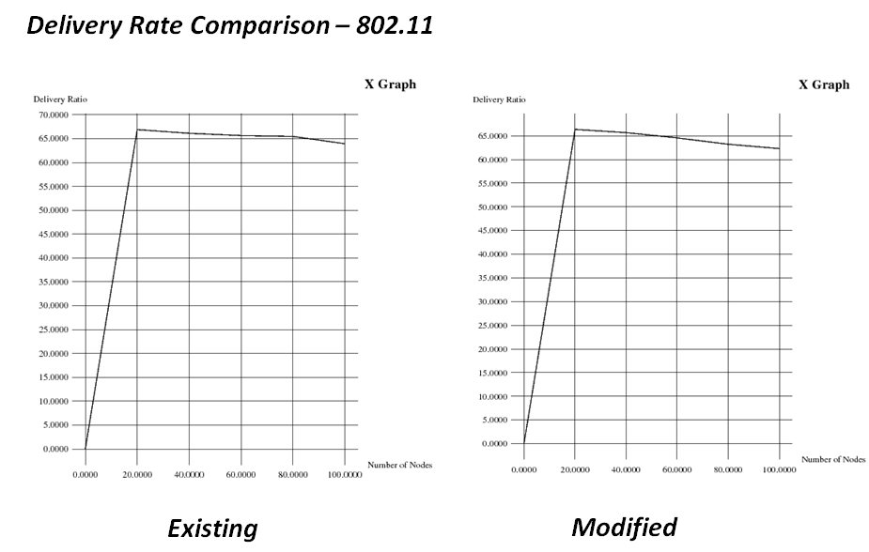

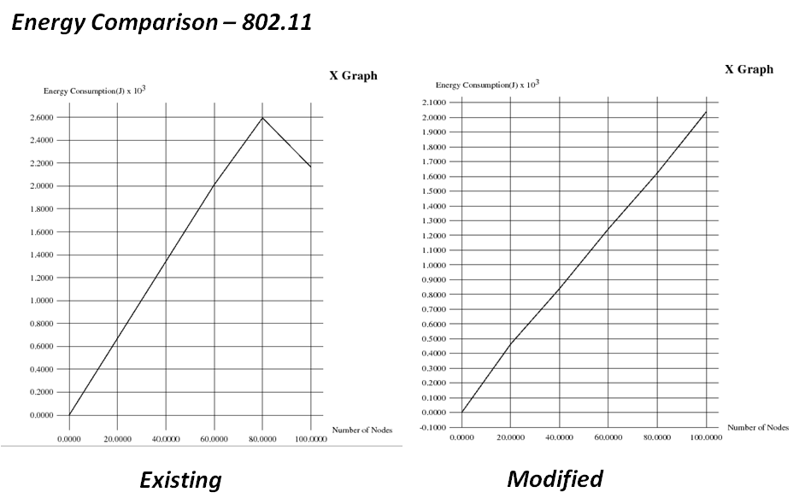

**4. Conclusion**

The overall performance was improved in the 802.15.4 mobile version. But the outcome in the 802.11 was almost the same.