**1. Proposed Title**

BEHAVIORAL MONITORING USING VOCAL SENTIMENT ANALYSIS

1. **How would you categorize this project? [Tick only ONE]**
   1. An effort to facilitate an existing Research/ Industry Project
   2. An effort to facilitate developing a Research/ Industry Funded Proposal for possible Funding
   3. An effort to facilitate Master’s/ PhD project objectives
   4. An exploratory study
   5. An experimental study for better lab utilization/ development
   6. A capstone project for students allowing them to apply their learning ✔

Other (please specify):

1. **What characteristics of the Complex Engineering Problem (CEP) are applicable to this project? [Tick one or more, if applicable]**
   1. Range of conflicting requirements: technical, engineering or other issues.
   2. Depth of analysis required: have no obvious solution and require abstract thinking
   3. Depth of knowledge required: require research-based knowledge ✔
   4. Familiarity of issues: Involve infrequently encountered issues ✔
   5. Extent of applicable codes: standards and codes devised by the professional bodies
   6. Extent of stakeholder involvement and level of conflicting requirements
   7. Consequences: Impact over the society ✔
   8. Interdependence: problems due to dependability
2. **Brief Outline**

Communication through voice is one of the main components of affective computing in human-computer interaction. Humans produce vocal sound which can be characterized by acoustic features like pitch, timbre, loudness and vocal tones. Human emotions can be differentiated on the basis of varying characteristics. Detecting human emotions from speech and analyzing them is potentially beneficial for improving human conversational skills. Using the current knowledge of sentiment analysis available, this proposed model handles speech data and extracts human emotion information like happiness, sadness, angriness etc. As the importance of providing services increases, vocal sentiment facilitates to monitor the human behavior. There are certain scenarios where human behavior leaves an imprint on others. This proposed model focuses on an application which takes human voice into account, processes it, extracts sentiments and give complete emotional insights to relevant higher authorities.

1. **Objectives**

The objective of this proposed model is to automate the time consuming task of supervisors i.e. to monitor the interactions of their employees with customers by extracting sentiments from their vocal data. We aim to develop a mobile based application which implements this model and returns a detailed insight on person’s emotion over different instances.

1. **Scope**

* Call Center Supervisors:

Interaction between employees and customer has to be monitored by the supervisors to ensure quality of every call. Supervisors can use this model for this task and based on the insights provided by our model, they can act accordingly.

* Emergency Scenarios (hospitals, police stations, fire stations etc.):

In case of emergency, caller agents should use a considerate tone to avoid any chaos. Supervisors can use this model to assess their behavioral compatibility in critical scenarios.

* Any organization where behavioral monitoring is needed

1. **Methodology**

This project requires following methodologies and tools:

Data Collection:

A voice dataset is collected that contains some basic but important features. With the help of which more accurate classification of the sentiments will be done. Tools will also be selected on the basis of programming language that will be used. Most probably, JUPITER NOTEBOOK, GOOGLE COLABORATORY and VISUAL STUDIO CODE will be preferred because their interfaces are quite descriptive that may help in demonstration.

Data Cleaning and Feature Extraction:

Data cleaning and feature engineering will be required for a good model with high accuracy. All the unnecessary data and redundant features will be removed from the dataset. All those features will remain in the dataset that can be added in sensitivity list.

Modeling and Training:

An efficient model will be chosen after testing different models/classifiers like SVM, HMM, CNN and some other neural network models. Predictive analysis is totally based on the accuracy of model that will be predicting the sentiments.

Report Generation using Data Analysis:

Based on the sentiments extracted by the deep learning model a detailed report will be generated using data analysis and visualization techniques. This report will provide enough insights to monitor the emotions of relevant people.

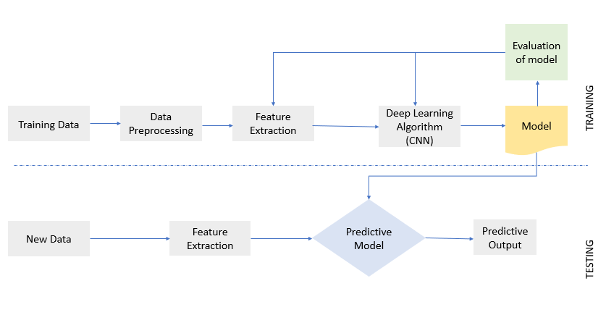

1. **Expected Outcomes of the proposed project**

A mobile application infused with a deep learning model which takes human voice as input, extracts vocal features using Sentiment Analysis and generates a detailed report of emotional behavior.

|  |  |  |  |
| --- | --- | --- | --- |
| **No.** | **Elapsed time (in months) from start of the project** | **Milestone** | **Deliverables** |
| 1. | 1st and 2nd month | Literature Review | SRS Document |
| 2. | 3rd, 4th, 5th month | Feature Extraction, Model Training | Deep Learning Model (CNN) |
| 3. | 6th, 7th month | Mobile Application Development with Cloud Deployment | Mobile Application |
| 4. | 8th month | Integration and Testing | Final Project |
| 5. | 9th month | Documentation | Final FYP Report |

1. **Expected Budget**

The dataset, tools and softwares all are available open source hence there is no significant budget of this project.

1. **Attach Gantt Chart for the Project Work**

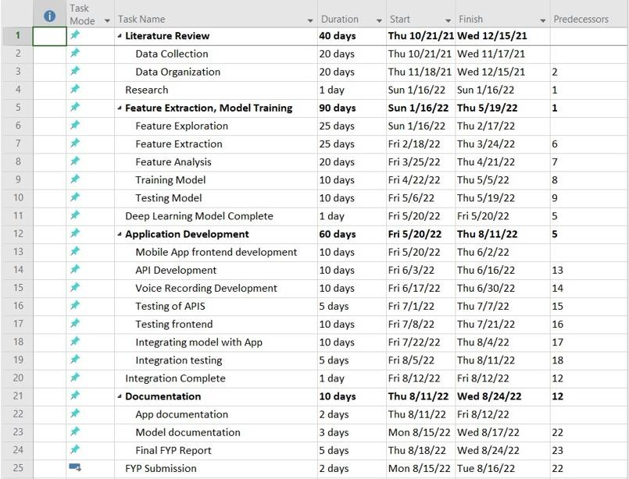

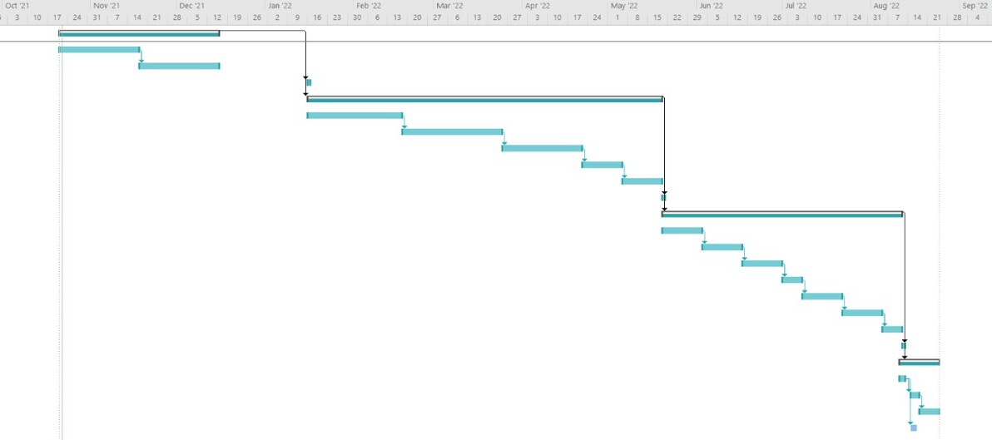

1. **Alignment of project with departmental/programme mission and SDGs*.***

As per Computer Information Systems Departmental mission we are transforming the society through technological innovations by developing a vocal sentiment analysis system that will help supervisors to supervise the behavior of employees.

SDG Goal 9 is “Build resilient infrastructure, promote inclusive and sustainable industrialization, and foster innovation”. SDG 9 has eight targets and progress is measured by twelve indicators.

One of the indicators is to enhance research and upgrade industrial technology. This proposed project is aligned with this SDG as we are implementing a system that is innovating the conventional approach for monitoring human behaviors.

Name of Supervisor: Dr. Urooj Ainuddin Signature: ________________

Name of Co-Supervisor (if any): ___NIL___ Signature: ________________

Name of Industrial Advisor (if any): ___NIL___

**Recommendations and Approval:**

**Chairperson (Head of FYDP Review Committee) Sign with Date:**