ESSP/BC Service Requirement: Advance Settlement
1. Service Name: Advance Settlement
Service Description: This service enables employees to settle advances received through an approved and paid Advance Payment Request by submitting actual expenses incurred, attaching supporting documents, and reconciling the advance received against the actual expenses.
The employee first receives an advance through an approved Advance Payment Request document. Only after the payment has been made can the employee initiate the Advance Settlement service.

2. Financial Reconciliation
The system should automatically calculate the following:
Description | Amount
Total Advance Received | Auto-calculated/retrieved
Total Actual Expenses | Sum of expense lines
Balance | Difference
The system should automatically determine the settlement outcome:
Scenario 1: Actual expenses equal the advance
Fully Settled
- No outstanding amount. The advance is fully accounted for.
Scenario 2: Actual expenses are less than the advance
Advance Surrender
- The employee must return the unused balance to the organization.
Additional information:
- Amount to be returned
- Repayment date
- Payment receipt/reference
Scenario 3: Actual expenses exceed the advance
Additional Reimbursement Claim
- The employee declares the additional eligible expenses incurred beyond the original advance amount.
Additional information:
- Additional amount claimed
- Justification for exceeding the advance
- Supporting receipts/documents

Important System Business Rules
The following requirements should be considered in/on ESSP/BC :
1. Advance Settlement must only be initiated after the original Advance Payment Request has been approved and paid.
2. The employee must select the original Advance Payment Request document number.
3. Advance details must be automatically retrieved from Business Central.
4. The system must allow multiple expense entries and supporting document attachments.
5. The system must automatically calculate the difference between the advance received and actual expenses incurred.
6. If expenses are less than the advance, the employee must surrender the unused balance.
7. If expenses exceed the advance, the employee must submit an additional reimbursement claim with justification and supporting documents.
8. The settlement must not be considered complete until the financial reconciliation is finalized.
9. The system must prevent duplicate settlement of the same advance.
Process flow
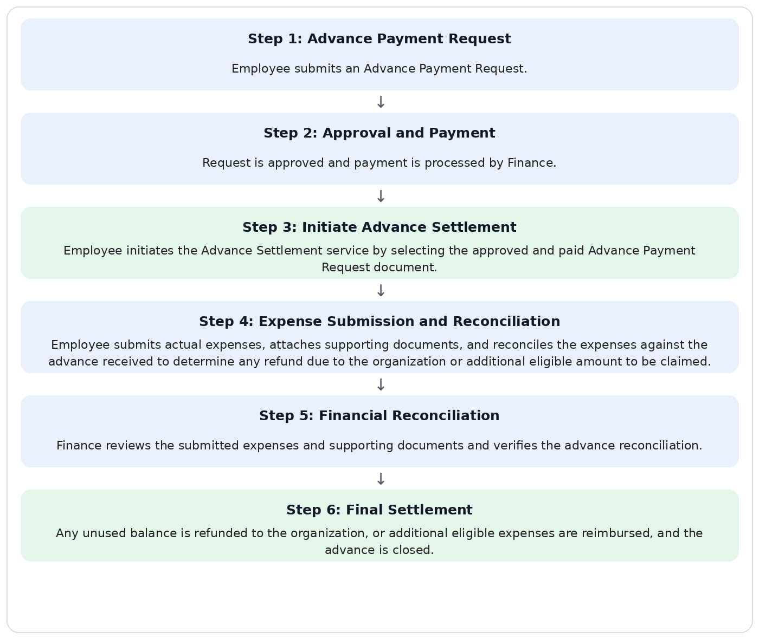

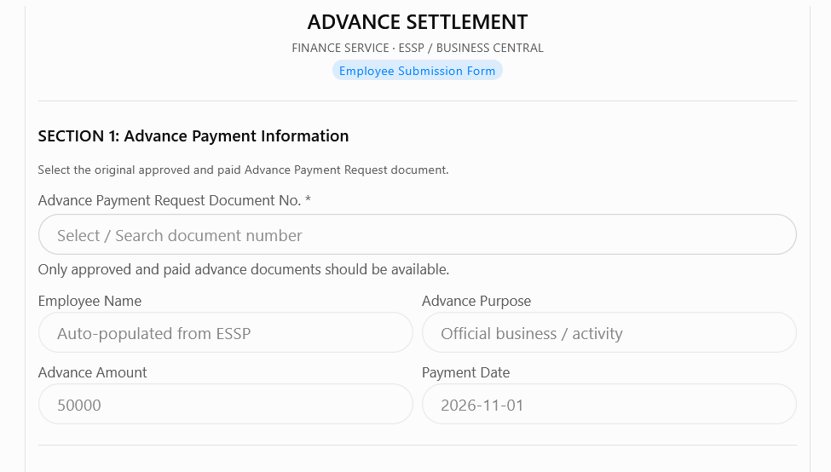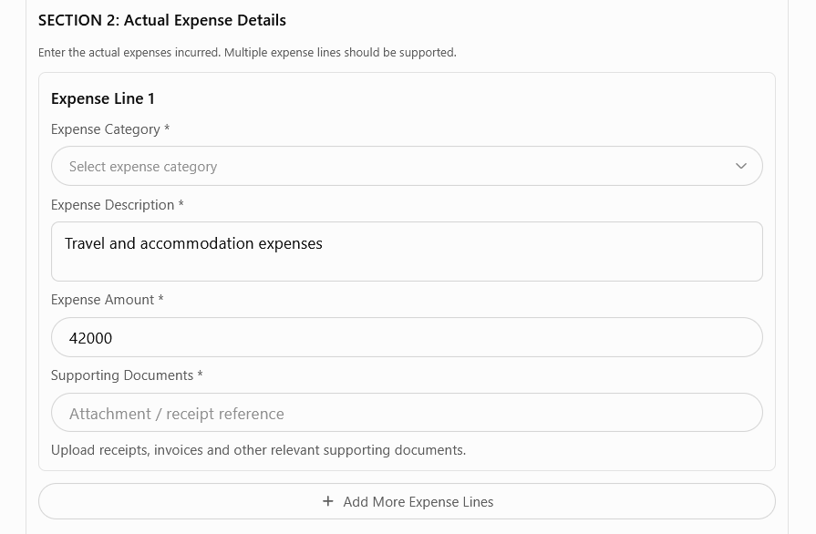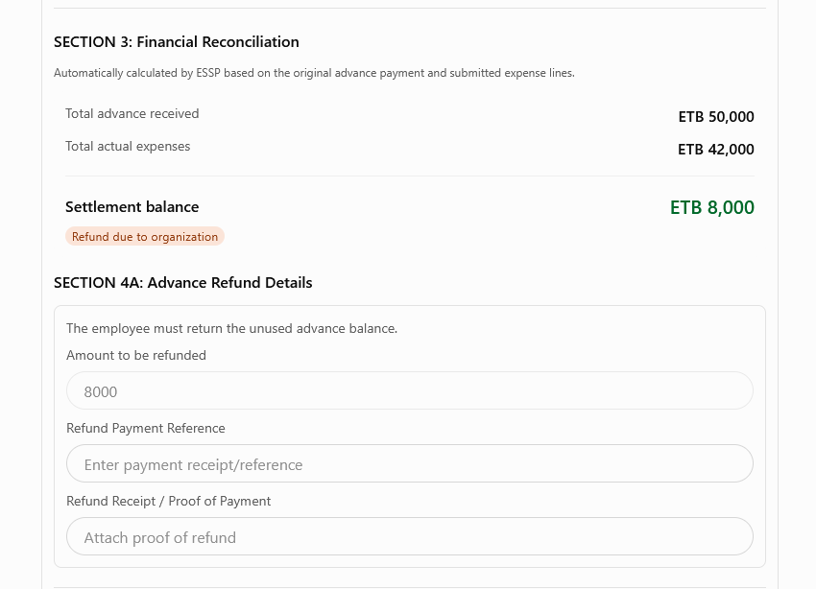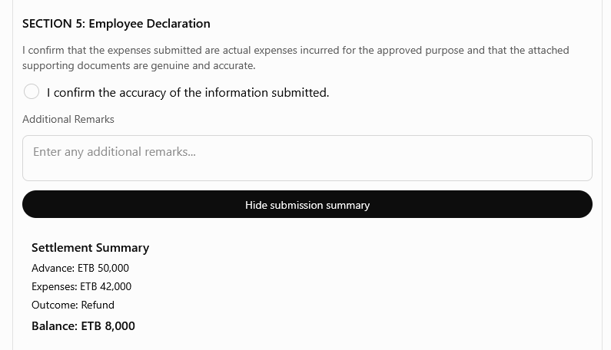
Note: Numbers in the form are Samples

